Adulien Calendar
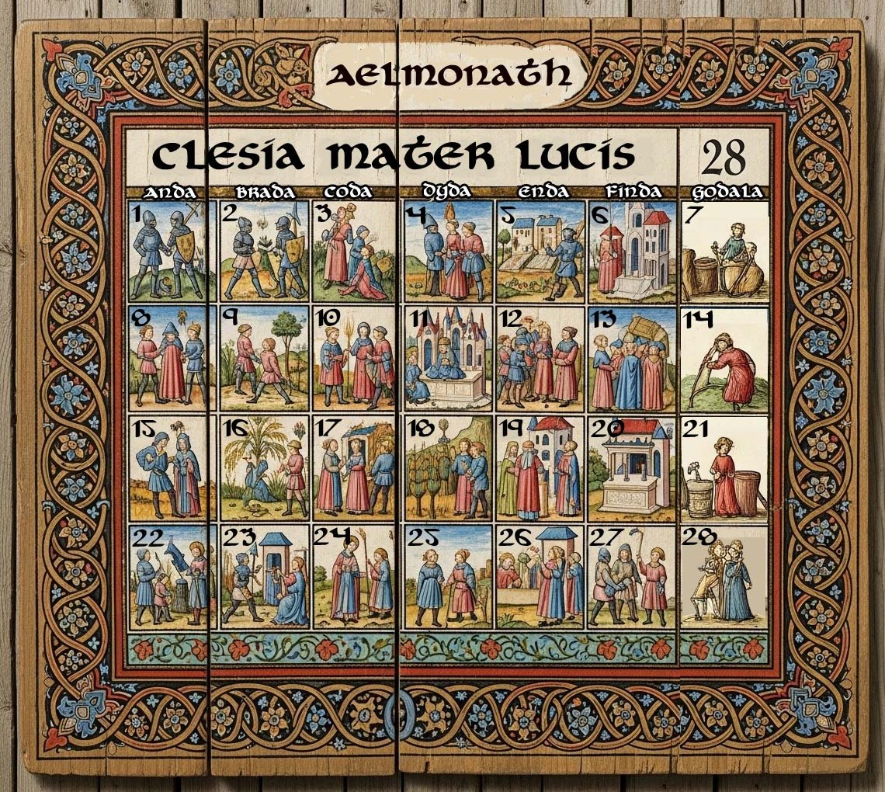
The calendar of the western kingdoms comes from the calendar imposed by the Celedonian Empire in the First Written Age, but its roots are the Adulien Calendar from the dawn of time. The year is divided into thirteen months, with twenty-eight days each. Each month is associated with one of the Clesian figures, whose aspects feature into the time of year. A full moon appears on the first of every month. The phases of the moon are full (day 1 of the month), waning gibbous (5), half-moon (8), waning crescent (12), new moon (15), waxing crescent (19), half-moon (22), and waxing gibbous (26).
Each week is seven days, with days of the week named with old Celedonian prefixes added to a contraction of the word ‘day.’ They are: Anda, Brada, Coda, Dyda, Enda, Finda, and Godala. Godala is short for “Good day!” which is an outdated saying. It became a day of worship in the Second Written Age when the Clesian Church grew into widespread popularity. The last Finda of each month is marked by local festivals honoring the season as well as the deity of that month.

Months of the Adulien Calendar
- Aelmonath – The first thaw; a time of awakening. This month belongs to Clesia, giver of life and the healer of souls, and ends in a festival in their honor. (late winter)

- Beorthlic – Brightmonth; known for returning light. This month belongs to Rhiannon, hero of the oppressed, and ends in a festival in their honor. (early spring)

- Cynewind – King's Wind; the stirring of spring breezes. This month belongs to Ceardren, winged master of the four winds, and ends in a festival in their honor. (early spring)

- Draegfold – Dragonfold; associated with the blooming of fireflowers. This month belongs to Rosmerta, herald of fertility, and ends in a festival in their honor. (mid-spring)

- Eorthmere – Earthlake; named for flooding rivers and swollen banks. This month belongs to Niskus, lord of the waters, and ends in a festival in their honor. (late spring)

- Frandegast – Flameguest; the time when hearth-fires burn low and spirits walk. This month belongs to Belisama, matron of fire and light, and ends in a festival in their honor. (early summer)

- Glimwold – Gleamforest; a luminous midsummer month. This month belongs to Wyrrin, the hunter, and ends in a festival in their honor. (mid-summer)

- Haerthwyn – Hearthjoy; a time of harvest and feasting. This month belongs to Croian, champion of feats and their celebration, and ends in a festival in their honor. (late summer)

- Isenbraec – Ironbreak; when frost returns to crack the fields. This month belongs to Draiachta, seeker of knowledge and order, and ends in a festival in their honor. (early fall)

- Jurnhalda – Yewhold; a sacred month of remembrance. This month belongs to Scylden, shield of the people, and ends in a festival in their honor. (mid-fall)

- Kyldestrem – Coldstream; bitter winds and frozen ways. This month belongs to Taranis, bringer of thunder and war, and ends in a festival in their honor. (late fall)

- Lufebryn – Loveborn; associated with midwinter rites of kinship. This month belongs to Litavis, blind shepherd of the earth below, and ends in a festival in their honor. (early winter)

- Mournheald – Mourningeld; the dark’s dominion before the new year’s fire. This month belongs to Erecura the dark and ends in a festival in their honor. (mid-winter)

Nithwyrm
The thirteen months are twenty-eight days each, giving us 364 days of a year. This leaves a single day to round out the 365 days of a year. This last day is a dark day, full of portents. Some say the powers below rise up and run free in the world, and all should lock their doors and stay hidden and silent. It is a dreaded day. It is Nithwyrm, the Day of the Dark Serpent, when the veil thins, the underworld stirs, and the wyrm of doom coils through the land. No fire is lit. No bell is rung. Even the stars seem to wink out of sight.
Nithwyrm Traditions
1. The Shrouding: On the eve of Nithwyrm, families hang black or ash-colored cloths over windows and mirrors. This is said to prevent spirits or dark reflections from crossing into the world. In wealthier homes, cloths are embroidered with binding runes or iron thread for added protection.
2. The Stillfast: No fires are lit, no food is cooked, and no one speaks aloud during Nithwyrm. Even footsteps are softened with straw mats or cloth-wrapped shoes. Many fast for the entire day, believing food attracts “those who hunger in shadow.”
3. The Salt Circle: Households scatter salt and crushed bone ash around the threshold and windowsills. This is meant to bar entry to wandering spirits or the agents of the wyrm.
4. The Iron Watch: A single blade of cold iron, often a knife or a nail, is placed under every pillow or across door lintels.

Nithwyrm Superstitions
1. The Crying Wind: If winds howl on Nithwyrm, it is said to be the Wyrm’s breath, searching for doors left open. Hearing your name in the wind is considered a dire omen—you are marked and must seek a priest, witch, or wise one before the next new moon.
2. The Shadow That Lingers: Shadows that remain after a person walks away are said to be souls unanchored, watching. No one may turn around if they sense one behind them, or risk being “mirrored.”
3. No Names Spoken: Speaking someone’s name aloud is forbidden; it is believed to draw their spirit out for the wyrm to claim.

