Notes on the Elven Kingdom of Ulynar

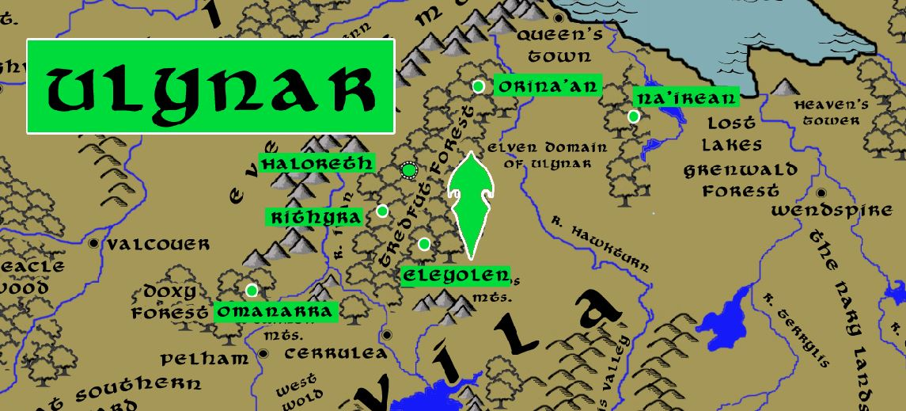

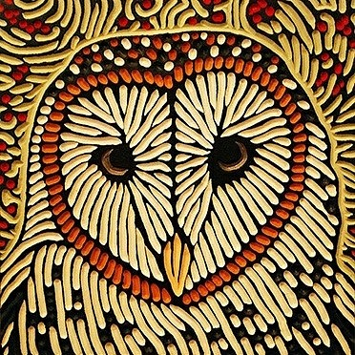
Sign of the Barn Owl
Location: Tredfut Forest, Western Amadar bordering the Kingdom of Treviland
- Overview
- Towns and Cities
- History
- Notes on Culture
- Magical Items
- Developer Notes

Overview
The elven kingdom of Ulynar enjoys relative solitude from the humans of Treviland since the area is lightly populated and heavily wooded. Near the Augemere Sea, Ulynar trades elven goods with passing traders visiting the town of Milady. The Ulynar keep the woods here under their protection and extend that to the Forsaken Pass to the south, sometimes patrolling the Vale of Faerdeep. The river leading to Eversong Lake is also under their protection. The Ulynnar gather regularly late at night along the river’s edge, and once a year at the Lake itself, to sing lively songs of legend as well as sad songs of remembrance for their fallen. The Evermore Mountains to the north are also patrolled by the Ulynnar to ward off evil that might grow there. Their ruler, Aymer Sandoral, is a wise and mirthful Elven lord. He is particularly fond of song and is known to wander in secret to the town of Lyre to partake of their singing and storytelling.

Ulynar remembers the early days of humans in this region. It was an ugly time with humans disrupting the land with crude earth magic and meting out terrible acts on one another. Today the elves see the humans as unruly children who have the potential for good but require watching. They do maintain good friendships with the human rangers from the Band of the Even Star out of Cerrulea as well as the druid Circle of the Willow out of Queen’s Town.

Faerdeep Vale is a place of special interest for the Ulynar. Nestled in the Awnos Mountains at the eastern edge of the Kendor lands, the valley is wild and dangerous. It is also a sanctuary for magical creatures and home to the fey Court of Faerie Queen Aradia. Elves travel here regularly to commune with the fey. They also stand ready to defend the valley from humans or other forces disturbing it.

The elves enjoy a special friendship with the copper dragon Isienth, who dwells in the Evermores. They seek her wisdom and in turn help protect her nest. It is not often they call on her help, but when they do she is a powerful ally. The brass dragon that lives far to the south in the Howling Hills is also a friend of the elves. Eoldru the Lore Beast enjoys telling the elves stories and receives stories from them in return.

The elves enjoy an uneasy friendship with the dwarves of Daemundra in the Evermore Mountains. Ulynar elves are amused by how serious the dwarves can be about their title as the eldest kingdom of dwarves (knowing Emraldren to the south is just as old). They smile at the contrived formality of the stately dwarves and their thinly veiled threats regarding any encroachment into their earthly domain. Ulynar elves are not above innocent pranks on the dwarves when they emerge on the surface, but they are quick to offer reparations to the easily-bruised dwarven pride. A long-held promise between them has been the Gwaedaear a special mine in the Evermores where the elves are allowed to obtain the ore for their magical forges and from which they craft the best swords in the world. The dwarves swore long ago to this agreement and would never think to refuse the elves access to the Gwaedaear, even if it galls some dwarves to remember it.

In truth Ulynar and Daeumundra have always stood together when evil threatens the land. Every ten years the king or queen of Daemundra meets with the lord or lady of Ulynar to drink a toast of friendship. And each year the dwarven ruler crushes the silver cups they drink from, swearing it is their last toast before storming off. But anyone who visits the court of Daeumundra will notice the famed silver shield Skjoldvenn hanging near the throne and inscribed with the motto “We remember our friends.” In truth the shield is made of the cups melted down and is carried forth as a standard in any battle where the dwarves come to the aide of the elves.

Legend has it that two elves, Alyndra of Ari’Aahn and Hatharal of Ulynar, children of elven lords, were once in love but their fathers denied them to see one another. The two would meet in secret on the shores of the Augemere Sea just west of Heaven’s Tower. One day the daughter stumbled across an invading army of orcs emerging from the Gunnar Gap (Second Dark Crusade, 662 WA3). Mortally wounded, she made it to Ulynar where she warned them of the invasion before dying in the arms of Hatharal. After the war, Hatharal spent his days retracing their path to the rendezvous spot overlooking the Augemere Sea. It is said where Alyndra’s blood fell along the way special flowers bloom. This is the Path of the Aching Heart. The flowers have special magical properties. It is said the couple buried a token of their love somewhere along the way that holds the key to removing a curse still suffered in both domains.

Towns and Cities
- Ulynar
  - Orinaan - large town, population 5,000, guards / soldiers 50, militia 250
  - Na'irean - large town, population 5,000, guards / soldiers 50, militia 250
  - Haloreth - large city, population 25,000, guards / soldiers 250, militia 2250
  - Rithyra - large town, population 5,000, guards / soldiers 50, militia 250
  - Eleyolen - large town, population 5,000, guards / soldiers 50, militia 250
  - Omanarra - large town, population 5,000, guards / soldiers 50, militia 250

Orinaan
Size: large town, population 5,000, guards / soldiers 50, militia 250
Trade Goods:
Local Goods:
Standard:
Colors:
Ruler: Haladavar Keymyar

Home:
Steward: Nasir Chaeqen
Marshal: Hatharal Ralophine
House Priest: Aravae Daesalor (f)
House Adviser (Scholar/Mage/etc): Rolim Wrantoris
Captain of the Guard: Itireae Glynzorwyn (f)
Chief Warriors in Service:
Malon Kristhyra
Miirphys Elvaris
Valindra Yelroris (f)

Local Powers:
Local Sites:

Description:

Industry:

Key Figures:

Local Lore:

History:

Customs:

Na’irean
Size: large town, population 5,000, guards / soldiers 50, militia 250
Trade Goods:
Local Goods:
Standard:
Colors:
Ruler: Jandar Olaleth

Home:
Steward: Lenna Carzana (f)
Marshal: Taeral Caiwarin
House Priest: Vulre Quitris
House Adviser (Scholar/Mage/etc): Sana Elric (f)
Captain of the Guard: Myrdin Vaydark
Chief Warriors in Service:
Taranath Eilwraek
Eriladar Zummyar
Halaema Reyralei (f)

Local Powers:
Local Sites:

Description:

Industry:

Key Figures:

Local Lore:

History:

Customs:

Haloreth
Size: large city, population 25,000, guards / soldiers 250, militia 2250
Trade Goods: timber, tea
Local Goods:
Standard:
Colors:
Ruler: Aymer Sandoral

Home:
Steward: Dain Yinthana
Marshal: Sinath Trismaer
House Priest: Laamtora Mirapetor (f)
House Adviser (Scholar/Mage/etc): Qildor Lular
Captain of the Guard: Naesala Qinmyar (f)
Chief Warriors in Service:
Velethe Faelyn
Alok Glanduil
Esta Persandor (f)

Local Powers: Band of the Syndratha (rangers)
Local Sites:

Description:

Industry:

Key Figures:
Their ruler, Aymer Sandoral, is a wise and mirthful Elven lord. He is particularly fond of song and is known to wander in secret to the town of Lyre to partake of their singing and storytelling.

Local Lore:

History:

Customs:

Rithyra
Size: large town, population 5,000, guards / soldiers 50, militia 250
Trade Goods:
Local Goods:
Standard:
Colors:
Ruler: Rennyn Theynore

Home:
Steward: Falael Qigeiros
Marshal: Almithara Chaemenor (f)
House Priest: Ivasaar Wrankian
House Adviser (Scholar/Mage/etc): Ulesse Umerora (f)
Captain of the Guard: Beluar Orijeon
Chief Warriors in Service:
Kymil Dorceran
Luvon Ulasandoral
Jandar Olaleth (f)

Local Powers:
Local Sites:

Description:

Industry:

Key Figures:

Local Lore:

History:

Customs:

Eleyolen
Size: large town, population 5,000, guards / soldiers 50, militia 250
Trade Goods:
Local Goods:
Standard:
Colors:
Ruler: Vulre Quitris (f)

Home:
Steward: Ninleyn Olodan
Marshal: Miirphys Greqirelle
House Priest: Taeral Caiwarin (f)
House Adviser (Scholar/Mage/etc): Nasir Heiwynn
Captain of the Guard: Urdusin Glyndove
Chief Warriors in Service:
Methild Glynydark
Raibyn Neriwenys
Myrdin Vaydark (f)

Local Powers:
Local Sites:

Description:

Industry:

Key Figures:

Local Lore:

History:

Customs:

Omanarra
Size: large town, population 5,000, guards / soldiers 50, militia 250
Trade Goods:
Local Goods:
Standard:
Colors:
Ruler: Calarel Wranjyre (f)

Home:
Steward: Aien Paxina
Marshal: Nym Wranlamin
House Priest: Mirthal Oricyne
House Adviser (Scholar/Mage/etc): Taranath Eilwraek (f)
Captain of the Guard: Kiirion Iarhana
Chief Warriors in Service:
Silvyr Tracyne
Eriladar Zummyar (f)
Rennyn Theynore (f)

Local Powers:
Local Sites:

Description:

Industry:

Key Figures:

Local Lore:

History:

Customs:

History
First Primordial Age (PA1)

Second Primordial Age (PA2)

Third Primordial Age (PA3)

Fourth primordial Age (PA4)
290 PA4 - King Aleaume of the Phrane Empire wages war with the elves of Ulynar, Aldalinh, and Ari'aanh; the elves utterly wipe out the Phrane armies and slay Aleaume

First Ancient Age (AA1)

Second Ancient Age (AA2)

Third Ancient Age (AA3)
90 AA3 – Red Leaf War - King Sevré of the Harduins wages war on elven kingdom of Aldalinh
90 - the Amulet Veritae, amulet of kings, is sundered in two at the act of Sevré's treachery; the second half is lost

110 AA3 - Elven settlements in Bane Wood and Treacle Forest wiped out by Harduin armies in the Red Leaf War

140 AA3 - end of the Red Leaf War - elven forces from Adulien and Ulynar encircle and wipe out Harduin forces, rescuing Aldalinh; King Sevré falls in battle when elves wield the second half of the Amulet Veritae and slay him

850-873 AA3 - Great Orc War of the West

851 AA3 - The Great Orc Army splits into four forces: The Banners of Blood, Bone, Claw, and Teeth; Blood and Bone march west, Claw invades the Dwarven Kingdom of Citerak, Teeth marches east into the Friendless Fringes

852 AA3 - Orcs of the Blood and Bone Banners assault the Great Darkwood Forest and the Kingdom of Kalanon

852 AA3 - Battle of Amrathain River - Orcs of the Blood and Bone Banners crush the Elven forces of Kalanon; the Elven towns of Kalanon are laid to waste

852 AA3 - Elves of Aldalinh and Adulien march to aide Kalanon

853 AA3 - the Orcs of Blood and Bone withdraw to Wyvern Pass; Elves of Aldalinh and Adulien are surrounded and ambushed at Wyvern Pass ; they flee west in retreat

854 AA3 - fall of the Elven settlements in Fangel Forest, Bane Wood, and the Faun Forest

854 AA3 - Banners of Blood and Bone assault Final Forest

857 AA3 - Elves of Ulynar march west, Elves of Ari'Aahn march east

858-872 AA3 - Kingdom of Aldalinh falls to the Orc invaders; fighting continues off and on around the Plenish Marches, Bane Wood, the Gunnar Gap, and the Plains of Arbock

873 AA3 - a series of victories over the Orcs drive them back from the Plenish Marches and the lands east of the Evermore Mountains; Aldalinh is liberated but the lands north of the Augemere Sea are lost to orc and goblin tribes

Fourth Ancient Age (AA4)

First Written Age (WA1)

Second Written Age (WA2)

Third Written Age (WA3)
640 WA3 - Second Dark Crusade

641 WA3 - Elves of Eida'Las march out to stop Mortavay at the Battle of Erstwyn River; Elven forces decimated and forced to flee the Idenbor Forest

662 WA3 - Elves of Ari'Aahn join with the Dwarves of Garnettren to aide the humans in encircling Mortavay's forces in Erigoth

663 WA3 - Trevilish and Tirudoran cities still free rally to attack Mortavay's center forces, cutting them off from the east; joined by the Elves of Ulynar attacking from Tredfut Forest

666 WA3 - Elves of Aldalinh join Plenish forces from Chryssla and Phaeria to battle Mortavay's central arm

670 - Mortavay defeated; end of the Second Dark Crusade

700 WA3 - Battle of Idenbor: Elves of Ari'Aahn return and take back the Idenbor Forest, restoring their kingdom

Fourth Written Age (WA4)

Notes on Culture
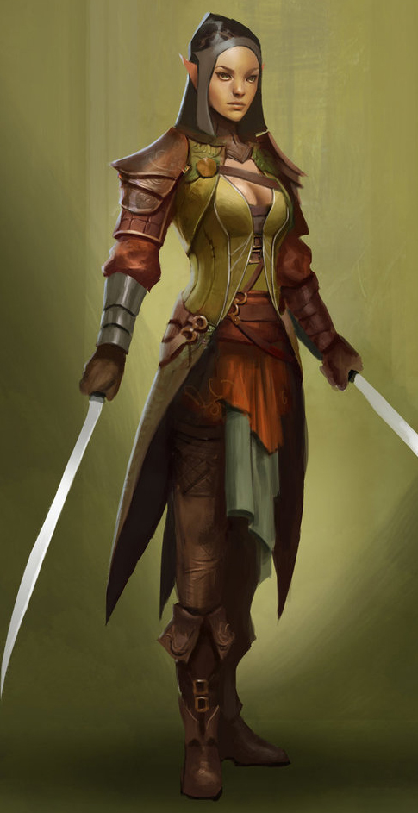
Taurean or Forest Elves
Locations: Adulien, Aldalinh, Ulynar, Ari’Aahn, Teinhir
Appearance: light brown skin; blonde to brown hair; brown or green eyes
Culture: Forest Elves are athletic, curious, and eager to explore. They are fond of stories and songs, both in the hearing and the performing. They are playful, mirthful, and relate well to other races. Forest Elves prefer the wilderness but welcome visitors to their lands. They relish life to the point that they are considered unruly by the more cerebral elves.
Common Attire: dark shades of green and earth tones
Traits: Taller than most elves and disciplined warriors. They are familiar with magic but without any special focus or natural spell-like abilities.
Ability and Skill Modifiers: same as standard elf in PHB

Magical Items

Developer Notes

