Notes on the Elven Kingdom of Adulien

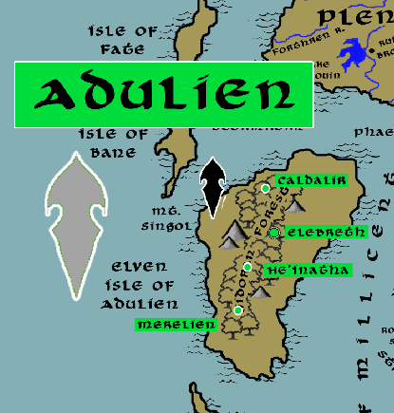

Location: Gidoran Forest, Isle of Adulien, Western Amadar

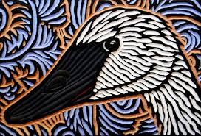
Sign of the White Swan
- Overview
- Towns and Cities
- History
- Notes on Culture
- Magical Items
- Developer Notes

Overview
The Isle of Adulien is the revered island home of the Elves, considered by some to be their birthplace in the dawn of Nemmyrl. Here is the center of the Ehlonna religion: the Great Tree of Aaralon is gleaming white and gargantuan and is the chief cathedral for worshippers worldwide. Predominantly populated by gray elves, Adulien nonetheless is also home to elves of every kind. Tribes of forest elves are scattered throughout the forest that covers the island. Aquatic elves thrive all along the shoreline in underwater caves that dot the coast.

Adulien has a massive navy defending her shores. The island is predominantly forest, where settlements occupy the upper tree tops and elves live at one with the land. While not a kingdom of man, it is still a sovereign power to be reckoned with. Elves watch over domains of large wooded areas throughout Nemmyrl, but all pay homage to Adulien.

Towns and Cities
- Adulien – Gidoran Forest, Isle of Adulien
  - Caldalir - large town, population 5,000, guards / soldiers 50, militia 250
  - Elebreth - large city, population 25,000, guards / soldiers 250, militia 2250
  - He’inatha - large town, population 5,000, guards / soldiers 50, militia 250
  - Merelien - large town, population 5,000, guards / soldiers 50, militia 250

Caldalir
Size: large town, population 5,000, guards / soldiers 50, militia 250
Trade Goods:
Local Goods:
Standard:
Colors:
Ruler: Luthais Zindove

Home:
Steward: Falael Qigeiros (f)
Marshal: Saelethil Petlana
House Priest: Ghilanna Krisxina (f)
House Adviser (Scholar/Mage/etc): Khilseith Xyrrona
Captain of the Guard: Pywaln Glynphyra
Chief Warriors in Service:
Illianaro Wynstina
Shandalar Miralamin (f)
Kethryllia Holanala (f)

Local Powers:
Local Sites:

Description :
Caldalir is the northernmost settlement in Gidoran Forest and has a strong connection to the sea. Shells decorate the trees, artwork depicts marine life, and even the people have the smell of the sea breeze on them. In addition to the sprawling network of treetop cottages and sky bridges, consistent with any woodland realm, there is a seaside village just north of the edge of the forest where the Wood Elves retire to commune with the ocean waters.

At the coastline the land drops off sharply. Here the cliffs are marked with cavities that form lagoons and coves. It is there visiting emissaries from the sea elves dwell in underwater caves. Unlike most underwater crevasses, these are palaces in their own right. Coral columns support tall ceilings illuminated by phosphorescent algae. The walls glitter with pearlescent veneer harvested from the shells of the sea. Seaweed is arranged in beautifully braided garlands. Just as land elves consider Gidoran Forest a holy place and capital, the Sea Elves consider Caldalir a holy site.

Industry:

Key Figures:

Local Lore:
Onoran the bronze dragon dwells just across the water on the Isle of Fate.

History:

Customs:

Elebreth
Size: large city, population 25,000, guards / soldiers 250, militia 2250
Trade Goods: timber, magic center, religious center
Local Goods:
Standard:
Colors:
Ruler: Ohmbryn Inakian

Home: Great Tree of Aaralon
Steward: Yhendorn Adzumin
Marshal: Haramara Bithyra (f)
House Priest: Halafarin Lunan
House Adviser (Scholar/Mage/etc): Zhoron Mirasatra
Captain of the Guard: Glanduil Umedove
Chief Warriors in Service:
Vesryn Perbella
Elanil Yelfaren (f)
Imbryl Ralocan

Local Powers: Merellien Sanctum (magic school), Great Tree of Aaralon (world seat of power for the worshippers of Ehlonna), Band of the Aloevan (rangers), Order of Aemar (paladins of Ehlonna)
Local Sites:

Description :
Elebreth is the capital of the Adulien kingdom and, by tradition, the seat of power for Elves the world over. It is the most ancient of Elven cities, where Ehlonna granted protection to the children awoken at the beginning of ages. It was here the High Circle of Elders began the Great Tome of Meditations over ten thousand years ago and commissioned the Order of Aloevan to go forth and explore this world. It is also here that the largest and most powerful of fonts flows with magical waters, communicating to all other Brightstar Fonts that have been built over the millennia.

At the center of Elebreth stands the Great Tree of Aaralon. It is said to be the eldest of trees in Nemmyrl. It stands a hundred feet tall, its pale white bark gleaming like a spire. Its lofty boughs are home to countless cottages that are barely visible from the ground. The giant tree’s outer roots begin above-ground, creating a honeycomb of archways and tunnels for miles. This is where the priests and priestesses of Ehlonna hold worship, finding balance between the soil and the air. Services are also held at the highest points of the tree during high holy days when certain stars are brightest.

A small faction of purists among the Elven people frown at the thought of humans on their sacred island. They are called the Vengella and secretly plot to overthrow the Elven court in Adulien to institute a radical form of racial purity. Sadly, they have lost their way and have resorted to consorting with agents of evil to see their plans realized.

Industry:

Key Figures:

Local Lore:

History:

Customs:

He’inatha
Size: large town, population 5,000, guards / soldiers 50, militia 250
Trade Goods:
Local Goods:
Colors:
Standard:
Ruler: Gaylia Eilzana (f)

Home:
Steward: Ailluin Zumxidor
Marshal: Shaundyl Aradan
House Priest: Narbeth Beirie
House Adviser (Scholar/Mage/etc): Ameria Norrieth (f)
Captain of the Guard: Illianaro Keadi
Chief Warriors in Service:
Elred Heikalyn
Isarrel Miradi (f)
Filaurel Faephyra (f)

Local Powers:
Local Sites:

Description :
He’Inatha is the understated settlement in Adulien. Caldalir and Merelien celebrate the sea and have melded with it. Elebreth is a city living in the shadow of the great cathedral, high offices of Elven state, and the meeting place of Elves from all over the world. But He’Inatha is a simple woodland town which, to all appearances, one would never know sits near the capital of Elvendom. It is here prominent Elves retire to find quiet and reflection. Here musicians and artists find inspiration in the simple beauties of the woods before returning to the capital and its splendor.

He’Inatha has a long history of breeding the greatest warriors. Some say this place creates a calm that helps one focus with the sword and bow. This is the place in the Gidoran Forest where the trees grow tallest. Elves will scale the trees without the aid of climbing gear and perch themselves near the tops for days to reflect. Those who wear the Pin of the Tangled Tree are known to have graduated from the fighting school of the same name based here.

Industry:

Key Figures:

Local Lore:

History:

Customs:

Merelien
Size: large town, population 5,000, guards / soldiers 50, militia 250
Trade Goods:
Local Goods:
Colors:
Standard:
Ruler: Ilphas Fenxidor

Home:
Steward: Pelleas Lusys
Marshal: Lura Olohice (f)
House Priest: Kesefeon Krisris
House Adviser (Scholar/Mage/etc): Elmar Oriris
Captain of the Guard: Aleratha Wysakas (f)
Chief Warriors in Service:
Lorsan Urirel
Hubys Ronan
Zaleria Naezana (f)

Local Powers:
Local Sites:

Description :
Merelien is the southernmost settlement of Adulien. It is from here that the mighty Adulien navy is controlled. The road west leads directly to the coast where a massive shipyard is home to hundreds (some say thousands) of lean and fast Elven warships.

Elves of Merelien are friendlier to outsiders than their kin to the north. They conduct business almost daily with the humans of Druindar. In the Fourth Ancient Age an explorer named Ahelissa Marais rescued an injured Elven ranger named Elephon and brought him back to Merelien. The two fell in love, and were later instrumental in defending the island in 180 AA4 when it came under attack by agents of evil. Such was the Elves’ respect that they consented to establishing a bond of friendship with the humans and allowing them to settle the nearby Isle of Giserne. In 185 AA4 the town of Druindar was founded. Today the town of Druindar is a model of coexistence and friendship between Elves and Humans.

It was here three thousand years ago that the Celedon Empire attempted to conquer the Isle of Adulien. And it was here (80 WA1) the Tertius Navy of Celedon was utterly destroyed by the Elven naval fleet protecting the island. To this day the Elven navy is feared and respected by ships in the region, even though the Elven ships rarely stray far from the island except if on special missions abroad.

Industry:

Key Figures:

Local Lore:

History:

Customs:

History
First Primordial Age (PA1)
0 PA1 - Corellon Larethian encircles the Isle of Adulien in a protective aura that contains the sleeping Elven children rescued from the Battle of the Vail; she meditates in a garden that becomes the Gidoran Forest

10 PA1 - Corellon Larethian draws forth waters within the Gidoran Forest and enchants them to become the Nén Calima Elen “Waters of Brightstar”

100 PA1 - The High Circle of Elven Elders awaken from a century-long sleep on the Isle of Adulien and assess the new world following the cataclysm of the Battle of Vail. They begin recording their work in the Great Tome of Meditations.

220 PA1 - High Circle commissions the Order of Aloevan, ranger ambassadors, to go out into the world and establish havens in every great forest to assume stewardship over the lands; Aloevan rangers take the magical Waters of Brightstar, which can be poured into fonts to communicate back to Adulien

340 PA1 - Rangers of Aloevan complete their hundred-year mission and report back to Adulien via the Brightstar Fonts

Second Primordial Age (PA2)

Third Primordial Age (PA3)

Fourth primordial Age (PA4)
60 PA4 - The Elven Order of Tharthanion forms in Adulien; it is an order of mages that study esoteric magic; in a magical accident they discover/create the Sidra'tasti: a sentient artifact that is attuned to magical phenomena and capable of traveling to loci of magic tied to fateful events; wizards use it to help in their studies

First Ancient Age (AA1)

Second Ancient Age (AA2)

Third Ancient Age (AA3)
90 AA3 – Red Leaf War - human forces in western Amadar wage war on elven kingdom of Aldalinh

110 AA3 - Elven settlements in Bane Wood and Treacle Forest wiped out by human armies in the Red Leaf War

140 AA3 - end of the Red Leaf War - elven forces from Adulien and Ulynar encircle and wipe out human armies, rescuing Aldalinh

850-873 AA3 - Great Orc War of the West

851 AA3 - The Great Orc Army splits into four forces: The Banners of Blood, Bone, Claw, and Teeth; Blood and Bone march west, Claw invades the Dwarven Kingdom of Citerak, Teeth marches east into the Friendless Fringes

852 AA3 - Orcs of the Blood and Bone Banners assault the Great Darkwood Forest and the Kingdom of Kalanon

852 AA3 - Battle of Amrathain River - Orcs of the Blood and Bone Banners crush the Elven forces of Kalanon; the Elven towns of Kalanon are laid to waste

852 AA3 - Elves of Aldalinh and Adulien march to aide Kalanon

853 AA3 - the Orcs of Blood and Bone withdraw to Wyvern Pass; Elves of Aldalinh and Adulien are surrounded and ambushed at Wyvern Pass ; they flee west in retreat

854 AA3 - fall of the Elven settlements in Fangel Forest, Bane Wood, and the Faun Forest

854 AA3 - Banners of Blood and Bone assault Final Forest

857 AA3 - Elves of Ulynar march west, Elves of Ari'Aahn march east

858-872 AA3 - Kingdom of Aldalinh falls to the Orc invaders; fighting continues off and on around the Plenish Marches, Bane Wood, the Gunnar Gap, and the Plains of Arbock

873 AA3 - a series of victories over the Orcs drive them back from the Plenish Marches and the lands east of the Evermore Mountains; Aldalinh is liberated but the lands north of the Augemere Sea are lost to orc and goblin tribes

Fourth Ancient Age (AA4)
180 AA4 - Ahelissa Marais and her human army of freelancers help Adulien ward off attack by invaders

185 AA4 - Maraias marries Elephon, a high born elf of Adulien; the elves and humans form a treaty and the town of Druindar is founded on the nearby Isle of Giserne

First Written Age (WA1)

Second Written Age (WA2)

Third Written Age (WA3)

Fourth Written Age (WA4)

Notes on Culture
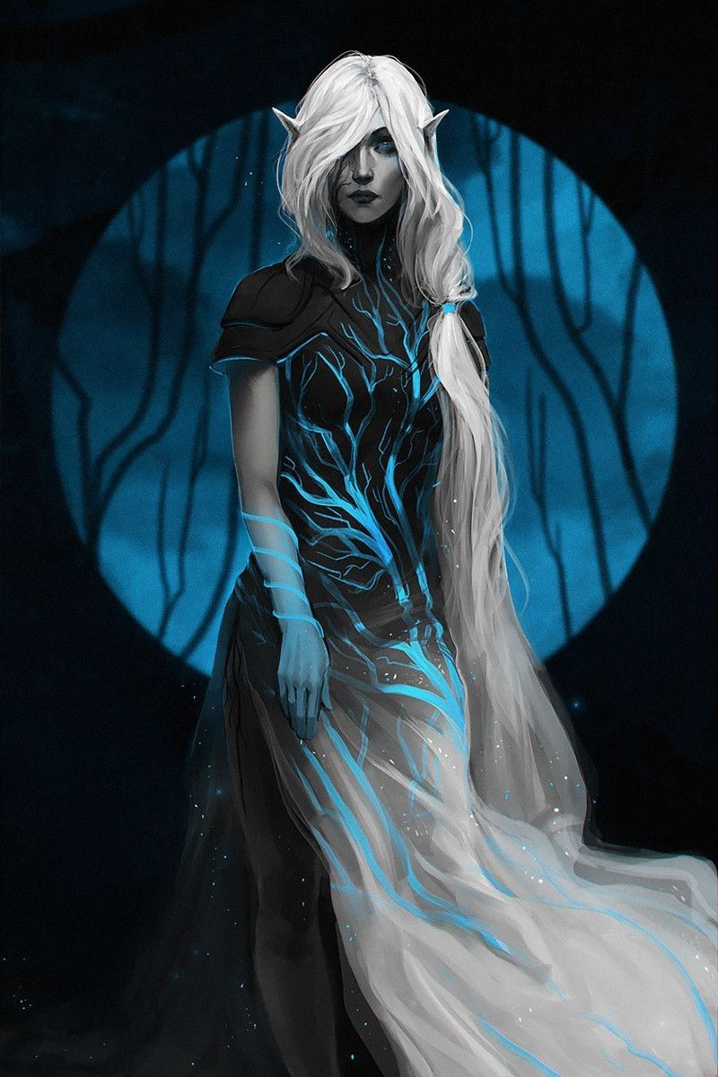
Sindren or Gray Elves
Location: Adulien
Appearance: pale gray skin; raven black hair; amber or violet eyes
Culture: Aloof and reclusive, Gray Elves are extremely intelligent. They are soft spoken, often lost in thought, and spend much of their time in meditation. They are impatient with outsiders but treat with other Elven races as needed. They are prone to melancholy, possessing limitless lore that compels them to reflect endlessly on history and destiny.
Common Attire: white, silver, yellow, or gold and cloaks of deep blue or purple
Traits: The most intelligent of all elves but also the most frail, Gray Elves are the eldest of their race. They are masters of lore, able to recall history to the beginning of time. They are also the creators and custodians of the Adulien Calendar and the Brightstar Fonts, as well as holders of ancient secrets of magic They are thought to have mental powers, which some suspect is why other Elves follow their lead. This may also be whey they are the arch-enemies of the illithid race.
Ability and Skill Modifiers: -3 Constitution, +3 Intelligence, with each level they become able to cast spells at will from the cleric magic domain spell list:
- Magic Domain
- Granted Power: Use scrolls, wands, and other devices with spell completion or spell trigger activation as a wizard of one-half your cleric level (at least 1st level). For the purpose of using a scroll or other magic device, if you are also a wizard, actual wizard levels and these effective wizard levels stack.
- Magic Domain Spells
- Magic Aura: Alters object’s magic aura.
- Identify: Determines properties of magic item.
- Dispel Magic: Cancels magical spells and effects.
- Imbue with Spell Ability: Transfer spells to subject.
- Spell Resistance: Subject gains SR 12 + level.
- Antimagic Field: Negates magic within 10 ft.
- Spell Turning: Reflect 1d4+6 spell levels back at caster.
- Protection from Spells M F: Confers +8 resistance bonus.
- Mage’s Disjunction: Dispels magic, disenchants magic items.

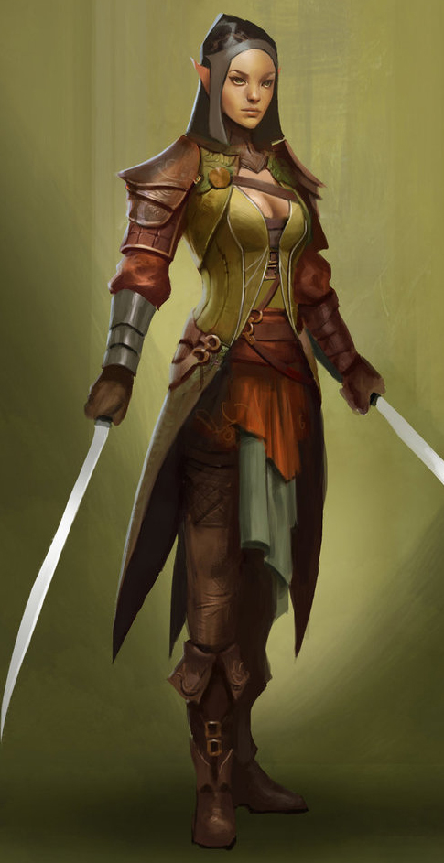
Taurean or Forest Elves
Locations: Adulien, Aldalinh, Ulynar, Ari’Aahn, Teinhir
Appearance: light brown skin; blonde to brown hair; brown or green eyes
Culture: Forest Elves are athletic, curious, and eager to explore. They are fond of stories and songs, both in the hearing and the performing. They are playful, mirthful, and relate well to other races. Forest Elves prefer the wilderness but welcome visitors to their lands. They relish life to the point that they are considered unruly by the more cerebral elves.
Common Attire: dark shades of green and earth tones
Traits: Taller than most elves and disciplined warriors. They are familiar with magic but without any special focus or natural spell-like abilities.
Ability and Skill Modifiers: same as standard elf in PHB

Magical Items

Nén Calima Elen “Waters of Brightstar” – an enchanted river at the heart of the Gidoran Forest created by Corelon Larethian at the beginning of time. The waters are imbued with an essence of righteous and pure light. When drawn out by the curators of the waters, they can be stored in vials for transport. Elven rangers in the beginning of the ages took these to the corners of the world where they commissioned fountains in each forest they found. These were called the Brightstar Fonts, and were used to communicate with Adulien and with other fountains located throughout the world.
Brightstar Fonts – These are magical pools created from the waters of the enchanted river on the Isle of Adulien. Each font is unique throughout the world, but is always featured as a large fountain of silver carved in intricate designs. Anyone who gazes upon the pool of water is able to concentrate and see images through any other Brightstar Font in the world.
Boons of Aaralon – Said to be the eldest and tallest of all trees in Nemmyrl, the Great Tree of Aaralon often grants boons of enchanted wood to the priests of Ehlonna. These are sometimes fashioned into wands of enormous power, and sometimes even wooden armor of incredible strength. The greatest gifts are the Staves of Aaralon, which are said to be pulsing with life and imbue any druid with greater mastery of spells.

Great Tome of Meditations – This magical tome is the collected writings of every elven scholar of Adulien who committed to record stories, songs, and magical formulae. It is the single greatest tome of elven wisdom and knowledge in the world. Such is its knowledge that it has become a sentient being. Any who feign to look upon its pages, if they be not worthy, will be stricken with madness.

The Adulien Calendar – Elven scholars as early as the Primeval Days watched the stars and kept record of the passing days, fashioning a calendar to mark the flow of time. What began as an esoteric demarcation of the seasons became a precise measuring stick for the rise and fall of kingdoms. A member of the star elves discovered a special crystal, called a Passing Stone, thought to have fallen from the heavens, pulsed a soft light in the presence of stars. Using the Passing Stone, the gray elves divided the years into one-thousand-year ages, and later into larger segments known as the Primeval, Ancient, and then the Written Ages. Only a handful of scholars among the humans and dwarves have knowledge of the Adulien Calendar. These are trusted allies in the battle against the loss of all knowledge, each of them carrying a sacred sigil to mark them. Some make pilgrimages to Adulien to learn the system and some even make copies of the records stored in hundreds of rolls of parchment and dusty books.

Developer Notes
11/22 moved Druindar to another island – made no sense that the reclusive gray elves would have a human town on the island. Below are notes left over from removing the text related to Druindar’s history.

High Cathedral of Ehlonna (seat of power for the church of Ehlonna),
Order of Hederren (order of paladins)

It is worth noting that a small faction of purists among the Elven people frown at the thought of humans on their sacred island. They are called the Vengella and secretly plot to overthrow the Elven court in Adulien to restore the old ways. Sadly they have lost their way and have resorted to consorting with agents of evil to see their plans realized.

Every citizen of Druindar carries a holly branch that marks them a friend of Adulien. It is recognized by Elves elsewhere in the world and considered a good testament of the person.

180 AA4 - Ahelissa Marais and her band of heroes come to the rescue of the Elves on Adulien, the elves invite them to settle on the island; town of Druindar is founded

Long ago an explorer named Ahelissa Marais rescued an injured Elven ranger found in Treacle Forest in Plenia. Ignoring the warnings of her fellow rangers, she delivered the Elf to the shores of Adulien. There she was imprisoned for over a year. But her bearing was such the Elves made her stay hospitable. Over time she impressed them enough that she was allowed to walk free amongst them. The Elven ranger whom she had rescued, named Elephon, fell in love with her and they married.

Not long after their union, the island came under attack by agents of evil. Ahelissa was resourceful and called on her longtime friends to aid her. The heroes were instrumental in thwarting the enemy. Such was the Elves’ respect that they consented to establishing a home for the humans. In 180 AA4 the town of Druindar was founded.

High Cathedral of Ehlonna Eroan Elynore Order of Hederren

