Notes on the Elven Kingdom of Teliddia
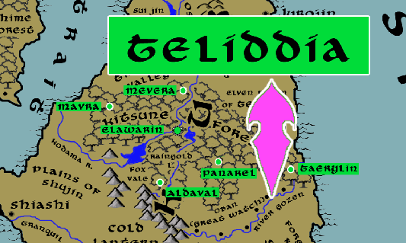

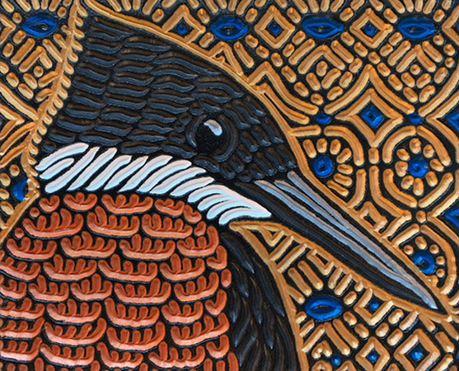
Sign of the Kingfisher

Location: Kitsune Forest, Continent of Sakura

- Overview
- Towns and Cities
- History
- Notes on Culture
- Magical Items
- Developer Notes

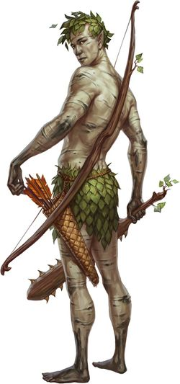
Overview
Teliddia is the last remnant of elves in the east. Centuries of war and corruption of the Katura continent drove out the forest-dwelling and peace-loving elves, leaving behind only their wicked kin the drow. The survivors settled the Shujin and entrenched themselves against future attacks from the humanoid forces of Cierath and drow forces in the Shantai Mountains. Teliddia also keeps a close watch over the sorcerous powers of Suramir far to the south in Mahabar.

Towns and Cities
- Teliddia
  - Mavra – large town, population 5,000, guards / soldiers 50, militia 250
  - Mevera – large town, population 5,000, guards / soldiers 50, militia 250
  - Elawarin – large city, population 25,000, guards / soldiers 250, militia 2250
  - Taerylin – large town, population 5,000, guards / soldiers 50, militia 250
  - Panarel – large town, population 5,000, guards / soldiers 50, militia 250
  - Aldaval – large town, population 5,000, guards / soldiers 50, militia 250

Mavra
Size: large town, population 5,000, guards / soldiers 50, militia 250
Trade Goods:
Local Goods:
Standard:
Colors:
Ruler: Ailuin Zinren

Home:
Steward: Airdan Iarphine
Marshal: Tyrael Lianelis (f)
House Priest: Taeral Keyzeiros
House Adviser (Scholar/Mage/etc): Maelyrra Herpeiros (f)
Captain of the Guard: Taeral Presnan
Chief Warriors in Service:
Adamar Miratoris
Anlyth Omaynore
Shaerra Neritumal (f)

Local Powers:
Local Sites:

Description:

Industry:

Key Figures:

Local Lore:

History:

Customs:

Mevera
Size: large town, population 5,000, guards / soldiers 50, militia 250
Trade Goods:
Local Goods:
Standard:
Colors:
Ruler: Zaleria Luhana (f)

Home:
Steward: Ellisar Virsalor
Marshal: Dalyor Faegwyn
House Priest: Shalaevar Petqirelle (f)
House Adviser (Scholar/Mage/etc): Wyrran Keykrana
Captain of the Guard: Alavara Zylberos (f)
Chief Warriors in Service:
Taenaran Trisgella
Ailuin Perlynn
Shanyrria Heipetor (f)

Local Powers:
Local Sites:

Description:

Industry:

Key Figures:

Local Lore:

History:

Customs:

Elawarin
Size: large city, population 25,000, guards / soldiers 250, militia 2250
Trade Goods: timber
Local Goods:
Standard:
Colors:
Ruler: Alloralla Shamoira (f)

Home:
Steward: Jorildyn Leuna
Marshal: Ayen Mirasalor
House Priest: Galather Oricyne
House Adviser (Scholar/Mage/etc): Sheera Thecyne (f)
Captain of the Guard: Lyklor Ulavalur
Chief Warriors in Service:
Halaema Iarhana (f)
Drannor Umeleth
Riluana Thecyne (f)

Local Powers: Band of the Neriphyra (rangers)
Local Sites:

Description:

Industry:

Key Figures:

Local Lore:

History:

Customs:

Taerylin
Size: large town, population 5,000, guards / soldiers 50, militia 250
Trade Goods:
Local Goods:
Standard:
Colors:
Ruler: Falenas Nerisalor (f)

Home:
Steward: Nieven Thewynn
Marshal: Zentha Ianzeiros (f)
House Priest: Bialaer Ralozeiros
House Adviser (Scholar/Mage/etc): Theodmon Glynkas
Captain of the Guard: Holone Ravastina (f)
Chief Warriors in Service:
Connak Liasatra
Tasar Beivaris
Flardryn Genvaris

Local Powers:
Local Sites:

Description:

Industry:

Key Figures:

Local Lore:

History:

Customs:

Panarel
Size: large town, population 5,000, guards / soldiers 50, militia 250
Trade Goods:
Local Goods:
Standard:
Colors:
Ruler: Gormar Helegolor

Home:
Steward: Eletha Aragwyn (f)
Marshal: Elluin Glynlar
House Priest: Leilatha Iarhice (f)
House Adviser (Scholar/Mage/etc): Kuskyn Holaqen
Captain of the Guard: Laiex Virwenys
Chief Warriors in Service:
Alen Daethyra
Elashor Lorarieth
Ealirel Pawraek (f)

Local Powers:
Local Sites:

Description:

Industry:

Key Figures:

Local Lore:

History:

Customs:

Aldaval
Size: large town, population 5,000, guards / soldiers 50, militia 250
Trade Goods:
Local Goods:
Standard:
Colors:
Ruler: Haglas Helewynn

Home:
Steward: Hagluin Quidi
Marshal: Nueleth Yesxidor (f)
House Priest: Chasianna Ravara (f)
House Adviser (Scholar/Mage/etc): Ashryn Glynhorn (f)
Captain of the Guard: Eldrin Neriharice
Chief Warriors in Service:
Delmuth Venlen
Ayla Olamaris (f)
Myantha Bigolor (f)

Local Powers:
Local Sites:

Description:

Industry:

Key Figures:

Local Lore:

History:

Customs:

History
First Primordial Age (PA1)

Second Primordial Age (PA2)

Third Primordial Age (PA3)

Fourth primordial Age (PA4)

First Ancient Age (AA1)

Second Ancient Age (AA2)

Third Ancient Age (AA3)
60 AA3 - War of the Chant - evil forces in Suramir encircle the elven kingdom of Ealoren

70 AA3 - end of War of the Chant - elven kingdom of Ealoren is wiped out by armies from Suramir

75 AA3 - elves driven out of Suramir settle in Kitsune Forest in Sakura and begin to drive out evil creatures ravaging the forest

120 AA3 - elven kingdom of Teliddia is established in Kitsune Forest in Sakura

Fourth Ancient Age (AA4)

First Written Age (WA1)

Second Written Age (WA2)

Third Written Age (WA3)
457 WA3 - Elves of Teliddia attack the Orcs of Harnhak and help contain his advance

Fourth Written Age (WA4)

Notes on Culture
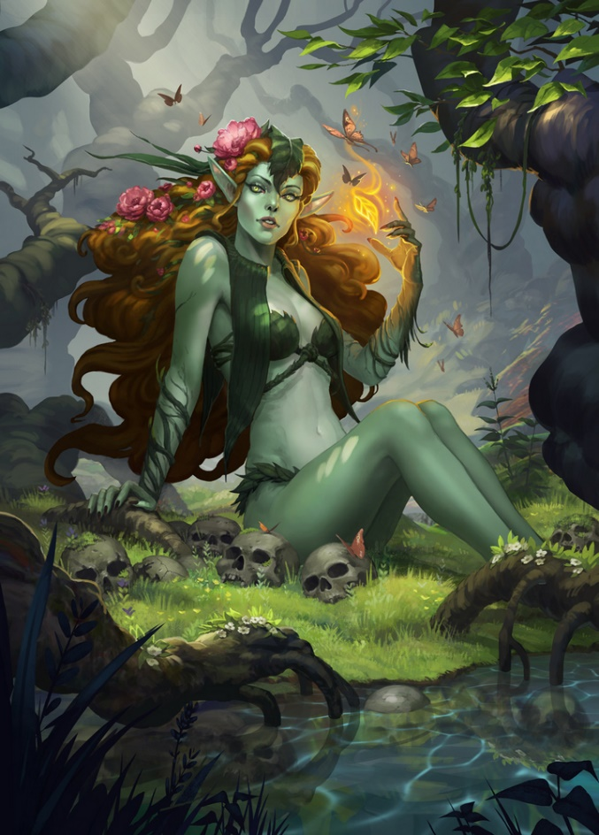
Laimaran or Flora Elves
Location: Teliddia
Appearance: dark green skin; brown or sunflower yellow hair; purple eyes
Culture: Flora Elves are placid, moving and talking at a leisurely pace. They tend enormous magical groves and collect exotic plants grown from tiny samples collected from all over the world. They are also inquisitive of plant-based magical aberrations. They enjoy a strong bond with dryads and fey creatures fond of flowers. They are whimsical with a strange sense of humor. They are also fond of partaking in mind-altering herbs and mushrooms to enter a spirit realm where they can travel out of their bodies
Common Attire: dressed entirely in vegetation woven into clothing, hair festooned with elaborate flower headdresses, wear elaborate flower garlands
Traits: Flora Elves are born with the ability to speak with plants. They can sense the presence and health of plant life from a distance. They are a frail subrace but masters of herbs and poisons.
Ability and Skill Modifiers: -2 Constitution, +2 Charisma, suffer +2 additional damage on any heat or fire attacks, with each level they become able to cast spells at will from the cleric plant domain spell list:
- Plant Domain
- Granted Powers: Rebuke or command plant creatures as an evil cleric rebukes or commands undead. Use this ability a total number of times per day equal to 3 + your Charisma modifier. This granted power is a supernatural ability.
- Add Knowledge (nature) to your list of cleric class skills.
- Plant Domain Spells
- Entangle: Plants entangle everyone in 40-ft.-radius.
- Barkskin: Grants +2 (or higher) enhancement to natural armor.
- Plant Growth: Grows vegetation, improves crops.
- Command Plants: Sway the actions of one or more plant creatures.
- Wall of Thorns: Thorns damage anyone who tries to pass.
- Repel Wood: Pushes away wooden objects.
- Animate Plants: One or more trees animate and fight for you.
- Control Plants: Control actions of one or more plant creatures.
- Shambler: Summons 1d4+2 shambling mounds to fight for you.

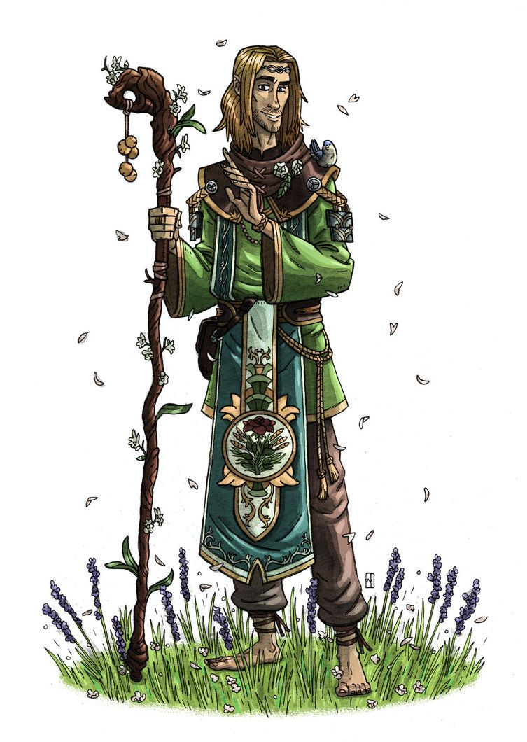
Magical Items

Developer Notes

