Notes on the Elven Kingdom of Sirathren

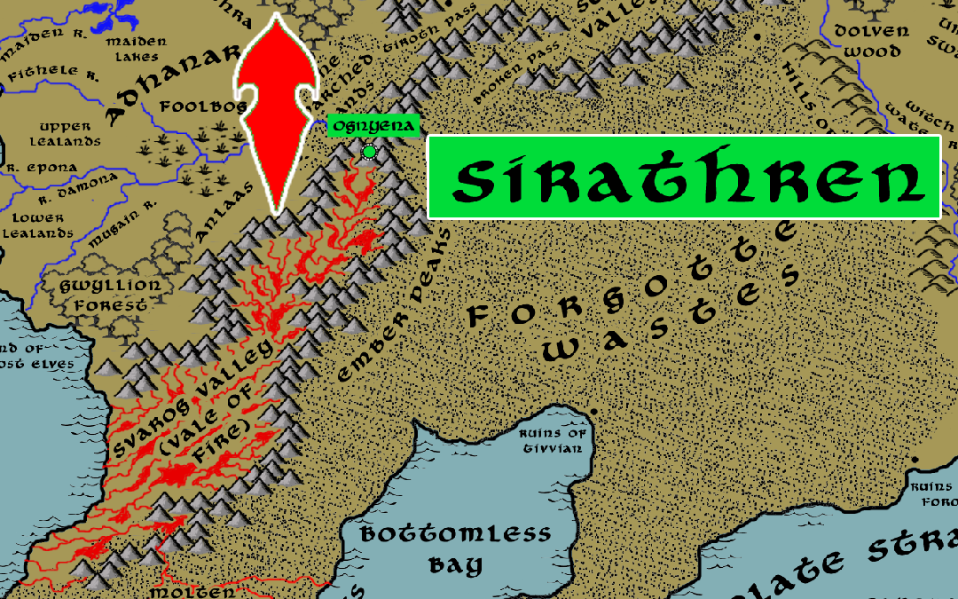


Location: Valley of Svarog, bordering the lands of Adhanar

Sign of the Phoenix
- Overview
- Towns and Cities
- History
- Notes on Culture
- Magical Items
- Developer Notes

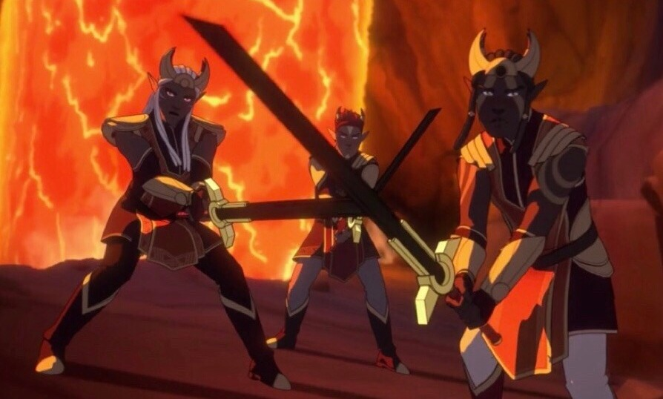
Overview
The broken lands of the Valley of Svarog are home to the fire elves. Here, where rivers of hot lava flow and the land shifts to spout jets of flame, the fire elves are masters of their element. Their sacred duty: to serve as stewards of the vale and seek higher truth in the fiery, unstable land. Outsiders are not welcome here and the fire elves defend it violently.

Towns and Cities
- Ognyena - large town, population 5,000, guards / soldiers 50, militia 250

Ognyena
Size: large town, population 5,000, guards / soldiers 50, militia 250
Trade Goods:
Local Goods:
Standard: the red and black phoenix
Colors:
Ruler: the Magma Queen

Home:
Steward: Anhaern Ilijyre (f)
Marshal: Ailuin Balzumin
House Priest: Marlevaur Inahorn
House Adviser (Scholar/Mage/etc): Amarille Xyrlen (f)
Captain of the Guard: Elre Helecaryn
Chief Warriors in Service:
Adamar Oriberos
Alre Cramaer
Umilythe Vacan (f)

Local Powers:
Local Sites: The Vault of Ignus, the Flame of Ages

Description: The Magma Queen rules over the fire elves from her palace fortress of Ognyena. It is a towering structure of stones fused together by heat, its outer surface a glittering black obsidian finish. Ognyena overlooks the valley where the Ember Peaks break off from the Karn Mountain range.

The Flame of Ages is enormous, projecting upwards out of a crack in the rocks. It is both a bubbling tower of lava and a seething ball of fire, and is so hot it can only be approached by fire elves without protection. It is also a gateway to the elemental plane of fire. Priests tend to the flame and study it for truths revealed to them in the flickering chaos.

The fire elves are fiercely independent beings, embracing chaos and the endless possibilities that it promises. What order does exist is imposed by force by the Magma Queen and her priests. Most fire elves dwell in the walled town surrounding Ognyena, but many make second homes in warrens they create all around the valley. A typical dwelling here is created from inert lava tubes and elemental wizards rearranging the rock into twisting decorative forms. There is a stark beauty to the architecture and artwork of the fire elves.

Fire elves share much in common with the sun elves in Kaduru. While the sun elves gain strength from the sun and relish in its life-giving power, they also temper their zeal with the wisdom to harness it. In contrast, the fire elves place no limits to the powers granted by the sun and molten earth and harness it with unbridled enthusiasm.

Industry: The fire elves are loath to deal with outsiders. However, they recognize their unique talents with fire and heat can be in demand by neighboring lands. Ornate obsidian sculptures and jewelry are traded with merchants in Adhanar in exchange for goods that are rare in this region.

Key Figures:
The Molten Queen is a regal and terrible figure, a creature transformed by elemental magic into a living being of molten rock. Hers is a fire granted by the Flame of Ages, a divine flame that burns in the underground holy site the Vault of Ignus. After several hundred years, for reasons no one knows, the Molten Queen’s flame ebbs, and a successor is chosen.

Local Lore:
The ancient Tower of Xarolax stands abandoned at the southern end of the valley. It was once the stronghold of the wizard Xarolax, a master evoker who collected relics of power and regularly traveled to the plane of fire. It was raided by the invader Dractus in the Fourth Primordial Age, who stole a piece of the Horex Dendracovox, or Crown of Power, which was here for a brief time. It is now a dark and evil place frequently used by demons as a stronghold coming to this plane.

The greatest of the fire elves enemies are the Drow of Hadronath, who dwell beneath the Eldedure Mountains to the north. The Drow covet the valley and the southern mountain ranges. They have waged a ceaseless war for centuries against the Sirathren.

Fire elementals are frequently summoned within the Vault of Ignus but some are drawn to the valley on their own volition. Those that appear without being beckoned are not under control and tend to wreak havoc. The fire elves relish such occasions and make sport of hunting and dominating the creatures. More challenging are the magma mephits, which appear and blend into the molten landscape. At any given time, there are any number of magma mephitis perched around the valley, ready to attack unwary travelers.

Less frequently, demons and devils are known to make an appearance in the Valley of Svarog. Those seeking to make trouble on the material plane are often drawn to this place of flame and ash. The fire elves hold no dominion over such creatures and find themselves fighting desperately against an unwanted visitor. At some points in history demons and devils have actually sought to conquer the vale and make it their foothold on this plane. The most recounted was the War of Fire and Stone in the Third Primordial Age.

History:

400 PA3 - War of Fire and Stone - The Thrunndi Gem unleashes a terrible curse, opening a portal to hell and beginning an invasion of demons and devils throughout the Svarog Valley region and the Emraldren Kingdom

410 PA3 - People of Iolanth are joined by the Elves of Gwyllion Forest and the fire elves of Sirathren to battle demons emerging from the Svarog Valley

670 PA3 - the city of Tivvian grows in power, controlling southern and central Gaeadon

680 PA3 - Tivvian forces invade Kazeldun, conquering the land

690 PA3 - the Sultan of Tivvian, hearing tales of the Molten Queen in Svarog Vale, launches a crusade to conquer the burning lands

700 PA3 - the Sultan of Tivvian conquers the Molten Queen with help of dark magic

705 PA3 - embracing the newfound power of the Svarog lands, the Sultan of Tivvian launches a massive invasion of northern Kaduru

707 PA3 - The Svarog War - Queen Malaka of Tengaibo calls on the water goddess Oya, defeats the armies of Svarog

708 PA3 - fleeing to Svarog Vale, the Sultan of Tivvian is incinerated by the enslaved Molten Queen after she frees herself; the Molten Queen dies from the effort

709 PA3 - Queen Malaka, tainted by the fire fever of Svarog's demons, transforms into a flaming humanoid like those native to Svarog Vale; the people of Svarog Vale convince her to beome their next Molten Queen

500 PA4 - Dractus' army finds the tower of Xarolax in Svarog Vale; Dractus brokers a truce with the Magma Queen to enter the vale and steals pieces of the Crown of Power, beginning Dractu's bloodlust to find them all

Fourth Written Age (WA4)

302 - 415 WA4 - War of the Green Flame: Empress Becred of the Hadronath uses the Cauldron of Virdroth to magically taint the fires of Svarog Vale, which cast a green flame and poison the land; the Sirathren fire elves fight a desperate war to defend their valley
311 WA4 - the Sirathren fire elves counter with the Staff of Candronor, which emanates a magical ether capable of cause the very blood of the Drow to burst into flames
415 WA4 - Battle of Tiroth Pass: the Sirathren crush the invading army of Hadronath, sending them home and ending the War of the Green Flame

Customs:
Fire elves, headstrong and sometimes reckless, often compete in games to prove their courage in the Valley of Svarog. One of these competitions is the Feats of the Fleet, where participants run a gauntlet of dangers over a field of active geysers. Challengers set out across the field, hoping to reach the end and claim a coveted totem crafted in Obsidian that marks the elf as a master of these lands. Outsiders, if befriended, are often goaded into this challenge but it is highly dangerous.

History
First Primordial Age (PA1)

Second Primordial Age (PA2)

Third Primordial Age (PA3)

Fourth primordial Age (PA4)

First Ancient Age (AA1)

Second Ancient Age (AA2)

Third Ancient Age (AA3)

Fourth Ancient Age (AA4)

First Written Age (WA1)

Second Written Age (WA2)

Third Written Age (WA3)

Fourth Written Age (WA4)

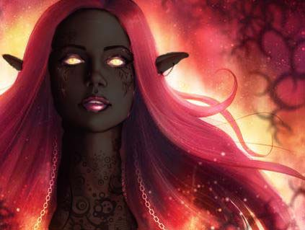
Notes on Culture
Urudren or Fire Elves
Location: Sirathren
Appearance: dark brown skin; red hair; hazel eyes
Culture: Fire Elves are mercurial, ill tempered, impatient, and vengeful. They are intolerant of other races and hold a deep hatred of ice elves. They are driven by a sense of chaos. They enjoy talking and singing loudly, and have a tendency to speak in hyperbole.
Fire elves share much in common with the sun elves in Kaduru. While the sun elves gain strength from the sun and relish in its life-giving power, they also temper their zeal with the wisdom to harness it. In contrast, the fire elves place no limits to the powers granted by the sun and molten earth and harness it with unbridled enthusiasm. Chaos and its endless possibilities are the core values of the fire elves. For this and other reasons they despise ice elves with their sense of order and cold, unwavering ways.

Common Attire: tunics and short robes with sashes, earthen colors with tones of red, yellow, and orange
Traits: Fire Elves are masters of the entropic principles of magic. They are also resistant to extremes of heat.
Ability and Skill Modifiers: +1 Charisma, -1 Wisdom, Resist Energy (Fire) 10, with each level they become able to cast spells at will from the cleric fire domain spell list:
- Fire Domain
- Granted Power: Turn or destroy water creatures as a good cleric turns undead. Rebuke, command, or bolster fire creatures as an evil cleric rebukes undead. Use these abilities a total number of times per day equal to 3 + your Charisma modifier. This granted power is a supernatural ability.
- Fire Domain Spells
- Burning Hands: 1d4/level fire damage (max 5d4).
- Produce Flame: 1d6 damage +1/ level, touch or thrown.
- Resist Energy*: Ignores 10 (or more) points of damage/attack from specified energy type.
- Wall of Fire: Deals 2d4 fire damage out to 10 ft. and 1d4 out to 20 ft. Passing through wall deals 2d6 damage +1/level.
- Fire Shield: Creatures attacking you take fire damage; you’re protected from heat or cold.
- Fire Seeds: Acorns and berries become grenades and bombs.
- Fire Storm: Deals 1d6/level fire damage.
- Incendiary Cloud: Cloud deals 4d6 fire damage/round.
- Elemental Swarm**: Summons multiple elementals.
  - *Resist cold or fire only.
  - **Cast as a fire spell only.

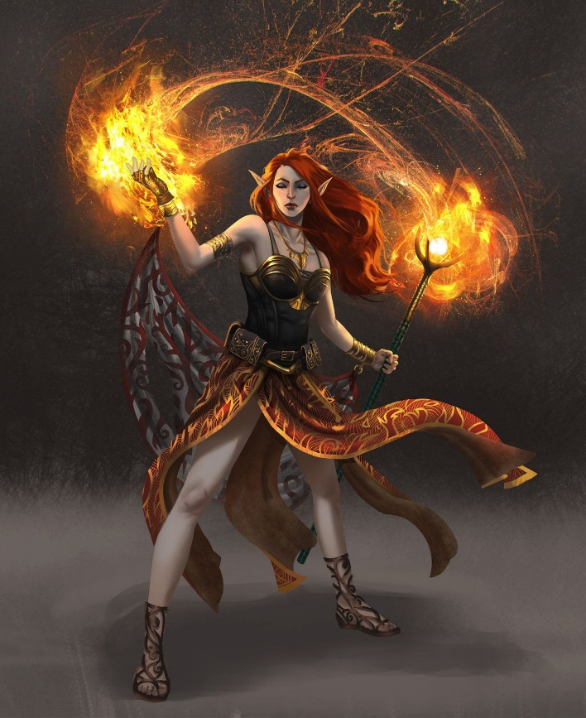
Magical Items

Staff of Fire
You have resistance to fire damage while you hold this staff. The staff has 10 charges. While holding it, you can use an action to expend 1 or more of its charges to cast one of the following spells from it, using your spell save DC: burning hands (1 charge), fireball (3 charges), or wall of fire (4 charges). The staff regains 1d6 + 4 expended charges daily at dawn. If you expend the last charge, roll a d20. On a 1, the staff blackens, crumbles into cinders, and is destroyed.
The Flame of Life
A flickering green flame kept inside of a lantern. It sparks brightly when kindled with life force. The flame starts with 3 charges, losing 1 after every long rest. may spend a hit die to 'feed' the fire with a portion of your energy, regaining a charge. If the flame runs out of charges, it will die, leaving its smouldering remains behind. Once a day, you may use the flame's rejuvenating energy to heal all allies within 10ft equal to your hit die value, spending a charge and using a bonus action. You may also spend a charge to unleash its mystical energy upon your foes, draining their own life force and dealing damage equal to your hit die. If the flame has above 3 charges before you spend a charge, add +3 to the healing or damage value.
Smoldering Arrow - target smokes and the temp around them become hot, they're at disadvantage, they must remove metal items (weapons, armor, etc)

Amulet of Wall of Fire - surrounds owner/caster with a wall of flame, creatures take damage for passing through the flames

Shield of flaming fury - front of shield is on fire, any creature in melee with the user, in front of them, takes damage - user can perform a shield smash for more damage

Gem of the Blue flame – when thrown and hits a target, encircles them in a blue flame that causes damage if they move (some DC check to stay complete still per round) and if they try to pass, a lot of damage

Crown of flames - a crown of flames on the user - can direct a firebolt attack (roll to hit, does maybe 2d6), hamper it with a recharge 3 or 4. Make it a bonus action if you pick recharge 5.

Inferno Bracers - turns your hands into flaming fists, does 2x damage on unarmed attacks (or adds d4 per str bonus modifier)

Flaming armor - you're covered in flames (which don't hurt you, does give off a light source, of course) and have a very intimidating appearance (+4 to intimidate) - anyone in melee with you takes fire damage. Recharge 6 - can cast the flame on an opponent which does 2d8 damage per round as long as you maintain concentration and don't attack anything else.

Elixir of Fire Breath
This strange elixir bestows upon the drinker the ability to spit gouts of flame. He can breathe fire up to three times, each time dealing 4d6 points of fire damage to a single target up to 25 feet away. The victim can attempt a DC 13 Reflex save for half damage. Unused blasts dissipate 1 hour after the liquid is consumed. Moderate evocation; CL 11th; Craft Wondrous Item, scorching ray; Price 1,100 gp.

Helm of Brilliance
This normal-looking helm takes its true form and manifests its powers when the user dons it and speaks the command word. Made of brilliant silver and polished steel, a newly created helm is set with large magic gems: ten diamonds, twenty rubies, thirty fire opals, and forty opals. When struck by bright light, the helm scintillates and sends forth reflective rays in all directions from its crownlike, gem-tipped spikes. The jewels’ functions are as follows:

Diamond: Prismatic spray (save DC 20)
Ruby: Wall of fire
Fire opal: Fireball (10d6, Reflex DC 20 half)
Opal: Daylight
The helm may be used once per round, but each gem can perform its spell-like power just once. Until all its jewels are depleted, a helm of brilliance also has the following magical properties when activated.

It emanates a bluish light when undead are within 30 feet. This light causes 1d6 points of damage per round to all such creatures within that range. The wearer may command any weapon he wields to become a flaming weapon. This is in addition to whatever abilities the weapon may already have (unless the weapon already is a flaming weapon). The command takes 1 round to take effect. The helm provides resistance to fire 30. This protection does not stack with similar protection from other sources.
Once all its jewels have lost their magic, the helm loses its powers and the gems turn to worthless powder. Removing a jewel destroys it.

If a creature wearing the helm is damaged by magical fire (after the fire protection is taken into account) and fails an additional DC 15 Will save, the remaining gems on the helm overload and detonate. Remaining diamonds become prismatic sprays that each randomly target a creature within range (possibly the wearer), rubies become straight-line walls of fire extending outward in a random direction from the helm wearer, and fire opals become fireballs centered on the helm wearer. The opals and the helm itself are destroyed. Strong varied; CL 13th; Craft Wondrous Item, detect undead, fireball, flame blade, light, prismatic spray, protection from energy, wall of fire; Price 125,000 gp; Weight 3 lb.

Necklace of Fireballs
This device appears to be nothing but beads on a string, sometimes with the ends tied together to form a necklace. (It does not count as an item worn around the neck for the purpose of determining which of a character’s worn magic items is effective.) If a character holds it, however, all can see the strand as it really is—a golden chain from which hang a number of golden spheres. The spheres are detachable by the wearer (and only by the wearer), who can easily hurl one of them up to 70 feet. When a sphere arrives at the end of its trajectory, it detonates as a fireball spell (Reflex DC 14 half).

Spheres come in different strengths, ranging from those that deal 2d6 points of fire damage to those that deal 10d6. The market price of a sphere is 150 gp for each die of damage it deals.

Each necklace of fireballs contains a combination of spheres of various strengths. Some traditional combinations, designated types I through VII, are detailed below.

Necklace 10d6 9d6 8d6 7d6 6d6 5d6 4d6 3d6 2d6 Market Price
Type I — — — — — 1 — 2 — 1,650 gp
Type II — — — — 1 — 2 — 2 2,700 gp
Type III — — — 1 — 2 — 4 — 4,350 gp
Type IV — — 1 — 2 — 2 — 4 5,400 gp
Type V — 1 — 2 — 2 — 2 — 5,850 gp
Type VI 1 — 2 — 2 — 4 — — 8,100 gp
Type VII 1 2 — 2 — 2 — 2 — 8,700 gp

If the necklace is being worn or carried by a character who fails her saving throw against a magical fire attack, the item must make a saving throw as well (with a save bonus of +7). If the necklace fails to save, all its remaining spheres detonate simultaneously, often with regrettable consequences for the wearer.

Moderate evocation; CL 10th; Craft Wondrous Item, fireball.

Developer Notes

