Notes on the Elven Kingdom of Lo’Shella

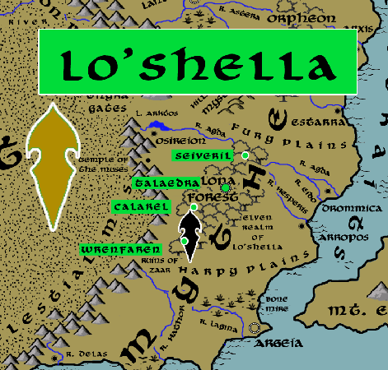

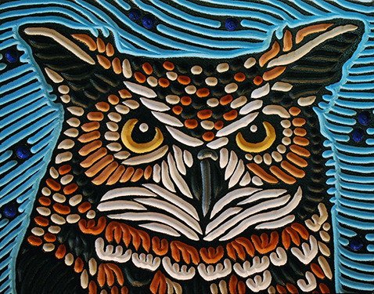
Sign of the Horned Owl
Location: Alona Forest, Arnland Continent bordering the Kingdom of Mythenia
- Overview
- Towns and Cities
- History
- Notes on Culture
- Magical Items
- Developer Notes
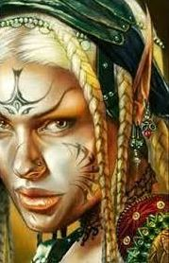
Overview
The elven realm of Lo’Shella hosts more mythical creatures than any other forest due to its location in Mythenia.

Towns and Cities
- Lo'Shella
  - Seiveril – large town, population 5,000, guards / soldiers 50, militia 250
  - Talaedra – large city, population 25,000, guards / soldiers 250, militia 2250
  - Calarel – large town, population 5,000, guards / soldiers 50, militia 250
  - Wrenfaren – large town, population 5,000, guards / soldiers 50, militia 250

Seiveril
Size: large town, population 5,000, guards / soldiers 50, militia 250
Trade Goods:
Local Goods:
Standard:
Colors:
Ruler: Rina Rocan (f)

Home:
Steward: Elpharae Norgella
Marshal: Liluth Arazorwyn (f)
House Priest: Airdan Yelleil
House Adviser (Scholar/Mage/etc): Arcaena Gendi (f)
Captain of the Guard: Rhistel Heirel
Chief Warriors in Service:
Paeral Trisleth
Erlan Leoris
Sana Thexina (f)

Local Powers:
Local Sites:

Description:

Industry:

Key Figures:

Local Lore:

History:

Customs:

Talaedra
Size: large city, population 25,000, guards / soldiers 250, militia 2250
Trade Goods: dyes
Local Goods:
Standard:
Colors:
Ruler: Anlyth Qivlen

Home:
Steward: Orrian Wysalen
Marshal: Glarald Valleer
House Priest: Lenna Iandithas (f)
House Adviser (Scholar/Mage/etc): Aymon Rendreth
Captain of the Guard: Lyara Kresfiel (f)
Chief Warriors in Service:
Neldor Genlynn
Eroan Jotris
Ruvena Helephyra (f)

Local Powers: Band of the Orilen (rangers)
Local Sites:

Description:

Industry:

Key Figures:

Local Lore:

History:

Customs:

Calarel
Size: large town, population 5,000, guards / soldiers 50, militia 250
Trade Goods:
Local Goods:
Standard:
Colors:
Ruler: Symania Raloran (f)

Home:
Steward: Revalor Reyqirelle
Marshal: Saphielle Elrie (f)
House Priest: Cornaith Yllacyne
House Adviser (Scholar/Mage/etc): Eldar Olostina
Captain of the Guard: Nylathria Aezorwyn (f)
Chief Warriors in Service:
Aelua Daepeiros (f)
Holone Yellana (f)
Meira Naenorin (f)

Local Powers:
Local Sites:

Description:

Industry:

Key Figures:

Local Lore:

History:

Customs:

Wrenfaren
Size: large town, population 5,000, guards / soldiers 50, militia 250
Trade Goods:
Local Goods:
Standard:
Colors:
Ruler: Erlathan Yesmenor

Home:
Steward: Goren Cairie
Marshal: Emmyth Luna
House Priest: Esiyae Valxidor (f)
House Adviser (Scholar/Mage/etc): Triandal Qingwyn
Captain of the Guard: Aolis Luthyra
Chief Warriors in Service:
Ehlark Inaphyra
Ailmar Torlee
Glanduil Ravaynore

Local Powers:
Local Sites:

Description:

Industry:

Key Figures:

Local Lore:

History:

Customs:

History
First Primordial Age (PA1)

Second Primordial Age (PA2)

Third Primordial Age (PA3)

Fourth primordial Age (PA4)

First Ancient Age (AA1)

Second Ancient Age (AA2)

Third Ancient Age (AA3)

Fourth Ancient Age (AA4)

First Written Age (WA1)

Second Written Age (WA2)

Third Written Age (WA3)

Fourth Written Age (WA4)

Notes on Culture
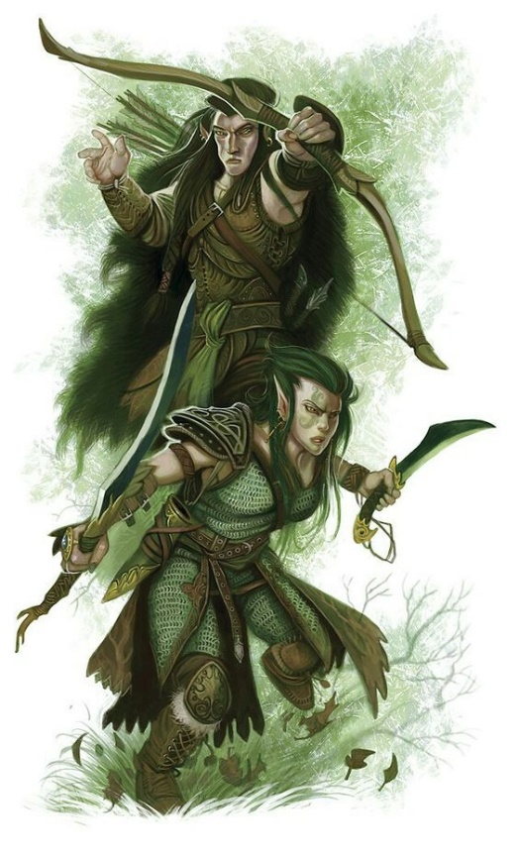
Hravaeran or Fauna Elves
Locations: Eida’Las, Elgelor, Elyon, Arbeiera, Lo’Shella
Appearance: pale skin; blonde, brown, or red hair; green eyes
Culture: Fauna Elves, also called Wild Elves, are less civilized than their distant cousins. Considered barbaric by most, they create very few works of art or literature. Instead they live as one with the land and form primal bonds with the beasts. Some Wild Elves even have feral qualities. They are the most athletic of all Elves and regarded for their rugged endurance. Wild elves are reclusive, rarely tolerating the company of those outside of their tribes. They particularly fierce in the protection of their lands. Fauna elves enjoy a special friendship with the fay, even more so than Elves do already. This is thought to be because their wild natures hearken to the free spirits of the fay and their ilk.
Common Attire: animal skins or woven plants, covered in tribal markings, some dye their skin in natural pigments
Traits: Fauna Elves have a natural strong connection to wild beasts. Many develop mental connections to a specific type of animal and, with it, some of their traits. They have the highest constitution of the elven races but also the lowest intelligence.
Ability and Skill Modifiers: +2 Constitution, -2 Intelligence, with each level they become able to cast spells at will from the cleric animal domain spell list:
- Animal Domain
- Granted Powers: You can use speak with animals once per day as a spell-like ability. You may add twenty ranks of Knowledge (nature) to your list of class skills.
- Animal Domain Spells
- Calm Animals: Calms (2d4 + level) HD of animals.
- Hold Animal: Paralyzes one animal for 1 round/level.
- Dominate Animal: Subject animal obeys silent mental commands.
- Summon Nature’s Ally IV*: Calls creature to fight.
- Commune with Nature: Learn about terrain for 1 mile/level.
- Antilife Shell: 10-ft. field hedges out living creatures.
- Animal Shapes: One ally/level polymorphs into chosen animal.
- Summon Nature’s Ally VIII*: Calls creature to fight.
- Shapechange F: Transforms you into any creature, and change forms once per round.
  - *Can only summon animals.

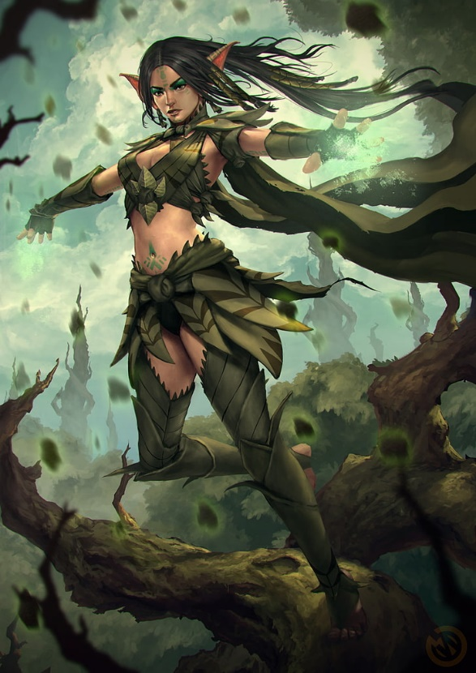
Magical Items

Developer Notes

