Notes on the Elven Kingdom of Laaktala

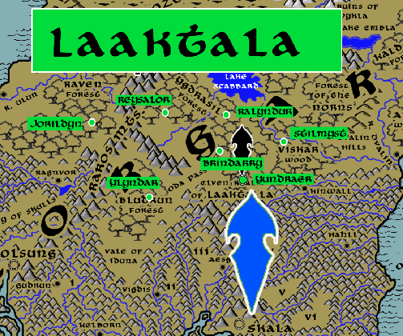

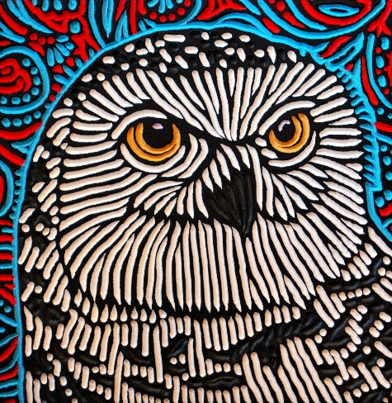
Sign of the Snow Owl

Location: Yggdrasil Forest, Continent of Norgarde
- Overview
- Towns and Cities
- History
- Notes on Culture
- Magical Items
- Developer Notes

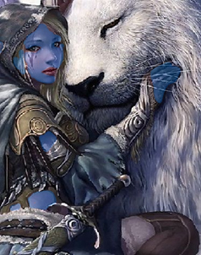
Overview
The Helceren or Ice Elves of Norgarde are a hard-edged version of their southern cousins. Weathering the cold climes of the north, they dress in beautiful gray and white furs and don hoods that resemble animal faces. Homes are made in the boughs of tall trees, stark and ominous as they tower over the landscape. Laaktalla Elves are both feared and respected by the Norgarde humans, who think them trickster spirits and dub them “Alfar.”

With settlements scattered across four forests, the Ice Elves occupy the central lands of the Norgarde continent and see themselves as guardians against the dark forces far to the north. But the northern reaches, being the coldest region of the world, are a place of endless fascination to Ice Elves who study the beauty of winter in all its forms. Elves of Laaktala often range far from their forests, able to endure punishing winds and temperatures and traveling almost unseen against the wintry terrain.

Towns and Cities
- Laaktala
  - Jorildyn – large town, population 5,000, guards / soldiers 50, militia 250
  - Reysalor – large town, population 5,000, guards / soldiers 50, militia 250
  - Ylyndar – large town, population 5,000, guards / soldiers 50, militia 250
  - Ralyndur – large town, population 5,000, guards / soldiers 50, militia 250
  - Brindarry – large town, population 5,000, guards / soldiers 50, militia 250
  - Yundraer – large city, population 25,000, guards / soldiers 250, militia 2250
  - Stilmyst – large town, population 5,000, guards / soldiers 50, militia 250

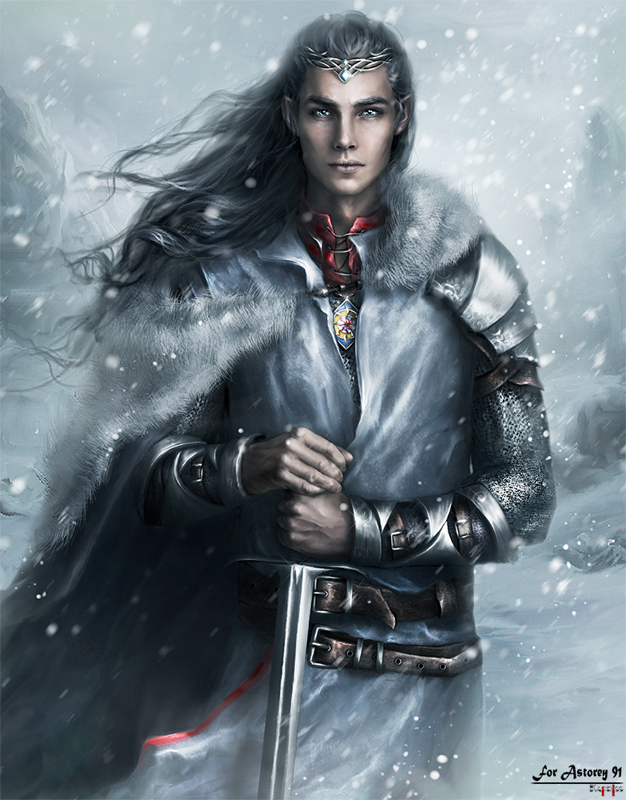

Jorildyn
Size: large town, population 5,000, guards / soldiers 50, militia 250
Trade Goods:
Local Goods:
Standard:
Colors:
Ruler: Larongar Sylzorwyn

Home:
Steward: Thallan Wysamaris
Marshal: Felaern Carlar
House Priest: Aerith Gilhorn (f)
House Adviser (Scholar/Mage/etc): Sanev Aehorn
Captain of the Guard: Wistari Olodan
Chief Warriors in Service:
Kendel Yelren
Ailre Olalynn
Arasne Chaefina (f)

Local Powers:
Local Sites:

Description:

Industry:

Key Figures:

Local Lore:

History:

Customs:

Reysalor
Size: large town, population 5,000, guards / soldiers 50, militia 250
Trade Goods:
Local Goods:
Standard:
Colors:
Ruler: Ruith Fentris

Home:
Steward: Tanithil Daena
Marshal: Usamea Lugeiros (f)
House Priest: Nym Chaepetor
House Adviser (Scholar/Mage/etc): Niossae Oriqen
Captain of the Guard: Yathanae Aradithas (f)
Chief Warriors in Service:
Elduin Dorwraek
Nelaeryn Yelric
Haemir Daefiel

Local Powers:
Local Sites:

Description:

Industry:

Key Figures:

Local Lore:

History:

Customs:

Ylyndar
Size: large town, population 5,000, guards / soldiers 50, militia 250
Trade Goods:
Local Goods:
Standard:
Colors:
Ruler: Ornthalas Yelxisys

Home:
Steward: Galather Eilmaris
Marshal: Essaerae Nerimoira (f)
House Priest: Vesryn Omayarus
House Adviser (Scholar/Mage/etc): Beldroth Torsys
Captain of the Guard: Thalanil Fenkian
Chief Warriors in Service:
Hagen Holapetor
Haladavar Daeydark
Keenor Sylhorn (f)

Local Powers:
Local Sites:

Description:

Industry:

Key Figures:

Local Lore:

History:

Customs:

Ralyndur
Size: large town, population 5,000, guards / soldiers 50, militia 250
Trade Goods:
Local Goods:
Standard:
Colors:
Ruler: Nindrol Wranren

Home:
Steward: Talanashta Norqirelle (f)
Marshal: Ettrian Zingeiros
House Priest: Kiirion Xilsalor
House Adviser (Scholar/Mage/etc): Nimeroni Valbella (f)
Captain of the Guard: Eldaerenth Grethyra
Chief Warriors in Service:
Rolim Fenfina
Hagen Arahorn
Elred Kelmaris

Local Powers:
Local Sites:

Description:

Industry:

Key Figures:

Local Lore:

History:

Customs:

Brindarry
Size: large town, population 5,000, guards / soldiers 50, militia 250
Trade Goods:
Local Goods:
Standard:
Colors:
Ruler: Tanithil Dafaren

Home:
Steward: Lathlaeril Miraceran
Marshal: Kali Jonelis (f)
House Priest: Ryo Ularona
House Adviser (Scholar/Mage/etc): Elkhazel Umewarin
Captain of the Guard: Ehlark Urirora
Chief Warriors in Service:
Galather Qisandoral
Druindar Zindi
Jastira Glynhana (f)

Local Powers:
Local Sites:

Description:

Industry:

Key Figures:

Local Lore:

History:

Customs:

Yundraer
Size: large city, population 25,000, guards / soldiers 250, militia 2250
Trade Goods: medicine, dyes
Local Goods:
Standard:
Colors:
Ruler: Ryllae Valberos (f)

Home:
Steward: Voron Gildan
Marshal: Hagwin Yelsys
House Priest: Wirenth Heixina
House Adviser (Scholar/Mage/etc): Phyrra Arafir (f)
Captain of the Guard: Luthais Tragolor
Chief Warriors in Service:
Orist Glynzumin
Aire Binelis
Vesperr Glynlar

Local Powers: Band of the Sariandi (rangers), Thalanil Sanctum (school of magic)
Local Sites:

Description:

Industry:

Key Figures:

Local Lore:

History:

Customs:

Stilmyst
Size: large town, population 5,000, guards / soldiers 50, militia 250
Trade Goods:
Local Goods:
Standard:
Colors:
Ruler: Yhendorn Aeralei

Home:
Steward: Kyrenic Holaneiros
Marshal: Vanya Erceran (f)
House Priest: Tanyth Adcyne
House Adviser (Scholar/Mage/etc): Thuridan Miamyar
Captain of the Guard: Filarion Cradithas
Chief Warriors in Service:
Jhaartael Jofiel
Pirphal Caivalur
Tasar Falar

Local Powers:
Local Sites:

Description:

Industry:

Key Figures:

Local Lore:

History:

Customs:

History
First Primordial Age (PA1)

Second Primordial Age (PA2)

Third Primordial Age (PA3)

Fourth primordial Age (PA4)

First Ancient Age (AA1)

Second Ancient Age (AA2)
40 AA2 - (Laaktala) Fall of the Elven settlement in the Stolen Forest as Krong's giants destroy the land

70 AA2 - Battle of the Godsbeard - Dwarves of Amberon, joined by Norgardian and elven warriors of Laaktala, fight Krong's forces and barely survive

Third Ancient Age (AA3)

Fourth Ancient Age (AA4)

First Written Age (WA1)

Second Written Age (WA2)

Third Written Age (WA3)

Fourth Written Age (WA4)
250 WA4 - War of the Sea Elves: King Beirkuld of Geirdir wins a decisive victory over the Aelfala sea elves and steals the Crown of Iargwyn
Notes on Culture

Helceren or Ice Elves
Location: Domain of Laaktala, Yggdrasil Forest, Norgarde
Appearance: pale blue skin; silver hair; blue eyes
Culture: Ice elves are a distrustful people, reclusive and intolerant of other races. They are also vengeful towards foes and hold a deep hatred of fire elves. Driven by a sense of order, they create elaborate ice sculptures that follow complex patterns to which they assign deep meaning. Ice elves are highly intelligent and calculating. They speak very little and do so with precise language and measured words. They are both feared and respected by the Norgarde humans, who think them trickster spirits and dub them “Alfar.” Homes are made in the boughs of trees, stark and ominous as they tower over the landscape. Order and its call for perfection are the core values of the ice elves. For this and other reasons they despise fire elves with their sense of chaos and mayhem.
Common Attire: elaborate tunics, neutral colors, beautiful gray furs with hoods that resemble animal faces
Traits: masters of order-aligned magic, study the esoteric logic of magic, resistant to extremes of cold
Ability and Skill Modifiers: +1 Intelligence, -1 Charisma, Resist Energy (Cold) 10, Endure Elements (cold), with each level they become able to cast spells at will from the cleric law domain spell list:
- Law Domain
- Granted Power: You cast law spells at +1 caster level.
- Law Domain Spells
- Protection from Chaos: +2 to AC and saves, counter mind control, hedge out elementals and outsiders.
- Calm Emotions: Calms creatures, negating emotion effects.
- Magic Circle against Chaos: As protection spells, but 10-ft. radius and 10 min./level.
- Order’s Wrath: Damages and dazes chaotic creatures.
- Dispel Chaos: +4 bonus against attacks by chaotic creatures.
- Hold Monster: As hold person, but any creature.
- Dictum: Kills, paralyzes, slows, or deafens nonlawful subjects.
- Shield of Law: +4 to AC, +4 resistance, and SR 25 against chaotic spells.
- Summon Monster IX*: Calls extraplanar creature to fight for you.
  - *Cast as a law spell only.
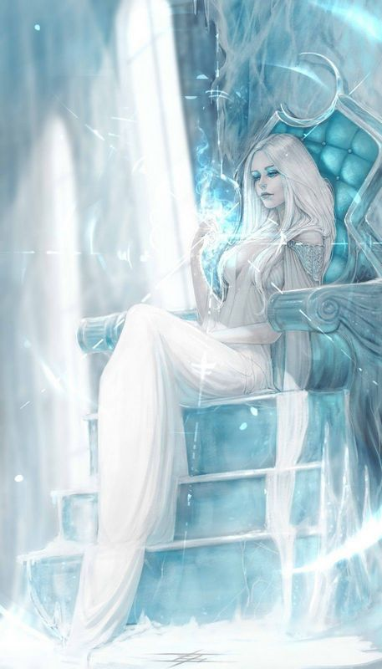
Laaktala Elves seldom interact with the humans of Norgarde, seeing them as nothing more than savage primates. Indeed, stories tell of wars between Jarls and the Ice Elves, mostly out of fear on the part of men that the most bitter winters are summoned by them. Fewer stories abound, but do exist, of the occasional wanderer falling prey to the cold but finding aide from the Elves who nurse them back to health. Heroes who render great service to Laaktala are often rewarded with a magical ice crystal, called the Vinterlys. These are permanent ice totems that every Ice Elf learns to craft as a personal calling card. Each is the size of a coin, glows a soft blue light, and is embedded with a snowflake design unique to the Elf who made it.

In addition to serving as stewards of the land, Ice Elves dedicate much of their lives to the study and perfection of ice sculptures and magical inscriptions within the snow and ice. For them, the delicate and complex matrices formed in the cold are sources of endless fascination. They claim that wondrous mysteries can be unlocked in the fractal designs seen when all is locked in the deepest cold. Scholars who visit Laaktala looking for ancient magical tomes are surprised to find towering pages of old writings are recorded here in sheets of permafrost on the sides of mountains. Human explorers wary of the Ice Elves will warn you that such ice sigils are placed on snow drifts and over chasms covered in snow and are placed there as traps by the trickster Elves. On the contrary, rangers who take the time to learn of these Ice Sigils will find they are either markers warning of perils or traps intended for trolls and ice goblins.

Friends of the Ice Elves tell of the warm hospitality of these wardens of the north if duly earned, but warn they are a quiet folk and are not prone to much outward cheer. Isvin, or Ice Wine, is a rare spirit produced in Laaktala. Made from the juice of frost berries, it is bracing to drink and potent.

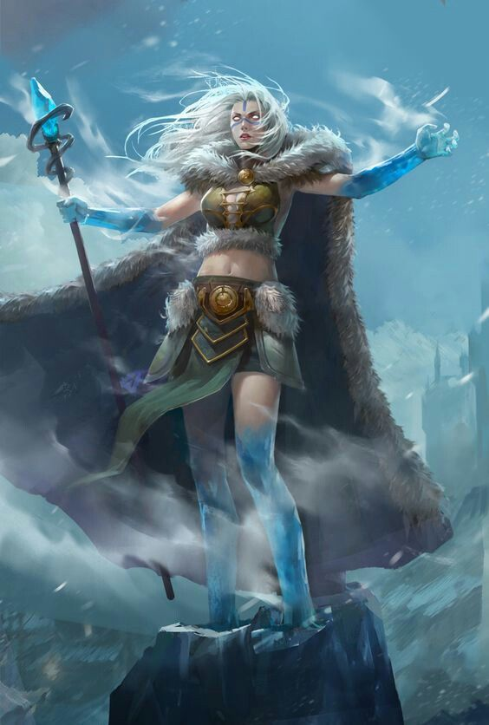
Magical Items

Staff of Frost
You have resistance to cold damage while you hold this staff.
The staff has 10 charges. While holding it, you can use an action to expend 1 or more of its charges to cast one of the following spells from it, using your spell save DC: cone of cold (5 charges), fog cloud (1 charge), ice storm (4 charges), or wall of ice (4 charges). The staff regains 1d6 + 4 expended charges daily at dawn. If you expend the last charge, roll a d20. On a 1, the staff turns to water and is destroyed.

Shield of Ice Warding
Shield, Very Rare (Requires Attunement)
While holding this shield, you have a +1 bonus to AC. This bonus is in addition to the shield's normal bonus to AC. When you and/or an ally within 10ft of you would take Cold damage, you can use a reaction to reduce the Cold damage you and all allies within 10ft of you would take by 3D6 + your Dexterity modifier. After you use this ability, roll 1D6. On a roll of 1-4 you cannot use this ability again until your next Short Rest.

Cloak of the White Wind
Wonderous Item, Rare (Requires Attunement)
A shimmering white cloak with a dark fur trim. The cloak never becomes dirty and cannot be damaged by cold conditions. If you take damage from a melee attack, you can use a reaction to releases a swirl of freezing snow. The attacking creature must make a DC15 Dexterity saving throw. On a failed save, the creature takes 3D10 Cold damage and you can teleport to an unoccupied space within 30ft. On a successful save, it takes half damage and you cannot teleport.

Trident of Winter's Agony
Trident, Very Rare (Requires Attunement)
You gain a +1 bonus to attack and damage rolls made with this magic weapon. Additionally, all attacks with this magic weapon deal an additional 1D4 Cold damage. You also gain resistance to Cold damage while holding this weapon. When a creature within 30ft of you takes Cold damage, you can use your reaction to inflict an additional 3D4 Cold damage to the target.

Icesplinter Morningstar
Morningstar, Very Rare (Requires Attunement)
You can use a bonus action to speak this magic weapon’s Command Word, causing a layer of thick ice to cover this weapon and reinforce it. While covered in ice, all attacks with this magic weapon deal an additional 1D8 Cold damage and an additional 1D6 Piercing damage. This weapon also gains the Heavy property in this form. The ice lasts until you use a bonus action to speak the Command Word again or until you drop or sheathe the weapon. On a critical hit in this form, this weapon also deals an extra 7 Piercing damage, but the ice shatters after the damage is dealt.

Snowslayer
Greataxe, Very Rare (Requires Attunement)
You gain a +2 bonus to attack and damage rolls made with this magic weapon.
This axe has 10 charges. When you hit a creature with an attack with this weapon, you can spend up to 3 charges to deal additional damage to the target. You deal an additional 1D10 Cold or Fire damage (your choice) for every charge spent. The weapon regains 1D8 + 2 expended charges daily at dawn. If you expend the axe’s last charge, roll a D20. On a 1, this weapon becomes a magical Greataxe with no additional properties.

Ice Fang Bracer
Wonderous Item, Very Rare (Requires Attunement)
This bracer covers a wearers arm and shoulder. It is constructed of bone, with the skull of a sabre toothed beast in place of it’s shoulder. The beasts fangs and the spikes across it’s arm are composed of enchanted frost that persists even in sweltering heat. While wearing this bracer, you gain the following benefits:
- If you are wearing no armour and carrying no shield, you gain a +1 bonus to your AC. You also gain a additional +2 bonus to AC against attacks that deal Cold damage.
- If you make an attack with your Unarmed Strike or Natural Weapons, and the attack doesn’t deal any Fire damage, you can deal an additional 1D6 Cold damage.
- If an attack that deals Cold damage misses you, you can use a reaction to make a melee attack against the creature that attacked you.
Frost Brand
When you hit with an attack using this magic sword, the target takes an extra 1d6 cold damage. In addition, while you hold the sword, you have resistance to fire damage. In freezing temperatures, the blade sheds bright light in a 10-foot radius and dim light for an additional 10 feet. When you draw this weapon, you can extinguish all non-magical flames within 30 feet of you. This property can be used no more than once per hour.

Applicable Weapons:
Name Type Damage Properties
Greatsword Martial Melee 2d6 slashing Heavy, two-handed
Longsword Martial Melee 1d8 slashing Versatile (1d10)
Rapier Martial Melee 1d8 piercing Finesse
Scimitar Martial Melee 1d6 slashing Finesse, light
Shortsword Martial Melee 1d6 piercing Finesse, light

Developer Notes

