Dwarven Kingdom of Rubelor

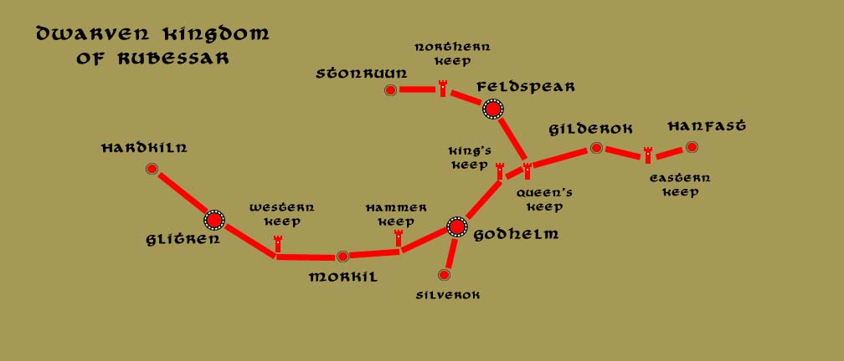

Overview
Located under the Cauldron Mountains that run to the edge of Vesper Bay. The dwarves of Rubelor tend to be the most worldly-minded of their race, mingling with surface-dwellers more than most dwarves. It is common for them to venture into the Vale of Emeron and trade their wares with the ships that come to port in Cold Anchor. The Rubelor have taken advantage of this relationship by crafting polished stones that are but baubles to them but have become a commodity exported around the world of men. Rubelor stones can be found in everything from high fashion to clerical adornments and are even valuable in magical applications for their extreme clarity.
The Rubelor along with their Citerak cousins to the east are constantly in a state of siege with the indigent orc and goblinoid population in this part of the world. Rubelor’s main hall is reputed to host the largest collection of orc skulls in the world, rivaled by the goblin collection hosted by Citerak. In fact, the two kingdoms enjoy a rivalry with one another as to which trophy collection is larger.

Notable Features

Dwarven Towns and Cities of Rubelor
- Hardkiln – small town, population 2,000, guards / soldiers 20, militia 100
- Glitren – large city, population 25,000, guards / soldiers 250, militia 2250
- Western Keep – small town, population 2,000, guards / soldiers 20, militia 100
- Morkil – large town, population 5,000, guards / soldiers 50, militia 250
- Hammer Keep – small town, population 2,000, guards / soldiers 20, militia 100
- Godhelm - metropolis, population 50,000, guards / soldiers 500, militia 2500
- Silverok – large town, population 5,000, guards / soldiers 50, militia 250
- King’s Keep – small town, population 2,000, guards / soldiers 20, militia 100
- Stonruun – small town, population 2,000, guards / soldiers 20, militia 100
- Northern Keep – small town, population 2,000, guards / soldiers 20, militia 100
- Feldspear – large city, population 25,000, guards / soldiers 250, militia 2250
- Queen’s Keep – small town, population 2,000, guards / soldiers 20, militia 100
- Gilderok – large town, population 5,000, guards / soldiers 50, militia 250
- Eastern Keep – small town, population 2,000, guards / soldiers 20, militia 100
- Hanfast – small town, population 2,000, guards / soldiers 20, militia 100

Hardkiln – small town, population 2,000, guards / soldiers 20, militia 100
Size:
Trade Goods:
Local Goods:
Standard:
Ruler:

Home:
Steward:
Marshal:
House Priest:
House Adviser (Scholar/Mage/etc):
Captain of the Guard:
Chief Warriors in Service:

Local Powers:
Local Sites:

Description :

Glitren – large city, population 25,000, guards / soldiers 250, militia 2250
Size:
Trade Goods:
Local Goods:
Standard:
Ruler:

Home:
Steward:
Marshal:
House Priest:
House Adviser (Scholar/Mage/etc):
Captain of the Guard:
Chief Warriors in Service:

Local Powers:
Local Sites:

Description :

Western Keep – small town, population 2,000, guards / soldiers 20, militia 100
Size:
Trade Goods:
Local Goods:
Standard:
Ruler:

Home:
Steward:
Marshal:
House Priest:
House Adviser (Scholar/Mage/etc):
Captain of the Guard:
Chief Warriors in Service:

Local Powers:
Local Sites:

Description :

Morkil – large town, population 5,000, guards / soldiers 50, militia 250
Size:
Trade Goods:
Local Goods:
Standard:
Ruler:

Home:
Steward:
Marshal:
House Priest:
House Adviser (Scholar/Mage/etc):
Captain of the Guard:
Chief Warriors in Service:

Local Powers:
Local Sites:

Description :

Hammer Keep – small town, population 2,000, guards / soldiers 20, militia 100
Size:
Trade Goods:
Local Goods:
Standard:
Ruler:

Home:
Steward:
Marshal:
House Priest:
House Adviser (Scholar/Mage/etc):
Captain of the Guard:
Chief Warriors in Service:

Local Powers:
Local Sites:

Description :

Godhelm - metropolis, population 50,000, guards / soldiers 500, militia 2500
Size:
Trade Goods:
Local Goods:
Standard:
Ruler:

Home:
Steward:
Marshal:
House Priest:
House Adviser (Scholar/Mage/etc):
Captain of the Guard:
Chief Warriors in Service:

Local Powers:
Local Sites:

Description :

Silverok – large town, population 5,000, guards / soldiers 50, militia 250
Size:
Trade Goods:
Local Goods:
Standard:
Ruler:

Home:
Steward:
Marshal:
House Priest:
House Adviser (Scholar/Mage/etc):
Captain of the Guard:
Chief Warriors in Service:

Local Powers:
Local Sites:

Description :

King’s Keep – small town, population 2,000, guards / soldiers 20, militia 100
Size:
Trade Goods:
Local Goods:
Standard:
Ruler:

Home:
Steward:
Marshal:
House Priest:
House Adviser (Scholar/Mage/etc):
Captain of the Guard:
Chief Warriors in Service:

Local Powers:
Local Sites:

Description :

Stonruun – small town, population 2,000, guards / soldiers 20, militia 100
Size:
Trade Goods:
Local Goods:
Standard:
Ruler:

Home:
Steward:
Marshal:
House Priest:
House Adviser (Scholar/Mage/etc):
Captain of the Guard:
Chief Warriors in Service:

Local Powers:
Local Sites:

Description :

Northern Keep – small town, population 2,000, guards / soldiers 20, militia 100
Size:
Trade Goods:
Local Goods:
Standard:
Ruler:

Home:
Steward:
Marshal:
House Priest:
House Adviser (Scholar/Mage/etc):
Captain of the Guard:
Chief Warriors in Service:

Local Powers:
Local Sites:

Description :

Feldspear – large city, population 25,000, guards / soldiers 250, militia 2250
Size:
Trade Goods:
Local Goods:
Standard:
Ruler:

Home:
Steward:
Marshal:
House Priest:
House Adviser (Scholar/Mage/etc):
Captain of the Guard:
Chief Warriors in Service:

Local Powers:
Local Sites:

Description :

Queen’s Keep – small town, population 2,000, guards / soldiers 20, militia 100
Size:
Trade Goods:
Local Goods:
Standard:
Ruler:

Home:
Steward:
Marshal:
House Priest:
House Adviser (Scholar/Mage/etc):
Captain of the Guard:
Chief Warriors in Service:

Local Powers:
Local Sites:

Description :

Gilderok – large town, population 5,000, guards / soldiers 50, militia 250
Size:
Trade Goods:
Local Goods:
Standard:
Ruler:

Home:
Steward:
Marshal:
House Priest:
House Adviser (Scholar/Mage/etc):
Captain of the Guard:
Chief Warriors in Service:

Local Powers:
Local Sites:

Description :

Eastern Keep – small town, population 2,000, guards / soldiers 20, militia 100
Size:
Trade Goods:
Local Goods:
Standard:
Ruler:

Home:
Steward:
Marshal:
House Priest:
House Adviser (Scholar/Mage/etc):
Captain of the Guard:
Chief Warriors in Service:

Local Powers:
Local Sites:

Description :

Hanfast – small town, population 2,000, guards / soldiers 20, militia 100
Size:
Trade Goods:
Local Goods:
Standard:
Ruler:

Home:
Steward:
Marshal:
House Priest:
House Adviser (Scholar/Mage/etc):
Captain of the Guard:
Chief Warriors in Service:

Local Powers:
Local Sites:

Description :

Godhelm
Size: large city, population 25,000, guards / soldiers 250, militia 2250
Trade Goods: mithril, copper, silver, gold, stone
Local Goods:
Standard:
Ruler: Gimurt Beljyr the Gold Bringer

Home:
Steward: Glakdrim Goldengrin
Marshal: Hordran Shalechin
House Priest: Lozzira Blesstone (f)
House Adviser (Scholar/Mage/etc): Dukgren Brewblade
Captain of the Guard: Thederas Forgestoke
Chief Warriors in Service:
Dokkilda Obsidiol (f)
Barinduli Bloodmace
Brousdruth Brownguard

Local Powers:
Local Sites:

Description :

Local Religions:

Local Power Bases:
- Religious Orders
- Merchant Companies
- Mercenary Companies
- Smugglers
- Pirates
- Assassins Guilds
- Thieves Guilds

small town, population 2,000, guards / soldiers 20, militia 100
large town, population 5,000, guards / soldiers 50, militia 250
small city, population 12,000, guards / soldiers 120, militia 600
large city, population 25,000, guards / soldiers 250, militia 2250
metropolis, population 50,000, guards / soldiers 500, militia 2500

Names: Dwarven names from www.fantasynamegenerators.com

