Notes on the Dwarven Kingdom of Onyklesh

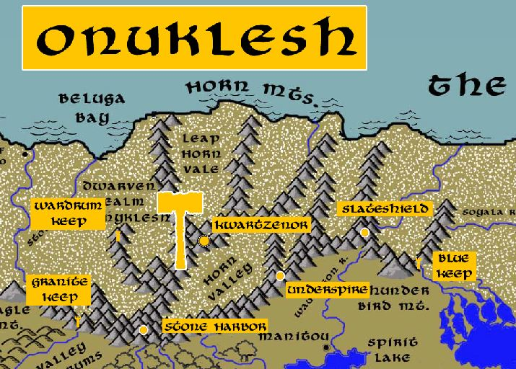

Location: Western Amadar, bordering the lands of the Haka’Na
- Overview
- Towns and Cities
- History
- Notes on Culture
- Magical Items
- Developer Notes

Overview
Founded in 100 PA3 by Khekgrik Underlander, who led his people out from the Kingdom of Amberon to settle in eastern Amadar and the Horn Mountains.

- pious community valuing religious service as the highest priority, congenial to outsiders in a condescending way, intolerant of any threats to their way of life
- the best at animal husbandry and subterranean farming in all dwarvenkind
- appearance: slight traces of blue in the hair and skin and very resilient to cold
- common attire: deep oranges and dark yellows garnished in a variety of furs
- fond of elaborate colorful paintings on the walls of their tunnels and halls
- weapon of choice: dwarven urgrosh (axe and spear double weapon)
- natural enemies: wendigo, frost giants, purple worms
- favored mounts: dire mountain goats
- custom: love stories and will spend hours telling old tales and debating their virtues
- common saying: “less thunder in the mouth and more lightning in the hand.”

Towns and Cities
- Onyklesh
  - Wardrum Keep - small town, population 2,000, guards / soldiers 20, militia 100
  - Kwartzenor - large city, population 25,000, guards / soldiers 250, militia 2250
  - Slateshield - large town, population 5,000, guards / soldiers 50, militia 250
  - Granite Keep - small town, population 2,000, guards / soldiers 20, militia 100
  - Stone Harbor - large town, population 5,000, guards / soldiers 50, militia 250
  - Underspire - large town, population 5,000, guards / soldiers 50, militia 250
  - Blue Keep - small town, population 2,000, guards / soldiers 20, militia 100

Wardrum Keep
Size: small town, population 2,000, guards / soldiers 20, militia 100
Trade Goods:
Local Goods:
Standard:
Colors:
Ruler: Hardrus Stormback

Home:
Steward: Therdrum Druthgeg
Marshal: Muirrum Motgekem
House Priest: Daermin Mightgrace
House Adviser (Scholar/Mage/etc): Brytria Darkfinder (f)
Captain of the Guard: Nisleen Gankeln (f)
Chief Warriors in Service:
Ummiir Drunksong
Karthrum Bangevock
Dulkuhm Lunkegir

Local Powers:
Local Sites:

Description:

Industry:

Key Figures:

Local Lore:

History:

Customs:

Kwartzenor
Size: large city, population 25,000, guards / soldiers 250, militia 2250
Trade Goods: mithril, gold, gems, stone
Local Goods:
Standard:
Colors:
Ruler: Forug Bolderhide the Orc Foe

Home:
Steward: Rorlig Flintfrend
Marshal: Skoghegret Dragonriver (f)
House Priest: Oddum Shattershale
House Adviser (Scholar/Mage/etc): Thakhegit Runebrand (f)
Captain of the Guard: Dozzrum Brewbarrel
Chief Warriors in Service:
Gorlig Handybrand
Grevig Chainbrow
Strommun Kragkin

Local Powers:
Local Sites: The Ruddy Corbel Inn & Tavern

Description:

Industry:

Key Figures:

Local Lore:

History:

Customs:

Slateshield
Size: large town, population 5,000, guards / soldiers 50, militia 250
Trade Goods:
Local Goods:
Standard:
Colors:
Ruler: Bardram Stormboot

Home:
Steward: Jyntyn Coldfists (f)
Marshal: Thorthran Lasthandle
House Priest: Tyrigg Battlebelt
House Adviser (Scholar/Mage/etc): Bryndeth Firstfist (f)
Captain of the Guard: Thulkyl Mountaintale
Chief Warriors in Service:
Thardohr Brawnbranch
Baergarn Cangek
Benrik Rurdukert

Local Powers:
Local Sites:

Description:

Industry:

Key Figures:

Local Lore:
Ciqala the great white dragon dwells near here in the Horn Mountains.

History:

Customs:

Granite Keep
Size: small town, population 2,000, guards / soldiers 20, militia 100
Trade Goods:
Local Goods:
Standard:
Colors:
Ruler: Jyndille Goldroar (f)

Home:
Steward: Baergarn Cangek
Marshal: Gwynnan Goldforge (f)
House Priest: Benrik Rurdukert
House Adviser (Scholar/Mage/etc): Nysnyl Thunderstorm
Captain of the Guard: Amrig Granharr
Chief Warriors in Service:
Bendram Runhiram
Ammor Bodarurr
Belnar Bloodbreaker (f)

Local Powers:
Local Sites:

Description:

Industry:

Key Figures:

Local Lore:

History:

Customs:

Stone Harbor
Size: large town, population 5,000, guards / soldiers 50, militia 250
Trade Goods:
Local Goods:
Standard:
Colors:
Ruler: Bylros Goblinfront and his wife Bralglian (f)

Home:
Steward: Bhargran Murden
Marshal: Horkam Firehorn
House Priest: Banram Rethgivik
House Adviser (Scholar/Mage/etc): Therthran Firsteyes
Captain of the Guard: Bretniss Wildforge (f)
Chief Warriors in Service:
Bunmond Goldkin
Thyrim Stoutpride
Galmir Frostsong

Local Powers:
Local Sites:

Description:

Industry:

Key Figures:

Local Lore:
The silver dragon Kiyiya dwells near here in the Horn Mountains.

History:

Customs:

Underspire
Size: large town, population 5,000, guards / soldiers 50, militia 250
Trade Goods:
Local Goods:
Standard:
Colors:
Ruler: Lyssyl Strerarr (f)

Home:
Steward: Hurmond Glelbroherr
Marshal: Bangrum Bralbrerr
House Priest: Reynleen Braveanvil (f)
House Adviser (Scholar/Mage/etc): Hjalnus Getgaken
Captain of the Guard: Magron Burrowbleeder
Chief Warriors in Service:
Ebbek Wildkind
Urmrig Coldbranch
Hariggs Greatbuster

Local Powers:
Local Sites:

Description:

Industry:

Key Figures:

Local Lore:

History:

Customs:

Blue Keep
Size: small town, population 2,000, guards / soldiers 20, militia 100
Trade Goods:
Local Goods:
Standard:
Colors:
Ruler: Bardelle Boldgrace (f)

Home:
Steward: Kargrun Stoutpast
Marshal: Tyren Gedack
House Priest: Lassnyl Ironfinder (f)
House Adviser (Scholar/Mage/etc): Armgran Throzzirk
Captain of the Guard: Nallyl Giantgift (f)
Chief Warriors in Service:
Armgran Throzzirk
Thurnum Munhuck
Gulryl Bubrahk

Local Powers:
Local Sites:

Description:

Industry:

Key Figures:

Local Lore:

History:

Customs:

History
First Primordial Age (PA1)

Second Primordial Age (PA2)

Third Primordial Age (PA3)
100 PA3 - Khekgrik Underlander leads a tribe of Dwarves from Amberon and heads east to begin a new colony; crosses under the sea into Agatren and then moves east to form the Dwarven Kingdom of Onyklesh in the Horn Mountains

Fourth primordial Age (PA4)

First Ancient Age (AA1)

Second Ancient Age (AA2)

Third Ancient Age (AA3)

Fourth Ancient Age (AA4)

First Written Age (WA1)
290 WA1 - an ancient dragon named Sephiran descends on Onyklesh and drives out the entire kingdom, razing every town and hording their treasure

630 WA1 - a Dwarven band of Onyklesh refugees led by Kuruk the Homeless steals the Sybalite from Daemundra to aide in their campaign to reclaim their home from the dragon Sephiran

632 WA1 - Kuruk and his band enter Onyklesh and beguile the dragon Sephiran; the dragon is enthralled by the diamond and consumes it, unleashing power that destroys the dragon utterly; Kuruk reclaims Onyklesh and becomes its new king

Second Written Age (WA2)

Third Written Age (WA3)

Fourth Written Age (WA4)

Notes on Culture
Onyklesh dwarves share some traits with the Amberon Dwarves, from whose kingdom their settlers originated. Very slight traces of blue in the hair and skin and very resilient to cold but not as much as those from Amberon. They are fond of elaborate colorful paintings on the walls of their tunnels and halls, mostly geometric in design but featuring beasts in the designs. The bow is a favorite weapon of theirs and great work has been put into developing very strong short bows of exceptional quality. Their favored enemies are the wendigo and ice giants. Tend to work furs into their wardrobe and their furriers put as much pride into their work as most dwarves put into their beards. Onyklesh dwarves love stories and will spend hours telling old tales and debating their virtues.

Magical Items

Developer Notes

Names: Dwarven names from www.fantasynamegenerators.com

