Notes on the Dwarven Kingdom of Garnettren

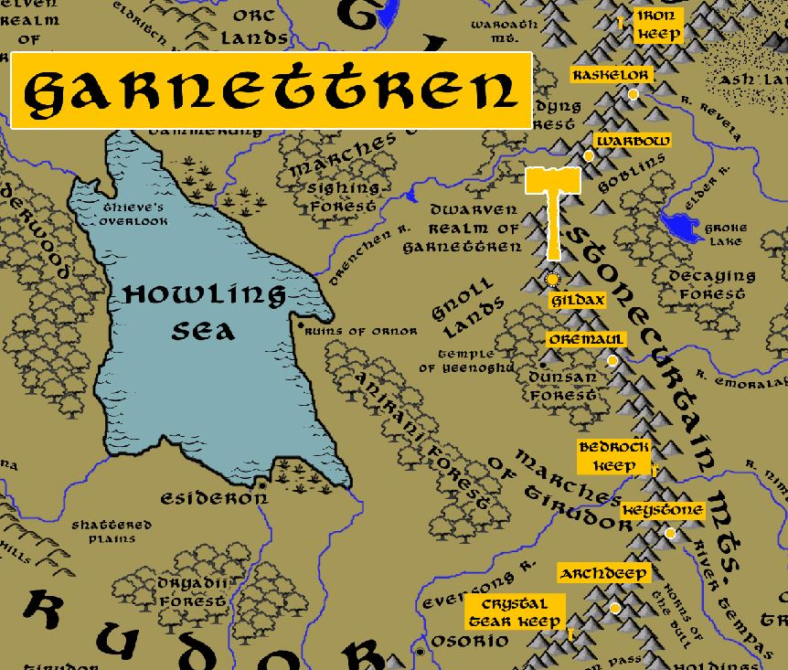

Location: Stonecutter Mountains, Lands of Oberon in Central Amadar

- Overview
- Towns and Cities
- History
- Notes on Culture
- Magical Items
- Developer Notes

Overview
One of the four kingdoms founded by the sons of Raknem the Chainbreaker. In 590 PA2 Noldrum Chainbreaker headed out from the Kingdom of Daemunndra and established the Garnettren colony.

Garnettren shares a strong bond with the kingdom of Agatren to the east. Dwarves from the two kingdoms have physical traits in common, namely the long earlobes, prodigious noses, and the occasional extra toe that folks in these parts call a “tren-toe” and consider it a mark of good luck. Both kingdoms have shared bloodlines, originating back from when Agatren split-off in the Third Primordial Age, also because intermarriage between the two kingdoms is common.

The two kingdoms also share the struggle against the dark forces that bubble up from the lands around the Oberon Sea. Orc, goblin, and gnoll armies have ruled the lands between the Stonecurtain Mountains and the Direfrost Mountains for the last four thousand years since the Scourge of Hrolith. It has been a never-ending struggle for both dwarven kingdoms as these creatures ceaselessly encroach into their mountains. Both kingdoms have sworn oaths to come to the aide of the other in times of crisis. One tradition the dwarves hold is the Ringing of the Rings. Captains in the armies from either kingdom are given rings bearing two stones: a garnet and an agate, crafted in the form of a hammer and anvil. Whenever companies from both kingdoms meet, it is customary for them to strike the rings together, creating a loud thunderclap that sounds like a hammer striking an anvil.

- thoughtful community of simple folk who embrace a frontier lifestyle but are avid readers and always curious
- the best at the study and mastery of arcane magic in all dwarvenkind
- appearance: dark brown skin and hair
- common attire: dark green colors, wear the small bones of random creatures
- weapon of choice: dwarven waraxe
- natural enemies: duergar, gnolls, orcs, goblins
- favored mounts: dire boars
- long earlobes, prodigious noses, and the occasional extra toe that folks in these parts call a “tren-toe” and consider it a mark of good luck; tight bond with Garnettren sharing bloodlines as well as mutual war with dark forces in Central Amadar; captains wear rings that are struck together when their armies meet
- Custom: Daemundran dwarves are fond of masterfully wrought belt buckles. They are keen to exchange them with newfound friends and during ceremonies.
- Common saying: “the greatest hammer is held between the ears”

Towns and Cities
- Garnettren
  - Iron Keep – small town, population 2,000, guards / soldiers 20, militia 100
  - Raskelor – large town, population 5,000, guards / soldiers 50, militia 250
  - Warbow – large town, population 5,000, guards / soldiers 50, militia 250
  - Gildax – large city, population 25,000, guards / soldiers 250, militia 2250
  - Oremaul – large town, population 5,000, guards / soldiers 50, militia 250
  - Bedrock Keep – small town, population 2,000, guards / soldiers 20, militia 100
  - Keystone – large town, population 5,000, guards / soldiers 50, militia 250
  - Archdeep – large town, population 5,000, guards / soldiers 50, militia 250
  - Crystal Tear Keep – small town, population 2,000, guards / soldiers 20, militia 100

Iron Keep
Size: small town, population 2,000, guards / soldiers 20, militia 100
Trade Goods:
Local Goods:
Standard:
Colors:
Ruler:

Home:
Steward:
Marshal:
House Priest:
House Adviser (Scholar/Mage/etc):
Captain of the Guard:
Chief Warriors in Service:

Local Powers:
Local Sites:

Description:

Industry:

Key Figures:

Local Lore:
Balinor the silver dragon dwells north of here in the Godsteeth Mts.

History:

Customs:

Raskelor
Size: large town, population 5,000, guards / soldiers 50, militia 250
Trade Goods:
Local Goods:
Standard:
Colors:
Ruler:

Home:
Steward:
Marshal:
House Priest:
House Adviser (Scholar/Mage/etc):
Captain of the Guard:
Chief Warriors in Service:

Local Powers:
Local Sites:

Description:

Industry:

Key Figures:

Local Lore:
Beladola the gold dragon dwells near here

History:

Customs:

Warbow
Size: large town, population 5,000, guards / soldiers 50, militia 250
Trade Goods:
Local Goods:
Standard:
Colors:
Ruler:

Home:
Steward:
Marshal:
House Priest:
House Adviser (Scholar/Mage/etc):
Captain of the Guard:
Chief Warriors in Service:

Local Powers:
Local Sites:

Description:

Industry:

Key Figures:

Local Lore:

History:

Customs:

Gildax
Size: large city, population 25,000, guards / soldiers 250, militia 2250
Trade Goods: mithril, silver, platinum, stone
Local Goods:
Standard:
Colors:
Ruler: Har Bonebit the Deep Delver

Home:
Steward: Garuk Whitbeard
Marshal: Yasgreth Goldenstone (f)
House Priest: Nekkaek Lavaron
House Adviser (Scholar/Mage/etc): Gomdren Fellgiant
Captain of the Guard: Varmek Monterron
Chief Warriors in Service:
Lozzirgith Jadethane (f)
Nommri Underblade
Rudimer Silverhead

Local Powers:
Local Sites: Malt and Mortar Inn & Tavern

Description:

Industry:

Key Figures:

Local Lore:

History:

Customs:

Oremaul
Size: large town, population 5,000, guards / soldiers 50, militia 250
Trade Goods:
Local Goods:
Standard:
Colors:
Ruler:

Home:
Steward:
Marshal:
House Priest:
House Adviser (Scholar/Mage/etc):
Captain of the Guard:
Chief Warriors in Service:

Local Powers:
Local Sites:

Description:

Industry:

Key Figures:

Local Lore:

History:

Customs:

Bedrock Keep
Size: small town, population 2,000, guards / soldiers 20, militia 100
Trade Goods:
Local Goods:
Standard:
Colors:
Ruler:

Home:
Steward:
Marshal:
House Priest:
House Adviser (Scholar/Mage/etc):
Captain of the Guard:
Chief Warriors in Service:

Local Powers:
Local Sites:

Description:

Industry:

Key Figures:

Local Lore:

History:

Customs:

Keystone
Size: large town, population 5,000, guards / soldiers 50, militia 250
Trade Goods:
Local Goods:
Standard:
Colors:
Ruler:

Home:
Steward:
Marshal:
House Priest:
House Adviser (Scholar/Mage/etc):
Captain of the Guard:
Chief Warriors in Service:

Local Powers:
Local Sites:

Description:

Industry:

Key Figures:

Local Lore:

History:

Customs:

Archdeep
Size: large town, population 5,000, guards / soldiers 50, militia 250
Trade Goods:
Local Goods:
Standard:
Colors:
Ruler:

Home:
Steward:
Marshal:
House Priest:
House Adviser (Scholar/Mage/etc):
Captain of the Guard:
Chief Warriors in Service:

Local Powers:
Local Sites:

Description:

Industry:

Key Figures:

Local Lore:
Orvereol the copper dragon dwells near here

History:

Customs:

Crystal Tear Keep
Size: small town, population 2,000, guards / soldiers 20, militia 100
Trade Goods:
Local Goods:
Standard:
Colors:
Ruler:

Home:
Steward:
Marshal:
House Priest:
House Adviser (Scholar/Mage/etc):
Captain of the Guard:
Chief Warriors in Service:

Local Powers:
Local Sites:

Description:

Industry:

Key Figures:

Local Lore:

History:

Customs:

History
First Primordial Age (PA1)

Second Primordial Age (PA2)
590 PA2 - Noldrum of the Five Brothers departs Daemundra and goes east and to establish the Dwarven Kingdom of Garnettren

Third Primordial Age (PA3)
40 PA3 - Torelgren Truetower leads a tribe of Dwarves from Garnettren and heads east and begins the Dwarven Kingdom of Agatren in the Direfrost Mountains

Fourth primordial Age (PA4)

First Ancient Age (AA1)
450 AA1 - The Sybalite Stone is stolen from Daemundra by the Duergar wizard Gergerim

480 AA1 - Gergerim is driven mad by the Sybalite's splendor and uses it to focus enormous magical energies to destroy half of the kingdom of Garnettren

481 AA1 - The Sybalite War - Dwarves from Daemundra, Garnettren, and Agatren converge on the Stonecurtain Mountains to rescue the Sybalite and stop Gergerim

492 AA1 - end of the Sybalite War - After years of bloody conquest the armies of Gergerim are defeated and the Sybalite restored to Daemundra

Second Ancient Age (AA2)

Third Ancient Age (AA3)

Fourth Ancient Age (AA4)
210-340 AA4 - Scourge of Hrolith - Orcs unite under the warlord Hrolith and sweep across Central Amadar

270 AA4 - Fall of the Kingdom of Vasera; Dwarven forces of Garnettren, fighting for years to aid the humans, are defeated and forced to retreat back into their mountains

First Written Age (WA1)

Second Written Age (WA2)
720 WA2 - Mortavay unites orc tribes and marches east into Haka'Na lands; wipes out Machakw, attacks Turuwe and Hurit

721 WA2 - Dwarven armies of Agatren are defeated by Mortavay and their mountain halls invaded

732 WA2 - Dwarven Kingdom of Garnettren fights a desperate losing battle to counter Mortavay's forces in Central Amadar

747 WA2 - Dwarven Kingdoms of Garnettren and Agatren destroy the last of Mortavay's invaders and are liberated

Third Written Age (WA3)
640-670 WA3 - Second Dark Crusade

642 WA3 - Mortavay's forces invade Dwarven Kingdom of Garnettran; a second front opens south at Tarvos Pass

644 WA3 - Dwarven kingdoms of Daemundra, Citerak, and Rubelor dispatch armies to join the fight

644 WA3 - Battle of Tarvos: Dwarves of Garnettren join Tirudoran forces to stop Mortavay at Tarvos Pass; Mortavay destroys the human and dwarven host and continues westward

662 WA3 - Elves of Ari'Aahn join with the Dwarves of Garnettren to aide the humans in encircling Mortavay's forces in Erigoth

663 WA3 - Trevilish and Tirudoran cities still free rally to attack Mortavay's center forces, cutting them off from the east; joined by the Elves of Ulynar attacking from Tredfut Forest

665 WA3 - Dwarves of Citerak and Rubelor rouse from their mountains and attack Mortavay's forces in Gremira

670 - Mortavay defeated; end of the Second Dark Crusade

Fourth Written Age (WA4)

Notes on Culture

Magical Items

Developer Notes

Names: Dwarven names from www.fantasynamegenerators.com

