Notes on the Dwarven Kingdom of Jasprendryn

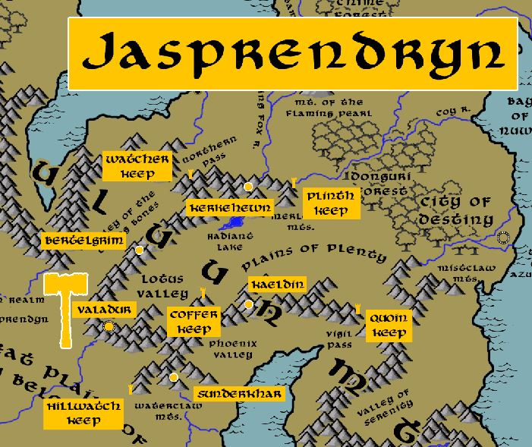

Location: Ryuluun Mountains, Continent of Xiandai

- Overview
- Towns and Cities
- History
- Notes on Culture
- Magical Items
- Developer Notes

Overview
Founded in 760 PA2 by Jouldrous Gemspawn when he led two tribes of Dwarves off from the Kingdom of Obseidon. One of the two tribes later split off after a brief civil war, traveling to Sakura to begin the Turquorzem Kingdom.

- A wise community in touch with the spirit world, dedicated to the studies of divine magic and integrating it into their subterranean realm, fond of philosophy and thoughtful action
- the best at the study and mastery of divine magic in all dwarvenkind
- appearance: dark brown skin with gray hair; Large, prominent foreheads that give them a frowning expression
- common attire: leather outer garments cut like short robes, leather sashes that bear the symbols of their studies
- Each dwarf is tattooed with a unique birth symbol that is tied to their family history
- Very sensitive to vibrations, believe they can hear the song of the deep emanating from every rock
- weapon of choice: bar mace
- natural enemies: gibbering mouthers, orcs, goblins, xorn
- favored mounts: yaks and water buffalo
- custom: will pose philosophical questions and riddles, some of which have no answers; tirelessly quiz one another and outsiders to measure their ability to form conjecture or ideas
- common saying: “Crooked rocks still make good bridges.”

Towns and Cities

- Jasprendyn
  - Watcher Keep – small town, population 2,000, guards / soldiers 20, militia 100
  - Kerkehewn – large town, population 5,000, guards / soldiers 50, militia 250
  - Plinth Keep – small town, population 2,000, guards / soldiers 20, militia 100
  - Bertelgrim – large town, population 5,000, guards / soldiers 50, militia 250
  - Valadur – large city, population 25,000, guards / soldiers 250, militia 2250
  - Coffer Keep – small town, population 2,000, guards / soldiers 20, militia 100
  - Kaeldin – large town, population 5,000, guards / soldiers 50, militia 250
  - Quoin Keep – small town, population 2,000, guards / soldiers 20, militia 100
  - Hillwatch Keep – small town, population 2,000, guards / soldiers 20, militia 100
  - Sunderkhar – large town, population 5,000, guards / soldiers 50, militia 250

Watcher Keep
Size: small town, population 2,000, guards / soldiers 20, militia 100
Trade Goods:
Local Goods:
Standard:
Colors:
Ruler: Krommus Blackhammer

Home:
Steward: Morthrum Goldbraid
Marshal: Harmek Taram
House Priest: Kamrig Kindlefire
House Adviser (Scholar/Mage/etc): Mystmura Genhager (f)
Captain of the Guard: Thalman Hightale
Chief Warriors in Service:
Daernir Mightbeard
Farkam Coppertoe
Amadin Garthek

Local Powers:
Local Sites:

Description:

Industry:

Key Figures:

Local Lore:

History:

Customs:

Kerkehewn
Size: large town, population 5,000, guards / soldiers 50, militia 250
Trade Goods:
Local Goods:
Standard:
Colors:
Ruler: Thalmiir Brawnstone

Home:
Steward: Galrak Brightring
Marshal: Hulrig Hardtale
House Priest: Bromgren Kindblood
House Adviser (Scholar/Mage/etc):
Captain of the Guard: Jenwynn Deepbranch (f)
Chief Warriors in Service:
Bramdrus Faranuk
Hurnum Strulbron
Dulmor Drukir

Local Powers:
Local Sites:

Description:

Industry:

Key Figures:

Local Lore:

History:

Customs:

Plinth Keep
Size: small town, population 2,000, guards / soldiers 20, militia 100
Trade Goods:
Local Goods:
Standard:
Colors:
Ruler: Amkohm Goldenshield

Home:
Steward: Malkam Marblebrow
Marshal: Tyron Keenedge
House Priest: Tasbelle Ridgewise (f)
House Adviser (Scholar/Mage/etc): Dulgram Ferthekinn
Captain of the Guard: Graldan Threnkam
Chief Warriors in Service:
Grennum Thrummlen
Magnik Cleancleft
Thelkahm Moltenson

Local Powers:
Local Sites:

Description:

Industry:

Key Figures:

Local Lore:

History:

Customs:

Bertelgrim
Size: large town, population 5,000, guards / soldiers 50, militia 250
Trade Goods:
Local Goods:
Standard:
Colors:
Ruler: Anlin Sternbone (f)

Home:
Steward: Gulnum Loudhorn
Marshal: Bromgren Fullercut
House Priest: Hjoldrak Broodsong
House Adviser (Scholar/Mage/etc): Runma Deepbranch (f)
Captain of the Guard: Thargran Firstward
Chief Warriors in Service:
Daerdohr Brazzenohr
Krumman Fudihr
Magdrum Gollurr

Local Powers:
Local Sites:

Description:

Industry:

Key Figures:

Local Lore:

History:

Customs:

Valadur
Size: large city, population 25,000, guards / soldiers 250, militia 2250
Trade Goods: copper, silver, gold, stone
Local Goods:
Standard:
Colors:
Ruler: Nadelynn Anvilcloak (f)

Home:
Steward: Kitrum Oreborn
Marshal: Golgud Bracehold
House Priest: Udmim Icebane
House Adviser (Scholar/Mage/etc): Vognum Bludfurnus
Captain of the Guard: Yomrun Beastfell
Chief Warriors in Service:
Lokhegra Drakefeet (f)
Dobael Smeltsmyth
Merlum Cavekin

Local Powers:
Local Sites: The Copper Crypt Inn & Tavern

Description:

Industry:

Key Figures:

Local Lore:

History:

Customs:

Coffer Keep
Size: small town, population 2,000, guards / soldiers 20, militia 100
Trade Goods:
Local Goods:
Standard:
Colors:
Ruler: Magdrum Steeleyes

Home:
Steward: Regdren Lastrock
Marshal: Amadin Dreldaken
House Priest: Banmor Smeltwell
House Adviser (Scholar/Mage/etc): Eremus Guldrom
Captain of the Guard: Dalbrek Druldem
Chief Warriors in Service:
Bromdohr Soundeep
Lessdelle Gleamring (f)
Gramdohr Deepsound

Local Powers:
Local Sites:

Description:

Industry:

Key Figures:

Local Lore:

History:

Customs:

Kaeldin
Size: large town, population 5,000, guards / soldiers 50, militia 250
Trade Goods:
Local Goods:
Standard:
Colors:
Ruler: Bhalrigg Hammerpass

Home:
Steward: Barkyl Onyxeye
Marshal: Brondish Granatchin
House Priest: Krummin Stonerest
House Adviser (Scholar/Mage/etc): Regram Modron
Captain of the Guard: Galbek Broadreach
Chief Warriors in Service:
Hulkum Tuhammer
Thulnar Greldohr
Arthrum Tapkeg

Local Powers:
Local Sites:

Description:

Industry:

Key Figures:

Local Lore:

History:

Customs:

Quoin Keep
Size: small town, population 2,000, guards / soldiers 20, militia 100
Trade Goods:
Local Goods:
Standard:
Colors:
Ruler: Tislin Mountainsong (f)

Home:
Steward: Dimwyn Greatneck (f)
Marshal: Bhelgrun Madfist
House Priest: Bengard Bronzegrace
House Adviser (Scholar/Mage/etc): Gremdan Keenwitt
Captain of the Guard: Baerdohr Anvilhead
Chief Warriors in Service:
Baerthran Faedugar
Margiel Tumnavahr (f)
Balthrum Gruffneck

Local Powers:
Local Sites:

Description:

Industry:

Key Figures:

Local Lore:

History:

Customs:

Hillwatch Keep
Size: small town, population 2,000, guards / soldiers 20, militia 100
Trade Goods:
Local Goods:
Standard:
Colors:
Ruler: Hulrus Starkstone

Home:
Steward: Thurgrim Risemount
Marshal: Thuldohr Mightslag
House Priest: Myrris Lightpride (f)
House Adviser (Scholar/Mage/etc): Emdan Darkjem
Captain of the Guard: Redleen Wildtale
Chief Warriors in Service:
Kromdar Firstwin
Thuldrom Buregim
Anleen Trollmight (f)

Local Powers:
Local Sites:

Description:

Industry:

Key Figures:

Local Lore:

History:

Customs:

Sunderkhar
Size: large town, population 5,000, guards / soldiers 50, militia 250
Trade Goods:
Local Goods:
Standard:
Colors:
Ruler: Galdan Grayreach and his wife Soldora (f)

Home:
Steward: Thalbrek Cragfoot
Marshal: Gilrim Silvervein
House Priest: Bungus Barroheft
House Adviser (Scholar/Mage/etc): Grilrus Evermask
Captain of the Guard: Maerdielle Thunderdrum (f)
Chief Warriors in Service:
Bhelnom Strahaln
Thelnum Bungunuk
Benmek Thrunkan

Local Powers:
Local Sites:

Description:

Industry:

Key Figures:

Local Lore:

History:

Customs:

History
First Primordial Age (PA1)

Second Primordial Age (PA2)
760 PA2 - Jouldrous Gemspawn leads two tribes to break off from Obseidon and go east under the sea to Xiandai to form the Dwarven Kingdom of Jasprendryn under Ryuluun Mountains

Third Primordial Age (PA3)
210 PA3 - Princess Hagguda Fireforge of Jasprendryn refuses to marry her father's choice of suitor, she delves beneath the Kamatsu Strait and finds the Domaru Mountains where she founds the Turquorzem Kingdom

Fourth primordial Age (PA4)
532 PA4 - The Dwarven Kingdom of Jasprendryn emerges from the Ryuluun Mountains to attack and destroy Dractus' rear guard at the Northern Pass

First Ancient Age (AA1)

Second Ancient Age (AA2)

Third Ancient Age (AA3)

Fourth Ancient Age (AA4)

First Written Age (WA1)

Second Written Age (WA2)

Third Written Age (WA3)

Fourth Written Age (WA4)

Notes on Culture

Magical Items

Developer Notes

Names: Dwarven names from www.fantasynamegenerators.com

