Notes on the Dwarven Kingdom of Obseidon

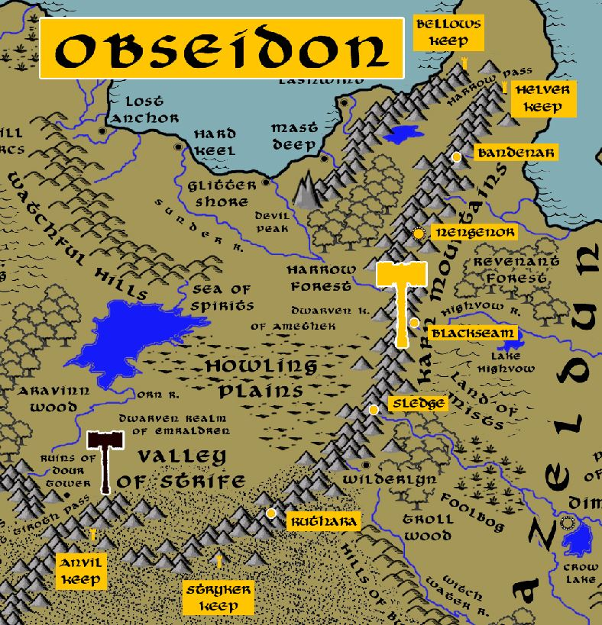

Location: Karn Mountains, Continent of Gaeadon, bordering the Kingdom of Kazelduun
- Overview
- Towns and Cities
- History
- Notes on Culture
- Magical Items
- Developer Notes

Overview
Founded in 720 PA1 by Bagrun Drumdinn, who led a tribe of Dwarves off from the Kingdom of Emraldren.

Located beneath the mountain range dividing Kyre from Kazeldun, Obseidon dwarves enjoy a rousing relationship with the warlike humans of Kazeldun, whom they see as worthy comrades in arms when they are not fighting them. The pass from Kyre to Kazeldun is fiercely protected by the Obseidon warriors, for they see it as their domain and exact a steep toll for passage. Obseidon dwarves take credit for the tradition of humans in Kazelduun painting themselves for battle, for they do so themselves in an array of earth colors. Metallic blue is seen as an opulent color to wear into combat for them, and marks dwarven chieftains of importance.

It was a dwarven hero named Shimney Footbeard who faced the great under-serpent Vrydeth two thousand years ago and slew it and, according to legend, sent forth such a shower of serpent's blood that Obseidon dwarven clerics captured it and made it into a potion of great power. Rumor has it that flasks of Vrydeth still exist today and create great champions among the Obseidon dwarves, but adventure seekers should beware the street vendors throughout Kyre and Kazeldun who would sell forgeries bottled to look like the real thing.

Obseidon dwarves are a surly and vicious lot, even by dwarven standards. Their love of warfare and brutality outpaces their love of stonework or even precious stones and gold. Obseidon dwarves live for war and spend most of their time perfecting engines of destruction. Obseidon armor is almost always dark black with dents painted in red for every kill a warrior has. Spikes cover the armor and helmets feature a face plate painted with a skull or demonic face. Their armies employ powerful percussion instruments that shake the depths and strike fear in their enemies. They chew on Rabid Root before and during battle, driving them mad with strength, speed, and immunity to pain. An Obseidon dwarf’s skin is covered in tattoos all over, most of them depicting their fallen enemies. The neighboring dwarves in Emraldren are at a loss for words explaining the severe attitude of their cousins to the east. War has even broken out between the two kingdoms, usually for no good reason as the Obseidon leaders are impossible to talk to when their minds are set on warfare.

- A bellicose community, intent on war and preparation for war, ill-tempered and cruel, entertaining designs on conquest of other dwarven kingdoms, unpredictable and violent
- the best at weapon smithing in all dwarvenkind
- appearance: paint themselves for battle in an array of earth colors and metallic blue, skin is covered in tattoos all over, most of them depicting their fallen enemies; Apply metal to their teeth
- Their armies employ powerful drums that shake the depths and strike fear in their enemies.
- They chew on Rabid Root before and during battle, driving them mad with strength, speed, and immunity to pain.
- leaders are impossible to talk to when their minds are set on warfare.
- common attire: armor is almost always dark black with dents painted in red for every kill a warrior has. Spikes cover the armor and helmets feature a face plate painted with a skull or demonic face.
- weapon of choice: morningstar
- natural enemies: basilisks, gricks, piercers, fire giants
- favored mounts: giant spiders / cave fishers
- enjoy a rousing relationship with the warlike humans of Kazeldun, paint themselves for battle in an array of earth colors and metallic blue
- a surly and vicious lot, love of warfare outpaces their love of stonework or even precious stones and gold, spend most of their time perfecting engines of destruction.
- Custom: in every battle, a dwarf is chosen to carry a spiked metal ball called the “belastig”; if they survive the ordeal they are celebrated and get to choose the next dwarf who carries the ball into battle
- Common saying: “Fire we took from the gods,” responded with “and with it we forge the world.”

Towns and Cities
- Obseidon
  - Anvil Keep – small town, population 2,000, guards / soldiers 20, militia 100
  - Stryker Keep – small town, population 2,000, guards / soldiers 20, militia 100
  - Ruthara – large town, population 5,000, guards / soldiers 50, militia 250
  - Sledge – large town, population 5,000, guards / soldiers 50, militia 250
  - Blackseam – large town, population 5,000, guards / soldiers 50, militia 250
  - Nengenor – large city, population 25,000, guards / soldiers 250, militia 2250
  - Bandenar – large town, population 5,000, guards / soldiers 50, militia 250
  - Helver Keep – small town, population 2,000, guards / soldiers 20, militia 100
  - Bellows Keep – small town, population 2,000, guards / soldiers 20, militia 100

Anvil Keep
Size: small town, population 2,000, guards / soldiers 20, militia 100
Trade Goods:
Local Goods:
Standard:
Colors:
Ruler: Duldrom Madhead and his wife Gwensyl (f)

Home:
Steward: Einlyl Stonehorn (f)
Marshal: Urmdor Marblek
House Priest: Brammar Gobrik
House Adviser (Scholar/Mage/etc): Bromadin Trollbane
Captain of the Guard: Bramadin Hezlunn
Chief Warriors in Service:
Daermus Coderk
Thurgram Catherek
Krumrus Trueforce

Local Powers:
Local Sites:

Description:

Industry:

Key Figures:

Local Lore:

History:

Customs:

Stryker Keep
Size: small town, population 2,000, guards / soldiers 20, militia 100
Trade Goods:
Local Goods:
Standard:
Colors:
Ruler: Gramgron Sternheart

Home:
Steward: Malnom Broodhead
Marshal: Brallemura Lehram (f)
House Priest: Dolnar Flinteye
House Adviser (Scholar/Mage/etc): Jennbelle Moltenra (f)
Captain of the Guard: Thomiir Thrallavor
Chief Warriors in Service:
Kharbrek Bronzemask
Gralkom Strahokohr
Benimir Strohneck

Local Powers:
Local Sites:

Description:

Industry:

Key Figures:

Local Lore:

History:

Customs:

Ruthara
Size: large town, population 5,000, guards / soldiers 50, militia 250
Trade Goods:
Local Goods:
Standard:
Colors:
Ruler: Rotryl Anvilston

Home:
Steward: Bhalman Roken
Marshal: Thynik Frostforge
House Priest: Gemmil Strongark (f)
House Adviser (Scholar/Mage/etc):
Captain of the Guard: Bharmyl Keenfront
Chief Warriors in Service:
Duldrus Burrowbrand
Ebkyl Mountbottom
Vonmur Gemnam

Local Powers:
Local Sites:

Description:

Industry:

Key Figures:

Local Lore:

History:

Customs:

Sledge
Size: large town, population 5,000, guards / soldiers 50, militia 250
Trade Goods:
Local Goods:
Standard:
Colors:
Ruler: Gemmyl Lastsong (f)

Home:
Steward: Gremmek Gremnegann
Marshal: Hjolgrun Methgunir
House Priest: Kimgrun Felbroke (f)
House Adviser (Scholar/Mage/etc): Lyrea Malluvin (f)
Captain of the Guard: Karmus Roarlan
Chief Warriors in Service:
Dalryl Grollen
Brilwen Cellonn (f)
Hogurn Braemekh

Local Powers:
Local Sites:

Description:

Industry:

Key Figures:

Local Lore:

History:

Customs:

Blackseam
Size: large town, population 5,000, guards / soldiers 50, militia 250
Trade Goods:
Local Goods:
Standard:
Colors:
Ruler: Galmiir Stoutgrace

Home:
Steward: Balrielle Glethgarr (f)
Marshal: Farrim Bladeren
House Priest: Ebgrun Strorthogim
House Adviser (Scholar/Mage/etc): Lysdyl Oldfist (f)
Captain of the Guard: Kargurn Loudstorm
Chief Warriors in Service:
Hjalkohm Daeldann
Ragkyl Broadkind
Griggs Wildpride

Local Powers:
Local Sites:

Description:

Industry:

Key Figures:

Local Lore:

History:

Customs:

Nengenor
Size: large city, population 25,000, guards / soldiers 250, militia 2250
Trade Goods: mithril, copper, platinum, stone
Local Goods:
Standard:
Colors:
Ruler: Thudak Agrimm the Skull Sitter

Home:
Steward: Gadgrem Clayhill
Marshal: Kondrouline Andraceth (f)
House Priest: Borfarlun Hammerhilt
House Adviser (Scholar/Mage/etc): Thalgoum Nighthand
Captain of the Guard: Grumlin Berylback
Chief Warriors in Service:
Safagrett Onyxym (f)
Mozmor Bonebrow
Volet Lightforge

Local Powers:
Local Sites: The Granite Gable Inn & Tavern

Description:

Industry:

Key Figures:

Local Lore:

History:

Customs:

Bandenar
Size: large town, population 5,000, guards / soldiers 50, militia 250
Trade Goods:
Local Goods:
Standard:
Colors:
Ruler: Bruldora Steelfall (f)

Home:
Steward: Byllevian Colreck (f)
Marshal: Ebermyl Gellon
House Priest: Ummiir Moltenbraid
House Adviser (Scholar/Mage/etc): Mystylia Dordihuhr
Captain of the Guard: Bromgren Lanhekerk
Chief Warriors in Service:
Farnur Gaerdehk
Kardram Goldfront
Bhelrus Stoneshaper

Local Powers:
Local Sites:

Description:

Industry:

Key Figures:

Local Lore:

History:

Customs:

Helver Keep
Size: small town, population 2,000, guards / soldiers 20, militia 100
Trade Goods:
Local Goods:
Standard:
Colors:
Ruler: Brumram Darkreach

Home:
Steward: Melnam Lightback
Marshal: Lysmera Gellihk (f)
House Priest: Lessdeth Steeltale (f)
House Adviser (Scholar/Mage/etc): Hurnik Cunagen
Captain of the Guard: Krumgram Sternchin
Chief Warriors in Service:
Bellethiel Glerdigiln (f)
Bharron Brunukkan
Bariggs Hardfury

Local Powers:
Local Sites:

Description:

Industry:

Key Figures:

Local Lore:
The gold dragon Kalameth dwells just north of here where it perches and watches over Harrow Pass.

History:

Customs:

Bellows Keep
Size: small town, population 2,000, guards / soldiers 20, militia 100
Trade Goods:
Local Goods:
Standard:
Colors:
Ruler: Thartharn Loudgrace

Home:
Steward: Baldain Stormbelch
Marshal: Nisdryn Gaehagor (f)
House Priest: Malgrom Burrowbark
House Adviser (Scholar/Mage/etc): Berkyl Darkstone
Captain of the Guard: Anvan Frostgift (f)
Chief Warriors in Service:
Thodrus Gamunirk
Tharrom Tenagog
Banrak Famegark

Local Powers:
Local Sites:

Description:

Industry:

Key Figures:

Local Lore:

History:

Customs:

History
First Primordial Age (PA1)
720 PA1 - Bagrun Drumdinn leads a company of Dwarves from Darkheim east and begins the Dwarven Kingdom of Obseidon in the Karn Mountains

Second Primordial Age (PA2)
760 PA2 - Jouldrous Gemspawn leads two tribes to break off from Obseidon and go east under the sea to Xiandai to form the Dwarven Kingdom of Jasprendryn under Ryuluun Mountains

Third Primordial Age (PA3)

Fourth primordial Age (PA4)

First Ancient Age (AA1)

Second Ancient Age (AA2)

Third Ancient Age (AA3)
190 AA3 - Shimney Footbeard of Obseidon faces the great under-serpent Vrydeth and slays it; according to legend, this creates such a shower of serpent's blood that Obseidon dwarven clerics captured it and made it into a potion of great power called Vrydeth

Fourth Ancient Age (AA4)

First Written Age (WA1)

Second Written Age (WA2)
890 WA2 - foraging party from Mast Deep crosses the Karn Mountains and encounters the Dwarves of Obseidon, establishing an alliance

980 WA2 - the hero Airk Braven of Mast Deep leeds a group of warriors to help the Dwarves of Obseidon retrieve the Amulet of Cormontem stolen by the orcs of Karn

Third Written Age (WA3)

Fourth Written Age (WA4)

Notes on Culture

Magical Items

- Vrydeth – powerful magical potion brewed by the Obseidon dwarves, created from the great serpent Vrydeth slain by Shimney Footbear in 190 AA3
- Amulet of Cormontem – powerful artifact that is difficult to wield; the wearer, if worthy, has the power to reshape rock and soil and according to legend can even move mountains

Developer Notes

Names: Dwarven names from www.fantasynamegenerators.com

