Notes on the Dwarven Kingdom of Emraldren

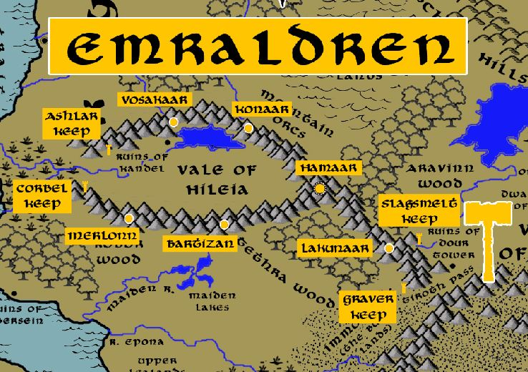

Location: Serpent Mountains, Continent of Gaeadon

- Overview
- Towns and Cities
- History
- Notes on Culture
- Magical Items
- Developer Notes

Overview
The Vagabond Mountains were the site of one of the first civilizations of Dwarves. Once called the Darkheim, the early Dwarven settlement was established as a kingdom in 670 PA1 with Throsdruck Orefrend its first king.
- A merry community, fond of stories and songs and food and drink, friendly with other races, very connected with the outside lands and feel an obligation to be good stewards of the land; masters of brewing ale, Emraldren ale is the most popular among dwarves worldwide
- the best at the brewing of ales and distilling spirits in all dwarvenkind
- the best lore masters and chroniclers of dwarven history
- appearance: pale brown skin and blondish hair and beards
- common attire: dark blues and purples with touches of gold; each dwarf wears a tiny bell that is a family heirloom
- weapon of choice: warhammer
- natural enemies: drow, fire giants, kobolds, driders
- favored mounts: giant badgers
- Fond of jokes and pranks, the jokes seem dark and not very funny to non-dwarves
- Tend to carry pet moles in their beards
- Custom: frequently give gifts, even to strangers, and gifts are never refused; this tradition sometimes cuts the other way when undesirable gifts are forced on rivals to send a message; the gift of a stone shaped to look like a fish is a traditionally insulting gesture for some reason – this is called the stygfisk and often leads to brawls
- Common saying: “Work is work,” answered by “and beer is beer!”

Towns and Cities

- Emraldren
  - Ashlar Keep – small town, population 2,000, guards / soldiers 20, militia 100
  - Vosakaar – large town, population 5,000, guards / soldiers 50, militia 250
  - Konaar – large town, population 5,000, guards / soldiers 50, militia 250
  - Hamaar – large city, population 25,000, guards / soldiers 250, militia 2250
  - Corbel Keep – small town, population 2,000, guards / soldiers 20, militia 100
  - Merlonn – large town, population 5,000, guards / soldiers 50, militia 250
  - Bartizan – large town, population 5,000, guards / soldiers 50, militia 250
  - Lakunaar – large town, population 5,000, guards / soldiers 50, militia 250
  - Slagsmelt Keep – small town, population 2,000, guards / soldiers 20, militia 100
  - Graver Keep – small town, population 2,000, guards / soldiers 20, militia 100

Ashlar Keep
Size: small town, population 2,000, guards / soldiers 20, militia 100
Trade Goods:
Local Goods:
Standard:
Colors:
Ruler: Umdal Boulderback

Home:
Steward: Brallewyn Farekem (f)
Marshal: Mordahr Lastpride
House Priest: Hormiir Fireflight
House Adviser (Scholar/Mage/etc): Branra Muldirt (f)
Captain of the Guard: Hornur Grayflint
Chief Warriors in Service:
Horrak Keenstrike
Farkom Madboot
Emkahm Braveneck

Local Powers:
Local Sites:

Description:

Industry:

Key Figures:

Local Lore:

History:

Customs:

Vosakaar
Size: large town, population 5,000, guards / soldiers 50, militia 250
Trade Goods:
Local Goods:
Standard:
Colors:
Ruler: Bonwyn Boldsong (f)

Home:
Steward: Umgus Lefdeniln
Marshal: Bramren Ruzzirt
House Priest: Darrim Hunkihr
House Adviser (Scholar/Mage/etc): Gwengiel Gretgohert (f)
Captain of the Guard: Myrrin Drollurr (f)
Chief Warriors in Service:
Thorbek Gunhehim
Hjalgrom Strathgakeg
Grenkuhm Fuzzuvann

Local Powers:
Local Sites:

Description:

Industry:

Key Figures:

Local Lore:

History:

Customs:

Konaar
Size: large town, population 5,000, guards / soldiers 50, militia 250
Trade Goods:
Local Goods:
Standard:
Colors:
Ruler: Gralrik Brawnbreaker and his wife Brondryn (f)

Home:
Steward: Mardryn Smugback (f)
Marshal: Ragkyl Silvergrip
House Priest: Thelmin Mountpass
House Adviser (Scholar/Mage/etc): Umgrim Loudtale
Captain of the Guard: Brildelle Broodgrip (f)
Chief Warriors in Service:
Brynrielle Garthohk (f)
Murryl Dankegohr
Kramtharn Drolldor

Local Powers:
Local Sites:

Description:

Industry:

Key Figures:

Local Lore:

History:

Customs:

Hamaar
Size: large city, population 25,000, guards / soldiers 250, militia 2250
Trade Goods: copper, silver, gold, stone
Local Goods:
Standard:
Colors:
Ruler: Falster Hardnukle the Bright Stone

Home:
Steward: Gowaelsia Snowshield (f)
Marshal: Rurmer Barrelmail
House Priest: Haghulir Darkmaster
House Adviser (Scholar/Mage/etc): Bezmora Grannit (f)
Captain of the Guard: Nazdan Koboldkilt
Chief Warriors in Service:
Hasdrem Mithrimail
Kadgres Fireriver
Tutharlig Redbrand

Local Powers: Spandrel Cathedral (Moradin)
Local Sites: The Gilden Quoin Inn & Tavern

Description:

Industry:

Key Figures:

Local Lore:

History:

Customs:

Corbel Keep
Size: small town, population 2,000, guards / soldiers 20, militia 100
Trade Goods:
Local Goods:
Standard:
Colors:
Ruler: Kharnum Flintaxe

Home:
Steward: Lessena Dongek (f)
Marshal: Rotgurn Dongek
House Priest: Reggran Darkcellar
House Adviser (Scholar/Mage/etc): Katmyla Deepshaper (f)
Captain of the Guard: Thothran Hofdahr
Chief Warriors in Service:
Regdohr Steelpost
Hulgrun Brezzeg
Umgrom Keenpast

Local Powers:
Local Sites:

Description:

Industry:

Key Figures:

Local Lore:

History:

Customs:

Merlonn
Size: large town, population 5,000, guards / soldiers 50, militia 250
Trade Goods:
Local Goods:
Standard:
Colors:
Ruler: Runnura Silverhelm (f)

Home:
Steward: Tazthel Firebranch (f)
Marshal: Myrnia Bravehorn (f)
House Priest: Brulbelle Bighead (f)
House Adviser (Scholar/Mage/etc): Rensyl Undercroft (f)
Captain of the Guard: Nisdora Stormrest (f)
Chief Warriors in Service:
Jynthiel Bloodfinder (f)
Lassena Boulderstorm (f)
Gemma Frosttankard (f)

Local Powers:
Local Sites:

Description:

Industry:

Key Figures:

Local Lore:

History:

Customs:

Bartizan
Size: large town, population 5,000, guards / soldiers 50, militia 250
Trade Goods:
Local Goods:
Standard:
Colors:
Ruler: Grildrum Ironroar

Home:
Steward: Benmor Sternhand
Marshal: Graval Thrukvak
House Priest: Kromdren Boulderkith
House Adviser (Scholar/Mage/etc): Daermura Darthehk (f)
Captain of the Guard: Bengus Maelbrock
Chief Warriors in Service:
Thymor Lunhumm
Murdrom Glenkin
Bheldrum Hardhilt

Local Powers:
Local Sites:

Description:

Industry:

Key Figures:

Local Lore:

History:

Customs:

Lakunaar
Size: large town, population 5,000, guards / soldiers 50, militia 250
Trade Goods:
Local Goods:
Standard:
Colors:
Ruler: Gramgrum Coldfist and his wife Gymbera (f)

Home:
Steward: Bendahr Stoneward
Marshal: Balrak Keendelve
House Priest: Kromkuhm Hardflight
House Adviser (Scholar/Mage/etc): Lyesma Grollavurk (f)
Captain of the Guard: Naldish Battleback (f)
Chief Warriors in Service:
Hormyr Dellarik
Thynir Mashmole
Mygwryn Gaffledark (f)

Local Powers:
Local Sites:

Description:

Industry:

Key Figures:

Local Lore:
The red dragon Sinjerin dwells just north of here in the Eledure Mountains.

History:

Customs:

Slagsmelt Keep
Size: small town, population 2,000, guards / soldiers 20, militia 100
Trade Goods:
Local Goods:
Standard:
Colors:
Ruler: Kathelle Broadhand

Home:
Steward: Gramryl Goldblood
Marshal: Rangan Rutgahr
House Priest: Gwennra Diredell (f)
House Adviser (Scholar/Mage/etc): Raggurn Wildhelm
Captain of the Guard: Brolda Hokanin (f)
Chief Warriors in Service:
Ganyln Mungen
Brommus Thrunhom
Brillen Mutgren

Local Powers:
Local Sites:

Description:

Industry:

Key Figures:

Local Lore:

History:

Customs:

Graver Keep
Size: small town, population 2,000, guards / soldiers 20, militia 100
Trade Goods:
Local Goods:
Standard:
Colors:
Ruler: Brillegwyn Starkstone (f)

Home:
Steward: Emgran Tunneler
Marshal: Lasmyla Cazovar (f)
House Priest: Thurnam Strafidenn
House Adviser (Scholar/Mage/etc): Kagrom Raebak
Captain of the Guard: Balkam Ironfall
Chief Warriors in Service:
Gerthrun Boldblade
Hulkahm Drunkbeard
Dulmus Lasteye

Local Powers:
Local Sites:

Description:

Industry:

Key Figures:

Local Lore:

History:

Customs:

History
First Primordial Age (PA1)
500 PA1 - (Emraldren) the first organized Dwarven tribes in the south form a community under the Vagabond Mountains and call themselves the Darkheim ruled by Throsdruck Orefrend

670 PA1 - Throsdruck Orefrend begins the Dwarven Kingdom of Emraldren in the Darkheim

720 PA1 - Bagrun Drumdinn leads a company of Dwarves from Darkheim east and begins the Dwarven Kingdom of Obseidon in the Karn Mountains

840 PA1 - Jornon Sandblud leads a company of Dwarves from Darkheim west under the sea and begins the Dwarven Kingdom of Sapphurnus under the Alcyon Mountains in Arnland

Second Primordial Age (PA2)
950 PA2 - Morrok Marblek leads a tribe of Dwarves from Emraldren south under the sea and begins the Dwarven Kingdom of Amethek under the Aramanga Mountains in Kaduru

Third Primordial Age (PA3)
340 PA3 - Folly of Thrunndi - Dwarven excavation by Emraldren miners unearths a boulder-sized gem and name it after the miner who found it

400 PA3 - War of Fire and Stone - The Thrunndi Gem unleashes a terrible curse, opening a portal to hell and beginning an invasion of demons and devils throughout the Svarog Valley region and the Emraldren Kingdom

Fourth primordial Age (PA4)

First Ancient Age (AA1)

Second Ancient Age (AA2)

Third Ancient Age (AA3)
720 AA3 – Karana, princess of Emraldren, weds King Grakkin of Amethek; Springs of Karana built in the Kingdom of Amethek by old king Grakkin as a wedding present to his bride Karana from the Dwarven kingdom of Emralden

Fourth Ancient Age (AA4)

First Written Age (WA1)

Second Written Age (WA2)

Third Written Age (WA3)

Fourth Written Age (WA4)

Notes on Culture

Magical Items

Thrunndi Gem

Developer Notes

Names: Dwarven names from www.fantasynamegenerators.com

