Notes on the Dwarven Kingdom of Amberon

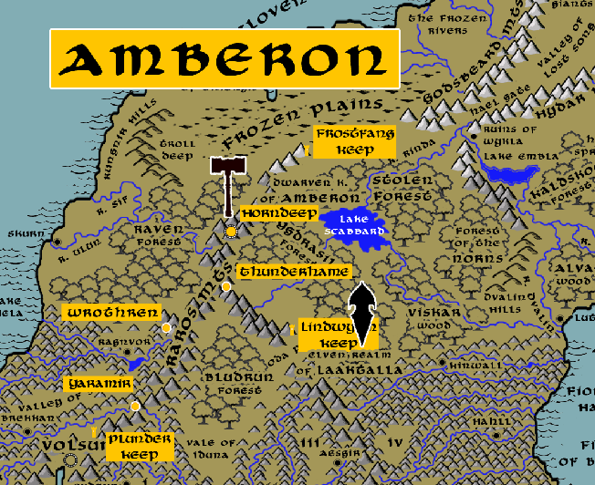

Location: Hydar Mountains, Continent of Norgarde

- Overview
- Towns and Cities
- History
- Notes on Culture
- Magical Items
- Developer Notes
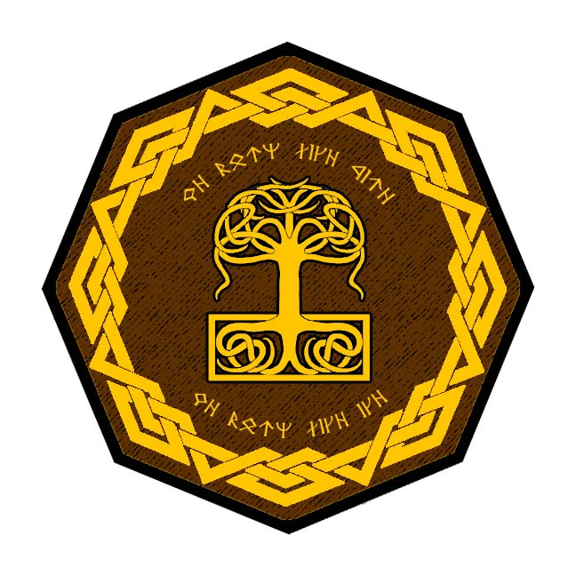
Overview
Far to the north, deep within the Raros Mountains on the continent of Norgarde, lies the glittering white court of Amberon. Frozen halls stretch for miles, upon their icy walls are chiseled masterful tableaus that never melt. Gardens grow in the warm tunnels of its towns, the air and ground warmed by thermal vents from below. Here dwell masters of the glaciers and ice sheets, able to divine their secrets as well as stone and earth.

The Kingdom of Amberon was founded in 630 PA2 by Krorher Thunderslag, the sixth son of Racknem the Chain Breaker but born a bastard. He was not part of Moradin’s widely-known commission for the sons of Racknem to go forth and establish new Dwarven strongholds. But unbeknownst to everyone, Moradin did indeed speak to Krorher in secret and so the Dwarf ventured off to Norgarde to find his destiny. To this day the Dwarves of Amberon resent the Kingdom of Demundra for the slighting of their founding father.

Amberon Dwarves make their home beneath the Raros Mountains in the center of Norgarde. Products of their environment, Dwarves here tend to have a bluish hue to their skin and hair and are incredibly resilient to cold. Their appearance has prompted a few unwise humans to ask of ties to the gray-skinned, white-haired Duergar. Such comments are sorely rebuffed. The Duergar are bitter enemies of Amberon. Many expeditions have been launched into the Hydar mountains far to the north, but the Duergar hold those mountains and have driven back the Amberon Dwarves time and again.

Vitlaga the white dragon is another bitter enemy of Amberon. Having settled in the region in the First Written Age, the Dwarves have lost many battles to her cunning tactics. Only a few hundred years ago they watched in horror as Vitlaga wiped out the humans in the Kallethem Vale to the west. It is now named Skull Valley and infested with Orcs and bloodthirsty humans out of Ragnvor. Amberon has sworn to fight both of these factions if the opportunity arises, but more cautious minds have kept them from an all-out war.

Amberon Dwarves are fond of fighting with pickaxes, which suit them well when working above-ground on the icy mountain-faces. Irsolas, Dwarven for 'Ice Tooth', was the name given to an exceptional pick-axe of legend, crafted with incredible power in the ancient times and used to fell the ice giant Norg in the Fourth Ancient Age. It is said the pick-axe reappears from time to time in the hands of a worthy Amberon dwarf if needed in a great battle.

- A close-knit community where hospitality is valued and where work and discussion are taken at a slow and purposeful pace.
- the best decorative metalsmiths in dwarvenkind ; work in precious metals as well as the best whitesmiths (tin and pewter); experts in creating delicate, masterful works of ornate jewelry and decorative metalworks
- appearance: bluish tint to their skin and hair, dark eyes, prominent noses
- common attire: snow-shoe boots, knit caps and mittens made from subterranean fibrous plants
- weapon of choice: pick axes and hand axes
- natural enemies: remorhaz, ice trolls, duergar, frost giants
- favored mounts: dire mountain goats
- highly resistant to cold, tend to be slow and measured in their work and speech
- custom – any act of kindness should be returned or it is considered an insult; Amberon dwarves can be exhausting with the level of hospitality they extend and the small gestures they make over outsiders; some jest that Amberon dwarves see all outsiders as children needing care
- common saying: “You never really know your friends from your enemies until the ice breaks.”
- Kingdom motto: “We burn like fire, we burn like ice”

Towns and Cities

- Amberon
  - Frostfang Keep – small town, population 2,000, guards / soldiers 20, militia 100
  - Horndeep – large city, population 25,000, guards / soldiers 250, militia 2250
  - Thunderhame – large town, population 5,000, guards / soldiers 50, militia 250
  - Wrothren – large town, population 5,000, guards / soldiers 50, militia 250
  - Lindwyrm Keep – small town, population 2,000, guards / soldiers 20, militia 100
  - Yaramir – large town, population 5,000, guards / soldiers 50, militia 250
  - Plunder Keep – small town, population 2,000, guards / soldiers 20, militia 100

Frostfang Keep
Size: small town, population 2,000, guards / soldiers 20, militia 100
Trade Goods:
Local Goods:
Standard:
Colors:
Ruler: Loldrin Hammerhood and his wife Lovrouna (f)

Home:
Steward: Stronmug Warbeard
Marshal: Namweamora Largetank (f)
House Priest: Olmeack Beastmaster
House Adviser (Scholar/Mage/etc): Brurhaere Giantbraids (f)
Captain of the Guard: Houtmat Hardgrip
Chief Warriors in Service:
Dorarhaes Forgebraid
Rubaeg Gravelback
Douldroid Broadthane

Local Powers:
Local Sites:

Description:

Industry:

Key Figures:

Local Lore:

History:
Site of a massive invasion by trolls from Troll Deep in the First Ancient Age (210 AA1).

Customs:

Horndeep
Size: large city, population 25,000, guards / soldiers 250, militia 2250
Trade Goods: mithril, platinum, gems, stone
Local Goods:
Standard:
Colors:
Ruler: Nrig Stonestave the White Peak

Home: Thrammotir Grumbleminer
Steward: Jodgraem Boneshield
Marshal: Yagnuk Bonechest
House Priest: Kurubena Blessedmantle (f)
House Adviser (Scholar/Mage/etc): Dhurba Benthorn (f)
Captain of the Guard: Vakumli Ingotbearer
Chief Warriors in Service:
Wesgran Mithrilsaver
Fikhurum Blazewielder
Duturlug Shalecrest

Local Powers:
Local Sites: Gold Leif’s Tavern

Description:

Industry:

Key Figures:

Local Lore:

History:

Customs:

Thunderhame
Size: large town, population 5,000, guards / soldiers 50, militia 250
Trade Goods:
Local Goods:
Standard:
Colors:
Ruler: Yotrumlin Bronzebranch and his wife Grudruline (b)

Home:
Steward: Umighuk Opaldigger
Marshal: Snarsunli Grayforge
House Priest: Ulmek Coalfoot
House Adviser (Scholar/Mage/etc): Toredorli Sapphireshield
Captain of the Guard: Dhodeag Leatherbringer
Chief Warriors in Service:
Thoznumli Chainpike
Sammoun Dragongut
Thitumri Bronzehorn

Local Powers:
Local Sites:

Description:

Industry:

Key Figures:

Local Lore:

History:

Customs:

Wrothren
Size: large town, population 5,000, guards / soldiers 50, militia 250
Trade Goods:
Local Goods:
Standard:
Colors:
Ruler: Godihulda Deephand (f) and her husband Kikhorli

Home:
Steward: Dhurgolin Alebrow
Marshal: Brourdurum Nobleborn
House Priest: Khessaebo Coalforge (f)
House Adviser (Scholar/Mage/etc): Grootmor Strongmail
Captain of the Guard: Glorigrig Forgebrew
Chief Warriors in Service:
Hotdrin Grayheart
Snadrin Leadbow
Strotgraegit Ashbender (f)

Local Powers:
Local Sites:

Description:

Industry:

Key Figures:

Local Lore:

History:

Customs:

Lindwyrm Keep
Size: small town, population 2,000, guards / soldiers 20, militia 100
Trade Goods:
Local Goods:
Standard:
Colors:
Ruler: Heddatin Trollblade and his wife Nolore (f)

Home:
Steward: Groodmerlum Bottleborn
Marshal: Glammeck Coinshoulder
House Priest: Skondil Merrygrog
House Adviser (Scholar/Mage/etc): Dalodrug Flatgranite
Captain of the Guard: Gimwaerika Hardforge (f)
Chief Warriors in Service:
Fotgroungrid Mudborn (f)
Hakharlum Blazinggranite
Varnaer Axegranite

Local Powers:
Local Sites:

Description:

Industry:

Key Figures:

Local Lore:

History:

Customs:

Yaramir
Size: large town, population 5,000, guards / soldiers 50, militia 250
Trade Goods:
Local Goods:
Standard:
Colors:
Ruler: Houssealine Warheart (f) and her husband Werit

Home:
Steward: Umidrerlum Heavycoat
Marshal: Glorirmirlun Marblemail
House Priest: Bhandrith Redpike
House Adviser (Scholar/Mage/etc): Grakgrulir Grayflayer
Captain of the Guard: Grouvrilda Cavebrand (f)
Chief Warriors in Service:
Bhargaem Boulderbelt
Eridgromli Giantgrog
Dengrabelynn Copperbraids (f)

Local Powers:
Local Sites:

Description:

Industry:

Key Figures:

Local Lore:

History:

Customs:

Plunder Keep
Size: small town, population 2,000, guards / soldiers 20, militia 100
Trade Goods:
Local Goods:
Standard:
Colors:
Ruler: Masseat Oakblade and his wife Thisabyrn (f)

Home:
Steward: Rakdrear Deepsunder
Marshal: Sazneth Smeltflayer
House Priest: Dazzarlig Bloodflayer
House Adviser (Scholar/Mage/etc): Sibrutrud Redbranch (f)
Captain of the Guard: Orimaegit Undershield (f)
Chief Warriors in Service:
Krafaerra Runestone (f)
Thrakdren Silverrock
Hunmouth Blazingforged

Local Powers:
Local Sites:

Description:

Industry:

Key Figures:

Local Lore:

History:

Customs:

History
First Primordial Age (PA1)

Second Primordial Age (PA2)
630 PA2 – Founding of the Kingdom of Amberon by Krorher Thunderslag, the sixth son of Racknem the Chain Breaker. Krorher was born a bastard and so was not part of Moradin’s widely-known commission for the sons of Racknem to go forth and establish new Dwarven strongholds. But unbeknownst to everyone, Moradin did indeed speak to Krorher in secret and so the Dwarf ventured off to Norgarde to find his destiny.

810 PA2 - 920 PA2 - Siege of Amberon by Norgarde armies under Jarl Dvalin

Third Primordial Age (PA3)
100 PA3 - Khekgrik Underlander leads a tribe of Dwarves from Amberon and heads east to begin a new colony; crosses under the sea into Agatren and then moves east to form the Dwarven Kingdom of Onyklesh in the Horn Mountains

Fourth primordial Age (PA4)
430 PA4 – the demon Luhzrug creates a cursed gem, the Ulfstone, to trick the Dwarves of Amberon into coveting it, but which drives anyone mad who possesses it for too long.

780 PA4 - Second Seige of Amberon: Chieftain Skardi of Hahll hears of the fortunes of Amberon and recruits an army to march on the Dwarves. The Ulfstone is stolen from a sealed crypt by some of Skardi’s soldiers, who go mad and plunge into a bottomless pit.

810 PA4 - Second Seige of Amberon ends when Orc tribes attack; Skardi and the Dwarven king join forces; Dwarves reward the Norgardesmen for their help and toast their bravery

First Ancient Age (AA1)
210 AA1 - Battle of Frostfang - an army of trolls invades Amberon and manage to ravage their way to Thunderhame before being driven out; the fabled Mortar of Moradin is stolen and never found

Second Ancient Age (AA2)
20-180 AA2 - (Amberon) The War of the Giants in Norgarde; giants from the Godsbeard, Hydar, and Raros Mountains wage war on Dwarves, humans, and Elves

70 AA2- Battle of the Godsbeard - Dwarves of Amberon, joined by Norgardian and elven warriors, fight the giant chieftain Krong's forces and barely survive an attempted takeover of Norgarde by the giants

Third Ancient Age (AA3)
350 AA3 – The witch Calder Serphent summons a giant water elemental to travel upriver into the Raros Mountains, invading Amberon and rupturing its halls as the water freezes. The kingdom’s fire mage Torpha Blacktooth defeats the water elemental by wielding the Gauntlets of Magma to melt the ice and vaporize the creature.

Fourth Ancient Age (AA4)
620 AA4 - the ice giant Norg is slain in Norgarde by Uldraen wielding the magic pick axe Irsolas

First Written Age (WA1)
610 WA1 - War of the Sea Serpents WA1 - Starn Scalethunder, Dwarven champion of Amberon, leads a crack squad of warriors to join the humans in fighting the Sea Serpents

810 WA1 - Amberon battles Vitlaga the White Dragon, but fail to slay her

Second Written Age (WA2)

Third Written Age (WA3)

Fourth Written Age (WA4)
405 WA4 - Gunnar Sverker, king in Skala, aids the dwarves of Amberon in defeating an army of trolls ; Dwarves gift Gunnar with the Ulfstone. Gunnar Sverker later goes mad, leads expedition into the wild northern sea and disappears along with the Ulfstone

Local Goods

Notes on Culture
Amberon Dwarves are slow and methodical compared to Dwarves in the lower kingdoms. Some say the cold has gotten into their blood, but Amberon Dwarves will argue that anything worth doing is worth taking one’s time doing it. Dwarves here tend to wear elaborately decorated mittens and caps featuring intricate geometric designs. The items are knitted from a subterranean plant the Dwarves call Rezam Root, which grows dense, fibrous tendrils along from the ceilings of the caverns and is harvested and spun into thread much like the humans do with sheep.

Amberon dwarves are bitter enemies to ice trolls and remorhaz, both of whom they feel a severe disgust for.

Magical Items
Irsolas, Dwarven for 'Ice Tooth', was the name given to an exceptional pick-axe of legend, crafted with incredible power in the ancient times and used to fell the ice giant Norg in the Fourth Ancient Age. It is said the pick-axe reappears from time to time in the hands of a worthy Amberon dwarf if needed in a great battle.

Ulfstone – a large amber gem that was cursed by the demon Luhzrug to trick the Dwarves of Amberon into coveting it, but which drove anyone mad who held it for too long. It was lost for ages, then unwittingly gifted to the Gunnar Sverker, a human chieftain who aided Amberon against a troll army. Gunnar went mad, leading expedition into the wild northern sea and disappearing. The current location of the Ulfstone is a mystery and its return to Amberon is feared to be inevitable.

Mortar of Moradin – a sacred mortar that, when used to crush soil from the deepest reaches of the Raros Mountains, creates a tonic that empowers paladins of Moradin to conquer any foe. The item was lost in the Battle of Frostfang in the First Ancient Age.

Gauntlets of Magma – enchanted gauntlets that can only be wielded by a fire elementalist and which can create enormous heat energy at great risk to the wielder. Used by Torpha Blacktooth against a water elemental in the Third Ancient Age when it threatened to crack the halls of Amberon.

Developer Notes

Rezam Root is based on Rhezomes, subterranean root systems

Names: Dwarven names from www.fantasynamegenerators.com

