Notes on the lands of Hyderis
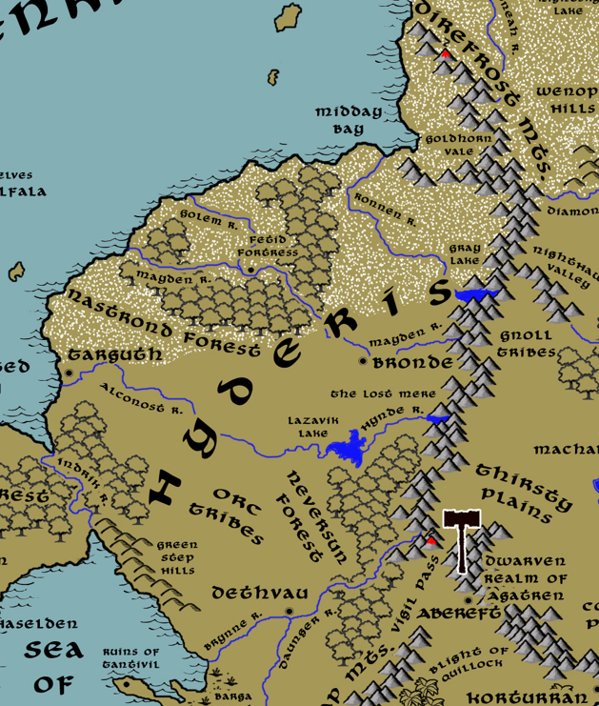
Table of Contents
- Overview
- Towns and Cities
- Best in the Land
- Stewards of Power in this Land
- Points of Interest
- History
- Local Goods
- Notes on Culture
- Weapons and Armor
- Local Deities
- Creatures
- Other Races
- Magical Items
- NPC Templates
- Developer Notes
Overview
The lands of Central Amadar are vast stretches of treacherous wilderness, chaotic lands ruled over by savages and humanoid tribes. Ruins of ancient civilizations dot the landscape: towers, keeps, and roads crumble and are forgotten. To the north lies Hyderis, a land of barbarian horsemen who rule the plains. Descending from the Dvar peoples, they hold to some of the old customs but have made their own culture. Over the wide-open plains, they travel on horse, moving their nomadic camps. Nowhere else in the world have orcs met humans they consider their match in brutality and fearlessness. For this reason, Hyderian mercenaries are often hired by the lords of the west when dirty work is to be done.

The Kingdom of Hyderis in its current form was established when the warlord Besarion conquered the rival tribes in the Battle of Bones and Blood in 330 WA2.

Peoples of Hyderis
Hyderis is made up of three regional peoples that have risen during the Written Ages.
Tvararik – The Tvariks dwell in the region governed by Targuth. The Tvarik lands extend from the southern edge of the Nastrond Forest in the north down to the northern edge of the Daghorn Forest in the south, and from the coastline overlooking Haunted bay in the west to two hundred miles inland overlooking the plains to the east.
Zharov – The Zharovs dwell in the region governed by Bronde. The Zharov lands extend from the snowline north of the Mayden River in the north down to the Hynde River and Lazavik Lake in the south, and from the DireFrost Mountains in the east to two hundred miles westward overlooking the plains in the west.
Sablyar – The Sablyars dwell in the region governed by Dethvau. The Sablyar lands extend from a hundred miles beyond the Brynne River in the north down to bend in the Daunger River in the south, and from the edge of the Sea of Oberon and the Green Step Hills in the west to the western edge of the Neversun Forest in the east.

Towns and Cities
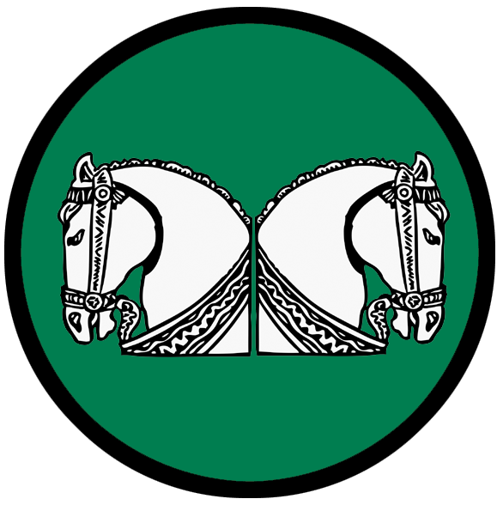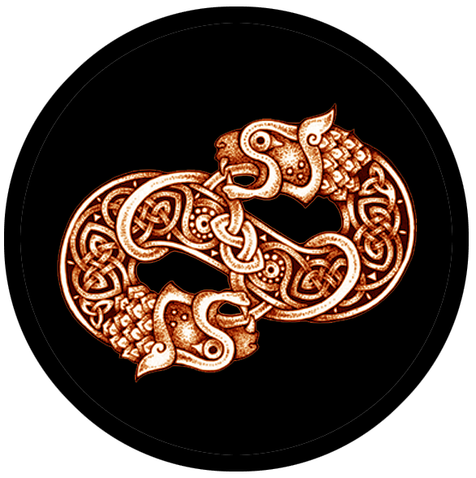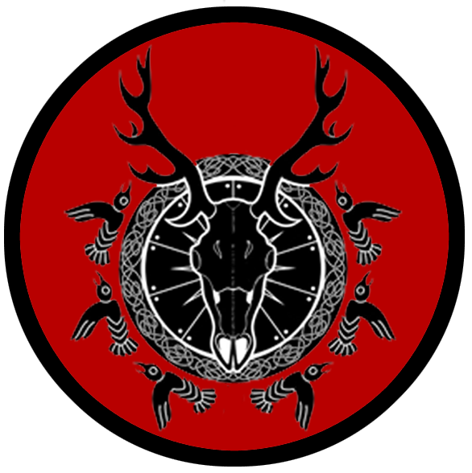
- Kingdom of Hyderis
  - Targuth – large town, sign of the twin horses
  - Bronde – large town, sign of the banded twin dragon
  - Dethvau - small city, sign of the stag skull and birds

Best in the Land
Trade Hub: Targuth
Religion:
Arts:
Magic:
Spirits: Dethvau
Steel: Bronde
Grain:
Crafted Goods (e.g. Pottery, Textiles, Metal Wares):
Harvested Goods (e.g. Aromatics, Medicine, Dyes):
Mined Goods: Bronde (Iron)
Precious Metals: Bronde (copper, silver), Dethvau (silver)
Ship Building:
Furs: Targuth, Dethvau
Wool: Targuth, Dethvau
Clay: Dethvau
Other:

Stewards of Power in this Land
Kings and their armies are not the only wielders of power. There are many unseen friends and foes that shape the destiny of the land. Each of the groups listed below are well known to the people of this region. Some are feared, others venerated. All of them play their part in the grand drama of this land’s story.

Merchant Companies
Bander Bright Traders – Targuth

Mercenary Companies
(none)

Smuggling Rings
The Troika – Dethvau

Centers of Worship (Churches, Cathedrals, Shrines, Lodges, Temples)
(none)

Orders of Paladins
Order of the Bogatyr – Dethvau

Druidic Circles
Circle of the Striding Stag - Bronde
Circle of the Sunset Gate - Dethvau

Bands of Rangers
Band of the Goshawk – Dethvau

Schools of Magic
(none)

Bardic Colleges
(none)

Warrior Academies
The Druzhina – Bronde

Assassins Guilds
(none)

Cults
(none)

Other Guilds
(none)

Monasteries
Hov of the Wisdom Helm - the mouth of the Mayden River overlooking the Sea of Fenris
Hov of the Phantom Queen - Direfrost Mountains at the head of the Hynde River
Pirates

Points of Interest
- Midday Bay
- Cliffs of Gondira -

- Nastrond Forest – The forest was once settled by Elves, but the settlement was wiped out in the Fourth Ancient Age. It was once ruled by the fallen druid, Bozhura, who It is now the domain of the evil wizard Arsalion, who breeds and commands a menagerie of dark abominations that terrorize these woods and the lands around it.
  - The Fetid Fortress is a crumbling stone castle that stands beside the Mayden River and is the lair of the wizard Arsalion. It is rumored to contain a host of undead Elven warriors and is protected by a swarm of skrzaks. Arsalion is said to control the Scoparia, a magical plant that is intelligent and resembles a scrub brush native to the Hyderian plains. The Scoparia generates offspring that roll as tumbleweeds across the plains, serving as spies for the Scoparia and in turn Arsalion himself.
  - Here dwell the tribe of ice goblins known as the Gruggs, who serve Arsalion when he summons them. They mark their territory with the sign of the mistletoe leaf.
- Neversun Forest - The forest was once settled by Elves, but the settlement was wiped out in the Fourth Ancient Age. In the Primordial Ages it was the haunt of the witch Zorana who rallied an army of goblins to conquer the plains around the Brynne River. Her ancient lair remains, buried under centuries of brush and its location a mystery. But its evil can still be felt in the forest.

- Golem River
- Indrik River
- Ronnen River - Giant wooly mammoths roam the ice covered plains in large herds along the icy coast west of the Direfrost Mountains. While normally docile creatures, they have developed a ferocity in the face of being hunted by humans. War chiefs of Targuth ride as heavy mounts in open battle. But none dare tame Thrahnga. She, the ancient magical guardian of her kind, has lived for time eternal. Twice the size of her kin, she rules over her the herds and protects them. She is a chaotic neutral beast who can communicate in the old tongue. It is said she holds power over the very land and indeed over the weak minded. Her power is untested but even the greatest warlords dare not hunt her.
- Mayden River – the mouth of the river is the site of the Monastery of the Wisdom Helm, where monks study and train in the ways of Kvasir, god of wisdom
- Alconost River –
  - Astride the river, overlooking the wide plains stretching in every direction, stands the keep of Uldrik of the Coffin Bone, Arch Mage of the Hyderian lands.
- Hynde River – at the head of the river is the site of the Monastery of the Phantom Queen, where monks study and train in the ways of Morrigan, the goddess of battle and slaughter
- Valnava River
- Brynne River
- Daunger River

- Gray Lake – once the haunt of the mad crone Bogdana, who aided the Dvaran heroine Radina and her band slay Radovan and destroy the Curse Mantle with the Vial of the Gray Unguent taken from the Gray Lake
- Lazavik Lake – realm of the Vodnik, a race of frog-like creatures who terrorize fishermen and farms near the water. The Vodnik travel up and down the Alconost and Hynde Rivers, floating on logs and watching the passing of humans unless disturbed.
- The Lost Mere

- Direfrost Mts.
  - the white dragon Aukstuma dwells in the northern reaches of the Direfrost Mountains where they overlook the northern sea
  - the gold dragon Gudraiseth dwells in the middle section of the Direfrost Mountains overlooking the mouth of the Hynde River
  - Here dwell the clan of the frost giants some call the Zugvrach.
  - Here dwells the tribe of Heemra, kobolds who command a mountain tunnel system that spans for hundreds of miles. They are known by their sign, two horizonal lines with three circles between them. Like most kobold sigils, this one is a mystery and carries some meaning only they understand.

- The Green Steps Hills

- Goldhorn Vale – a magical valley that is protected by the legendary white chamois bucks that bear horns of gold. The mountain slopes here are decorated in blood-red Triglav flowers. Any who enter the vale are questioned by one or more of the goldenhorn. If evil is found in their heart, the intruders are struck with the horns and their memory of the place removed. Those who petition the goldenhorn for refuge and are of noble heart are invited to take their rest here. Few have ever seen the valley and those who have find it difficult to recall its location.

- Orc Tribes - The plains east of the Green Steps Hills are dominated by three tribes that Dethvau have marked as enemies: the Hudra, known by their sign of the broken horseshoe; the Marrohunt, known by their sign of the claw with five talons; and the Goghuru, known by their sign of the downward flowing roots forming a skull. In the last decade all three tribes have come under the thrall of one Orc warlord: Ogrizek the Shieldless.
- Realm of Ezrigor – Nestled in a crook of the Direfrost Mountains is the secluded Vale of Ezrigor, where once dwelled a mighty warlord of Hyderis by the same name. Such was Duke Codrin Ezrigor’s wealth and power that he carved out his own realm east of the Lazavik Lake and bordered by the Hynde River. There he ruled absolute, for no king or noble dared question Ezrigor’s might. But years dragged on for far many more years than any normal man may abide. Ezrigor ruled still from his castle, even riding forth when called in times of warfare (more for the sport of slaughter than for any oaths he held with the throne). Stories began in taverns that Ezrigor fell into darkness, dabbling in magic to extend his life. Some say he became a vampire lord with a host of minions that haunt the land. What godforsaken world enshrouds the lives of the many villages in that realm, none dare imagine. No one crosses into the land and returns. The few who claim to have been there are frightful souls, their hair blanched white, their speech a senseless rambling of recounted horrors.

Targuth
Size: large town
Trade Goods: trade hub, wool, furs
Local Goods:
Standard: sign of the twin horses
Colors: green and white
Patron Deity: Belobog – the white god, giver of fortune
Ruler: Knyaz Lolke Kootstra and his wife Knyaginya Sibrecht Kootstra (f)

Home: Brindle Keep
Steward: Eibert Ypma
Marshal: Heitse Kuiken
House Priest: Iemke Bakker
House Adviser (Scholar/Mage/etc): Olle Terpstra
Captain of the Guard: Garmun DeBoer
Chief Warriors in Service:
Hearke Elkinga
Hotsje Deinum
Siltsje Vanderveer

Local Powers: Bander Bright Traders, Black Zilant (thieves guild)
Local Sites: The Yeoman Inn & Tavern, The Batten Boar Inn & Tavern

Description:
Tall towers bristle atop the high cliffs overlooking Haunted Bay. At their center rises a tall statue of twin horses, facing outward. The great Hynde River rolls by just outside the city and plummets to the bay as a roaring water fall. The mist coming off the falls blankets Haunted Bay in mists, adding to its name.

Much of the town is built into the side of the cliffs. Wide stone stairs lead down from one landing to another, ending at the base where it opens to a sprawling marina. Along the way narrow walkways run for a quarter mile in either direction across the cliff face. Doorways lead into the interior of the rock, opening to workshops, taverns, and great merchant halls. Inside there seems to be a persistent whistling noise and the smell of salt air as the sea winds buffet the town’s exterior.

The palace and fortifications are located at the cliff’s top. Brindle Keep sits atop the highest point, with gradually descending terraces each ringed with low stone walls. A stable of the world’s finest breeds of horses is housed along the upper terraces. Sheep herds graze on the lowest terraces and just inside the tall outer wall.

Targuth is located in the lands of Tvarik, which extend from the southern edge of the Nastrond Forest in the north down to the northern edge of the Daghorn Forest in the south, and from the coastline overlooking Haunted Bay in the west to two hundred miles inland overlooking the plains to the east. The Tvariks have their own unique customs and cultural identity, but hold fealty to the Hyderian banner.

Targuth is the oldest fixed settlement of the Hyderians, dating back to the original camp made by the Dvars in 871 AA2.

Industry:
The Bander Bright Trading Company maintains full control of the marina and all boats that sail into it. The Targuth trade hub serves as the hand-off point for ships coming east from the Svarda Route and those coming west from the Fenris Crossing. A great deal of the trade goods coming out of Norgarde pass this way, as well as items in high demand by Norgardians from markets abroad. Bander Bright holds an advantage over other merchants in being able to negotiate with Norgardsmen more easily due to shared cultural ties between the peoples.

Targuth employs a sizeable host of horsemen to help carry goods back and forth across the Hyderian plains to Bronde and Dethvau.

Key Figures:
Knyaz (Lord) Lolke Kootstra – distant, absent-minded, mysterious, possessed

Lord Kootstra is a short, heavy-set man with thinning dark hair, bulging blue eyes, and fat, round cheeks bedecked with a bushy beard. He dresses in the richest velvet high-collared tunics decorated with gold thread. On his head sits a cloth cap embroidered with the sign of the twin horses. About his neck hangs a bright green emerald pendant which he never takes off. Lolke is an even-tempered man, intelligent and specific in his instructions to his staff on the management of the city and of the docks. But in truth he is ensorcelled by the power of the emerald pendant, which is in turn controlled by the court mage Olle Terpstra. Since coming under the pendant’s spell, Lolke has been methodically dispatching ships to remote locations along the Noreast Jaunt to retrieve mysterious boxes hidden in caves along the coastline.

Knyaginya (Lady) Sibrecht Kootstra (f) – witty, playful, musical, clever

Lady Kootstra is a full-bodied woman with bright blue eyes and a mane of golden brown hair she wears in elaborate braids. She dresses in the finest high-collar tunics in the Hyderian fashion but cut in rich fabrics and decorated in intricate needlework. She is a very charismatic and engaging woman, happy to tend to the affairs of the manse and entertain visitors. She also wears an enchanted pendant that binds her to the will of Terpstra, the court mage. Since coming under the pendant’s spell she has busied herself with spreading gossip among the wealthy merchants and other visitors to the town.

Olle Terpstra – court mage and advisor – shifty, nervous, stammering

Terpstra is a small man with thin, dark hair that hangs loosely and in an unkempt fashion. He has narrow hands which he wrings together constantly. He dresses in somber black robes stained from a thousand mysterious solutions. Atop his head is a cloth cap embroidered with the twin horses of the town, but the cap is always in danger of sliding off. Terpstra long ago entered a pact with the infernal arch-demon Howzilith who has bent him to doing his bidding in the Hyderian lands. Howzilith gave Terpstra the Mindless Garland, a necklace of enchanted emeralds. The chief and largest emerald is capable of commanding the minds of any who wear the lesser gems. Terpstra wears the chief gem under his garments and is methodically placing them on key figures in Targuth, starting with Lord and Lady Kootstra.

Local Lore:
Giant wooly mammoths roam the ice-covered plains in large herds along the icy coast west of the Direfrost Mountains. While normally docile creatures, they have developed a ferocity in the face of being hunted by humans. War chiefs of Targuth ride mammoths as heavy mounts in open battle. But none dare tame Thrahnga. She, the ancient magical guardian of her kind, has lived for time eternal. Twice the size of her kin, she rules over her the herds and protects them. She is a chaotic neutral beast who can communicate in the old tongue. It is said she holds power over the very land and indeed over the weak minded. Her power is untested but even the greatest warlords dare not hunt her.

History:
Three thousand years ago (520 WA1) the Celedonian Crantor Legion crushed the last of the tribes of the Dvars and established a garrison at Targuth. This base would operate to control the Sea of Fenris and the region of present-day Hyderis, but was never able to overwhelm the Norgarde ships that operated out of the fiords to the west.

Customs:
Targuth pays homage to Dethvau, seat of power among the Hyderians. As majestic and well-engineered as the town is, the history and culture of Hyderis favor the plains. The town is caught between two worlds: their past traditions of boat building and travelling by sea, and their more recent culture of riding the plains as great horsemen. Some say they have traded the blue sea for a green one.

Belts are a point of superstition to them – all Hyderians wear specially-crafted belts that they feel ward off evil and ill fortune.

Bronde
Size: large town
Trade Goods: steel, iron, copper, silver
Local Goods:
Standard: sign of the banded twin dragons
Colors: black and copper
Patron Deity: Azov - The Mistress of the Copper Mountain
Ruler: Knyaginya Anneke Bazhaeva (f)

Home: Blackwater Keep
Steward: Jannes Snijder
Marshal: Wiardus Feitsma
House Priest: Deimus Swart
House Adviser (Scholar/Mage/etc): Sintsje Glas (f)
Captain of the Guard: Harrent Hof
Chief Warriors in Service:
Bane Steenstra
Afke Douma (f)
Rienik Haarsman

Local Powers: Abandoned Apprentices (thieves guild), Circle of the Striding Stag (order of druids)
Local Sites: The Fiery Arrow Inn & Tavern, The Footbolt Inn & Tavern, Marmeladova’s (brothel), The Druzhina (warrior school and forge)

Description:

Bronde began as a stop-over for the Dvarin nomads crossing the Mayden River in summer. The early Dvars erected a stout wooden bridge over the river employing boat-building techniques learned from the Norgardians. The interlinked rafts served as a bridge for crossing horses for years until large poles could be dropped into the river and a permanent bridge erected. Today the town straddles the river, with the original bridge at the center.

Hyderian nomads still flock to Bronde in the summer. Today the camp has grown to have perimeter walls for protection and cultivated hay fields for grazing horses. People here are thin on conversation, settled to a life of hard work and always watchful for the threats all around them.

Bronde is located in the lands of Zharov, which extend from the snowline north of the Mayden River in the north down to the Hynde River and Lazavik Lake in the south, and from the DireFrost Mountains in the east to two hundred miles westward overlooking the plains in the west. The Zharovs have their own unique customs and cultural identity, but hold fealty to the Hyderian banner.

Industry:
Bronde is a town of plains people and horse lords, but its livelihood comes from the mountains. Copper, iron, and silver are mined upriver in the Direfrost Mountains and transported here by river barge. Hyderians are keen smiths by tradition. Copper and silver are worked into elaborately designed jewelry in an old Dvaran decorative style. The smithing of steel is of particular pride. Since the Pact of Kalaraak in the Fourth Ancient Age the smiths of Bronde have adopted skills from the Dwarves and perfected the forging of fine weapons and light armor. Arrow heads of Bronde are created in a wide array of deadly and effective styles that archers speak of in other lands.

The Druzhina are a fellowship of weapons smiths and veteran warriors who train Hyderians in the way of the light axe, short sword, and firing the bow from horseback. The rulers of Targuth and Dethvau send young men and women to Bronde to earn the mark of the Druzhina: the brand of the Sagaris axe. In times of dire need on the plains it is the Druzhina who are summoned to form the tip of the spear in battle.

Key Figures:
Knyaginya (Lady) Anneke Bazhaeva (f) – noble minded, touched by destiny, worried, protective, solemn

Lady Bazhaeva is a tall, thin woman with an angular face, a noble chin, and thin lips that are pursed in concern. Her curly, dark-blonde hair is worn up, exposing a slender neck. She wears her woolen tunic dresses in shade of blue embroidered in triglav flowers.

Anneke was once a pleasant and carefree wife to the lord of Bronde. Eight years ago he passed and rumors spread it was owing to his wife’s family curse. Anneke’s ancient ancestor was Bajarnen, legendary ranger of the Dvaran people. Thousands of years ago Bajarnen pledged his bloodline would always protect the land. He was blessed by the noble goldenhorn and his line was named the Vonsveta or Warriors of Light. But trouble has always sought out the children of Bajarnen. Every tenth generation a dark power rises up and the Vonsveta are tasked to defeat it. For Anneke it is the demon Poludnitsa, known to commoners as Lady Midday. Every summer Anneke rides out to defeat the demon and every year Lady Midday grows stronger. Prophecy foretells that one day their battle will be the end of them both.

Local Lore:
The plains surrounding Bronde are flat and featureless. To the distant north lies the frost line where frost worms roam in search of prey. Downriver lies the Nastrond Forest where dwell goblins. And to the east are the Direfrost Mountains where the Heemra tribe of kobolds lurk and the Zugvrach frost giants rule. The region has molded the people of Bronde and their faithful horses into hardy survivors.

It is said that beneath the cathedral is buried the lost Harvester Blossom, a cursed flower that resembles an extremely large tulip bulb the size of a full-grown man. It has an unsettling purplish color to it and emanates an aura of evil. It was once a beautiful life-giving flower grown from one of Azov’s magical garden seeds, but it was corrupted after capturing the Hollow Host of demon riders in the Primordial Ages. It is said to hunger for souls, good or evil, having acquired a taste for them.

History:
The region around Bronde is where the original Dvaran people originated. Since the Hyderian people came to power in the Written Ages the throne was raised in Dethvau. This causes no real tension between the lands, for the Dvars are long gone. But Bronde and its surrounding villages still have a unique culture tied to the Dvaran traditions particularly the food, customs, and attire.

200 AA4 - Dwarves of Agatren attack Bronde over a captured druid named Lithia (f) they suspect is a spy; Orc chieftain Gravik invades Kalaraak as Lithia tried to warn them

201 AA4 - heroes from Bronde infiltrate Kalaraak to rescue Lithia, stumble onto Gravik's warriors and unleash magic to drive them out of Kalaraak

202 AA4 - Pact of Kalaraak: Dwarves of Agatren apologize to the humans of Bronde; grant them mining rights in the Direfrost Mts and train them in steel smithing

Customs:
Belts are a point of superstition to them – all Hyderians wear specially-crafted belts that they feel ward off evil and ill fortune.

Dethvau
Size: small city
Trade Goods: wool, clay, furs, silver, spirits
Local Goods: karshkaya spirit
Standard: sign of the stag skull and birds
Colors: red and black
Patron Deity: Chernobog - the black god, giver of misfortune
Ruler: Knyaz Staerik Godina and his wife Knyaginya Dobrila Godina (f)

Home: Castle Karmagek
Steward: Sekle Visser
Marshal: Tebbe Poelstra
House Priest: Hiske Cuperus
House Adviser (Scholar/Mage/etc): Koneva (f) of the Darkened Soil
Captain of the Guard: Pypken De Graaf
Chief Warriors in Service:
Pyns Dijkstra
Ryt Nijholt
Ljomme Roos

Local Powers: Haunting Hosts (thieves guild), The Troika (smuggling ring). Order of the Bogatyr (order of paladins), Circle of the Sunset Gate (order of druids), Band of the Goshawk (order of rangers)
Local Sites: The Rusty Pike Inn & Tavern, The Wolftrap Inn & Tavern, Karshkaya House Distillery

Description:
Dethvau sits atop a rocky plateau astride the Brynne River just where the River Daunger breaks off to the south. The city sits high above the plain floor, its thick walls ringing the plateau. A long narrow road snakes around the face of the rock allowing passage one horse at a time under the cover of countless murder holes and arrow slits. The climb is steep. Markings on the outside of the walls testify to countless orcs slain trying to take the city over the ages.

Castle Karmagek and its fortifications are built to withstand a siege without end. Cisterns are built into the rock where water is stored from rainfall. Wooden booms are built into the city walls that can rotate out over the two rivers and draw up water or even set down small boats. Where the rivers run underground, a well has been dug to access the ground water. Crops grow in abundance along the top of the plateau, as crank-operated pumps draw up the water from the well and cisterns.

Dethvau is located in the lands of Sablyar, which extend from a hundred miles beyond the Brynne River in the north down to bend in the Daunger River in the south, and from the edge of the Sea of Oberon and the Green Step Hills in the west to the western edge of the Neversun Forest in the east. The Sablyars have their own unique customs and cultural identity, but hold fealty to the Hyderian banner.

Industry:

Dethvau is a poor city that sustains itself in the midst of the wild plains. Flocks of sheep are tended on the northern banks of the Brynne River, then brought up to pens within the city walls. Trappers work upriver near Neversun Forest to harvest pelts while workers downriver collect clay from the region where the two rivers diverge. Silver was once mined extensively in the Direfrost Mountains and transported by boat, but the Neversun Forest has grown too dangerous and that supply has dwindled. Once a month an armed caravan travels north to Targuth to trade goods and return with much-needed supplies.

Hyderians distill potatoes into a vile, potent spirit called Karshkaya. It is a clear liquid that is highly flammable and an acquired taste, but Hyderians consider it the only spirit worth imbibing. Crates of it make their way out of the Targuth port where they find a market abroad as an exotic drink.

Key Figures:
Knyaz (Lord) Staerik Godina – blustering, foolhardy, warmongering

Lord Godina is a heavily built man with large hands, a long dark beard, and dark hair cropped short. His large blue eyes stare suspiciously over his even larger nose. He is a restless man, eager to take the battle to his city’s foes wherever they may be. He sees himself as a conqueror of old and obligated to dominate these lands as in the days when the orc tribes feared the death riders. He has ventured to the Dwarven kingdom of Agatren and sued them for an alliance to wage war on the orcs of the plains. But the Dwarves see him as an unstable man and lacking honor. At his side Staerik carries the legendary light axe Soul Reaver, an axe in the sagaris style known to this region and which was first carried by Surdan the conqueror who founded Dethvau 80 AA3.

Knyaginya (Lady) Dobrila Godina (f) – calculating, cold, vengeful, curious

Lady Godina is a tall, lean woman of fair skin and blonde hair with dark menacing eyes and a cruel smile. She dresses in a bright red velvet svita, the traditional Hyderian outer garment, stitched in gold. In her hands are often stems of roses, for she is an avid gardener. Dobrila is a quiet figure, saying little but doing so in menacing tones. The people fear her, as does her husband. She was taken as a child from her tribe and married at a young age. She does not forget the cruelty of the nobles towards the nomadic tribes. She has researched the legacy of the witch Zorana, who famously conquered this region in the First Primordial Age long ago. Dobrila has spies scouring the Neversun Forest for Zorana’s ancient lair and the secrets to her power. Her rose garden she keeps private, for she was gifted seeds reputed to come from Zorana’s magic coffers. She has enlisted Koneva, the court mage, to instruct her in the ways of magic and looks to breed her roses with powers over men.

Local Lore:
Orc attacks are constant as these lands are over run with them. There is a long-standing tradition of war between the humans and orcs here. Both sides respect the strength of the other but their hatred burns fierce. The plains east of the Green Steps Hills are dominated by three tribes that Dethvau have marked as enemies: the Hudra, known by their sign of the broken horseshoe; the Marrohunt, known by their sign of the claw with five talons; and the Goghuru, known by their sign of the downward flowing roots forming a skull. In the last decade all three tribes have come under the thrall of one Orc warlord: Ogrizek the Shieldless. Spies have revealed that Ogrizek seeks Dethvau as his prize and has launched scouts deep beneath the ground to find a way to burrow into the city. In response, rangers from the Band of the Goshawk have recruited the aide of Dwarves in exploring the subterranean depths to thwart orc invaders.

Perytons are known to hunt around the Neversun Forest region. Hyderian riders are always on the lookout from these terrors of the sky, known to scoop up horse and rider as their prey. Tales tell of heroes venturing into the Neversun Forest to battle these creatures but few can be recalled who overcame them. Every Hyderian secretly fears their heart feeding one the beasts.

Rusalka, the water spirits of drowned maidens, are said to lurk along the banks of the Brynne and Daunger Rivers.

History:
It was built a thousand years ago by the Hyderian war lord Surdan who was warned not to settle in the lands near the Orc tribal plain. Surdan had grown tired of hearing the tales of Orc savagery and angrily turned on his counselors. “Are these beasts more ferocious than the Hyderian? I will sleep a full moon on their plains. Let them come.”

A month later Surdan’s horse brothers ventured out to see how their lord had fared. To their surprise they found him reclining on the plateau overlooking the rivers, a shank of Orc flesh roasting on a spit. All around the plateau had been heaped a hundred or more dead Orcs. Shortly after that the tribe moved to the plateau and began building a settlement (80 AA3).

Customs:
Hyderians are a proud people. They count courage and toughness above all else. One tradition of Dethvau is to do the Lone Ride. At a coming-of-age ceremony the youth are sent out on horseback to retrieve the head of an orc. Belts are a point of superstition to them – all Hyderians wear specially-crafted belts that they feel ward off evil and ill fortune.

History of Hyderis
Most recent rulers
- 273-472 WA3 – Norgardian occupation: after taking Targuth and Bronde, Norgarde warlord Øysten Hallkels declares himself Jarl over Hyderian lands and rules the north from Targuth
- 472-596 WA3 - Husak line of rulers begins; Bohdan of the clan Husak is crowned Korol (king) of Hyderis after defeating the Norgardian armies in the Battle of Broken Axes and drives them out of Hyderis
- 596-598 WA3 - brief reign of Yurij the Defiler, who entrances the people into following his cult and murders the royal family
- 598-612 WA3 – Civil War as chieftains rally to overthrow the tyrannical Yurij the Defiler
- 612-802 WA3 - Tokar line of rulers begins; Borys Tokar, paladin of Targuth, defeats Yurij the Defiler’s dark magic and slays him with the Sword of Kalinov, a blade foretold to only be wielded by kings
- 802 WA3 - 79 WA4 –War of the Three Koroleva: civil war between Koroleva (queen) Halyna Zhuk of Dethvau, Koroleva Tayisiya Holovko of Targuth, and Koroleva Lina Moroz of Bronde
- 79-209 WA4 - Velychko line of rulers begins; Anzhela, grand-daughter of Lina, retrieves the Sword of Kalinov and crushes the three factions dividing Hyderis; Anzhela is crowned the one true Koroleva of Hyderis
- 209-340 WA4 - Chernysh line of rulers begins; Oksana Chernysh assumes the throne after enticing Yakymchuk Velychko to confront the orc hordes near the Green Step Hills, resulting in his death; Oksana banishes the Sword of Kalinov to the bottom of the Oberon Sea and reigns the land for over a century with her dark powers
- 345-today Bodnar line of rulers; Petro Bodnar, a simple farm boy, is called by Azov to seek the Sword of Kalinov; after many adventures the boy retrieves the sword from the water spirit Orysya, ruler of the Oberon Sea; Petro slays the witch Oksana and is crowned Korol of Hyderis

First Primordial Age (PA1)
Dawn of the Dvars

640 PA1 - Radovan, war chief of the Dvars, slays the demon Vehren, steals the Curse Mantle, and begins a reign of darkness over the plains

672 PA1 - the slave Radina escapes Radovan's sacrificial camps and leads a revolt of the Dvars

678 PA1 - Radina and her band of heroes slay Radovan and destroy the Curse Mantle with the Vial of the Gray Unguent taken from the Gray Lake by the Mad Crone Bogdana

681 PA1 - Radina is crowned the first queen of the Dvars and rules with the power of the Bright Helm

Second Primordial Age (PA2)

440 PA2 - the witch Zorana forges the Staff of Despair and incites a goblin army to take over the region around the Brynne River

466 PA2 - Zorana's armie of goblins are swallowed up by the Barga Marsh; Zorana flees to the forests in the east

472 PA2 - Zorana opens a portal to the Abyss which blights the forest, veiling it in darkness; the land is dubbed Neversun Forest

Third Primordial Age (PA3)
170 PA3- War of the Plains - Krenn tribes expand to the north and encounter the nomadic riders of the Hyderian plains; war breaks out that lasts two hundred years with massive losses on both sides

380 PA3 - Hyderian nomads drive out the last of the Krenn armies and secure the lands north of the Brynne River

410 PA3 - explorers from Norgarde first land on the northern coastline of central Amadar; within a century fishing villages appear and the start of Hyderian culture to settle this land

Fourth primordial Age (PA4)

872-888 PA4 - The Wizard War: Telemechus triggers a world-wide war of mages, some of whom march on Ongolk to stop him and some who join him in attacking the ley lines in their lands; epic battles wage all over the world, destroying cities and upsetting the balance of magic

888 PA4 - The Battle of Forlorn: Telemechus is slain but not before rupturing the magical ley lines permeating Nemmyrl; the victorious general Dragan of Celedon seizes the opportunity to rid the world of magic and ruptures the Singularion as it is embedded in the ley lines; the resulting explosion sends a shock wave that ruptures the magical ley lines around the world and triggers the Dead Century

First Ancient Age (AA1)
0-100 AA1 - The Dead Century: the Wizard War results in all magic suffering a terrible blow, all artifacts not protected in special shrines are rendered inert, magical creatures who do not seek shelter in other planes die a horrible death

101 AA1 - The Union of the Great Circle: Druids all over the world receive a vision calling them to chant in unison to heal the world; armies of man mobilize to exterminate the druids to maintain power

102 AA1 - after a full year of heroes rising up to defend the druids, the chant is complete with the final Unuttered Word and the lay lines of Nemmyrl are restored; magic returns to the world

Second Ancient Age (AA2)

120 AA2 - Bajarnen, chief ranger of the Dvars, rescues the king of the goldenhorn; the goldenhorn blesses Bajarnen and all his lineage as the Vonsveta or Warriors of Light and charges them with protecting the lands of present-day Hyderis

131 AA2 - Bajarnen dies slaying the dragon Fyrygh; his magic sword Luxeria appears in the hands of his son to continue the charge of the Vonsveta

760 AA2 - Hegren tribes from present-day Norgarde invade Hyderian lands; most are driven out but maritime traditions are adopted by the Dvars in present-day Targuth

871 AA2 - founding of Targuth

Third Ancient Age (AA3)
80 AA3 - founding of Dethvau by Hyderian warlord Surdan

Fourth Ancient Age (AA4)
200 AA4 - Dwarves of Agatren attack Bronde over a captured druid named Lithia (f) they suspect is a spy; Orc chieftain Gravik invades Kalaraak as Lithia tried to warn them

201 AA4 - heroes from Bronde infiltrate Kalaraak to rescue Lithia, stumble onto Gravik's warriors and unleash magic to drive them out of Kalaraak

202 AA4 - Pact of Kalaraak: Dwarves of Agatren apologize to the humans of Bronde; grant them mining rights in the Direfrost Mts and train them in steel smithing

First Written Age (WA1)
500 WA1 - Celedonian Crantor Legion finally takes Dethvau and invades interior of Hyderian lands

520 WA1 - Celedon Crantor Legion crushes the tribes of Hyderis, establishes a garrison at Targuth

800 WA1 - Hyderian forces lure Celedonians to an open engagement near the Nastrond Forest; the Crantor Legion is encircled by light cavalry marching out of the Daghorn Forest and slowly decimated in the Battle of Daghorn

Second Written Age (WA2)
270-330 WA2 - War of the Plains: a hundred different Hyderian tribes battle for control of the land

330 WA2 - Battle of Bones and Blood: Kingdom of Hyderis forms when the warlord Besarion conquers the rival tribes and unites everyone under one banner

Third Written Age (WA3)
260 WA3 - Norgarde raiders sack Targuth and Haselden

270 WA3 - Norgarde raiders sack Bronde, are stopped by Orc tribes after crossing the Hynde River

640 WA3 - Second Dark Crusade reaches Hyderis

850 WA3 - the Great Migration - the king of horses rallies all horses to move to the Green Steps

Fourth Written Age (WA4)
360 WA4 - the Great Horse War

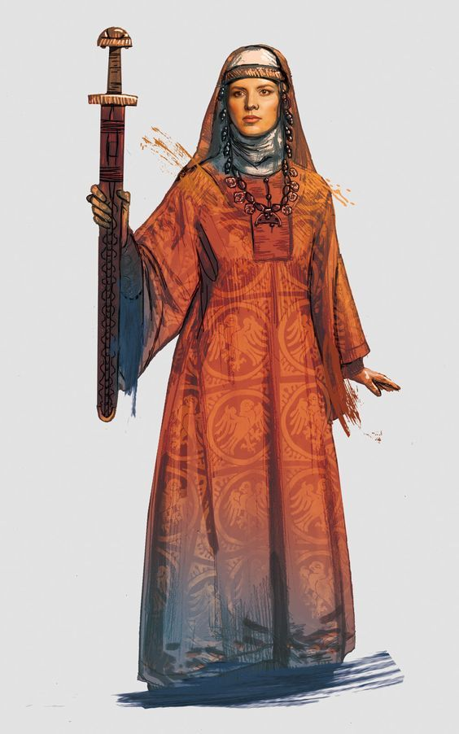

Local Goods of Hyderis
Cereals: einkorn (wheat), barley, oats, rye
Fiber: nettle, hemp and flax
Fruits: sloes, plums, apples, blackberries, lingenberries, blueberries, bilberries, raspberries, elderberries, cloudberried (hjortron), hawthorn berries, cherries, sour cherries, bullaces, cloudberries, strawberries, crabapple, rose hips, rowan berries, cranberries (tranbär), juniper berries (enbär)
Meat and poultry: beef, mutton, lamb, goat, pork, horse, chicken, geese, ducks
Nuts: hazelnuts
Vegetables: carrots, parsnips, turnips, celery, spinach, wild celery, cabbage, radishes, fava beans, beets, angelica, mushrooms, leeks, onions, edible seaweeds, potatoes, rutabaga, beans, peas
Herbs: sage, dill, coriander, hops, poppyseed, black mustard, fennel, watercress, cumin, mustard, horseradish, lovage, parsley, mint, thyme, marjoram, wild caraway, juniper berries
Oils: cod liver oil, shark liver oil, sheeps wool oil, other fish liver oil
Fermented Drink: barley for beer, honey for mead, hops and bog myrtle were used to flavor ale, bjórr - a drink which was both very alcoholic and which is described as being sweet, akvavit fermented from grain and potatoes
Salt-water fish: cod, coalfish, herring, haddock, flat-fish, ling, horse mackerel, smelt, saithe, roach, rudd, bream, whale meat
Fresh-water fish: perch, pike
Esturiane fish: oysters, cockles, mussels, winkles, smelt, eels, salmon, and scallops
Wood: alder, aspen, ash, birch, boxwood, elder, elm, fruitwood (cherry, blackthorn, apple, pear, hawthorne), hazel, maple, oak, poplar, pine, spruce, spindlewood, willow, yew, beechwood, sweet chestnut
Textiles: wool, linen (flax)
Dishes: Osyrat Kornbröd (Barley Flatbread), Green Soup, Nässelsoppa (Nettle Soup), Rökt Fisk (Smoked Fish), Chicken Stew With Beer, Honey Glazed Root Vegetables, Kokt Svinmålla (Boiled Lambsquarters), Pancake with Berries, Färskost (Skyr), Kornmjölsgröt (Barley Porridge)

Hyderis Names: Frisian http://www.fantasynamegenerators.com/frisian-names.php

Notes on Culture of Hyderis
Korol (king) and Koroleva (queen)
Knyaz (noble title, lord) and Knyaginya (noble title for women, lady)

Druzhina – a retinue knights in service to a lord
Bogatyr – knight errant hero
ancient belief that belts kept evil spirits away from their wearers
Clothing / Fashion / Attire
My first impression of Hyderis would be Eastern European. I gravitated to the peoples around the Black Sea region: Slavs, Russians, Cossacks, then delved deeper into ancient Scythians and even found commonalities with the Ottoman Turks. But the funny thing about Baltic states is their proximity to Turkey and the Middle Eastern influences. Certain elements just won't work as well from these influences, they fit better in the sandy terrain of Tarbia, which is based solely on the Middle East and a Thousand and One Nights Arabia. But Hyderis is too far removed from Tarbia to have any cross-over. So the process will be about picking and choosing elements that fit an Eastern European flair and segregating the Muslim influences to Tarbia.

Clothing (if basing it on the Ottoman Turks)
Upper-class or royal people in Hyderis wear fur-lined, embroidered kaftans. The middle-class wear cübbe and hırka, a specific style of jacket. The lower class also wear a jacket called cepken or yelek. Bashlyks, a type of hat, are the most important status signifier: kavuk is the most common type, and a tradesmanship was formed due to the significance of bashlyks in the 17th Century.
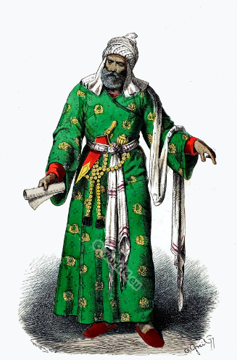
The administrators and the wealthy wore caftans with fur lining and embroidery, whereas the middle class wore 'cübbe' (a mid-length robe) and 'hırka' (a short robe or tunic), and the poor wore collarless 'cepken' or 'yelek' (vest).
Headgear was the most potent indicator of male social status. While commoners wear "külah's" covered with 'abani' or 'Yemeni', higher-ranking men wear a wide variety of turbans.

Ottoman:
Women's everyday wear is şalvar (trousers), a gömlek (chemise) that comes down to the mid-calf or ankle, a short, fitted jacket called a zıbın, and a sash or belt tied at or just below the waist. For formal occasions, such as visiting friends, the woman add an entari or kaftan, a long robe that is cut like the zıbın apart from the length. Both zıbın and kaftan are buttoned to the waist, leaving the skirts open in front. Both garments also have buttons all the way to the throat but are often buttoned only to the underside of the bust, leaving the garments to gape open over the bust. All of these clothes are usually brightly colored and patterned. In public some women cover their clothes with a ferace, a dark, modestly cut robe that buttons all the way to the throat. She also covers her hair and face with a pair of veils. Women also wear head pieces, usually embroidered with bangles hanging in front or all around.

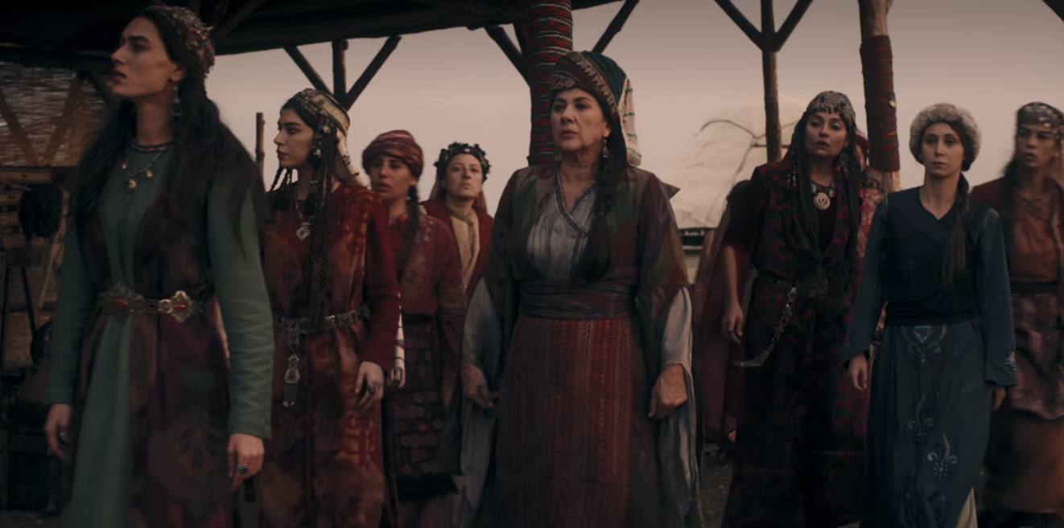

Music
The duduk is an ancient Armenian double reed woodwind instrument made of apricot wood. It is indigenous to Armenia. Variations of the Armenian duduk appear throughout the Caucasus and the Middle East, including Azerbaijan, Georgia, Russia, Turkey, and Iran. Duduk, Balaban, and Mey are almost identical, except for historical and geographical differences.
It is commonly played in pairs: while the first player plays the melody, the second plays a steady drone called dum, and the sound of the two instruments together creates a richer, more haunting sound.

Weapons and Armor
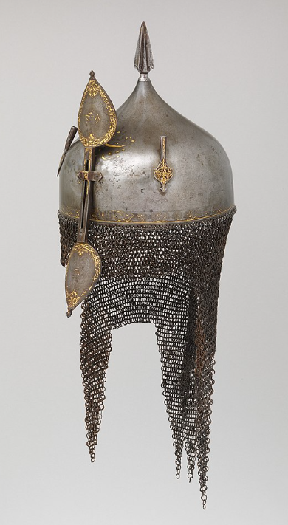
Khula Khud helmets are worn my captains and mounted officers in the Hyderian armies. They are also worn in Tarbia and Mahabar. Made of steel, these bowl-shaped helmets are designed as either low and flat, or high and pointed. They sometimes contain a spike socket at the top of the helmet, which resembles a spearhead with a cross-like section. Two or three plume holders are attached on either side of the skull, used to mount feathers from birds such as the egret.
The helmet has an iron-and-brass or brass-and-copper aventail that hangs at the base of the helmet to protect the neck, shoulders and the temple of the face. Sometimes, the aventail extends down to cover the eyes and the nose. The low end of the aventail is often shaped in a zig-zag triangular pattern (vandyked).
A bar made of iron or steel is attached to the front of the helmet with a bracket and can be adjusted in position - so when not in use, it can slide upward and fasten with a link, a hook, or a set screw. The two ends of the bar expand into leaf-shaped plates, forming a final. In some Khula Khud helmets the lower end of the bar is designed as a large crescent-shaped metal guard that protects most of the face below the eye level.
Despite the similarity in their design, the Khula Khud helmets are decorated with a wide degree of variations depending on the tribes or regions from which they were created. Decorations often appear in the skull and the nasal bar, which are often heavily decorated with patterned motifs of inlaid brass, silver or gold; or decorated with figurative images.

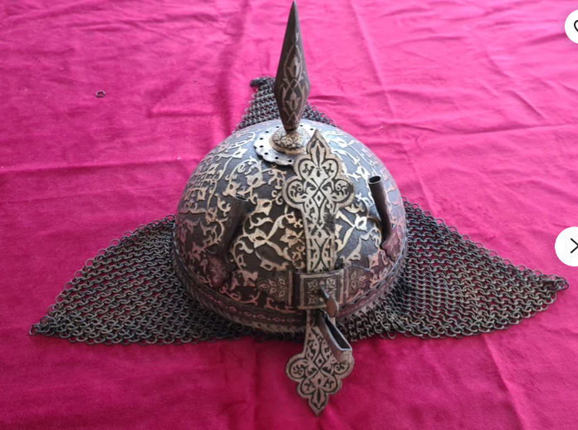

Local Deities
Belbog – the white god, giver of fortune; patron deity of Targuth
Czernobog – the black god, the giver of misfortune; patron deity of Dethvau
Azov - The Mistress of the Copper Mountain, patron deity of Bronde

Creatures
Alconost
Azov, Mistress of the Copper Mountain
Dzedka
Goldenhorn
Indrik
Lady Midday
Lazavik
Mammoths
Skrzaks
Vodnik

Alconost - a woman-headed bird. It makes amazingly beautiful sounds, and those who hear these sounds forget everything they know and want nothing more ever again.

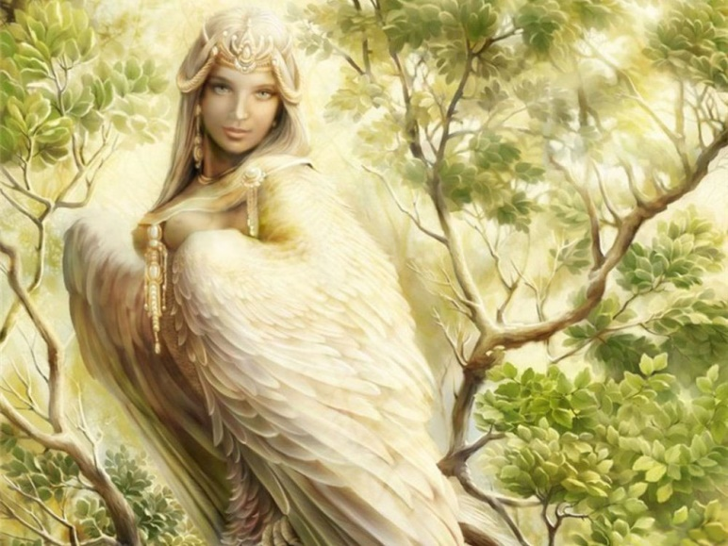

Azov - The Mistress of the Copper Mountain has the appearance of an extremely beautiful young woman with green eyes. She has dark braided hair, ribbons from thin tinkling copper, and a gown that is made from malachite. She wears a diadem decorated with malachite and precious stones. As a mountain spirit, she is the protector and owner of hidden underground riches. She is always surrounded by her servants, small lizards, which can be green, blue, golden or luminous. The Mistress can even appear as a lizard herself. Any person who looks upon the Mistress comes under her spell. She shows kindness to good people and skilled craftsmen, helping them to find jewels and gold, but if her conditions aren't met, the person loses all his luck, skill and can even die. She can permit or prevent the mining in certain places, give or take wealth.
The sacral being, the Mistress is surrounded by rituals and taboos. Women are not allowed down in the mine, because it is the Mistress's domain, and young men seeking her patronage do not marry. Violation of the taboos brings a harsh punishment. Children are taught not to shout and quarrel next to the stones, and to keep quiet in the mines, because the Maid dislikes loud noises. Her distinguishing attributes are lizards, copper and malachite.
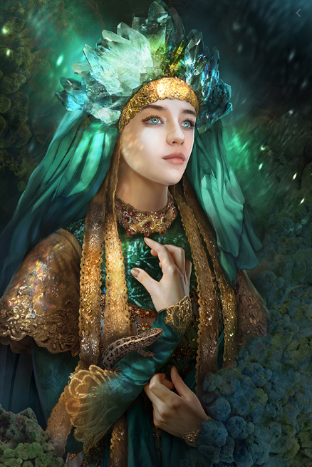

Dzedka - a good mythological creature. It is considered to be the symbol of richness and fortune companion. Dzedka is described as an old man with long red beard and red eyes. Dzedka wears simple clothes and looks like a beggar with a bag. In the daytime Dzedka walks around the roads and fields. When a person meets Dzedka, prior to noticing it, this person falls asleep. When the person wakes up, he or she discovers a desired sum of money. If rich, but unhappy people meet Dzedka, it shows such people in a dream what they need to do to become happy.
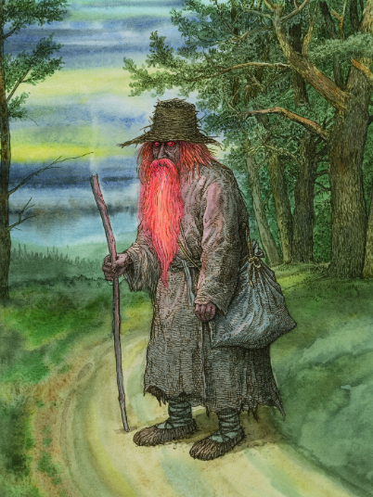

Goldenhorn - a legendary white chamois buck, whose golden horns are the key to a treasure hidden in the Direfrost Mountains. Its head butt and goring are naturally more powerful and more painful than attacks by ordinary horns. Some also claim that it has power to scent certain gold-loving species, such as Dwarves, to perceive a potential threat to its golden horns. It is said to sprout magic Triglav flowers that grow from its blood. These grant enormous life power and healing properties when eaten. In the event of an injury, it will attempt to leave a trail of its own blood, within which will grow a patch of blood-red flowers. Whether or not any other species can safely partake of the flowers is unknown, but if the Goldhorn manages to eat of the sanguine-colored blooms, they will not only be healed of the former injury, but will gain extraordinary strength, durability and stamina with which to drive the enemy away. Some even believe that Goldhorns use this trick in old age or in the event of sickness, to ward off a painful and untimely death.

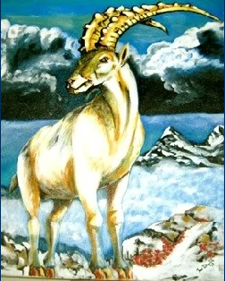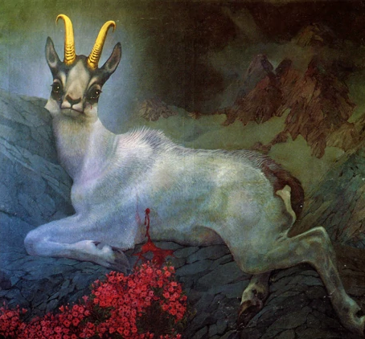

Indrik - a fabulous beast, the king of all animals, who lives on a mountain known as "The Holy Mountain" where no other foot may tread. When it stirs, the world trembles. It resembles a gigantic bull with legs of a deer, the head of a horse and an enormous horn protruding from its snout.
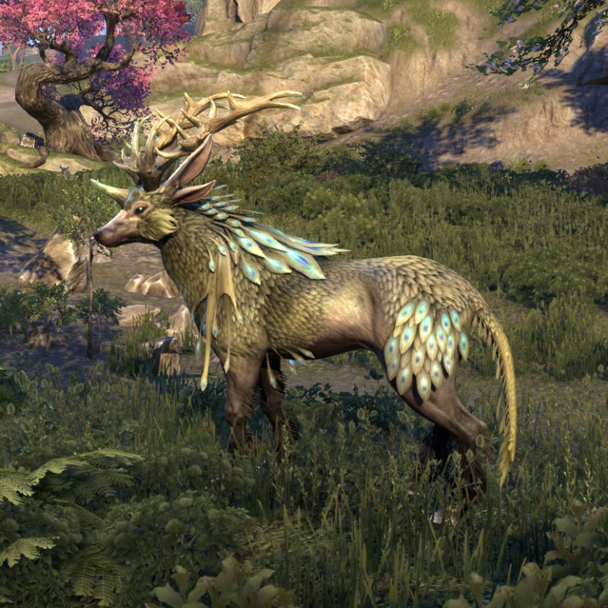

Lady Midday – is a demon named Poludnitsa who makes herself evident in the middle of hot summer days, takes the form of whirling dust clouds and carries a scythe or shears. She will stop people in the field to ask them difficult questions or engage them in conversation. If anyone fails to answer a question or tries to change the subject, she will cut off their head or strike them with illness. She may appear as an old hag, a beautiful woman, or a 12-year-old girl. She is only seen on the hottest part of the day.

Aka Poludnitsa (Noonwraith) is spirit that appears on summer grain fields in the noon. It is represented as pale girl in white dress. She likes to grab men and women who appear on fields and throw them on the ground mercilessly.

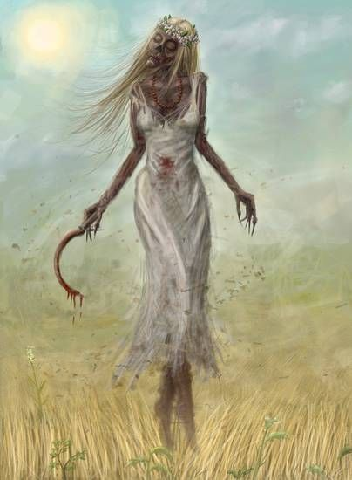

Lazavik - a benevolent character that lives amid the vine bushes. He is a small creature with one eye, a long beard and a very long whip in his hand. When Lazavik walks through the marsh lands his eye shines like a light. The creature Lazavik prefers to stay unnoticed by people, and constantly tries to hide in its house. The house of Lazavik is small, with no windows and no doors. In fact, Lazavik is the guardian of Hyderian marshes. It is believed that Lazavik dies if its marshes are drained. With its whip, Lazavik drives away small, harmful, and noisy Lozniks through the vine bushes.

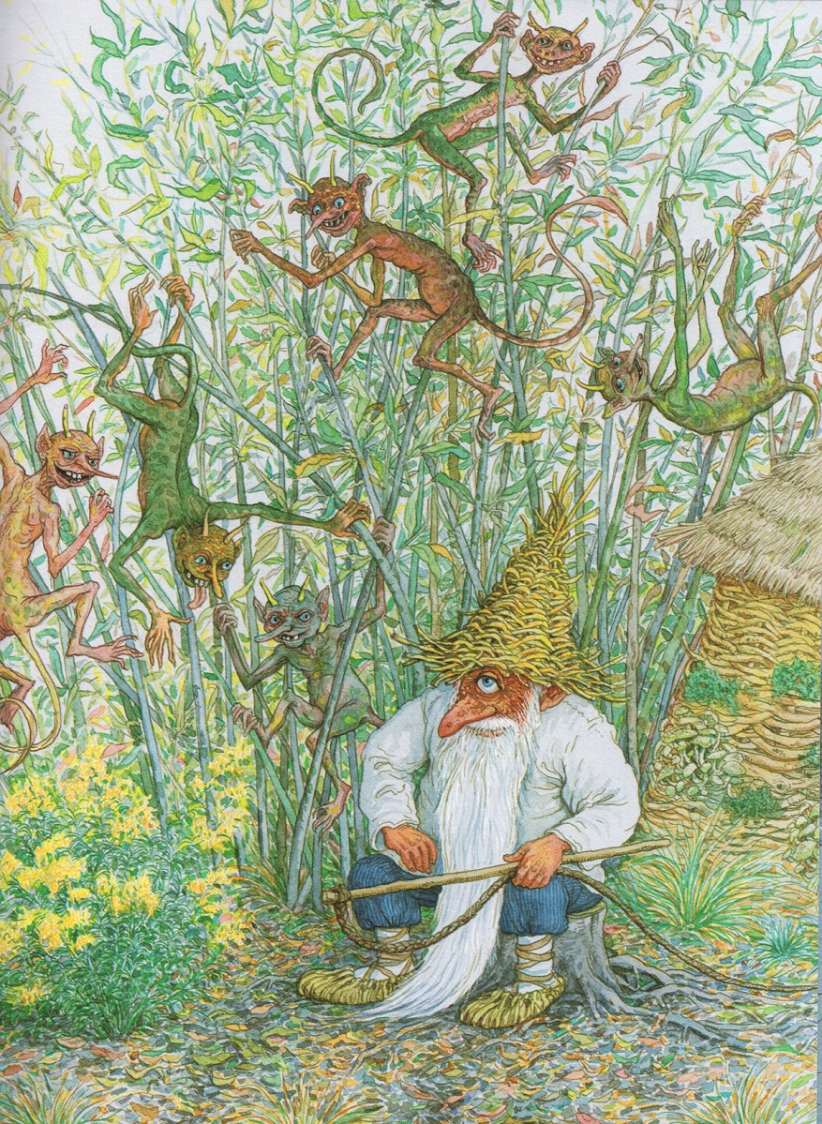

Lozniks –

Mammoths - Giant wooly mammoths roam the ice covered plains in large herds along the icy coast west of the Direfrost Mountains. While normally docile creatures, they have developed a ferocity in the face of being hunted by humans. War chiefs of Targuth ride as heavy mounts in open battle.
But none dare tame Thrahnga. She, the ancient magical guardian of her kind, has lived for time eternal. Twice the size of her kin, she rules over her the herds and protects them. She is a chaotic neutral beast who can communicate in the old tongue. It is said she holds power over the very land and indeed over the weak minded. Her power is untested but even the greatest warlords dare not hunt her.

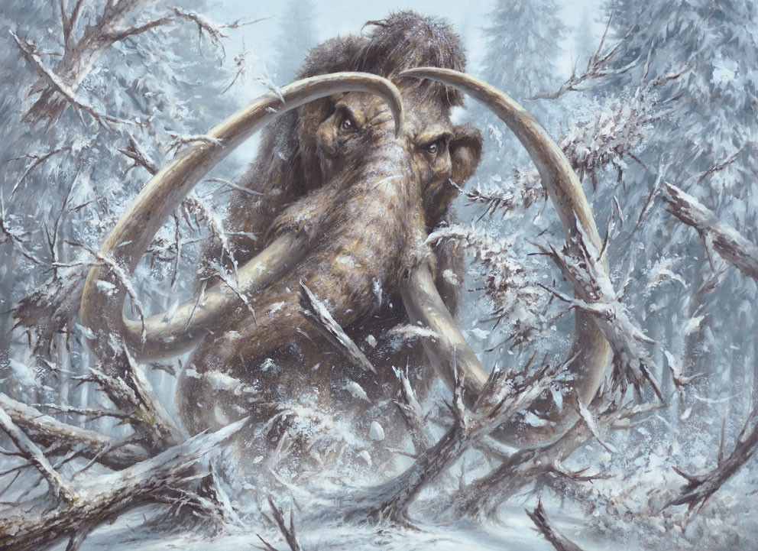

Skrzaks - little flying imps that dwell in underground labyrinthine mazes. Living primarily in dark, high ceiling enclosures, these creatures attack trespassers without mercy. If their target was able to avoid the razor-sharp fangs and claws, the maniacal laugh that these imps emit would instead drive a man mad. Their pursuit is relentless and their cackling consistent. These small creatures tend to have human-like appearances, even though their flesh is purplish-black, and they rarely walk but instead fly on the large wings on their backs.

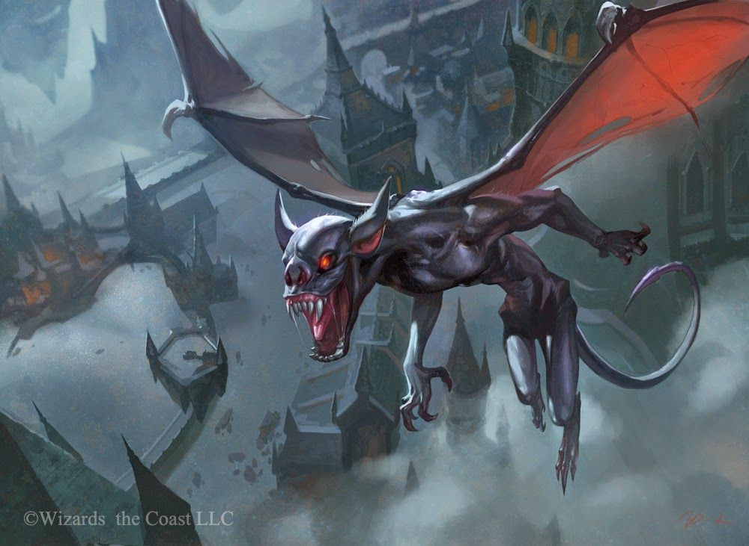

Vodnik
The Vodnik is a water creature that dwells in rivers and lakes. It has a humanoid body, appearing like a naked old man with a greenish, tangled beard and long hair. Its body is covered in black fish scales coated in muck, it has webbed paws instead of hands, a fish's tail, and eyes that burn like red-hot coals. It usually rides along the river on a half-sunk log making loud splashes. When angered the vodnik breaks dams, knocks down buildings near the water's edge, and drowns people and animals. Fishermen often throw a pinch of tobacco in the water as an offering to "Lord Vodnik" to gain its favor in catching a fish.

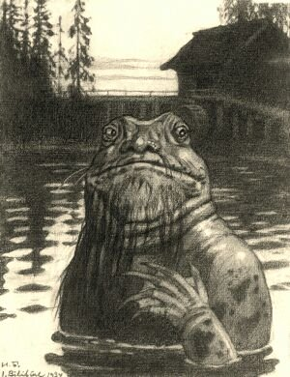
Rusalka – water spirits that appear in the form of young attractive women. Legend holds that the soul of a young woman who had died in or near a river or a lake would come back to haunt that waterway. This undead rusalka is not invariably malevolent. Most are content to nurture crops and other vegetation with their tears. If approached, they will tell their tale of woe and bid the stranger to avenge them through some act of courage.
One who has met a violent end at the hands of a lover or abusive husband possess red hair and nurses a dangerously vengeful heart. She will make herself visible to men and, if approached with ill intent, will seduce by either her looks or her voice, into the depths of said waterways where she will entangle their feet with her long red hair and submerge them. Her body would instantly become very slippery and not allow the victim to cling on to her body in order to reach the surface. She would then wait until the victim had drowned, or, on some occasions, tickle them to death, as she laughed.
Orysya is the most famous Rusalka, for she rules from the bottom of the Oberon Sea. She is temperamental, sometimes fascinated with the plights of man and at other times vengeful towards them. In 345 WA4 the farm boy Petro Bodnar was called by Azov, Mistress of Copper Mountain, to seek the Sword of Kalinov; after many adventures the boy retrieved the sword from the Orysya and used it to slay the witch Oksana to become Korol (king) of Hyderis.

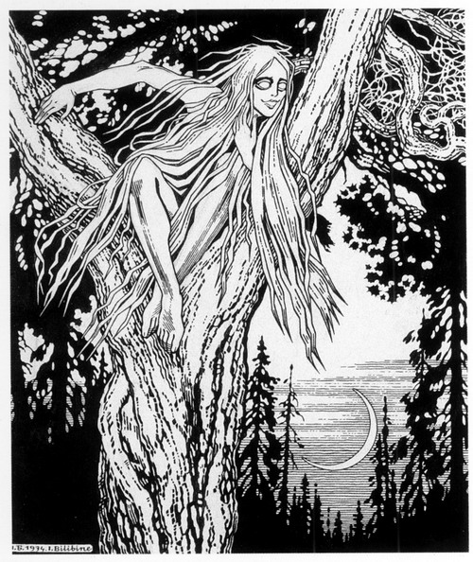

More Creatures to develop:
https://mythus.fandom.com/wiki/List_of_Slavic_creatures

Azhdaya is demonic version of Zmaj (Zmaj, Dragon). Created from serpent that lived up to 100 years or eaten another one. Usually in stories they have odd number of heads, rarely two. They spit fire, have terrible roar and have evil look on their faces. They live in caves or mountains, from where they escape and cause hailstorms or devour humans or cattle. They were so known in Slavic (and in European) Pagan folklore that Christianity adopted it as perfect image for devil - being greedy and hungry all the time and extremely hostile to all living beings. In serbia it is thought that St. George killed an azhdaya, not a dragon.

Balachko is 3-headed giant from Serbian tales. From one head he could spit fire, from second one he could breathe cold wind. When he depleted his magical weapons, he was easy to kill. He was under the rule of Mihailo the king of Leđane. He was killed by the serbian hero Miloš Vojinović when he tried to kidnap princess Roksanda, the bride of Tsar Dušan. This tale was told in the serbian epic poem "Tsar Dušan's wedding" (Женидба Душанова). He was refered to as a Voivode.
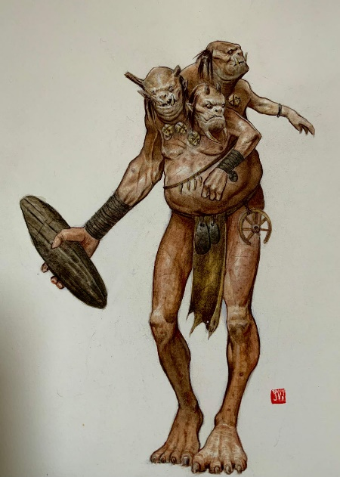

Bauk was creature from Southern Slavic beliefs, especially from Serbian beliefs. Parents used to scare children with him. Word bauljati is used when somebody walks weirdly. Bauk had weird walking and lived in dark places, in holes or abandoned houses from where he preys upon humans and eats them. The only way to banish bauk is to use light or noise. English word that is close to Bauk is ogre.
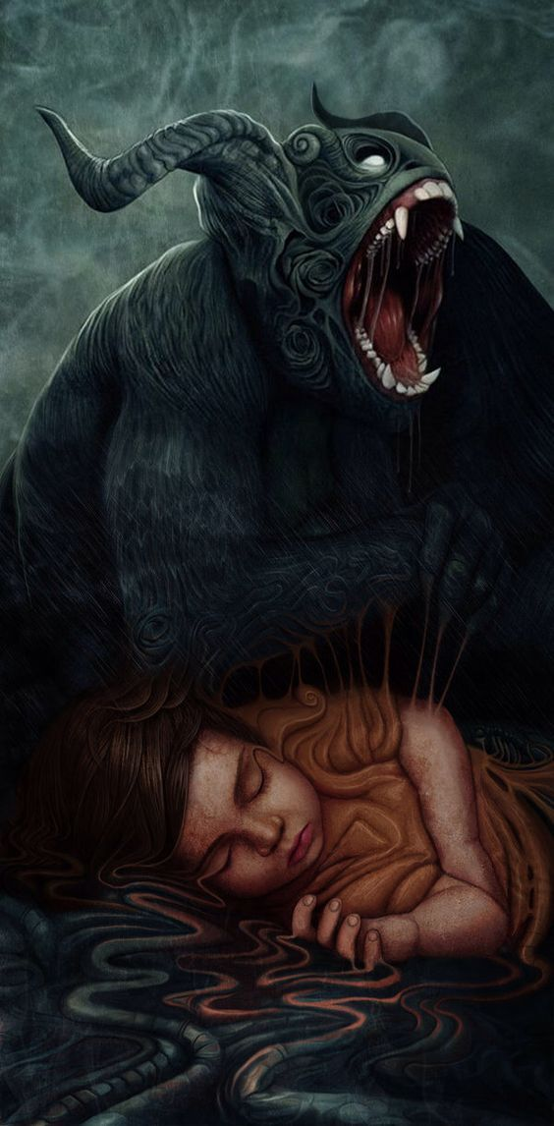
Beda (or bijeda or misery) is demon from Southern Slavic folklore that is far descent from ghosts and close to Chuma. She wanders across the world, attacks people and torture them. There are sayings that Beda found them or Beda follows them from cradle to grave. Beda is bony and slimy creature that breeds very quickly, likes to steal things from people and to dig them deep into the ground.

Bes is demon from Serbian folktales. Its name in English is literally Anger. They like to possess people and animals, causing extreme rage in them. Bes is evoked when somebody threads on Sunday or spits on fire. Name Bes is very old one for a demon and it's known in all mythologies on Earth.
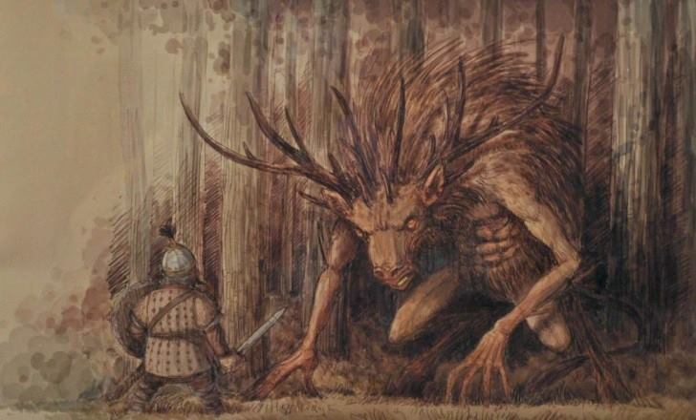

Besomar is demon that is connected to disgust and hatred that had similarities with Werewolf or Vampire. Sometimes, historians mistake Besomar with them, saying that it's just another name for same demon. Name is made from bes (anger, rage) with mora (torture, death). Some historians say that Besomar is king of all Bes spirits, while some say that it's another name for Chernobog.

Bukavac is demonic creature from Southern Slavic tales, especially of Serbs that live on northern part of Serbia. Similar to Drekavac, it likes to yell very loudly, but unlike Drekavac, it lives close to swamps, rivers and lakes and has different look. It has six legs, slimy skin, big mouth, long tail and long curved horns on head. It likes to drown people and animals who happen to walk close to their watery lair at late night. During the 1900s locals reported sightings of this creature on the shores of the Sava river in the region of Syrmia.
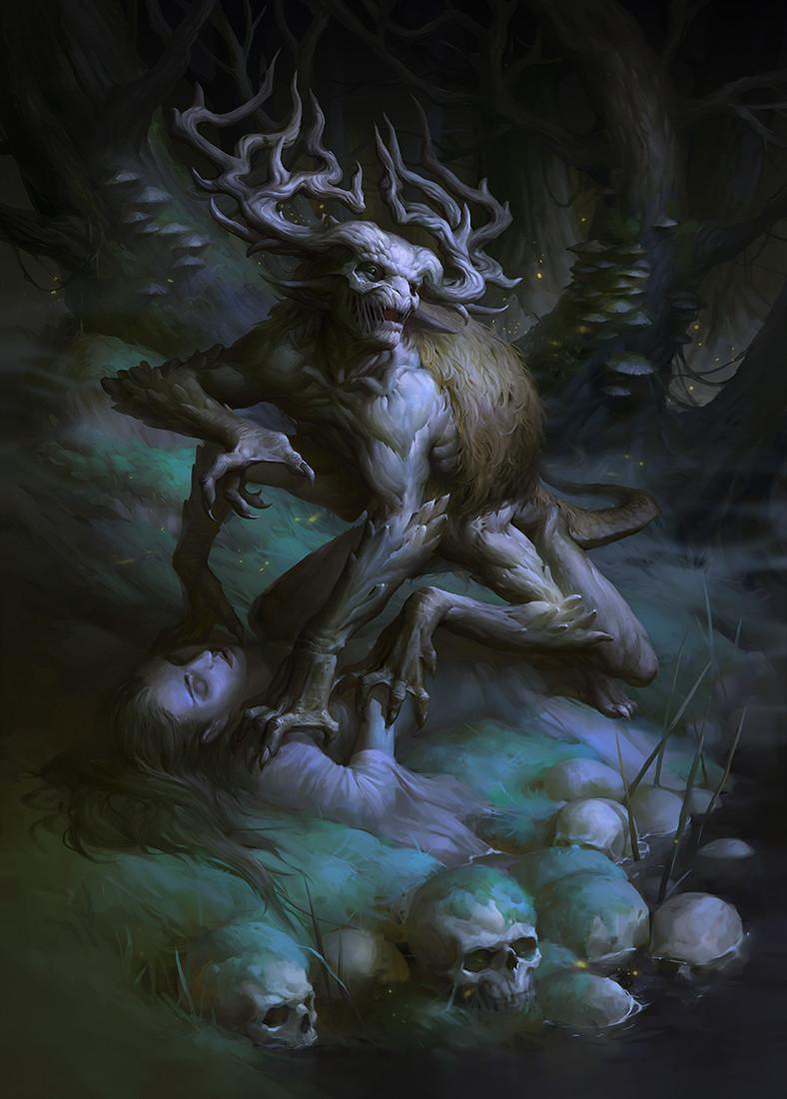

Chort is demon from Russian folklore whose name passed into similar-worded Russian swearing (chyort - damn). It is usually represented as human with goat's hind legs, long tail and goat's horns, known to bring misery to anybody that it encounters or to destroy their property. Its look is adapted into Christianity for devil. It appears as one of monsters in Witcher III game.

Chuma is embodiment of Black Death disease from Serbian folktales. According to them, it is represented as ugly old woman with big eyes and messy hair. Chuma appeared at night from attic or chimney, carrying clay bowl with arrows. People tended to wash their dishes before sleep, because Chuma had habit to scratch them with her dirty nails and to poison them.

Chudo-Yudo???
The Chudo-Yudo is a multi-headed water-dwelling dragon. Some legends portray him as the brother of Koshchey the Deathless, and thus the offspring of the witch Baba Yaga; others present him as a personification of the witch in her foulest form. A Chudo Yudo is one of the guardians of the Water of Life and Death, and his name traditionally was invoked in times of drought. He can assume human-like form and is able to speak and to ride a horse. He has the ability to regenerate any decapitated heads.
The term Chudo-Yudo may not be a name for a specific type of dragon at all, but rather a fanciful term for a generic "monster". According to this explanation, the term is to be understood as a poetic form of chudovishche meaning "monster", with a -iudo ending appended simply for the rhyme. Chudo in modern Russian means "a wonder", and once also had the meaning of "a giant"; "yudo" may relate to Iuda, the Russian form of the personal name "Judas", with connotations of uncleanness and the demonic.
Three- and six-headed zmei, slain by the titular hero in "Ivan Popyalov" (Иван Попялов, "Ivan Cinders", Afanasyev's tale #135) appear as six-, nine-, and twelve-headed Chuda-Iuda in the cognate tale #137 "Ivan Bykovich" (Иван Быкович). The inference is that Chudo-Yudo must also be a dragon, even though the word "serpent" (zmei) does not appear explicitly in the latter tale. The six-, nine-, and twelve-headed Chuda-Yuda that appear out of the Black Sea are explicitly described as zmei in yet another cognate tale, #136 "Storm-Bogatyr, Ivan the Cow's Son" (Буря-богатырь Иван коровий сын). The Storm-Bogatyr possesses a magic sword (sword Kladenets), but uses his battle club (or mace) to attack them.
A Chudo-Yudo's heads have a remarkable healing property: even if severed, he can pick them up and re-attach them with a stroke of his fiery finger, according to one of these tales, comparable to the regenerative power of the Lernaean hydra that grows its head back.
Folktales often depict Chuda-yuda as living beyond the River Smorodina [ru] (the name may suggest "Stench River")—that is, in the realm of the dead, reached by crossing over the Kalinov Bridge [ru] ("White-hot Bridge").

Danitsa is Slavic name for Venus planet which could be seen as morning star that calls upon the dawn. In folk tales, it is represented as sister of Sun or Moon, sometimes even as daughter of Sun.

Domovoy (or Domovik, Matsich) is house spirit known in all Slavic countries. Represented as tiny middle-aged man with fur cloak, he guarded houses and cared for cattle and therefore connected with God Veles. He could transform into dog, cat and cow, rarely and into snake or frog. He lived often in corner close to hearth, on attic or in garden. He could be heard, but it was dangerous to be seen. If people don't bring tribute to him (in form of bread or wheat), he could abandon their home and cause sickness of inhabitants and cattle.
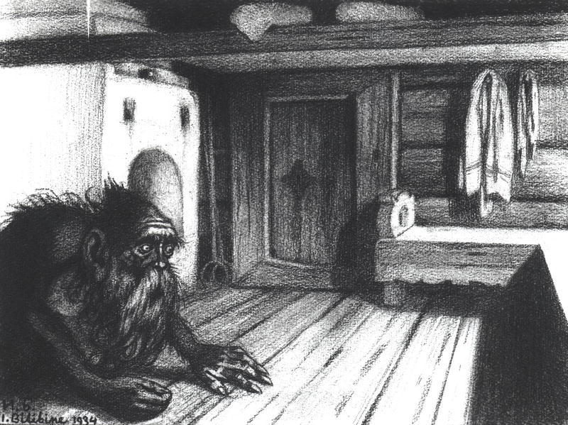

Drekavac (Drekavac or Screamer) is demon from Southern Slavic folklore, created from dead, unbaptized toddlers. It is represented as tiny hairy creature with long sharp claws and long fur, which he stomps upon and yells in mixture of child's cry, scream and wolf's howling. He could scream so loudly that people could get deaf from him. He lives in graveyards, in forests or shores of rivers, generally, in places where it died as human. If a human approaches him, he could jump on their back and force them to run until first calls of rooster. If human resists Drekavac, their face could be shredded with claws. Drekavac is afraid of light and dogs. Drekavac is commonly sighted in the forests of Mount Zlatbor in Serbia.
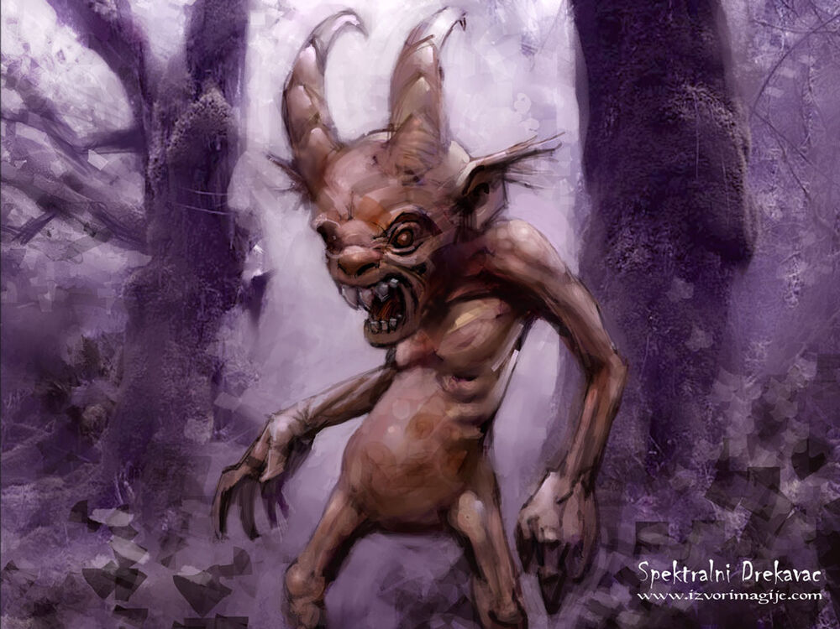

Gamayun is prophetic bird from Eastern Slavic folklore. Pretty much like Alkonost and Sirin, she is imagined as large bird with head of beautiful woman who live close to Iriy. As messenger of God Veles , she spreaded divine messages and prophecies to everybody who could hear her. She knew everything about creation of sky and Earth, Gods, heroes, creatures, animals and birds. When she flies from the East, she could bring deadly storms.

Djerman is creature from Southern Slavic folklore tied to weather. He could cause hailstorms, rain and thunderstorms. People used to create little figures out of clay to evoke rain during Summer Solstice (or Kupala celebration).
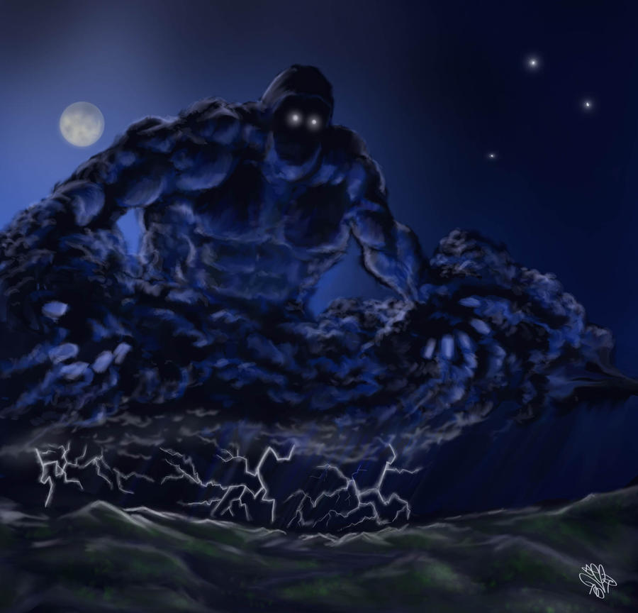

Kikimora is female house spirit that is known in Eastern Slavic countries. There are two different kinds of Kikimoras. The one that comes from the house is married to the Domovoi. The other one comes from the swamp and is married to Leshy. It is said that she can be identified by her wet footprints. When home builders wanted to cause harm to someone buying a house, they would bring in Kikimora. Once she is inside, it is difficult to get her to leave. Her role in house is juxtaposed with Domovoi, and is usually bad in comparison with him. She lives in cellar and behind stoves and produce noises similar to mouse. She scares naughty children and sometimes could be seen spinning thread in cellar.
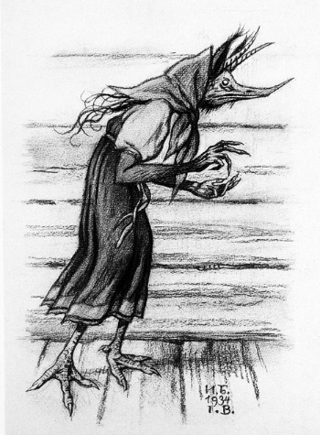

Lesnik (Leshiy or Lesovik) is creature known in all Slavic countries. His wife is called Lesovika. His role was to protect forests and wildlife that inhabited them. He could change his size from size of grass to the tallest tree. He had blue cheeks because of blue blood, pale skin, hair and beard created from grass and vines and vivid green eyes. Slavs thought that migrations of animals are actually Lesnik's orders. If human befriends Lesnik, they could learn everything about magic. Farmers and shepherds usually made pact with him, so he could take care of their animals and farms. Lesnik is known that he could lead people to wrong way in forest, where he could tickle them to death and people had habit to wear their clothes upside-down, so they won't get lost. If two Lesnici meet each other, they could wreak havoc upon forests, destroying trees and make animals scared and scattered.
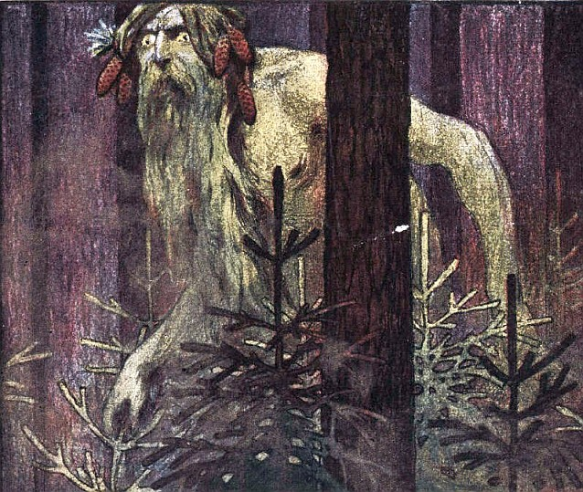

Likho is demon of misfortune known in all Slavic countries. She is represented as old skinny woman with one eye who is wearing black clothing. She is usually found in fairytales.
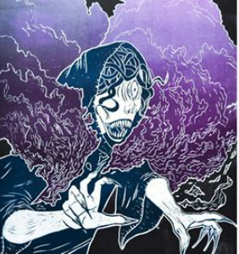

Milosnitse are demons of plague, known in all Slavic countries. Their name in English would be merciful ones and Slavs called them like that, because they wanted to appease them and to avoid plague that they bring. They are represented as women in black and they walked in groups, rarely alone. Amount of Milosnitse was measured by amount of sicknesses that they brought. There was no cure from them, but there was a way to appease them and to eventually avoid their plagues. People could light fires on crossroads and on village's entrance and they could share food and drink and even sing before fire.

Mora is night demon that, because of her name is usually mistaken with Marzanna (Morana). She is created from girl baby that is born with blood and had habit to sit on people's chest while they are sleeping and drink their blood. They could take form of hair or straw and could pass through keyhole.
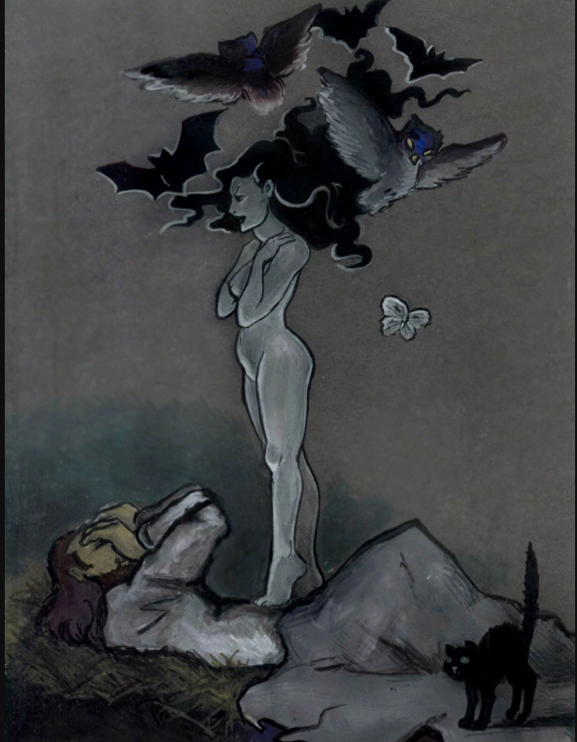

Nav (plural Navi, Mavke or Navke) is demon known in all Slavic countries. As they shared name with Nav - realm of dead and are created from dead, unbaptized babies, they embodied death itself. They are represented as black birds with baby heads who attacked pregnant women and children. They also could attack and cattle and steal milk from them.

Nezhit is tiny demon that could cause physical sicknesses in humans, making their teeth to fall out, making flu, deafen them and blind them.

Nocnitsa is the most common name for a nightmare spirit also called plachky, kriksy, mrake and vidine. The name roughly translates as “night hag.” In some countries, she is viewed as a type of succubus. The Nocnitsa is most often said to sit on the chest of sleeping children, draining their life energy. A stone with a hole cut in the centre can protect against the spirit. Some say she is made of shadow.
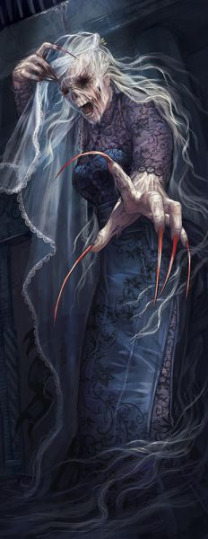

Osenya is female demon from folklore of Eastern Serbia. She is represented as woman in white clothes. She could be seen on bridges, close to roads or on hills in middle of night. Osenya had habit to seduce men and to lead them across forests and fields, making them tired at dawn.

Patuljak (Dwarf) is creature known in all Slavic countries, as well and in World folklore. It is polar opposition of Giants by having tiny stature and great intellect. Serbs know dwarves from stories, like one when Gods decided to create them, but they didn't have any purpose, then they decided to create Giants, who also proved to be useless, then in the end they created humans that are neither giant or tiny. Dwarves in Serbian folklore had magical powers, as well and ability to transform into frog.

Psoglav is demon from Serbian folklore. It is represented as chimera, with horse hind legs, human torso and dog's head with one eye and iron teeth. It lived in caves with plenty of gemstones, but without Sun. It ate people, sometimes and dug their graves to feast on their corpses.

Rusalka is type of fairy that lives close to lakes and rivers. Pretty much like Vila, they are imagined as beautiful, eternally young girls with red or green hair, however they are extremely hostile toward humans. They like to seduce men and to drown them, or to kill them with loud laughter. They are created from souls of young girls that are drowned or faced violent death. The most powerful repellent against Rusalke is wormwood or garlic.

Sirin is creature from Eastern Slavic folklore. Pretty much like Alkonost and Gamayun, she is imagined like bird with head and chest of woman who live close to Iriy. She has gold crown and feathers without shine. Sometimes she appears as owl. It was believed that some people could hear her, but those people lost their minds and followed her until death. People then banished them by cannon shots or by church bells.

Stratim is the mother of all birds in the world. She is an assistant of the god of wind, Stribog. Just one movement of her wing may create a huge wave in the sea. Also, her screams can cause storms. Like the most Slavic mythological birds, she is imagined as a bird with the head and chest of a woman. She is said to live close to the Ocean-Sea.

Sudjenitse (or Sudjaye) are trio of spirits known under different names across all Slavic countries. They are weaving destiny of every newborn child, including and how long child will live and how it will die and nobody can escape that. Slavs had habit to welcome them with clean house and clothing for mother and child who is surrounded by already made bread, wine, picked basil plant and gold and silver coins as tribute to them. Three days after child is born, they appear in their home. First sudjaya is very ugly and evil, she is telling the death of child. Second one is also evil and she threads child's dysfunctions, while third one is the most beautiful of them and she threads longevity of child's life and success in marriage. Usually, people pick second option that is neutral.

Todorats is the most powerful and evil demon from Balkan folktales that is half-human, half-horse. But it should not be mistaken for Greek centaur.
They look like riders sprouting from horse's back who are wearing cloaks that obscure their faces. Nobody ever saw their faces. While they are passing trough villages and towns, they kill everybody on their path by stomping them.
Somewhere at the end of winter, there was Todor's Saturday and it was the only day when they appeared. Among them there was Great Todor, who was lame, white demon covered in white cloak and carried rattling chains. People then had special ritual to appease them and to banish them. They created cookies that looked like horse hooves and portion of those cookies was always given to horses. At that day, children were forbidden to get out of house and people didn't work.
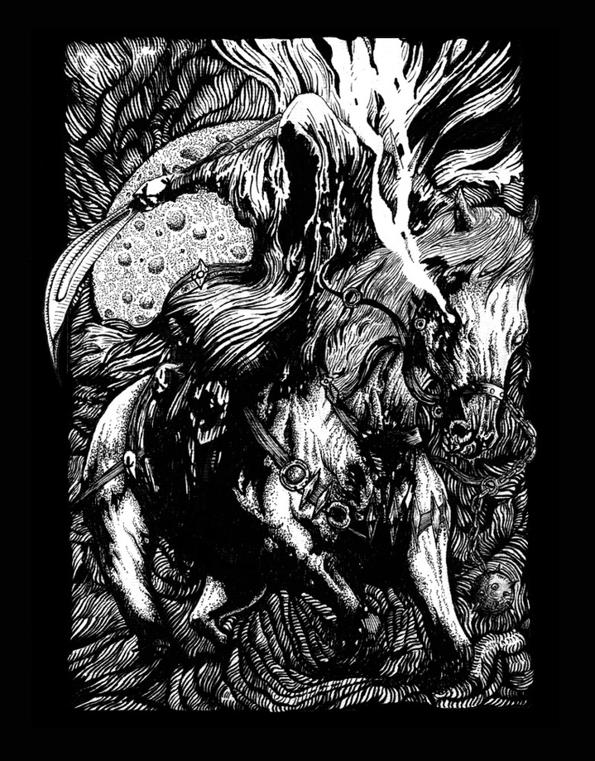

A Tsikavat or Cikavac is a bird-like creature with a long beak and pelican-like sack that, according to belief, could be created when woman stole egg of black hen and put it under her armpit for 40 days. Until hatching, woman could not confess, pray, cut her nails or wash her face. Once a tsikavat is created, it remains very loyal to its master. It could steal honey or milk from nearby beehives or cows, then give it to its master. Also it could give its owner a power to understand animal language. Belief in tsikavats originated in Serbia.
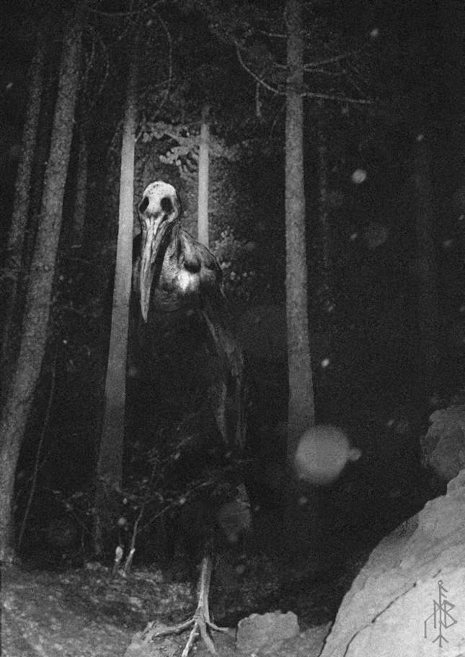

Usud (Fate) is a being from South Slavic folklore. He is the personification of fate. Acording to folktales, one day Usud lives a luxurious life in a castle and then when midnight comes a voice is heard saying "Oh Usud! Oh Usud! today this many and that many souls were born, give them what you will." Usud then opens a box and starts throwing gold coins, while saying "How it is for me today, let it be like that for them till the end of their lives." The next day he lives in a middle sized house and when midnight comes a voice is once again heard saying "Oh Usud! Oh Usud! today this many and that many souls were born, give them what you will." he once again opens a box but this time it is full of silver coins with which he does the same thing as yesterday. The house and the amount of money keep getting smaller every time until he is living in a tiny shack with barely any money left. The next day he is once again living in a castle and the cycle repeats from there. Depending on how wealthy Usud is on the day that you are born you will be that whealty for your entire life.

Vampir (or Vampire) is the only Serbian word accepted in all world's languages. Everybody knows them as human-shaped undead blood-drinkers with fangs that pops up in almost all RPG games, cartoons, animes and movies. But original Slavic vampire is far much different from their Hollywood siblings. They usually came from people who were either truly evil while alive, or who ended their lives with suicide or being tortured. Sometimes, evil spirit possesses and bodies from innocent people and their living corpse or their ghost (belief is depending of region) comes to vampire's hometowns and attacks people, sustaining themselves with their flesh and blood.
Unlike their siblings from pop-culture, Vampires are not charming and sparkling aristocrats, who wear goth-like clothes and act very calm and seductive toward their victims, nor they make wars with Werewolves, nor they have just two fangs. Original Vampires came from all classes of society and wear whatever they brought into their grave. They never make relationships with mortals and act very violent in search for blood - ripping off victim's throat, almost beheading them with their sharp teeth, much like their werewolf relatives. And their faces turn red when they are full. While Werewolves had human shadow and mirror image, Vampires don't have it at all.
Also, they don't shift into bats. Vampires originally shapeshifted into butterflies or moths, as they have habit of gathering around moonlight. That shifting into bats is Hollywood thing, because vampire bats exist in New World.
The most known Vampir is Petar Blagojević - villager that lived in Serbian village of Kisiljevo who died in 1725. and became vampire few weeks later. That village was under reign of Austro-Hungarian Empire and every human died every day from plague that was apparently caused by him. There is also and story that his apparition came to his living wife, searching for opanci (Serbian shoes). When Austrian doctors came to that village and dug him out from grave, his corpse had fresh, red face and had blood on his mouth. And news that Vampire appeared caused massive panicking among people of Austro-Hungary. Thanks to Petar Blagojević, Vampires became known and beyond Slavic territory.
The only common thing between original and Hollywood vampire is their treatment - they can be banished with garlic and Holy Cross and water. And can be killed either by beheading or by stabbing in chest with stakes made of whitethorn tree.

Vila (or Fairy) is creature from Southern Slavic beliefs that is usually benign to humans. She is imagined as very beautiful and eternally young girl with bird or butterfly wings, golden hair, white dress and armed with bow and arrows. By beliefs, her power was in her hair. She lives far from humans, in forests, close to lakes and rivers or in clouds. It is believed that Vila is born from dew, certain flowers or when rainbow appears on sky.
She could transform into any animal, especially falcon, wolf, swan or mare. She could be seen riding horses or elks in hunting, but very often could be seen dancing in circle with other Vile. She could seduce heroes in fairytales or sometimes be their sisters-in-law, healing their wounds with various herbs that are created in battles. Human girls used to appease her for beauty or protection.
Vila hardly forgives insults and could kill the offender with her eyesight or bow and arrows. Even in cases when she causes evil things, she still remains beautiful and seductive. She can become loyal to human by stealing her clothes or she can become ordinary woman if somebody takes out her wings. It is believed that seeds of garlic plant give her eternal youth.
During times of New Moon, she becomes similar to Rusalka and therefore dangerous to humans.
Vila are believed to perform rituals next to small bodies of water like streams, ponds and even wells.

Vilenjak (Elf) is male version of Vila, known in all European beliefs. But Slavic Vilenjak is as tiny as flower of clover and could be summoned only if somebody finds or eats four-leaf clover. It is believed that they bring good luck to people.

Vodenjak (Vodenyak or Vodyanoy) is creature from Eastern and Western Slavic stories that lives in water, especially close to watermills. They are created from souls of drowned people, especially ones that didn't meet funerary rites. Some people believed that Vodenjak is soul of very evil human that is punished by Gods to live in water. It is represented as human with long claws and tail, covered in moss or grass, or as old man with green beard and hair or as fish covered in mud. During day, he rests in decorated lair, while at night he pulls down unlucky people down into water, especially married men, so they can steal their women and make them into servants. He often damages watermills, bridges and fishing nets. People appeased Vodenjak by throwing rooster, chicken or sheep. Sometimes, people sacrificed and well-fed horse by throwing into water with stone tied to their neck.

Vukodlak (or Werewolf) is actually human that shifts into half-wolf creature every night.
But in Slavic mythology, being werewolf is far different than Hollywood thing like getting bite or scratch. One way for man to become werewolf is to skin killed wolf and to cover himself without tanning it (killing wolf in Slavic belief was the biggest sin, like rising hand against ancestor and being werewolf is considered as embodiment of Dazbog's punishment). Another belief is that when pregnant woman dies and when wolf passes over her body (Slavs used to burn bodies in funerals), her dead child can turn into werewolf and grows into adult over time, eventually popping out of her womb for hunt.
It is believed that werewolf could cause eclipse by devouring Sun or Moon and spitting it out after certain amount of time.
And unlike pop-culture werewolves, these werewolves do not transform others into one, nor they age, nor they make tribes/packs nor make wars with vampires. Some people believed that werewolves are siblings with Vampires, because they both are immortals, stuck between Yav (world of humans and mythical creatures) and Nav (world of dead) and they both share same food - human blood and flesh. They don't do tribal stuff (tattoos, jewelry, decorative feathers and religious rituals like Native Americans). They hunt alone and are craving for flesh once they transform. In general, they are acting like every canine with rabies. Werewolf can temporarily turn back into human by touching anything made of silver or gold and he can be killed by beheading with weapons made of same material.
Werewolves in human form could be recognized by unibrows, hairy hand palms and same lenghth of index and middle fingers. And to say - wolf in Slavic folklore was as much feared as it was worshipped.
Belief in werewolf comes from all Slavic nations, but they became very popular in Europe for few centuries next to vampires.

Zhar-Ptitsa (or Žar-Ptica, Rarog, Phoenix) is known in all Slavic countries and in Euroasian folklore at all. In Slavic countries, it is imagined as tall, otherworldly beautiful bird that sleeps during day and gets out at night. Its feathers glowed like fire (they didn't burn like fire) and could illuminate whole areas like Sun. It is believed that whoever catches Zhar-Ptitsa, it could fulfill their wishes or bring hope. Unlike pop-culture Phoenix, Zhar-Ptitsa didn't cremate itself to be reborn, but it's represented as immortal bird.

Zmaj (Zmaj or Dragon) is known in almost all World's cultures. However Zmaj in Slavic folklore is represented as rather benign creature, created from certain animals which lived up to 30 or 100 years (rooster, carp, horse, ox, ram or dog). It always had either one or even number of heads and traits from animal that it borrowed. It fought against Azhdaya and it was invisible to everybody, except to woman whom he falls in love. Relationship between Zmaj and human women could bring zmajevite children (Dragonborn children) and they differed from humans by having large head or eyes and tiny wings under their armpits.
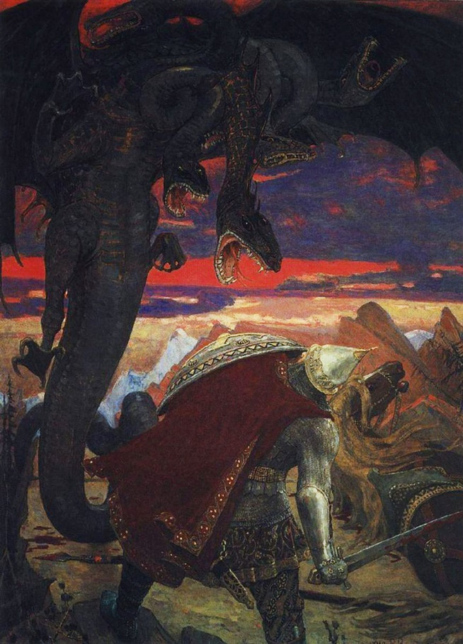

Rusalka – Water nymphs or spirits found in Slavic folklore, typically haunting rivers or lakes. They are sometimes benevolent, but they can also lure and drown humans.
Vila (plural: Vily) – Enchanting female spirits in Slavic folklore who inhabit forests, mountains, or rivers, often luring travelers with their beauty and song.
Leshy – A forest guardian spirit in Slavic mythology, often taking the form of a man who can shapeshift, controlling animals and protecting the woods.
Domovoi – A household spirit in Slavic tradition, said to protect the home and bring fortune if treated well but cause trouble if angered.
Bannik – A spirit of the bathhouse in Russian and Baltic mythology, known for its mischievous and sometimes dangerous behavior if not respected during rituals.
Strzyga – A vampiric or demon-like creature in Polish folklore, similar to a ghoul, said to have two hearts and two souls, sometimes rising from the dead to prey on the living.
Zmey (plural: Zmeyovi) – A dragon-like creature in Slavic mythology, often multi-headed and sometimes benevolent or wise, although some stories depict them as dangerous.
Giltinė – A Lithuanian death spirit or goddess, symbolized as a young woman or a crone with a long tongue, believed to foretell and bring death.
Laukų Dvasia – A Lithuanian and Latvian field spirit, often seen as a guardian of crops and nature, sometimes appearing as a spectral figure in fields.
Pūķis – A Latvian spirit, often depicted as a serpent-like or dragon creature that can bring wealth or fortune if fed milk and other offerings.
Upinis – A river spirit in Baltic folklore, known to dwell near rivers and lakes, protecting or avenging the waters if disturbed.
Chort – A demonic figure from Eastern European folklore, often a mischievous or evil spirit that causes trouble for humans.
Mara (or Marzanna) – A Slavic goddess or spirit of winter and death, often associated with the end of the winter season and celebrated during the spring festival.
Jezinka – A Czech and Slovak forest spirit or ogre-like creature, often known for its cunning nature and ability to lure people into danger.
Aitvaras – A household spirit in Lithuanian folklore, resembling a small dragon or fiery serpent, which brings prosperity to a family at the cost of great misfortune.
Vodenjak – A water spirit in Slavic mythology, often malevolent, living in rivers, lakes, or wells and sometimes dragging humans underwater.
Kikimora – A household spirit in Russian and Eastern European mythology, often associated with the female household spirits and known for either protecting or haunting a home.
Laumė (plural: Laumės) – Spirits of Lithuanian and Latvian folklore, sometimes portrayed as helpful fairies who tend to nature but can be vengeful if angered.
Navka – A Slavic water spirit similar to a Rusalka, sometimes seen as the restless spirit of a woman who died prematurely, inhabiting ponds and rivers.
Wila (or Wiła) – Enchanting and powerful female nature spirits in Polish folklore, similar to fairies or nymphs, with a strong connection to nature and the wilderness.

Other Races
Elves

Dwarves
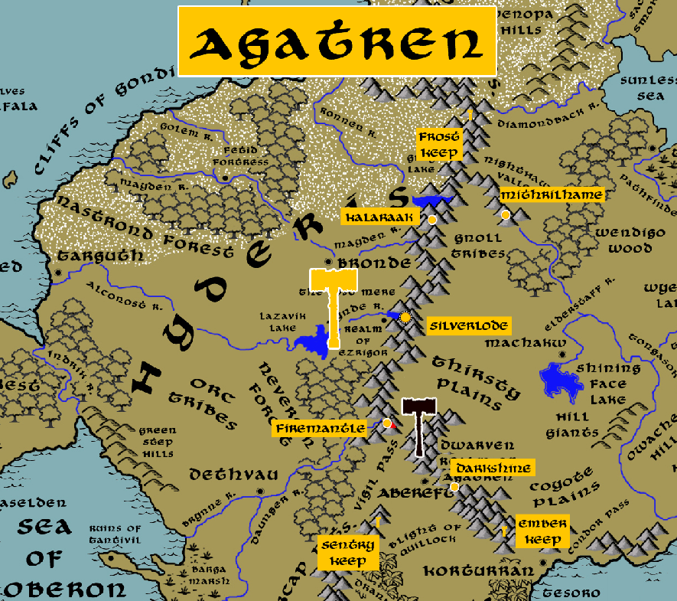

Magical Items
The Curse Mantle – artifact created by the demon Vehren, which grants terrible powers of blight and disease at the command of its wearer; stolen by Radovan in the First Primordial Age and used to corrupt the plans of present-day Hyderis

Vial of the Gray Unguent – the brown crystal vial is filled waters taken from the Gray Lake by the Mad Crone Bogdana; it destroys anything it touches and its vapors carry death; used by the heroine Radina to destroy the Curse Mantle in the First Primordial Age

The Bright Helm – a wrought iron crown fashioned in the First Primordial Age from the cages in Radovan’s slave camps, it was set upon the head of Radina the first queen of the Dvars but was transformed into a glittering copper crown that radiated courage

The Staff of Despair – forged by the witch Zorana in the Second Primordial Age; wields the power of terror over the weak-minded over a very large area, used by Zorana to incite goblin tribes to fight for her and take over the Brynne River region before she was defeated and the staff was lost

Soul Reaver - legendary light axe in the sagaris style known to this region and which was first carried by Surdan the conqueror who founded Dethvau 80 AA3. Now carried by the sitting ruler of Dethvau

The Sword Luxeria – magic sword of the Vonsveta or Warriors of Light; first wielded by Bajarnen legendary ranger of the Dvars, who was the first Vonsveta and who died slaying the dragon Fyrygh; his magic sword is passed on to each generation to wield and protect the land

Scoparia - a magical plant that is intelligent and resembles a scrub brush native to the Hyderian plains. The Scoparia generates offspring that roll as tumbleweeds across the plains, serving as spies for the Scoparia and in turn the wizard Arsalion who commands it from his lair in the Nastrond Forest.

The Mindless Garland - a necklace of enchanted emeralds. The chief and largest emerald is capable of commanding the minds of any who wear the lesser gems. The wizard Terpstra of Targuth currently wears the chief gem under his garments and is methodically placing them on key figures in Targuth, starting with Lord and Lady Kootstra. Terpstra long ago entered a pact with the infernal arch-demon Howzilith who has bent him to doing his bidding in the Hyderian lands and gave him the Mindless Garland to enslave its leaders.

The Brand of the Sagaris – The brand given by the warriors of the Druzhina fellowship to those who master their teachings. The brand imbues certain protections on the wearer that only work if they carry no magic on their person.

Triglav flowers – flowers that grow from the blood of the magical goldenhorn bucks. These grant enormous life power and healing properties when eaten. In the event of an injury, the goldenhorn will attempt to leave a trail of its own blood, within which will grow a patch of blood-red flowers. Whether or not any other species can safely partake of the flowers is unknown, but if the Goldhorn manages to eat of the sanguine-colored blooms, they will not only be healed of the former injury, but will gain extraordinary strength, durability and stamina with which to drive the enemy away.

Ravenous Chest of Emek – A cursed chest which has no visible opening and can only be breached by dark powers. It consumes the souls of the living, storing them until its master releases them. It was created in the Second Primordial Age by the evil cleric Emek. It was found by the evil cleric Asparuh in the Third Written Age, who used it to launch an army of the undead across the Hyderean lands. It was lost again in the Battle of Fetid Fortress in 741 WA3, when the fallen paladin Ezrigor stole it after becoming a vampire. It remains with Ezrigor now in his cursed castle Vurkhoven in eastern Hyderis.

Harvester Blossom – This cursed flower resembles an extremely large tulip bulb the size of a full-grown man. It has an unsettling purplish color to it and emanates an aura of evil. The blossom first came to life in the Fourth Primordial Age when Azov, Mistress of the Copper Mountain, granted the hero Ilian one of her Zhivot seeds to defeat the evil cleric Zmeyo and his Hollow Host of demon riders. The seed blossomed into a flower full of life force and swallowed the demons, but the petals snapped shut and the flower died. Ilian pruned the bulb of the flower and stored it away. But it was found again by the fallen druid Bozhura who opened it to unleash the Hollow Host and terrorize the land. In 530 AA4 heroes slew Bhozhura and banished the Hollow Host, then closed the blossom and hid it away. It is now buried beneath the cathedral in Bronde. It is said to hunger for souls, good or evil, having acquired a taste for them.

Zhivot Seeds – these are magical seeds from the secret garden of Azov, Mistress of the Copper Mountain. It is unknown exactly what the properties are of the seeds, for they are only acquired as gifts from Azov. But the most famous seed was granted to the hero Ilian in the Fourth Primordial Age, who used it to consume the demonic riders of the Hollow Host.

NPC Templates
This is a list of notes and stats to help develop NPC’s relevant to this region.

Developer Notes
This is a list of notes on the development of this document, including notes on history, culture, and changes to the document.
Hyderis draws from the eastern European people of the Black Sea region, specifically the Scythians, the Slavs, and the people of the Ottoman Empire. Also the Cossacks.

The Scythians were an ancient Eastern Iranian equestrian nomadic people who had migrated from Central Asia to the Pontic Steppe in modern-day Ukraine and Southern Russia from approximately the 7th century BC until the 3rd century BC. Skilled in mounted warfare, the Scythians replaced the Cimmerians as the dominant power on the Pontic Steppe in the 8th century BC. In the 7th century BC, the Scythians crossed the Caucasus Mountains and frequently raided West Asia along with the Cimmerians. After being expelled from West Asia by the Medes, the Scythians retreated back into the Pontic Steppe and were gradually conquered by the Sarmatians. In the late 2nd century BC, the capital of the largely Hellenized Scythians at Scythian Neapolis in the Crimea was captured by Mithridates VI and their territories incorporated into the Bosporan Kingdom. By the 3rd century AD, the Sarmatians and last remnants of the Scythians were overwhelmed by the Goths, and by the early Middle Ages, the Scythians and the Sarmatians had been largely assimilated and absorbed by early Slavs. The Scythians were instrumental in the ethnogenesis of the Ossetians, who are believed to be descended from the Alans. After the Scythians' disappearance, authors of the ancient, mediaeval, and early modern periods used the name "Scythian" to refer to various populations of the steppes unrelated to them.
The Scythians played an important part in the Silk Road, a vast trade network connecting Greece, Persia, India and China, perhaps contributing to the prosperity of those civilizations. Settled metalworkers made portable decorative objects for the Scythians, forming a history of Scythian metalworking. These objects survive mainly in metal, forming a distinctive Scythian art.
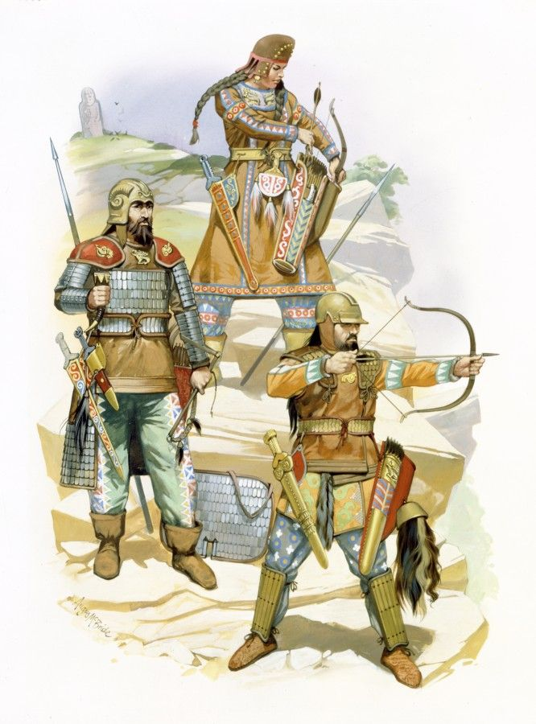

The Ottoman or Turkish Empire controlled much of Southeast Europe, Western Asia, and Northern Africa between the 14th and early 20th centuries. It was founded at the end of the 13th century in northwestern Anatolia in the town of Söğüt (modern-day Bilecik Province) by the Turkoman tribal leader Osman I. After 1354, the Ottomans crossed into Europe and, with the conquest of the Balkans, the Ottoman beylik was transformed into a transcontinental empire. The Ottomans ended the Byzantine Empire with the conquest of Constantinople in 1453 by Mehmed the Conqueror.
Under the reign of Suleiman the Magnificent, the Ottoman Empire marked the peak of its power and prosperity, as well as the highest development of its governmental, social, and economic systems. At the beginning of the 17th century, the empire contained 32 provinces and numerous vassal states. Some of these were later absorbed into the Ottoman Empire, while others were granted various types of autonomy over the course of centuries. With Constantinople (modern-day Istanbul) as its capital and control of lands around the Mediterranean Basin, the Ottoman Empire was at the center of interactions between the Middle East and Europe for six centuries.

Hyderis Names
Bulgarian http://www.fantasynamegenerators.com/bulgarian-names.php
Chechen http://www.fantasynamegenerators.com/chechen-names.php
Czech http://www.fantasynamegenerators.com/czech-names.php
Dutch http://www.fantasynamegenerators.com/dutch_names.php
Estonian http://www.fantasynamegenerators.com/estonian-names.php
Finnish http://www.fantasynamegenerators.com/finnish-names.php
Frisia http://www.fantasynamegenerators.com/frisian-names.php
Georgian http://www.fantasynamegenerators.com/georgian-names.php

Names for chieftains or lords: Knyaz (lord) Knyaginya (lady)
Knyaz or knez (князь) is a historical Slavic title, used both as a royal and noble title in different times of history and different ancient Slavic lands. It is usually translated into English as prince, duke or count, depending on specific historical context and the potentially known Latin equivalents of the title for each bearer of the name. In Latin sources the title is usually translated as comes or princeps, but the word was originally derived from a common Germano-Slavic *kuningaz (king).[1][2] The female form transliterated from Bulgarian and Russian is knyaginya (княгиня), kneginja in Slovene and Serbo-Croatian (Serbian Cyrillic: кнегиња). In Russian, the daughter of a knyaz is knyazhna (княжна). In Russian, the son of a knyaz is knyazhich (княжич in its old form).[3]
The title is pronounced and written similarly in different European languages. In Serbo-Croatian and some West Slavic languages, the word has later come to denote "lord", and in Czech, Polish and Slovak also came to mean "priest" (kněz, ksiądz, kňaz) as well as "duke" (knez, kníže, książę, knieža).[4] In Sorbian it means simply "Mister" (from "Master".

Clothing
When medieval Russians dressed both men and women put on a garment called a rubakha first. This was a simple tunic with a high neckline and very long sleeves which they could pull over their hands to protect them from the cold. These were made out of heavy wool or linen. These were worn with a belt in an ancient belief that belts kept evil spirits away from their wearers. They often wore another rubakha over this. Women wore various pieces of clothing over their rubakha. They sometimes wore a shorter tunic called a navershnik over their rubakhas. These might be different colors; the most popular color for clothes in medieval Russia was red because the people loved bright colors. Green and blue were also popular. They often embroidered their clothing with red thread if the garment itself was not red. Women might also wear a panova, which was a skirt of three separate panels of fabric attached to a leather strip, which was used to tie the garment around the waist. Since this skirt opened at the front, it looked rather like a "reverse apron." Another popular garment, mainly for unmarried girls, was a zapona. This looked much like a tabard except for being narrowly stitched at the sides. Men wore tunics over trousers. The next layer of clothing for both men and women was a coat called a svita. Over the svita a cape or mantle might be worn. It was not uncommon to wear all of these clothes inside as well as when they ventured out into the cold.

The cut and shape of Russian costumes were basically the same for all classes. The main difference between the clothing of the wealthy and the peasants was in the fabric. The peasants wore clothing of rough wool and linen; the wealthy wore brocade, taffeta, and velvet, all made out of silk and imported from either Constantinople or Alexandria. On ceremonial occasions, Russian royalty and nobility wore ornate tunics called dalmatiks. This was originally a Byzantine garment adopted by the Russian rulers in the tenth century. Early on, Russian rulers wanted to unite the country into an Empire and rule it with absolute authority, just like the Byzantine Emperors. These garments were worn over a rubakha and another long tunic. Over the dalmatik they would wear a collar, which they called an ozherelya. Both dalmatiks and ozherelyas were heavily embroidered with pearls and precious stones like diamonds and rubies. Dalmatiks and ozherelyas were so heavy that the people who wore them had to be pulled by a servant when arising from a chair! Over this court garb many wore mantles and coats. Russians of all classes wore fur on their clothing. The peasants might wear sheepskin while the nobility wore more expensive furs like sable and ermine. However, the purpose of clothing for both rich and poor in period Russia was the same: keeping warm!
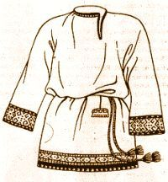
Rubakha

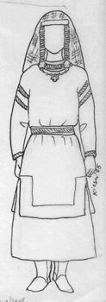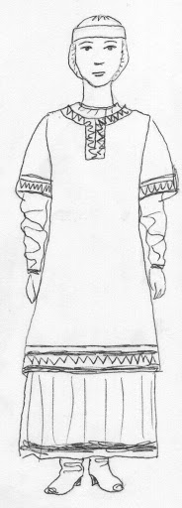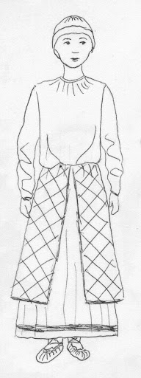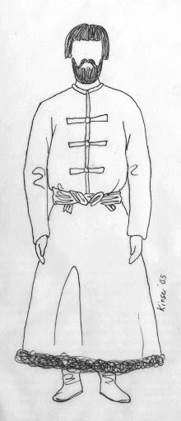
Navershnik – shorter tunic over the Rubakha ; Panova (2nd from right); Svita (far right)
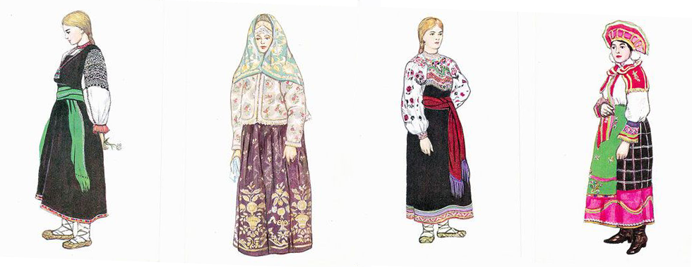
Scythians and Cimmerians as equivalent to Dvars
Bronze pointed/conical helmets
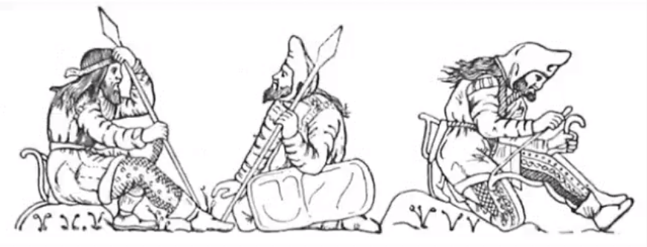

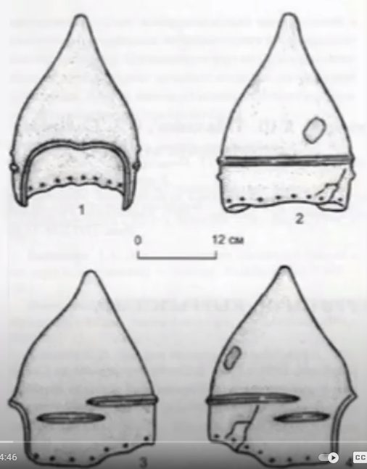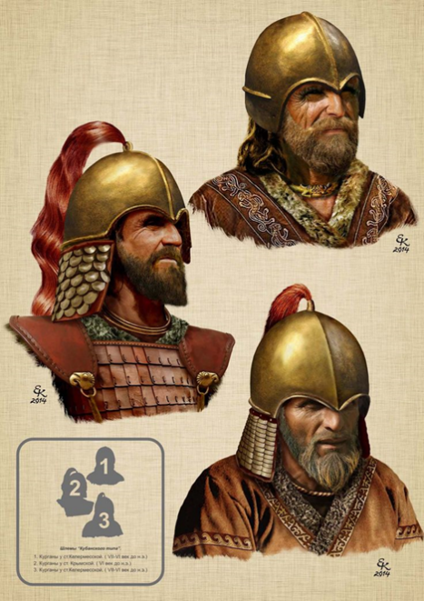
Weapons: axes (Sagaris), javelins, spears, lances, short swords, daggers, composite bows a primary weapon; heavy cavalry
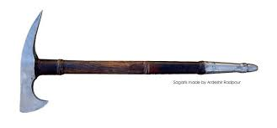
Sagaris axe used by the Scythians
Use of javelins to attack from a distance, often from horseback
Sarmatian helmet – the Kuban helmet

Druzhina
Druzhina, drużyna, or družyna (Slovak and Czech: družina; Polish: drużyna; Russian and Ukrainian: дружи́на, druzhýna literally a "fellowship") in the medieval history of Kievan Rus' and Poland was a retinue in service of a Slavic chieftain, also called knyaz. The name is derived from the Slavic word drug (друг) with the meaning of "companion, friend".[1][2] The English equivalent is retinue.

Bogatyr
A bogatyr is a stock character in medieval East Slavic legends, akin to a Western European knight-errant. Bogatyrs appear mainly in Rus' epic poems—bylinas. Historically, they came into existence during the reign of Vladimir the Great (Grand Prince of Kiev from 980 to 1015) as part of his elite warriors (druzhina), akin to Knights of the Round Table. Tradition describes bogatyrs as warriors of immense strength, courage and bravery, rarely using magic while fighting enemies[2] in order to maintain the "loosely based on historical fact" aspect of bylinas. They are characterized as having resounding voices, with patriotic and religious pursuits, defending Rus' from foreign enemies (especially nomadic Turkic steppe-peoples or Finno-Ugric tribes in the period prior to the Mongol invasions) and their religion. In modern Russian, the word bogatyr labels a courageous hero, an athlete or a physically strong person.

Hussars
Hussars were light cavalry soldiers who fought in Europe from the 15th to 19th centuries. They were known for their flamboyant uniforms and were often used for reconnaissance and skirmishing. The term "hussar" originated in Hungary or Serbia, where they were light raiders. The Hungarian hussars were known for their brightly colored uniforms. The Polish hussars were heavy shock cavalry that developed in the 16th and 17th centuries.
Equipment
Hussars wore light armor, such as shields and thick coats. They rode fast horses and were often equipped with pelisses, which were short jackets with fur edges. They also wore busbies or shako fur hats.
Battle tactics
Hussars were shock troops who used their uniforms to instill fear in their enemies. They were effective for scouting and raiding lightly guarded areas.
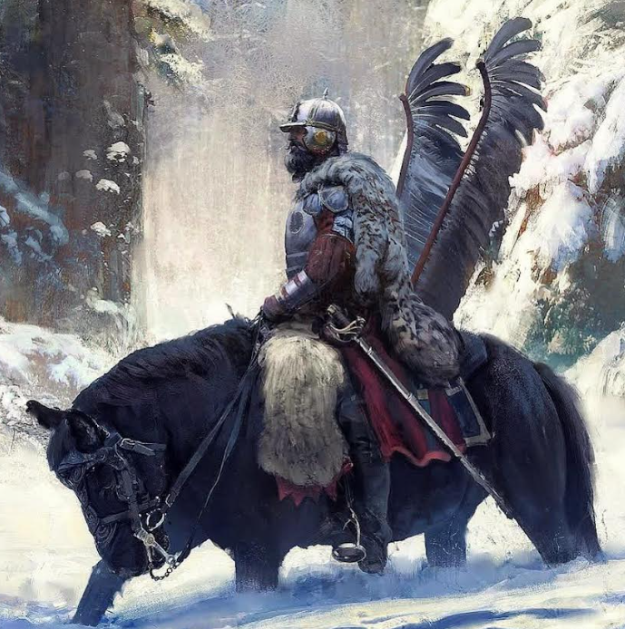
From Facebook, may require verification:
The towarzysz usually wore a leopard (sometimes tiger, jaguar, or lion) pelt over his left shoulder, or as often depicted in the surviving Podhorce Castle paintings, he had the exotic pelt underneath his saddle or wrapped around his hips. Wolf, brown bear and lynx pelts were reserved for leaders and veterans (starszyzna). ("Towarzysz" is a Polish word that translates to "companion" in English. It can also be used as a military rank or to refer to a fellow member of a group. "Towarzysz" was a military rank in the Polish–Lithuanian Commonwealth from the 16th century until 1795. It was used for junior cavalry officers or knight-officers. "Towarzysz" was also the rank of a senior soldier in the Polish winged hussars.
The winged hussars' military prowess peaked at the Siege of Vienna in 1683, when hussar banners participated in the largest cavalry charge in history and successfully repelled the Ottoman attack.⁣
From 1576 to 1653, hussar armor consisted of a comb-like zischagge (szyszak), burgonet or morion helmets with a hemispherical skull, 'cheekpieces' with a heart-shaped cut in the middle, neck-guard of several plates secured by sliding rivets, and adjustable nasal terminating in a leaf-shaped visor. Zischagge and kettle hat helmets for the lower rank (retainers) were often blackened as was their armor. A cuirass (breast plate), back plate, gorget, shoulder guards and of the Great Steppe, Western vambraces with iron glove and later, during the 1630s, the Persian-originated karwasz vambrace, for forearm protection. A towarzysz also could wear tasset hip, cuisse thigh and poleyn knee protection, underneath a thigh-length coat of mail or specially padded coat with mail sleeves. Retainers usually wore less expensive and older armor, often painted black, and, after the 1670s, might have no cuirass, according to some sources.
The cuirass of a Polish winged Hussar, victorious at the Siege of Vienna on 12 September 1683. The events that transpired that day inspired J.R.R. Tolkien's events at the Siege of Minas Tirith in his novel The Lord of the Rings.
After having been besieged for two months by the Ottoman Empire's 120,000 strong army, the Viennese garrison was growing weak and only a handful of infantry was left. Several Ottoman explosive charges had been located within the city walls and defused, but time was running out. A messenger managed to slip past the Ottoman lines to call for help from the Polish-Lithuanian Commonwealth and the Holy Roman Empire.
It is recorded that, just as all hope seemed lost for the last remaining infantry, being pinned down amidst the fighting and facing a seemingly certain death - a number of Polish cavalry emerged slowly out of the forest, to the cheers of the onlooking infantry. Polish King Jan Sobieski III came charging down the hill. From behind the hill, 18,000 cavalry would emerge from the forest and follow him into battle. Of these, 3,000 were heavy Polish winged Hussars. This was the largest single cavalry charge in recorded history.
The effect of this charge was so dramatic - so destructive - that it sealed the end of the Ottoman Empire's 300-year expansion into Europe. After the battle was won, King Jan Sobieski III paraphrased Julius Caesar's famous line, saying "Venimus, vidimus, Deus vicit"- "We came, we saw, God conquered".

