Notes on the lands of Treviland

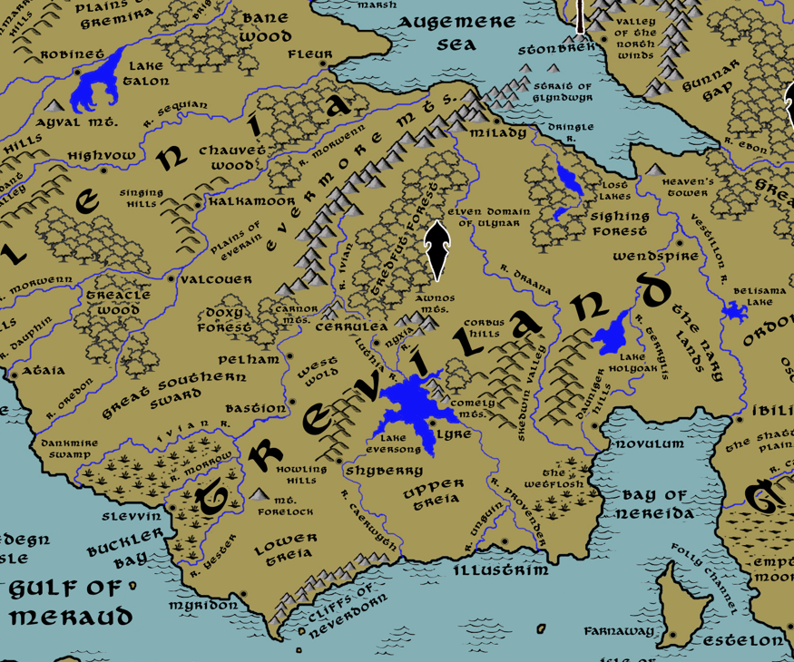

Table of Contents
- Overview
- Towns and Cities
- Best in the Land
- Stewards of Power in this Land
- Points of Interest
- History
- Local Goods
- Notes on Culture
- Weapons and Armor
- Local Deities
- Creatures
- Other Races
- Magical Items
- NPC Templates
- Developer Notes

Overview

(Overview of the History of the West)
At the dawn of the west there came the man-tribes: the Phranes in the west, the Druuns and Gaufs in the north, the Volds in the south, and the Vells in the east. Great powers of magic rose against them and threatened to blot them out. But the hearts of men held out and great deeds were done. Then came the Great Wizard War, when magic itself was stymied for a time, and the Ancient Ages saw new civilizations: the Druuns and Myrda in the north, the Vards and Fenns in the northeast, the Harduin and the Savrens in the west, the Hundra Eymor to the south, and the Tuscorans and the Aldeians in the east. But another cataclysm came and from the ashes the enlightened kingdoms appeared: Plenia in the west, Treviland to the south, Erigoth to the northeast, Tirudor in the east, and the lands to the north lost to Orcs.

“Take me to the fields of bluebells and foxglove, to taverns at every cross road, to old Trevilish songs sung with a pint and a pipe. From the rustic wolder-folk in the north to the merry music-makers of Lyre; from the sea-drenched walls of Myridon to the sullen men of Novulum: all of ‘em crown the glittering jewel of Illustrim: the shining city and greatest in the west.”
- Passage from the ‘Maid of Kendor’
Treviland is one of the four kingdoms of the west. It is a land of sheep, of ale, of mysterious standing stones, and of a whimsical gentility claimed even by the common folk. Raised up from barbaric tribes that survived occupation by Celedon, the kingdom has grown fast and set its eye on exploring the world. Yet it finds itself still locked in ages-old rivalries with its neighbors both politically and religiously.

The lands of Treviland extend from the Morwenn River in the west to the Terrylis River in the east, and from the shores of the Augemere in the north to the coastline meeting the Ferrago Sea in the south. In Primordial times these were the lands of the Vold tribes, and in the Ancient Ages the Eymor and the Hundra. After the Celedon Empire was driven out, there came the tribes of the Brimmor, the Swinta, the Hartha, the Culver, the Wolder, the Wicla, and the Scildr. Today the people identify as Trevilish, though each of the seven regions carries the name of their original tribes that came out of the Celedonian occupation and cling to their ancestral traditions.

Peoples of Treviland
Treviland is made up of seven regional peoples that have risen during the Written Ages.
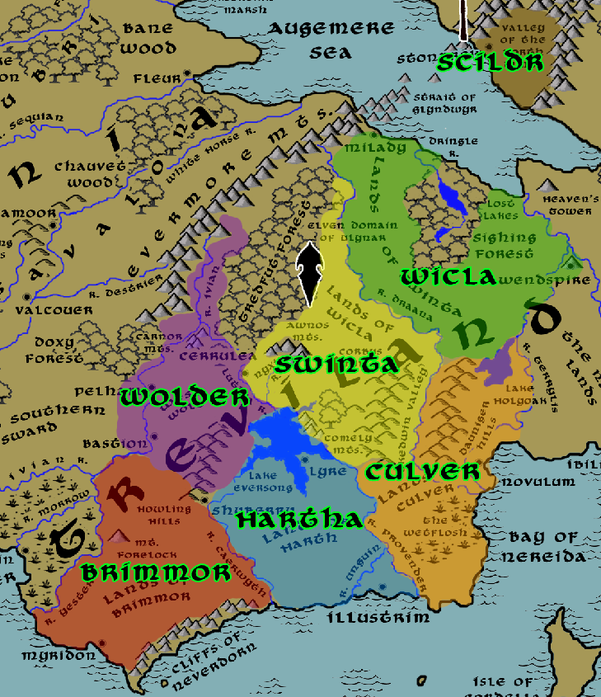

Brimmor - The Brimmorans dwell in the region governed by Myridon. Their lands extend Ivian River where it is flanked by the Howling Hills in the north down to the southern coastline, and from the Yester River in the west to the Caerwyth River to the east.
Hartha - The Harthans dwell in the region governed by Illustrim and includes Lyre. Their lands extend from the northern banks of Lake Eversong in the north down to the coastline to the south, and from the Caerwyth River in the west to the Provender River in the east.
Wolder - The Wolders dwell in the region governed by Pelham and includes Bastion. Their lands extend from the lands just north of the Carnor Mountains in the north down to the Howling Hills in the south, and from the western banks of the Ivian River in the west to the western shores of Lake Eversong in the east.
Swinta - The Swintans dwell in the region governed by Cerrulea. Their lands extend from the Augemere Sea to the north to the Draana River and the northern edge of the Dauniger Hills in the south, and from the Draana River in the west to the Terrylis River in the east, albeit with a bit of land just beyond where the Terrylis and Vestillon Rivers split.
Culver - The Culvers dwell in the region governed by Novulum. Their lands extend from the northern banks of Lake Holyoak in the north down to the coastline in the south, and from the Provender River in the west to the coastline of Nereida Bay up along the Terrylis River in the east.
Wicla - The Wiclans dwell in the region governed by Wendspire includes Milady. Their lands extend from the eastern flank of the Tredfut Forest in the north to where Lake Eversong spills into the Provender River in the south, and from the Luthia River in the west to the Draana River in the east.
Scildr - The Scildrs dwell in the region governed by Stonbrek. Their lands cover the Valley of the North Winds and some of the Evermore Mountains that encircle it.

A Brief History of Treviland

The Kingdoms of the West were born two thousand years ago in the Second Written Age. Hundreds of tribes rose up against the waning power of the Celedonian Empire and drove them out.
Such was the turmoil that followed that the holy cities of Indiron and Hylux moved in, hoping to shape the new world. This led to the War of Cathedrals (470 WA2 – 560 WA2) as armies within the three kingdoms turned on one another. Even today the lands are divided between the faiths of Heironeous and Pelor.

A thousand years ago, during the Third Written Age, a Trevilish chieftain named Renus fought the War of the Secondborn with Plenia and Tirudor. He won and anointed himself “Hyrennus” in honor of his god. But, soon after, the Second Dark Crusade threatened to lay waste to the land. The Trevilish prevailed along with its allies in the west.

Finally, as recent as the current age (WA4) hostilities broke out once again between Treviland and its neighbors during the War of the Red Moons (150 WA4 – 260 WA4).

The House of Ballaster has ruled over the land now for four hundred years, but there is great unrest amidst the regions. Novulum to the east makes its bid to take over the kingdom, while Illustrim rules with firm authority. The rest of the land waits breathlessly for war to break out within, all while eyeing Plenia and Tirudor for attacks from without.

Towns and Cities

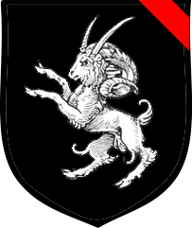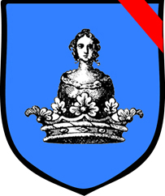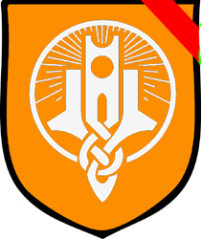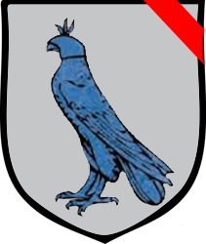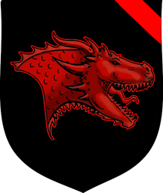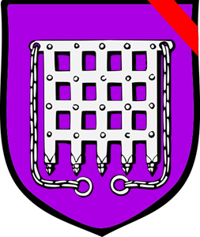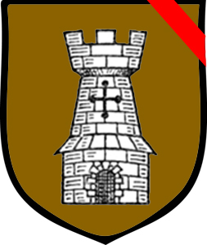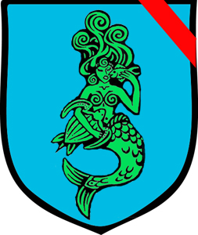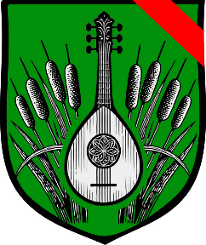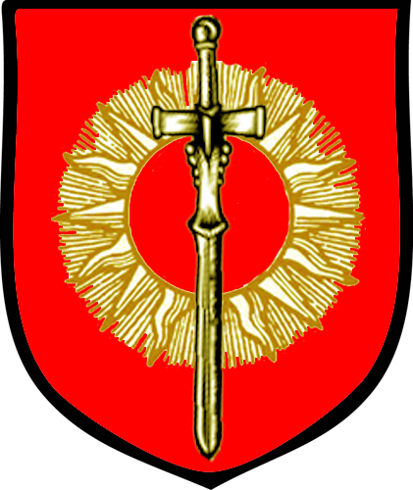
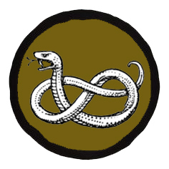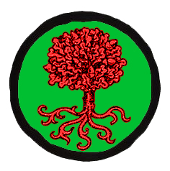

- Stonbrek – large town, sign of the ram, House Camby
- Milady – large town, sign of the queen and her crown, House Hillock
- Wendspire – large town, sign of a winding stair up a hill, topped with a tower, House Miter
- Cerrulea – small city, sign of the blue hawk, House Stalworth
- Novulum – large city, sign of the dragon, House Morley
- Pelham – large town, sign of the gate, House Herlen
- Bastion – large town, sign of the tower, House Lucrous
- Myridon – large city, sign of the mermaid, House Proy
- Lyre – small city, sign of the silver harp, House Sivvian
- Illustrim – metropolis, sign of the radiant gold sun and sword, House Ballaster
- Slevvin – large town, sign of the serpent, Dorean
- Shyberry - small town, sign of the tree with many roots, Oldbuck
- Villages – assorted villages, their exact locations being negotiable

Human controlled regions
This map indicates the extent of control human settlements have over the lands claimed by Treviland. The light-yellow areas include armed patrols as well as travel by merchants and regular folk. The further out from the town or city, the less likely there are armed forces present to enforce the king’s law. Areas of various other colors indicate loose tribes of humanoids that pose a danger to the land. Caution should be taken when traveling through these areas.
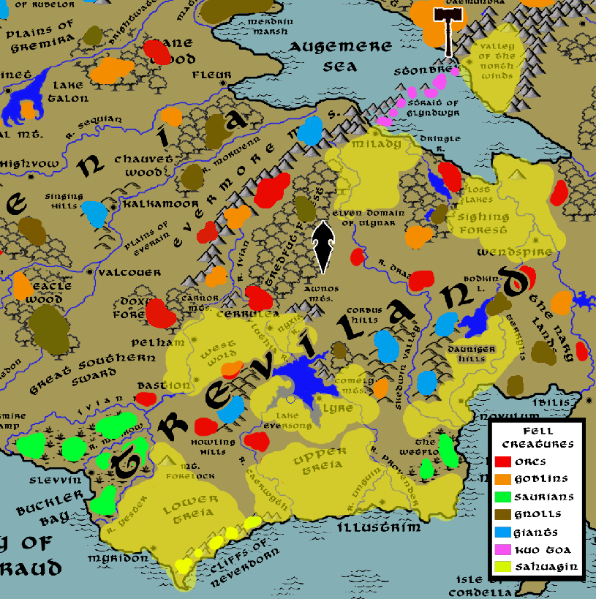

Best in the Land
Below is a list of trade goods from this land and which towns or cities generate them on a scale or quality that generate significant trade with other lands. Also listed are other, less tangible, commodities such as centers of religion, arts, and magic that create their own form of influence.

Trade Hub: Myridon, Illustrim, Novulum
Religion: Illustrim
Arts: Lyre
Magic: Illustrim
Spirits: Wendspire (Heathertop Wine), Lyre (Idlemay Wine), Shyberry
Steel: Novulum
Grain: Cerrulea, Bastion, Illustrim
Crafted Goods (e.g. Pottery, Textiles, Metal Wares):
Harvested Goods (e.g. Aromatics, Medicine, Dyes): Shyberry (tobacconist (Silversnuff))
Mined Goods: Stonebrek (stone, Guild Home), Stonbrek (iron), Novulum (iron, Guild Home)
Precious Metals: Milady (gold), Novulum (copper)
Ship Building: Myridon
Other: Wool: Milady, Cerrulea, Novulum, Bastion (Guild Home), Lyre
Textiles: Bastion, Lyre

Stewards of Power in this Land
Kings and their armies are not the only wielders of power. There are many unseen friends and foes that shape the destiny of the land. Each of the groups listed below are well known to the people of this region. Some are feared, others venerated. All of them play their part in the grand drama of this land’s story.

Merchant Companies
Silver Moon Trade Company - Novulum
Still Cloud Traders - Myridon
Heralds of Provender - Illustrim

Mercenary Companies
The Vanguard - Myridon

Smuggling Rings
Lords of Barley – Slevvin

Centers of Worship (Churches, Cathedrals, Shrines, Lodges, Temples)
Chapel of the Sacred Corbel - Stonbrek
Chapel of the Filling Heart - Milady
Diaphanous Chapel - Wendspire
Cathedral of the Threshing Floor - Cerrulea
Cathedral of the Cudgel - Novulum
Chapel of the Fire Flagon - Pelham
Chapel of the Endless Watch - Bastion
Cathedral of Following Seas - Myridon
Cathedral of Canticle - Lyre
High Cathedral of the Illumination - Illustrim
High Cathedral of the Yondalla - Shyberry (halfling)

Orders of Paladins
Heavenly Host - Wendspire
Order of the Kestrel - Cerrulea
Order of the Gauntlet - Illustrim

Druidic Circles
Cirle of the Willow - Milady
Circle of Ennuit - Pelham

Bands of Rangers
Band of the Even Star - Cerrulea

Schools of Magic
Lostros Sanctum - Cerrulea
Orealta Sanctum - Illustrim

Bardic Colleges
The Sardonic - Lyre

Warrior Academies
(none)

Assassins Guilds
Burke Brotherhood - Novulum

Cults
The Secret Hand – Lyre

Other Guilds
The Grimrodor (stone masons) - Stonbrek
Isernbrest (iron and steel) - Novulum
Epona House (wool and weavers) - Bastion
Nodens House of Shipwrights (shipwrights) - Myridon
Reaper House (casino) – Slevvin

Monasteries
Monastery of the Sorceled Star - head of the Ivian River in the Evermore Mountains
Monastery of the Night Queen - Mt. Forelock
Monastery of the Sacred Grove - Serpsis Valley near the River Hawkturn
Monastery of the Petrichor – Lands of the Wetflosh

Pirates
(none)

Points of Interest
- Buckler Bay – Dark, murky waters sit at the mouth of the Morrow River. Here, dense roots of swamp trees snake outward keeping boats from making landfall. The wrecks of a hundred ships can be seen lying just below the surface, making navigation dangerous at night. Most merchant ships steer away from Buckler Bays for fear of pirates, for these waters are controlled by the outlaw town of Slevvin. The Myridon fleet has found it hard to enforce the king’s law this way and so there is little protection for a ship that goes astray.
- Gulf of Meraud – The Gulf of Meraud is called the antechamber of the western seas. All traffic passing from the Ferrago Sea westward travels through here between the Trevilish shoreline to the north and the Celedonian shores on the south. Coastal cities in this area often try to exert their control over these waters. The Trevilish city of Myridon often grapples with the Plenish city of Ataia but the Holy City of Hylux to the south has commissioned peacekeeping vessels to cite the will of the church in staving off conflict. Several historical battles have been waged in the Meraud, littering the sea floor with the wrecks of war ships. It is said on clear moonless nights one can see the ghost ship Ifurin, a Plenish ship sunk in these waters four hundred years ago. It is captained by the damned and said to drag the ships of the living into the depths.
- Cliffs of Neverdorn – The low mountains that top the easterly shores here are known as the Shield of Myridon, for storms blowing in from the east barely reach the city of Myridon. Instead, these cliffs are buffeted year-round by strong winds and towering waves. Sea captains warn of strong tidal forces that pull unwary ships off-track as they pass westward from the Ferrago Sea and drive them into the cliffs. Legend tells of a jealous sorcerer from Myridon named Hijeryon who centuries ago coveted the noble lady Saebaia. When Saebaia was betrothed to a Tirudoran prince, Hijeryon flew into a rage and caused the prince’s approaching ship to be dashed on the cliffs. It is said that Saebaia retreated to a reclusive life as a priestess of Pelor. Her ghost is said to wander the cliff tops at night.
  - There are underwater caves at the foot of the cliffs that are home to a mighty Sahuagin colony that goes by the name of the Aeralugh, known by their sign of the trident skewering a fish. They have burrowed up into the mountains and have strongholds looking out onto the Lower Treias plains. At times the Aeralugh numbers reach a point that they make trouble in this region.
  - In this region dwell the tribe of Storm Giants known as the Skylfalla, known by their sign of a circular swirl breaking against three jagged lines. It is rumored the giants hold sway over the winds and waves in the Straits of Fortune. This is only true when they are disturbed by passing ships or angered by the folly of men. Or if they are bored.
- Strait of Glyndwyr – Where the Evermore Mountain range dips into the Augemere Sea, only the tops of the mountains can be seen peeking up out of the water. Here there are channels winding through the slick, moss-covered slopes. But the ways are tight and perilous. The wide opening of the Strait is the only safe route through. Here also dwell the Kuo Toa of the Bwytawyr Clan. They are extremely dangerous and attack any ship trying to pass this way but since the fall of the North few ships find any need to travel north of the Strait.
- Causeway Bay – The eastern arm of the Augemere Sea narrows here as it feeds the Ebon River, flowing to the Howling Sea. The bay separates the savages of Gunnar Gap on the north bank from the northernmost lands of Upper Ordonia on the opposite bank. Many great battles have converged here over the years, most notably in 648 WA3 and the Battle of Causeway Bay during the Second Dark Crusade. Erigoth troops trapped in the Gunnar Gap were rescued by Tirudoran soldiers who built a makeshift bridge across the Ebon River from timbers from the Elderwood Forest. The holding action resulted in several companies making it west before Mortavay's forces overwhelmed the region. It also earned the area its name.

- Augemere Sea – large body of water that dominates the center of Western Amadar and is bordered by Plenia, Treviland, Erigoth, and the lost lands of the north. The Evermore Mountain range cuts through the center of the lake, broken up into submerged peaks that appear here and there along the surface. These peaks and surrounding rocks make passage over the water treacherous. The Strait of Glyndwyr is the safest route through these rocks.
  - The Dwarven Kingdom of Demundra spans the area beneath this sea. They are skilled at managing bulwarks against the water and guard against evils of the deep that enter their kingdom from the sea.
  - Here dwell the tribe of Storm Giants known as the Grondar, known by their sign of the three peaks beneath waves. The giants spend half their time beneath the sea, the other half roaming the jagged rocks protruding from the sea. They tend to keep to themselves, but are thought by some to bring foul weather to boats if disturbed. Grondar is the old Trevilish word for “Thunderwave.”

- Doxy Forest – The Doxy Forest is a wild and untamed wood, filled with dryads who are jealous of their privacy. To the north, near the foot of the Evermore Mountains, giant spiders have taken residence. Their great webs are impossible to see, ensnaring unwary travelers. It is said the wicked spider Elselkess rules over his kin and plots to invade the Evermores and take back the under lands there.
- Tredfut Forest –The Tredfut Forest is the largest forest in Treviland and filled with wonders. An ancient green wood, it is home to a vast array of magical creatures such as treants, fairies, brownies, pixies, unicorns, and sprites. These reside in peace alongside the Elves of the domain of Ulynar, who consider the forest their protectorate. Towering over all these creatures is the oldest of treants, Oakbold the Forgetful. He is a wise and compassionate creature who shepherds the creatures of the forest but is often unseen for months as he wanders off absent-mindedly.
  - Even so, there are gnolls who dwell in the northern reaches in the shadow of the Evermore Mountains as well as orcs that live in the far south near the Carnor Mountains, which are called Drulukk Orcs. Some say the great spiders once dwelled here, but they’ve moved on to the Doxy Forest.
- Sighing Forest – the site of one of the settlements of the Elven Domain of Ulynar, also the site of the Lost Lakes

- Plains of Everain – flat lands stretching from the Singing Hills to the Evermore Mountains, it is a dreary and flat land, perennially covered in sullen clouds and rain showers. The land here is soft and slick with mud, prompting travelers to hurry through here or around, and always an obstacle to armies on the march. Some say the rain is enchanted and will last forever. Others warn to take heed, as there are often fell creatures lurking in the inclement weather.
- Great Southern Sward – an immense stretch of plains and grasslands west of the Ivian River. The land here is fertile but wild, with tall grasses dominating the soil and making farming difficult. This region is currently under Plenish control but has changed hands between them and the Trevilish several times. It is frequently the site of major battles. It is said the tall grasses conceal the remains of a hundred thousand slain warriors. A prophecy warns of a necromancer who will raise the dead hidden on the Great Sward and march them to conquer the west.
- Lands of Brimmor -
- Lands of Hartha -
- Lands of Culver -
- Lands of Wolder -
- Lands of Swinta -
- Lands of Wicla -
- Lands of Scildr Nary Lands - the delta and all lands south of the split between the Terrylis and Vestillon Rivers. The region is a dangerous no-mans-land where countless battles have been waged between Treviland and Tirudor for who will control it. Today it remains a wild region filled with dark creatures and frequented by war parties spoiling for a fight.

- Ivian River – site of the Monastery of the Sorceled Star, where monks train and study in the ways of Sirona, star goddess, and Noctiluca, goddess of magic
- Morrow River
- Yester River
- Luthia River
- Nyxia River
- Caerwyth River
- Unguin River
- Provender River
- Draana River
- Dringle River
- Terrylis River

- Eversong Lake – a large lake system fed by the Luthia River and which in turn lets out at the Caerwyth and Provender Rivers. The town of Lyre dominates the southern banks of the lake. Boats from Cerrulea make regular passage south to Illustrim across these waters. The lake is home to Melusine, a powerful water spirit that rules over the lake and the many lesser water spirits and Nyads who dwell in it and its rivers.

  - On the western bank of the lake stands the secret keep of Hereswith (f) the Cunning, Arch Mage of the Trevilish lands.
- Lost Lake – site of the calamity in 420 AA4 when the evil cleric Dawinnis angered the gods and caused the town of Serene to sink to the bottom of the lake. The ruins of Serene lie deep beneath the surface to this day. Some say that secrets remain here from the ancient times, but that a mysterious race of creatures has taken up residence here.
- Lake Holyoak -

- Dankmire – This is a vast wetland stretch from the Ivian River in the west to the Yester River in the east, with the Morrow River running through the middle of it. It is a dark and dangerous place. Tall, gnarled trees rising up from the water to blanket the interior in darkness with their overhead canopies. Enormous poisonous serpents, toads, and salamanders lurk in the waters. Sea hags are known to build their lairs in the hulks of giant rotting tree trunks. Time passes strangely here, it is said. And the vapors of the waters create noxious fumes. On the western banks of the Dankmire sits the pirate town of Slevvin.
  - The Saurian tribe, the Khusk, dominates the northern half of the swampland
  - Oghiniam, a ferocious black dragon, makes his lair here
- Wetflosh – The boggy mires of the Wetflosh are a place of dread: the skies seem perennially gray, nasty insects swarm overhead like clouds. An unsettling stench hangs over the putrid water. Lurking within the waters are enormous eels. Hiding within the reeds scamper water goblins. Mud huts lay hidden deep within where hags spin strange curses. But, against all odds, there also dwell humans: the shabby and unwelcoming Floshen folk. They are short, thin people who ply the waters on light, flat boats they push along with poles. They are notorious thieves and much maligned by anyone outside the Wetflosh. They are a reclusive bunch except when it comes to trading, then they become very fast talkers and very persuasive. They have a reputation for being sneaky and untrustworthy but handy with building and repairing things. Their clothing lacks color, usually some shade of gray. It is oily and reeks of pyrethrum, which comes from the dried, crushed flowers of certain chrysanthemum species and serves as an insect repellant.
The marshlands have played a historical role, separating Illustrim and Novulum and preventing successful marches between them. Even those who think they know a safe way around them have been surprised, for the borders of the bog seem to shift and move, threatening to swallow up any who venture too near it.
  - site of the Monastery of the Mystic Mists, where monks train and study in the ways of Bussumarus, weather deity who controls the rain, wind, hail and fog

- Evermore Mts. – Sung in songs and mentioned in many a saga, the ancient bulwark of the west (as it is called) runs from the midst of Treviland’s western lands all the way northward to the frigid waters of the Heedless Straits where the Erigots built the town of Hammer Hold. It even cuts across the Augemere Sea, its mountain range plunging beneath the water’s surface with ony the tips of its peaks showing and forming a dangerous reef. Countless battles have waged around and within this storied range and many armies have broken against it.
  - Within these mountains stand the halls of the Dwarven Kingdom of Demundra
  - Here dwell the Orc tribes that call themselves the Yargol, whose sign is that of the broken spear
  - At the southern reaches dwells Isienth, an old copper dragon. Known as Isienth the Wise, she has been a protector of upper Kendor for centuries. It was she who helped Travix the Moth-eaten rout the orcs of the Awnos Mountains four hundred years ago. None know the location of her lair, but those who seek her counsel may scale the high hill of Adathorn where a lone tall tree stands. If one hangs a gem of exceeding brightness and beauty, Isienth is likely to come.
- Carnor Mts. – The low grey peaks of the Carnors represent the southernmost spur of the Evermore range. They are bleak, uninviting mountains with little vegetation and animal life. They form the western boundary of the Kendor Vale, the lands around the town of Cerrulea.
  - Here dwell the Drulukk, a tribe of Orcs known by their sign of the dead bird
  - Location of the ruins of Khundrukar, a Dwarven colony from Demundra that was wiped out by Drulukk Orcs
  - This was the site of the Battle of Carnor Mountains in 111 AA3, where King Reglif of Hundra slew King Aelmen of Eymorwhich, ending the War of the Lost Sons and beginning six hundred years of Hundran rule of the lands of present-day Treviland.
- Awnos Mts. – The shimmering purple peaks of the Awnos Mountains stand out prominently amidst the green fields of the Wicla Lands. The range forms a horseshoe, enclosing the Vale of Faerdeep within which can only be approached from the west. The Awnos represent the easternmost borders of the Kendor Vale, the lands around the town of Cerrulea.
  - Tucked away in one cleft between peaks stand thousands of stone statues of goblins, figures frozen in various poses of terror. These were goblins following Phlazik, their chieftain, in 32 WA4 when they sought to take over Treviland with the Seeds of Madness. But the wizard Travis the Moth-Eaten turned them all to stone.
  - Here dwell the Bagrak Orcs, known by their sign of the split eye
- Heaven's Tower
- Mt. Forelock – site of the Monastery of the Silver Steed, where monks study and train in the ways of Rhiannon, goddess of horses
- Comely Mts.
  - Here dwells the tribe of goblins called the Geelgrub, known by their sign of the dismembered foot
  - The cult of the Secret Hand meets here
- Howling Hills
  - Here dwells Eoldru the Lore Beast, a brass dragon. He is friends with the Elves of Ulynar but also enjoys the company of other friendly folk. He enjoys telling stories and receiving stories in return.
- Corbus Hills
  - Dwelling place of the Gogmagog clan of hill giants. They are bitter rivals of the Badaden hill giants across the Skedwyn Valley in the Dauniger Hills.
- Dauniger Hills
  - Dwelling place of the Badaden clan of hill giants. They are bitter rivals of the Gogmagog hill giants across the Skedwyn Valley in the Corbus Hills.

- Skedwin Valley – The River Draana flows lazily through the middle of the Skedwin Valley, flanked on the west by the Corbus Hills and to the east by the Dauniger Hills. Heather, gorse, and coarse grasses grow over the rolling terrain. Only a few scattered farms occupy the valley, for as beautiful as it is the soil is difficult to cultivate. Occassionally the valley is the site of tumultuous battles between the Badaden and Gogmagog tribes of hill giants, who dwell in the surrounding hills.
The valley is rich in wild magic. Fay creatures lurk along the river banks and in hidden dells. Druids from the Circle of the Willow make regular journeys from Milady to the north down to this valley to convene and tend to this beautiful region. It is said that a strange flower grows here called the Lullaby, which emits a scent that can put a man to sleep. Druids often use this flower to defend the valley. They’ve been known to put entire armies to sleep that dared to trespass this way or to use the flower on the hill giants when their battles get out of hand.
  - site of the Monastery of the Sacred Grove, where monks study and train in the ways of Anotemen, “she of the sacred grove”
- Valley of the North Winds – Shrill howls fill the flat, rocky landscape where winds rolling in off the Augemere Sea buffet the terrain and carve beautiful lines in the stones. This valley sits in a shoulder of the Daeumundra mountains, barring access here except by way of the Augemere Sea. Here sits the town of Stonbrek, a dismal mining town that produces most of the quality stone for Treviland. It is said an air elemental dwells in this region where it has battled an earth elemental since the beginning of time. It is also said many have gone mad from the constant howls of the winds and that mountain-dwelling creatures use the sound as cover when snatching unwary travelers in the night.
- Faerdeep Vale - The Faerdeep Valley lies on Kendor’s eastern borders. It is wild and untamed and few dare to travel there. It is said that to be the realm of the Faerie Queen Aradia, who rules over a wild assortment of mystical creatures. Rangers who have ventured into the vale speak of a land of giant plants, talking trees, purple waterfalls, and toadstools as large as houses. The air there is filled with tiny faeries and underfoot there are nixies, pixies, grigs, and brownies. Those that venture in with ill intent are never heard from again. Only those of pure heart are safe, but even those are in jeopardy of falling under the faery spell and slumber for a year or more.
  - In 580 PA1 Caedmon, fallen priest of Heironeous, wielded the Empty Amulet to cleanse the Awnos Mountains of all magical creatures; Gytha the Faerie Queen directed the land to funnel all the energy back into Caedmon, causing him to explode with magic; Gytha ruled over the land now known as Faerdeep Vale.
  - Faerdeep Vale is frequently visited by the elves of Ulynar who make their home in the nearby Tredfut Forest. It is also visited by the human rangers from the Band of the Even Star out of Cerrulea.

- Demundra - Dwarven Kingdom – Evermore Mountains - Located beneath the Evermore Mountains, the Demundran Dwarves play an active role in the history of man in this region. Many times, the Dwarves have closed the pass from Erigoth in the east and thwarted shipping lanes across the sea to Fleur in the west. Demundra is usually on good terms with humans, however, except where mining rights are concerned. Disputes have flared up with lords of Stonbrek in Treviland, as well as those in Wolfenfels among the Erigoth. Demundran dwarves enjoy the company of the lake people around the Augemere Sea, however, and come to their aid whenever called. King Glorain Kilbek the Stone Guardian rules with a firm hand from his throne in Hammerfine.
  - Khundrukar - Dwarven town of Demundra
  - Broadren - Dwarven town of Demundra
  - Hammerfine - Dwarven city of Demundra
  - Drakebane - Dwarven town of Demundra
  - Merryhorn - Dwarven town of Demundra
  - Longdelve - Dwarven town of Demundra
  - Lonely Keep - Dwarven outpost of Demundra
  - Eagle Keep - Dwarven outpost of Demundra
  - River Keep - Dwarven outpost of Demundra
  - Barrel Keep - Dwarven outpost of Demundra
  - Long Keep - Dwarven outpost of Demundra

- Ulynar - Elven Kingdom – Tredfut Forest - The elven kingdom of Ulynar enjoys relative solitude from the humans of Treviland since the area is lightly populated and heavily wooded. Near the Augemere Sea, Ulynar trades elven goods with passing traders visiting Milady. The Ulynar keep the woods here under their protection and extend that to the Forsaken Pass to the south, sometimes patrolling the Vale of Faerdeep. The river leading to Eversong Lake is also under their protection. The Ulynnar gather regularly late at night along the river’s edge, and once a year at the Lake itself, to sing lively songs of legend as well as sad songs of remembrance for their fallen. The Evermore Mountains to the north are also patrolled by the Ulynnar to ward off evil that might grow there. Their ruler, Aymer Sandoral, is a wise and mirthful Elven lord. He is particularly fond of song and is known to wander in secret to the town of Lyre to partake of their singing and storytelling.
  - Omanarra - Elven town of Ulynar
  - Rithyra - Elven town of Ulynar
  - Haloreth - Elven city of Ulynar
  - Eleyolen - Elven town of Ulynar
  - Orina'an - Elven town of Ulynar
  - Na'irean - Elven town of Ulynar

Stonbrek
Size: large town, population 5,000, guards / soldiers 50, militia 250
Trade Goods: iron, stone
Local Goods: mining, precious metals, marble, stone for fortifications
Standard: ram
Colors: grey and black (with red ribbon for Treviland)
Patron Deity: Pelor; Saint Duthren of the Sacred Corbel
Ruler: Lorcan Camby and his wife Naomh
Sons Canice 20, Manus 18
Daughter Nainsi 16

Home: Bellicos Keep
Steward: Edan Shaw
Marshal: Brian Inroy
House Priest: Lumin Kesan Ward
House Adviser (Scholar/Mage/etc): Greagoir Griffin
Captain of the Guard: Tadg Sailkirk
Knights in Service:
Sir Aran Dwyer
Sir Dubhan Reid
Sir Brogan Shanly
Sir Shane Glavin

Local Powers: The Streetsweeps (thieves guild), Chapel of the Sacred Corbel, The Gimrodor (stone masons guild), The Isernbrest (iron works guild)
Local Sites: The Hearty Hathel Inn & Tavern, The Lamb Shank Inn & Tavern, The Brass Nail (brothel)

Description:
Stonbrek is a colorless mining town. Squalid shacks of black timber crowd narrow, winding streets inside the tall, slate-gray outer walls. Higher up, near the center of the town, taller stone buildings sit, squat and plain, with very little ornament or decoration. At the far end of town, butted up against the mountains, towers Bellicos Keep, castle of House Camby. There is little decoration or flair to break up this vista. Signage is plain and heavily regimented. Much of the town and its people are covered in fine dust from the mines, adding to the unnatural pallor of the place.

Condemned criminals from around Treviland are sent here to work the mines. Others are laborers who have travelled from miles away after opportunities dried up in their homelands. Here they toil inhuman hours in miserable conditions hoping to get lucky and pocket a gem or two. On the edge of the town they huddle in slums, where many are ill from working in the depths of the Evermore Mountains.

Isolated on the far side of the Augemere Sea, Stonbrek is situated within the Valley of the North Winds. The town is essentially cut off from regular contact with the rest of Treviland. This leaves it vulnerable to the east, where the sea and a break in the Evermore Mountains allow encroachment from Erigoth troops. Over the centuries this has posed a problem, so Stonbrek invests heavily in a fortified garrison stationed one hundred miles outside its walls.

Stonbrek governs the lands of Scildr, which cover the Valley of the North Winds and some of the Evermore Mountains that encircle it. These lands were settled by Scildr tribes after the ouster of Celedonian occupation in the First Written Age. The Scildr have their own unique customs and cultural identity, but answer to the Trevilish banner.

Industry:
Mining is the life blood of Stonbrek and few towns are more accomplished in dressing and finishing stone. The town was once allied with the Dwarves of Demundra and its artisans still use the trade secrets handed down from them. But greed and isolationism set in and the humans pillaged the mountains with no regard for the beauty of its caverns or the creatures living there. Today there is constant conflict with the Kingdom of Demundra. Entire mines change hands as wars are waged underground.

Stonbrek is always looking for ways to get its products to market. Overland routes pass through bordering kingdoms to the east, making travel dangerous. Ferries crossing the Augemere Sea haul huge stone blocks to Milady, and more recently down the Ebon River to Wendspire. Both towns add sizeable mark-up to the goods before sending them downriver to Novulum. By the time the goods reach Illlustrim, any goods not reserved for the king are sold at premium prices. For this reason, if any lords wish to purchase the best stone for their strongholds, they hire caravans to go north and purchase them directly from Stonbrek.

The Isernbrest is the iron guild based in Novulum. It controls the mining and refinement of iron ore for all of Treviland as well as production of quality steel. Silas Halben is the head of the local chapter of Isernbrest located in Stonbrek. He is a short, dumpy man with boorish manners and a short temper. He is loyal to Camby, but he fears the guild master in Novulum more and grows rich working for him.

Key Figures:

The Gimrodor – The Gimrodor is an ancient order of stone masons headed by Morgan Tavlin. This secretive guild formed out of master masons studying the science of stone and architecture. It is now a powerful cabal controlling the stone and mining industry throughout Western Amradar. Members travel far, learning of practices in other lands and compiling information. The guild also sends agents to interfere with those they see as competitors and influence the markets. It is a secret and dangerous group, known to hire assassins to collapse tunnels of its competitors and kidnap masons who don’t cooperate. Gimrodor holds a tight grip on Stonbrek and, by extension, all over Treviland. Tavlin tolerates Lord Camby but entertains his own designs for power.

Lord Camby – miserly, tyrannical, scheming
Lord Camby is a thin, pale man stooped with age. Long thinning gray hair frames a face permanently gnarled into a scowl. His dark eyes peer at everyone with a suspicious squinting expression. He is a rude man who speaks plainly and often rudely. He dresses in shabby nobleman’s attire, dark black and bronze striped robe over a dark linen long shirt. There are no hints of decoration or jewelry except for the large ring on one finger bearing Canby’s seal.
From his belt, Camby wears the fabled Verudecus, a magic item that is said to detect the truth or soundness in things. The item is a small, triangular device marked with a horizontal line. From this hangs a slender cord of silvered thread connected to a jeweled plumb bob. On command, the plumb line will hang straight over the vertical line if a person or venture seems to be of a legitimate nature. If the subject of the query is full of deceit or gives cause for concern then the plumb line deviates from hanging straight down. The more troubled the subject, the farther to one side the line will hang. Camby is fond of using the Verudecus when posing questions to his subjects or when evaluating a building project. It is unclear if the magic item is bound to tell the truth, or if it may be enchanted to steer the actions of its owner. But many poor souls have suffered at the hand of Camby for his rigid interpretation of the item’s portents.
Canby is a miserly tyrant, always plotting to squeeze every cent out of his people and his trade partners. He loudly proclaims himself cursed to rule such a gloomy place but makes no effort to improve conditions in Stonbrek. Instead, he is keen on exploiting the poor and driving the miners and quarry men to produce. It has earned him enormous wealth, the extent of which he keeps hidden from his king. He secretly stockpiles large sums for reasons of his own. It is rumored he is as quick to cut deals with the Erigots of Wolfenfels as he is to pledge his fealty to the throne in Illustrim.

Greagoir Griffin – court mage
Master Griffin is a slight, elderly man with a thin face wearing a grave expression always. He wears robes of slate gray and carries a staff adorned with ten unremarkable stones embedded at the head. Griffin is a cynical man of little cheer. He serves House Camby faithfully but is inclined to be distracted by his pet projects as wizards are like to do. His specialty is in transmutation. He uses his powers to reshape stone and study its properties. Griffin has carved out an elaborate series of dungeon levels outside of the Undercroft controlled by Camby. A charm that Griffin wears about his wrist would interest scholars of demonology. The charm is of magical design and can command a demon if used correctly.

Local Lore:
The Chapel of the Sacred Corbel is a small but proud structure, lacking in decorative flair but to the trained eye it is a masterpiece of stone masonry. It is so named for a section of wall at the head of the building where a magically enchanted support extends from the wall. Built as a load-bearing device, it is larger than a normal corbel at twenty feed wide and ten feet deep and sits at just under six feet above a raised floor. A large portion of the wall it supports has crumbled away. Priests found it had the power to take on even spiritual burdens. Worshippers come here to pray and leave some heavy weight from their souls. These spiritual burdens: fear, guilt, oppression, all take the form of physical objects. The pile of objects is enormous, towering fifteen feet and disappearing into the back of the wall. Every new object that appears pushes the pile backwards, burying past burdens and never spilling over the side. The oppressed people of Stonbrek find great relief in leaving behind whatever weighs down their heart. On a few rare occasions, thieves have broken into the cathedral and used magic to retrieve some token of a person’s burden which seems to leave this place as a cursed object. There are magical wards to prevent this, but word has spread and some of the kingdom’s spies look to retrieve these objects as leverage against prominent pilgrims who unburdened themselves here.

The Undercroft - Stories are told of the labyrinthine maze of a dungeon that the rules of Stonbrek have crafted over the centuries. It is called the Undercroft and is rumored to be filled with all sorts of murderous horrors overseen by Lord Camby. Some say there are treasures there that the King of Treviland would very much like to know about but are kept secret. Some even say the lords of Stonbrek have been known to make alliances with goblin armies as part of their military forces and housed them in the Undercroft.

Bluecaps occasionally appear as strange companions to workers in the mines of Stonbrek. These are spirits that inhabit underground tunnels and appear as a small blue flame. If miners treat them with respect, the bluecaps lead them to rich deposits of minerals. Like knockers or kobolds, bluecaps can also forewarn miners of cave-ins. Mistreating them can invite disaster. They are also hard workers. They expect to be paid a working man's wages, equal to those of an average putter (a mine worker who pushes the wagons). Their payment is left in a solitary corner of the mine, and they will not accept any more or less than they are owed.

Kobolds are indigenous to the Evermore Mountains and a constant threat to the tunnels Stonbrek manages. Miners are regularly stumbling onto traps set by the kobolds or triggering landslides and cave-ins. The Clabbix are the most well-known of the Kobold tribes, known by the sign of a dark red horizontal bar over a triangle. It isn’t clear what the symbol stands for, but some speculate it is a representation of a lever and fulcrum. The Clabbix are notorious for setting murderous tripwires and elaborate death traps then picking an area clean of treasure or goods after a trap goes off. They believe they are the rightful rulers of the tunnels near Stonbrek and will do anything to rid the land of humans.

Deep within the mountains above Stonbrek are the ruins of the Temple of Dubrum, which long ago housed an order of earth elemental wizards. It is said that they temple fell to ruin in the late Ancient Ages, but many secrets remain entombed within. Among the lost treasures of Dubrum were the Shackles of Ornarath, which could summon and command earth elemental constructs. It is said that the magic among the ruins is unstable and dangerous so few ever venture that way. But every so often one or more earth elementals will wander down to threaten Stonbrek and wreak havoc before they can be defeated or dismissed.

History:
The people of Stonbrek descend from the Scildr tribes which moved into the Valley of the North Winds after a failed attempt by their leader, Turstin Mortmain, to assassinate the leader of the Harthans (638 AA4). Mortmain’s people moved into this region three thousand years ago and conquered the kobolds who lived here. They were eager to explore the Evermore Mountains for gold. But they quickly drew the attention of the Dwarves of Demundra. A war broke out between humans and Dwarves that lasted decades and was called the War of Wind Valley (661 AA4). It was only ended when an orc army threatened to wipe them both out. A hasty peace was made between Stonbrek and Demundra, and the two peoples fought side-by-side out of necessity. The chief warrior of Stonbrek, Var Vengalen, fought heroically and won the respect of the Dwarves (680 AA4). This led to a pact with the Dwarves which lasted for two thousand years.

In the Second Written Age the town once again warred with the Dwarves, this time allying with Wolfenfels. (820 WA2). The war was so fierce it awoke the dragon Syzith, who destroyed all Demundra settlements north of the Rastalan River. Wolfenfels joined the Dwarves in driving the dragon back; but Stonbrek exploited the weakened Dwarves and continued aggression against them. This began a feud with the Dwarves that continues to this day.

Customs:
Scildren folk are short and lean, their arms sinewy from working the mines. Some say they resemble the Dwarves who are their neighbors, but both they and the Dwarves take offense to the comparison. Scildrs are dour and colorless people, thinking very straightforward without imagination. But they are hard workers, stubborn, and a hardy breed. They dress in like fashion to Culvers, wearing monotone colors, but with hoods attached to most everything they wear. Their hands are calloused, their skin almost always covered in a fine dust. (Stonbrek is Scildren in heritage, but some have Culvren blood)

Death by stone: crimes of any kind in Stonbreak are punished by stoning or by placing stones atop a criminal until the weight crushes them. Their blood is taken and added to the mortar in a ceremonial cauldron in the The Chapel of the Sacred Corbel called the Dreorled, or Blood Cauldron. The priests use the mortar from the cauldron in special ceremonies, usually in anointing a new lord of the town, a new high priest, or consecrating a building site. It is said the mortar imbues powers of invulnerability or strength to the person or structure to which it is applied.

Stone Challenges: Locals are known to routinely throw small rocks at strangers passing through. It is considered a test of one’s character to accept the assault without complaint. If any were to protest, they would be obligated into a stone-throw challenge, where each party stands twenty feet apart and lobs ever-larger rocks at the other until one yields or is rendered unable to continue.

Destiny Stones: It is strongly held in the Valley of the North Winds region that stones are strongly connected to magic and fate. A special quarry in the mountains is the source of Destiny Stones. These are geodes that are carefully selected by stone druids, called the Lithren, for each child born in this land. It is believed that each stone holds the fortune of the newborn for whom it is chosen. A special ceremony involves breaking the geode open and interpreting the child’s destiny from the color and pattern of the crystals within.

Terra Construct: Pluton Fatum: On the far end of the special quarry where Destiny Stones are harvested is a massive vertical wall exposed on the side of the mountains. Brilliant veins of minerals can be seen running through the wall and stretch a hundred feet overhead. Lithren druids of Stonbrek are said to be gifted in reading the lattice work of minerals and interpret events of the past, present, and future.

Minor Quest: Characters must solve a riddle or complete a task commissioned by the wall’s writings. One member of the party must leave a trace of their blood on the stone. After this, a Lithren Druid or a cleric casting a Divination spell successfully will reveal the quest.

Major Quest: Characters must receive instructions from the wall’s writings on how to unlock or combine the other Constructs. This requires a Lithren Druid or a cleric casting a Divination spell successfully.

Valley of Souls – A tradition in Stonbrek is to memorialize people and events in stone, the medium residents know best. Multiple times each year the people nominate someone to be commemorated with a statue or an event with a carved fresco. The Stonbrek masons take great pride in creating these masterpieces, which are unveiled in a nearby valley and kept there for display as a growing museum. A festival is held each time one of these works is unveiled. Each time the festival is held the town folk lay colorful sashes and flowers on the existing works. It is one of the rare times that the people of Stonbrek allow themselves to rejoice and enjoy a splash of color in their lives. A rumor persists among the elders of the town that a Lithren long ago placed a spell over the valley, causing the statues to come to life each night on a new moon. They say the statues possess the knowledge and personality of the people for whom they were created. Others say it is a curse and the souls are trapped within the stone.

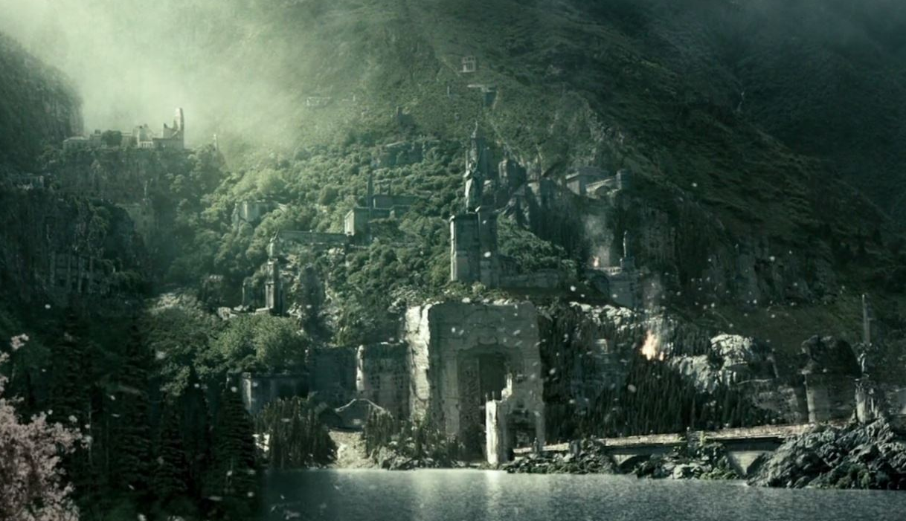

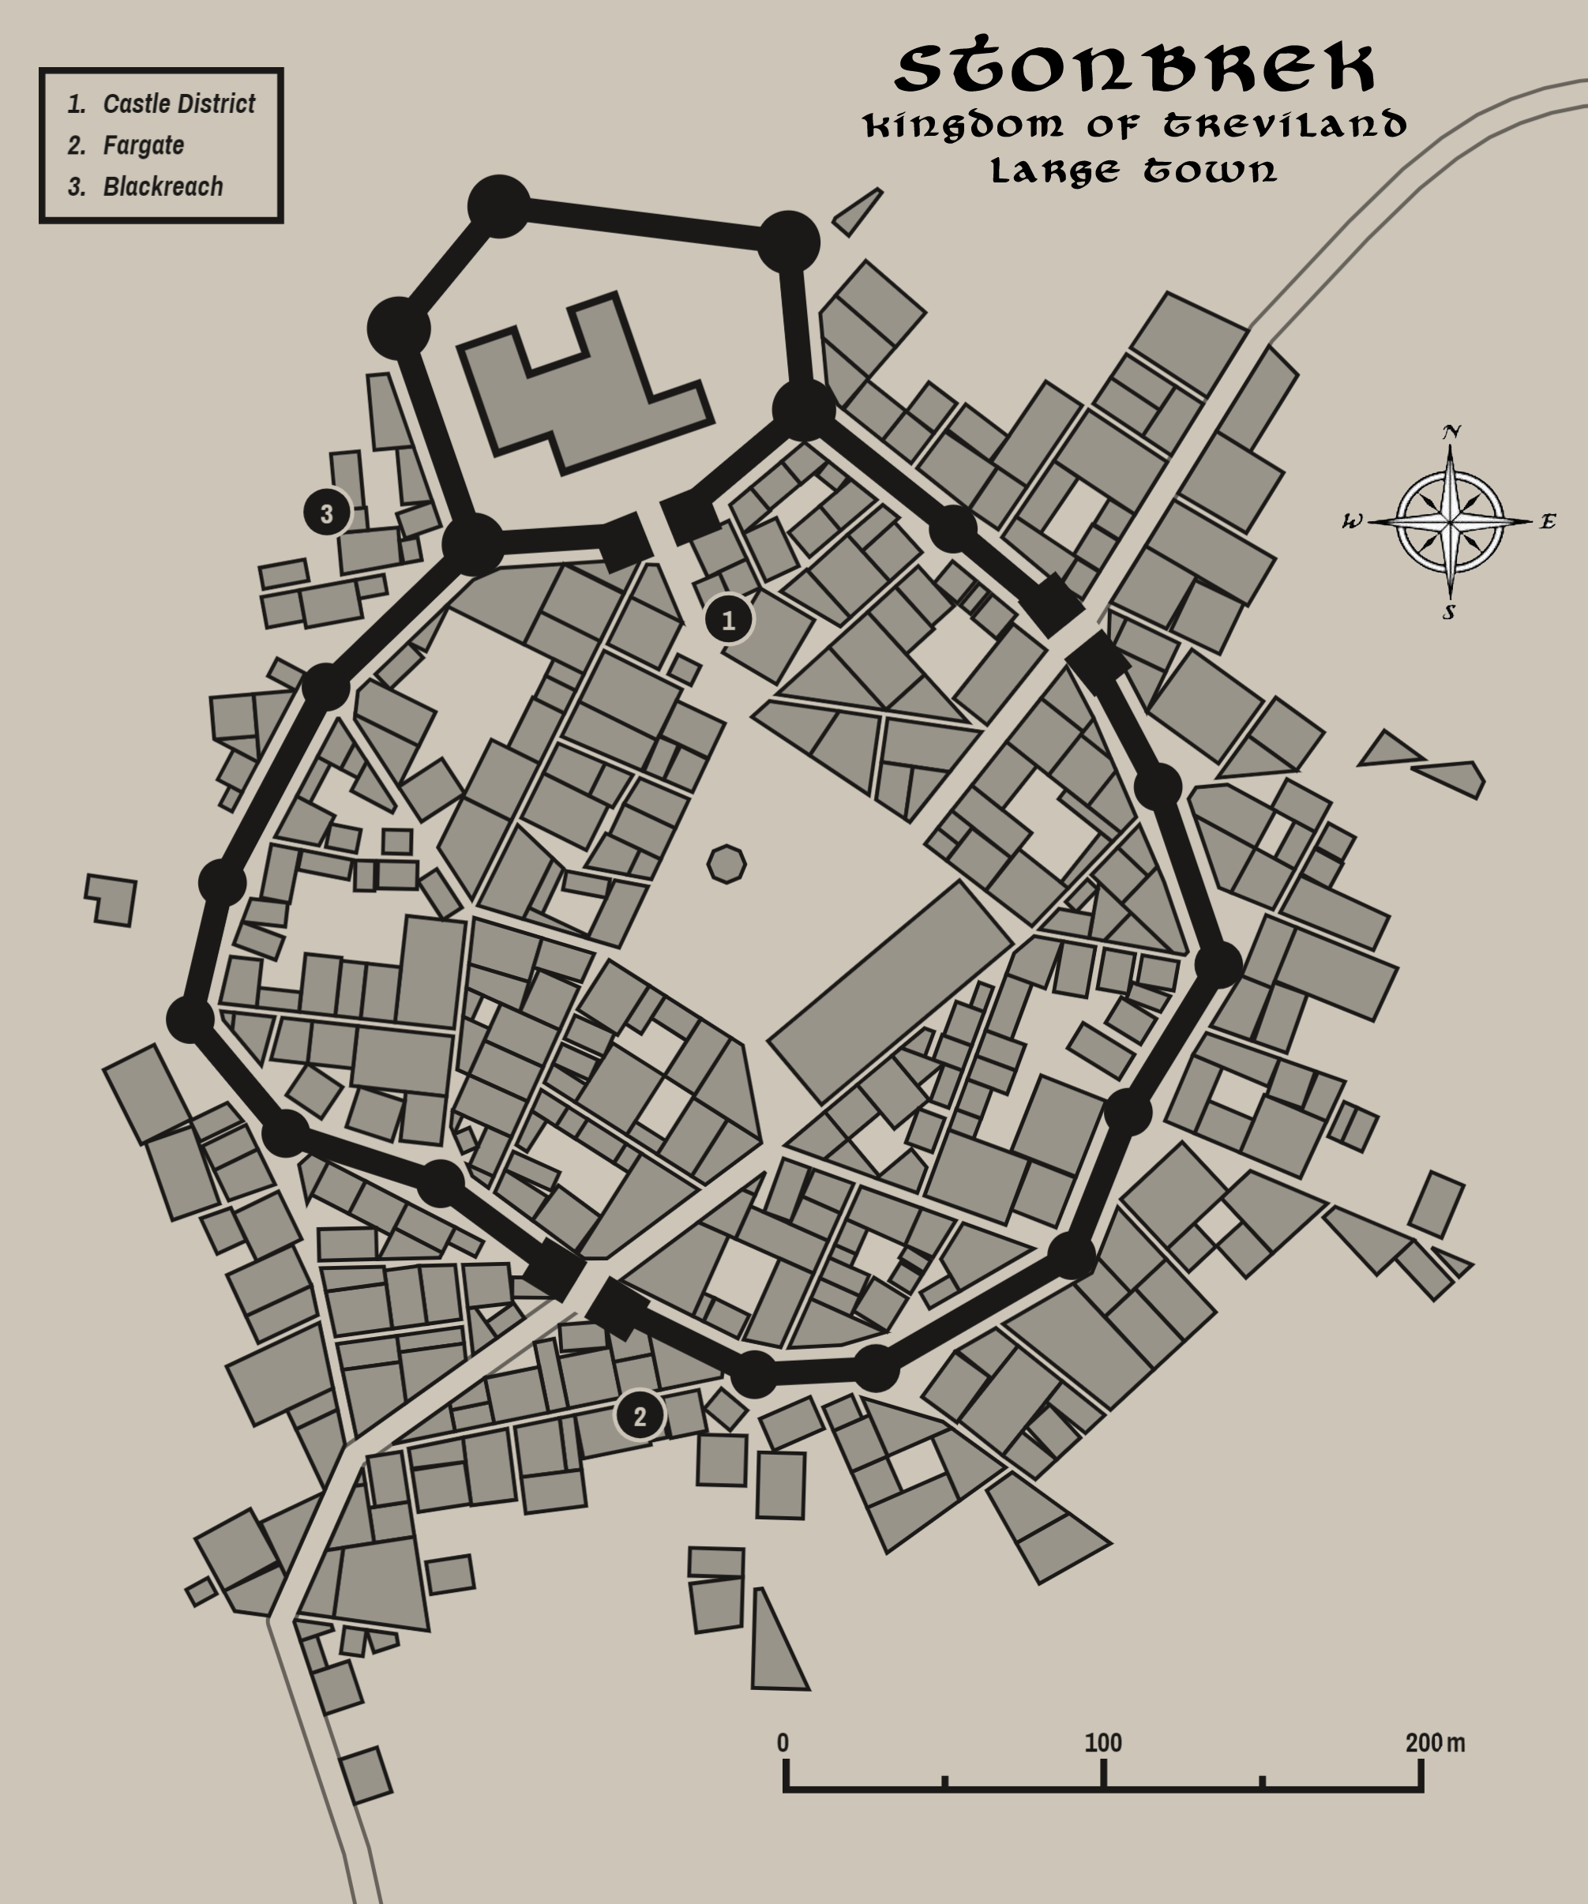

Milady
Size: large town, population 5,000, guards / soldiers 50, militia 250
Trade Goods: wool, gold
Local Goods: purchasing of goods from Stonbrek and transporting them downriver
Standard: image of Queen Gertha and her crown
Colors: blue and silver (with red ribbon for Treviland)
Patron Deity: Heironeous; Saint Agatha (f) of the Filling Heart
Ruler: Baron Cathal Hillock and his wife Baroness Desmona Hillock
Sons Samuel 16, Ferndon 13
Daughters Eathla 14, Bronnwyn 9

Home: Castle Dumnonia
Steward: Willem Bhaird
Marshal: Loman Artain
House Priest: Zephan
House Adviser (Scholar/Mage/etc): Morten Sporain
Captain of the Guard: Collum Craig
Knights in Service:
Sir Ultan Fallon
Sir Declan Guinne
Sir Enan Loudaine
Sir Toal Dorsair

Local Powers: The Crestlocks (thieves guild), Circle of the Willow (order of druids), Chapel of the Filling Heart, Epona House (chapter of the wool and weaver’s guild in Bastion)
Local Sites: Gramarcy’s Inn & Tavern, The Silver Hound Inn & Tavern, The Velvet Devil (brothel)

Description:
Queenstown is a sleepy country hamlet grown big. The keep and upper bailey sit atop a shelf carved into the Evermore Mountains, with a low wall descending and encircling a lower bailey. Outside its gates the town spreads out and meets the shores of the Augemere Sea. Behind the town the Evermore Range continues northeast across the Augemere, growing lower and lower as it peeks out from the waters. Here the low mountains pause and form the Glyndwyr Strait, a break in the peaks that allows passage north to the rest of the sea. The town is kept tidy, with handsome half-timber houses lining cobble stone streets.

Queenstown lies in the lands of Wicla, which extend from the Augemere Sea to the north to the Draana River and the northern edge of the Dauniger Hills in the south, and from the Draana River in the west to the Terrylis River in the east, albeit with a bit of land just beyond where the Terrylis and Vestillon Rivers split. Wendspire also lies within these lands and shares a cultural bond with Queenstown, as they were both settled by Wiclan tribes after the ouster of Celedonian occupation in the First Written Age. The Wiclans have their own unique customs and cultural identity, but answer to the Trevilish banner.

Industry:
Milady has a few scattered gold mines in the Evermores. This proved to be a source of conflict with the nearby Dwarven kingdom of Demundra. The Dwarven town of Merryhorn opens out of the mountains a few miles from the town. But currently there is peace, even if the humans and Dwarves have little to do with one another. Fishermen work the sea and shepherds tend flocks of sheep in the rich grasslands here. But a sizeable portion of industry here comes from brokering stone from the town of Stonbrek, which sits at the northern shores of the Augemere. Stonbrek barges ferry stone and other goods mined from the Valley of the North Winds, which Queenstown purchases and transports down the Draana River to Novulum and Illustrim. Stonbrek regularly quarrels with Milady on the exchange rates for these goods. Recently it has begun to divert some of its goods east to the Ebon River and the town of Wendspire. But over time Wendspire has done the same as Queenstown and milked the position for profit.

Epona Guild - The wool and weaver’s guild of Bastion controls the wool market in Treviland. A chapter of the guild is based here, taking orders from Bastion on production, transport, and prices. Ymbert Boutet is the head of the chapter here. Like most guild members, her loyalties to the local lord and lady are often at odds with orders from the guild. Likewise, she may occasionally work deals with merchants off the books, which can be dangerous.

Key Figures:
Baron Cathal Hillock - hunter, charming, decadent, fond of stories
Baron Hillock is a charming ruler but has excessive appetites: hunting, feasting, fighting, and women. He is keen for adventures and word of the outside world. Any travelers passing this way are summoned to the keep, where Hillock will listen intently to tales and to song. If there are women among them, he is prone to be distracted and may put on lavish airs to woo them. He is known to engage adventurers in hunting trips into the mountains to hunt bugbears and dire boars.
Hillock is a large man with large appetites. He has broad shoulders from his days as a warrior but his ponderous gut suggests his fighting days are behind him. He dresses in lavish attire, silk shirts covered by jackets with brocade, silver-threaded knee-pants ending in long socks of brilliant colors with slippers to match. Hillock has a long moustache which he waxes into fancy curls. His blue eyes are bright with merriment (and sometimes petulant rage). He is a mercurial man, prone to mood swings. He very much enjoys his wealth and the amenities that come with his title, but he is known to sneak off to taverns in disguise and consort with the common folk in wild ribaldry.

Local Lore:
The Chapel of the Filling Heart is a small and rustic structure, with half-timbered walls and dark wooden floors. Modest stained-glass windows are brilliantly colored and feature scenes of Queen Gertha coming to Milady, her charitable works, and her defiance of the king’s oppression. The altar at the head of the church is a fountain which flows with blessed water that emanates a soft blue glow at night. Those who drink from it and are free of evil intent find themselves refreshed. On rare occasions those in desperate need and of great faith have reached into the fountain and gained some object or token that has miraculously aided them.

The slopes of the Evermore Mountains in this region are heavy with Bugbear camps. Much of the early days of Furlaan were spent staving off Bugbear raids and the humans were almost wiped out. Typically these creatures are enslaved by goblin chiefs and pressed into military service. Those that remain in the area are loosely organized into small nomadic groups that roam the mountains, descending from time to time to pillage. The chief among them, Oggerbosh, has led the Bugbear camps in times of all-out war and his name is mentioned with fear by the folk of Milady. It is said that Oggerbosh carries a cursed club that he calls The Heavy that spreads pestilence. Some say it was the wizard Anguithor that bestowed the club on him in hopes he could help him rid the region of humans and free it up for his own purposes. Many heroes have sought Oggerbosh’s head but few return to tell of their defeat.

At the center of town is the Fountain of Faraway Faces. Created by a wizard long ago, the fountain is a masterfully sculpted stone structure featuring elaborate decorations of vines, flowers, and faces of all sorts. It is said on certain nights the faces move, creating a variety of expressions. Some rumor they even talk if one is keen to listen. The water cascading down from the top changes colors every so often and sometimes even sparkles. But the most bizarre property of the fountain is that when one peers into the waters along the base, the faces of strangers peer up from the water instead of one’s own reflection. The people seem to be staring down into a fountain from a different location (or perhaps a different time!). Sometimes the people appear similar in complexion and dress as others in Western Amadar, sometimes they appear far more exotic and are rumored to be from the other side of the world. However, the people in the reflection carry on normally and do not seem to notice the person on the other side.

History:
In the First Ancient Age the Hundra made the fishing village Gaelaga their seat of power. It was destroyed when the Celedonians invaded, but later rebuilt in 31 WA2 by the Wiclans named Furlaan and it was a fishing village for centuries. Four hundred years ago, King Simon of house Fullwyrth sent Queen Gertha here following the birth of their first son. In secret, the child was the product of the king’s affair with Lady Constance, a powerful noble woman from Novulum. The king resented Gertha’s popularity with the people, whom she championed against his growing abuses of the land, and he coveted power in spite of her many pleas to help their people.

After Gertha’s departure, the king taxed his people brutally to fund his aspirations for power. He launched attacks into Plenish lands, slaughtering whole villages. At last, the knights of the court who frowned upon such recklessness petitioned the queen to lead them. And so, she did, helping overthrow King Simon and banishing Lady Constance. Upon her return to power, Gertha passed the power of the throne to Sir Lord Trinton, captain of the guard. She then returned to Furlaan to live out her days as a commoner. Gertha’s popularity with the people led them to rename her the town Milady (109 WA4).

Milady sits in the shadow of the Evermore Mountains while overlooking the Augemere Sea to the east. Construction over the last five hundred years has carved fortifications out of the mountainside. Newer parts of the town are perched at elevated levels with better protection. This includes the keep where Baron Hillock and his family reside.

Customs:
Wiclan folk are considered a rustic and dim-witted people, more acclimated to the forestlands and the colder north. They can be dour people upon first meeting, and are keen on codes of honor. They are accomplished horse masters and hunters. The best cavalry units in Treviland hail from these lands. Wiclans tend to adorn themselves in yellow ribbon, thread, or feathers. The color comes from an ancient tradition honoring the sun. Swintans consider the color lucky and work it into their garments. (Milady and Wendspire are of Wiclan heritage)

Unlike most Harthans, people here are exceedingly polite. Strangers are always greeted warmly and afforded hospitality. However, the people here are a garrulous lot and can talk for hours if allowed. Even if one thinks a conversation is at an end, a local may feel the need to resume the talk if they see the stranger at a later time. Travelers are wise to find an excuse to end the conversation, usually done so with a small gift.

Day of Queens – Once each month the women of the town wear crowns made of flowers to honor Gertha. It is said that every woman is a queen in her own right. The crowns are placed on them by a friend or someone in their family or sometimes by an admirer. In the rare case a woman isn’t presented a crown it is considered a misfortune and the woman feels great shame. Travelers are cautioned never to bestow a crown upon a lady here, for it is often seen as a proposal for marriage.

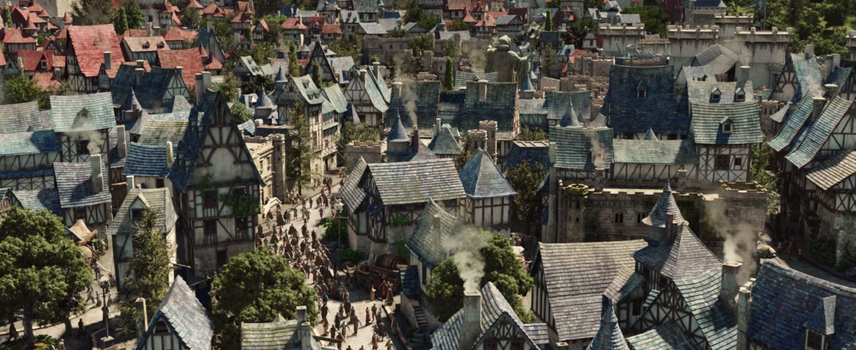

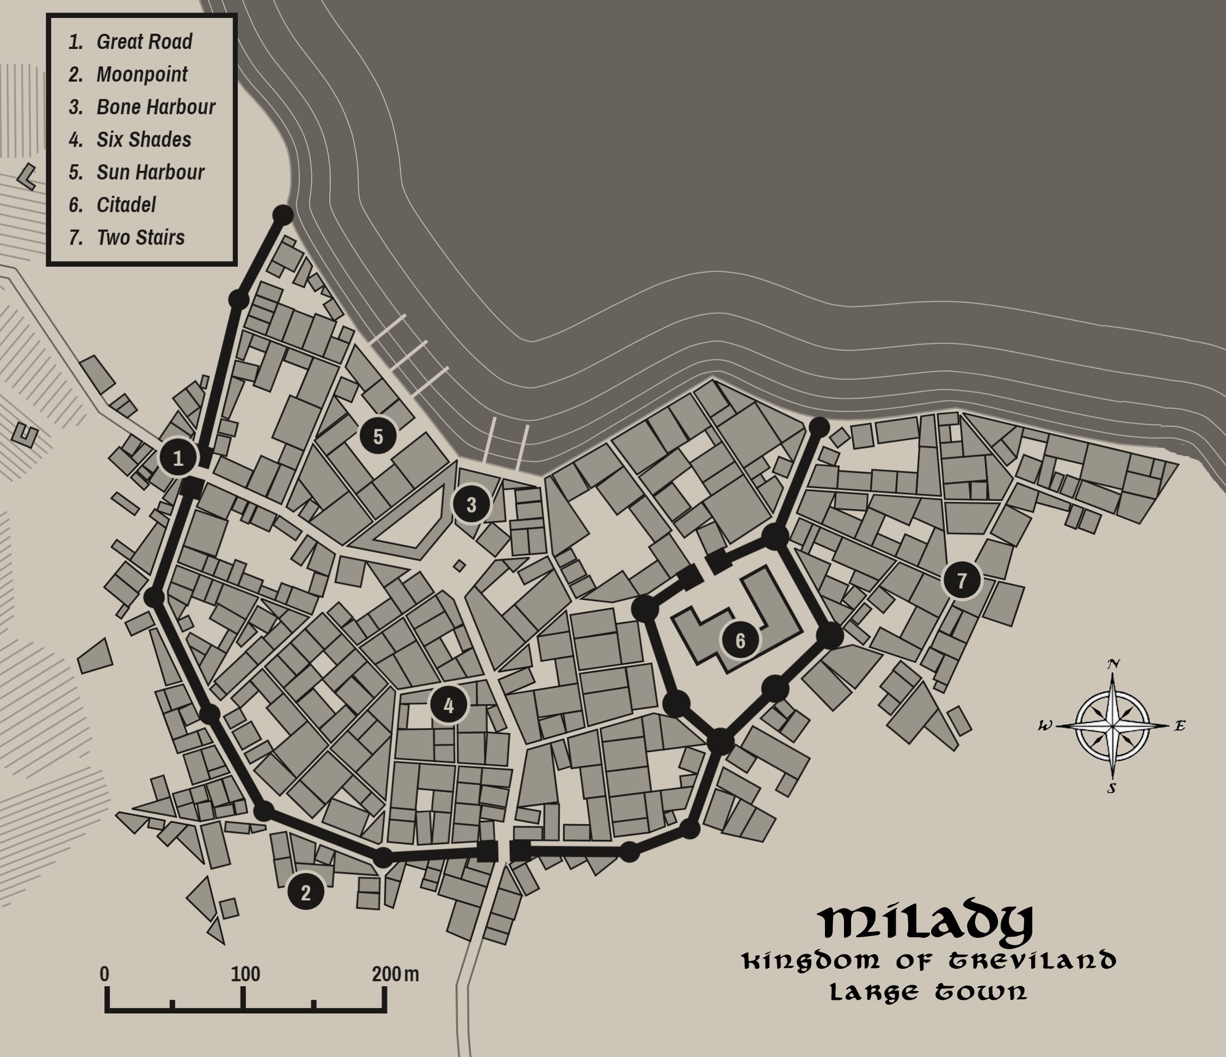

Wendspire
Size: large town, population 5,000, guards / soldiers 50, militia 250
Trade Goods: timber, wine
Local Goods: Saint Regis of the Unseen Summit
Standard: sign of a winding stair up a hill, topped with a tower
Colors: orange and white (with red ribbon for Treviland)
Patron Deity: Pelor; Saint Regis of the Unseen Summit
Ruler: Lord Padrig Miter and his wife Ennis (f)
Sons Eoin 18, Suibne 14
Daughters Mallaide 15, Ceana 13, Rose 7

Home: Castle Avia
Steward: Aidan Mellis
Marshal: Devin Suain
House Priest: Archlumin Reid Finbar
House Adviser (Scholar/Mage/etc): Abban Kail
Captain of the Guard: Kieran Tulloch
Knights in Service:
Sir Michan Varish
Sir Bryn Diarmid (f)
Sir Owen Elshender
Sir Garadh Lorcan

Local Powers: Hallowed Hunt (thieves guild), Diaphanous Chapel, Heavenly Host (order of paladins), Heathertop Vineyards
Local Sites: The Quelched Fonne Inn & Tavern, Pipe and Drum Inn & Tavern, The Well-Read Reading Room (brothel)

Description:
Perched atop Spire Mountain sits the town of Wendspire, built into the rock with streets winding back and forth down the side. Slender spires radiate upward, affording a breathtaking view for hundreds of miles. Colorful kites float lazily in the sky, aloft in the updrafts that swirl around the summit. A wall of pale bleached stone encircles the base of the mountain, with lower walls guarding the upper terraces. Dark orange veins marble the stonework, matched by the color of the rooftops of buildings. At sunrise and at sunset it is said the orange city looks to be a part of the heavenly canvass.

Called the Gateway to the East, the town commands bridges over the Terrylis and Vestillon Rivers as well as the embattled land between them, called the Nary Lands. An ancient system of ramparts and towers extends from the base of the mountain and over both rivers where bridges control traffic east and west. These were built by the Celedonians during their occupation three thousand years ago. The wall was built to defend against the barbarians of old that lived in the east. Today it is a beautiful and formidable citadel commanding the region.

Wendspire governs the lands of Wicla, which extend from the Augemere Sea to the north to the Draana River and the northern edge of the Dauniger Hills in the south, and from the Draana River in the west to the Terrylis River in the east, albeit with a bit of land just beyond where the Terrylis and Vestillon Rivers split. Queenstown also lies within these lands and shares a cultural bond with Wendspire, as they were both settled by Wiclan tribes after the ouster of Celedonian occupation in the First Written Age. The Wiclans have their own unique customs and cultural identity, but answer to the Trevilish banner.

Industry:
Wendspire, like Milady to the west, serves as intermediary for valuables shipped down from Stonbrek. River transport is the chief industry of the town. In addition, it sponsors timber works to the east and grows crops in the rich delta between the rivers. In times of peace the town also does business with the Tirudoran town of Ibilis, downriver by way of the Vestillon.

The Heathertop Vineyard near the top of the mountain is run by priests who ferment a wine called Heathertop Red. It is highly coveted throughout Treviland as well as abroad.

Key Figures:
Lord Miter is a slender man of average build. He has a neatly groomed beard that shines from many expensive oils he uses on it. He typically wears a light blue jerkin over which are bright blue robes threaded in silver. He is fond of aromatics and walks with a cloud of sweet smells about him. On his right hand he wears a dazzling ring of sapphire that is said to be enchanted and able to control the clouds above. Rumor has it that when he is alone Miter likes to draw pictures in the clouds like a child.

Miter is a simple man and not overly bright. Some say he has the mind of a child. His wife, Ennis, is an older woman from a prominent family of Wendspire. She has piercing eyes and an authoritative air to her. In public she says little but in the counsel chambers she does most of the talking.

Miter is a cautious ruler, always fearful of the lands around him and signs of trouble. His town relies on support from the city of Novulum to the south. Miter offers fealty to the city of Illustrim, but he regularly takes counsel from Novulum and is sympathetic to its ambitions.

Archlumin Finbar is a powerful figure here. Every sunrise he leads devout followers in prayers to the skyward gods that bless this place. Night time rituals can be seen from miles away, as divine light projects upward from the mountain and into the heavens. Finbar’s paladins of the Heavenly Host enforce order and peace here and in the ravaged lands below.

Abban Kail, the court wizard, is rumored to venture into the skies above the town. There he has befriended the cloud giants and learned many of their secrets. He is an able adviser but he keeps his plans to himself.

Diaphanous Chapel: At the center of the town a single tower ascends and disappears, obscured by a whisp of clouds that never seem to move or clear up, even in the fairest of weather. A hundred feet above the town the stair ends at an oval-shaped, open platform ringed in delicate tracery. This is the Diaphanous Chapel. A divine power holds here, generating an invisible ceiling that is visible only in the rain. But most times it is left open. Priests greet the dawn and sunset and summon mighty winds, seemingly unafraid of the mighty torrents that whirl about them. A font at the center of the cathedral is topped by the Vane of Borrum, an ancient artifact that is said to hear portents carried on the winds. The vane appears as a wrought iron array of spires but is light and often inexplicably becomes invisible.

The Heavenly Host is an order of neutral good paladins serving the god Pelor. Rare among paladins, these knights employ giant eagles as their steeds. Knights of the Host wear glittering golden armor over tunics of sky blue. Their helmets are crested with wings. Their charge is the safety of the town as well as fighting evil in this region. They are often called upon to aide in the secular battles in the Nary Lands, but often refuse if it does not serve Pelor’s will. This has cast a shadow over their reputation among generals of Treviland.

Local Lore:
North of the town is the holy site of Heaven’s Tower. Pilgrims travel from as far as Phaeria and beyond to visit the site. The holy Temple of the Tower was built in Wendspire and hosts a garrison of Paladins named the Heavenly Host who pledge to protect the site and any who travel there.

South of the city the plains of the Nary Lands crawl with various perils, both from men and other creatures. Most famous of them are the baying hounds that can be heard for miles. Some say they are hell hounds unwittingly summoned by the fallen priest Dando hundreds of years ago. Dando was a drunken priest but a capable huntsman. According to legend, Dando was resting during a hunt and found himself short of his normal spirits. He proclaimed “I’d hazard hell itself to fetch a pint of Heathertop!” A mysterious figure appeared and bid him open a strange door in the side of a hill. Dando obliged but was surprised when flaming hounds leapt forth. To this day it is said the hell hounds roam in packs across the plains and beset the unwary traveler. Visitors to Wendspire are warned to be on the lookout for Dando’s Hounds.

History:
Wendspire is the easternmost holding of Treviland. The Celedonian Brontes Legion founded the town (240 WA1) after fierce fighting to take the lands between Terrylis and Ebon Rivers. Wendspire was the last of the Celedonian conquests to expand the lands of the Treian tribes.

This land is now called the Nary Lands, named for the perils here that ‘nary a man should hazard.’ It has traded hands countless times between the Trevilish and the Tirudorans. Soldiers from both sides often ride out to these parts and assail travelers for sport, for all who travel here are considered outside the protection of any king.

Wendspire is strongly fortified against assaults by the Tirudorans from the east and the Erigoths from the north. It relies heavily on support from Novulum far to the south. For this reason it has often sided with Novulum in its quarrels with the throne in Illustrim.

Wendspire has a shared history with its nearby neighbors of Ibilis and Novulum. In 861 AA3 the Great Orc War of the Northwest arrived in Ordonian Lands. Six years of bloody battles later, Ordonian generals allied with human armies from Wendspire and Novulum to encircle the Orcs and destroy them at the Battle of Belisama (867 WA3). The human victors were so relieved to prevail that they swore a pact of friendship. The pact was celebrated by the three weapons of Gorgorak, general of the Orc armies: Goordak’s spear, axe, and helmet. Each of these items now sits in one of the three cities. They are sometimes brought out of storage during diplomatic talks or feasts where any of the three cities are present.

Customs:
Wiclan folk are considered a rustic and dim-witted people, more acclimated to the forestlands and the colder north. They can be dour people upon first meeting, and are keen on codes of honor. They are accomplished horse masters and hunters. The best cavalry units in Treviland hail from these lands. Wiclans tend to adorn themselves in yellow ribbon, thread, or feathers. The color comes from an ancient tradition honoring the sun. Swintans consider the color lucky and work it into their garments. (Milady and Wendspire are of Wiclan heritage)

The people of Wendspire, sheltered atop their mountain perch, feel a world apart from the dangerous crossroads of the lands below. This can make them appear detached from the rest of the world, as they feel figuratively as well as literally above it. Many hold that the town itself came from the heavens and is blessed. Once each year the faithful worship in a ceremony where they believe the city rises into the sky for one night. Those who travel below the mountain are said to line their shoes with sacred leather that keeps them from touching the ground outside of the mountain. It is a source of distress if a person from Wendspire is forced to touch the ground outside their town.

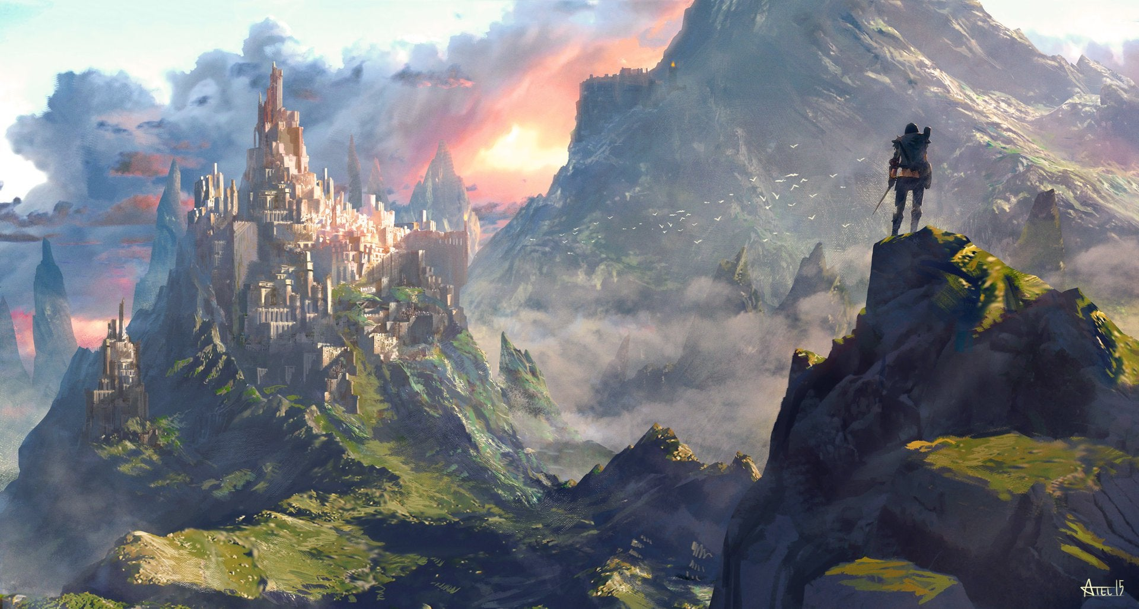

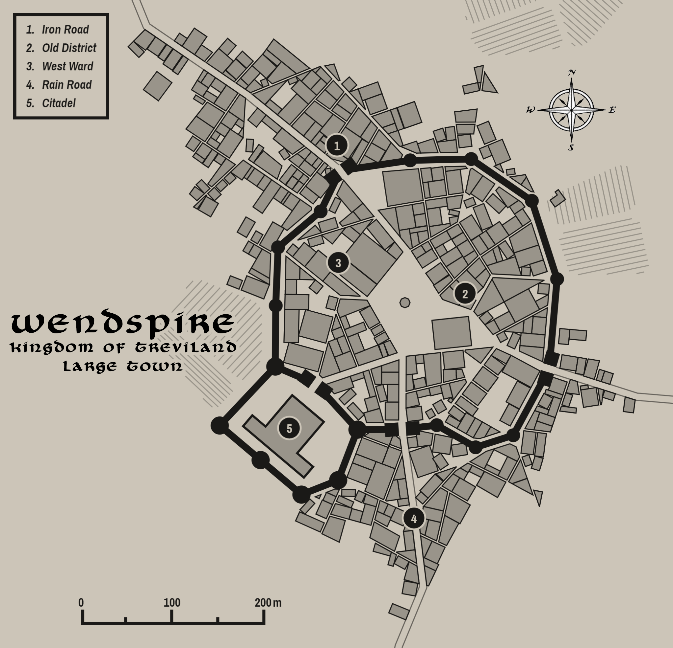

Cerrulea
Size: small city, population 12,000, guards / soldiers 120, militia 600
Trade Goods: grain, timber, wool
Local Goods:
Standard: hawk in blue
Colors: grey and blue (with red ribbon for Treviland)
Patron Deity: Heironeous; Saint Everild (f) of the Fecund Flail
Ruler: Lord Alder Stalworth (game: Duchess Kereth)
Lord Alder Stalworth and his wife Ceana
Sons Padraig 21, Ros 19, Killian 12
Daughters Erin 16, Colleen 14

Home: Castle Hardin
Steward: Kelan Buckley
Marshal: Carbry Guinness
House Priest: Lumin Allean Clancy
House Adviser (Scholar/Mage/etc): Domhnall Devilly
Captain of the Guard: Cavan Leish
Knights in Service:
Sir Gordon Dermond
Sir Coll Brennan
Sir Greer Kesson
Sir Nevin Honan

Local Powers: Nameless Graves (thieves guild), Order of the Kestrel (order of paladins), Band of the Even Star (order of rangers), Lostros Sanctum (school of magic), Cathedral of the Threshing Floor, Epona House (chapter of the wool and weaver’s guild in Bastion)
Local Sites: Mary's Trumpet Inn & Tavern, Griffon’s Head Inn & Tavern, Hochle House (brothel)

Description:
Sitting along the banks of the sleepy Luthia River, Cerrulea is a large farming town that has blossomed into a small city in the Wiclan heartland. Locals call it the Blue City, after its walls of blue granite that sparkle in the rays of the setting sun. It presides over the ancient Kendor lands, which stretch from the Ivian River in the west to the Awnos Mountains in the east. Life is quiet here, far removed from the political intrigue at court or the hustle and bustle in the coastal cities. Kendor people are more interested in what the mysterious forest-dwellers called the Wyrrin are up to in nearby Tredfut Forest, or if there might be trouble brewing over in Faerdeep Valley. Larger cities look down on Cerrulea as being too rustic and its people being too simple. But the people here are proud of their heritage.

Cerrulea governs the lands of Swinta, which extend from the eastern flank of the Tredfut Forest in the north to where Lake Eversong spills into the Provender River in the south, and from the Luthia River in the west to the Draana River in the east. These lands settled by Swintan tribes after the ouster of Celedonian occupation in the First Written Age. The Swintans have their own unique customs and cultural identity, but answer to the Trevilish banner.

Cerrulea reigns over the lands of Swinta, a people who settled here millenia ago. But it also sits at the eastern edge of the large rolling plains called the West Wold, presided over by the towns of Bastion and Pelham. In Cerrulea the Swintan and Wolder traditions melt together. Being so far north, these three towns share a common culture distinct from the rest of Treviland. These are frontier people, living half in the wild. And in times of war these are the people who defend the kingdom’s western borders. It is hardly surprising the three towns often share tight alliances and come to one another’s aid.

Industry:
Cerrulea is a farming boom town that has prospered from wool and grain merchant guilds. The land enjoys fertile soil and an abundance of crops. It supplies much of the grain, timber, and wool for Illustrim by way of ferries across Lake Eversong and down the River Provender. Not much else comes from the Kendor region, giving it an undistinguished reputation in the eyes of its neighbors. But when times are lean it is usually this region feeding the rest of Treviland.

Epona Guild - The wool and weaver’s guild of Bastion controls the wool market in Treviland. A chapter of the guild is based here, taking orders from Bastion on production, transport, and prices. Griffin Spicer is the head of the chapter here. Like most guild members, his loyalties to the local lord and lady are often at odds with orders from the guild. Likewise, he may occasionally work deals with merchants off the books, which can be dangerous.

Key Figures:
Lord Stalworth is a plain man, tall and built like a man who has known work. He has a short dark beard and dark eyes that are earnest but kind. He normally dresses in simple attire, usually a dark leather jerkin with dirty boots, and often carrying a baby goat or pig while talking to the farmers visiting from the countryside. He is a man of the people and unafraid of mingling with them. Occasionally his advisors convince him to hold court, but he always appears uncomfortable in court finery.
Stalworth is firm with his people and principled. Having hailed from yeoman’s stock, he is seen as a petty noble by his peers and overly serious for a lord. He is fond of hunting and sport and is liked by the commoners. Lady Ceana is a plump woman and sturdy, easy to mistake for a farmer’s wife in spite of her apparel. She is free with her tongue and speaks plainly where other noble ladies shy from political topics. Lord and Lady Stalworth are loyal to the king in Illustrim and are outspoken towards those towns that waffle on that score.

The Order of the Kestrel is an order of lawful good paladins in the service of Heironeous. It is a small order, with only a few dozen knights. It is considered less noteworthy than the orders of the Heavenly Host or the Gauntlet. But what few there are consider themselves pure and passionate to their cause. Kestrel knights wear armor of muted silver with dark blue tunics and surcoats. Each swears on the Souconna, the longsword once carried by Artidius Kendor during the Second Dark Crusade. Blessed by Heironeous himself, the sword grants feats and powers to the knights who pledge service to it.

Academy Lostros – The school of magic in Cerrulea is a strange fixture in a city so far north. Founded by the wizard Akhmeton a hundred years ago, it is a new school and a small one. Akhmeton drew the attention of the wizarding circle in Novulum, but refused the offer to begin his school there. He had grown fond of Kendor and made it his home and thought the study of magic should be far from the powerful coastal elite. It is located in a venerable old keep left over from Cerrulea’s founding. Its graduates bear the sigil ring of the shooting star, which contain spells involving light and illusion.

Local Lore:
The Cathedral of the Threshing Floor is a squat, wide structure with a short nave and a single bell tower. Wings carved of stone extend out and back of the structure then join to enclose an open-air courtyard filled with a lush garden. At the rear of the complex is a large interior area accessible by heavy doors much like those seen on a barn. This area is mostly empty, magical writings covering a bare stone floor. This is the threshing floor, where worshippers bring a portion of their harvest each spring. Priests bring forth the Fecund Flail, a magical flail designed as a farming implement but which Saint Evilde used as a weapon against evil centuries ago. The blessed flail is used to thresh a sample of each harvest but it also reveals the nature of each person who comes before it: husks and grains are separated but some sign appears as well. Those of good heart may find ten-fold grains appearing or a small totem of blessing they can take with them. Those with guilt hanging over them may see blood appear or something written in the grains that fall to the floor.

Many legends spring from this region. Stories tell of sleeping dragons, reclusive witches, and fairy gardens. Orc tribes were driven out of this region a thousand years ago, but small tribes still persist. In the Carnor Mountains dwell the Drulukk, in the Awnos Mountains the Bagrak. Elves from the kingdom of the Ulynar rule the Tredfut Forest, but are on good terms with the court of Cerrulea. It is said that the ancient Wyrrin dwell in the Tredfut Forest, wild people who live at one with the land and who were the first humans to dwell here as far back as the Primordial Ages.

Faerdeep Valley lies on Kendor’s eastern borders. It is wild and untamed and few dare to travel there. It is said that to be the realm of the Faerie Queen Aradia, who rules over a wild assortment of mystical creatures. Rangers who have ventured into the vale speak of a land of giant plants, talking trees, purple waterfalls, and toadstools as large as houses. The air there is filled with tiny faeries and underfoot there are nixies, pixies, grigs, and brownies. Those that venture in with ill intent are never heard from again. Only those of pure heart are safe, but even those are in jeopardy of falling under the faery spell and slumber for a year or more. The rangers of the Band of the Even Star know this region well and are friends of the fay as well as their protectors.

Isienth, an old copper dragon, makes her home far to the north in the Evermore Mountains. Known as Isienth the Wise, she has been a protector of upper Kendor for centuries. It was she who helped Travix the Moth-eaten rout the orcs of the Awnos Mountains four hundred years ago. None know the location of her lair, but those who seek her counsel may scale the high hill of Adathorn where a lone tall tree stands. If one hangs a gem of exceeding brightness and beauty, Isienth is likely to come.

The Wyrrin are a strange people who inhabit the forest lands around Cerrulea. Little is known about them. They dress in furs, mark their bodies in tattoos and blue pigment, and speak an unknown language. Some say they are the long-lost ancestors of the Volds who settled these lands in the Primordial Ages. They are one with the land and worship forgotten gods that are hailed by the sign of an eight-pointed star. It is said they speak to trees and plants, causing them to twist and grow into strange and beautiful shapes. Another tradition says that each spring they choose their mates with a hunt. Women from their tribes chase down the young men who come of age, wrestling them to the ground and making them their husbands for the next year.

Terra Construct: On the easterly road leading from Cerrulea to the Awnos Mountains there is a tall stone formation growing out of the ground. This is called the Culmen Calix. No one knows where it came from, for there are no other rock formations in the vicinity.

History:
Cerrulea has traditionally allied with the capital and with the town of Lyre which sits between the two. Cerrulea is also known to heed the call when towns to the west, such as Bastion and Pelham, come under attack from Plenish forces.

Over four hundred years ago the wizard Travix the Moth-eaten led an army of dwarves and men to rout goblins in the Awnos Mountains in Kendor, turning the goblin army to stone (30 WA4). The goblins followed their chieftain Phlazik after he found the Seeds of Madness left behind by the mad druid Garruld Rotroot. The goblins used the seeds to create an epidemic in the Kendor lands.

Orc tribes out of the Evermore Mountains have been a constant worry in recent ages. In 290 WA4 the Yargol tribe of Orcs from the Evermore Mountains invaded Treviland. They made it as far as the Trevilys River when in 310 WA4 Cragtilus the wizard and the heroine Breanna Hightower of Pelham crushed them. But a hundred years later the Orcs returned. In 480 WA4 they invaded from the Evermore Mountains. King Ceirdrec of Illustrim, newly crowned, defeated the Orc armies in a massive battle still celebrated to this day.

Customs:
Cerrulea’s people hail from the old Swinta tribes. Swintan folk are exceptional farmers and have cultivated these lands into the breadbasket of Treviland. They are considered a bit odd by anyone outside of their borders, for people here are friends to both Elf and Dwarf. All manner of strange creatures are said to live this near to the Evermore Mountains and the Tredfut Forest. But the Swintans don’t seem to mind and are avid explorers of the wild lands. Swintans are known for adorning their clothes with mistletoe. The colors green and red are often worked into their attire and decorations. (Cerrulea is Swintan in heritage)

Every spring the city holds a massive Vernal Fest. Maypoles and pavilions are erected, competitions held among the young men and women of the region, and a grand tournament of knights. Music and dancing are accompanied by large spreads of food offered from people’s gardens and home recipes. There is also the Feast of Cups. Merrymakers carry simple wooden cups which are filled with samples of the foods. It is considered back luck if a cup is empty, so the delicacies never seem to stop. Meanwhile in the forest, young Wyrrin maidens depart from their hidden villages before sunrise and race through the forest, pursued by the young Wyrrin men who seek to catch them for their brides.

Every fall the farmers in the region gather in Cerrulea for the Straw Festival. Effigies are made by each household and brought to a field, where they are erected in rows. The effigies represent the armies of orcs that invaded twice in the last three hundred years. They have also come to represent the fears of the community, each straw figure signifying some dread held by their maker. At the height of the festival the head priestess from the Cathedral marches out bearing the Fecund Flail and utters prayers while destroying the effigies to the cheers of the entire town.

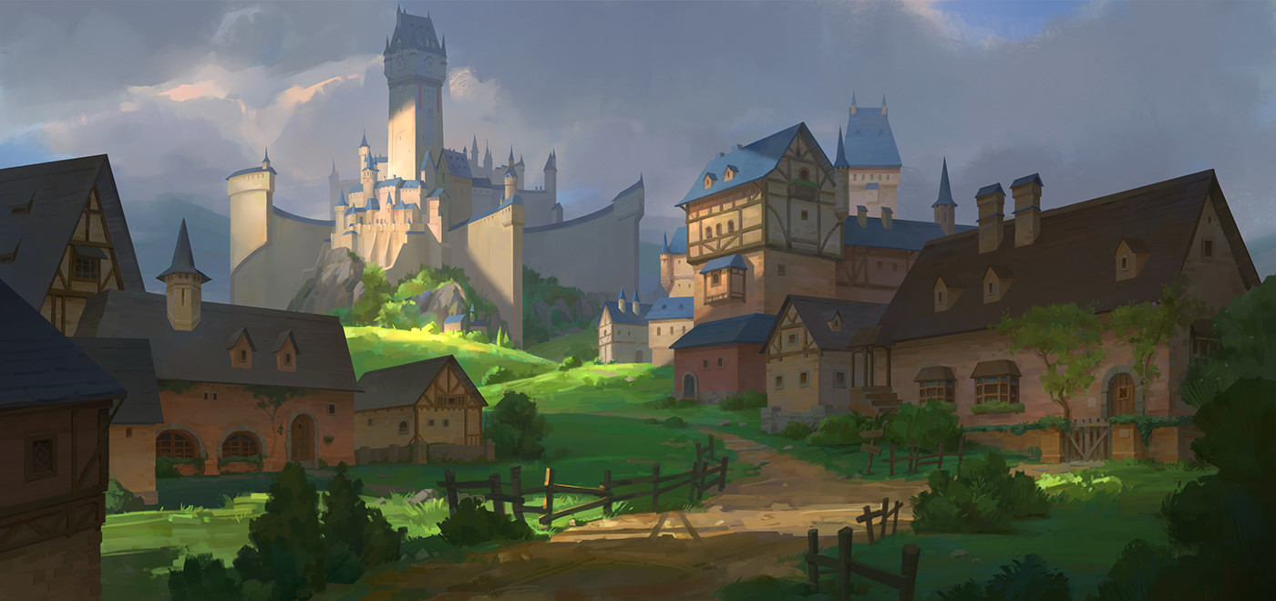

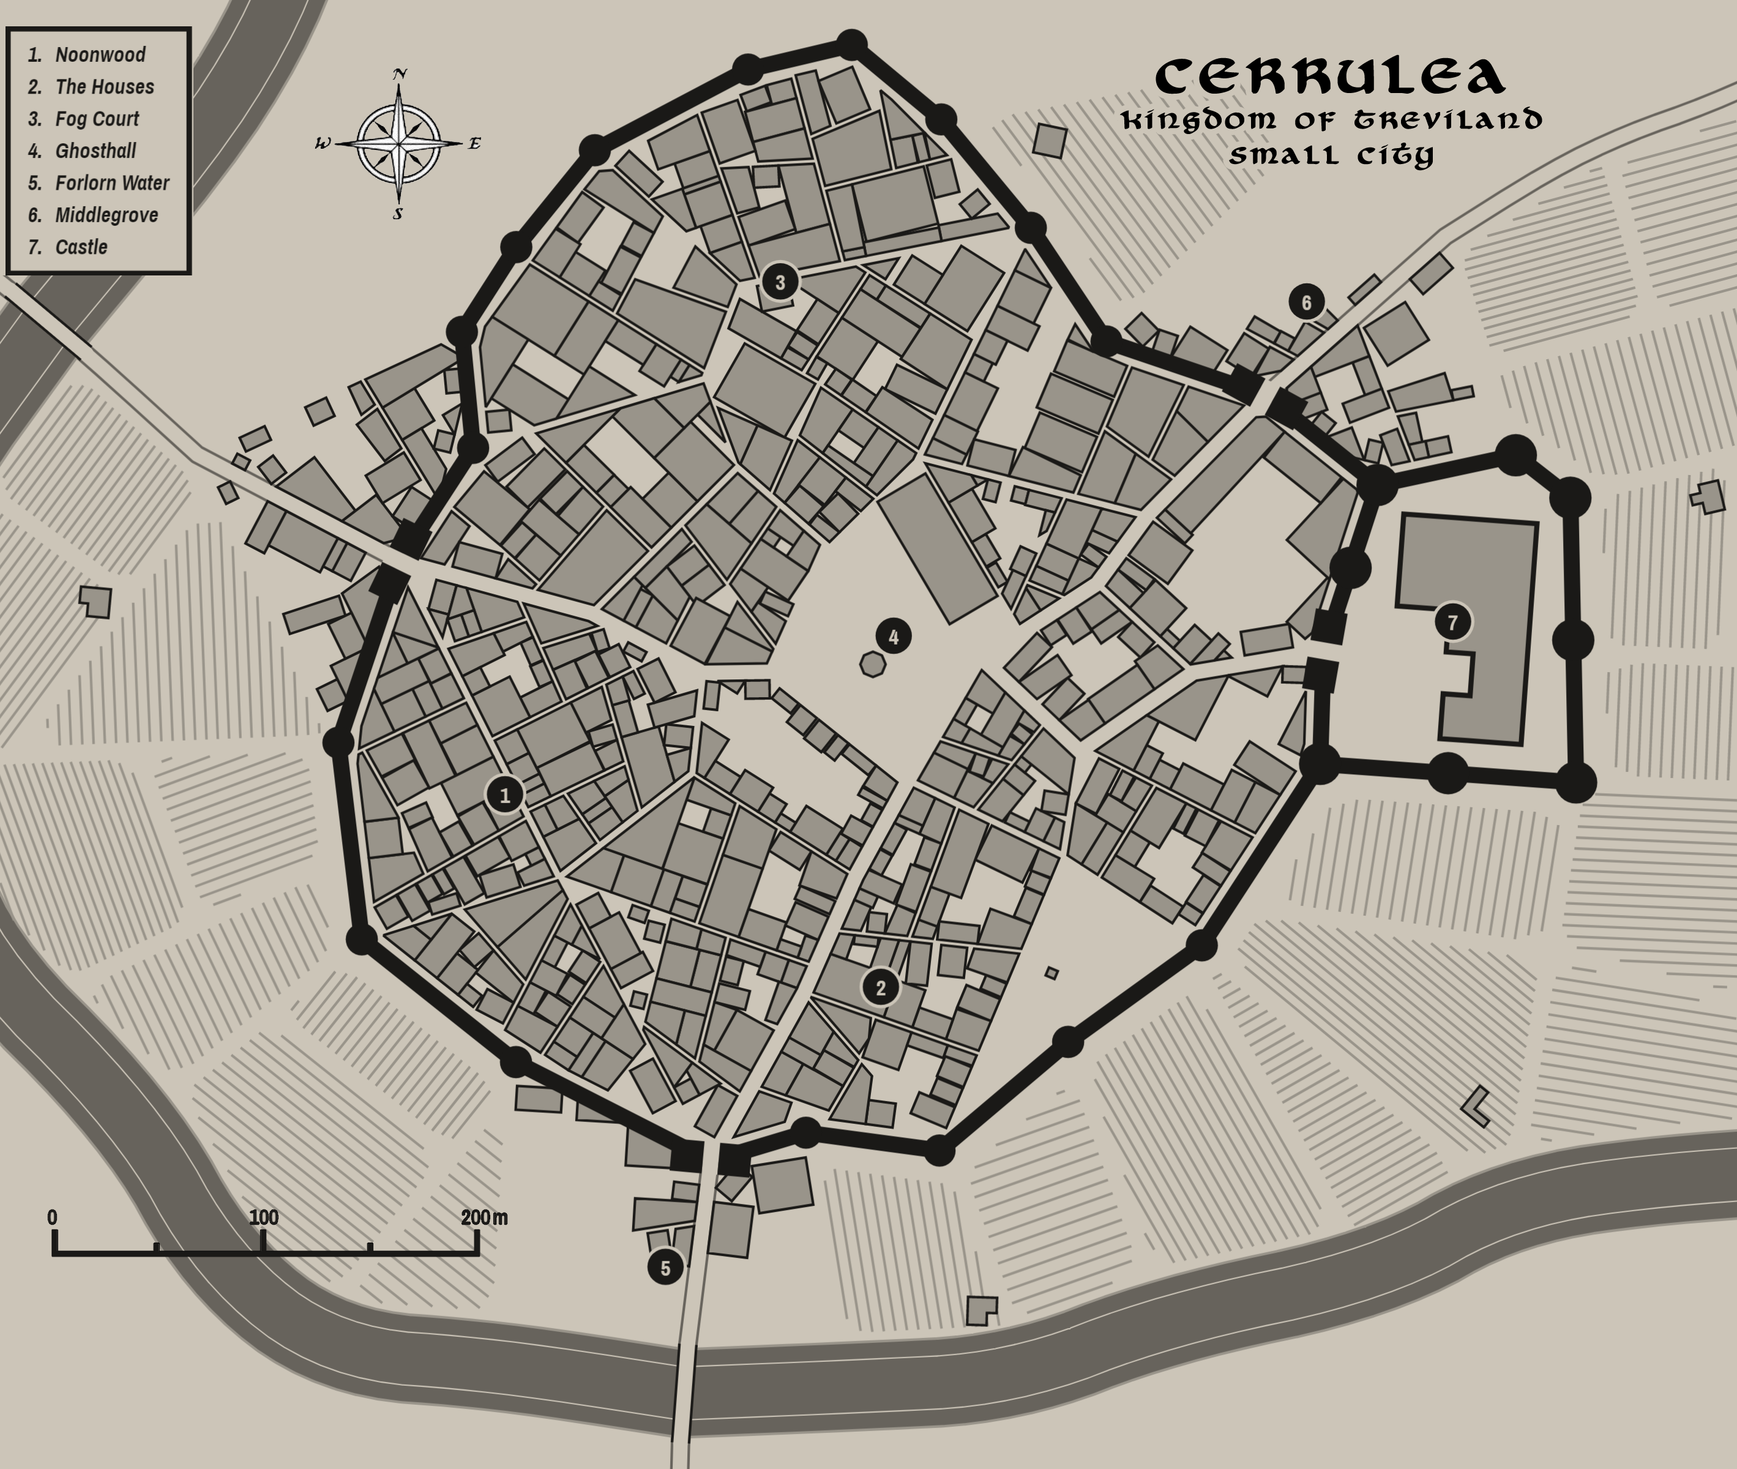

Novulum
Size: large city, population 25,000, guards / soldiers 250, militia 2250
Trade Goods: trade hub, steel, iron, wool, copper
Local Goods:
Standard: sign of the dragon
Colors: black and red (with red ribbon for Treviland)
Patron Deity: Pelor; Saint Tostig of the Cudgel
Ruler: Lord Alco Morley and his wife Sive Daughters Mona 16, Moira 14, Meave 10

Home: Carrack Castle
Steward: Teague Arasgain
Marshal: Parkin Cowan
House Priest: Lumin Alastair
House Adviser (Scholar/Mage/etc): Ruadh Conlan
Captain of the Guard: Declan Sorley
Knights in Service:
Sir Parlan Blair
Sir Bruce Leenan
Sir Ulick Gillivray

Local Powers: Silver Moon Trader Company, Quiet Quills (thieves guild), Burke Brotherhood (assassin’s guild), Cathedral of the Cudgel, Isernbrest (iron and steel guild), Epona House (chapter of the wool and weaver’s guild in Bastion)
Local Sites: Pitchkettle Inn & Tavern, The Cracked Chalice Inn & Tavern, The Dancing Dryad (brothel)

Description:
Novulum is a masterpiece of Celedonian engineering. From its founding three thousand years ago, the city was envisioned as the model from which the empire would rule the northern continent. Towering aqueducts converge here from the Terrylis River, their red stonework adorned with mascarons of a thousand different faces. Streets are paved with stones of a hundred different colors, each laid with absolute precision to form brilliant designs that tell the stories of Celedon. Stone columns and statues of ancient and masterful design support terraces from which ivy hangs and arched bridges span.

The people of Novulum consider their city’s aesthetic beauty as validation of their roots in history and therefore their greatness. This is in spite of the city being much younger than most villages in Treviland. Regardless, they chafe at Trevilish traditions and have a more progressive philosophy. To the average person from Novulum, they are the future of the west and have a destiny from on high. Many people find this overbearing, while other towns and villages are quick to appease the city for fear of reprisal.

Novulum govern the lands of Culver, which extend from the northern banks of Lake Holyoak in the north down to the coastline in the south, and from the Provender River in the west to the coastline of Nereida Bay up along the Terrylis River in the east. The lands were settled by the Culver tribes after the ouster of Celedonian occupation in the First Written Age. The Culvren have their own unique customs and cultural identity, but answer to the Trevilish banner.

The church of Novulum is powerful and holds enormous sway over the city. Statues of St. Tostig can be seen everywhere, his grim expression staring down disapprovingly with his cudgel held menacingly in his hand. Priests stroll the streets in their dark mantles, cudgels in hand, punishing any who the church finds out of line with seemly behavior. People here dress conservatively and in muted colors but in clothes cut in finer material than most.

Industry:
Novulum is an industrious city on the rise. Iron and steel works drive an engine of construction and arms. The expansive port opens up to the Bay of Nereida and commands westerly shipping lanes leading out to the Ferrago Sea. Across the waters is the Tirudoran city of Ibilis, Novulum’s rival in these waters.

Epona Guild - The wool and weaver’s guild of Bastion controls the wool market in Treviland. A chapter of the guild is based here, taking orders from Bastion on production, transport, and prices. Johanna Fuller is the head of the chapter here. Like most guild members, her loyalties to the local lord and lady are often at odds with orders from the guild. Likewise, she may occasionally work deals with merchants off the books, which can be dangerous.

Key Figures:
Lord Alco Morley
Lord Morley is an awkwardly tall man with long dark hair, pale skin, dark eyes, and a prodigious nose. His mouth sits at a crooked angle, his large lips appearing petulant. He dresses almost exclusively in shades of dark purple, a tribute to his late and doting mother. At his side he carries the Toma Totalem, an ancient and mysterious book handed down by his ancestors that promises ultimate knowledge. Some consider it cursed, but the lord of Novulum consults it nightly and claims it has given him great visions.

Morley is aloof and cruel, pressing his subjects to be industrious, for he sees Novulum as the future power in the West. He works the eastern sea trade routes east to amass wealth and contacts. His iron and steel works have built up his armory and those of his allies. He has secretly secured alliances with Wendspire to the north as well as agents from Tirudor across the bay. And he currently works to buy the support of Stonbrek and Milady. Morley pays fealty to Illustrim, but in name only: he bides his time until he can find an opportunity to overthrow Illustrim and restore Novulum to the greatness promised to its founders.

The Isernbrest is the iron guild based in Novulum. It controls the mining and refinement of iron ore for all of Treviland as well as production of quality steel. The mines in Stonbrek are part of their network.

Theodoric is a local barber and surgeon who treats his patients with leeches and boar’s vomit.

Arica Semain
Hailing from a long line of minor lords in Tirudor, Arica’s house fell out of favor with the ruling powers a hundred years ago after a failed campaign in Erigoth. House Semain has suffered scorn and ill repute with the last three kings. Their banner of the marching hoof was removed from the hall of Colova by King Eduardin, sending Semain into near exile.
Arica is a striking beauty, her lustrous dark hair matched by penetrating eyes. An angular face frames bright red pouting lips. Her glare is hard and rarely shows warmth. She is quick to wrath when provoked. Her speech is loud and quick and heavily accented in Tirudoran but speaks Trevilish fluently.
Arica was pledged to Lord Morley when she was only six. Morley was busy with campaigns but planned ahead to wed her when she came of age so he could boast a young beauty for a bride. Arica’s heart burns with hatred for the Trevilish, seeking to use her role as a lady of Treviland to subvert the region around Novulum and prepare for Tirudoran invasion to win power for her house. She uses her wiles to secude men close to Morley and bring them under her control.

The Silver Moon Trader Company is a ruthless enterprise that seeks to disrupt the other merchant companies in the west. Following Morley’s orders, they employ a company of cutthroat mercenaries to sink ships, pay off port authorities, steal shipments, and spread disinformation to sour the relations of other merchants they see as competition. Silver Moon vessels frequently find themselves at odds with the naval patrols out of Myridon who seek to carry out the king’s justice.

The Cathedral of the Cudgel is a towering structure of dark stone, dazzlingly decorative tracery, and tall and narrow windows. The exterior is covered in grim reliefs of saints staring down in condemnation, above which are grotesque carved totems of gargoyles, demons, and other frightening creatures. Inside the lofty ceilings are covered in gold tiles, the floor is polished purpled marble. At the head of the cathedral sits a wide pit with a large fire always burning. Worshippers kneel before the great fire as liturgies are read. Each person is brought forth to stand before the fire. It is said those of pure heart have nothing to fear, but those of ill intent will see their shadow dance as if an evil spirit follows them. These are taken into the back and beaten to drive out the evil. Stories abound of evil spirits being released in this place but never leaving, trapped within the darkened walls or becoming one of the decorations outside.

The Cathedral is home to a dark priesthood order intent on spreading their doctrine throughout the kingdom. Ambrose Prophete, the head priest, looks down on the rest of the Trevilish church as weak and fallen from the purer faith. Suspected heretics are stolen away at night and tortured in the catacombs beneath the cathedral. Chancel priests dress in sinister black robes with red cudgels as their mark and their weapon. It is said they wield frightening powers over their enemies.

Local Lore:
The Speaking Mascarons: The faces in the masacarons adorning the aqueducts are said to carry the wisdom of the Celedonians who erected them. Each face is imbued with some scrap of lore that has long since been lost when Celedon fell. No one knows how to command the faces to talk: they randomly come to life, mostly at night and speaking to passersby. Scribes spend sleepless nights waiting by the aqueducts, scroll and quill in hand, waiting to write down what they say. One theory is that each face can sense when a person is of the right mind to hear what they have to say.

The Dauniger Hills are the dwelling place of the Badaden clan of hill giants. They are bitter rivals of the Gogmagog hill giants across the Skedwyn Valley in the Corbus Hills. The king of each clan carries the name of the tribe and is taller and more powerful than most hill giants. Each winter they come down from the hills to make war on one another in the valley. Often the war spills over into human settlements: farms are crushed with flying boulders, people taken and eaten as spoils, and entire herds stolen for winter provisions. By spring the two tribes make peace, partially to combat the humans that launch assaults on them in reprisal.

History:
Over three thousand years ago the Celedon Empire marched across western Amadar, conquering every tribe in its way. When General Aratus entered the realm of the Treian tribes he recognized the potential of the land. He sacked the powerful city of Eathra (130 WA1), the site of present day Illustrim, because it was the seat of power among the tribes. When he moved on to the Bay of Nerieda he envisioned a new seat of power at the mouth of the Terrylis River. He commissioned great building projects and named the new city Novulum in 180 WA1, which implied the new start to the land. Ruins of the old Celedonian stronghold still stand where the mighty Brontes Legion once ruled over the land.

After the Celedonians left the Treian tribes warred constantly for power. Tradition-minded chieftains restored the power to the ruins of Eathra and built a glittering palace. They anointed the city Illustrim in 900 WA1. Power shifted west again. Novulum has never forgotten its former role and eagerly covets to wrest the power back.

Ibilis has a shared history with its nearby neighbors of Ibilis and Wendspire. In 861 AA3 the Great Orc War of the Northwest arrived in Ordonian Lands. Six years of bloody battles later, Ordonian generals allied with human armies from Wendspire and Novulum to encircle the Orcs and destroy them at the Battle of Belisama (867 WA3). The human victors were so relieved to prevail that they swore a pact of friendship. The pact was celebrated by the three weapons of Gorgorak, general of the Orc armies: Goordak’s spear, axe, and helmet. Each of these items now sits in one of the three cities. They are sometimes brought out of storage during diplomatic talks or feasts where any of the three cities are present.

Customs:
The people of this region are Culvren folk, descended from the tribes that settled in and around the marshlands of the Wetflosh. Centuries ago, they were press-ganged by the invading Celedonians into draining the marshes and building a city from which the invaders could rule their new dominion. They learned much of engineering and architecture from their occupiers. Alas, they also inherited the Celedonians’ ambitious drive and their sense of superiority. They can be an industrious people and clever, but they also have a reputation for being unscrupulous.

Like their swamp kin to the south, the Floshen, Culvren folk are smaller in stature, dark of hair, and pale in complexion. Their clothing, like their disposition, tends to be dreary and colorless, running from black to light gray.

The church of St. Tostig requires every person entering the city to wear the symbol of purity, the pendant of the cudgel. Simple lead pendants attached to lengths of leather are handed out at the gates as visitors enter, wooden ones to the peasants. Wearing them is compulsory. There are severe fines or worse for those caught without the pendants worn visibly.

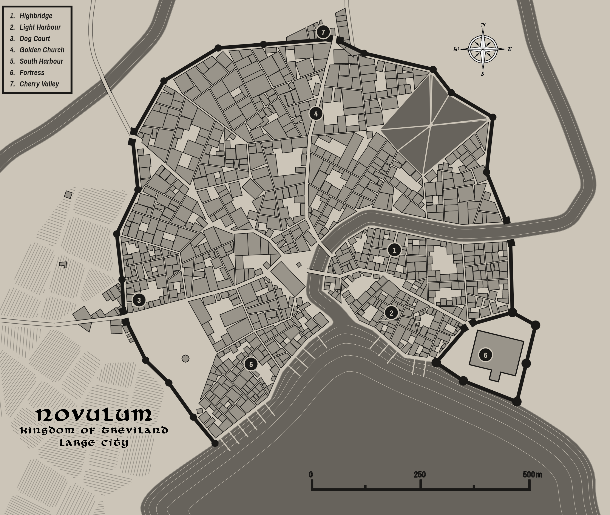

Pelham
Size: large town, population 5,000, guards / soldiers 50, militia 250
Trade Goods: timber, furs
Local Goods:
Standard: sign of the gate
Colors: purple and white (with red ribbon for Treviland)
Patron Deity: Heironeous; Saint Cynebald of the Fire Flagon
Ruler: Nile Herlen and wife Flora
Son Radulf 17, daughter Fermin 13

Home: Jarrow Keep
Steward: Edgar Armisan
Marshal: Cynric Marcinel
House Priest: Lumin Harlin Smedley
House Adviser (Scholar/Mage/etc): Widdard Storm
Captain of the Guard: Paxton Newell
Knights in Service:
- Sir Tomas Morgulot
- Sir Charles Winbow
- Sir Tate Palolot
- Sir Bede Whittard
- Sir Edward Palaivere
- Sir Robert Flur
- Sir Ansley Abram
- Sir Artimus Carolaine
- Sir Denton Ransley
- Sir Richard Dinears

Local Powers: The Hard Hasps (thieves guild), Circle of Ennuit (order of druids), Chapel of Fire Flagon
Local Sites: Hare’s Foot Inn & Tavern, The Brown Boggart Inn & Tavern, Dora’s Dance Hall (brothel)

Description:
Pelham is known as a town of adventure. It is a crossroads where knights meet to travel upriver to the Evermores and merchants cross into the lands of Kendor or west into Plenish lands. Many tales tell of the dangers of the nearby Doxy Forest and Carnor Mountains (and the fortunes to be had). The town sits at the western border of the Kendor region and overlooks the river Ivian and the Plenish lands beyond. More than one war between Treviland and Plenia have begun and ended with battles in and around the town. Today it is a well reinforced town that trades peacefully with the Plenish.

Pelham governs the lands of Wolder, which extend from the lands just north of the Carnor Mountains in the north down to the Howling Hills in the south, and from the western banks of the Ivian River and the large rolling plains called the West Wold in the west to the western shores of Lake Eversong in the east. Bastion also lies within these lands and shares a cultural bond with Pelham, as they were both settled by Wolder tribes after the ouster of Celedonian occupation in the First Written Age. The Woldren, sometimes referred to as Wolderfolk, have their own unique customs and cultural identity, but answer to the Trevilish banner.

Wolder is flanked on the east by the small city of Cerrulea, located in the lands of Swinta. The three settlements have strong ties with one with another. In times of war, it is the people of the Wold who defend the kingdom’s western borders and Cerrulea often heeds the call to aide them.

Industry:
Timber and furs are the mainstay of industry in this town on the plains. Farming is enough to feed the people but not enough to be an export unless requisitioned by the throne in times of war. Trappers and timber men are the chief laborers here. It is a modest town with little wealth to impress its neighbors.

Pelham is well allied with Cerrulea to the east, for it remembers the long tradition of the Blue City answering the call when Pelham needed aide. It is also very close to its twin town of Bastion, just down the river. Both of these border towns secretly send goods downriver to the rogue town of Slevvin where they know the residents will pay well for supplies that are shipped overseas or to equip pirate ships in need of provender.

Key Figures:
Lord Nile Herlen – curious, overly confident, charming, adventuresome, womanizer
Lord Herlen was the youngest of five and the only son to the former ruler of Pelham. To many he was a disappointment, often traveling afar instead of sitting at the feet of his tutors. At the age of fifteen he enlisted in the Plenish militia and traveled to the Friendless Fringes. He came back with a small fortune and many friends among the Plenish (and a few enemies among their daughters). With the town in his charge, Herlen is restless and eager to find new ways to face risk and greater reward.
Herlen is a short man of light build, with long blondish brown hair and mirthful eyes. His grin is both mischievous and disarming. He wears shirts spun in cloth of gold beneath a leather jerkin that still carries a few battle scars. He is fond of the ladies and never missing for company, but he is mostly interested in women from far-off lands.
Herlen is friendly with Cerrulea and knows from his father’s accounts what a reliable ally they can be. He pays the proper respects to the throne in Illustrim but feels no real sense of responsibility for the Kingdom of Treviland. Though he is an adventurer at heart, he has grown to care for the lands of western Treviland and the welfare of his neighbors, including Bastion to the south.

The Circle of Ennuit is an ancient order of druids in this region. They are the reputed experts on the old ways of the land of Treviland and are consulted in dire times. They gather at a remote circle of stones of same name, calling on the old gods of nature. While the new gods have erected cathedrals in this land, the druids remember the ones who favored them in the dark times. Here, the god Wyrrin is called upon on each special moon.

The druids commune regularly with the elves of Omanarra in the Doxy Forest, an outpost of the Elven kingdom of Ulynar. Occasionally they come in contact with the dwarves from the Lonely Keep, which is part of the Dwarven kingdom of Demundra. The people of Pelham are on good terms with both Dwarves and Elves and trade regularly with them.

Local Lore:
The Chapel of Fire Flagon is in fact a domed basilica built by the Celedonians two thousand years ago. A long nave and twin towers were built onto it when the first bishop of Heironeous reconsecrated this site. Now fieldstone walls make up a long barrel-vaulted nave and side aisles extending from the basilica. The cathedral is a mix of building styles and features mosaics along the outside in brilliant colors. Priests tend to the altar of the many cups, serving from sacred flagons. A large brewery sits to the rear of the church, which produces a heady ale used in worship. Visitors are invited to drink from the altar, choosing from any of one hundred and twenty-one cups. The number of cups honors the number of days the town held out in a siege by Plenia during the War of the Red Moons. It is said those of pure heart looking for courage here will find the one true cup, but others say the gods fill a man’s mind and heart with what they need. The drink has even known to offer visions.

It is rumored that gremlins are a persistent problem in this region. Drifting down from the Carnor Mountains, they wreak havoc on well winches, farming tools, and military equipment in and around Pelham. Some say they originally settled in the Carnor Mountains, where they preyed on the machinery of the Dwarves in the now-defunct colony of Khundrukar. A handful of gremlin hunters work out of Pelham. They are crafty hunters and are not quite right in the head, but they seem to think like the gremlins so they are tolerated. So far, they have been unsuccessful in wiping out the gremlin scourge.

History:
The Dwarves of Demundra have long watched in disbelief at how often the town of Pelham came under attack during wars between the Trevilish and Plenish forces. Twelve hundred years ago they offered to help reinforce the town’s walls in exchange for tokens of friendship. Baron Geoffryd spurned the offer, scoffing at the need for Dwarven aide. This soured relations for hundreds of years until eight hundred years ago a human ranger named Masyn Elgan heard of orc attacks on Lonely Keep. He rallied the men of Pelham, citing the shame brought on them by Geoffryd many years ago. Pelham mounted an attack on the rear of the Orc host, shattering their forces. The Dwarves of the Lonely Keep thanked them for the assistance and drank to renewed friendship. Soon after they came and reinforced the outer walls of Pelham with their strongest granite slabs. To this day the workmanship of Pelham’s walls is impressive to behold and it has never been breached by an enemy force.

Customs:
The people of Pelham hail from the tribes known as the Woldren. Wolder Folk are a hardy lot, having survived centuries of conflict with the neighboring Plenish. They are more reserved than their Wiclan kin, given to the discipline of warfare. They are devoted to their gods whom they believe protect them in war and have chosen them to be the protectors of the realm. Wolder Folk tend to wear simple clothing and everyone carries at least one weapon on their person. Travelers are often surprised to find even a peasant girl carrying a hidden dagger. A Wolder’s only adornment are their battle pins, which are awarded even in peace time for training achievements. There are many pins in all shapes and sizes, most of which are a mystery to anyone not from this land. (Wolder folk inhabit Pelham and Bastion)

Rolling of the Heads – Once each year the town folk gather at the keep, carrying balls made of various materials. A race is held where everyone kicks their balls down the winding steps and streets of the town. Each participant is expected to keep up with their own ball and finish the course just outside the western gate, where they kick their ball as hard as they can. The festival commemorates the ouster of the Plenish conquerors who once held the town and their leaders beheaded. The balls represent the heads of the enemy and the kicking of the balls to the west signifies the people returning the heads to Plenia from whence they came. In addition to prizes for finishing the race first, a special prize is awarded to the one who kicks his or her ball the farthest. Stone markers stand in the fields to the west, marking where each year’s winner kicked their ball.

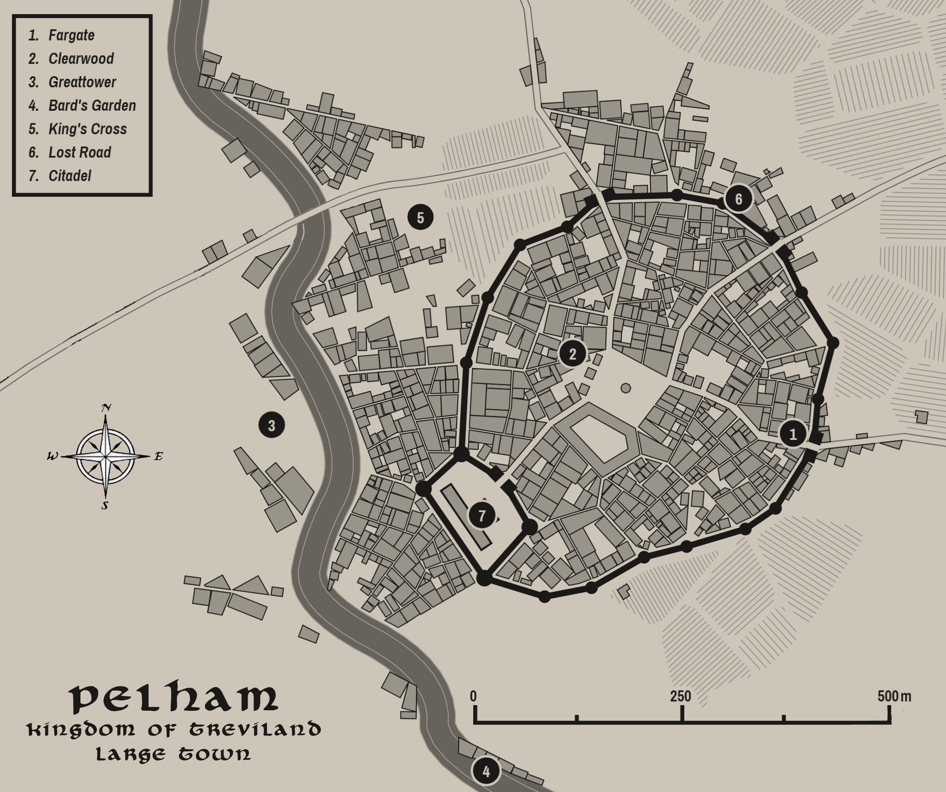

Bastion
Size: large town, population 5,000, guards / soldiers 50, militia 250
Trade Goods: grain, wool, textiles
Local Goods:
Standard: sign of the tower
Colors: brown and white (with red ribbon for Treviland)
Patron Deity: Heironeous; Saint Birstan of the Endless Watch
Ruler: Martin Lucrous and wife Matielle
Daughter Griselda 7

Home: Thistle Keep
Steward: Abel Thacker
Marshal: Hadley Horn
House Priest: Lumin Marlow Odell
House Adviser (Scholar/Mage/etc): Lucius Woolgar
Captain of the Guard: Darren Benbow
Knights in Service:
- Sir Redford Weston
- Sir Pierce Herlunt
- Sir Rigby Koy

Local Powers: Keen Blades (thieves guild), Chapel of the Endless Watch, Epona House (wool and weavers guild for all of Treviland)
Local Sites: Foyson House Inn & Tavern, The Shepherd’s Daughter Inn & Tavern, The Wandering Mistress (brothel)

Description:
Straddling the great Ivian River, Bastion is a storied town caught between the kingdoms of Plenia and Treviland. Many battles have been fought here as the town exchanged hands over the centuries. Its name comes from its reputation as one of the most resilient fortifications ever built.
The inner walls of Bastion date back two thousand years, built with river stones by the early Treian people. The second wall was built by the Celedonians when they moved eastward across Amadar. The third, outer wall was put in place two hundred years ago after repeated assaults by the Plenish proved it necessary. The areas between the walls are kept clear of huts to allow artillery against attackers, but plots for farming are permitted as long as there are no plants large enough to offer cover.

Bastion lies in the lands of Wolder, which extend from the lands just north of the Carnor Mountains in the north down to the Howling Hills in the south, and from the western banks of the Ivian River and the large rolling plains called the West Wold in the west to the western shores of Lake Eversong in the east. Pelham also lies within these lands and shares a cultural bond with Bastion, as they were both settled by Wolder tribes after the ouster of Celedonian occupation in the First Written Age. The Woldren, sometimes referred to as Wolderfolk, have their own unique customs and cultural identity, but answer to the Trevilish banner.

Wolder is flanked on the east by the small city of Cerrulea, located in the lands of Swinta. The three settlements have strong ties with one with another. In times of war, it is the people of the Wold who defend the kingdom’s western borders and Cerrulea often heeds the call to aide them.

Industry:
Bastion is called the Woven Throne, for it commands the textile industry in the kingdom. Flocks of sheep adorn the hillsides around Bastion. Expert weavers create lavish clothing and decorative tapestries. Epona House trains the finest weavers and sets the standard for masterful woven goods. It is also the center of the powerful Wool and Weavers Guild, which controls the textile houses all over Treviland and the kingdom’s exports. Chapters of the guild exist in every other town or city that works in wool.

Bastion and its sister town to the north, Pelham, share close ties as well as the Ivian waterway. Both secretly trade with the rogue town of Slevvin on the coast.

Key Figures:
Lord Lucrous is a pale, thin wisp of a man and often mistaken for a large boy. He has pale skin, small eyes, and shoulder length reddish hair cut in a bob. He wears a worried expression most times, with his lips protruding outward when he is thinking. The servants jokingly refer to him as ‘Lord Kissing Duck.’ He wears only the fanciest of court clothes and is fond of foppish hats. He regularly shocks everyone in town with his extravagant clothing, which features blinding colors, jewels, puffy frills, and very tall hats.
Lucrous is a young and foolish ruler. Some consider him a pale reflection of his late father, who was a respected military commander. He is fond of drink and silly games and leaves the running of the town to his advisers. His one saving grace is his friendship to Lord Herlen of Pelham. The two grew up together as the sons of their respective towns’ rulers and are like brothers. Herlen is constantly on him to get out of the castle and live life more fully, but Lucrous insists his advisers have warned him against it.

Hadley Horn, marshal of Bastion, is always wary of dangers to the town. An old soldier, he is always spoiling for a fight. He regularly takes a patrol of soldiers over the Ivian River and into the Great Southern Sward. While most are content with peace, he eagerly looks to start trouble with the Plenish.

Local Lore:
The Chapel of the Endless Watch is built like a defensive keep: its exterior walls made up of odd-sized fieldstones from when it was first erected generations ago, its roof embattled, and its windows narrow. Softening its forbidding aspect, ivy covers the sides of the building and angelic statues look down from above as well as decorate the courtyard. Within the building stone floor mosaics and stained-glass windows tell the tales of the many wars the town has weathered. The tallest tower of the church is topped with a window gallery that can see out over the lands in every direction. At night one with a keen eye can see the ghosts of sentinels past still watching over the town, scanning the horizon for signs of the enemy.

The Habetrot is a part of the folklore around Bastion. Said to be a deformed old woman with a twisted mouth, she is a spirit of the spinning wheel and loom and said to have magical powers. Those who can persuade her to weave them a garment are said to be free of illness. She is reputed to steal any wool that is left unspun or unwoven at the end of the year. None know where she resides but it is thought she dwells in the forest far outside of town. She appears from time to time, eager to teach young maidens the art of spinning.

History:

Customs:
The people of Bastion hail from the tribes known as the Woldren. Wolder Folk are a hardy lot, having survived centuries of conflict with the neighboring Plenish. They are more reserved than their Wiclan kin, given to the discipline of warfare. They are devoted to their gods whom they believe protect them in war and have chosen them to be the protectors of the realm. Wolder Folk tend to wear simple clothing and everyone carries at least one weapon on their person. Travelers are often surprised to find even a peasant girl carrying a hidden dagger. A Wolder’s only adornment are their battle pins, which are awarded even in peace time for training achievements. There are many pins in all shapes and sizes, most of which are a mystery to anyone not from this land. (Wolder folk inhabit Pelham and Bastion)

Bastion is a farming town and peaceful when not caught in border wars. The people are friendly to travelers but wary of those with a Plenish accent. Festivals are regular affairs and revolve mostly around farming.

Horn Dance – On the last day of summer the town folk gather for the annual Horn Dance. A group of revelers emerges from the chapel in Bastion carrying elaborate reindeer horns which they carry about their shoulders and dance gaily. They are accompanied by a fool in motley, a person dressed as a horse who attempts to corral the reindeer, a child with a bow who shoots at the horse, and a maiden who leads the way. The procession, accompanied by musicians, walks for days along the Ivian River stopping at the villages where villagers greet them with food and drink. This procession continues until they come to the chapel in Pelham. There they are greeted by the head priest and a great festival signals the end of the ritual. The tradition dates back hundreds of years to the Great Erobring, when the Norgardian invaders landed here and engaged in fertility rituals.

Weaver’s Eve – Once each spring the weavers of Bastion are celebrated. Locals pack the town square to visit booths showing off masterful woven items, some of them magnificent detailed works of art that the weavers work on all year for just this day. Food and music and casual tourneys between knights take place while storytellers weave tales of their own. An elaborate obstacle course is erected that can only be navigated quickly if one knows the patterns of the local weavers’ techniques.

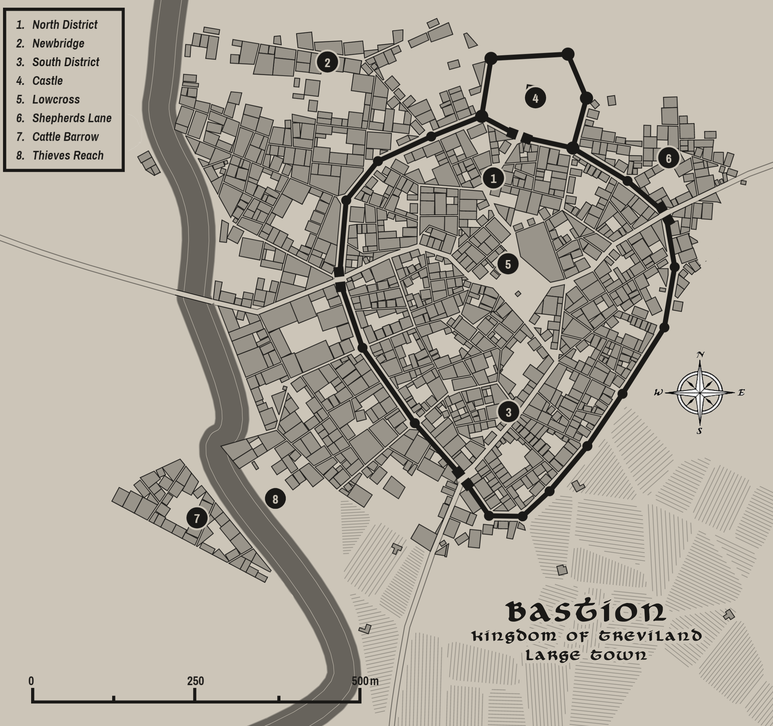

Myridon
Size: large city, population 25,000, guards / soldiers 250, militia 2250
Trade Goods: trade hub, clay, fishing, ship-building
Local Goods: master boat building, fishing, naval warfare, sea exploration
Standard: mermaid
Colors: blue and green (with red ribbon for Treviland)
Patron Deity: Pelor; Saint Maerwynn (f) of the Following Seas
Ruler: Lord Nevan Proy and his wife Moreen
Sons Donnchad 17, Mellan 16, Eimear 14, Finlay 11
Daughters Ailis 13, Arline 9

Home: Castle Gullwyn
Steward: Darach Mellis
Marshal: Alaois Orchard
House Priest: Archlumin Garbhan
House Adviser (Scholar/Mage/etc): Cavan Lagan
Captain of the Guard: Gilroy Corbett
Knights in Service:
Sir Chay Clambroch
Sir Gavin Master
Sir Kirk Leay
Sir Shane Duthie

Local Powers: Still Cloud Traders, Holy Priers (thieves guild), Nodens House of Shipwrights, The Vanguard (mercenary company), Cathedral of the Following Seas
Local Sites: The Hende Lady Inn & Tavern, Fore and Aft Inn & Tavern, The Broken Bed (brothel)

Description:
Myridon is a city that seems birthed by the sea, tall white buildings marbled in iridescent green and covered in ivy. Long piers have been built out from the coastline, forming a complex web on the waters that is almost a town to itself. The crystal-clear waters off the coast offer a stunning view of centuries-old Celedonian pillars and masonry that have crumbled and decorate the ocean floor. Castle Gullwyn towers over the upper part of the city, which in turn overlooks the lower wards butting up against the coastline.

Tall monolithic formations jut out from the ocean for miles around. These are called the Teeth of the Deep. Only experienced sailors know the best route through the stones and few hazard sailing into or out of Myridon during storms for fear of striking them. Lighthouses and small fortifications have been built on some of these monoliths.

Myridon governs the lands of Brimmor, which extend from the Ivian River where it is flanked by the Howling Hills in the north down to the southern coastline, and from the Yester River in the west to the Caerwyth River to the east. Slevvin also lies within these lands and shares a cultural bond with Myridon, as they were both settled by Brimmoran tribes after the ouster of Celedonian occupation in the First Written Age. The Brimmoran have their own unique customs and cultural identity, but answer to the Trevilish banner (at least, Myridon does).

Industry:
Myridon is Treviland’s primary nautical city, nicknamed the Emerald Port. It fosters a brutal rivalry with the Plenish nautical city of Ataia. They city is one of the two greatest ship builders in the west, the other being Saludor.

It is also a major trade hub commanding trade routes of the Ferrago Sea: the Inner Via Maris and the Ewa and Norso Crossings. It is also a major ship-building center that has influenced history. The Nodens House of Shipwrights produces the best sailors, ships, and military fleets of this part of the world. Dating even before this Myridon commanded a thriving fishing industry that still stands today.

Key Figures:
Baron Proy is a tall man, lean but strong. He has dark hair that he wears in a sailor’s knot. His cold blue eyes seem to take in everything around him. His large hands bear scars from years at sea working the lines. In spite of the fine cut of his noble clothing he insists on wearing sturdy boots bleached by salt. At his side he carries the enchanted sword Arianoer, or Cold Silver in the common tongue.

Proy rules the port city of Myridon with two hands: one dispensing rigorous levies on all trade passing through here, the other in fostering relations with Plenish and Tirudoran envoys. He is a man of exacting detail, proud of his stewardship of the city for the throne in Illustrim. He commands a third of the kingdom’s navy and is eager to use it. An old sea dog and a master naval tactician, Proy secretly longs for the days past when navies did battle on the Ferrago sea. He often disappears without warning, commanding expeditions to hunt down privateer ships. There are rumors that missing Plenish and Tirudoran ships have met their end at Proy’s hands, even in peace time. He is a patient and calculating tactician and has a thirst for battle.

Myridon tolerates the rogue town of Slevvin to the west but only as long as its activities don’t interfere with the king’s business. Disgruntled sailors from the Myridon navy are known to join up on crews in the Slevvin ports. Slevvin smugglers who are captured are branded with a snake-like letter ‘S’ and usually hanged. Those that survive wear the mark as a sign of honor but are quick to hide it around Myridon sailors.

The pirate Aylmer Holdforth is a vile presence in the waters near here. His ship, the Teran, sails out of the Isle of Sabina and raids ships passing from the Gulf of Meraud to the Ferrago Sea. Baron Proy is keen to find and hang the pirate and ships who follow him. Some say that Holdforth is the one who gave Proy his ugly scar. Others say that Holdforth stole the Map of Terrible Tides from Proy years ago and uses it to evade capture.

Captain Aerin “Anlas” Gayle is the youngest man in the western kingdoms to command a ship. An orphan of a Trevlish sailor, he grew up in Slevvin learning the skills of a smuggler, a gambler, and a privateer. At the age of sixteen he charmed his way into his majesty’s naval academy in Myridon. At eighteen he’d already hijacked a galleon and sunk a Plenish cog, returning a noble’s errant daughter before being expelled. The years that followed saw him join the crews of three pirates, get cursed by a sea witch, earn a fortune in Farnaway, summarily lose the fortune, and eventually find himself in chains in Illustrim’s dungeons. But Captain Hemash Pemmerton came calling one day. It was his niece the lad had rescued years before. He had Aerin freed and secured his own command aboard the newly christened galleon, the Goldemane. In the years that followed, Gayle has won a string of victories for Treviland, his reckless daring at sea concealing a prodigious tactical mind. He is a known scoundrel at court, but it has never kept him from being invited time and again to its royal balls. Women of the court blush at the sound of his name, the generals detest him, the nobles applaud him while hiding their fine jewels. Standing shorter than most men, his golden hair and blue eyes still earn him adulation. Baron Proy mumbles disagreeably about him in private, but knows he has a weapon in the dashing young captain and calls on him regularly. For Gayle, his service to the throne is amusing in light of his past, but he does his duty as long as it is good sport. At his side he carries his rapier, “Herrow,” given to him by the Queen of Tirudor as a token of affection.

Local Lore:
The Cathedral of the Following Seas is an enormous structure that appears to be emerging from the sea itself: low, thick walls are mortared with fieldstones mixed with seashells, the windows are tinted a light green, and the twin towers are decorated in coral-shaped tracery. The western end of the church, housing the chancery and altar, is built over the water, with under crofts descending into the waters. Behind the altar a large window frames the setting sun. Wide cisterns in the front of the church act as tidal basins, with outlets beneath them connected to the sea. On high holy days fish, crabs, sea turtles, and other creatures emerge from below. The priests are dressed in blue-green robes garlanded with sashes fashioned to resemble seaweed. Worshippers come to pray for fair weather and good news on the tide. They are welcome to wade into larger pools of seawater located near the altar.

The waters around Myridon are beset with a myriad of water menaces. Chief among them are the water caves along the coast that are home to knuckers or water dragons. These caves are often surrounded by mist. Knuckers emit a poison gas in addition to their sharp teeth and claws. They swim freely in the waters near the coastline but some inhabit ponds and other water holes further inland. They are keen to attack small fishing boats as well as cattle on the mainland.
The undersea caves beneath Myridon are many and deep. Some were once home to a merfolk kingdom. When the merpeople fled human aggression for the Cliffs of Neverdorn, some stayed behind. Merfolk live here still and appear regularly near the tall monoliths that project out from the sea off the coast.

Selkies are rumored to dwell in this area. These are beings capable of changing from seal to human form by shedding their skin.

History:
Myridon began as a large fishing village in the time of the Volds. The deep coves here teemed with life fed by the warm currents rolling in from the Gulf of Meraud. Such abundant and strange marine life drew the Volds to the sea where they made their lives.
But in the dawn of time the sea was its own kingdom: sea gods, merfolk, and leviathans of the deep were drawn to the coves. Tales tell of apocalyptic storms raging here, met by priests who fought to calm them. Mighty sea monsters came, destroying the settlements here time and again while being hunted by brave mariners. For some time even the creatures of the sea lived here in peace with the humans. But over time the merfolk fled their caverns deep within the coves and migrated to the Cliffs of Neverdorn.
It is said that the Teeth of the Deep, the name given to the tall monoliths projecting up from the waters here, had their origin before recorded time. Some say the sea gods fought here for the love of a mermaid queen. Others say they were raised by an angry god as guardians of this place, but they went to sleep over the eons.
When the Celedonians invaded they marveled at the area’s potential. They built up great sea breaks and piers extending farther out than the Volds could imagine. When Celedon collapsed the Trevilish took what they had learned from their conquerors and built up a large navy. As their rival town of Slevvin fell into disarray, Myridon rose to power in this region.

Customs:
The people of Myridon hail from the Brimmor tribes who settled this region. Brimmoran folk are at home along the coast as well as in the wetlands around the banks of the Yester River. They are master ship builders and fishermen. They are recognizable from their red stocking caps, which they decorate with family and religious emblems. (Myridon and Slevvin are both Brimmoran in heritage)

As a major sea port city, Myridon has many nautical traditions. Each spring the people load up a boat with goods, usually an older one about to be retired, and festoon it with garlands of flowers. The ship is set off to sea just after being set aflame. This is meant as a sacrifice to the god Nodens, who was worshiped by the early Treians as god of the sea, the hunt, and healing.
There is also the Vernal Regatta, a ceremonial race of small craft from a launching point near the horn. The boats race to the finish line in Myridon where the victor is hailed Duke of the Sea for one year, an honorary title.

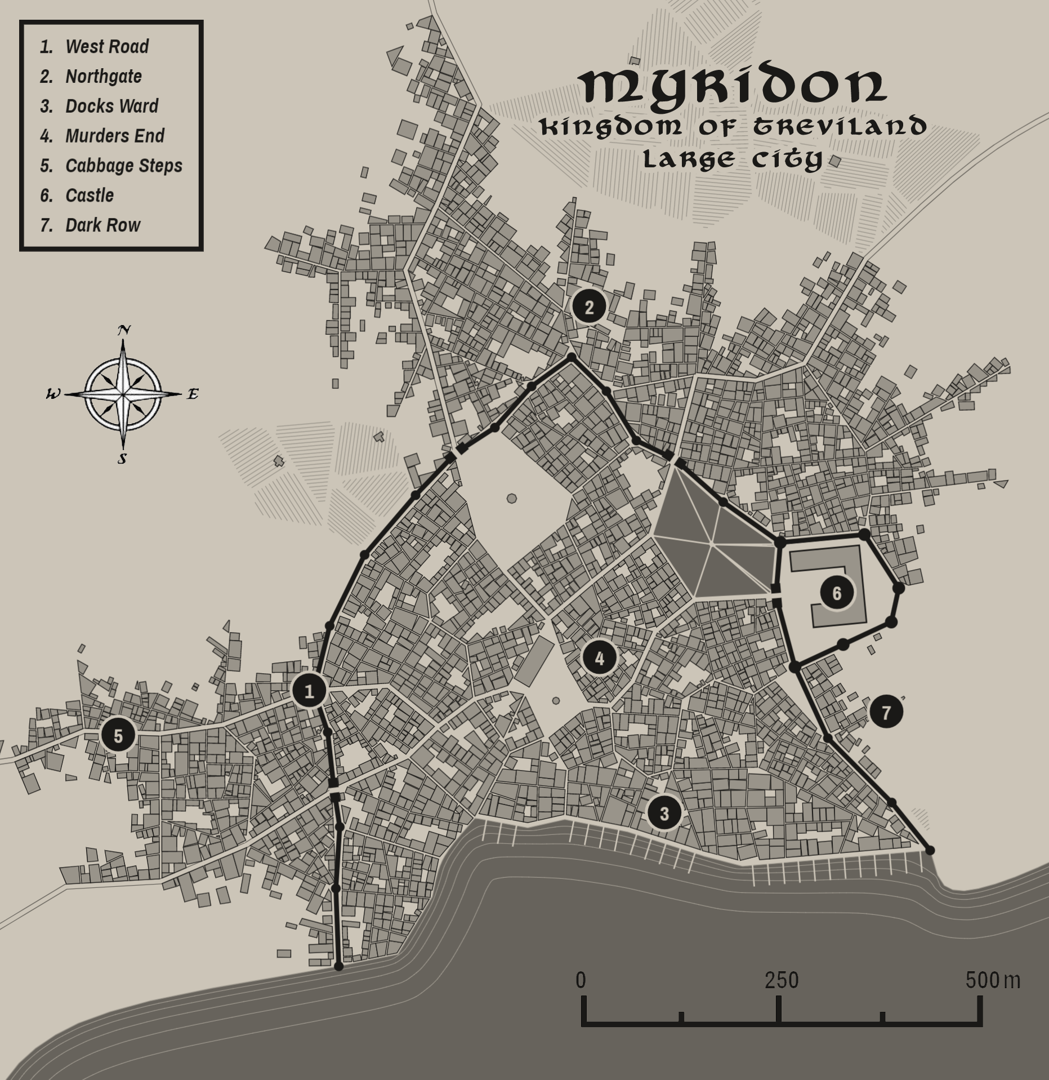

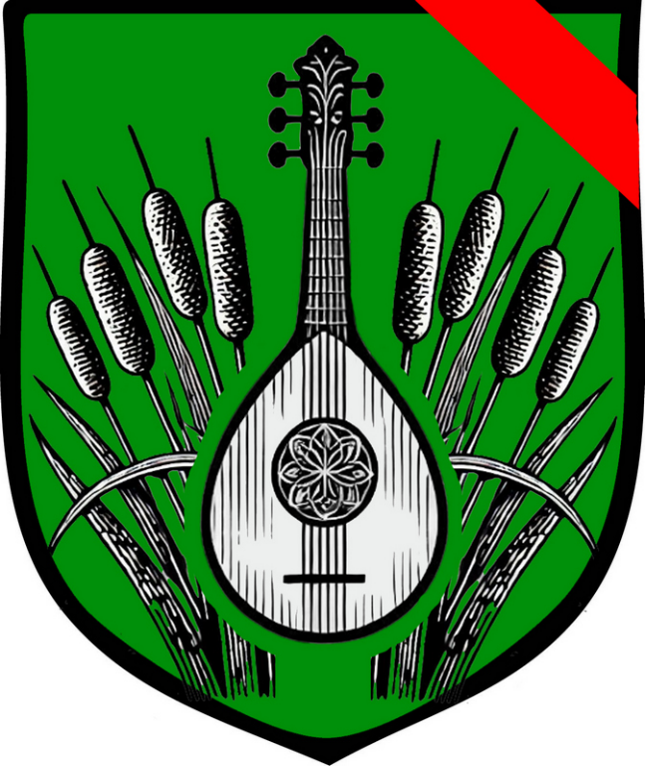
Lyre
Size: small city, population 12,000, guards / soldiers 120, militia 600
Trade Goods: wool, wine, textiles
Local Goods: fishing, water transport, musical arts
Standard: silver lyre harp
Colors: green and silver (with red ribbon for Treviland)
Patron Deity: Heironeous; Saint Oelfwine of the Canticle
Ruler: Lord Brogan Sivvian and his wife Myranna
Sons Padraig 24, Flurry 18
Daughters Alastriona 21, Dana 16, Cait 8

Home: Castle Balladeer
Steward: Alan Coyne
Marshal: Mahon Hale
House Priest: Lumin Doyle Lomas
House Adviser (Scholar/Mage/etc): Oisean Finnever
Captain of the Guard: Royce Kellar
Knights in Service:
Sir Niall Fowlis
Sir Osgar Gahan
Sir Sorley Cowan
Sir Manus Devane

Local Powers: Loot Players (thieves guild), Cathedral of the Canticle, Idlemay Vineyards, The Sardonic (bardic college), The Secret Hand (cult), Epona House (chapter of the wool and weaver’s guild in Bastion)
Local Sites: The Blue Nightingale Inn & Tavern, Banner and Bell Inn & Tavern, The Open Bailey (brothel)

Description:
In all the west, no place is quite as merry nor as enchanted with the magic of melody as the town of Lyre. It is an idyllic country town, sitting half on land and half on Lake Eversong. Wide wooden piers extend out into the water where stilt houses overlook boats paddling lazily down the water-streets between. In olden days large stone plinths were sunk into the lake and from them grew small towers. Situated at a promontory of land, the town is well defended the earthen causeway the only egress.

Lyre lies in the lands of Hartha, which extend from the northern banks of Lake Eversong in the north down to the coastline to the south, and from the Caerwyth River in the west to the Provender River in the east. Illustrim also lies within these lands and shares a cultural bond with Lyre, as they were both settled by Harthan tribes after the ouster of Celedonian occupation in the First Written Age. The Harthans have their own unique customs and cultural identity, but answer to the Trevilish banner.

The people here are industrious but simple compared to the cities along the coast. Travelers are regular here, but few stay for long. During the good times, the town flourishes on song and food and merriment. In darker times, when goblin tribes threaten it from the nearby Corbus Hills and the Comely Mountains, the town becomes a citadel on the water.

Few would count the lake people as valorous or particularly clever. But few would also suspect that the town’s oral tradition contains more songs and stories than many libraries hold in their books. Even the most illiterate sheep farmer here can be counted to know an impressive array of history and legend. As the wizard Agringetorix once wrote, “Look to the hearts of the lake town when the courage of the west breaks: for from their song cavaliers rise from cowherds and anthems from their tavern songs. There is great knowledge held in the tavern halls of Lyre.”

Industry:
Residents are expert boatmen and fishermen, plying their trade from the lake. Shepherds tend flocks along the banks of the Lyre where vineyards thrive. Expeditions are sent across the water or by land to the nearby Comely Mountains to the north for small mining operations.

Idlemay Vinyard - The soil here makes for a unique blend of wine named Idlemay, which is pinkish in color, sweet, and has a heady bouquet. It is sniffed at by connoisseurs, but is a cheap wine popular among the commoners.

Much of Lyre’s commerce comes by way of cargo boats coming south from Cerrulea on their way to Illustrim. Lyre is often credited as the supplier of the capital, though much of the grain comes from Cerrulea originally. Lyre is steadfast allies with both cities. It is also steward of the farmlands south in the Upper Treia region.

Epona Guild - The wool and weaver’s guild of Bastion controls the wool market in Treviland. A chapter of the guild is based here, taking orders from Bastion on production, transport, and prices. Avelina Faucon is the head of the chapter here. Like most guild members, her loyalties to the local lord and lady are often at odds with orders from the guild. Likewise, she may occasionally work deals with merchants off the books, which can be dangerous.

Key Figures:
Lord Sivvian is a stout, overweight man of average height. He has a prominent chin, rosy cheeks, a tussle of blonde hair going grey, and gleaming blue eyes. He is a jolly man with a large laugh. He is dressed like a country gentleman, with a plain frock and short pants with hose. On his feet he wears boatman’s shoes, for he is not afraid of boarding every boat that makes port and talking up visitors.
Sivvian is a loyal vassal to King Ballaster in Illustrim and holds with Cerrulea and the towns of the west. He is not a shrewd man, but he is earnest and a capable custodian of the farmlands of the Upper Treia region.

Sivvian’s wife, Myranna, is an aloof and mysterious beauty. She is tall and slender, with long dark blonde hair that carries a tint of green. Her skin is as pale as milk and her eyes are a deep blue-green. Her eyes seem to be set slightly wider apart than is normal, giving her an otherworldly aspect. There are whispers at court that Myranna is of fey origin, having come from the lake or the woodlands around it.

Thingle is a simple human merchant but he’s traveled the world and has many contacts in Darmidia. He tends to have items other merchants do not. If he doesn’t have them then he can put his hands on them. He is an unscrupulous dealer of things, willing to break the law to make his fortune. He has contacts in the thieve’s guild in Lyre and most other towns and cities in Treviland. Thingle operates as a fence for the guilds and buys their friendship with good coin and no questions asked. He operates a plain shop on the main street of Lyre but this operates as a front for several rooms below the shop, one of which leads to a tunnel that lets out down river where boats can come and go unseen. Thingle has roots in Lyre, but his name is spoken in Plenios and Tirudor as well as across the sea to the south lands of Darmidia. He is a thin man, plainly but neatly dressed, of fair complexion with immaculately plaited braids in his dark beard. His gray eyes are narrow and watchful. He wears upon one hand a ring showing the seven cities of the Tarbian desert, a gift from a sultan there for his past dealings with the nomadic tribes.
The Secret Hand is a cult operating out of the Comely Mountains. Thought to be a druid sect that turned to evil, its followers believe in eternal life through sacrifice to the underworld. Patrols out of Lyre regularly encounter carcasses and corpses staked out along the eastern banks of Eversong. Occasionally travelers go missing and are found later on sacrificial open-air altars. Secret Hand followers are known to use a mysterious toxin that enslaves the mind and drive their victims mad. Some say this creates recruits for their fellowship.

Local Lore:
The Cathedral of the Canticle is a marvel to the eye of western worshippers. In contrast to a long nave with a tall ceiling, the cathedral is built wide and rounded and is paneled with special timbers to capture music and amplify it. Indeed, the entire structure is dedicated to worship in the form of music. The choir gallery is twice the size of that in Illustrim. Large banks of metallic tubes dominate one wall to form a massive organ. Instruments of many makes and sounds are played, including a rare claviorgan. Far above, a belfry holds a host of bells that play elaborate tunes. Bards who have never stepped within a church before travel leagues to play within this special place. Every priest is an accomplished vocalist or musician. It is said that the careful ear can hear the words of the divine in the chants and the notes of this place. At the head of the cathedral stands a tall metallic cylinder etched in old markings. This is the legendary Chime of Passage, reputed to transport the spirit of the faithful with a single strike by a trained priest.

Eversong Lake is home to water nymphs, some tied to the lake and some from the rivers that empty into it. Other creatures roam the forests including pixies and grigs. These are mostly kind-natured creatures but untrusting of humans and their ways. The water spirit Melusine, who appears as a mermaid, rules over the lake and all nymphs answer to her. A statue to Melusine stands atop a rocky promontory at the center of the lake. On moonless nights it is said that Melusine appears and sings a haunting melody. Proverbs warn that evil men who sully the waters may well be met by the water nymphs and taken below.

To the east, the Basin of Konsonas sits atop the Comely Mountains. It is a perfect bowl-shaped depression that holds the supernatural power to capture and amplify sounds made at its center. For centuries it was used by bards and clerics to utter their songs and prayers in perfect harmony. Deep within the mountain, far below the basin, lies the ruins of the Shrine of Konsonas also called the Hallowed Halls of Harmony. It is the location of a powerful focal point in the world’s magical lay lines buried in the ground.
The Corbus Hills are the dwelling place of the Gogmagog clan of hill giants. They are bitter rivals of the Badaden hill giants across the Skedwyn Valley in the Dauniger Hills. The king of each clan carries the name of the tribe and is taller and more powerful than most hill giants. Each winter they come down from the hills to make war on one another in the valley. Often the war spills over into human settlements: farms are crushed with flying boulders, people taken and eaten as spoils, and entire herds stolen for winter provisions. By spring the two tribes make peace, partially to combat the humans that launch assaults on them in reprisal.

Geelgrub Goblins prowl the northern and eastern edges of the lake. Most come from the Comely Mountains, where the tribe makes its home. Smaller bands wander in from the Howling Hills and the Corbus Hills. On three separate accounts in history the town of Lyre has been razed by goblin or orc marauders: eighteen hundred years ago by the Geelgrubs (680 WA2), thirteen hundred years ago by Norgardian raiders during the Great Erobring (150 WA3), and most recently two hundred years ago in 290 WA4 when the Yargol tribe of Orcs from the Evermore Mountains invaded all of Treviland.

History:
While most days are peaceful in Lyre, goblins from the Comely Mountains on the northern shores occasionally march out to harass the outlying farms. Three hundred years ago the hero Muriel Dyneley led a host of warriors to meet a massive army of goblins and hobgoblins that marched on the city. The flaming arrows of the goblins nigh well burned the cottages and piers down. But Muriel’s magic horn, which created notes both sweet and terrible, rallied the soldiers of Lyre and struck such fear into the hearts of the goblin army that they were utterly destroyed. Muriel’s horn, named Assaxa, is still held in the Sardonic to this day.

Customs:
The people of Lyre hail from the Harthan tribes who settled this region. Harthan folk are lake and river people, and a merry lot. They have a rich oral and musical tradition. A long line of leaders of the Volds and Treians hailed from the Harthan tribes. Harthans are marked by their short breeches which are capped at the knees with intricate overlapping straps covering their lower legs. Even the women folk wear the straps along their lower legs and their skirts are designed to be pinned up around the knees when needed. Such vestments are more practical for working in and around water. (Lyre and Illustrim are both Harthan in heritage)

Lyre came by its name for the great songsmiths and musicians that come from here. Residents sing in a style unique to the region and many popular songs in the West can trace their origin to here. A famed bardic college, the Sardonic, was founded here hundreds of years ago by legendary bard, Elric Buslingthorpe. It is sought out by musicians from around the world. Storytelling is a fine art here, and it is said that one should avoid a Lyrean from recounting a tale or else one will lose the better part of a day or more to their silvered tongues.

The city of Lyre holds many festivals throughout the year. In the winter there is the Tourney of Bards, where musicians from all over compete for a silver harp. In the spring there is the Casting of the Petals, where flowers are strewn on the lake in honor of Melusine and her water nymphs. In the summer there is the River Regatta, where small boats row to the northern banks and back to see who is the swiftest. And in the fall there is the Baron’s Harvest Feast, where food and drink and music are aplenty for a week or longer.

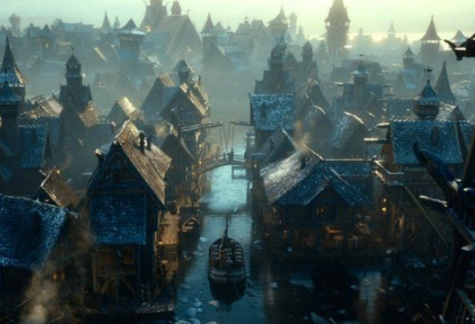

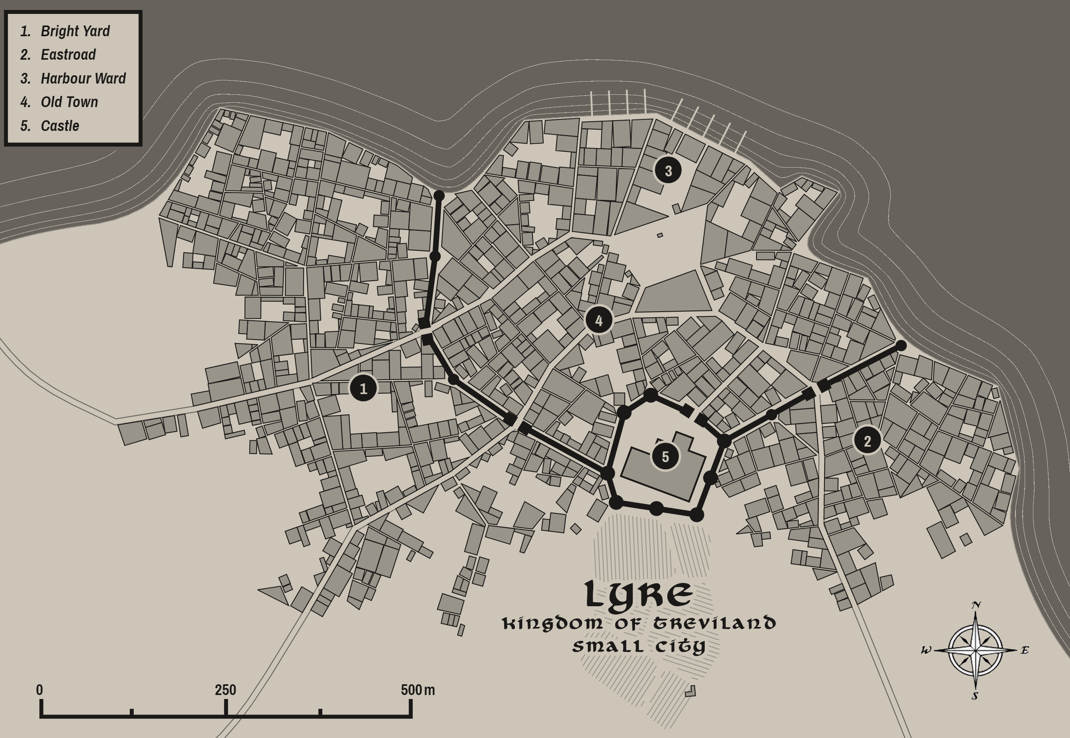

Illustrim
Size: metropolis, population 50,000, guards / soldiers 500, militia 2500
Trade Goods: trade hub, grain, tea, magic center, livestock
Local Goods: seat of power in Treviland, naval forces, infantry forces, fishing, ship building, exploration, sale of goods coming downriver from Cerrulea and Lyre
Standard: radiant sun
Colors: red and gold
Patron Deity: Heironeous; Saint Brighid (f) of the Illumination
Ruler: King Cennyd Ballaster and his wife Kayla (f)
Son Flann 18, Daughter Aislinn (f) 16

Home: Castle Riverstone
Steward: Earc Daly
Marshal: Sbaronas Roian
House Priest: Lumin Ryan Byrne
House Adviser (Scholar/Mage/etc): Tuathal Sheehan
Captain of the Guard: Doyle Kavanagh
Knights in Service:
- Sir Finlay Roibert
- Sir Shane Lyons
- Sir Kiefer Suain
- Sir Lee Kumor
- Sir Wilfred Holt
- Sir Tyne Burchard
- Sir Feldaumor Quick
- Sir Hawthorne Clemons
- Sir Palmer Koy
- Sir Cody Alden

Local Powers: Heralds of Provender Trading Company, Footfells (thieves guild), High Cathedral of the Illumination, Orealta Sanctum (school of magic), Order of the Gauntlet (order of paladins)
Local Sites: The Goose Scrag Inn & Tavern, The Lazy Lion Inn & Tavern, Lady Diamond (brothel)

Description:
It is called the Golden City of the West. Tall steeples rise from behind elegant stone walls of dandelion yellow chased in marble the color of corn silk. Cobblestone streets trace through a maze of half-timber houses rising up from the shoreline over ever-rising terraces, the houses and cottages growing in size and splendor all the way up to Castle Riverstone at the top. The Cathedral of the Unseen Sun stretches its spires skyward to catch the daylight and shine like a beacon across the countryside. It is a city of a hundred districts, the finest culture of Treviland, and the most lucrative markets.

Illustrim governs the lands of Hartha, which extend from the northern banks of Lake Eversong in the north down to the coastline to the south, and from the Caerwyth River in the west to the Provender River in the east. Lyre also lies within these lands and shares a cultural bond with Illustrim, as they were both settled by Harthan tribes after the ouster of Celedonian occupation in the First Written Age. The Harthans have their own unique customs and cultural identity, but answer to the Trevilish banner.

Nestled between the Rivers Unguin and Provender, Illustrim sits atop a high plateau that are well defended along the waterways. The high walls are guarded by a host of artillery, infantry, and war ships anchored in the massive harbor at the mouth of the Unguin River. The red banners bearing the Sun of Illustrim fly prominently as an inspiration to Trevlish folk that their kingdom in the west is strong.

Industry:
Illustrim is swimming in wealth. The Heralds of Provender trading company drive hard bargains from the wily merchants of Darmiddia far across the Ferrago Sea. The Church of Heironeous enjoys a powerful stronghold in the Cathedral of the Unseen Sun. Money, religion, and politics are all played at high levels in Illustrim as power in the west is decided by many players.

Key Figures:
King Ballaster is a stately, regal man. He is tall, with high cheekbones and a strong chin. His long gray hair curls near his shoulders and his thin beard is perfectly shaped as if from a painting. His pale grey eyes are casually wise and simultaneously mirthful. He speaks with a soft and even voice, but summons a cauldron of gravitas when provoked. He wears gilded brocade shirts trimmed in ermine like one would wear a sleeping shirt, for power and wealth have long since worn off their luster for him. He is his own man and cannot be bothered by those who make a fuss over him. At his side he carries Luxorum, the hereditary blade of his house. It is said to be a fearsome weapon casting searing light at its enemies.

Ballaster has continued the reign of the last five generations of his house. He has kept the lands south of the mountains united under one banner in spite of machinations by Novulum to upend the order of power. He is cautious but open, receiving envoys from Erigoth and Tirudor. Plenia, an ancient enemy, is not welcome in these lands but they are far west during this time and of no apparent threat. Ballaster is fond of jokes at their expense.

The king is wary of Lord Morley in the east, for Novulum was once the seat of Treviland’s power when the Celedon Empire invaded and relocated it there. Ballaster is keen to avoid being baited by Morley into decisions that would split the kingdom. He has rewarded the friendship of the Wolderfolk and the river lords of Cerrulea and Lyre who supply his city with resources. Myridon he has kept close by saluting Proy’s achievements and granting him open license to police the seas. Where he has no friends, Tringon has invested heavily in loyal soldiers to keep the mines in Stonbrek under his control.

The Order of the Gauntlet – The knights of the Gauntlet are proud and haughty, most hailing from highborn families and knowing little of charity. Gauntlet knights are charged with protecting the kingdom but are more concerned with glory than with aiding the weak. Riding in glittering armor with their red capes, they are indeed an impressive sight. Any quests commissioned by the high church seat that concern the kingdom are handed to the Gauntlet Order first. Those that they deem beneath them are sent on to the Kestrel and Heavenly Host orders.

Local Lore:
The High Cathedral of the Illumination is one of the three most extravagant houses of worship in the west, rivaled only by the Cathedral of the Severed Sword in Arrione and the Madrugada Cathedral in Colova. Illustrim’s cathedral boasts an enormous structure with a lofty ceiling decorated in sparkling gems, floors paved in gold tiles, and amber tinted windows that fill the interior with a golden light. The statue of St. Brighid looms over the place, her arms outstretched in welcome as her eyes peer heavenward. Warmth emanates from Brighid’s bosom where the legendary stone, the Eye of Heironeous, hangs from a heavy chain. Priests here consider their cathedral the new home of the Heironean faith and take pride in attracting many worshippers who once made the pilgrimage to the city of Indirron far to the east and actual seat of power for the world faith. This has caused more than a little tension between Treviland and the Isle of Indirron.

The river lands around Illustrim are rolling pastures dotted by ancient burial mounds and gullies where the sunlight never reaches. These are the lairs of wights and other fell creatures that stalk the plains in the moonlight. Here too are many sites of ancient battle fields where lie the remains of countless slain warriors. It is not uncommon for necromancers to plunder these sites to recruit gruesome soldiers for their causes.

History:
In 591 AA1 Chaldrik, chieftain of the Eymor tribes, was crowned its first king in the village of Eathra. Eathra was razed by the Celedonians to break the spirits of the Eymor and move the seat of power to the new city of Novulum. But in 792 WA1 Harald Trevin of Hartha united the tribes of Brimmor, Hartha, and Wolder to defeat the Celedonians outside the ruins of Eathra. They liberated the Harthan lands. Harald rebuilt Eathra and renamed it Illustrim.

Seven hundred years ago the necromancer Polluxris claimed the Dark Hand of Ages and mounted an army of fearsome creatures. Uniting with orcs from the Dauniger Hills (and some say mercenaries hired by Novulum), Polluxris stormed Illustrim and threatened to take it (820 WA3). It was the heroes Urian Heron, Bothild Harbird (f), and the wizard Ivo of the Seven Stars who managed to launch a counter attack from boats coming up the Provender River that turned the tide of battle. Though the battle was won, today necromancers comb the land for the Dark Hand of Ages and seek to harass the city and its folk.

Customs:
Illlustrim is home to a wide variety of people from every Trevilish tribe as well as people from abroad. But among the commoners who trace their ancestry back a long way, these hail from Harthan tribes who settled this region. Harthan folk are lake and river people, and a merry lot. They have a rich oral and musical tradition. A long line of leaders of the Volds and Eymor hailed from the Harthan tribes. Harthans are marked by their short breeches which are capped at the knees with intricate overlapping straps covering their lower legs. Even the women folk wear the straps along their lower legs and their skirts are designed to be pinned up around the knees when needed. Such vestments are more practical for working in and around water. (Lyre and Illustrim are both Harthan in heritage)

Once each year the king in Illustrim joins forces with the lord of Novulum in an annual campaign into the Skedwyn Valley. Hill giants from the Dauniger Hills have long troubled these lands. The campaign is as much to strengthen the bond between the two cities as it is to keep the giants in check. A great festival in Illustrim marks the departure of the king and his retinue as well as their victorious return.

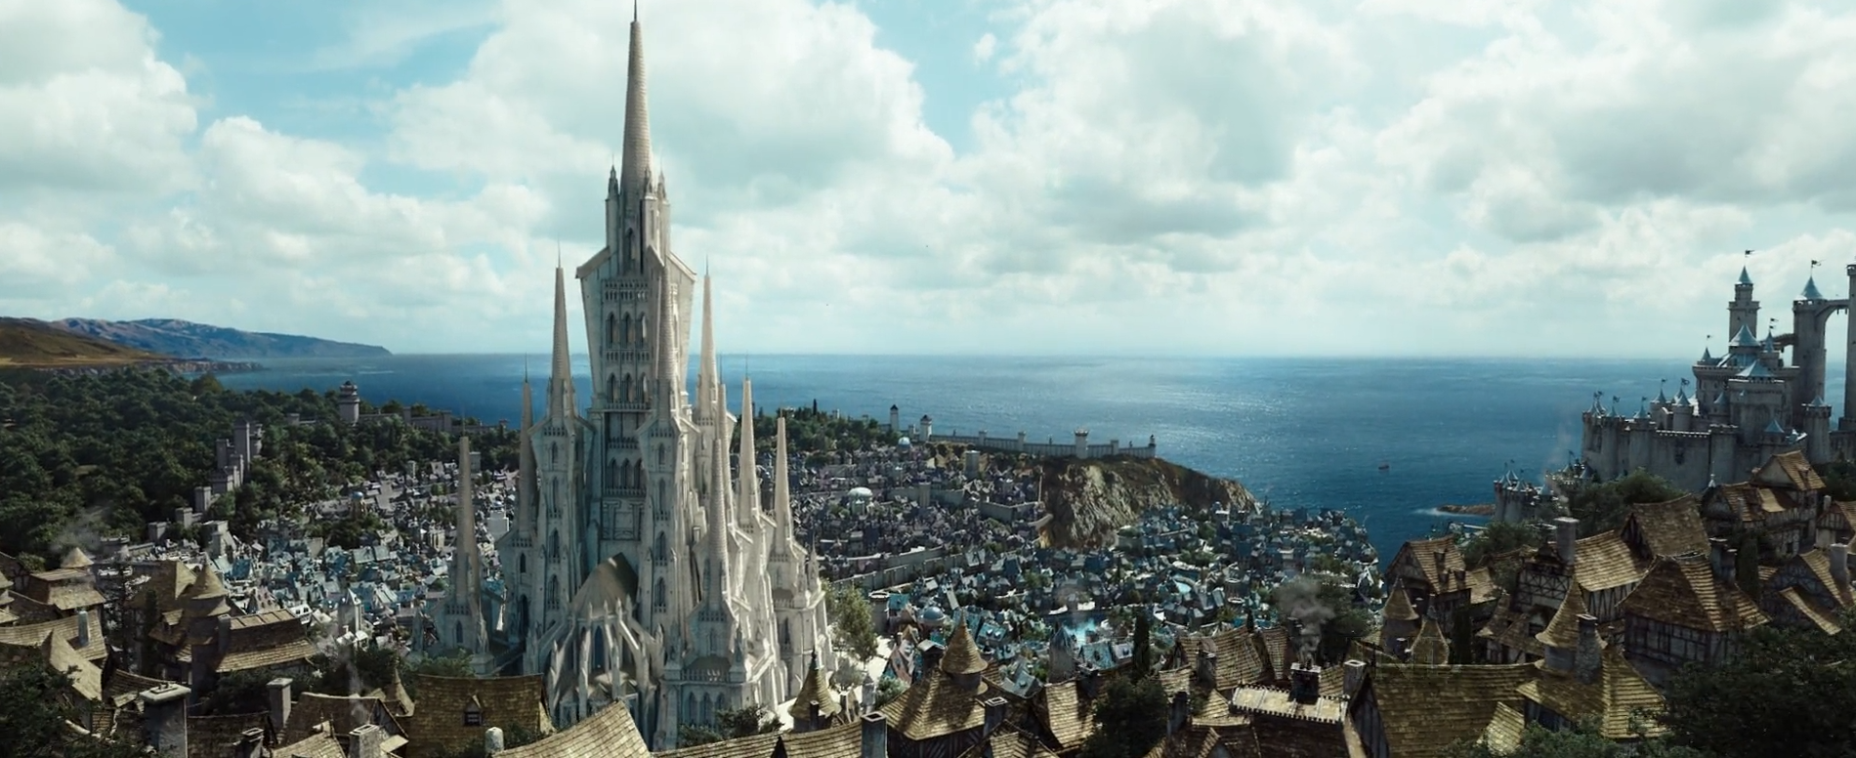

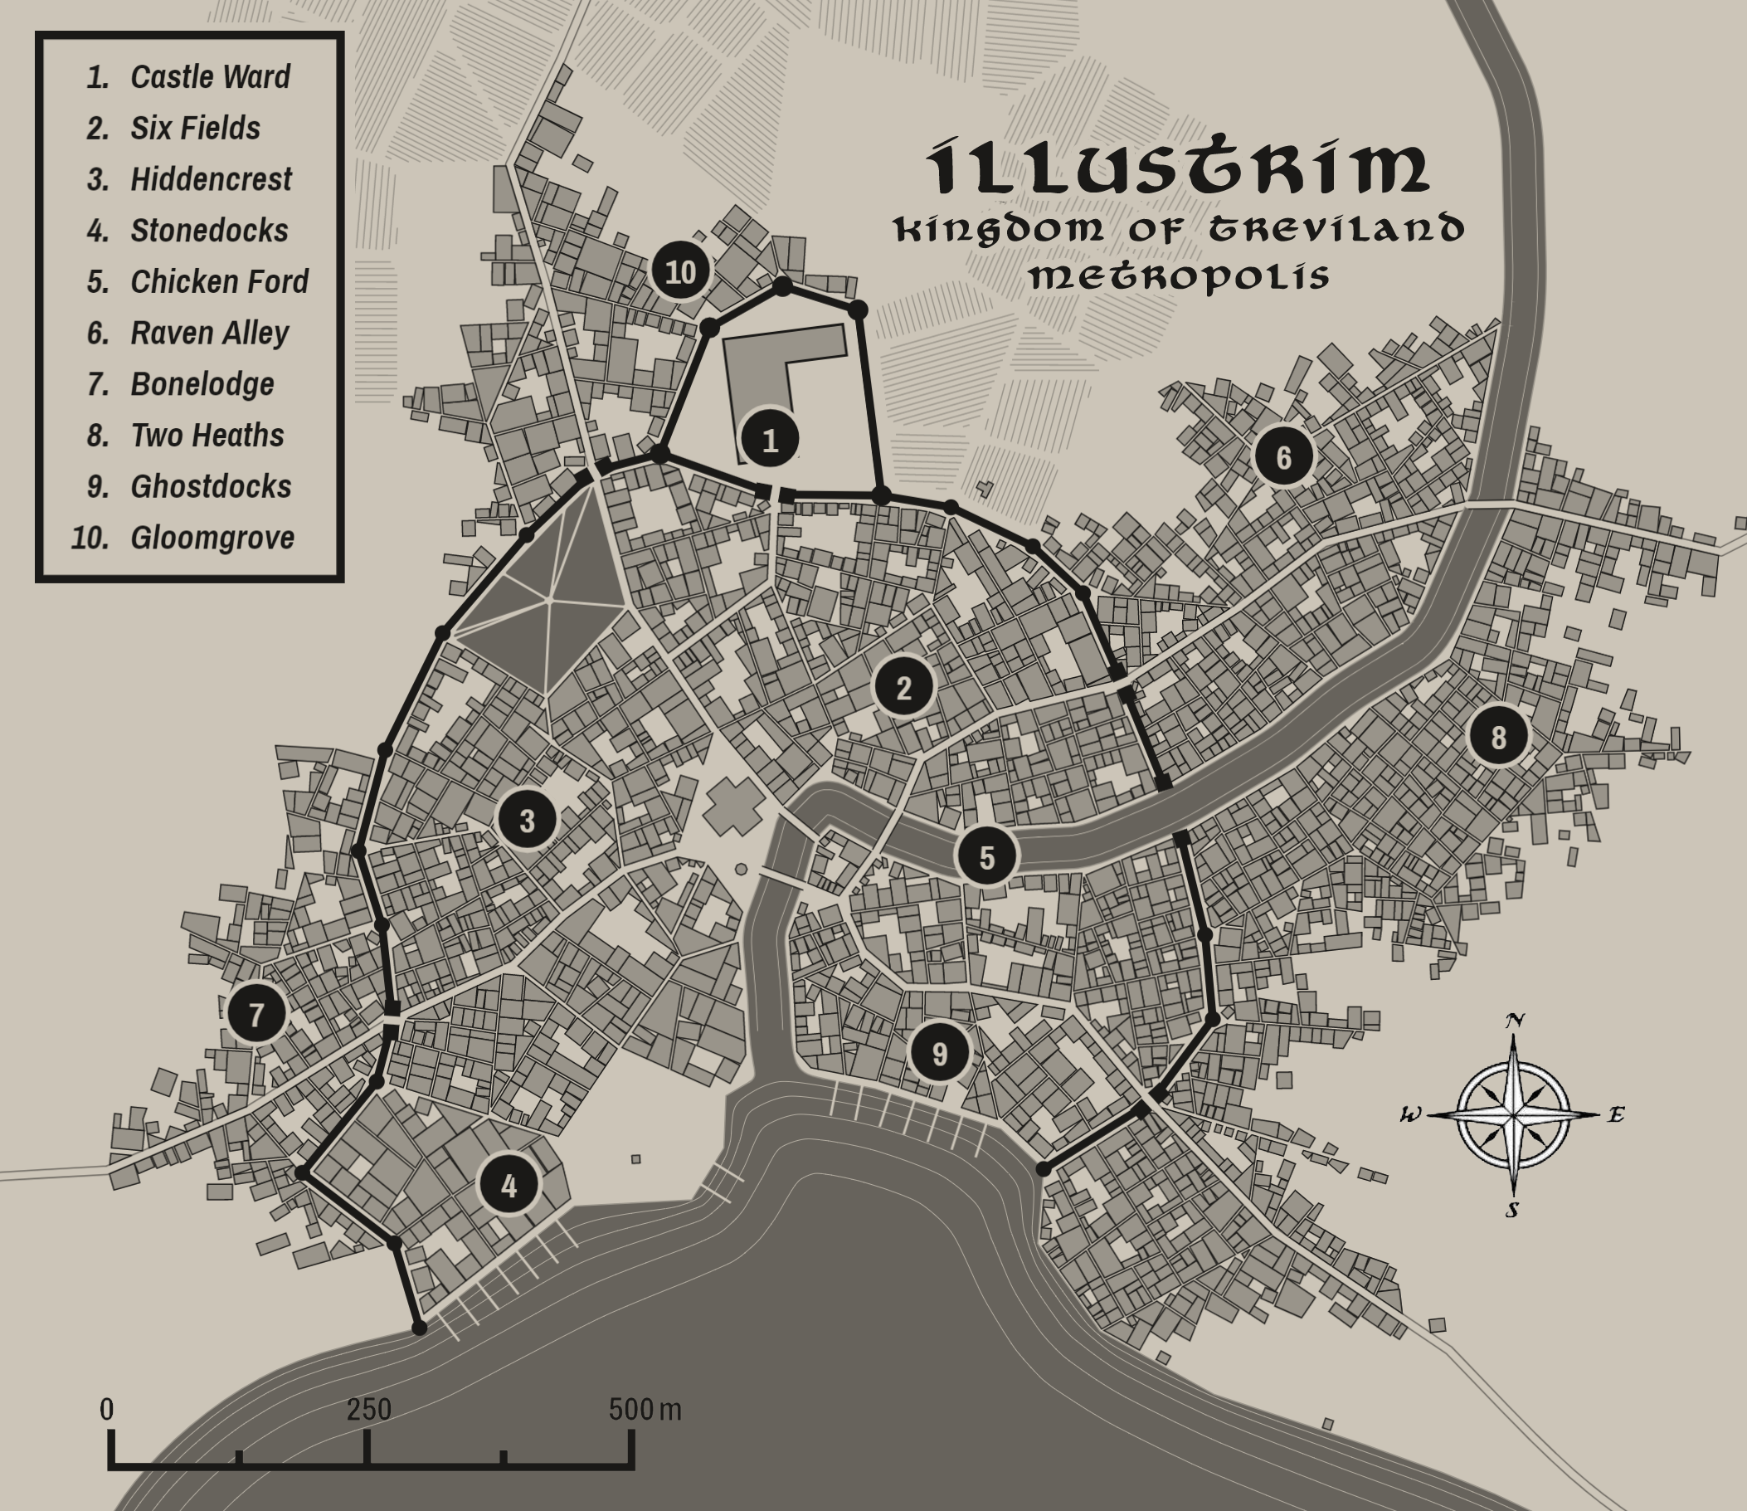

Slevvin
Size: large town, population 5,000, guards / soldiers 50, militia 250
Trade Goods: dyes, clay
Local Goods: smuggling, piracy, black market
Standard: sign of the serpent
Colors: none
Patron Deity: Olidammara; Saint Hethin the Apostate
Ruler: Kesan Dorean and his wife Naomh
Sons Padraig 24, Bryon 18
Daughters Alastriona 21, Dana 16, Cait 8

Home: Dour Tower
Steward: Alan Coyne
Marshal: Mahon Hale
House Priest: Lumin Doyle Lomas
House Adviser (Scholar/Mage/etc): Oisean Finnever
Captain of the Guard: Royid Kellar
Knights in Service:
Sir Niall Fowlis
Sir Osgar Gahan
Sir Sorley Cowan
Sir Manus Devane

Local Powers: Turnkeys (thieves guild), Lords of Barley (smuggling ring), Reaper House (casino)
Local Sites: The Happy Munuc Inn & Tavern, The Topaz Inn & Tavern, Turgid Tower (brothel)

Description:
Shrouded on all sides by the murk of Dankmire Swamp, Slevvin is a rogue town overlooking Buckler Bay. Dark-timbered buildings covered in moss stand atop submerged pilings. A network of rope bridges and piers connects them all, creating a multi-layered honeycomb of slums, taverns, gambling houses, brothels, fight pits, and thieves’ dens that stands high above the water. Music drifts out of open windows, accompanying a never-ending symphony of laughter, curses, oaths, and moans. To many civilized folk this would be the epitome of hell, but to cutthroats and the lawless this is paradise.

Slevvin lies just outside the lands of Brimmor, which extend from the Ivian River where it is flanked by the Howling Hills in the north down to the southern coastline, and from the Yester River in the west to the Caerwyth River to the east. Slevvin shares a cultural bond with Myridon, as they were both settled by Brimmoran tribes after the ouster of Celedonian occupation in the First Written Age. The Brimmoran have their own unique customs and cultural identity, but answer to the Trevilish banner (at least, Myridon does).

Long ago, escaped slaves from the Celedon occupation found their way to the coast and created a hideaway camp. Over the centuries, pirates, smugglers, and thieves found refuge here and the camp grew. Robber barons came and went, each of them taking charge over the work even as they took their own slice of the profits. Today the place is sacred to outlaws just as it is also one of the most dangerous places in Western Amadar. Treviland forces long gave up trying to control it. Darmiddian merchants often make use of it for smuggling. Landed lords often hire mercenaries who are mustered in and around the place.

Industry:
A prominent establishment in Slevvin is Reaper House, a famous and profitable gambling den. Pirates from all over the world have heard of the place and look to try their fortunes there. Decorated with the filched fixtures of royal courts from all over, the place is styled to appear like a luxurious ballroom. Servants wait on visitors in fancy livery, serving pirate swill in crystal goblets. Every visitor is treated like a king. But there are few gambling houses more talented at cheating and it is common for blood to be spilled when arguments break out. It is a dangerous place, for all its allure.

Key Figures:
Kesan Dorean is a lightly built man, tall and thin with a pale complexion. His long dark hair he wears up, fastened and decorated by exotic-looking implements from around the world. His moustache has grown exceedingly long, giving him the appearance of a soothsayer from Xiandai. His bright green eyes carry equal parts mirth and menace from behind darkened eyelids. He wears a loose-fitting jacket and shirt, along with dark trousers which he rolls up to his knees in sailor fashion when at sea. On each finger rests a gawdy ring, each one a different precious stone. At his side are his two short rapiers, Besa and Mata (“kiss and kill” in Tirudoran), which are rumored to have been worn by every baron of Slevvin since the town’s creation.
Dorean is himself a retired pirate and rules the town as the latest in a long line of Thief-Barons. He knows every face that passes through this place and marks them in the Slevvin Ledger, which has been kept since the town’s inception. A charming rascal, Dorean is always working out schemes for any rogue willing to serve him. He has his hands in every game in town, including the Lords of Barley which is his personal smuggling ring. He is a clever leader and cautious of others seeking to take his seat. He is protected by his personal guard, the Order of the Adder, who are marked by a dark serpent on both forearms.

Local Lore:
Slevvin sits at the mouth of the River Morrow. Residents prefer to travel by sea rather than venture into the swamp, but a handful of guides know the ways through it. It is rumored that travelling by either the River Morrow or its sister river the Yester at full moon will curse travelers who are never seen again. Others say the rivers themselves are portals into ages past or those yet to come.

The Revenant Tree – A trail leads from the ramshackle town into the dark swamps. At the end stands a dark and gnarled tree, its boughs stretching wide in a menacing shape. Something about the tree feels sick, twisted, angry. But also powerful. Overhead a thousand or more drinking jugs hang from cords tied to the limbs. A careful eye will see not a one of them is corked, and a strange ichor seems to leak down the branches and into the jugs. These are called the Reaper Jugs, which were drained of their liquor by folk what passed through Slevvin at some point or another and left here to drink now from the tree. It is said that any who drink a full measure of Slevvin’s special spirit (emptied only by the person, mind you, no sharing and all in one go) and leave their jug can have the town’s priest (after a fashion) say words over the jug and hand them the cork. If that person ever be slain anywhere in the world and his body returned, the cork can be exchanged with the tree and the jug poured into the corpse’s mouth. The corpse will come to life, burning with the living hate of the tree, and be made to walk again but only for one purpose: vengeance against whoever was their end. Now it need not be the exact person, I’ve heard – but the one ultimately responsible, even if they didn’t do the deed themselves. But that revenant will walk the world for as long as it takes to complete the task and, if they succeed in exacting their revenge, the body goes lifless in an instant, the job complete. Well, that’s the legend, leastways.

The Dankmire is filled with unspeakable horrors. The area is choked by vegetation and a welcome hiding place for hags and witches. Other creatures of old, such as shellycoats and grindylows, prey on unwary travelers. Tribes of Saurians control large sections of the swamp, naming it their own kingdom. Chief among them is Uszrux the Lidless, a savage warlord with flaming orange skin. He carries an infamous poisoned harpoon and rides a giant crocodile the locals call Dethroll. His tribe, the Khusk, rule all of Dankmire north of the Morrow River and are terrors of the Great Southern Sward. They are known by their sign of the alligator jaws. Uszrux tolerates Slevvin partially because the town is formidable but also because Dorean sends him regular tribute in the form of live food on two legs.

The southern Dankmire reaches are home to Oghiniam, a ferocious black dragon. Also known as Oghiniam the Wretched, he has terrorized the countryside as far as Myridon and was once responsible for devouring an entire caravan of envoys from Plenia. It is said that Oghiniam strikes deals with those with enough gold to employ his service, but he is devious as well as terrifying and isn’t above turning on his allies.

A strange creature that dwells in these parts is the Sigil Slug. These tiny creatures are harmless, but have the mysterious habit of crawling across living skin and leaving a lasting mark similar to a tattoo. Left to their devices, a Sigil Slug somehow draws out arcane symbols and glyphs in a language lost to knowledge. A few shaman who dwell in Slevvin still understand the language and, when consulted, have revealed that the symbols are portents of the future. Many a resident of Slevvin awakens to find a Sigil Slug’s mark on them. Typically a person will only receive one of these marks in their lifetime, but in rare cases two or more may appear. A very few regulars of Slevvin have their entire bodies covered in the marks and tend to have strange powers, either as a result or perhaps as a sign.

History:
It is rumored that seven hundred years ago the pirate Griffin Fogg, terror of the Ferrago Sea, led an expedition into the Dankmire and set up camp somewhere within (770 WA3). There he buried his massive treasure. But some say he and all his crew were cursed by the spirits of the swamp and slowly turned into creatures of the plant and muck itself. Stories told in Slevvin taverns speak of grotesque figures dressed in old sailor garb wandering the Dankmire, either guarding the treasure or seeking it.

Customs:
The people of Slevvin hail from the Brimmor tribes who settled this region. Brimmoran folk are at home along the coast as well as in the wetlands around the banks of the Yester River. They are master ship builders and fishermen. They are recognizable from their red stocking caps, which they decorate with family and religious emblems. (Myridon and Slevvin are both Brimmoran in heritage)

The denizens of Slevvin are a mixed and myriad lot, many of them hailing from the various Trevlish tribes or even from lands abroad. But for the poorest residents who can trace their ancestry back longer than most, these hail from the Brimmor tribes who settled the coastline and rivers of this region. Brimmoran folk are at home along the coast as well as in the wetlands around the banks of the Yester River. They are master ship builders and fishermen. They are recognizable from their red stocking caps, which they decorate with family and religious emblems.

An early code dictated a “portion o’ fortune” be paid by any who dropped anchor or did business here, owing to the upkeep and development of the place. The custom remains to this day. Any traveler who sets foot in Slevvin is levied a tax.

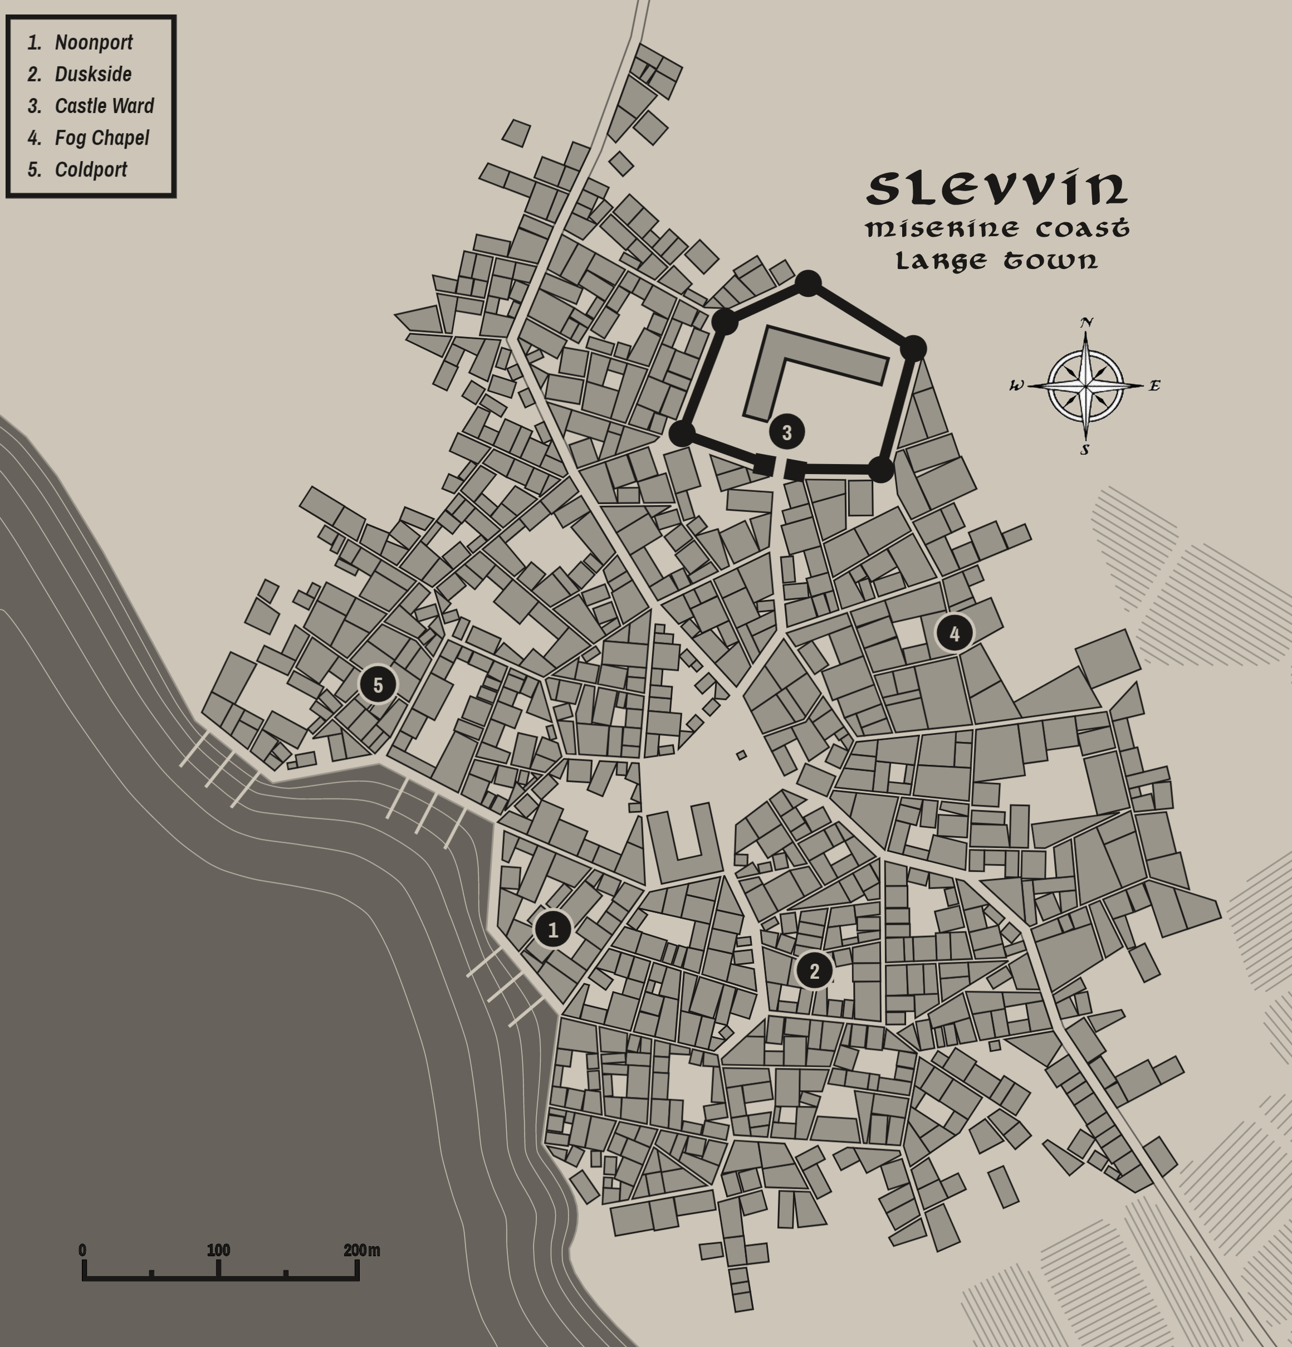

Shyberry
Size: small town, population 2,000, guards / soldiers 20, militia 100
Trade Goods: religious center, wine
Local Goods: ale, pipe weed, Brownback Ale, Snorri’s Port, Farmer Seamus’ smoked hams, Sogbottom, Long Leaf, Laughing Crone, and Follyfae
Standard: tree with many roots
Colors: green and red
Patron Deity: Yondalla, godess of the halflings
Ruler: Fredegar Oldbuck and his wife Abigail
Sons Walaric, Fulvus ; Daughters Ingitrude, Joveta, Elanor

Home: Thornburrow Keep
Steward: Burchard Hayward
Marshal: Berthaire Whitbottom
House Priest: Theobald of the Sacred Sling
House Adviser (Scholar/Mage/etc): Basina the Clever
Captain of the Guard: Arnoul Langham
Warriors in Service:
Ansegar Burrows
Leuthard Dewfoot
Lamorac Hogpen
Fulvus Tunnelly

Local Powers: High Cathedral of Yondalla (world seat of power for Church of Yondalla), Last Tumblers (thieves guild), House of Elation (abbey and distillery), Silversnuff (tobacconist)
Local Sites: Hither Thither Inn & Tavern, The Wishing Well Inn & Tavern

Description:
Shyberry is the largest Halfling settlement in the west and considered the capital of Halfling culture and religion. The people keep to themselves, but are friendly with those who pass through. Homely inns have been erected on the outskirts of the town to facilitate visitors and keep their influence at a distance.

Nestled in the southern end of the Howling Hills, the Halflings have made a comfortable home inside the hills as well as the smaller hillocks surrounding them. Visitors may notice it difficult to find the town. Basina the Clever, the court mage and illusionist, erected illusionary spells all around the countryside to keep troublemakers away. For those visitors that are expected, a hummingbird will come to meet them on the road. If they know the password, the hummingbird leads them to the town’s gates.

Shyberry sits between the lands of Brimmor, Wolder, and Hartha, but the halflings hold allegiance to no human ruler in spite of what some courtiers argue. The town is mostly forgotten by everyone and is almost impossible to find by most humans.

Industry:
Elation House - The priests of Yondalla brew a heady plum wine called Elation by its locals. It is popular enough it is barreled and taken to markets in Illustrim, where it is in demand in pubs throughout Treviland. They also produce Brownback Ale and Snorri’s Port.

Other local goods include Farmer Seamus’ smoked hams,

Silversnuff is a family-owned tobacco house, offering a wide range of pipe weed that is popular throughout Treviland. In fact, the industry has brought in quite a lot of coin to the town from human merchants. The most popular blends are Sogbottom, which is rich but overpowering, Longleaf, which is cleaner and more widely used, and Old King Brag’s, which has a pleasant scent to it but is a bit pricey. On occasion one can find Halflings enjoying Laughing Crone Leaf, which dulls the senses and evokes great merriment. Some say there is a leaf called Follyfae, which is rumored to have strange effects on the mind. The problem with Follyfae that no one seems to know where they got it after they’ve recovered!

Key Figures:
Mayor Oldbuck is a roly-poly, jolly fellow. He has curly red hair that is mostly gone except around his ears, rosy cheeks, and bright green eyes that twinkle with mischief. He is normally dressed in a gentleman’s waistcoat and short trousers, his pipe held to his lips so he looks like he’s thinking of something wise. He strolls the town daily, making sure he talks to everyone: from the goat herder to the washer women to the sleepy guard at the gate. Oldbuck is a fast talker and always looking to recruit his town folk into his latest ideas. Currently he is hiding a secret garden of radishes that he is convinced are touched by magic and will end up being a big seller. Unfortunately, the radishes have taken on strange properties and Oldbuck keeps having to sneak off to get the garden and its offspring under control.

Lady Abigail is an industrious woman who endlessly fusses over the state of the town and its folk. She is a broad-shouldered woman with curly brown hair that is always trying to escape from her bonnet. She wears an apron about her waist in spite of being the mayor’s wife and is seldom cooking in her own house. She has a high, shrill voice that can be heard throughout the town and uses it to sweetly pester every resident about the jobs they are doing.

Thoebald, the town’s head priest, is often away on one of his walks. He fancies a flask of Elation and is pleasantly pickled most of the time. An older Halfling, his white hair has grown long in the back and his skin is a ruddy brown from being out of doors more than in the church. He is a friendly fellow and ready with a blessing and a sage piece of advice.

Local Lore:
Redcaps are a fixture of local lore. They are tiny figures who menace the countryside and look to draw blood which they use to soak their hats and give them their red color. In halfling fairy tales, redcaps are said to be former halflings cursed as punishment for betrayal.

On the far side of the Howling Hills dwells a brass dragon by the name of Eoldru the Lore Beast. Eoldru is a secretive creature, almost impossible to find. But he regularly makes unannounced visits to halfling farms where he enjoys days-long conversations with anyone who will listen. Eoldru is an avid collector of stories and poems and can recite from memory entire digests of history. It is said his treasure trove is more full of books and scrolls than it is of gold or gems. Wizards and other scholars occasionally make pilgrimages into the Howling HIlls seeking an audience with the dragon and access to his library. More often than not, they are met with Eoldru’s insistence that he knows all his material by heart and he will be happy to recite it, whatever it is the person is looking for.

History:
210 WA2 - Hagen Forlock, chieftain of a loose band of halflings driven out of the Corbus Hills, leads his people to the Howling Hills and establishes the first burrows that will grow to become Shyberry

211 WA2 - Hagen Forlock travels into the Howling Hills and recovers the magic sword Brathuneidr ("biting snake")

212 WA2 - Battle of the Broken Yoke: Hagen Forlock leads a band of halfling defenders to defeat the Wrovugs, goblin chieftain of the Howling Hills

250 WA2 - Shyberry grows to become a town in its own right; halflings deposit the Seeds of Yondalla as the holy relic around which the High Cathedral of Yondalla is built

Customs:
The people of Shyberry are farmers and shepherds primarily. Gossip is the most popular pastime, followed by storytelling, singing and drinking. Shyberry food is hearty fare and a source of great pride. Festivals are year-round, as the folk are fond of merriment. In the spring tents are spread out on the lawns and music plays til the fireflies retire. In the winter the great hall is opened to all including those from the outer farmsteads, for no one should feel left out.

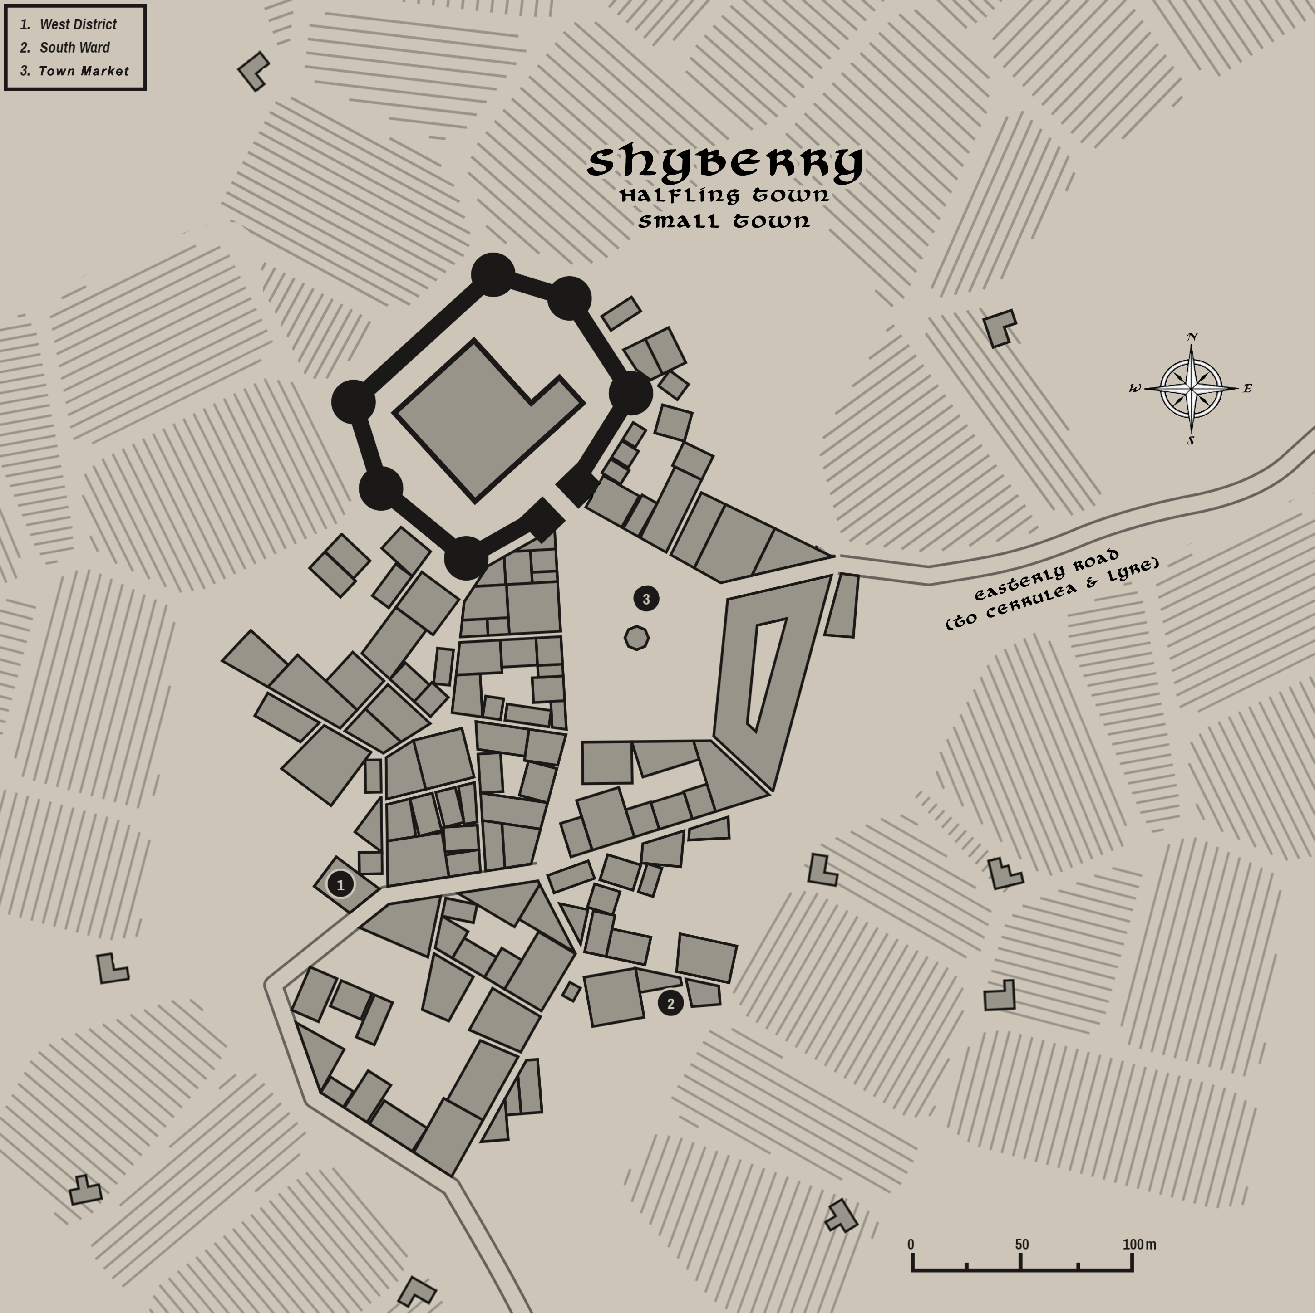

Villages

Lost Button – The village of Lost Button sits at the edge of a wide pasture, flanked by encroaching forest. Legend tells the village is so named for a peddler name Farley who lost a copper button from his waistcoat in the pasture. He settled here after refusing to leave without it, setting up shop to passersby. Over time he built a lean-to shack that served well enough as a tavern and lodgings to weary travelers. One hundred and fifty years later, the village is a homely affair of barley farmers. People are congenial, if a bit dim. The button grew into a bit of lore. Some whisper the button lies in the pasture still, filled with a magic that protects the village and offers good fortune. Others believe they can join in on the luck and throw buttons out into the pasture while making a wish. Farley’s old coat still hangs in the house of the village head man, a worn relic only the passing bard may find interesting.

Puddling – Puddling is a wretched cluster of soot-dark houses situated at the bend in the river. It is so named for the mire that forms in the dirt streets with every rain. It is a village of fishermen, with not much else to distinguish it. The air is thick with the smell of fish and the river. People here are cheerless and untidy and not at all comfortable with strangers. Their sallow skin droops beneath listless eyes. Singing serves as the little color the village has. Everyone, young and old, carry on in a tune that is throaty and sounds like a funeral dirge sung in unintelligible words. They call their style of music Oorfan, and it is sometimes accompanied by a squeezebox built from reeds native to these river banks. It is a dreadful sound befitting a dreadful place.

History of Treviland
Kings and Queens of Treviland
111 AA3 – 746 AA3 - Hundran rule of the lands of present-day Treviland
749 AA3 – 57 AA4 - Eymore rule of the lands of present-day Treviland
57 AA4 – 132 WA1 – split rule of the lands by Hundra and Eymore houses
566 AA4 – 132 WA1 - rule of House Alden (Eymor), Celedonian conquest ends both Hundra and Eymor lines
182 WA1 - 485 WA1 – rule of House Tregon (Culvren, vassal of Celedon)
485 WA1 - 729 WA1 – rule of House Baynton (Culvren, vassal of Celedon)
731 WA1 - 79 WA2 – rule of House Laken (Culvren, vassal of Celedon)
843 WA1 - 79 WA2 – rule of House Trevin (first Trevilish rulers)
80 WA2 - 522 WA2 – rule of House Swanborn
523 WA2 - 731 WA2 – rules of Houses Derring and Digby, which rule separately
731 WA2 - 772 WA2 – rules of Houses Derring and Digby, which rule together
772 WA2 - 164 WA3 – rule of House Derring
171 WA3 - 602 WA3 – rule of House Faintree
605 WA3 - 645 WA3 – rule of House Wylvern
681 WA3 - 82 WA4 – rule of House Fullwyrth
82 WA4 - 172 WA4 – rule of House Trinton
(172-254 WA4 War of the Red Moons, the land is occupied and without a king)
254 WA4 - 490 WA4 – rule of House Ballaster
(civil war)
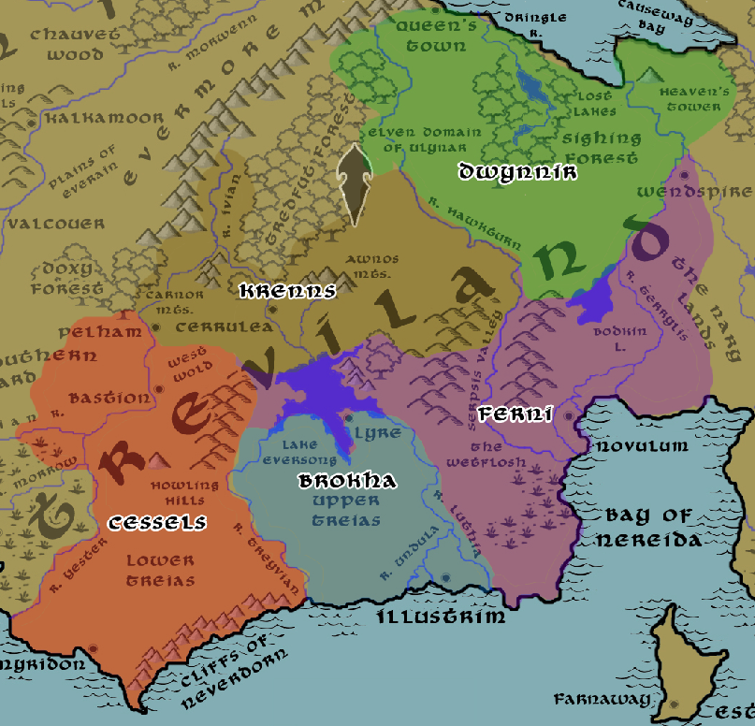
In the Ancient Ages the Vold Tribes warred for land and for survival against dark forces. They were the Cessels, the Brokha, the Ferni, the Krenns, and the Dwynnir.

First Primordial Age (PA1)
Dawn of the Volds
10 PA1 - Heironeous descends to the material plane at Heaven's Tower, his light serves as a beacon for decades inspiring humans to follow the path of virtue and hope

390 PA1 - Eckmuir fellowship of druids forms; begin erecting the Sarsen Hylith structures all over present-day Treviland lands

580 PA1 - Caedmon, fallen priest of Heironeous, wields the Empty Amulet to cleanse the Awnos Mountains of all magical creatures; Gytha the Faerie Queen directs the land to funnel all the energy back into Caedmon, causing him to explode with magic; Gytha begins dominion over the land now known as Faerdeep Vale

Second Primordial Age (PA2)
170 PA2 - Phrane Empire sweeps into Vold lands, conquering the tribes and holding dominion over the land; famine throughout the Vold lands leaves them weak in the face of the Phranes

860 PA2 - the Volds drive the Phranes out of the region of present-day Treviland

Third Primordial Age (PA3)

Fourth primordial Age (PA4)
470 PA4 - Tower of Karkuth is built in present day Treviland by an unknown wizard

580 PA4 - Vold tribes muster along the Caerwyth River, invade Vold lands
800-910 PA4 - War of the Downs - Vold tribes conquer Vold fortifications, take over present-day Trevilish lands

868 PA4 - Vold tribes crown their first overlord to rule over all the tribes in present-day Treviland: Bretwalda; decline of the Vold people and culture

872-888 PA4 - The Wizard War: Telemechus triggers a world-wide war of mages, some of whom march on Ongolk to stop him and some who join him in attacking the ley lines in their lands; epic battles wage all over the world, destroying cities and upsetting the balance of magic

888 PA4 - The Battle of Forlorn: Telemechus is slain but not before rupturing the magical ley lines permeating Nemmyrl; the victorious general Dragan of Celedon seizes the opportunity to rid the world of magic and ruptures the Singularion as it is embedded in the ley lines; the resulting explosion sends a shock wave that ruptures the magical ley lines around the world and triggers the Dead Century

First Ancient Age (AA1)
150 AA1 - Writing of the tome "Dreámcræft," which described the Vold art form of storytelling and music. It is the first record of the Treaian peoples of present day Treviland

240-280 AA1 - The War of the Talismans between the Vold Tribes

560-590 AA1 - Blight of Dankmire – Saurians of the Khusk tribe raid the Lower Treias and battle the human tribes

Second Ancient Age (AA2)

Third Ancient Age (AA3)
150 AA3 - tribes from all over western Amadar wage relentless war for control of the land

180 AA3 - war in western Amadar ends with King Marius ruling all the land west of the Evermore Mountains

420 AA3 - end of Marius dynasty in western Amadar

Fourth Ancient Age (AA4)
420 AA4 - the evil cleric Dawinnis angers the gods and causes the town of Serene to sink beneath a huge lake within the current Valley of the Lost Lake

638 AA4 - Turstin Mortmain attempts to take control of the Harthan tribes and is defeated; he and his followers are banished and move north across the Augemere Sea

647 AA4 - Mortmain's people conquer the kobolds in the Valley of the North Winds

652 AA4 - Mortmain founds the town of Stonbrek in the Valley of the North Winds

661 AA4 - War of Wind Valley: Mortmain's people incite war with the Dwarves of Demundra

680 AA4 - Orc armies attack Demundra; Var Vengalen of Stonbrek comes to the aide of the Dwarves of Demundra, ending the feud between the town and the Dwarves

First Written Age (WA1)
110 WA1 - Celedonian Conquest: Celedon invades present-day Treviland

130 WA1 - Celedonian Conquest: Spargeus Legion is joined by the Brontes Legion and defeats last of the Vold tribes, sacks Eathra (currently Illustrim); King Alfsig is taken to Celedon in chains, ending the Alden lineage
180 WA1 - Celedonian Conquest: Brontes Legion founds the city of Novulum and establishes it as the new seat of power in Treviland; Volds sympathetic to the Celedon rulers are placed in control of the city
182 WA1 - Leofing Tregon of the Vold people is crowned as king in Novulum as a puppet ruler answering to the Celedonians
240 WA1 - Celedonian Conquest: Brontes Legion commissions the building of Wendspire in the Nary Lands
485 WA3 - King Gamel is assassinated by Aldeian rebels; end of the Tregon house; Eygar Baynton, an Vold general, assumes the Vold throne during occupation
727 WA3 - Queen Ailleth steals the Cask of Orcus from the Celedonians; she wields dark powers over the land, slaying thousands of the Aldeians
729 WA3 - Esabel Faramond leads a group of heroes to thwart Ailleth; they fight their way into Novulum's dungeons, slay the queen, and cast the Cask of Orcus into oblivion; end of the Baynton lineage

731 WA3 - Siward Laken assumes the throne in Novulum after the death of Ailleth; he plunders the land with taxes making his Vold allies wealthy
792 WA1 - Celedonian Conquest: Harald Manston of the city of Eathra unites the Aldeians to defeat the Celedonians, renames the city to Illustrim

822 WA1 - Godwin, son of Harald, wars with the Aldeian tribes to conquer the region

843 WA1 - Edric son of Godwin unites the Aldeian tribes and is crowned the first Aldeian king; beginning of the Manston royal lineage

Second Written Age (WA2)
22 WA2 - Aldeian tribes defeat the Brontes Legion in the Culvren lands; King Trevin falls in battle after defeating the Celedonian's general, Bakrus; end of the house of Manston
22-79 WA2 - Aldeians war with the Vold tribes and their Celedonian allies
79 WA2 - Aldeians conquer Novulum and depose King Heregod, ending the rule of the last Vold king and the Laken lineage; last of the Celedonian forces in Treviland are destroyed

80 WA2 - The magical sword of King Trevin chooses Sir Ithamar of House Swanborn to rule the Aldeians; Ithamar is crowned king; the throne moves back to Illustrim and the region is collectively referred to as "Trevin's Land"

210 WA2 - Hagen Forlock, chieftain of a loose band of halflings driven out of the Corbus Hills, leads his people to the Howling Hills and establishes the first burrows that will grow to become Shyberry
211 WA2 - Hagen Forlock travels into the Howling Hills and recovers the magic sword Brathuneidr ("biting snake")
212 WA2 - Battle of the Broken Yoke: Hagen Forlock leads a band of halfling defenders to defeat the Wrovugs, goblin chieftain of the Howling Hills
250 WA2 - Shyberry grows to become a town in its own right; halflings deposit the Seeds of Yondalla as the holy relic around which the High Cathedral of Yondalla is built
330 WA2 - the town of Lyre is destroyed by goblins of the Geelgrub tribes out of the Comely Mts.
400 WA2 - mad druid Garruld Rotroot seeks to wipe out humans to protect his lair in the Tredfut Forest; rangers from the Band of the Evenstar hunt Garruld down and after a mighty battle slay him; the Seeds of Madness, Rotroot’s weapons, are lost

470-747 WA2 - The War of Cathedrals between the High Holy Churches of Hylux and Indiron
490 WA2 - Treviland split as Illustrim, Lyre, Cerrulea, Bastion, Pelham, and Milady fight for Indiron while Myridon, Novulum, Stonbrek, and Wendspire fight for Hylux

522 WA2 - King Torkel ignores the warnings of the druids and sets fire to the Doxy Forest in an attempt to trap the armies of Hylux; Torkel falls in battle as his enchanted armor fails him; end of the Swanborn lineage

523 WA2 - Treviland has two kings, as Solomon Dering is crowned in Illustrim while Nigel Digby is crowned in Novulum

730-749 WA2 - First Dark Crusade: Mortavay unearths the Crown of Power and enchants a horde of thousands to march on the west, beginning the First Dark Crusade; combined forces of orc, goblin, and gnoll tribes join and march westward and absorb Hyderis and Central Amadar around the Oberon Sea
730 WA2 - King Silas Digby mounts an attack on Queen Constance Derring in Illustrim, taking advantage of the chaos caused by Mortavay; King Silas is captured and imprisoned

731 WA2 - after a year of imprisonment, Silas and Constance fall in love and marry, sparking both alarm and rejoicing among the people

741 WA2 - Queen Raseda of Tirudor unites the kingdoms of the west to march against Mortavay's growing army; the War of Cathedrals pauses in the face of encroaching evil, the two faiths set aside their rivalry to join Raseda's army

748 WA2 - Baldwyn Derring, young son of Silas and Constance, sneaks off to join the war; Constance sends the court wizard Mortimer the Insane to help him;

748 WA2 - Baldwyn quests into the Stonecurtain Mountains; he retrieves the sword and armor of the legendary paladin Sir Atalann; Baldwyn battles heroically in the Battle of Fangring, winning renown

749 WA2 - Battle of Fangring: after years of carnage the forces of the west meet Mortavay's army at Tarvos Pass; Queen Raseda falls in battle, but eight heroes arise to slay Mortavay and destroy her crown; end of the First Dark Crusade

750 WA2 - armies of the west return home as a changed people, having faced true darkness and savoring the light; the pious return to their churches with tolerant hearts

751 WA2 - End of the War of Cathedrals: emissaries from Hylux and Indiron who continue to preach war are banished from the kingdom or executed

772 WA2 - after many attempts on his life by nobles in Novulum, Baldwyn Derring crowned king; the throne moves exclusively to Illustrim, Baldwyn has the traitorous nobles executed

820 WA2 - War of Syzith's Wrath: Wolfenfels and Stonbrek go to war with Dwarves of Demundra
840 WA2 - War between Men and Dwarves awakes the dragon Syzith, who destroys all Demundra settlements north of the Rastalan River

842 WA2 - Wolfenfels, sickened by the destruction of Syzith, joins the Dwarves in driving the dragon back; Stonbrek instead attacks the weakened Dwarves

843 WA2 - Wolfenfels strikes an alliance with Demundra; Stonbrek begins its feud with both Wolfenfels and the Dwarves

Third Written Age (WA3)
14 WA3 - the druid Esla Mandrake helps rout an army of gnolls invading Treviland

150 WA3 - The Great Erobring begins: Norgarde raiders invade eastern Treviland and western Tirudor; sack Lyre, Novulum, and Ibilis

150-472 WA3 - The Great Erobring sees Norgardian boats repeatedly sail the riverways of Western Amadar, raiding and plundering; Trevilish forces are constantly out-witted by hit-and-run tactics while the Norgardians make off with fortunes

164 WA3 - King Hardwin falls in battle attacking the Norgardians; end of the Derring lineage

171 WA3 - Alfrun Faintree crowned queen of Treviland; after seven years of squabbling between nobles, Alfrun rides out to challenge each noble individually and defeats or slays them, earning the throne for herself

320 WA3 - Norgardian settlers colonize lands from Hartha to Culver to the Nary Lands and parts of Ordonia; they build large wooden defensive works to protect their occupied lands
458 WA3 - Nobles of Treviland band together and defeat Norgarde raiders in the Battle of Keslinga
472 WA3 - End of the Great Erobring: last of the Norgardian warlords driven out of Amadar; Norgardian settlements remain but their people swear allegiance to their new lords

588 WA3 - Maynard Faintree, second born behind his heir-apparent sister Jocelyn, marries the Duchess Alixia of Ataia; his marriage relinquishes his claim to the Treviland throne
602 WA3 - War of the Secondborn: Jocelyn is poisoned and presumed dead; Maynard lays claim to the Trevilish throne and conquers Pelham and Bastion
609 WA3 - Sir Renus Wylvern of Bastion wields the magical sword Epitrax and slays Maynard; the Plenish are ousted from Pelham and Bastion
609 WA3 - Renus crowned king of Treviland
610 WA3 - Plenia and Tirudor unite to fight Treviland
616 WA3 - Plenia occupies half of Treviland
621 WA3 - Tirudor turns on Plenia; Renus seizes the opportunity to destroy Plenia's navy; no one suspects Renus planted the suspicion in Tirudor's mind to attack Plenia
632 WA3 - Battle of Nary Lands: Trevilish and Tirudoran troops die in waves trying to claim the lands between the Terrylis and Vestillon Rivers; neither succeed and the land is left wild
640 WA3 - Second Dark Crusade: the three kingdoms abandon their war and unite against Mortavay's invasion; end of the War of the Secondborn
645 WA3 - King Renus falls in battle, ending the Wylvern dynasty
650 WA3 - Trevilish cities in the path of Mortavay fall during the Second Dark Crusade: Wendspire, Cerrulea, Pelham, Bastion
663 WA3 - Trevilish and Tirudoran cities still free rally to attack Mortavay's center forces, cutting them off from the east; joined by the Elves of Ulynar attacking from Tredfut Forest
665 WA3 - Trevilish knight Artidius Kendor slays the general of Mortavay's forces in Treviland, saving the lives of thousands fleeing the conflict; his sword Souconna is blessed by Heironeous with great power
670 WA3 - Mortavay vanquished, end of Second Dark Crusade
672 WA3 - Quest of the Lantern: the kingdom devastated by war and left without a king, Treviland's archlumen commissions all knights of noble blood to find the lost Lantern of Clesia to restore the land
681 WA3 - Edwa Fullwyrth, paladin of Illustrim, retrieves the Lantern of Clesia and unites the broken people of Treviland; Edwa is crowned Queen, beginning of the reign of House Fullwyrth
710 WA3 - Masyn Elgan of Pelham leads a rescue of Lonely Keep from Orcs, wins the friendship of the Dwarves of Demundra

770 WA3 - the pirate Griffin Fogg terrorizes the Ferrago Sea, makes his home in Dankmire Swamp outside Slevvin

820 WA3 - the necromancer Polluxris claims the Dark Hand of Ages and attacks Illustrim; heroes defeat him and the Dark Hand is lost

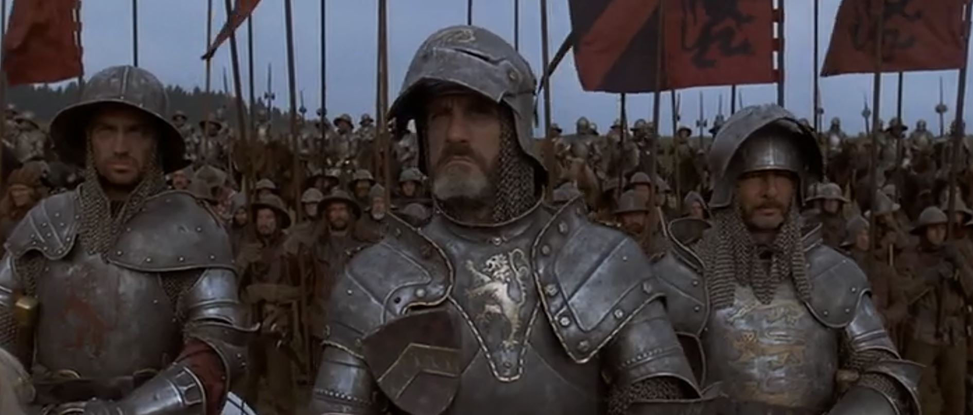

Fourth Written Age (WA4)
31 WA4 - goblins out of the Awnos Mountains, led by their chieftain Phlazik, find the Seeds of Madness left behind by the mad druid Garruld Rotroot. The goblins use the seeds to create an epidemic in the Kendor lands.
32 WA4 - the wizard Travix the Moth-eaten leads an army of dwarves and men and the brass dragon Isienth to rout goblins in the Awnos Mountains in Kendor, turning the goblin army to stone
79 WA4 - Queen Gertha is exiled to Furlaan by King Simon of House Fullwyrth
82 WA4 - Gertha returns to overthrow her husband and place Lord Trinton on the throne; Gertha returns to the town of Furlaan as a commoner but lives on as a folk hero
109 War - the town of Furlaan is renamed Milady to honor Lady Gertha after her death
158-261 WA4 - War of the Red Moons: Plenia and Tirudor wage war on Treviland
172 WA4 - The Novulum Revolt: Novulum seizes the opportunity of the war to overthrow the Trinton throne, ending their dynasty
172-254 WA4 - the kingdom is divided between warring nobles as Plenish and Tirudoran forces conquer and occupy much of the land between the towns
254 WA4 - Sir Hiram Ballaster leads the Trevilish and overcomes Novulum; he regains control of Treviland, uniting the people and is crowned king
261 WA4 - End of the War of the Red Moons; House Ballaster drives Plenish forces west of the River Oredon and the Tirudorans east of the River Vestillon
290 WA4 - Yargol tribe of Orcs from the Evermore Mountains invade Treviland
310 WA4 - Cragtilus the wizard and the heroine Breanna Hightower of Pelham drive back the Orc invasion
363 WA4 - Queen Luilda Ballaster deploys Captain Engelise (f) and Myridon's fleet; after months of hunting, Engelise destroys half of Plenia's fleet that were posing as privateer ships
474 WA4 - Jocelyn Faintree awakens from her crypt; using the little magic she learned as a child, she frees herself and finds her house died off 700 years ago
484 WA4 - Yargol orcs invade Treviland from the Evermore Mountains; King Ceirdrec of House Ballaster defeats them with the Crown of Power but his wife dies as a direct result; Ceirdrec scatters the pieces among his Dukes
490 WA4 - King Ceirdrec of Treviland Assassinated, igniting the war of Succession in Treviland
492 WA4 - Benificus of the Church of Heironeous commissions a quest to find the Eight Scepters of power; heroes march from Bastion

Local Goods
Cereals: wheat, spelt (wheat), barley, oats, rye
Fiber: cotton, hemp, flax
Fruits: blackcurrant, damsons, juniper berry, pear, raspberry, bilberry
Meat and poultry: beef, pork, boar, chicken, lamb, mutton, duck, geese, pheasant, quail, venison, veal, rabbit, goat
Nuts: chestnuts, hazelnut
Vegetables: angelica, cabbage, parsnips, radish, rapeseed, turnip, potatoes, carrots
Herbs: caraway, dill, hops, tarragon, thyme, oregano, wormwood, ramson, borage, celery, chives, gale, horseradish, juniper, mugwort, southernwood, water cress
Oils:
Fermented Drink: beer (ale, lager, malt, stout) with the following types: amber, blonde, brown, cream, dark, pale, strong, wheat, red, pilsner, golden, fruit, honey, and merchant; wines red and white
Salt-water fish: herring, cod, oysters, mussels and scallops
Fresh-water fish: pike, carp, bream, perch, lamprey, and trout
Wood: willow, alder, ash, beech, birch, chestnut, fir, hornbeam, larch, oak, pine, poplar, spruce, walnut, sycamore
Textiles:
Dishes:
All sop (pieces of bread served with broth, soup or wine, salt water)

Erigoth sausages
Tirudor maccu (soup prepared with dried and crushed fava beans (also known as broad beans) and fennel),

Notes on Culture
Customs of Treviland
Clothing and attire
People in the western kingdoms tend to wear woolen clothing with undergarments made of linen. Men don woolen tunics with hose, leggings and/or breeches. Men of station wear doublets, a close-fitted padded garment with long sleeves. Sometimes they wear jerkins, a tight-fitted sleeveless jacket, over the doublet. Women wear long gowns with sleeveless tunics and wimples to cover their hair. Sheepskin cloaks and woolen hats and mittens are worn in winter. Women of station wear flowing gowns and elaborate headwear, ranging from headdresses shaped like hearts or butterflies to tall steeple caps and Italian turbans.

Peasants wear simple hide shoes or footwear made of cloth bound by leather straps. Commoners wear leather boots of varying heights, sometimes with straps and buckles. The wealthy may wear boots of great quality and decoration. Dyes are common, so even peasants wear colorful clothing. Fabrics of the brightest and richest colors are found on nobility and the very rich. Brighter colors, better materials, and a longer jacket length are usually signs of greater wealth.

Clothing of the aristocracy and wealthy merchants tend to be elaborate and change according to the dictates of fashion. Some materials are sable, velvet, cloth of gold, or silk. Garments are often lined with fur or garnished with silver or gold thread.

Magic
Those who practice arcane magic are known as Cunning Folk. Some peasants refer to good wizards and witches as “pellers,” which is a contraction of the word “expellers” for their gift to expel demons. Witches are referred to as 'wise women' or "Nicnevins" ("daughters of heaven").

Healers who train under wizards refer to the Lacnunga, a tome of remedies that mix herbalism with magical properties.

Customs
Maypole – Every spring a tall tree is felled and carved into a decorative pole called the May Pole. It is erected during the Feast of the Vernal Equinox, capped with long colorful streamers that children hold and dance around the pole. Part of the tradition is a ritual of good-natured maypole theft between villages. Rivals attempt to steal any reasonably portable maypole, despite the fact that most will be specifically guarded against such an eventuality. Rules may vary: guards can be coaxed away, guards must have a hand on maypole all night, etc. Once the maypole is stolen, it has to be released against a forfeit, which is usually the pole’s weight in spirits.

Two ancient words are still in use to describe minstrels and bards of the Trevilish region. HLEAHTOR-SMIÞ – “laughter smith”, one who can make you laugh. These bards study an ancient form of storytelling and music, called “dreámcræft”

Primroses are sprinkled on window ledges and above doorways to protect the house.

Trevilish people have many customs to ward of tricksome fae:
Iron shears are hung on the wall in a baby’s room to prevent the child being swapped with a fairy child.
Peasants sometimes carry an iron nail in the pocket to prevent being carried off by fairies. Some warn that if you hear someone call your name (usually the mothers voice) don’t follow it, you’ll be taken by the fae.
Don’t take anything that you know isn’t yours (like a branch on your sill) that is accepting a gift from the fae and making a contract with them. Those are unbreakable.

Mari Lwyd - During Winter Solstice, villagers dress in bright attire and carry a decorated horse’s skull on a pole. They dance from house to house, singing loudly to try and gain entry. Those of good spirit respond in song and let them in to share in food and drink.

Wooden Spoons - Some peasants have a custom where a boy who fancies a girl will make her father a wooden love spoon. He carves it himself, often in a very ornate style. The gift is given to the father as a sign: the more care and attention put into the spoon, the more care the young man may show his true love (and the handier he is overall).

Weapons and Armor
Military Clothing, Weapons, and Armor
Clothing: The typical soldier of the west, high-born or low, is attired in a mid-length tunic, breeches, belt, and leather boots or shoes. Knights and well-funded soldiers may wear a higher quality cloth, some even silk, decorated in threadwork and high boots of rich leather and shiny buckles.
Armor: Common foot soldiers and archers wear a gambeson (also aketon, padded jack, pourpoint, or arming doublet), which is a padded, quilted defensive jacket constructed of linen or wool. Professional soldiers and knights wear medium to heavy armor over this jacket. Foot soldiers carry kite shields or, in some cases, tower shields. Cavalry carry light shields.
Weapons: Conscripts carry only a spear and perhaps a short sword or dagger. Militia and professional soldiers carry long swords, battle axes, heavy maces, or some form of polearm. Mounted soldiers carry a heavy lance as well as a longword, light mace, flail, or battle axe.
Base Stats: (Infantry) Splint Mail +6 AC, Heavy Steel Shield +2 AC, Longsword 1d8 / 19-20, Spear 1d8 / x3, Mace, light 1d6 / x2; (Archer) Scale Mail +4, Long Bow 1d8; (Conscript) Leather +2, Spear 1d8 / x3, Short Sword 1d6 / 19-20, Light Wooden Shield +1; (Cavalry) heavy or medium armor, long sword 1d8 / x2, lance 1d8 / x3, heavy metal shield +2 AC, Long Sword 1d8 / x2
Markings and Standards: Western armies prominently display the devices and colors of their local lord or lady on banners, shields, and clothing. Soldiers of the king or queen bear the device and color of the throne. Vassal armies feature a diagonal sash of the kingdom’s color on their shields and banners to show their allegiance. Knights and high-ranking soldiers may wear a tabard, a sleeveless jerkin or loose overgarment, bearing the colors of their lord. Conscripts carry no device on their shields, but may be issued a ribbon of their house or kingdom color to wear on their left arm. In well-funded campaigns, conscripts receive a tabard of coarse cloth.

Local Deities
At the dawn of the Written Ages, the western kingdoms of Plenia, Treviland, and Tirudor fell sway under the civilized churches of Hylux and Indiron. Cathedrals and abbeys were built, holy days set, and rituals adopted into everyday life. The people abandoned the old gods of their tribes. The influence of the church crept into every court, elevating kings into divine rulers and knights into holy crusaders. Such was their power, the two churches fueled holy war between the cities and towns in the Second Written Age. Neighbor turned on neighbor in what was later called the War of the Cathedrals. When the dread of the First Dark Crusade loomed, the people put aside their holy war. But the land is still divided to this day, with some regions honoring Hylux and the others honoring Indiron.

There stand many churches dedicated to Pelor and Heironeous. But it is the saints that the common folk have come to pray to.

Saints of the Trevilish Churches
Stonbrek - Saint Duthren of the Sacred Corbel (saint of Pelor)
Milady - Saint Agatha (f) of the Filling Heart (saint of Heironeous)
Wendspire - Saint Regis of the Unseen Summit (saint of Pelor)
Cerrulea - Saint Everild (f) of the Fecund Flail (saint of Heironeous)
Novulum - Saint Tostig of the Cudgel (saint of Pelor)
Pelham - Saint Cynebald of the Fire Flagon (saint of Heironeous)
Bastion - Saint Birstan of the Endless Watch (saint of Heironeous)
Myridon - Saint Maerwynn (f) of the Following Seas (saint of Pelor)
Lyre - Saint Oelfwine of the Canticle (saint of Heironeous)
Illustrim - Saint Brighid (f) of the Illumination (saint of Heironeous)
Slevvin - Saint Hethin the Apostate

The Old Gods of the West
Still yet, the old gods persist, even to this day. Their crumbling stone shrines, covered in clover and moss, still whisper to the common folk who listen. These are the gods of the druids and rangers. These are the powers of nature that the common folk still call upon in their darkest hour. In lonesome monasteries hidden along the countryside the disciples of these old gods pray to harness the powers of the wind and earth, stars and moon. Their wandering prophets are called the Faidh and they speak riddles and the dooms of men. The old gods are the same among all Western Amadar, having hailed from the Primordial Ages when the western tribes were as one.

- Aermid – goddess of healing and herbalism
- Áine and Grian - goddesses of the summer sun and winter sun
- Ankou – god of the dead and the underworld, appears as a skeleton wearing a black robe and a large hat which conceals his face, or, on occasion, simply as a shadow. He wields a scythe and sits atop a cart for collecting the dead. Sometimes he drives a black coach drawn by four black horses accompanied by two ghostly figures on foot. He protects grave yards and, as the saying goes, “When the Ankou comes, he will not go away empty.” Anytime a wagon wheel squeaks or the cry of an owl is heard, it is said to be the squeaking of Ankou’s cart. The owl is referred to by some as the “Death Bird” for this reason.
- Anotemen – goddess of the sacred grove
- Artaius – protector god of sheep and cattle herders, takes the form of a bear
- Asteron – goddess of the dawn, beginnings, and resurrection, patron deity of Windenfre
- Baduhenna - matron goddess of war, patron deity of Hansla
- Belisama – goddess of crafts and the forge, of fire and of light
- Branwen – goddess of love and beauty
- Brighid - goddess of healing, poetry and smithcraft
- Bussumarus - weather deity who controlled the rain, wind, hail and fog
- Cathubodua – goddess of war
- Grannus – god of thermal springs, healing
- Hillon – god of sun and music
- Matona - river goddess
- Nehalennia - protector goddess of ships and sea trade
- Noctiluca – goddess of magic
- Niskus – god of the sea
- Ogma – god of eloquence and poetry
- Rosmerta – goddess of fertility and abundance
- Rhiannon – goddess of fertility, the moon, night, and death; her name means “night queen”; she is strong minded, intelligent, politically strategic, and famed for her wealth and generosity
- Sandraudigr - goddess of wealth and military pride; she appears with outstretched hands stained red with blood but gold covering her feet, patron deity of Dammerung
- Sirona – star goddess
- Sucellos – god of agriculture and wine; carried a large mallet and a barrel
- Taranis - god of thunder who carries a hammer and a wheel, patron deity of Hammer Hold
- Weylund - weird and malicious blacksmith god, patron deity of Wolfenfels
* Underlined indicates a monastery dedicated to this god or goddess
For the Druid priest-healers the seven 'sacred' herbs were clover, henbane, mistletoe, monkshood, pasque-fiower, primrose and vervain.

Creatures

Brownies
Goblins
Hobgoblins
Faeries
Pixies

Jackdaw – Jackdaws are a species of bird native to the Treviland region and resemble a smaller cousin to ravens. They have a blackish crown, wings and tail, with the rest of the plumage being a pale brown. All jackdaws are imbued with at least a small degree of wild magic tied to the Treviland region. A rare few are enchanted to the degree they are intelligent and can even speak and cast minor spells. Even the simplest of these birds commune with Trevilish druids, who use them as messengers. They are often seen around druid monuments, to which they are drawn, and gather in great numbers wherever powerful magic appears. Swarms of jackdaws are seen as an evil portent or as the wandering eyes of some druid who can see through them.

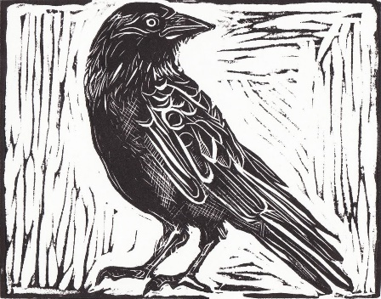

Trow
Trow are small, troll-like fairy creatures short of stature, ugly, and both shy and mischievous in nature. They are nocturnal creatures, venturing out of their 'trowie knowes' (earthen mound dwellings) solely in the evening. The often enter households as the inhabitants sleep. They have a fondness for music and are in the habit of kidnapping musicians or luring them to their dens. Some say they possess a supernatural wisdom which can be useful if one were to win their friendship.

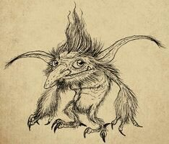

Kirk Grim or Church Grim
Kirk Grims are attendant spirits of churches, overseeing the welfare of the hallowed grounds on which their church stands. They are said to enjoy loudly ringing the bells. They may appear as black dogs or as small, misshapen, dark-skinned people. The Grim is said to protect against devils and demons.

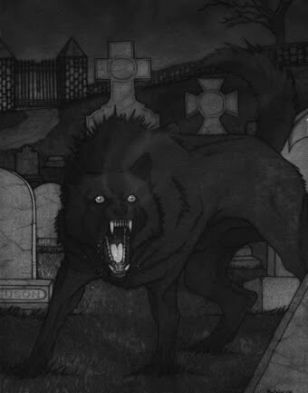

Afanc
The Afanc is a monstrous creature that inhabits remote lakes and attacks anyone who falls or swims in its waters. It is said to be rendered helpless in the presence of a young maiden. It is incredibly strong and capable of breaking chains if bound.
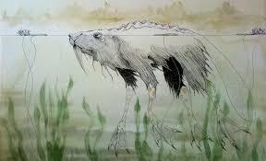

Bean-Nighe
The Bean-Nighe (pronounced ben-nee'-yeh) is a visitor from the Otherworld—the world of gods, fairies, spirits, and the like. She appears near secluded streams as an elderly and misshapen washerwoman. She is horribly ugly with webbed feet, a single tooth, a single nostril, and other deformities. In rare cases, she appears in the form of a beautiful woman, but only as an illusion for her purposes. The Bean-Nighe foretells the deaths of mortals and cleans the bloody clothes of those who are fated to die. If one asks nicely enough, she can tell you the names of those who shall die. If you are especially careful, you can ask her three questions, but only if you answer three in return. Those who see her must not turn away, but quietly approach from behind so that she is not aware. If she says the clothing she is washing belongs to an enemy, then one can allow the washing to continue. But if the clothes belong to onself or any of your friends, then you can stop her from completing her task and avoid your fate.

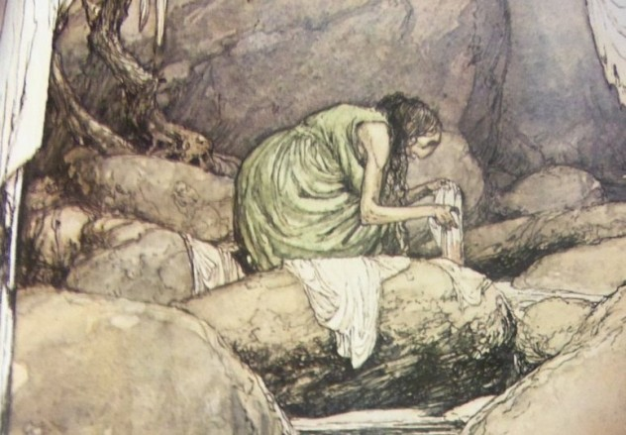

Faerie Dogs
They say that certain crossroads are doors to another world, the world of the faeries and the gods and demons that act in ways that we don’t usually see. Every now and then, these crossroads will have a peculiar occupant—the faerie dog. These aren’t the puppies you and I know—these dogs are bright green and will bark once or twice as a warning. But upon the third bark, the listener is doomed.
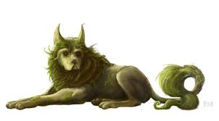

Alp-luachra
When a person falls asleep by a stream, the Alp-luachra will take the form of a newt and crawl down the victim’s throat to have a tasty snack out of the victim’s previous meal. In one tale, it’s said that you must devour salted meat in order to get the thing out of your throat.
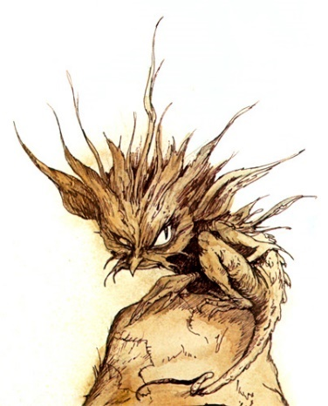

Herne the Hunter
Herne the Hunter was once the keeper of Windsor Forest during the days of Queen Elizabeth I, and when he committed some sort of great offence, he hung himself in order to avoid facing the shame. Now, he guards the woods as a spirit of the forest and haunts them when the country is in some sort of grave danger.

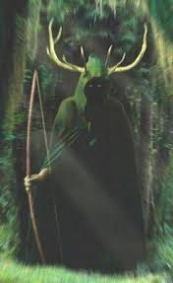

Gwyllgi
Also known as the Dog of Darkness, it is a black ethereal dog that haunts lonely country roads. Seeing one is a dark omen.
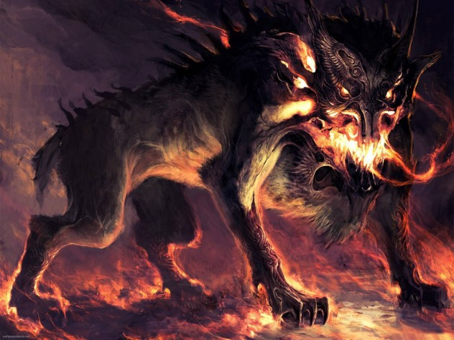

Nuckelavee
The nuckelavee is both an undead and in a way, a fey creature. A nuckelavee's horse body doesn't have skin, leaving black muscles and bones visible, the humanoid body that is connected to its back looks the same. ... Nuckelavees prefer to live in swamps, where it can easily hide, and stalk their prey.
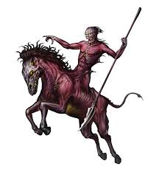

Kelpie
The kelpie may appear as a tame pony beside a river. It is particularly attractive to children – but they should take care, for once on its back, its sticky magical hide will not allow them to dismount! Once trapped in this way, the kelpie will drag the child into the river and then eat him. These water horses can also appear in human form. They may materialize as a beautiful young woman, hoping to lure young men to their death. Or they might take on the form of a hairy human lurking by the river, ready to jump out at unsuspecting travellers and crush them to death in a vice-like grip. Kelpies can also use their magical powers to summon up a flood in order to sweep a traveller away to a watery grave.

The sound of a kelpie’s tail entering the water is said to resemble that of thunder. And if you are passing by a river and hear an unearthly wailing or howling, take care: it could be a kelpie warning of an approaching storm.

But there is some good news: a kelpie has a weak spot – its bridle. Anyone who can get hold of a kelpie’s bridle will have command over it and any other kelpie. A captive kelpie is said to have the strength of at least 10 horses and the stamina of many more, and is highly prized.

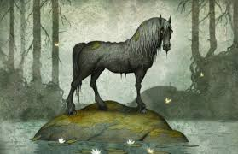

Selkies - beings capable of changing from seal to human form by shedding their skin.
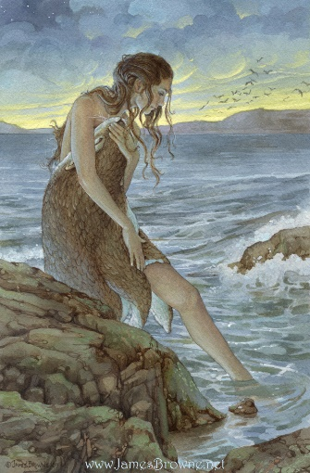
Famous Witches
Black Annis, a blue-faced hag, haunts the Dane Hills in Leicestershire
Gentle Annie who governs storms in the Scottish lowlands
The Pendle Witches
Mother Ludlam a friendly old white witch who lives in a cave close to the village of Frensham in Surrey. She developed quite an enviable reputation by lending local villagers anything they asked for, under the rather peculiar proviso that it should be returned within two days. Would-be borrowers were required to stand on a boulder on the entrance to Mother Ludlam’s cave and clearly state what they required. Once they got home they would then find the object of their desire waiting for them on their doorstep. One day, a local man visited the cave (now known as Mother Ludlam’s Hole) and asked to borrow the witch’s cauldron. Hesitant to grant his request as this was her personal property, Mother Ludlam reluctantly agreed but reminded the man that it must be returned within two days. Perhaps the man was half way through slow cooking his Sunday lunch, but for whatever reason he failed to return the cauldron and Mother Ludlam – gripped by rage – left the confines of her cave to seek vengeance. Upon hearing that he was a wanted man, the borrower sought refuge in Frensham Church and this is where the cauldron remains to this day. Whether or not this legend holds any truth remains conjecture, but what we do know is that the cauldron was used for centuries by the priests of Frensham for the brewing of church ale.

Other Races
Elves
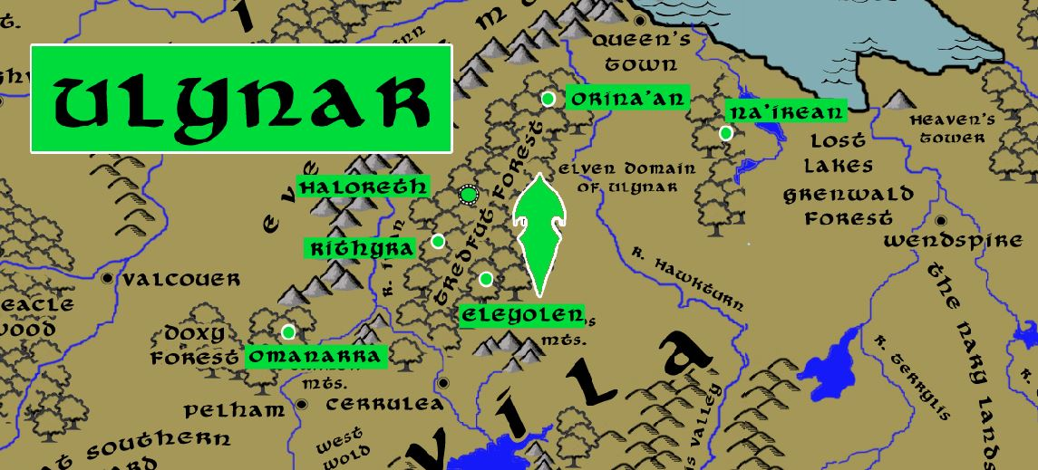
Dwarves
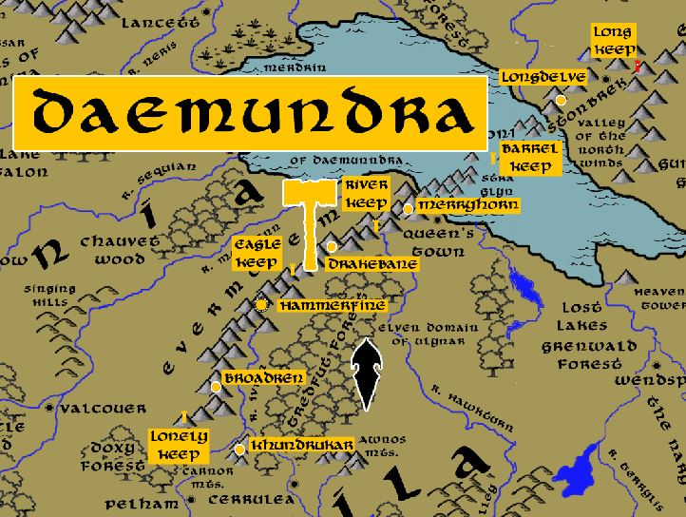

Magic in this Land
- Destiny Stones – Stonbrek; each child born in Stonbrek is gifted a Destiny Stone, a geode which, when broken open, will tell of the life the child is to live
- Lithren – Stonbrek; stone druids who specialize in geological formations and the ecology living within and around them; tasked with selecting the Destiny Stones for each child born in Novulum
- Verudecus – Stonbrek - magic plumb line that tells if something or someone is false
- Pluton Fatum – wall of rock in Stonbrek that is said to contain secrets of the past and future
- The Heavy - cursed club carried by Bugbear chieftain Oggerbosh that he calls The Heavy, item is cursed and spreads pestilence
- Helm of the Old Gods – magical helm worn by Harald Trevin of Hartha in 699 WA1 in his campaign to drive out the Celedonians
- Sword of Taranis – magical sword wielded by by Harald Trevin of Hartha in 699 WA1 in his campaign to drive out the Celedonians
- Dark Hand of Ages – magic relic wielded seven hundred years ago by the necromancer Polluxris who mounted an army of fearsome creatures and stormed Illustrim (820 WA3). The hand was lost after Polluxris was defeated.
- Empty Amulet – wielded by Caedman the fallen priest of Heironeous in 580 PA1 to cleanse the Awnos Mountains of all magical creatures; Gytha the Faerie Queen directed the land to funnel all the energy back into Caedmon, causing him to explode with magic; the amulet was lost to history
- Brathuneidr ("biting snake") – magic sword of the halflings in Shyberry
- Epitrax – wielded by Renus to drive Plenish forces from Pelham and Baston in the War of the Secondborn
- Sybalite Stone – Dwarven item from Demundra almost lost in the First Ancient Age in the Sybalite War; a giant diamond of such flawless perfection that it carries a powerful enchantment tied to the elemental plane of earth
- Seeds of Madness – magic seeds grown by the mad druid Garruld Rotroot who sought the destruction of men who threatened his lair in the Tredfut Forest. The seeds grow fruit that drive people insane. After Garruld’s death in 400 WA2 the seeds were lost until goblins from the Awnos Mountains found them and created an epidemic in the Kendor lands. The seeds were lost again after Travix the Moth-Eaten and his allies defeated the goblin lord Phlazik.
- The Speaking Mascarons: The faces in the masacarons adorning the aqueducts of Novulum are said to carry the wisdom of the Celedonians who erected them. Each face is imbued with some scrap of lore that has long since been lost when Celedon fell. No one knows how to command the faces to talk: they randomly come to life, mostly at night and speaking to passersby. Scribes spend sleepless nights waiting by the aqueducts, scroll and quill in hand, waiting to write down what they say. One theory is that each face can sense when a person is of the right mind to hear what they have to say.
- Vane of Borrum, an ancient artifact located in the Diaphanous Chapel in Wendspire. It is said to hear portents carried on the winds. The vane appears as a wrought iron array of spires but is light and often inexplicably becomes invisible.
- Soucanna – magic longsword carried by Trevilish knight Artidius Kendor in the Second Dark Crusade (665 WA3); carries the blessing of Heironeous to empower any lawful good knight who carries it or follows its wielder; now used by Order of the Kestrel in Kendor to anoint and empower its knights
- Luxorum - the hereditary longsword of the throne of Illustrim. It is said to be a fearsome weapon casting searing light at its enemies.
- Chime of Passage – a tall metallic cylinder covered in ancient markings reputed to transport the spirit of the faithful with a single strike by a trained priest. Located in the Cathedral of the Canticle in Lyre.
- Eye of Heironeous – magically blessed stone that hangs from the statue of St. Brighid in the High Cathedral of Illumination in Illustrim; said to carry the essence of Heironeous and is arguably the single greatest focal point of his power
- The Books of Luira – these are the collected books of poetry written in the Ancient Ages. They are said to capture the essence of a hundred poets, each of whom added writings to them.
- Dreorled, or Blood Cauldron – located in the Chapel of the Sacred Corbel in Stonbrek, this magic cauldron contains a ceremonial mortar that the priests have mixed for centuries. It is here that the blood of criminals slain by stoning, is added. The priests use the mortar from the cauldron in special ceremonies, usually in anointing a new lord of the town, a new high priest, or consecrating a building site. It is said the mortar imbues powers of invulnerability or strength to the person or structure to which it is applied.

Terra Construct: The lands of Treviland are imbued with a living magical energy that resonates from the time of creation. In the oldest texts it is called the Draikin (pronounced drī-kĭn). This force permeates the land and energizes all things. It is unique to Treviland and forms its Terra Construct. Wielders of magic who pass this way unknowingly draw from the Draikin just as travelers may draw water and drink from whatever source is close at hand. But almost no one knows of the Draikin except the oldest of mages, and fewer still know how it works. Eight sites exist within Treviland where this magic shines brightly and forms the anchor points for the Construct:
- Bael Henge – fire – Evermore Mts. near Milady
- Estmere Henge – water – Culmen Calix stone near Awnos Mts. in Kendor
- Erlyft Henge – air – Comely Mts.
- Earden Henge – earth – Howling Hills
- Bealusid Henge – death – Forelock Mt.
- Aldor Henge – life – Dankmire Swamp
- Dwolma Henge – darkness – Lake Holyoak
- Blacern Henge – light – Cliffs of Neverdorn

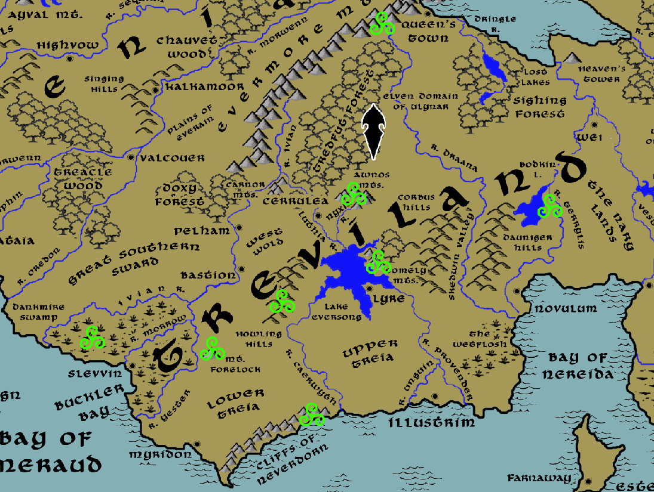
Location of the eight focal points of the Draikin

NPC Templates
This is a list of notes and stats to help develop NPC’s relevant to this region.
Anglo-Saxon warriors fought on foot during battles. They carried spears, axes, swords, and bows and arrows. They wore helmets and carried shields that were usually made of wood. The most common Anglo-Saxon weapon was a spear, the most feared weapon was a battle-ax, and the most precious was a sword.
The blades of long swords were sharp, strong and flexible and capable of slicing through armour. They were often made of a mixture of iron and steel using a process called pattern welding. The Anglo-Saxons also used another type of sword with only one sharp edge or blade, known as a seax.

Developer Notes
This is a list of notes on the development of this document, including notes on history, culture, and changes to the document.
The Volds (Primordial Ages) roughly approximate the Britons and Celts
The Treians (Ancient Ages) roughly approximate the Ango-Saxons
The Trevilish (Written Ages) roughly approximate the English after the Normans arrived in 1066
For words in Old English: https://www.oldenglishtranslator.co.uk/
Sarsen Stones - a silicified sandstone boulder of a kind which occurs on the chalk downs of southern England. Such stones were used in constructing Stonehenge and other prehistoric monuments.

Clothing and Attire

Most people in the Middle Ages wore woolen clothing, with undergarments (if any) made of linen.

Among the peasantry, wool was generally shorn from the sheep and spun into the thread for the cloth by the women of the family. Dyes were common, so even the lower-class peasants frequently wore colorful clothing. Using plants, roots, lichen, tree bark, nuts, crushed insects, mollusks and iron oxide, virtually every color could be achieved. Dyes came from different sources, some of them more expensive than others. Even the humble peasant could have colorful clothing. Dyed fabric would fade if it was not mixed with a mordant. Bolder shades required either longer dyeing times or more expensive dyes. Fabrics of the brightest and richest colors cost more and were therefore most often found on nobility and the very rich. Brighter colors, better materials, and a longer jacket length were usually signs of greater wealth.

Men wore stockings (hose) and tunics. Noblemen wore tunics or jackets with hose, leggings and breeches. The wealthy also wore furs and jewelry.

Women wore long gowns with sleeveless tunics and wimples to cover their hair. Sheepskin cloaks and woolen hats and mittens were worn in winter for protection from the cold and rain. Women wore flowing gowns and elaborate headwear, ranging from headdresses shaped like hearts or butterflies to tall steeple caps and Italian turbans.

Throughout much of the Middle Ages and in most societies, undergarments worn by both men and women didn't substantially change. They consisted of a shirt or undertunic, stockings or hose, and, for men at least, underpants.

Leather boots were covered with wooden patens to keep the feet dry. Outer clothes were almost never laundered, but the linen underwear was regularly washed. The smell of wood smoke that permeated the clothing seemed to act as a deodorant.

Clothing of the aristocracy and wealthy merchants tended to be elaborate and changed according to the dictates of fashion. Some materials would be sable, velvet, cloth of gold, silk.

Fur was often used to line the garments of the wealthy. Jewelry was lavish, much of it imported. Gem cutting had not been invented until the fifteenth century, so most stones were not lustrous. Ring brooches were the most popular item from the twelfth century on. Diamonds became popular in Europe in the fourteenth century. By the mid-fourteenth century there were laws to control who wore what jewelry. These were called Sumptuary Laws. Knights were not permitted to wear rings.

Sometimes clothes were garnished with silver, but only the wealthy could wear such items.

Virtually everyone wore something on their heads in the Middle Ages, to keep off the sun in hot weather, to keep their heads warm in cold weather, and to keep dirt out of their hair. as with every other type of garment, hats could indicate a person's job or station in life and could make a fashion statement. Hats were especially important, and to knock someone's hat off his or her head was a grave insult that, depending on the circumstances, could even be considered assault.

Types of men's hats included wide-brimmed straw hats, close-fitting coifs of linen or hemp that tied under the chin like a bonnet, and a wide variety of felt caps. Women wore veils and wimples; among the fashion-conscious nobility of the High Middle Ages, some fairly complex hats and head rolls were in vogue.

Both men and women wore hoods, sometimes attached to capes or jackets but sometimes standing alone. Some of the more complicated men's hats were hoods with a long strip of fabric in the back that could be wound around the head. A common accoutrement for men of the working classes was a hood attached to a short cape that covered just the shoulders.

Most of the holy orders wore long woolen habits in emulation of Roman clothing. St. Benedict stated that a monk's clothes should be plain but comfortable and they were allowed to wear linen coifs to keep their heads warm. Benedictines wore black; the Cistercians, undyed wool or white. Franciscans wore grey, and later brown.

Silk was the most luxurious fabric available to medieval Europeans, and it was so costly that only the upper classes, and churchmen, could afford it. While its beauty made it a highly-prized status symbol, silk has practical aspects that made it much sought-after. It is lightweight yet strong, resists soil, has excellent dyeing properties and is cool and comfortable in warmer weather.

Western Europeans imported silks from Byzantium, but also import them from India and the Far East,. Wherever it came from, the fabric was so costly that its use was reserved for church ceremony and cathedral decorations.

Muslims, who had conquered Persia and acquired the secret of silk, brought the knowledge to Sicily and Spain.From there, it spread to Italy. By the 13th century European silk was competing successfully with Byzantine products. For most of the Middle Ages, silk production spread no further in Europe, until factories were set up in France in the 15th century.

Laws dating back to the Romans restricted ordinary people in their expenditure. These were called Sumptuary Laws. The word Sumptuary is derived from the Latin word for expenditure.

English Sumptuary Laws were imposed to curb the expenditure of the people. Sumptuary laws might apply to food, beverages, furniture, jewelry and clothing. These Laws were used to control behavior and ensure that a specific class structure was maintained. Penalties for violating Sumptuary Laws could be harsh - fines, the loss of property, title and even life.

Arming cap / Biggins / Coif
Biggins are also often worn under nicer hats, helmets, coifs and caps to keep sweat and oils from staining them and to help keep the hair neat. Peasants and children almost always wore the biggins alone, as they had no other cap.

St. Birgitta’s Cap

Notes on Saxons
-ham means village (e.g. Birmingham)
-ford means river crossing (e.g. Stratford)
-ton means farm (e.g. Middleton)
-bury means fortified place (e.g. Banbury).
-ley means forest clearing (e.g. Henley)

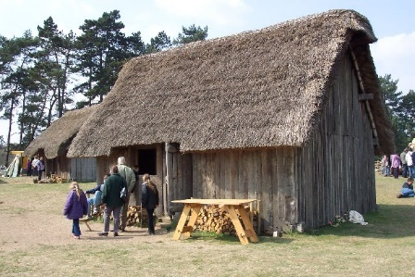
- Some Anglo-Saxons built their houses inside the walls of Roman towns.
- Others cleared spaces in the forest to build villages and make new fields.
- Many villages were built near rivers because the Anglo-Saxons were good sailors.
- A high wooden fence would be built around a village to protect it from wild animals like: wolves, foxes and boars.
- Anglo-Saxon houses were rectangular huts made of wood with roofs thatched with straw. Each family house had one room, with a hearth with a fire for: cooking, heating and light. The houses were built facing the sun to get as much heat and light as possible.
- The biggest house in the village was the hall where the chief lived with his warriors.
- Other huts were used as workshops for things like weaving or pottery.
- Each village would have an area of common land for everyone to use to graze their cattle.
History of Britain
- 8000 BCE: Celtic people began migrating to the British Isles from southern Europe.
  - This group included a tribe called the Britons who settled on the largest island which gave the island its current name.
  - Gauls settled the island today called Ireland
- Stone age: lasting up to about 2000 BC
- Bronze Age: 2000 BCE to 600 BCE
- Iron Age: 600 BCE to 50 CE: Celts and Celtic Tribes (Atrebates, Belgae, Brigantes, Cauvellauni, Dumnonii, Ordovices, Silures); languages: Gaelic, Brythonic (Britannic)
- Romano-British: 50 CE to 400 CE
- Angles / Saxons / Picts: 400 CE to 800 CE
- 425-450 CE British leader Vortigern invites Germanic Saxons into alliance against Picts and Scots
- Saxons turn on the Britons and conquer Britain; invasion by Saxons, Angles, Jutes; Britons and Celtic culture displaced into Wales, Cornwall, Ireland, and Brittany (France)
- Germanic culture: The Danelaw / Norse and Danish invaders: 800 AD to 914 AD
- Seven Anglo-Sazon kingdoms: Northumberland, East Anglia, Mercia (Angles), Kent (Jutes), Essex, Sussex, Wessex (Saxons)
- Norman invasion: 1066 AD
- Tudor Britain: 1485 AD
- Stuart Britain: 1603 AD
- Georgian Britain: 1714 AD
- Victorian Britain: 1837 AD

http://dndspeak.com/2018/02/101-festivals-holidays/

Changes:
Luthia River was Provender River
Nyxia River was Wool River
Caerwyth River was Treyvian River
Unguin River was Undula River
Provender River was Luthia River
Draana River was Hawkturn River

Witan – a Saxon council of high-ranking men

Kingdom Cypher:
There are ten items dating back to the Primordial Ages that one of the gods fashioned for use by humans or elves or someone. Each of these items/markers/sites is located near each of the ten towns and cities. Each one has a power that is tied to this location, creating a magical effect in line with the town or city’s theme. A kingdom-level quest would involve visiting each location and manipulating the marker/collecting a token of the item/etc and unlocking a key that affects the entire kingdom.

World Cypher:
Same as above but only one item/marker/site/figure in the entire kingdom is tied to a world-spanning puzzle.

