Notes on the Pirates of Nemmerle

The open seas of Nemmerle are the hunting grounds where merchant ships are the prey and privateer vessels make their own law. Wherever there is sea trade there are raiders, large and small. Some captains have distinguished themselves with their exploits and attracted partners to form small fleets. They sail the world round, but call the Gulf of Korsair their home and the abandoned city of Madrina their capitol. Pirate crews come from all over the world, their feats are legendary, and even the mighty merchant companies watch the horizon with trepidation to see the sails of the Pirate Lords.

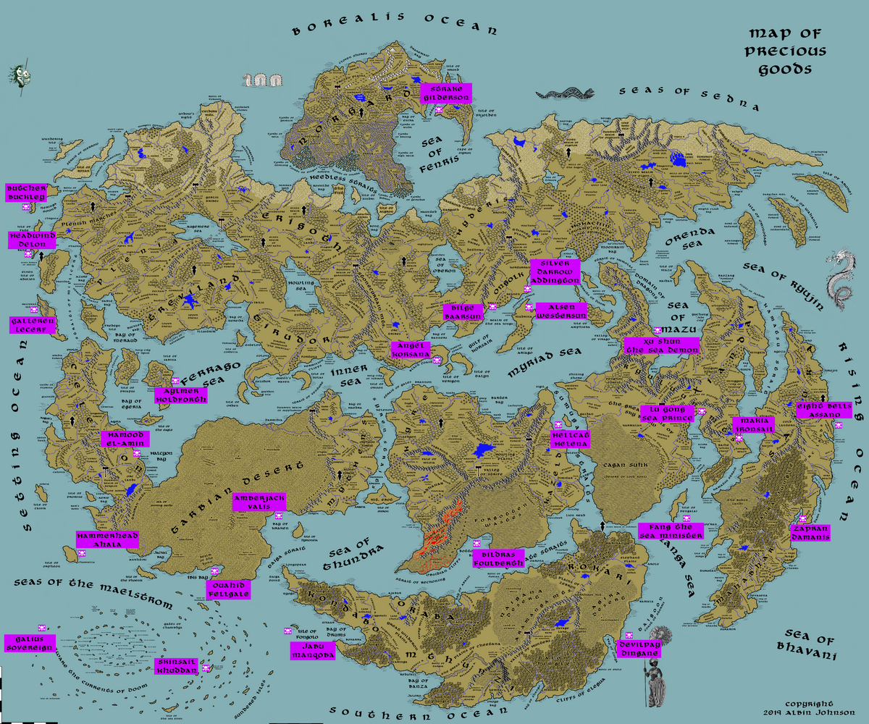

The Pirate Lords of Nemmyrl
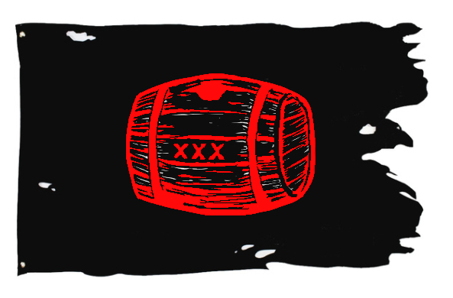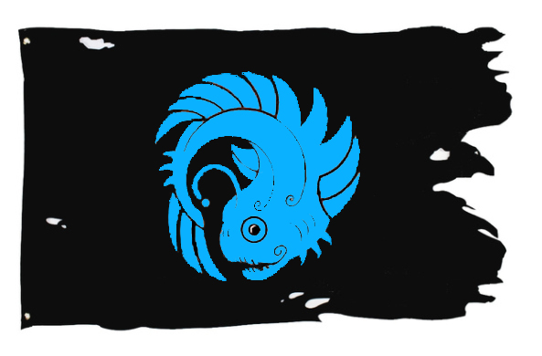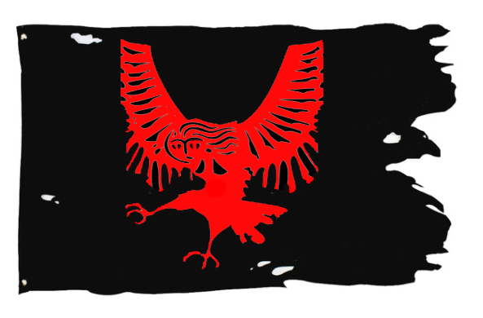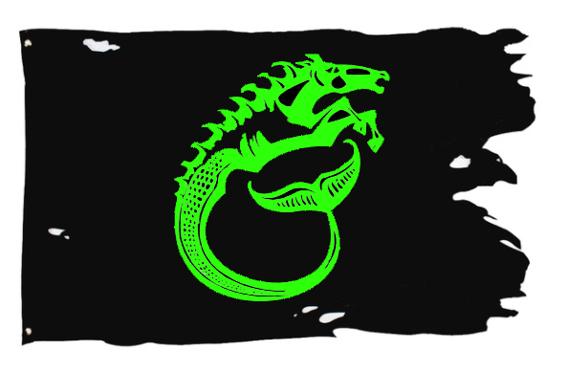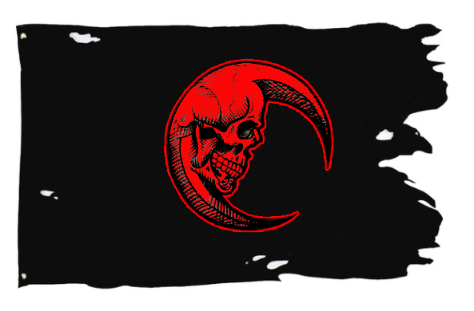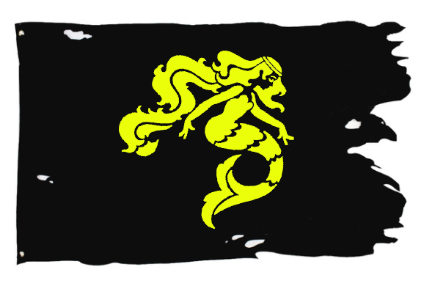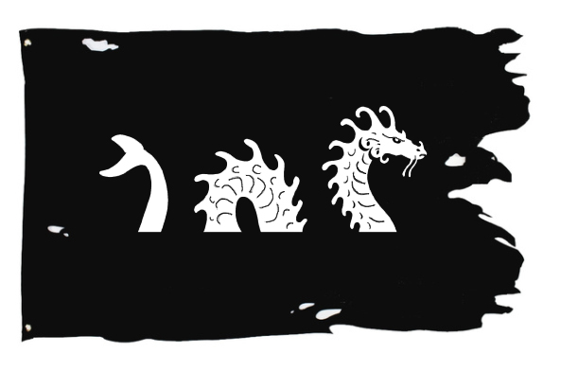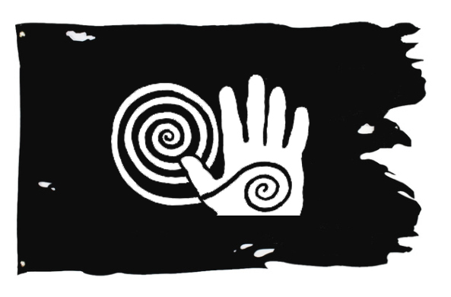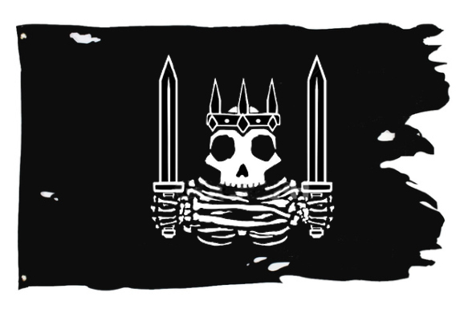
- Captain Strake Gilderson - Sea of Fenris, sign of the six lightning bolts
- Captain Harwood the Butcher Buckley - Western Seas, sign of the cracked buckler with skull
- Captain Headwind Delon - Western Seas, sign of the bull with five horns
- Captain Galleren Lecerf - Western Seas, sign of the two parrot feathers
- Captain Aylmer Holdforth - Ferrago Sea, sign of the two tall spires
- Captain Hamood el-Ameen - Ferrago Sea, sign of the fire serpent
- Captain Hammerhead Ahala - Southern Seas, sign of the hammerhead shark
- Captain Galius Sovereign - Southern Seas, sign of the head of a wolf with waves
- Captain Farrid Skinsail Khuddan - Southern Seas, sign of the circlets of wind
- Captain Ouahid Fellgale Akoujan - Southern Seas, sign of the white rhinoceros with red eyes
- Captain Jabu Manqoba - Southern Seas, sign of the green sea serpent
- Captain Ashraf Amberjack Valis - Sea of Thundra, sign of the three-headed hydra
- Captain Bildras Foulberth Ghun - Strait of Reckoning, sign of the one large eye
- Captain DevilPay Dingane - Shanga Sea, sign of the black octopus
- Captain Kao Fang the Sea Minister - Shanga Sea, sign of the open mouth of shark's teeth
- Captain Makia Ironsail (f) - Kamatsu Strait, sign of the mermaid holding a flask
- Captain Lu Gong the Sea Prince - Azura Bay, sign of the sea serpent coiled around a ship
- Captain Hellcat Helena (f) - Myriad Sea, sign of the flaming leopard
- Captain Eight Bells Assano - Eastern Seas, sign of the three skulls beneath waves
- Captain Zapran Damanis - Eastern Seas, sign of the stag with a fish tail
- Captain Xu Shun the Sea Demon - Sea of Mazu, sign of the red devil
- Captain Silver Darrow Addington - Myriad Sea, sign of the three spears
- Captain Bilge Baarsun - Myriad Sea, sign of the upside down five-pointed star
- Captain Alsen Westersun Sarmiento - Myriad Sea, sign of the winged serpent
- Captain Angel Korsana - Inner Sea, sign of the red-eyed woman with flowing hair

Nautical Magic Items
Ship Names
Minor Mishaps at Sea
100 Sailing Conditions

Captain Strake Gilderson
Fleet Size: fifteen longships
Waters: Sea of Fenris
Home Port: Isle of Skjolden
Standard: six lightning bolts
Colors:

Flagship: the Berserker
First Mate: Koigrim Onäm
Quartermaster: Lodin Rodmars
Sailing Master: Yngvar Hrosskels
Boatswain: Styrr Geirasar
Carpenter & Surgeon: Oddkell Sýrusar
Master Gunner: Kori Uglubarth
Mate: Aleifr Sigvatsson
Able Bodied Seamen:
Orlyg Bodalf
Gamli Gædas
Engli Geirstein
Hagi Arnketill

Description:

History:
Gilderson and most of his crew hail from Norgarde.

Captain Harwood Butcher Buckley
Fleet Size: two carracks, five caravels, three cogs
Waters: Western Seas
Home Port: Isle of Daysend
Standard: cracked buckler with skull
Colors:

Flagship: The Butcher’s Bill
First Mate: Augustin Stokerton
Quartermaster: Odbert Lyfelde
Sailing Master: Diggory Malster
Boatswain: Urian Lyrypine
Carpenter & Surgeon: Athelstan Dixton
Master Gunner: Sivert Balingen
Mate: Mateo Kergoat (Tirudor)
Able Bodied Seamen:
Alfsige Wetherden (Erigoth)
Millan de Bort (Plenia)
Lorcan O'Hogan (Kyre)

Description:

History:
Buckley and most of his crew hail from Treviland.
Aboard the Butcher’s Bill is the ship’s bell, which is rumored to be enchanted. If struck by any relic of faerie origin, the bell will sound a peel that will lull any who hear it into a trance for anywhere from a day to a week. The captain is keen to order his men to stopper up their ears before striking it with a special tiny mallet he carries on his person.

Captain Headwind Delon
Fleet Size: three carracks, three caravels, two cogs
Waters: Western Seas
Home Port: Isle of Bane
Standard: bull with five horns (Quinotaur)
Colors:

Flagship: The Quinotaur
First Mate: Arnoult Lazard
Quartermaster: Henriet Vérany
Sailing Master: Chekani (Kaduru)
Boatswain: Jurrien Greevink (Norgarde Colonies)
Carpenter & Surgeon: Baudet Allard
Master Gunner: Jamet Bonnel
Mate: Bastiano Fontana (Hylux Islands)
Able Bodied Seamen:
Haazim el-Sader (Tarbia)
Jin Xia (Xiandai)

Description:

History:
Delon and most of his crew hail from Plenia.
The duchess of Phaeria has resorted to allying herself with pirates in her efforts to foil her rivals. Captain Headwind Delon receives regular payment to harass ships sailing to and from Arrione’s port. Captain Galleren Lecerf has been paid to harry the efforts in Ataia’s ship building yards.

Captain Galleren Lecerf
Fleet Size: two carracks, five caravels, three cogs
Waters: Western Seas
Home Port: Isle of Giserne
Standard: two parrot feathers
Colors:

Flagship: The Imp Prince
First Mate: Eustace Peletier
Quartermaster: Lefwald Borrow
Sailing Master: Elgar Fithen (Treviland)
Boatswain: Cardin Rousselot
Carpenter & Surgeon: Nicolas Riqueti
Master Gunner: Remon Millet
Mate: Iohann Eberhart (Erigoth)
Able Bodied Seamen:
Gautier Flandin
Shay MacCoghlan (Kyre)
Ramiro de Aramayo (Tirudor)

Description:

History:
Delon and most of his crew hail from Plenia.
The duchess of Phaeria has resorted to allying herself with pirates in her efforts to foil her rivals. Captain Headwind Delon receives regular payment to harass ships sailing to and from Arrione’s port. Captain Galleren Lecerf has been paid to harry the efforts in Ataia’s ship building yards.

Captain Alymer Holdforth
Fleet Size: one carrack, three caravels, three cogs, three galleys
Waters: Ferrago Sea
Home Port: Isle of Sabina
Standard: two tall spires forming a loch or channel
Colors:

Flagship: The Teran
First Mate: Laurence Rowdon
Quartermaster: Nathaniel Cryppys
Sailing Master: Sampson Brewse
Boatswain: Griffin Baker
Carpenter & Surgeon: Johann Zwick (Erigoth)
Master Gunner: Dexter Gray
Mate: Attwell Rochforth
Able Bodied Seamen:
Marsilio Foscari (Korsair Bay)
Ansketel Denton
Bartolo de Zeniçeros (Tirudor)

Description:

History:
Holdforth and most of his crew hail from Treviland.

Captain Hamood el-Ameen
Fleet Size: two galleys, three dromonds, three triremes, three cogs
Waters: Ferrago Sea
Home Port: Ruins of Feronia
Standard: fire serpent
Colors:

Flagship: The Falak
First Mate: Hishaam al-Mir
Quartermaster: Hamza al-Ally
Sailing Master: Haatim al-Khalili
Boatswain: Mubashshir al-Yacoub
Carpenter & Surgeon: Azhaar el-Abdelrahman
Master Gunner: Gopolang Kgosie (Kaduru)
Mate: Muammar al-Salman
Able Bodied Seamen:
Pelegon (Mythens)
Lutfi el-Shahan
Sadoon al-Younan

Description:

History:
El-Ameen and most of his crew hail from Tarbia

Captain Hammerhead Ahala
Fleet Size: three galleys, three dromonds, three triremes, one cog
Waters: Southern Seas
Home Port: Isle of Orpheon
Standard: hammerhead shark
Colors:

Flagship: The Alkyon
First Mate: Paulus Tanicius
Quartermaster: Bruscius Kessoro
Sailing Master: Aulus Calventius
Boatswain: Abdul Ghafoor (Tarbia)
Carpenter & Surgeon: Quintis Epidius
Master Gunner: Arruns Ovidus
Mate: Fanaka (Kaduru)
Able Bodied Seamen:
Claudius Decmus
Servius Septimus
Vibius Iovinus

Description:

History:
Ahala and most of his crew hail from Celedon.

Captain Galius Sovereign
Fleet Size: three galleys, six dromonds
Waters: Southern Seas
Home Port: (unnamed island in the Maelstrom)
Standard: head of a wolf over waves
Colors:

Flagship: The Agriopas, galley
First Mate: Opiter Bato
Quartermaster: Pullus Coruncanius
Sailing Master: Etano Fualema (Southern Islands)
Boatswain: Marcus Castus
Carpenter & Surgeon: Chimwamtaba (Kaduru)
Master Gunner: Herius Falerius
Mate: Numerius Martialis
Able Bodied Seamen:
Ateius Senecianus
Abbaas el-Shakoor (Tarbia)
Egred Faulkner (Treviland)

Description:

History:
Captain Sovereign and most of his crew hail from Celedon. The pirate captain is rumored to carry a sounding bell that allows him to navigate safely through the dangerous waters of the mighty Maelstrom seas, steering into the center of the mysterious islands there that prove unreachable to normal sailors.

Captain Farrid Skinsail Khuddan
Fleet Size: three galleys, three triremes, eight dhows
Waters: Southern Seas
Home Port: Isle of the Pirate Lord Dravalo
Standard: circlets of wind
Colors:

Flagship: The Hatif
First Mate: Muhyddeen al-Abood
Quartermaster: Humaidaan el-Saade
Sailing Master: Kamaaluddeen el-Baccus
Boatswain: Haamid el-Pirani
Carpenter & Surgeon: Abramo Calvacanti (Tirudor)
Master Gunner: Farijika (Kaduru)
Mate: Ofo Lea'ai (Southern Islands)
Able Bodied Seamen:
Salmaan el-Mohemda
Rewi Witika (Southern Islands)
Selwyn Merrick (Kyre)

Description:
Menandros (Mythens)

History:
Khuddan and most of his crew hail from Tarbia.
Khuddan is rumored to possess a magical kamal, an observation device that determines latitude by finding the angle of the Pole Star above the horizon.

Captain Ouahid Fellgale Akoujan
Fleet Size: three galleys, two dromonds, two triremes, six dhows
Waters: Southern Seas
Home Port: Bay of Kobra
Standard: white rhinoceros head with red eyes
Colors:

Flagship: The Karkadann
First Mate: Dwaraka Dasgupta
Quartermaster: Chandrahaas Thakur
Sailing Master: Ishwar Guhathakurta
Boatswain: Falgu Parveen
Carpenter & Surgeon: Shubhang Yagnik
Master Gunner: Ualesi Tanielu (Southern Islands)
Mate: Chosamatenda (Kaduru)
Able Bodied Seamen:
Somu Hamid
Anil Jain
Dipen Maharaj
Basant Maitra
Ajit Sayeed

Description:

History:
Akoujan and most of his crew hail from Tarbia.

Captain Jabu Manqoba
Fleet Size: three galleys, three dromonds, three triremes, three dhows
Waters: Southern Seas
Home Port: Isle of Fongolo
Standard: green sea serpent
Colors:

Flagship: The Kongamato
First Mate: Jata Chanhe
Quartermaster: Musa Mpenda
Sailing Master: Magosi Letsogile
Boatswain: Tapiwa Sesupo
Carpenter & Surgeon: Tamandani Kangulu
Master Gunner: Protesilaus (Mythens)
Mate: Sawluk Bolaan (Kazelduun)
Able Bodied Seamen:
Kifeda
Tambo
Rajuba

Description:

History:
Manqoba and most of his crew hail from Kaduru.

Captain Ashraf Amberjack Valis
Fleet Size: two galleys, two dromonds, seven triremes
Waters: Sea of Thundra
Home Port: Bay of Kraken
Standard: three headed hydra
Colors:

Flagship: The Skolopendra
First Mate: Autolycus
Quartermaster: Hermeros
Sailing Master: Polypemon
Boatswain: Eurydemon
Carpenter & Surgeon: Kreon
Master Gunner: Memnon
Mate: Kgalefa Kabelano (Kaduru)
Able Bodied Seamen:
Epistrophos
Enops
Orthaeus
Pythogenes
Dromeus
Phanias
Talos
Aigeus

Description:

History:
Valis and most of his crew hail from Mythens.

Captain Bildras Foulberth Ghun
Fleet Size: two galleys, five dromonds, three triremes, three dhows
Waters: Strait of Reckoning
Home Port: Bottomless Bay
Standard: one large eye
Colors:

Flagship: The Tartalon
First Mate: Shahdoust
Quartermaster: Baazo
Sailing Master: Hamdard
Boatswain: Meskaan
Carpenter & Surgeon: Daksha Barvadekar (Mahabar)
Master Gunner: Soubaan
Mate: Dramshok
Able Bodied Seamen:
Jangeyaan
Sawl
Shambo
Dorrukk
Mehrdel
Chegerd

Description:

History:
Ghun and most of his crew hail from Kazelduun.

Captain Devilpay Dingane
Fleet Size: one galley, three dromonds, three triremes, five dhows
Waters: Shanga Sea
Home Port: Keromang
Standard: black octopus
Colors:

Flagship: The Umdhlebi
First Mate: Darweshi
Quartermaster: Hamisi
Sailing Master: Azima
Boatswain: Safiri
Carpenter & Surgeon: Salehe
Master Gunner: Faraji
Mate: Kaswatu
Able Bodied Seamen:
Chifuniro
Chifundo
Kabuula
Duka
Imikizani
Chidano

Description:

History:
Dingane and most of his crew hail from Kaduru.

Captain Kao Fang the Sea Minister
Fleet Size: two galleys, ten war junks
Waters: Shanga Sea
Home Port: Isle of Pengalai
Standard: open mouth of shark’s teeth
Colors:

Flagship: The Demon Fang
First Mate: Zhuan Bo
Quartermaster: Luo Zhen
Sailing Master: Chen Peng
Boatswain: Meng Jun
Carpenter & Surgeon: Xun Huo
Master Gunner: Zhen Jie
Mate: Yang Yun
Able Bodied Seamen:
Guo Kun
Sun Zhihao
Hu Shi
Kong Rong

Description:

History:
Fang and most of his crew hail from Xiandai.

Captain Makia Ironsail (f)
Fleet Size: ten war junks, four dhows
Waters: Kamatsu Strait
Home Port: Doragon Reach
Standard: mermaid holding a flask
Colors:

Flagship: The Shōjō
First Mate: Hyong Myung-Ki
Quartermaster: Kye Min-Ho
Sailing Master: Nan Jun-Seo
Boatswain: So Jae-Hui
Carpenter & Surgeon: Kal Ju-Won
Master Gunner: Ryang Do-Hyeon
Mate: Kangjon Jae-Wook
Able Bodied Seamen:
Nu Ji-Hun
Nae Chunho
Tongbang Young
Hong Hee-Chul
Ryu Jeong-Hun
Ko Kwang-Seok

Description:

History:
Ironsail and most of her crew hail from Xiandai.

Captain Lu Gong the Sea Prince
Fleet Size: eleven war junks, three dhows
Waters: Azura Bay
Home Port: Phoenix Valley
Standard: sea serpent coiled around a ship
Colors:

Flagship: The Ikuchan
First Mate: Xiang Hua
Quartermaster: Kam Kwang-Hyok
Sailing Master: Wu Zemin
Boatswain: Long Lingxin
Carpenter & Surgeon: Xiong Jia
Master Gunner: Man Chunso
Mate: Ma Ye-Jun
Able Bodied Seamen:
Yi Fang
Cai Dong
Shi De
Chang Mu

Description:

History:
Lu Gong and most of his crew hail from Xiandai.

Captain Hellcat Helena (f)
Fleet Size: three caravels, three galleys, one dromond, one war junk
Waters: Myriad Sea
Home Port: (unsettled lands east of Karn Mts.)
Standard: flaming leopard
Colors:

Flagship: The Matagot
First Mate: Kot'Or
Quartermaster: Jalab
Sailing Master: Pasund
Boatswain: Shaahal
Carpenter & Surgeon: Kotuwaal
Master Gunner: Braaho
Mate: Dousteyn
Able Bodied Seamen:
Gaalei
Hammal
Nawroz
Shams
Rynko
Oumaan
Suhrag
Cheraag

Description:

History:
Helena and most of her crew hail from Kazelduun.

Captain Eight Bells Assano
Fleet Size: twelve war junks, three dhows
Waters: Eastern Seas
Home Port: Forgotten Reach
Standard: three skulls beneath the waves
Colors:

Flagship: The Fayūrei
First Mate: Ukita Kazutada
Quartermaster: Yamagata Hideteru
Sailing Master: Otagi Kanetoshi
Boatswain: Kouno Ieyoshi
Carpenter & Surgeon: Kamiizumi Takatada
Master Gunner: Anayama Hidetomo
Mate: Konishi Hidekatsu
Able Bodied Seamen:
Konishi Arikazu
Asano Michiari
Gou Arishige
Yamada Nakaharu
Hozumi Aritoki

Description:

History:
Assano and most of his crew hail from Sakura.

Captain Zapran Damanis
Fleet Size: two galleys, one dromond, nine dhows
Waters: Eastern Seas
Home Port: Bay of Pindari
Standard: stag with a fish tail
Colors:

Flagship: The Makara
First Mate: Maha Chitanis
Quartermaster: Maha Bakshi
Sailing Master: Cyavana Bagchi
Boatswain: Maha Anagal
Carpenter & Surgeon: Sayana Randhawa
Master Gunner: Dharya Kamal
Mate: Ragoba Shrivastav
Able Bodied Seamen:
Amar Rajavade
Acarya Mayadev
Raghu Sardar
Sahadeva Bakshi
Vasishtha Dayal
Hira Bhatta

Description:

History:
Damanis and most of his crew hail from Mahabar.

Captain Xu Shun the Sea Demon
Fleet Size: fifteen war junks
Waters: Sea of Mazu
Home Port: East of the Elderwyrm Mountains
Standard: red devil
Colors:

Flagship: The Haimogu
First Mate: Mangjol Shin-Young
Quartermaster: Sin Shi-Woo
Sailing Master: Uh Byung-Ho
Boatswain: Hwan Byung-Chul
Carpenter & Surgeon: Pi Seung-Heon
Master Gunner: Yang Yeong-Sik
Mate: Su Minjae
Able Bodied Seamen:
P'yo Kyung-Soo
Sang Shin-Il
Ryom Minjae
Pyon Chung-Hee
Yun Kwang-Hyun
Chi Chun-Ho
Ko Shin-Il

Description:

History:
Xu Shun and most of his crew hail from Xiandai.

Captain Silver Darrow Addington
Fleet Size: one carrack, three caravels, three cogs, three galleys
Waters: Myriad Sea
Home Port: Reavan
Standard: three spears
Colors:

Flagship: The Bodach
First Mate: Clauwes Wirt (Erigoth)
Quartermaster: Filip Haren (Kyre)
Sailing Master: Gilles Baumé (Plenia)
Boatswain: Dandaulo (Kaduru)
Carpenter & Surgeon: Gracchus (Celedonian)
Master Gunner: Giunta Bellegno (Hylux)
Mate: Sulan al-Farag (Tarbia)
Able Bodied Seamen:
Ciaran Ritchie (Kyre)
Scythas (Mythens)
Ormar the Snyder (Barter Bay)
Ceowald the Toller (Barter Bay)
Ok Woo-Jin (Xiandai)
Adam Grey (Treviland)

Description:

History:
Addington hails from Treviland, but his crew is a mix of peoples from all over the world.

Captain Bilge Baarsun
Fleet Size: five caravels, three cogs, five galleys
Waters: Myriad Sea
Home Port: Brazan
Standard: upside down five-pointed star
Colors:

Flagship: The Black Drude
First Mate: Jehanin Emmanuelli (Tirudor)
Quartermaster: Braun Sackwebers (Erigoth)
Sailing Master: Moosha al-Aziz (Tarbia)
Boatswain: Veturius Salinator (Celedonian)
Carpenter & Surgeon: Kgolo Oteng (Kaduru)
Master Gunner: Riwall Le Faucheur (Kyre)
Mate: Petera Piripi (Southern Islands)
Able Bodied Seamen:
Deval Sutton (Barter Bay)
Iri Skulisson (Norgarde)
Nayavu (Haka’Na)
Ping Yong-Sun (Xiandai)
Christopher Bischoptree (Treviland)
Peter Pecke (Treviland)

Description:

History:
Baarsun hails from Hyderis but his crew is made up of peoples from all over the world.

Captain Alsen Westersun Sarmiento
Fleet Size: one carrack, three caravels, one dromond, three galleys
Waters: Myriad Sea
Home Port: Madrina
Standard: winged serpent
Colors:

Flagship: The Culebre
First Mate: Niko Savea (Southern Islands)
Quartermaster: Philips Stylle (Treviland)
Sailing Master: Franz Herdern (Erigoth)
Boatswain: Gaone Oesi (Kaduru)
Carpenter & Surgeon: Koulmig Le Douget (Plenia)
Master Gunner: Takoda (Haka’Na)
Mate: Govind Punja (Mahabar)
Able Bodied Seamen:
Hani Akarana (Southern Islands)
Julian Stokes (Treviland)
Fujioji Iekiyo (Sakura)
Marcus Faenius Trenico (Celedonian)
Waaja (Kaduru)
Tuketu (Haka’Na)

Description:

History:
Sarmiento is from Tirudor but his crew is composed of pirates from all over the world.

Captain Angel Korsana (f)
Fleet Size: one carrack, three caravels, two cogs, four galleys
Waters: Inner Sea
Home Port: The Black Coast
Standard: red-eyed woman with flowing hair
Colors:

Flagship: The Banshee
First Mate: Cathal O'Breen (Kyre)
Quartermaster: Gustaaf Loeks (Erigoth)
Sailing Master: Rura Upasani (Mahabar)
Boatswain: Ashkii (Haka’Na)
Carpenter & Surgeon: Kaleb Cook (Kyre)
Master Gunner: Yop Sung-Soo (Xiandai)
Mate: Anenokoji Morouji (Sakura)
Able Bodied Seamen:
Khumo Theo (Kaduru)
Shyrjaan (Kazelduun)
Natana Teira (Southern Islands)
Thorfinn Svafarsson (Norgarde)
Maas Blink (Erigoth)
Prosperity Templeton (Barter Bay)

Description:

History:
Korsana hails from Kyre, but most of her crew are from all over.

Captain
Fleet Size:
Waters:
Home Port:
Standard:
Colors:

Flagship:
First Mate:
Quartermaster:
Sailing Master:
Boatswain:
Carpenter & Surgeon:
Master Gunner:
Mate:
Able Bodied Seamen:

Description:

History:

Nautical Magic Items
Source: http://dndspeak.com/2018/01/100-aquatic-items/
- Ring of Calamari: A silver ring with an octopus on it with emerald eyes. Gives you the ability to use the darkness spell 1d4 times per day rolled at dawn.
- Dolphin’s Tooth Crown: An ornate crown made of dolphin bones and teeth. Gives you advantage on Perception, Investigation, and Nature checks while underwater.
- Cup of Yises: when you fill it with water, it transforms it into wine
- Blue Bag of Tricks: Like the standard item but filled with shells that when thrown turn into (d8): 1) sea horse, 2) dolphin, 3) quipper, 4) constrictor snake, 5) giant sea horse, 6) reef shark, 7) giant octopus, 8) hunter shark
- Staff of Flowing Water: Requires attunement. An ornate blue staff. The head is a large blue sapphire with a blue and gold setting in the shape of a cresting wave. While attuned to the staff, you can cast Create or Destroy Water, Water Breathing, Water Walk, Control Water without needing the required spell components. Additionally, up to three times per day, you can use the staff as if it were a Decanter of Endless Water.
- Message In A Bottle: A glass bottle with a piece of paper inside that details the truth behind a mysterious murder.
- A Talking Crab: This little guy can speak common and says he was cursed by a warlock. He wants the party to break the curse, but has no idea how that could be done in the first place.
- Neptune’s “First” Trident: A metal trident with a poorly carved “Neptune’s” on the shaft. Allows the holder to summon an incorporeal giant seahorse to ride while in water.
- Spear of Lilia: A green-copper spear with a tip of obsidian. When this spear deals enough damage to reduce a creature to 0 HP, the wielder may choose to instead bring the creature to 1 HP. This may be used once per short rest.
- The Ocean’s Testament: A book bound in leaves of seaweed. The book grants 1d8 bonus radiant damage to any melee attacks, 1d10 bonus radiant damage to any ranged attacks, and 2d6 bonus healing to any healing spells cast through it. Each bonus removes 1 charge, the Testament contains 7 charges, 1d4 regained at dawn. If all charges are expelled, use the usual artifact charge rules.
- Second Elder’s Wrath: A mundane-looking bow embedded with clusters of gems at either end and strung with kelp. This bow may be fired underwater at no penalty, and deals a bonus 1d6 piercing damage to any creatures hit while underwater.
- Brinelord’s Bane: A silvery steel blade, with the hilt embellished with gold. The blade must be submerged in seawater once a week or else it crumbles to dust. The blade gives advantage to all attack rolls against elementals, undead, fiends, constructs, and fey. Damage against these creatures gains 1d4 damage for every year that the blade has been held by the same wielder.
- Repentance: A small, purple gem. Roll a D20; if the roll is a 20, roll a D100; if the roll is a 1 or a 100, the wielder now has 1d4-1, minimum of 1, wishes. May only be used once every 30 days. Once the wishes are dispensed, the gem becomes inert for 3 years.
- Mask of Water Breathing: Not what you think. This mask was made to allow aquatic sentient beings to breath water on land. Unweary travelers have drown because of that slight misunderstanding.
- Snorkeling kit: Made of rubber, glass and a pipe. Can breath indefinitely while within two feet of surface, advantage on perception underwater.
- Castanets: A percussion based instrument made up of a pair concave seashells attached on the edge by a string. When pinched together they make a clicking noise.
- Kelp Armor: When dry the kelp provides no more protection than light robes. But when underwater or wet it provides heavy armor protection at no movement penalty.
- Trilobiter: A naturally formed sword, older than man. Within it is a plethora of deep see fossils, sharpened by volcanoes and waves. This sword is unbreakable by any non-magic means.
- Salt Bomb: A crystallized dynamite stick with a waterproof fuse. When ignited, it crystallizes everything within a 10 ft circle radius. Everything within a 20 ft radius is heavily dusted in salt. A fuse can be cut short enough for the dynamite to detonate in the same round or long enough to take several minutes to detonate.
- Ship in a Bottle: A dusty old bottle with a tiny pirate ship inside. When the cork is removed a full sized pirate ship explodes out and shatters the bottle. Ship is fully manned by hostile pirates.
- Captain Curly’s Crude Crusty Cup: The small metal cup turns any fresh water into salt water when filled.
- Shell Armour: Shells fashioned in scale style, covers one arm. Light armour; +1 ac against slashing & bludgeoning attacks.
- Conch Helm: +1 ac against slashing & bludgeoning attacks. Wearer can hear the ocean by listening.
- Puffer fish poison: 1d12 poison damage.
- Electric Eel Squeezings: Used as a poison. 1d12 electric damage.
- Sea Glass weapon: As durable as any steel equivalent, but lighter and much prettier. May come in enchanted form.
- Seal Skin Parka: Buoyant and streamlined, gives bonus to swimming (athletics) checks (e.g. +1, advantage.)
- Merflippers: Movement speed of wearer is doubled in water.
- Shell Shield: Shield made from the shell of a giant clam or turtle. Standard stats at half weight.
- Conch Ocarina: Instrument, flute proficiency may apply.
- Sword of Triton: A pirate sword with a pommel made from a large, blue gem. The wielder may control a sea-faring vessel they stand on from any point as if they were at it’s helm (i.e. steer the wheel of a ship from the crow’s nest.)
- Coral Blade: Sharpened blade made with magically hardened coral. Longsword stats + 1d6 lightning, finesse. Requires attunement.
- Scroll of Kelp: An arcane scroll that, when activated, entangles one enemy of the user’s choosing in 50 feet of soaking wet sea weed. Required a STR check of 13 or higher to break. u
- The Megalodon: A sword made from two planks of wood and a set of razor sharp sharks teeth. Deals 2d4 slashing damage. May appear as a great sword of same design, dealing 3d4 slashing.
- Shark Tooth Spear: When a creature is struck by this weapon the shark-tooth at the end breaks off and the creature bleeds each turn, if capable. A shark is summoned and attacks the bleeding creature if in water deep enough to allow. The tooth regrows every long rest.
- Staff of the Deep: Magical quarterstaff +2; on a critical hit oily black tentacles burst from the chest dealing an additional 2d12 necrotic damage, if a foe is killed with a critical hit, the body explodes in a 10 foot radius dealing 2d6 piercing damage to all foes or half on a dc 15 dexterity save, the area then fills with darkness for two turns.
- The Pearl Trident: A great golden trident embellished with white pearls. On land, the trident deals 3d4 piercing damage. However, when the trident is within 5 meters of a water source, the damage jumps to 6d4 piercing damage, +1d6 radiant damage, which manifests in the form of glowing golden lights around the tips of the weapon.
- The Sea-folk Scissors: A copper dome with a handle inside, meant to be worn over the hand. The top of the dome boasts a foot-long copper pole, terminating in a flat semicircular axe head, sharpened to a razor edge. The weapon deals 2d6 slashing damage, and provides +1 to the users AC.
- Pistol Shrimp Power Bracelet: A bracelet of crustacean shell, color changes with the time, is always vibrant. Free action, if the bracelet hand is free, the bracelet can become a large shrimp claw that overtakes the entire hand. As an action, the claw can shoot out 1d4 balls of scalding water that deal 1d4 bludgeoning damage on impact and then 1d4 of fire damage. Has 10 charges, recovers 1d4 charges while submerged in water over 8 hours.
- Kelp Bracer of Rebreathing: While in water, gain +1 to AC and can hold breath underwater for twice as long.
- Driftwood Shield: When soaked in ocean water, gain +1 AC.
- Fishscale flippers: Gain +20 ft movement in water. Can take the dodge action as a bonus action when fully submerged in water.
- Singing Conch: Once per day, can be used to take advantage on soothing an aquatic beast w/ animal handling check.
- Sticky Seeds: These seeds, when fertilized by the oceans waters grow into small throwable sticky grenades; DC 15 Dex save on dodge, DC 17 Strength save to escape. Cover a 1 sqft area.
- Porthole: A 1ft wide metal hoop, bound to a porthole in the hull of a sunken ship. It has a pool-like surface in place of glass, and acts as a portal to that same sunken wreck. If held with both hands, a torrent of salt water is pushed through from both sides, doing bludgeoning damage and pushing back anything in it’s path. STR check each turn or dropped.
- The Merfolk King’s Merman Fins: Silvery blue and made of some sort of magically infused fabric. These shoes are awkward and cumbersome to wear, -5 ft maximum movement on land +30 ft underwater movement speed, when underwater the wearer appears to have one single fin in the place of legs.
- Diving Helm: Ancient and rusted. Gain water breathing for as long as this helmet is worn, as a bonus action underwater you may choose to sink 60 ft; whenever a foe critically hits you, take an additional 1d6 damage.
- Sharktooth Necklace: A simple twine necklace with teeth from at least 5 different types of shark. Whenever you take a melee attack action you may also take a bite attack as part of that action as your head temporarily takes on the form of a great white shark’s. Bite: +6 to hit, 5ft reach, 1d8+2 piercing damage.
- Arya’s Grass Ship: A model ship, woven carefully from grass. If one blows into the sails, it will lift from their hands and float away in the direction it is pointing. It can carry items of up to 8 oz. Does not work if wet.
- Seafarer’s Scurvy Skein: A small salt-crusted leather waterskin. If a ritual spell is cast in its vicinity, it fills itself with potable orange juice.
- Cuttlefish Cutlass: A rusty cutlass with an enchanted cuttlefish wrapped around it. The cuttlefish will grapple anyone it touches. Functions as a touch-range wand of hold person.
- Bender’s Conch Shell: A conch shell the size of a chicken’s egg. While held in the users mouth, the user can speak with aquatic animals at will.
- Coral Wand: A multi-colored length of coral that is enchanted; requires attunement. User gains the ability to cast the cantrip Light one per round as an action. And gains the ability to cast the 1st level spell Color Spray once per day without expending spell slots (and the user doesn’t even have to have any spell slots to cast).
- Bracer of the Sacred Shanty: Iron bracer covered with thin ropes tied into intricate knots. Gives the user advantage on strength checks to pull, haul, or push as long as they are singing loudly.
- Crustacean Claw Gauntlets: Count as unarmed weapons. When worn you can use the big meaty claws as your hands or as dull knives for low damage.
- Crossbow of Sinan: An old, light crossbow; it smells of ash and salt water. When shot directly in the air you can choose to destroy the projectile to know which way north is.
- Sash of Fair Winds: A sash stitched together from soft and supple canvas, rumored to come from the sails of a famous exploratory fleet. Grants the wearer advantage on checks to navigate at sea.
- Siren’s necklace: When worn, the wearer gains a singing voice equal to the mystical siren or the horrific wails of the wenches of the sea. Especially effective if wearer is aware of enemy’s desires.
- Kelpy capsules: When thrown into salt water, out a emerges a fully grown kelpy ready to ride out to where the rider desires. Throw it into freshwater and you get a dead kelpy.
- Narwhal Horn: Literally just the horn of a narwhal. Can be used as a spear, with normal spear damage.
- Goldfish Wand: It has 10 charges, and recharges 1 per day. It can be used against any creature to impose a CR 13 WIS save. On a failed save, the targets forgets everything that happened that day, except for the last 5 minutes.
- Whale Staff: Has 5 charges, and regenerates 1d4 + 1 charges a day. It can be used to pull in creatures in a 20ft long cone, and then blast them 60ft away with a water jet. Any creatures knocked into a wall take 2d6 concussion damage.
- Nemo’s Hat: A while and blue magical hat, that gives the wearer +3 CHA. Also stops any ship the wearer is on from sinking. Requires attunement.
- Current Legs: Tight magical legs that adjust themselves to fit the wearer (on attunement). They give the wearer +50ft water movement speed and stop them from getting hypothermia, but are CURSED: once attuned, the wearer can’t take them off without removing the curse, and they also get -15ft ground movement speed, and vulnerability to electric damage.
- Horn of the Sea Creature: A large horn, broken off some deep-sea beast. Holes and cracks cover the artifact. When blown into, one of four creatures will appear: a small school of harmless fish, a dolphin, a mermaid, or a shark.
- Nodby’s Cage: A small, iron cage, 1 cubic foot of interior space. Any creature that is small enough to fit within the cage may be stored in the cage. An environment that is most suitable to the creature is created within the cage, allowing the creature to stay inside for as long as the wielder would like. Creatures within the cage do not feel hunger, thirst, age, or suffer from any other conditions or bonuses that may be incurred.
- The Primordial Hammer: A stone greathammer filled with fossil sea life. Upon hit the target must succeed on a DC 9 Constitution saving throw against being magically Petrified. On a failed save, the creature begins to become encased in fossilizing rock and is restrained. It must repeat the saving throw at the end of its next turn. On a success, the effect ends. On a failure, the creature is trapped for 24 hours.
- Cloak of the Traveler: A Cloak that billows around a native of the elemental plane of water creating a sort of bubble of water that the creature may travel in.
- Pearl Necklace of Spell Storing: A necklace made of giant pearls harvested simultaneously from the same 400 year oyster. A necklace stores as many levels worth of spells as there are pearls. Excessive value.
- Staff of Weed to Eels: Once per day, the staff can be used to transforms one sinuous piece of seaweed per caster level into a small eel. The eel has a 5% chance of being electric per caster level. The eels are under the caster’s command and vanish when the staff regains its daily use. The staff can also be used in reverse to transform an equal number of eels to weed.
- Ship Bell of Iceberg Avoidance: When attuned to a ship, this otherwise silent bronze bell begins to loudly ring if the ship is on course to strike a large damaging obstacle, such as an iceberg, within the next five minutes. Despite the name, it detects any type of hull-damaging obstacle including sandbars and even invisible hazards.
- Lantern of Steady Cargo: When attuned to a ship and lit, this lantern steadies and magically restrains any innaminate large cargo objects its yellow light touches, preventing cargo from shifting or breaking loose from lashings. It works even in horrendous swells.
- Cursed Black Pearl: A fist-sized black pearl which brings tragedy wherever it surfaces. Those who can see the pearl must make a will save or else be filled with an overwhelming desire to possess the pearl by any means. Anyone in possession of the pearl is stalked by a shadow in the shape of a Manta Ray which will attempt to attack at least once every 12 hours. The curse can be ended by casting the pearl into a large body of water.
- Living Rigging: A long length of sailor’s grade cord which was once the rigging of a demonic ship. Once attuned, the user can direct the rope to lash out at a creature within 30 feet of it that the user can see. That creature must succeed on a Dexterity saving throw or be pulled 20 feet directly toward the rope.
- Anglerfish Circlet: A reddish copper circlet with a blue gem set in the front and adorned with small, sharp teeth. Requires attunement, and lets the attuned player “turn on” or “turn off” the gem, as if using the light spell. The light has no duration limits, but will go dark if unattuned and doesn’t require concentration.
- Sting Ray Dagger: Tail turned weapon; has enough venom for two hits dealing bonus 1d12 poison damage. Fragile.
- Turtle Shell Lyre: Stringed instrument, beautiful but finicky. A good performance with this sounds twice as nice, but a poor one is insultingly bad.
- Pacific Polymorph Potion: Roll 1d6 for form: 1. Orca, 2. giant seaturtle, 3. medium shark, 4. swordfish, 5. octopus, 6. giant crab.
- Conch of Setiwoh: A Mace or Flail; An nigh-unbreakable natural conch. It’s spikes and sides deal 1d4 piercing and 1d8 bludgeoning damage.
- Deep Sight Eyepatch: A dark leather eyepatch, painted with the image of an odd, inhuman eye that subtly moves in the peripheral vision of those that look at it. The wearer can sense the presence, but not the location of, any aberrations within 200 feet.
- Squid-Bait: A deep-sea fish, treated and jarred as bait, attracts giant squids. Roll a d6 for the number of turns in combat it takes to appear, or else a d20 for minutes. Hostile to whatever is nearest the bait until it is consumes the bait, or the bait is lost for other reason.
- Shark-Bait: A bottle of chum, treated and jarred as bait, attracts large sharks. Roll a d4 for the number of turns in combat it takes to appear, or else a d12 for minutes. Hostile to whatever is nearest the bait until it is consumes the bait, or the bait is lost for other reason.
- Inseine Twine: A 1d10-foot length of tarred twine. This miraculous material is known as the “Sailor’s Lifeline.” A one-foot length can be cut off and used to cast the Mending spell as a bonus action at will, consuming the piece.
- Nereid’s Love: A golden sardine, disappears at touch. The PC who touched it finds a single fresh fish on their person once a day for 100 days.
- Ring of Hydrothermy: Allows use of fire magics underwater, but any damage is halved rounding down. No splash damage, if applicable.
- Sea Harness: A riding harness designed for a medium sized aquatic animal. Adjusts well between dolphin and shark, but may be fitted for others.
- Eye of the Eye of the Deep: Requires attunement. The eye of a lobster-like beholder cousin, fitted onto a amulet clearly intended for larger creatures. Once per long rest, can produce a 30ft cone from its front. Creatures in the area must DC17 CON check or be stunned 2d4 rounds.
- Fishy Dice: A trusty pair of loaded dice, almost always landing on their 5 and 6 sides.
- Kraken Beak: Not magical, but very rare crafting material.
- Ring of Sebek: Cursed ring, made of ivory. Can only be removed by powerful divine magic if equipped by a good or neutral creature, or upon death. Wearer turns into a feral were-crocodile, once per month, advancing to once per week after four months.
- Shanty Bell: can be rung underwater and heard like if rung above water.
- Merman’s Bottle: A small blue teardrop shaped bottle that can contain any liquid except salt water. (It let’s you drink health potions under water.)
- Driftwood Armor: A waterlogged chest plate with the same stats as leather armor that makes the wearer unable to be submerged underwater unless the creature pulling the wearer makes a DC 18 strength check. Basically it’s a life jacket.
- Angler Bulb: A small bio-luminescent ball that can be thrown 60 feet. When thrown all creatures within 30 feet must make a DC 13 intelligence saving throw or be compelled to move as close to the bulb as they can. (Note that these bulbs should normally be found in packs of 5 or 6).
- The “Something’s Fishy”: A small amulet in the shape of a fish. It gives you advantage to Insight and Investigation checks.
- Driftwood Compass: Points toward the nearest solid land.
- Borgnine Belt: When worn, the users legs become like a mermaid tail. If the belt is worn upside down, it makes the wearers legs heavy as though they were wearing iron boots.
- Cliffy’s Magic Shell: Can be asked for simple advice with a yes/no answer once per day.
- Chromatic Kelp: A multi-color rare kelp that can be used with Herbalism kit to make medicine. (Chromatic Kelp Medicine: Gain “Your hit dice that you roll” Hit points and cure all the non-magical disease.)
- The Ring of Friendly Seals: a ring that allows the wearer to instantly tame Seals once touched by the user.

Ship Names
Source: http://dndspeak.com/2020/01/100-names-for-a-ship/
- La Desollador
- Tide Gorger
- The Dragon Turtle
- The Maidens Call
- Reef Sprinter
- Wrath of Umberlee
- Northstar
- The Prid Of The North (the bloke painting the name on the boat forgot a letter)
- The Wavebreaker
- The Morning Moon
- The Mourning Moon
- The Midnight Sun
- The Ship With No Name (Don’t point out that surely that is it’s name because the captain will get tetchy)
- The Copperhead
- The last Plank
- The Seaward
- Centennial
- Old Salty
- Illithids Thrall
- Helm’s Harrier
- Swift Sorcerer
- Gibbous Crescent
- Nightfall’s Rest
- The Darkmantle
- The Whippersnapper
- The Parched Parrot
- The Grand Mast
- The Red Thief
- The Tall Maiden
- The Wicked Temptress
- Dock-Breaker
- Accipiter
- The Sea Maid
- Spring’s Kiss
- Storm’s Wrath
- Uppertide
- Poseidon’s Witness
- The Black Horizon
- The Iron Tide
- The Ingot
- Jergal’s Debtor
- The Crusader
- The Lich’s Sorrow
- The Death Cheater
- The Far Roamer
- The Aboleth’s Dream
- The Storm Stalker
- The Antagonist
- The Cuttlefish
- The Winged Siren
- Shorebreaker
- Lady of Black Waters
- The Slaughtered Brig
- Righteous Indignation
- Errant Venture
- Victory
- Interceptor
- Divine Intervention
- La Pucelle
- The Skate
- Two for Flinching
- Kraken’s Kiss
- Triton’s Bane
- Waverunner
- The Red Falchion
- The Mayfly
- The Busty Beluga
- Mistral Secret
- The Torrent
- Black Budgie
- The Silver Spur
- The Seafoam Martyr
- The Dynamo
- The Brandywine
- In Amber Clad
- Misfit’s Gamble
- The Allswell Aboleth
- Shoshanna
- Kraken Bait
- Storm Giants Wake
- Eye of the Storm
- The Wailing Wyvern
- The Shooting Star
- Blue Inferno
- Astral Wake
- Shadow Squall
- Emerald Cutter
- The Wraith
- Hell’s Requiem
- The Omen
- Crimson Tide
- Willow
- Jackdaw
- The Fairweather Fortune
- Caballero
- Shy Mare
- Neptune’s Favor
- Jupiter’s Revenge
- Humungous
- The Killing Joke
- The Windcutter
- Spearhead
- Swordfish
- Mother of Giants
- Lord of the Dance
- Perfection
- Bloodmoon
- Victor
- All Seeing Eye
- Morning Glory
- Harmogaunt
- Olliphaunt
- Seawolf
- Wave Weasel
- Emperor’s Calling
- Justice Dealer
- Heavens Sent
- Dragonprowess
- Night Raven
- Vulcanicus
- Sea Sprite
- Maelstrom’s Bane
- Windgrace
- Hammerhead
- Waterdancer
- The Kraken’s Grasp
- The Drowning Spirit
- The Goading Riptide
- The Kilfenora
- Solitude
- Tigress
- Imposter
- Empress Celestina
- Coincounter
- Firewalker
- Victorious
- Golem
- Deepracer
- Queen’s Grace
- The Stygian
- The Arcadia
- Umberlee’s Steed
- The Misty Veil
- The Arduous Spear
- The Greymaiden
- A Blackheart’s Curse
- The Narwhal’s Horn
- The Siren’s Tear
- The Abyssal Shriek
- The Hungry Troll
- The Fat Cat
- The Devil’s Promise
- Deep Horizon
- The Morning Mist
- The Mermaid’s Kiss
- The Resplendence
- Magnificence
- Kraken’s bane
- Serpent’s Tooth
- Tide Runner
- Hopeless Folly
- The Dovekie

Minor Mishaps at Sea
Source: http://dndspeak.com/2020/01/100-minor-inconveniences-at-sea/

- Two crew are fighting over who gets top bunk. They are at each others throats! Maybe this is about more than the bed?
- There is a rat aboard your generally rat-free vessel. So far it has eaten half a sack of rice and 5 loaves of bread.
- Your navigation equipment is slightly miscalibrated. By the time you’ve noticed, you’re already a day behind schedule.
- You are about a day short on rations. The crew will survive but you’ve got to find a way to smooth it over with them or make sure they ever find out.
- Two seagulls seem dead-set on making a nest at the top of one of the masts. This wouldn’t be such a problem if they weren’t pooping on the deck so much!
- You see a raft with a dead, dehydrated body on it. The raft has clearly been made on a deserted island. There is a coconut with painting on it that make it look like a face.
- You arrive on a site where two ships fought. You see dead bodies and ship carcasses, clothing floating and other objects. -you see two ships fighting at the horizon, you can either investigate or continue on your way
- Someone finds a dress on board. Rumor is that there is a naked woman on the ship somewhere.
- No more water, only Rum left.
- The wind stops for exactly 13 minutes.
- There are reports of ghosts aboard the ship. Upon closer investigation, it turns out a crewmate was drying his laundry on the ship’s rigging at night.
- there’s a pod of adorable dolphins swimming alongside the ship and the deck crew are distracted from their duties
- There’s a leak! Not a major one, but whenever it rains water drips directly onto your bunk. Right in the middle of your forehead.
- There’s a shy siren trying to lure your ship onto the rocks. She’s not doing a great job and honestly it’s just kind of awkward.
- A very cranky albatross with a broken wing is now stuck on the deck of your boat and will flap aggressively at anyone who comes near.
- Crew shortage requires two 12 hour shifts and watch instead of the normal three 8 hour shifts.
- Rain for days.
- The 1st mate finds the crew’s secret liquor stash that the captain was pretending he didn’t know about.
- A female stowaway is found. The superstitious sailors see this as a bad sign and are arguing whether or not to throw her overboard.
- A game of bets leads to a crew member becoming rich, but can he survive the night?
- ‘The crap’ goes around the ship and half of the crew are laid up for the week. It’s up to the party to fill in as deck mates and runners while the healthy crew run the ship.
- A small pirate skiff harasses the vessel. It doesn’t have equipment to board the high sided ship with, but they verbally abuse the party and crew for several days.
- A crew member painting the bow has accidentally broken off the mermaid figurehead. The superstitious crew refuse to work until someone other than them carves a new one. With questioning they admit that it has to be someone else because none of them have seen a woman in proper lighting for years.
- A goblin stowaway has been found. He has his own rations, and he isn’t stealing anything, but be still shouldn’t be there.
- There is a heated debate about whether the vessel you are on qualifies as a ship or is merely a boat. No one seems to have a definitive answer, and everyone is too upset to work.
- The crew discover the ship’s name is spelled slightly differently on each side of the prow.
- It turns out the Bottomless Barrel of Grog is actually a Bottomless Barrel of Bog and is filled with an endless supply of peat.
- Two sirens with inverse waveform voices are attempting to lure the crew to their death. Fortunately, their voices cancel each other out. Unfortunately, the resulting turf war is making it difficult to navigate.
- The trade winds have been cursed! For a full day, they will not fill the sails of any non-mercantile ship.
- You arrive at a sea known for its high salt contents. For 1d any dice of the dms choice amount of days,any food the water splashes on will be contaminated with a high salt content, causing said food to invoke thirst into players and npc’s who eat it
- Your boat passes under a cloud that was enchanted by a wizard many decades ago. When any boat passes beneath it, the cloud immediately begins raining (not a thunderstorm, just an annoying ordinary rainfall). The cloud follows the boat until a new vessel passes beneath it.
- Man overboard! A crewmember falls overboard during routine operations and now they need to be rescued before they drown or the waves pull them too far away to be spotted.
- Cranium Rat infestation. The rats onboard are actually a form of sentient hive mind and are too crafty to be caught easily. They are however willing to parley.
- Whilst at port someone bought a howler monkey and smuggled it aboard, probably while both were drunk. It is now awake, proving its name is indeed accurate, and the top crow’s nest is his now.
- A member of the Crew has appointed himself the entertainment coordinator and had dragooned numerous crew into his shenanigans. It seems he wants to put on a play and has roped everyone that can sing, dance, or play an instrument into it. While they seem to only practice during their times of rest, the rest of the crew wonders why anyone would make a play about a bunch of cats.
- A large water fowl crashed to the deck and appears badly injured by some predator. Some of the crew want to nurse the bird back to health, others think it’s best to toss it into the sea and let nature take its course, a few think that’s a waste of perfectly good bird meat and have started making some stuffing out of their biscuits.
- The crew spot a massive schooling of fish off course. The fish seem to leap into the air and the water is silvery with their skin. The crew is demanding that they take a few days netting, eating, and possibly drying or curing that treasure of fish.
- A small ship’s sail boat is spotted, drifting through the sea. It is partly covered by a cloth waning for shade, while the mast only holds enough sail to keep the boat stable, and it sits fairly low in the water. Some of the crew are worried that there’s something wrong with the boat, others point out the duty of all sailors to recuse those in need, and the captain seems to recognize the sail boat’s (or at least a marker on the mast).
- Fog. Dense, heavy fog for days that inhibits navigation, dampens the spirits, and makes for a nail biting encounter with a small reef.
- Several ropes are found to be frayed or otherwise in disrepair. Should the captain order the crew to use what they have and risk breakage or sail with half sails and fall behind schedule?
- The first mate turns out to be fresh from land with only theoretical knowledge of the job. He/she seems competent enough but the crew might not take kindly to it.
- A dispute breaks out between the crew over some possibly loaded dice.
- Someone pooped on the poop deck, and ya gotta clean it up (AGAIN!).
- A merfolk vendor tries to sell you fire coral necklaces. The coral is still alive…it hurts so bad.
- A sea serpent vomits on the deck. It had the whole damn ocean. Why?
- A boulder sized iceberg hits the boat. It’s loud and scary, but no real damage can be observed.
- You awake one morning to find that your ship has stopped. Apparently one of the night crew fell in love with ‘the Muse of the Sea’ that night and is anxiously awaiting her return.
- Your ship comes upon pod of mutilated whale carcasses. The smell is awful, and the crew is on edge, unsure of what creature might have caused such destruction. Rumors begin to spread.
- A crew member pulls up a message in a bottle requesting rescue. The ink seems fresh, and the bottle does not appear to be worn from being at sea. However, according to your maps, there are no islands nearby.
- Your helmsman apparently cut himself accidentally while steering the ship. This wouldn’t be a problem, except one of the sailors insists ‘the bloody helm’ is a bad omen and wont let anyone near the wheel.
- The new cabin boy has not gotten his sea legs yet, and some of the more veteran members of the crew are growing increasingly annoyed by the sounds of vomit off the side of the ship.
- The crew member in the crows nest has gone almost entirely blind. They keep yelling ‘LAND HO!’
- You find a stowaway, who only speaks a language from a faraway place.
- There is a small hole in the ship, requiring immediate repair.
- One of the sails gets a tear in it, and the ship sails at half speed until its fixed.
- An entire cannon went missing and no one can find it.
- The crewman are obsessed with a dice game, and are betting away all of their rations.
- A band of seagulls is intent on following the ship. This far from land, they’re certainly not turning back, and have gotten greedy in their pursuit for food.. food which is disagreeing with their seagull digestion.
- The ship’s crew are uncertain about your dialect and keep misusing commonplace words. Amongst other issues, they’re calling for ‘mutiny’ several times a day when they really mean ‘mealtime.’
- Someone left all the chamberpots at the harbor after taking them there for cleaning. The captain is insistent that nobody uses his ‘fine, artisan’ boxes or barrels, and due to ‘fine, artisan’ ‘decorations’, squatting over the edge of the ship is.. inconvenient. This is combined with a witch hunt over who forgot the pots and who keeps crapping in the waste barrel in the kitchen.
- The crew is obsessed with a game called ‘slapball’ from their native land, where a barrel is put at the side of the ship and a ball is slapped with an open palm to land in it from the opposite side. If you miss, into the ocean you go to retrieve it. The crew is very well practiced in this game and are rather insistent that the party plays and act deeply offended if refused. However, once the party plays enough to be annoyed, they laughingly admit that it’s just something they do to tease landlubbers.
- It’s a hot day and the sails don’t catch a single breeze of wind. It’s up to the players to either wait it out or create some form of energy to keep going.
- The only musical instrument on board breaks.
- A game of dice ends in two crewmates fighting.
- There is rumor of mutiny on board, perhaps it is all a misunderstanding?
- A huge storm breaks out, not dangerous, but everybody is tensed and the mood is bad after it.
- One of the crew is singing a song that doesn’t belong on a ship and nobody can find out where he is. Also he is super off key.
- A small hole has formed in the deck in front of the door to the captain’s quarters. It is just small enough to not be worth fixing, but just large enough to catch people’s ankles 1/3 of the times they enter without specifically avoiding it.
- The ship you chartered has a crew that is much less experienced than they first let on. Mistakes are frequent and the severity of the consequences are hard to determine.
- There is a small hole in the boat just above the waterline. It can’t be properly repaired unless docked and it was just noticed several days out. The boat won’t sink from it so long as someone keeps throwing the buckets of sea water overboard, but it has to be done day and night, affecting both morale and overall efficiency of everyone on board.
- One of the passengers on the ship is a wizard who refuses to stop conducting his alchemical experiments, regardless of how potentially corrosive/explosive his concoctions are, regardless of the conditions at sea.
- Multiple giant squid are following the boat, they’re a few hundred feet behind and don’t seem to be catching up, but its got everyone on edge.
- A sickly blue/green/yellow fog rolls over the ship. In a few minutes it’s gone, but it has dissolved every piece of glass that was on the ship.
- A large group of Merfolk are blocking the shipping lane you need to take in protest of some political/environmental strife. A different route must be taken, or a lot of minds need to be changed about their cause.
- A giant sea urchin (about half the size of the boat) has attached to the bottom of the ship, slowing it down and causing difficulty steering. It seems quite content to just stay connected.
- You see, from very far away, what appears to be a powerful storm sorcerer and what is likely a Circle of the Land (Coast) Druid in the middle of a magical fight. They are right in the middle of the path to your destination.
- The best way to get to where you’re trying to go gets very close to a number of islands that have a very religious group of people on there. They have a habit of stopping ships so that they can try and convert those on board although they’re otherwise harmless.
- The captain’s pet parrot is old, senile, and can’t see very well anymore. Anything small enough that it can pick up it thinks might be food, and if it can’t eat it, it will end up dropping it wherever it happens to be at the time, even if that’s in the water.
- Part of the wood used in construction of the ship you’re on was made from a dead Treant. Plant life your ship comes across with any intelligence does not take kindly to your boat.
- A spectral school of ghost fish are following the ship. Though they cause no damage, they scare off living fish, and emit both ghastly light and eerie noise at all times of day. Some have even taken to ‘swimming’ on the deck and in the halls.
- A small fire breaks out. Might have been a freak incident- no one will cop to having started it on accident or purpose.
- Plumes of ash and leaping gouts of lava roil out from an underwater vent close to the surface, as the start of a new island slowly births itself close to the ship. Chunks of hot ash and rock arc through the air, with the ship potentially under the area of effect.
- One of the crew members is collapsing in fits of uncontrollable laughter throughout the day. Might be a bad omen.
- The crew keeps spotting flotsam, in greater and greater quantities as the day goes on. They eventually find some valuable-looking crates adrift on the waves, which happen to contain… cross-section termite mounds, with hundreds of termites still trapped inside. Opening the crates releases them onto the ship.
- Strange pollen carried by a strong wind sets off the extremely severe allergies of a few important crew members, causing an overall reduction in workforce potency until they can get back on their feet.
- A dog with a litter of pups is found in the cargo hold, subsisting on the food stores.
- Nobody brought buckets. Was it your job? Steve’s? Either way, no buckets!
- The crew gets cat called by some mermaids.
- The cook runs out of spices the food is extremely bland.
- The ship has run out of limes, increasing your chance of scurvy by 10%.
- An Albatross shows up, not seeking food or anything. Just watches from the port bow.
- The rope wears on the main sail must be replaced. This could take all day.
- A lantern has gone missing for the navigator and a new one must be found in storage. This could take a few hours.
- Three idiots decide to throw a mutiny, just those three idiots. They think they can take the captain and anyone else.
- A Kingsguard ship stops your vessel for an inspection.
- A giant crab has found its way on board and the crew are having a hard time wrangling it without getting snapped.
- One of the crew brings it to your attention that your ships colors are not welcome in the waters you’re sailing.
- The nights pot of dinner is dropped and spilled on the floor. Rations will be replaced with rum.
- A crew member falls from the rigging and breaks his leg, leaving a small repair needed on deck and a crew that’s a little on edge.
- You discover an uncharted island!

100 Sailing Conditions
Source: http://dndspeak.com/2019/11/100-sailing-conditions/
- An unfavorable wind blowing the ship towards shore. Sailing into the wind means tacking, which is hard and exhausting work for the crew and navigator.
- A Blue sea dragon demands tribute, Gold, Valuables, or Blood
- A Crate with a cures Crown made of blue scales and golden thorns
- A Floating bottle with a Treasure map inside! (DC 18 to spot)
- A Floating Treasure chest filled with GOLD! PAYDAY! (Dex DC 17 to catch) (STR DC 15 to lift it out)
- A large sea creature surfaces nearby
- A Legendary Party boat floats by, almost like a floating city and they try to get the party to join!
- A marshy isthmus blocks the way ahead, the crew may have to get out and pull the ship across
- A mass of bubbles and cavitation beneath the ship cause it sink suddenly, before the bubbles cease and the now swamped vessel and crew must struggle to the surface.
- A Merchant ship who is willing to trade goods!
- A pre-existing naval battle between two opposing fleets. Dare they try to navigate around them, or will they push forwards and into the crossfire?
- A tear in the Material Plane leading to the Elemental Plane of Water, causing more and more water to violently pour into the sea along with whatever creatures may follow… These could be the roughest waves seen to date!
- Ahead of the ship you can see a massive storm event. The distance to it and its size are indiscernible, but it looks like a hurricane, and the sudden choppy wake only confirms it.
- An Aquamarine Sea Dragon appears, and, with cooperation, blesses the crew
- An unexpected desert island (Very small) In the distance, with an NPC trying to flag the ship (DC 18 perception)
- Beautiful sunset, no clouds, decent winds but not very fast
- Castaways on a lifeboat needing help,
- Choppy grey waters that elude to a storm despite a mostly clear sky
- Choppy seas on a sunny day. Tritons and Kuo-ta wage battle just beneath the surface.
- Clear skies wind against
- Clear sunny skies no wind
- Cloudy and Rainy with capsizable waves
- Cloudy and Rainy with Favorable winds
- Cloudy and the wind is running away with the ship
- Cloudy with choppy seas, struggle to maintain direction
- Cold air, travel waters become half ocean half ice sludge; impedes travel to a slow pace
- Crimson floods the sky and the moon seems closer than usual. The water seems to be behaving… for now.
- Dark night, not a star in the sky – making night time navigation difficult
- Dark, cloudy sky and cold air. Dark shadows swim beneath what at first glance appears to be an empty ocean
- Doldrums – scorching heat, clear sky, no wind whatsoever. Better have packed fresh water.
- Foggy and no wind to guide direction
- Frenzy of flying fish feeding in fog upon which the frequency and size of the fish increases over time eventually overwhelming even the largest ships as the fattest whale sized flying fish slap down onto the decks
- glowing woman appears in front of the ship. (Ghost Encounter)
- Green waters that move unnaturally, it’s unclear if it really is water or not
- Heavy winds creating a waterspout
- In the middle of the deep the water becomes still; Lilly pads grow on the surface and the water is rich with vegetation and life.. the water is sweet and pleasant to drink
- Incredibly cold and slightly snowy, poor visibility
- It is overcast but otherwise calm, but the air is filled with static and occassionally lightning strikes in the distance.
- Jagged rocky spires suddenly jutting out of the ocean, corpses of boats litter them – requires expert and slow movement
- lear skies and favorable wind
- Lightning strikes the water up ahead.
- Mega waves sweeping across the deck of the boat
- Patches of the sea start bubbling, causing boats to sink
- Progressively larger icebergs float by, nearly hitting your ship, Mementos from each characters past bob up to the surface, yet when reached for, they reveal themselves as mirages. DC 12 DEX check to avoid falling in.
- Sargasaum. No wind or current, seaweed and garbage everywhere
- Scorching hot and stale winds
- Scratching sounds coming from outside the hull, heard belowdecks
- Shallow reefs or rocks make travel dangerous.
- Stormy the winds rip the sails
- Stormy, un-tamable winds
- Suddenly a meteor strikes the ocean not even 200 ft ahead of the ship. The massive energy from the impact suddenly creates a massive tidal wave like effect and heats the water so it burns to the touch.
- Sunny with light winds moving into sandbars
- Sunny, but with a light rain and a cold breeze
- The air is thick and humid, so much so that you can see the misty vapors as the light wind moves it.
- The boat sails past jetsam from a carnival boat
- The boat sails past thousands of dead fish
- The boatswain spies a spectral ship off the port bow!
- The party is visited by a god of chaos, and is willing to play a game, for a fee
- The sea and air taste sweet, not salty
- The sea is unusually calm, flat as far as the eye can see, makes a perfect reflection of the sky
- The seas are brimming with fish and life, dolphins accompany the boat as it glides though the water
- The water Begins to smell of rotten eggs (Con save)
- The water exudes a greenish mist, but is otherwise calm as one would expect from good weather at sea.
- The water is abnormally glassy, like an untouched lake.
- The water is abnormally salty and the ship seems unstably buoyant.
- The water seems normal. Fish are jumping out of the water in delight of the clear skies.
- The water seems to be accelerating towards port side. With careful inspection through a spyglass, you can see a large whirlpool in the distance.
- The water seems to be… boiling?
- The water suddenly goes silent and stops moving as the boat slides through the wake
- There are a suspicious amount of fish in these waters, almost as if they’re fleeing something
- There is a mirage of boats floating upside down beneath the water
- They are visited by a god one of the party members worship and is blessed.
- Unfavorable winds or currents requiring ‘kedging’ (using rowboats, ropes, pulleys, poles, and anchors to move the ship manually).
- You find a Derelict ship that’s better than theirs, with no crew on board.
- You hear arrhythmic soft thumps against the hull of the ship. Looking overboard is a sea of floating lifeless bodies.
- “What’s that singing I hear off in the distance?”
- A twenty-meter tall wave crashes into the hull of the ship, dealing 2d10 bludgeoning damage to the ship and players. (Players can make a DC 18 Dexterity saving throw to half the damage to themselves).
- The water in a 100-meter radius of the boat turns into magic ice which can be broken with either a DC 22 Strength check or the use of a damaging 1st-level spell or higher.
- Gale-force winds push you to your location at four times the traveling speed of your vessel for one hour. Each hour, any player on the top of the deck has to make a DC 10 Dexterity saving throw in order to no be thrown off the ship.
- An airship (see Unearthed Arcana: Of Ships and the Sea for star block) flies overhead and shoots a ballista (3d10 piercing damage) at your vessel.
- Strange magnetic ore in the coral reefs causes the compass to spin in circles.
- Several large ships seem to be chasing a smaller ship.
- Water in the area starts freezing, creating chunks of ice.
- You spot a ship circling a giant whirlpool. The ship cant quite seem to get enough speed to break free from the whirlpools grip.
- A forest of giant kelp starts brushing against the bottom of the ship.
- Discover a strong ocean current. Bonus points to speed if traveling in the same direction.
- Some titanic sized creature surfaces underneath the ship, lifting the ship out of the water. The creature is large enough to not have even noticed the ship or it’s crew.
- A sea monster leaps from the water and lands on the deck. It keeps pacing along the deck and stares over the rails while shivering.
- Hundreds of sea birds start landing on the deck.
- You spy a derelict ship. Upon closer inspection, it looks like the entire crew was massacred by something.
- You spy a large tower in the middle of the sea. As you get closer, you see several docks around it with several ships already docked. The tower is the entrance to an underwater city.
- You see a group of Sauhaugin riding towards you atop a pack of sharks. You’re under attack!
- You here a mysterious scratching from below deck. Further investigation reveals that it’s comg from underneath the ship.
- It is raining cats and dogs. All the meowing and barking is going to get annoying very quickly. The cats and dogs that land on deck seem ready to go to war.
- A water elemental emerges from the sea, attacking you and screaming about pollution.
- A group of sea elves swims up beside your ship, inviting you to visit an underwater city.
- A school of killer whales use their collective strength to push your ship off course. It seems like they want you to follow them.
- You are sailing into a lot of large rocks and many wrecked ships. This is a ship graveyard.
- A mesmerizing song on the wind beckons to you. Sailors must save or jump overboard and swim toward what each of them imagines is the source.
- Perfect weather. All clear.

