Notes on the Lands of Kondabo

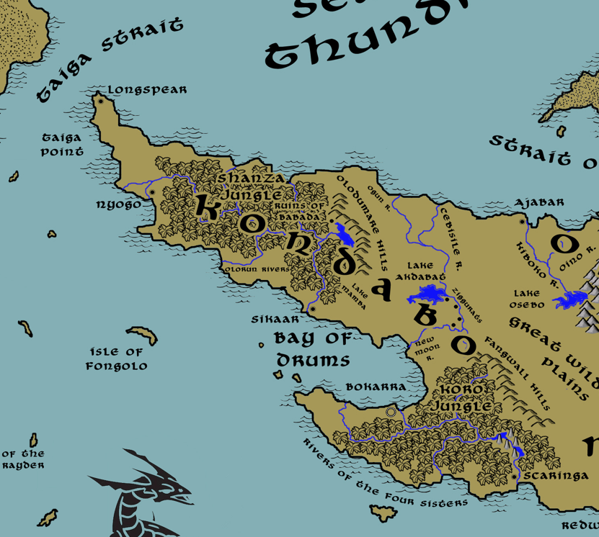

Table of Contents
- Overview
- Towns and Cities
- Best in the Land
- Stewards of Power in this Land
- Points of Interest
- History
- Local Goods
- Notes on Culture
- Weapons and Armor
- Local Deities
- Creatures
- Other Races
- Magical Items
- NPC Templates
- Developer Notes

Overview
Kaduru is a wide continent stretching along the southern edges of Nemmyrl. It is a tropical land, covered in dense jungles separated by arid plains and deserts. The interior of Kaduru remains largely unexplored wilderness, but towns along the coasts have built up into powerful hubs of sea trade. Chieftains, holding the title of Sumba, control groups of tribes and smaller towns. Their seats of power are hereditary but are constantly challenged by rivals in personal combat. Over them are kings, called Masumba, who have consolidated power in the four regions and waged wars by land and sea to control the continent.
The people here are proud, fierce, and crafty warriors not to be underestimated. The land itself is tied to primal elements and nature, and the people have developed skills and professions to master it.

Kondabo is the western kingdom, marked by coastal plains, some interior plains, a hilly region, and two large jungles. The people here are more worldly, connecting with kingdoms like Mythenia, Adhanar, and Tarbia and beyond.

Oraba is the northern kingdom, marked by mostly coastal lands and hemmed in by mountains and the imposing Chanbara Jungle and Ape City. The Straight of Reckoning and the burnt lands of Southern Gaeadon are their closest neighbors. This has led them to be a militaristic society, valuing strength over all else.

Rokari, the eastern kingdom, is also a coastal region with only limited plains far to the east and northwest. The rest is jungle and marsh. But while their neighbors across the water are far from hospitable (the Kazeldun and Moghun peoples), the east is their gateway into Mahabar and southern Xiandai. Eastern culture has taken hold here, prompting the Rokari to embrace art and learning and a sense of regal nobility. Of all the kingdoms, here is where the most learned dwell.

Mthunzi lies far to the south, half of it hemmed in by the Great Crevasse and the Dead Peak Mountain range, the other half dominated by the Bay of Banza and opening into the Wilderon and Cheetana Plains. So far removed from the far-off lands to the north, Mthunzi is a more tradition-minded people and the most connected to the land. Their dress is less formal and more functional, loose-fitting and evocative of the surroundings. Most shamans and wielders of wild magic hail from here.

The Lost Lands in the southeast comprise the fifth region of Kaduru and are not a civilized kingdom as much as a collection of free towns and villages. Barricaded behind the mighty Aramanga Mountains to the west and the Agira Desert to the north, it is a wild and dangerous place filled with dinosaurs and rampaging barbarians. This is a lawless and chaotic place and its people are the most connected to the wild and its predatory nature.

The Konda people reign over this region, having come into power late in the First Written Age. In 795 WA1 they eliminated the Celedonian invaders who occupied the land. In 833 WA1 they crowned their first Masumba over the entire region and united the towns and cities.

Towns and Cities
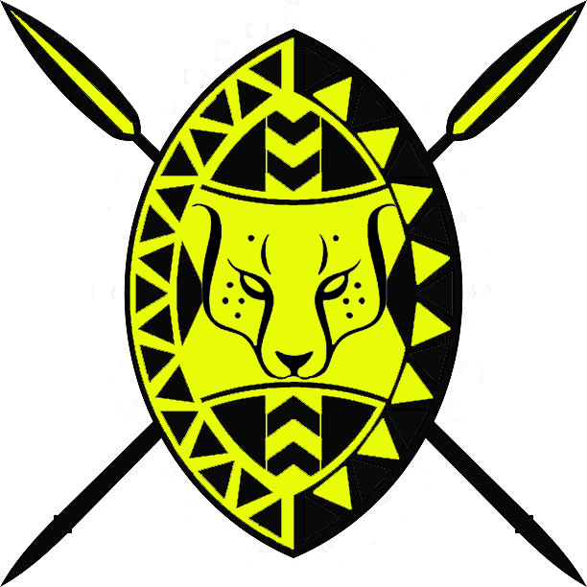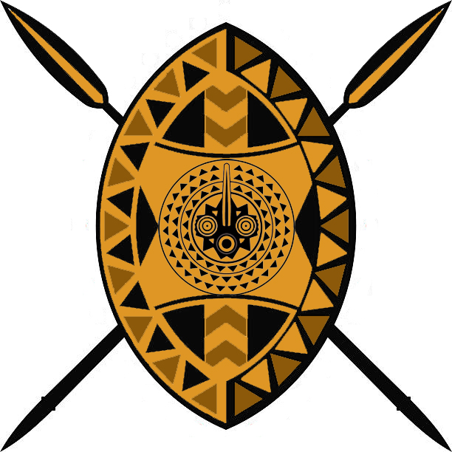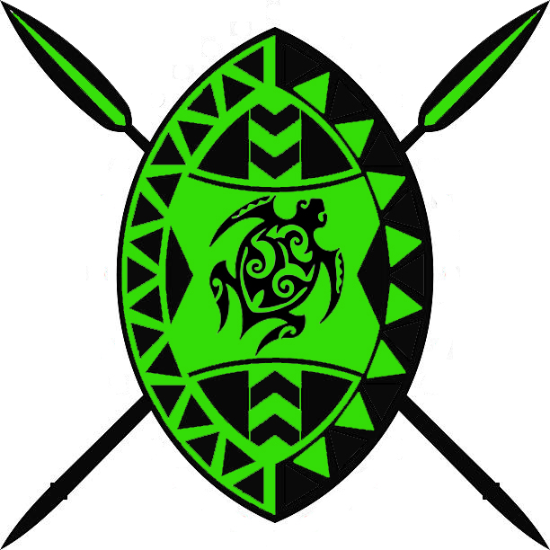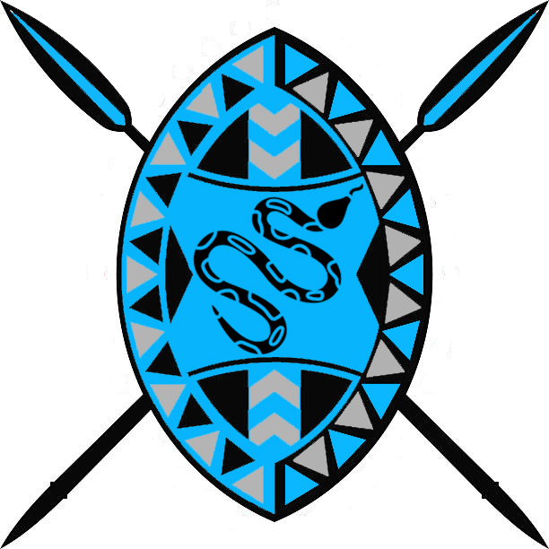
- Kondabo (Western Kaduru)
  - Bokarra - large city, seat of power in Kondabo, sign of the cheetah
  - Longspear - large town, sign of the chameleon
  - Nyogo - large town, sign of the sea turtle
  - Sikaar – small town, sign of the boa constrictor

Best in the Land
Trade Hub: Longspear, Tengaibo, Harikanya, Jaloro
Religion: Harikanya
Arts: Harikanya
Magic: Harikanya
Spirits: Jaloro
Steel: Ajabar
Grain: (none)
Crafted Goods (e.g. Pottery, Textiles, Metal Wares): Harikanya
Harvested Goods (e.g. Aromatics, Medicine, Dyes): Bokarra, Sikaar, Wakabi
Timber: Tengaibo, Nyogo, Masuba
Mined Goods:
Precious Metals:
Ship Building: Longspear, Keromang
Livestock: Bokarra
Ivory: Bokarra, Tengaibo, Wakabi, Harikanya, Arolo
Tobacco: Sikaar, Ramala, Scaringa, Redwall, Keromang
Other:

Stewards of Power in this Land
Kings and their armies are not the only wielders of power. There are many unseen friends and foes that shape the destiny of the land. Each of the groups listed below are well known to the people of this region. Some are feared, others venerated. All of them play their part in the grand drama of this land’s story.

Merchant Companies
Guiding Star Traders - Longspear

Mercenary Companies
(none)

Smuggling Rings
Adder Brotherhood – Nyogo

Centers of Worship (Churches, Cathedrals, Shrines, Lodges, Temples)
Cathedral of Ogun – Bokarra
Cult of the Black Mamba – Nyogo

Orders of Paladins
Order of the Sengese - Bokarra

Druidic Circles
Circle of the Standing Stones – Nyogo

Bands of Rangers
Band of the Bending River – Sikaar

Schools of Magic
(none)

Bardic Colleges
Wanahabari – Longspear

Warrior Academies
(none)

Assassins Guilds
Nightshade – Bokarra

Cults
(none)

Other Guilds
(none)

Monasteries
Shrine of the Two Spirits - Western Kondabo, Taiga Point
Shrine of the Second Rain - Dumare Hills
Shrine of the Right Hand - Lake Akdabat
Shrine of the Five Winds - Fangwall Hills

Pirates
Captain Jabu Manqoba - Isle of Fongolo

Points of Interest
- Isle of Fongolo – Located hundreds of miles from the shores of the Kaduru lands, the Isle of Fongolo is the domain of Bokarra, which keeps a garrison of soldiers there. Over hundreds of years the island has taken on its own culture and some consider it a place altogether separate from Kaduru. The throne in Bokarra has repeatedly been surprised by rogue commanders who ignore royal decree and set off on campaigns of their own in the Maelstrom Seas.

- Taiga Point – Taiga Point is well known to those who sail the southern seas. It is a prominent landmark passing through the Taiga Strait and a welcome sight to those evading the Maelstrom Seas. A thin spit of land covered in date palms and milkwood trees, its banks rise in places to display a white chalky substrate visible for miles. The Isibani Lighthouse stands here, safely guiding ships from the light of an enchanted diamond placed here by sea giants thousands of years ago.
- Bay of Drums – This has been the site of many naval battles, either between Kondabo and Mthunzi forces or, more often, between Bokarra and other cities including its own. The bay is so named for the mysterious rhythmic sounds that carry over the waters here and which cause the surface of the sea to vibrate. Long ago the sea giant Amafu the Cloud Scraper was slain by a massive Kaduru fleet of ships and sent to the bottom of the waters. Some say the giant never fully died, but is still dying or just sleeping, and that the sound and vibrations are from its still-beating heart.

- Shanza Jungle
  - Here dwells the Slazcla tribe of gnolls, known by their mark of the three parallel jagged lines in a lightning bolt pattern.
- Koro Jungle
  - home to the mighty red dragon Ukusha (“burn”)
  - In the waters off the coast of the jungle lurk the tribe of Sahuangin known as the Nalzathor, known by their sign of a spikey urchin.

- Olorun River
  - Here dwells the Hasakas tribe of saurian, known by their mark of the red fern leaf
- Karra River
- Mambele River
- Ogun River
- Cebesile River
- Rungu River
- Onzil River
- New Moon River
- Toshanan River
- Balmurak River

- Dumare Lake – nestled in the arm of the Dumare Hills
  - On the southern bank stands the tower of Koda Bokano, Arch Mage over all the lands of Kondabo.
- Akdabat Lake

- Dumare Hills - East of Longspear, the hills encircle Dumare Lake where it is home to a wide host of exotic birds. An ancient settlement here, now in ruins, was the home of a powerful druid sect called the Babada. Priests of the Babada were rumored to take the form of beasts and hundreds of years ago they dominated the western peninsula until an army from Nyogo crushed them out of existence. There are rumors that the valley is still held by the Babada and it is avoided at all costs.
  - The hills are the dwelling place of the tribe of Hill Giants known as the Warkabari.
- Fangwall Hills
  - Here dwell the tribe of Stone Giants known as the Dhagaarra.

- Ruins of Babada – The kingdom of Babada was once the greatest city of the Primordial Ages. Humans stood ten feet tall, bathed in pools of pure magic, wielded innate powers over the land, and could speak with animals as well as transform into them. In 970 PA4 the queen of Babada was tricked by demons into breaking the oath that protected the land. Thereafter the town decayed until it was overrun by a Gnoll army in the Third Ancient Age.
- The Ziggurats (ruins) – The ziggurats are a place of mystery and dread. Four structures stand on the western banks of the New Moon River, far from any villages. Some say they are haunted. Built in the Second Primordial Age to honor the gods, they eventually fell into darkness during the Ancient Ages and abandoned. The ancient Trials of Yudoye make the Ziggurats the final objective: whoever reaches them first becomes the reigning paladin of Yudoye and inherits the ancient weapon of its namesake.

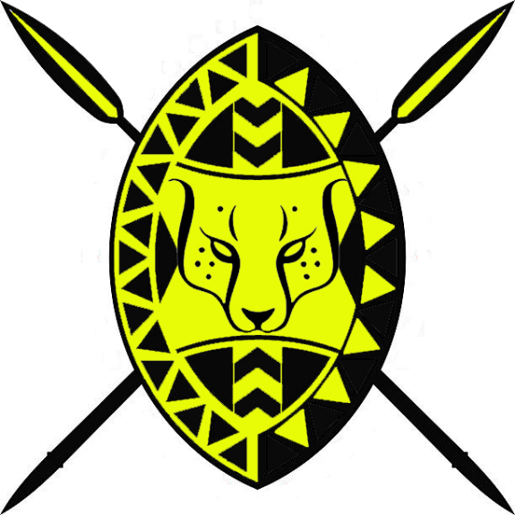
Bokarra
Size: large city, population 25,000, guards / soldiers 250, militia 2250
Trade Goods: dyes, furs, ivory, gems, livestock
Local Goods: fishing, ship building, trade
Standard: cheetah
Colors: yellow and black
Patron Deity: Ogun, hunting god of lethal metalwork
Ruler: Masumba Azima of the Duma tribe and his wife Nothembi (f)

Home: Ivory Palace
Steward: Sifiso
Marshal: Kedisi
House Priest: Ubaba
House Adviser (Scholar/Mage/etc): Lwazi
Captain of the Guard: Dandalaza (f)
Chief Warriors in Service:
Mhambi
Ciko
Mnotho

Local Powers: Green Teeth (thieves guild), Nightshade (assassin’s guild), Cathedral of Ogun, Order of Sengese (order of paladins)
Local Sites: Farasi’s Inn & Tavern, Kongomato’s Inn & Tavern, Paka Palace (brothel)

Description:
Chief city of the Kondabo lands, Bokarra is the seat of power over Longspear, Nyogo, and Sikaar. It is called the Seat of Light for its immense wealth, much of it from the crushing tribute it demands from Longspear and other towns. Overlooking the Bay of Drums, Bokarra operates an active port and is home to a vast naval fleet that controls all sea trade west of the Cebisile River. While Longspear may build the ships, it is the military might of Bokarra that commands them.

The walls of Bokarra are painted in the colors yellow and black, fashioned after the cheetah of the Wilderon Plains. Signature cheetah spots are ubiquitous in decorations throughout the city and on its soldiers. Warriors paint themselves in bright yellow spots and adorn their black armor in yellow trim.

Visitors to Bokarra will marvel at the austere beauty of the city. The city is built on wide terraces leading down to the Bay of Drums. There the shoreline bristles with docks maintain ships built in Longspear and garrisoned here. An enormous statue of Ogun stands fifty feet tall in the middle of the bay, built upon an atoll. Ogun brandishes his mighty war club, shaking it defiantly westward.

Industry:
Dire elephants in the Koro Jungle kill more hunters from Bokarra than anything else. But their tusks are a prized commodity shipped to ports abroad. Some say Koro Ivory is unique in its value for making magical items, especially of an evil kind.

Key Figures:
Azima reigns as the Masumba, or king, over the Kondabo region. He is a sadistic warlord, always wary of uprisings in his towns and cities. He offers regular tribute to Ogun, the god of war, and is even know to offer human sacrifice. His Duma tribe has a long history of seizing and maintaining power through warfare, and Azima has quite the appetite for it. Even the smallest slight from one of his vassal towns has been known to elicit the Bokarran infantry to march. Some say Azima launches attacks against his allies as sport, others say it is to send a message of fear. This has won Bokarra little loyalty and it is only a matter of time before Nyogo or Longspear rise up to challenge their ruler.

The elite of the Bokarran army are the Hunters. These are soldiers trained to have exceptional speed, travel light for days on end without rest, and fight savagely. The Hunters are marked by their cheetah furs, but they are rarely seen as they strike quickly in hit-and-run attacks and at night. Hunter units are exceptional for scouting and harassing enemy camps. Even in peacetime they are feared, for even in peace the Hunters never stop hunting.

Local Lore:
For generations the people of Bokarra have spoken of mysterious children, usually little girls, who appear briefly in the region only to vanish without a trace. These are the emere, spirits in disguise, ghosts of children who are thought to have died during a time of great joy. They refer to death as if it were life, despise the living and seek random mayhem upon them, and are clever enough to disguise their objectives. Believed to be more powerful than witches, they upset the balance between the two worlds while they are present. Strange catastrophes occur while they walk in this world.

History:
Centuries have seen Nyogo and Bokarra fight for control of the west. There are long stretches where smaller kingdoms have existed, but Bokarra alone has repeatedly asserted its domination over western Kaduru. What it lacks in proximity to the westernmost tip of Kaduru it makes up for in its wealth and reach, drawing in merchants and the profits from Longspear, Nyogo, and Sikaar.

Six thousand years ago the gods Ogun, Olorun, Takhar, and Shango bickered over Kaduru and who among the peoples there were the mightiest. As a test they dispatched the Four Spears of Ogun to Bokarra, Tengaibo, Jaloro, and Harikanya. This sparked the rise of the Four Kaduru Empires.
In 150 AA2 the Bokarra armies marched across western Kaduru, claiming all towns and villages as far as the Joro Mountains and the Nthelu River. This transpired at the same time Tengaibo, far to the northeast, was mounting a similar campaign to take all of northern Kaduru lands. Bokarra and Tengaibo clashed at the edge of the Wilderon Plains. A similar campaign emerged between Harikanya and Jaloro in the east and south.
Beginning in 140 AA2 Bokarra attacked the Elven settlements in the Koro, Kuthu, and Shanza Jungles, wiping them out. In 220 AA2 Bokarra invaded southern Arnland and held the lands there for three hundreds of years before the Bokarran power subsided.
In 550 AA2 the Battle of the Sky Spears saw Masumbas of all four Kaduru Empires meet on the Plains of Cheetana to claim all of Kaduru. It was the single greatest battle ever seen in Kaduru and ended with the destruction of all four armies and their Masumbas. This signaled the decline of the Four Kaduru Empires.

Customs:

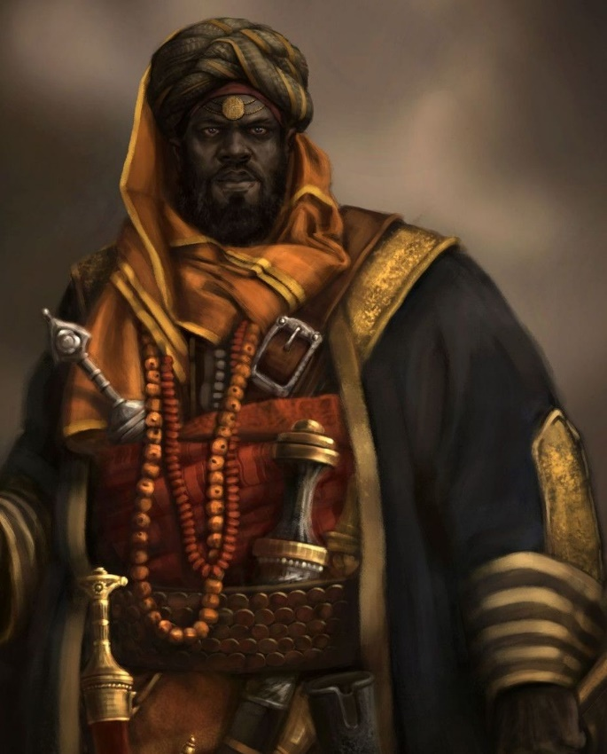

Longspear
Size: large town, population 5,000, guards / soldiers 50, militia 250
Trade Goods: trade hub, cotton, ship building
Local Goods: fishing, trade
Standard: chameleon
Colors: brown and orange
Patron Deity: Elegua: messenger of Olorun, trickster god, guardian of the Crossroads of Life
Ruler: Sumba Atieno of the Koro tribe and his wife Bongani (f)

Home: Flame Lily Palace
Steward: Admassu
Marshal: Cashile
House Priest: Siyabonga
House Adviser (Scholar/Mage/etc): Vumile (f)
Captain of the Guard: Assefa
Chief Warriors in Service:
Yamarshet (f)
Melaku
Mzamo

Local Powers: Guiding Star Traders, The Jackals (thieves guild), Wanahabari (bard’s college)
Local Sites: The Duma Den Inn & Tavern, The Red Hippo Inn & Tavern

Description:
Standing like an amber beacon of welcome at the western end of Kaduru is the majestic trade town of Longspear. Squat round buildings sit astride a steep hillside overlooking the sea. Buildings of various architectural styles dot terraced landings that wind down to the harbor. Wide stairs lead from the docks all the way to the palace at the top, where glittering spear-shaped promontories top the walls. All over there are vibrant orange pinions trailing in the wind and the smells of a thousand spices drift in the air as raucous music plays in the streets. Markets and bazaars stand alongside luxurious pools where servants tend to a traveler’s every care. Longspear is indeed a paradise for outlanders.

The reigning Koro tribe is to thank for the town’s diverse character. They see the opportunity to trade with outlanders and have created a haven for enterprise here. This is a town for merchants and travelers. Even the name of the town was adapted to the Common tongue. Some in Kondabo shake their heads at this, thinking the town greedy and abandoning the old ways. But business is brisk here and far off lands eagerly seek out this haven in the south seas.

Located at the western-most tip of Kaduru, Longspear is a major trade port and considered the doorway to the continent. Explorers sailing from Mythens, Darmiddia, and Kazelduun acknowledge Longspear as a strong partner. It is also the only safe place to land in the Kondabo kingdom without permission from one of the tribal chieftains, or Sumba. The people here are welcoming and speak many languages.

Industry:
Darmiddian merchants are well invested in the town and have many partnerships and ventures, as well as the friendship of the Koro elders. The Guiding Star Traders is the major player in port with markets all across the Thundra Sea. The Darmiddians helped to establish the local merchant house, but it has now grown large enough that the merchants are looking to push the Darmiddians out when the time is right.

Longspear pays homage to Bokarra, which is the seat of power in Western Kaduru. It is an uneasy relationship. Ships of great strength and speed are built here, but the town’s militia is no match for Bokarra’s infantry. So many of the ships are taken to Bokarra, where a mighty naval fleet controls the sea as well as the land.

Key Figures:
Sumba Atieno of the Koro tribe and his wife Bongani
Atieno is a lean, handsome figure and young to be a Sumba. He wears brightly colored sashes and a hundred gold bracelets, which he gifts to any traveler who impresses him. He is an ambitious man and scoffs at the rebuke of his elders who think the town is too welcoming to outsiders. Atieno is an avid student of other lands and will invite travelers to his manor house to hear their stories.

Longspear is also the site of the famous Wanahabari school for musicians and storytellers. Gifted singers and orators travel here to study at the feet of masters and spend years joining in the town’s festivals to perfect their craft. It is a high mark to be known as a travelling Wanahabari storyteller, and most in fact do leave Longspear to wander Kaduru to collect and tell great tales to the Sumbas abroad.

The priests of Elegua, the trickster god, can be seen everywhere around the town and especially at the docks welcoming those disembarking from their ships. The priests are constantly moving, for they are also members of the Jackals thieves’ guild. They consider it worthy offerings to their god that come in the form of cut purses from unwilling donors. Visitors beware.

Local Lore:

History:
Three hundred years ago the Darmiddians convinced the chieftain of Longspear to revolt against Bokarra (180 WA4). A fortune was spent on arming the warriors of the region. For twelve years war raged on land and at sea: from the Dumare Valley to the Bay of Drums. In two crucial victories Bokarra overcame the revolt and restored control of Longspear: Battle of Drum Bay (190 WA4) and Battle of the Winds (195 WA4).

Three thousand years ago (150 WA1) the Celedonian Quartus fleet raided Longspear and was met with fierce resistance. Eventually the Celaeno Legion took the city and garrisoned here as a base of operations for further conquests inland. The conquerors erected an imposing fortress looking out over the seas and named it Cynolycus Citadel. It was so named for a creature from Celedonian mythology, a creature with the body of a stag, a lion's neck, cloven hooves, and a wide mouth with a sharp, bony ridge in place of teeth. It imitates the human voice, calls men by name at night, and devours those who approach it. It is as brave as a lion, as swift as a horse, and as strong as a bull. It cannot be overcome by any weapon of steel. This citadel stands to this day, blending in with the variety of architectural styles on display in Longspear.

Customs:
The people of Longspear are worldly and curious. They are also quick students of other languages and traditions and talented at mimicry. It is appropriate that the town’s symbol is that of the chameleon, for Longspear residents are masters of disguise and deception.

Umkhonto was the original name of the town, meaning ‘spear’ in the native language. Savvy wanderers will know to speak the name to locals to win their trust, for it is a forbidden word after the town changed its name.

Longspear is a festive town. At night the town erupts into frenzied revelry. Large fires are built and ritual dances are performed in the town square. Visitors are feasted like conquering heroes. The patron god, Elegua, is a trickster god and so visitors are dressed in foolery that has come to be a ritual for any making landfall in Longspear for the first time. But travelers are wise to watch their coin purses. Every act of deference in Longspear is designed to bring in wealth. It is not uncommon for unwary visitors to be presented with wives at these feasts. If one carelessly drinks from a cup offered by a Son or Daughter of Elegua, then the Koro consider them married. This is a common trick that tends to end in payment made to free oneself from the bond. And that is the whole point. One should watch for any servant wearing the pendant of Elegua who drinks from a cup before offering it.

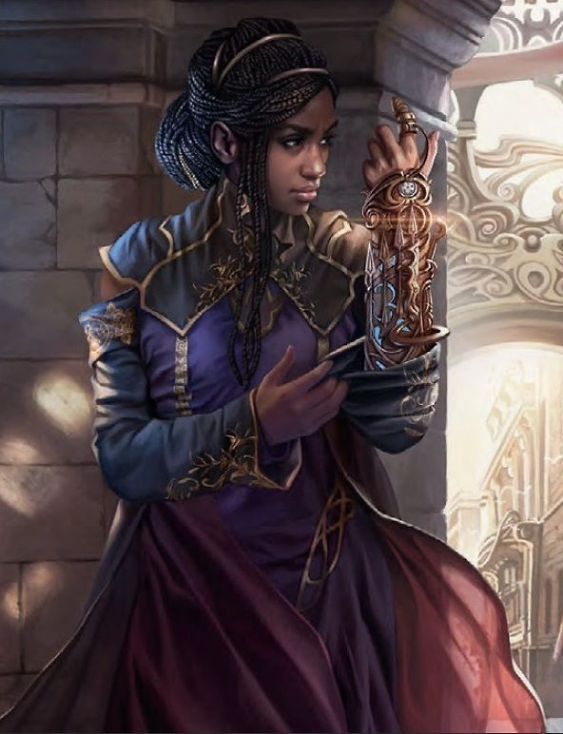

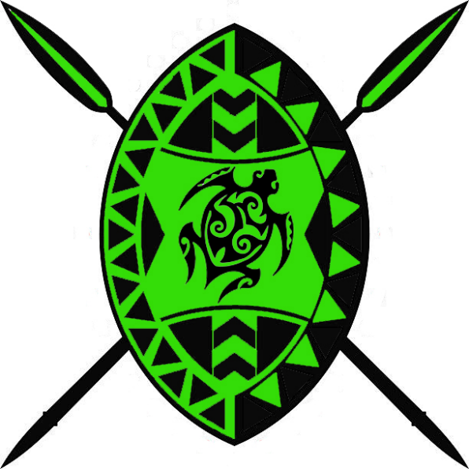
Nyogo
Size: large town, population 5,000, guards / soldiers 50, militia 250
Trade Goods: timber, sugar, spices
Local Goods: farming, fishing, trade, rare plants
Standard: sea turtle
Colors: black and green
Patron Deity: Aje, patroness of trade and wealth
Ruler: Sumba Mshindi of the Sefu tribe and his wife Thulani (f)

Home: Hawksbill Keep
Steward: Ndeleni
Marshal: Cothoza
House Priest: Nokuthula (f)
House Adviser (Scholar/Mage/etc): Sthembiso
Captain of the Guard: Bhekinkosi
Chief Warriors in Service:
Asamenew
Aregawi
Zekulu

Local Powers: Four Stars (thieves guild), Adder Brotherhood (smuggling ring), Grutsele Cult of the Black Mamba, Circle of the Standing Stones (order of druids)
Local Sites: The Farmer King Inn & Tavern, Seven Palms Inn & Tavern

Description:
Nyogo is another town that receives frequent visitors from the west but carefully controls passage into the land’s interior. Unlike Longspear, however, little effort has been put into building a venue to host travelers. The buildings are built in traditional Kaduru styles, squat round buildings with teak planked rooftops, and the culture is more intact from days of old. Black walls surround the town with bright green foliage trailing downward from the ramparts on all sides.

Hawksbill Keep is so named for the breed of sea turtles that make these waters their home.

Industry:
While Longspear looks beyond the sea with its merchant companies, Nyogo is content to farm while hosting several smuggling operations. Farming thrives along the banks of the Olorun River system. Sugar plantations north of the Olorun River are a source of great wealth. Timber of many tropical varieties are harvested in the jungle and shipped abroad for their exotic beauty: Iroko (Kaduru teak), Afara (Korina), Sapelli, Utile, Ayan, Ebony, Sipo, Okoumè (Gaboon), Moabi, Ayous, Kaduru mahogany (Khaya), Wengwe, and Ozingo.

Although not a major trade good, extremely rare plants are foraged from expeditions into the nearby Shanza Jungle. These are highly sought after by healers, alchemists, and mages from around the world. Guides are ready to lead these expeditions but only for a handsome sum.

Nyogo pays homage to the larger city to the south, Bokarra, which is the seat of power over all of Western Kaduru. Nyogo played a small part in the Longspear revolt three hundred years ago. It supported Longspear secretly for a time, but switched sides when Bokarra began to have the upper hand. Nyogo remains a major rival to Bokarra for control of the Kondabo region, but it fears for reprisal and bides its time.

Key Figures:

Local Lore:
The Cult of the Black Mamba resides somewhere outside of Nyogo. It is an evil cult that worships the snake god Grutsele. It is known to kidnap unwary travelers and sacrifice them to their god, which may or may not dwell in the deep Shanza Jungle protecting a horde of mystical diamonds. The dark priests of Grutsele can be seen in the marketplace, wearing black and purple robes. Their reign of terror is great enough that the Sumba here dares not move against them.

The patron deity of Nyogo is Aje, goddess of prosperity and trade. She is the daughter of Olorun and is the owner of many charms and gourds containing specific magical medicines. The akoko leaf is considered sacred to Aje and used to invoke the goddess and in enchantments. It is said of her, “Aje turns the wise man into a fool, and makes a fool of the wise man.” It is believed the priests of Aje, along with the Druids of the Standing Stones, wage a secret war against those of Grutsele.

History:
Nine hundred years ago Nyogo was the site of the War of the Mamba (920 WA3). An evil shaman summoned Grutsele and her children, sending a massive wave of large poisonous snakes to Nyogo to consume a child of prophecy. For three years the people battled a hopeless war against the serpents, with many casualties. At last the hero Naledi (f), a druid of her people, devised a plan to trick the serpents into thinking the priest was the chosen child. Grutsele consumed the evil shaman and the entire cult and left the town in peace.

Four thousand years ago (460 AA4) the Shanza Jungle birthed a terrible serpent. Said to have spawned from Grusele himself, Nyoka terrorized the town and waters as far as Longspear. It is said that the hero Izagala, a druid of the sea, rose up against the serpent. He called upon the great sea turtle Ufudu, and rode atop it in a great sea battle with the serpent. In the end the turtle decapitated the serpent and ate its body. Izagala bore the serpent’s head into the city as a prize. It is said there are magic relics lost to man that were fashioned from the eyes and fangs of the serpent. These are called the Relics of Nyoka and contain terrible power. From that day to now the Olorun Rivers appear to have a reddish color that locals claim is the blood of the serpent.

Customs:

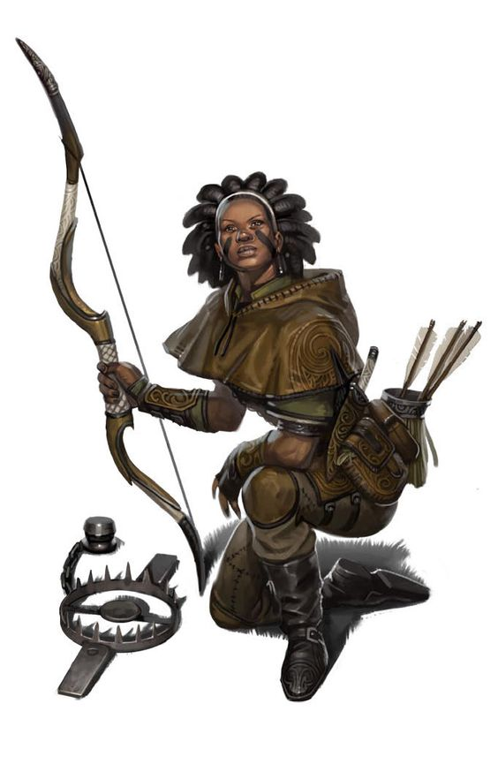

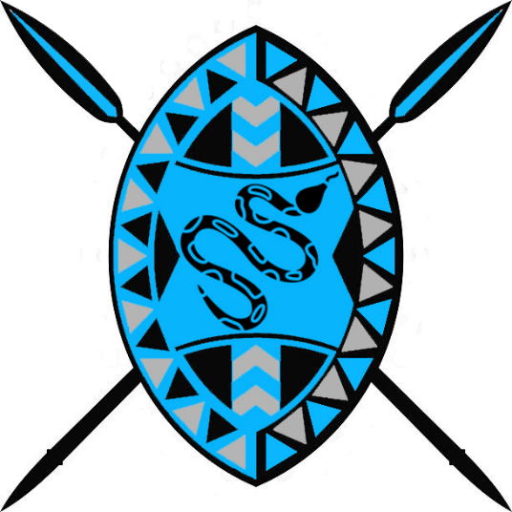
Sikaar
Size: small town, population 2,000, guards / soldiers 20, militia 100
Trade Goods: medicine, tobacco, silver
Local Goods: fishing
Standard: boa constrictor
Colors: grey and blue
Patron Deity: Obaluaye, god of healing
Ruler: Neway Benti of the Asmelash tribe and his wife Thandekile (f)

Home: Boomslang Keep
Steward: Ketema
Marshal: Aregash (f)
House Priest: Thembinko
House Adviser (Scholar/Mage/etc): Manelesi (f)
Captain of the Guard: Chweba
Chief Warriors in Service:
Zamani
Thatha
Kiya (f)

Local Powers: The Bush Birds (thieves guild), Band of the Bending River (order of rangers)
Local Sites: The Silver Kpinga Inn & Tavern, Lady Fang’s Inn & Tavern

Description:
The small town of Sikaar sits at the mouth of the easternmost of the Olorun Rivers. There the river empties into the southern seas. The town overlooks the beginning of the Bay of Drums. Far upriver are the Shanza Jungle and the ruins of the ancient city of Babada.

Sikaar pays homage to the city of Bokarra, which is the seat of power in Western Kaduru. Bokarra lies on the other side of the Bay of Drums and controls the waters all along the coastline. Centuries have seen Sikaar repel the overlords from across the water. For this reason Sikaaran warriors have become exceptional guerilla fighters. Each warrior is branded at a young age with the symbol of the snake-god Nyaminyami. It is a symbol of their tradition of resistance and defending their river home.

Boomslang keep is so named for the breed of highly venomous tree snakes that dwell in this region. Their venom is extremely dangerous, affecting the blood and causing its victims to bleed from every orifice if not treated.

Industry:
Sikaar has tobacco plantations stretching east and west of the river. Silver is mined far upriver from the Olodumara hills and transported by boat. Experienced rangers know the Shanza Jungle and harvest rare medicinal plants.

Key Figures:

Local Lore:
The healers of Sikaar are renowned for their natural gifts. The town’s patron god, Obaluaye, is said to have gifted the people of Sikaar with great constitution and resistance to poisons. Obaluaye once made friends with the serpent Nyaminyami. While the other gods feared the serpent, Obaluaye learned of its secrets and gleaned restorative powers. It is said the god instilled this power in the very blood of the Sikaar people.

The Dingonek is a fearsome water creature having the body of a fish the length of three men, is covered in scales, and has the head and coloring of a leopard. It has two enormous fangs that can pierce the thickest of hides and claws that capture and crush its prey. The people of Sikaar tremble at the thought of encountering the Dingonek on the river ways.

History:
Sikaar was once the trade port for Babada, which fell almost five thousand years ago in 720 AA3. In those days the Babada Empire was an impressive force in the west. But war with the Slazcla gnolls of Shanza Jungle eventually led to its downfall.

Three thousand years ago (200 WA1) Celedonian naval forces Quartus and Quintus attacked the Kaduru towns of Sikaar, Ajabar, and Skaringa in a coordinated campaign. They deployed the Gerana and Acanthis Legions to move behind Kaduru forces holding the Wilderon. The town was held hostage for hundreds of years under Celedon rule. Ancient military buildings can still be found crumbling in parts of the town.

Customs:
The Tamasha Wanyama is a monthly custom held during a full moon. Musicians and dancers gather in a sacred clearing just outside of town, where they sing and dance and play music for four days. The celebration draws animals out of hiding, coaxing them with praise for their various gifts. The scene is a surreal one, with beasts of every kind taking residence among the partygoers. Food is offered to the beasts, laid out as a banquet to esteemed guests. There is a spirit of harmony during this time. It is said that each beast seeks out the young boys and girls who embody their own traits. In this way, the town marks those who will excel in speed, strength, wisdom, and cunning.

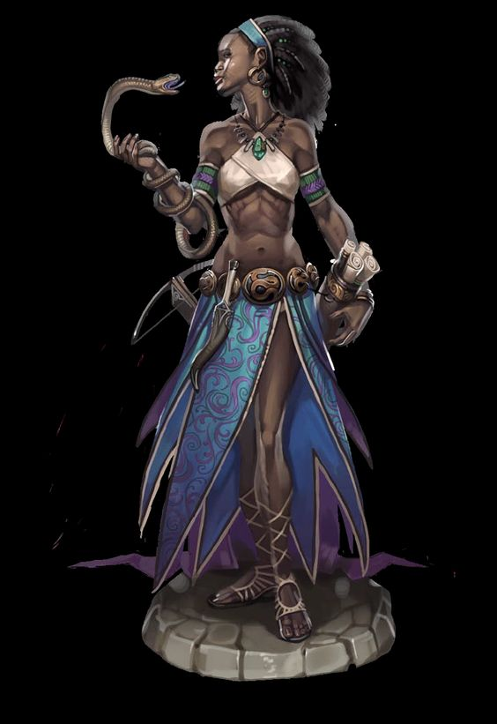

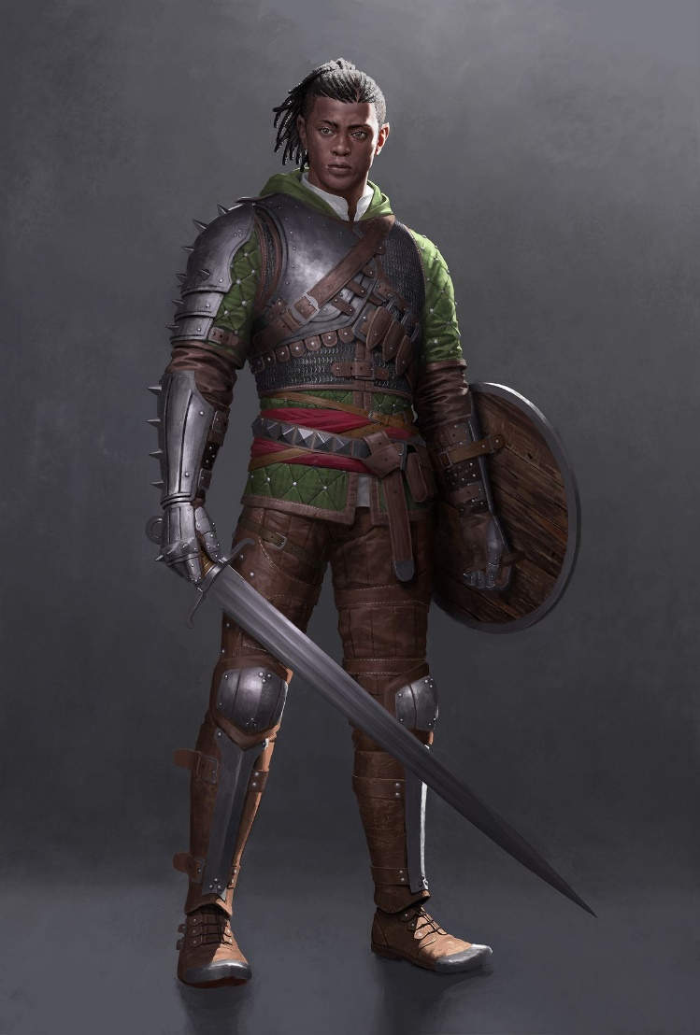
History of Kondabo
First Primordial Age (PA1)
The first people of Kaduru, the Watu, emerge in the savage jungle valley east of the Aramanga Mountains; it is a primal struggle to survive as the gods see if humans are fit to live in this new land.

50 PA1 - the gods Olorun, Ogun, Oya, and Eleduwa arrive in Kaduru and wager to divide the land up between them

173 PA1 - the Watu are challenged by the gods to explore all of Kaduru; any who can survive the savage lands are invited to settle what lands they find most appealing

580 PA1 - After years of adversity surviving the perils of the land, Watu tribes from the Southern lands reach Western Kaduru and begin building permanent settlements. The trials of the gods have made them strong and they quickly adapt to their new home.

Second Primordial Age (PA2)
20 PA2 - The first Trials of Yudoye are held: warriors from all over Kaduru meet in Bokarra for the great race to the Ziggurats, where a mighty weapon is hidden; the winner is the Paladin of Yudoye for the rest of his or her life, at which point another Trial of Yudoye is held

Third Primordial Age (PA3)
390 PA3 - the Ziggurats are built near Lake Akdabat to honor the gods of Kaduru

Fourth primordial Age (PA4)
190 PA4 - Argeia sends armies into western Kaduru, conquering the towns and occupying lands west of the Joro Mts.

660 PA4 - Argeian forces are wiped out in western Kaduru

864 PA4 - the Queen of Babada is tricked by demons into breaking the oath that protects the realm; Babada loses its enchantment and the gods turn their backs on it

872-888 PA4 - The Wizard War: Telemechus triggers a world-wide war of mages, some of whom march on Ongolk to stop him and some who join him in attacking the ley lines in their lands; epic battles wage all over the world, destroying cities and upsetting the balance of magic
888 PA4 - The Battle of Forlorn: Telemechus is slain but not before rupturing the magical ley lines permeating Nemmyrl; the victorious general Dragan of Celedon seizes the opportunity to rid the world of magic and ruptures the Singularion as it is embedded in the ley lines; the resulting explosion sends a shock wave that ruptures the magical ley lines around the world and triggers the Dead Century

First Ancient Age (AA1)

Second Ancient Age (AA2)
130 AA2 - the gods Ogun, Olorun, Takhar, and Shango bicker over Kaduru; they send the Four Spears of Ogun to Bokarra, Tengaibo, Harikanya, and Jaloro; sparks the Four Kaduru Empires

150 AA2 - Bokarra armies march across western Kaduru, claiming all towns and villages as far as the Joro Mountains and the Nonthelelelu River, clash with Tengaibo's armies at the edge of the Wilderon Plains
220 AA2 - Kondabo invades southern Arnland: Tarbia and Mythenia

462 AA2 - Kondabo forces are driven out of present-day Mythenia

480 AA2 - Rasalased ("the Lion's Mane") rises up out of Tijara and drives the Kondabo armies out of Tarbia

550 AA2 - the Battle of the Sky Spears - Masumbas of all four Kaduru Empires meet on the Plains of Cheetana to claim all of Kaduru; it is the single greatest battle ever seen in Kaduru and ends with the destruction of all four armies, signaling the decline of the Four Kaduru Empires

Third Ancient Age (AA3)
248 AA3 - the Green Sails enter Kondabo: after many adventures at sea the fleet enters Longspear and are given refuge

251 AA3 - the Third Flight of the Green Sails: local nobles begin persecuting the refugees dwelling in their city; the local priestess Kaafiya begs the Green Fleet to liberate peasants from the slave quarter; the fleet grows by another thirty ships and sets sail to the open sea

720 AA3 - Fall of the kingdom of Babada in Kaduru: war with the Slazcla gnolls of the Shanza Jungle

841 AA3 - Gnolls take over the Ziggurats as a place of worship

Fourth Ancient Age (AA4)
460 AA4 – Kalamang the serpent attacks Nyogo; the hero Izagala calls the great sea turtle Ufudu and destroys the serpent

First Written Age (WA1)
150 WA1 - Celedonian Quatortus navy lands in Kaduru, Celaeno Legion sacks Longspear and moves east, stopped at the Wilderon Plains by the Kaduru armies
200 WA1 - Celedonian naval forces Quartus and Quintus attack Kaduru towns of Sikaar, Ajabar, and Skaringa, deploys the Gerana and Acanthis Legions to move behind Kaduru forces holding the Wilderon
220 WA1 - Celedonian Celaeno, Gerana, and Acanthis Legions surround the Western Kaduru forces and slaughter them in the Battle of the Wild Drums; Celaeno Legion establishes a garrison at Longspear
350 WA1 - Celedonian Gerana and Acanthis Legions march eastward into Kaduru along the Plains of Cheetana, destroying villages and slaying the tribes they meet

790 WA1 - Celedonian Talos Legion marches north to the Joro Mts after hearing false rumors of gold told to them by the locals. A massive army of warriors from the Konda people march out of the Koro Jungle and attack from the Celedonians from the rear; the legions, cut off from the coastal garrisons, are wiped out.

795 WA1 – Konda tribes decimate the confused and demoralized Celedonian garrison forces, freeing the region from occupation.

833 WA1 - Rise of the Konda people as they crown their first Masumba over the entire region and unite the towns and cities.

Second Written Age (WA2)

Third Written Age (WA3)
570 WA3 - War of the Mamba in Nyogo

724 WA3 - The Great Storm of Storms: a mighty monsoon blows in from the sea, leveling Arolo, Ramala, and Keromang; people flee inland to the desert settlement Sanctuaren

Fourth Written Age (WA4)
180 WA4 - Longspear revolts against Bokarra

190 WA4 - Battle of Drum Bay: Bokarra ships encircle and destroy the Lonspear fleet

195 WA4 - Battle of Winds: Lonspear infantry in the Valley of Dumare are defeated by Bokarra forces as winds disrupt the Longspear forces, perhaps from a mystical source

Local Goods
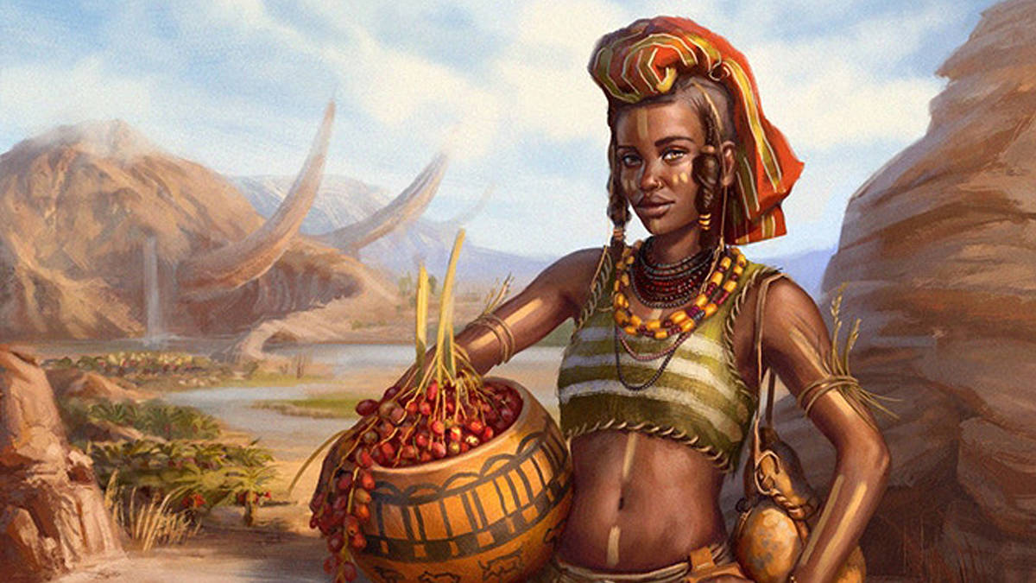
Cereals: sorghum, fonio, finger millet, teff, emmer (wheat)
Fiber: cotton, capok, sisal, palm, flax, hemp, jute, kenaf, coconut, pinewood, baobab bark
Fruits: baobab, bananas, cassava, monkey orange, marula, gac (melon), pare (bitter melon), charentais melon, kiwano (horned melon), egusi (wild melon), watermelon, safou (butter fruit), dika, honeydew melon
Meat and poultry: beef, chicken, pig, lamb and mutton
Nuts: dika nuts, marama nuts, marula nuts, mongongo nuts, palm nuts
Vegetables: okra, black-eyed pea, corn, eggplant, cowpea, lablab, moringa, bambara bean, locust bean, pigeonpea, potato, enset, marama, moringa
Herbs: grains of paradise, kani pepper, sesame, silphion, tamarind, cumin, saffron, iru, kan kan kan (peanut powder, chili powder, allspice, bouillon cubes), mitmita blend (cloves, cardamom, salt, cumin, gigner, cinnamon, chili), za'atar (hyssop, marjoram, thyme, oregano, coriander, cumin, sesame seeds, sumac, salt), berbere (chili, garlic, cumin, ginger, coriander, cinnamon, nigella, fenugreek, ajwain), ras el hanout (the finest spice blend of 40 to 100 spices)
Oils: marula oil, maringa oil, palm oil, panda nut oil
Fermented Drink: marula beer, abada, akpeteshie, kumi kumi, chouk
Salt-water fish: oysters, shrimp, octopus, prawn,
Fresh-water fish: bream, tilapia
Wood: sapele, abura, walnut, agba, avodire, ebony, gaboon, iroko, mahogany, mansonia, obeche, zebrano, teak, bloodwood, podo, olive
Textiles:
Dishes: fufu, amala, poundo, kenkey, piri piri chicken (hot piri piri and creamy coconut sauces, with hints of cashews and peanuts), jollof rice and egusi soup (rice, tomatoes, onions and pepper), suya (skewered meat), sadza (maize porridge), kapenta (fried bream dish), nsima (stiff porridge), chambo (fish stew), ndiwo (relish made of pumpkin or cassava leaves, tomatoes and groundnut powder), ifisashi (a dish of greens in a peanut sauce), muamba (spicy, somewhat oily stew made with with palm oil or palm butter, garlic, chilis and okra), breyani (fragrant dish comprising layers of marinated meat, rice, lentils and spices topped with crisp-fried onions and hard-boiled eggs), biryani (humble vegetable assemblages sometimes incorporating meat and seafood), pilau (meat dish generously spiced with cardamom, cumin and pepper), nyama na irio (mashed-up potatoes, peas, beans, corn and onion and often served with spiced roasted meat),
Other: coffee, kola

Notes on Culture

Clothing
Amidst arid deserts, balmy jungles, and heat-baked savannas of Kaduru, her people have adapted with attire befitting their environs. Most find comfort in minimal clothing: breech cloths, baggy trousers gathered at the knee, open short-sleeved tunics, woven halters, colorful sarongs wrapped about the body and head. Within the confines of their opulent towns, their regalia amplifies in splendor as well as material.

Like many other lands, clothing here is fashioned from wool in the colder months, cotton or linen in the summer, and silk for the very rich. Regional differences inform the cut, color, and decoration of the clothing, as well as what is worn as jewelry. Earth tones of brown, tan, black, and dark red serve as a base, with brilliant geometric adornments in yellow, white, orange, green, blue, and purple.

A staple of Kaduru is the Uzari, the collective name given to lengths of woven cloth that are traditionally dyed and painted in extravagant colors and designs. The Uzari is a device of infinite uses: worn like a sarong it can clothe the body as a halter, a sash, a skirt, a wrap-dress, a head dress, even a cloak. Lesser Uzari are used as an apron, a table cloth, a pot holder, a curtain, a baby carrier. The cloth can be painted with symbols and even words, all of them unique to their region, their tribe, or their kingdom.

The ceremonial version of this cloth is called the Bashogo. The Bashogo represents the tribe, region, or kingdom, and it is worn with pride in battle and in formal ceremonies such as the giving of oaths. Meanwhile, the Ajaye is a blessed version of Uzari inscribed with magical glyphs, words, or prayers that offer protection to the wearer. The design of Uzari tells much of the station and kinship of the person wearing it. Some are handed down as heirlooms, others offered as tribute, all are celebrations of life on the Kaduru continent.

Outside of towns and while working, many commoners keep to minimal clothing to free up movement. Remote villagers and hunters may wear only a loin cloth along with animal skins and feathers and an Uzuri sarong. In the towns people wear more substantive clothing, albeit with the same degree of elaborate decorative patterns as those in the wild. Short- and long-sleeved tunics with loose, high-cut trousers for men, sarong dresses and head wraps for women. Over these can be robes of various cuts.

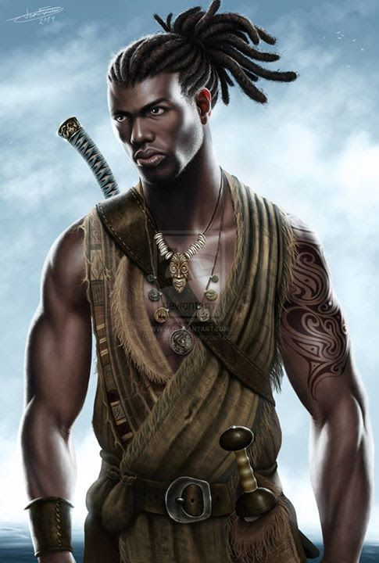
Men
Outside of town men tend to wear baggy, knee-length pants. Their upper torso may remain bare, or they wear sashes that cross in the front, or a sleeveless tunic shirt. Around this they sometimes wear a length of Uzari wrapped around the body that can be worn as a cloak or used for a variety of purposes.

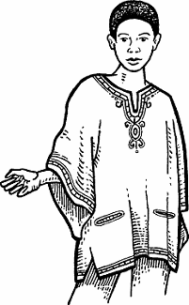
Closer to towns, men often wear a Dashiki, a unisex loose-fitting shirt, long or full-sleeved, with an embroidered V-shaped collar. This comes in many forms and colors and elaborate designs along the edges.

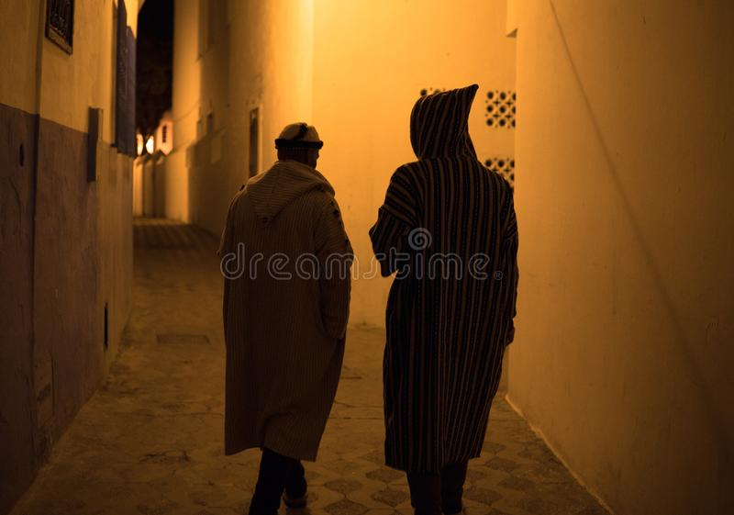
The Jillaba is a commoner’s robe, worn to ward off the elements. It is long, loose-fitting unisex outer robe with full sleeves and pointed hood. This is a general-purpose robe worn by everyone including travelers. It can be floor-length and made from wool for winter or shorter and made from cotton for the summer. The baggy hood, called a gob, comes to a point in the back. It is used both to keep out the sun, sand, or cold, as well as to serve as a roomy pocket for carrying food.

Kaftan - a variant of the robe or tunic, worn in a number of cultures around the world for thousands of years and is of Xiandai origin. It may be made of wool, cashmere, silk, or cotton, and may be worn with a sash. The kaftan is often worn as a coat or as an overdress, usually having long sleeves and reaching to the ankles. In regions with a warm climate, it is worn as a lightweight, loose-fitting garment. In some cultures, the kaftan has served as a symbol of royalty.
Men’s Formal Wear:
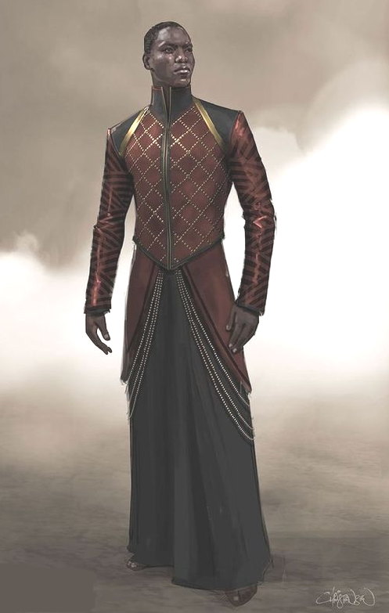
On formal occasions men may wear a Kanzu, a floor-length, long-sleeved tunic over which they can wear a flowing robe. These are close-fitted, often tailored with silver or gold threadwork. They are a mark of distinction and serve as formal dress.

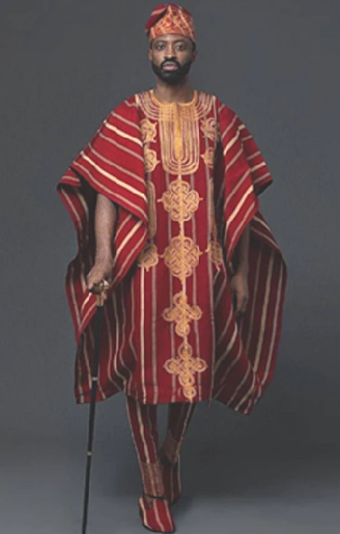
Priests or officials wear an Agbada, a flowing wide-sleeved robe decorated with intricate embroidery. The Agbada consists of three pieces: a pair of tie-up trousers that narrow towards the ankles (known as a ṣokoto), a long-sleeved shirt, and a wide, open-stitched sleeveless gown worn over these. The three pieces are generally of the same color.

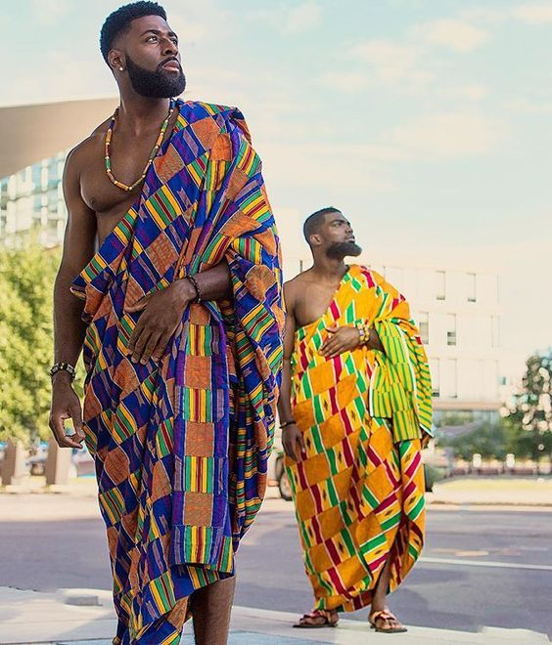
The Bashogo is worn in high religious and royal ceremonies. Worn as a toga by the nobility and very wealthy, it is a sign of high office. Military commanders who are invited to be honored by their chieftains will wear the Bashogo of their army’s colors.

Women’s Attire

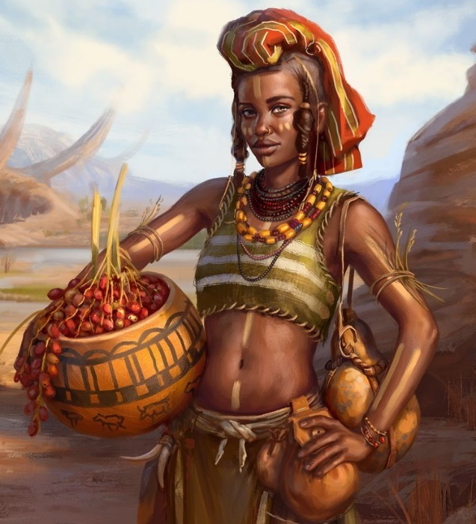
Outside of towns women wear wrap skirts or baggy, knee-length pants with a halter. At times they may wear a sarong as a wrap dress or two of them, one each for the upper or lower torso. They may also carry an Uzuri, a square-cut piece of colorfully dyed cloth, which they drape over their shoulder or wear as a wrap-dress.
The most versatile piece of clothing worn by women is the Uzuri. It is a single two-yard length of fabric dyed in brilliant colors with elaborate designs. Similar to a sarong, they are often worn by women and wrapped around the chest or waist, over the head as a headscarf, or as a baby sling. They can also be used as decorations on dinner tables or hung on walls.
The color, design, and how the headwrap is tied are all closely related to the woman’s position. Multiple Uzuri can be worn, covering head, upper torso, lower torso, and one slung over the shoulder.

In the towns and cities of Kaduru the residents often wear more elaborate clothing. Below are some examples.

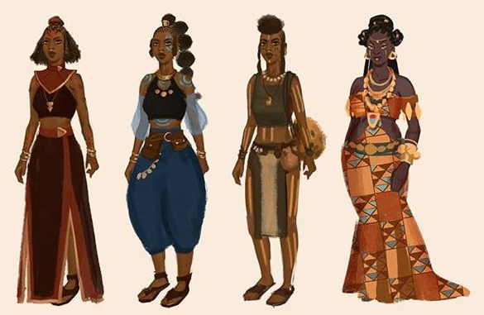
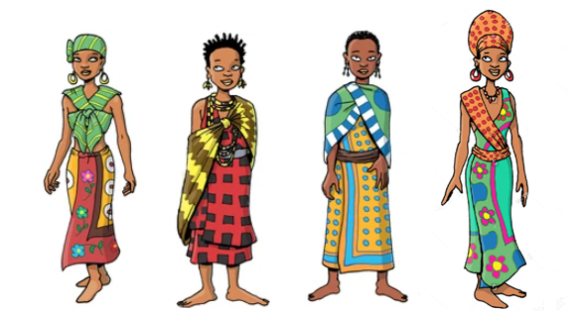

Women’s dresses are incredibly varied across the continent. Some women wear a halter or sarong top with a long, flowing skirt. Some may wear a full-length wrap or sarong dress. Others may wear crossing sashes across the chest or use a length of cloth as a head wrap. Over these another length of cloth is worn as a wrap. Each region has its own traditional production of the Uzuri cloth, usually made of cotton, and its own unique style of pigmentation and decoration. The patterns woven or painted into the lengths of cloth may contain meaningful symbols, patterns, or even words.

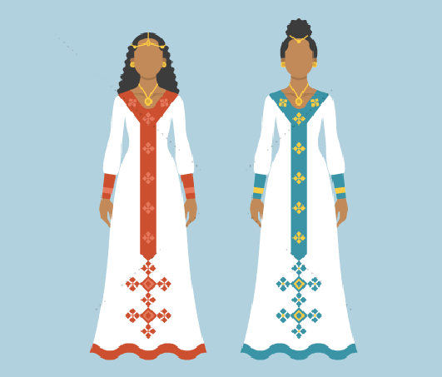
Women’s formal dress
A Zuria is a dress worn that goes to the ankles, sometimes with a gauze hood around the head and shoulders. It typically comes in gray, beige or white and features multi-colored accents sewn along the waistband, cuffs, or hems. It is usually worn at formal events, holidays and invitations.

Hairstyles
Kaduru hairstyles are as varied as the clothing. Men and women both choose from shaved heads, intricate braids, woven locks, and woven rows plaited close to the head.

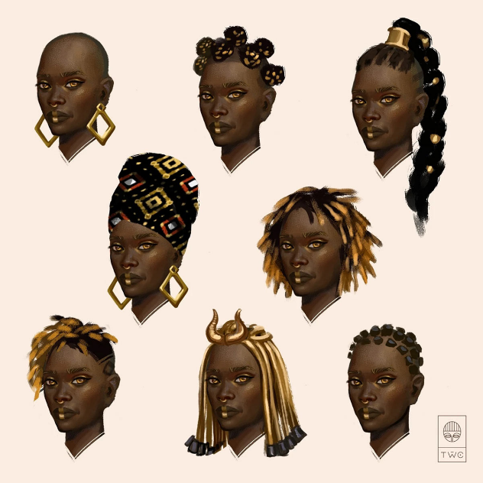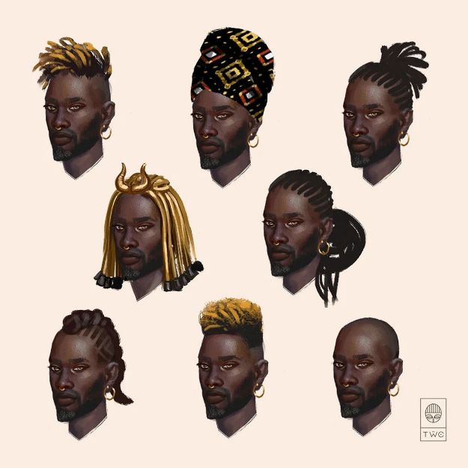

African Musical Instruments
- Kora – one of the most famous stringed instruments; also known as the “Jali.” The design of the instrument is similar to that of a guitar. It features 21 strings placed on a gourd covered with the skin/hide of an animal.
- Kalimba – aka the thumb piano, consists of strips of varied lengths placed on a resonator. A sound is produced by plucking the ends of the flexible strips. Originally made from bamboo strips but moderns strips are metal. The resonator is made from wood.
- Talking Drum – probably the most known drum in Africa. It is an hour-glass-shaped drum usually placed under the arm. To vary the pitch or sound, the player presses or squeezes the narrow edge.
- The Balafon – resembles a xylophone or African marimba. It is a percussion instrument made from wooden planks that are loosely bound by a string and placed over large gourdes. Sound is produced by hitting it with miniature clubs/mallets.
- Shekere – one of the most famous shakers in Africa. The instrument consists of closely woven beads that form a net placed around a gourd. Sound is produced by either shaking it or slamming it against the hands.
- Djembe / Jembe – a type of drum consisting of animal skin or hide stretched over a curved piece of wood. A hole is curved out in the upper region of the wood where the skin is stretched out. The top surface is usually wider than the bottom surface.
- Udu – a type of drum that resembles the vessels or jars used to draw water from the river. Unlike most percussion instruments, it is made from clay instead of wood. The sound or pitch is influenced by the hollow, size, and style of playing.
- Marimba – a type of African Xylophone made by placing small wooden planks on a wooden box (resonator). The different-sized planks are secured loosely using a piece of chord/string. Sound is produced by hammering the planks using sticks or mallets.
- Mbira – a thumb piano that resembles the Kalimba; made up of two rows of metal strips that come in staggered dimensions. They are placed on a wooden resonator (sound box) and plucked by finger.
- Algaita – a popular wind instrument closely related to the oboe. Unlike the oboe, it comes with a wider opening at the base as well as open finger holes. It is made from reeds.

Tribal Masks found in Kaduru and the Sanctum of Masks https://en.wikipedia.org/wiki/Traditional_African_masks

Tribal masks are an ancient tradition unique to Kaduru, involving the crafting and wearing of masks on the face or on top of the head. Masks usually have a spiritual and religious meaning and are used in ritual dances and social and religious events. A special status is attributed to the artists that create masks to those that wear them in ceremonies to evoke some principle or message. Masks are worn for sacred ceremonies, in battle, or to memorialize ancestors or famous rulers. Many masks are enchanted with divine powers cast by priests or shaman.
The person who wears a ritual mask loses his or her human life and turns into the spirit represented by the mask itself. This transformation of the mask wearer into a spirit usually relies on other practices, such as specific types of music and dance, or ritual costumes that contribute to the shedding of the mask-wearer's human identity. The mask wearer thus becomes a sort of medium that allows for a dialogue between the community and the spirits (usually those of the dead or nature-related spirits). Masked dances are a part of most traditional African ceremonies related to weddings, funerals, initiation rites, and so on.
Animal masks represent the spirit of animals, so that the mask-wearer becomes a medium to speak to animals themselves (e.g. to ask wild beasts to stay away from the village); in many cases, nevertheless, an animal is also a symbol of specific virtues.
A common variation on the animal-mask theme is the composition of several distinct animal traits in a single mask, sometimes along with human traits. Merging distinct animal traits together is sometimes a means to represent unusual, exceptional virtue or high status.
The dead is also a common subject for masks, honoring dead ancestors. These are crafted around a skull motif with markings that relate to the ancestor. They are often worn on the hip of the one memorializing the ancestor.
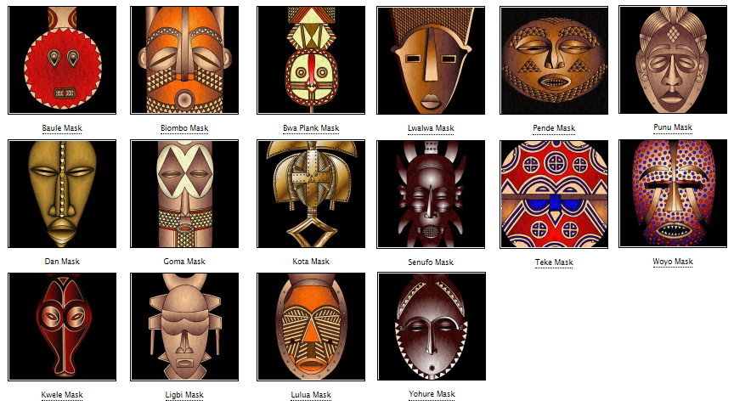
- Baule mask which is also known as a Goli mask. It is used in tribal dances during harvest festivals, in processions to honour distinguished visitors and at the funerals of important figures.
The circular face represents the life-giving force of the sun and the horns symbolize the great power of the buffalo.
- Bwa - These masks are plank shaped with a circular face at one end and a crescent moon at the other. Their wearer looks through a hole in the mouth. The eyes are based on an owl and the hooked nose comes from the hornbill. Both these birds are thought to possess magical powers. Used to celebrate children’s initiation into adulthood, represent information about the myths and morality that the child must learn before they can be accepted into adult society
- Nwantantay masks represent the flying spirits of the forest; since these spirits are deemed to be invisible, the corresponding masks are shaped after abstract, purely geometrical forms
- Bwa and Buna - hawk masks, with the shape of the beak identifying a mask as either Bwa or Buna. In both cases, the hawk's wings are decorated with geometric patterns that have moral meanings; saw-shaped lines represent the hard path followed by ancestors, while checkered patterns represent the interaction of opposites (male-female, night-day, and so on)
- Senufo - have their eyes half closed, symbolizing a peaceful attitude, self-control, and patience
- (name) - small eyes and mouth represent humility
- (name) - wide, protruding forehead represents wisdom
- Gabon - large chins and mouths represent authority and strength
- Grebo - masks with round eyes to represent alertness and anger, with the straight nose representing an unwillingness to retreat
- Poro secret societies - masks that celebrate the exceptional power of the society by merging three different "danger" symbols: antelope horns, crocodile teeth, and warthog fangs
- Baoule - buffalo (usually representing strength, as in the Baoulé culture)
- (name) - crocodile
- (name) - hawk
- (name) - hyena
- (name) - warthog
- Dogon – antelope, representatives of agriculture; masks are highly abstract, with a general rectangular shape and many horns as a representation of abundant harvest.
- Chiwara - antelope masks have long horns representing the thriving growth of millet, legs (representing roots), long ears (representing the songs sung by the working women at harvest time), and a saw-shaped line that represents the path followed by the sun between solstices
- Makuria - depicts dancing masks decorated with cowrie shells imitating some animal with long snouts and big ears
- Punu - mask celebrating ideal of feminine beauty long curved eyelashes, almond-shaped eyes, thin chin, and traditional ornaments on their cheeks, as all these are considered good-looking traits
- Baga – mask celebrating women of strength, features ornamental scars and breasts
- Awa – used by cults of the dead
- Bini – used by cults of the communication with the spirits
- Lebe – used by cults of nature

Weapons and Armor

dagger 1d4 19-20/x2
punching dagger 1d4 /x3 shotel (hooked blade) or Ngombe Ngulu (Executioner's Knife)
sickle 1d6 x2 Shotel (curved blade for hooking shields)

club 1d6 x2 Rungu (note: can be used as a throwing weapon)
heavy mace 1d8 x2
short spear 1d6 x2 Iklwa

long spear 1d8 x3 Assegai (long throwing spear)
quarterstaff 1d6/1d6 /x2 Donga Staff
spear 1d8 x3 Assegai

dart 1d4 /x2 Kpinga (multi-bladed throwing knife)
javelin 1d6 x2 Umkhonto
sling 1d4 x2

throwing axe 1d6 x2 Nsapo
hand axe 1d6 x3 Nsapo
kukri 1d4 18-20/x2
short sword 1d6 19-20/x2 Seme

battle axe 1d8 x3 Nzappa
long sword 1d8 19-20/x2 Kaskara
scimitar 1d6 18-20 x2 Nimcha

falchion 2d4 18-20 x2 Akrafena
great axe 1d12 x3 Kilonda
great club 1d10 x2 Knobkierie (note: can be used as a throwing weapon)
great sword 2d6 19-20/x2 Takouba
lance 1d8 x3

longbow 1d8 x3
composite longbow 1d8 x3
short bow 1d6 x3 Horn Bow (North African) or Teda Bow
composite short bow 1d6 x3

bastard sword 1d10 19-20/x2 Salambasa
whip **** 1d3 /x2 Sjambok

bolas 1d4*** x2
blowgun 1d4 x3
spear-thrower 1d4 x2
net (special)

Light Armor
Padded +1 Padded Cloth Armor (Farafin Kurun)
Leather +2 Cuir Bouilli (Boiled Leather) or Leather Lamellar (Gara Kurun)
Studded Leather +3
Chain Shirt +4

Medium Armor
Hide +3
Scale Mail +4 Chainmail or Scale Mail (Kurunba)
Brigandine +4
Chainmail +5 Sahelian Mail (used by Mali, Songhai, and Hausa warriors)
Breastplate +5

Heavy Armor
Splint Mail +6
Banded Mail +6
Half-Plate +7
Full-Plate +8

Shields
Buckler +1
Shield, Light Wooden +1
Shield, light steel +1
Shield, heavy wooden +2
Shield, heavy steel +2
Shield, tower +4

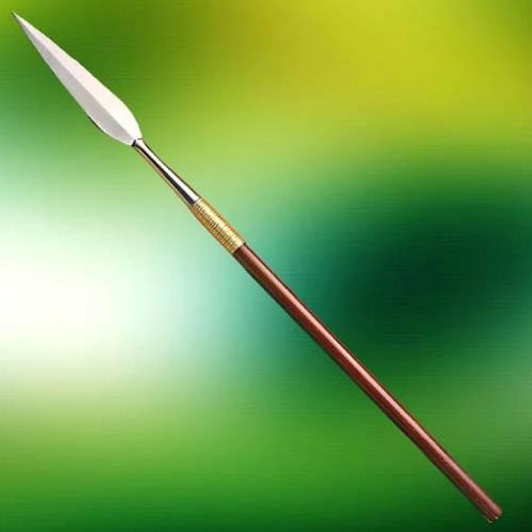
Iklwa - shorter stabbing spear with a two-foot (0.61 m) shaft and a larger, broader blade one foot (0.3 m) long. This weapon is otherwise known as the iklwa or ixwa, after the sound that was heard as it was withdrawn from the victim's wound

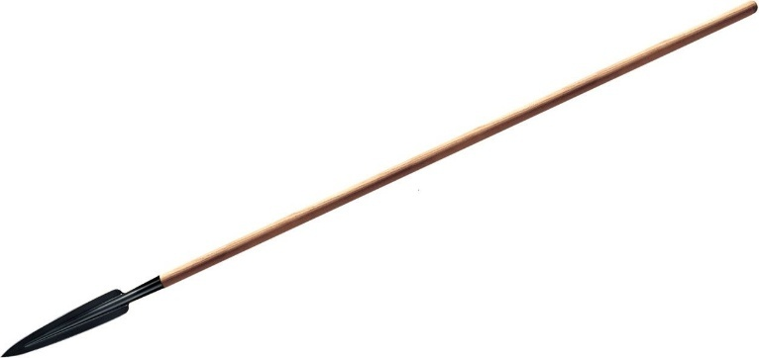
Assegai – spear – wooden shaft, iron head

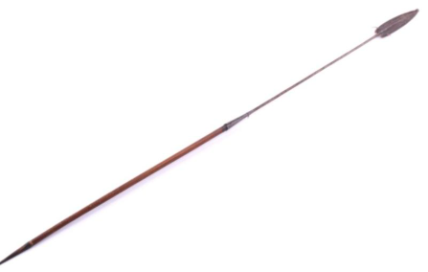
Umkhonto - javelin

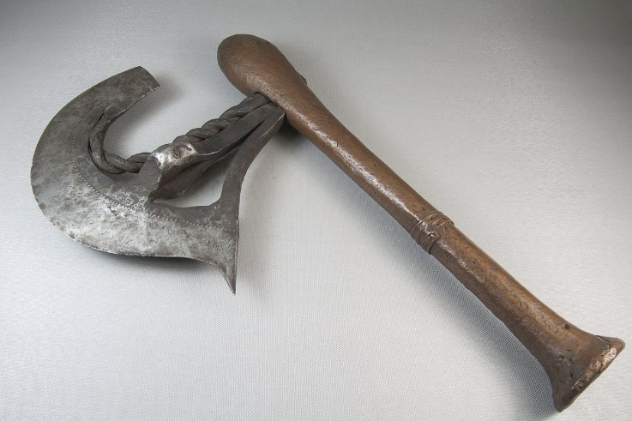
Nsapo – aka zappozap, nzappa, kilonda, kasuyu

For our purposes:
Nsapo – hatchet or hand axe
Nzappa – battle axe
Kilonda – great axe

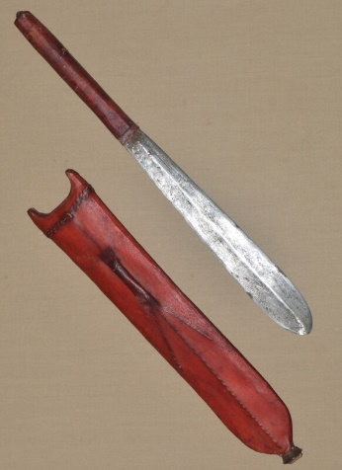
Seme – short sword

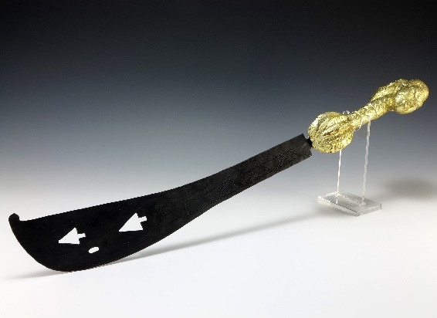
Akrafena – heavy curved sword with weight pommel for balance, equivalent to a falchion

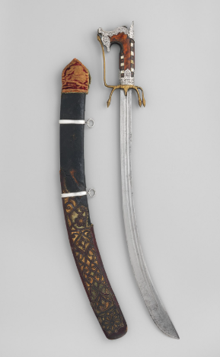
Nimcha – equivalent to a scimitar

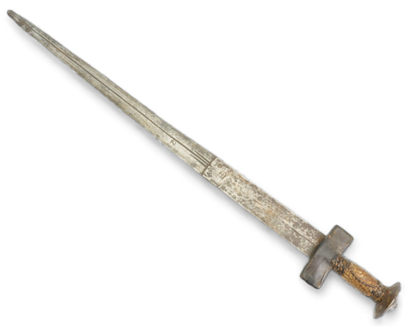
Kaskara – equivalent to a bastard sword

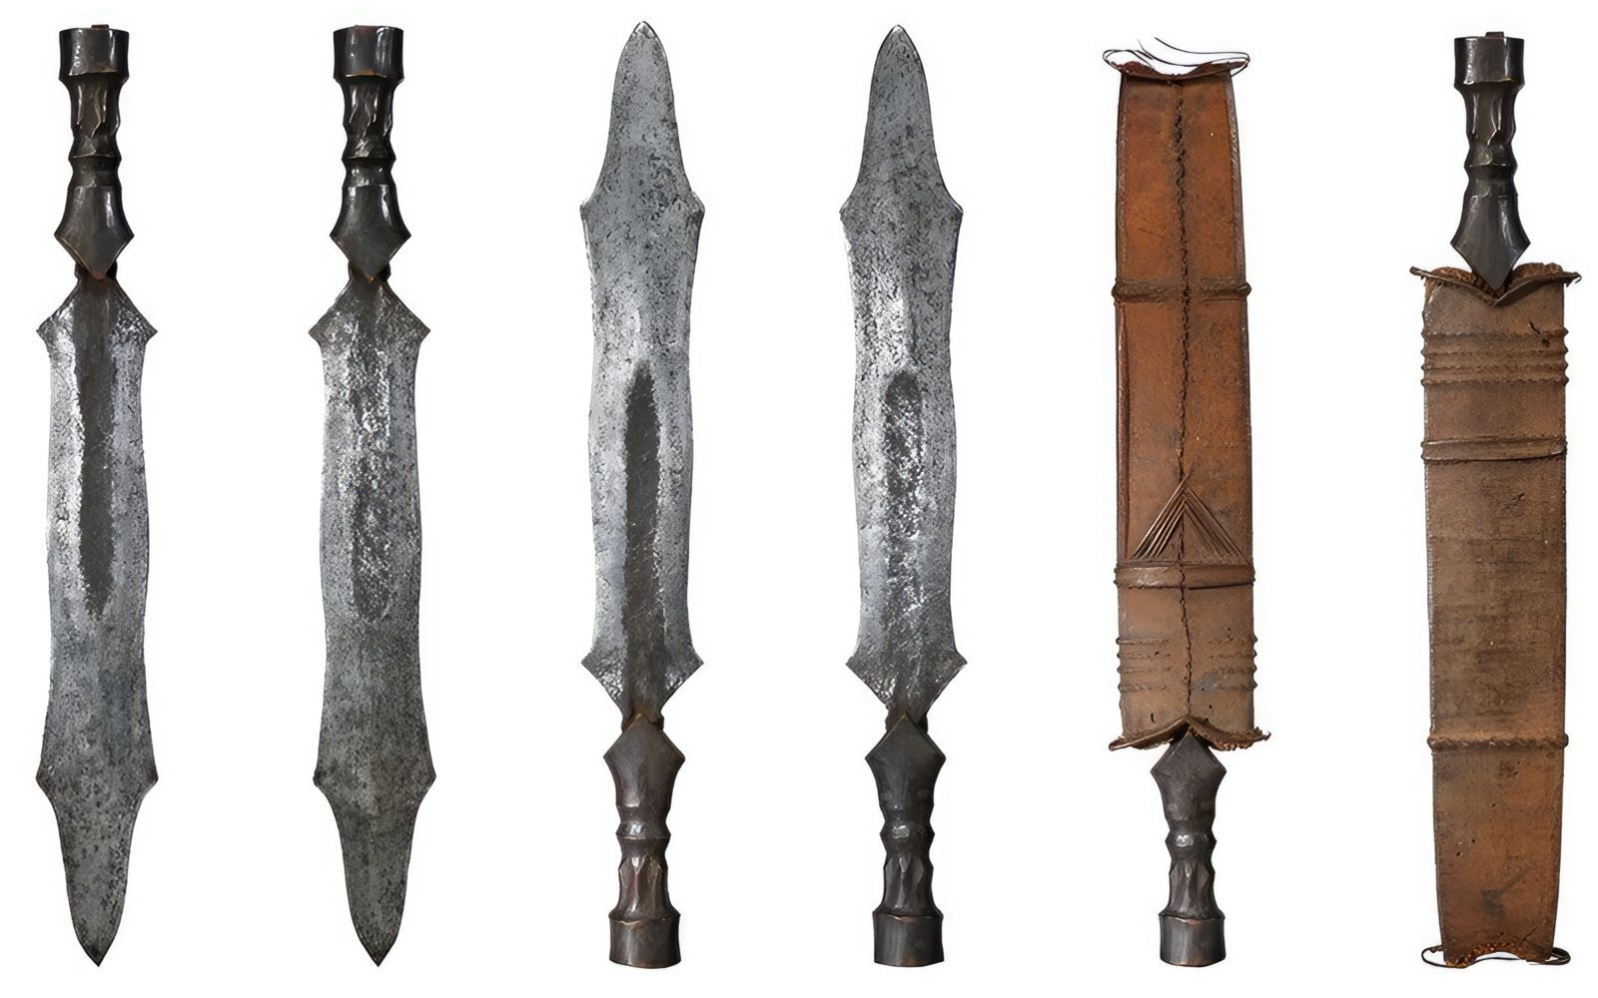
Salambasa – equivalent to a bastard sword; double-edged with five sharp points

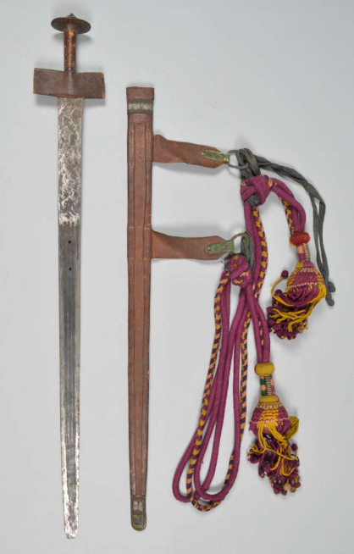
Takouba - equivalent to a great sword

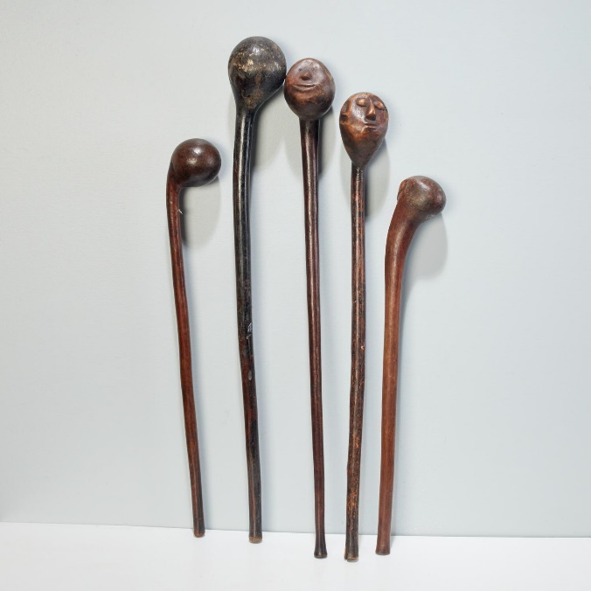
Knobkierie – great club with a large knob at one end
(note: can be used as a throwing weapon)

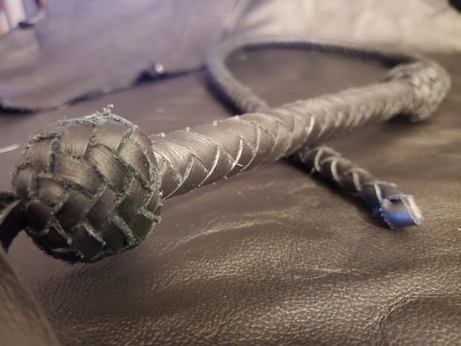
Sjambok – whip made from hippopotamus hide, about five feet in length

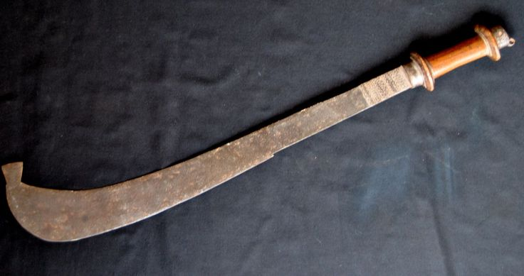

Yoruba sword

Special Exotic Weapons of Kaduru
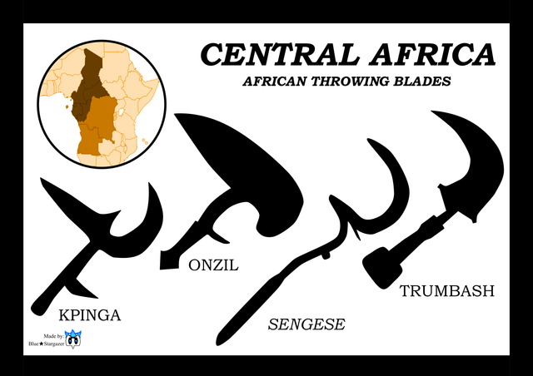

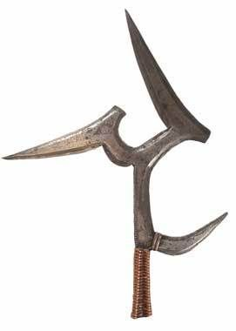
Mambele - an iron blade with a curved back section and rearward spike. It can be used in close combat as a hatchet or dagger, or more typically as a throwing weapon. It usually consists of four blades, three on top and one on the side. The curved hook was used to keep the weapon in the victim, and if pulled out, caused further damage. It would have been about 22 inches in length. These African iron weapons are thrown with a rotatory motion, and can inflict deep wounds with their projecting blades.

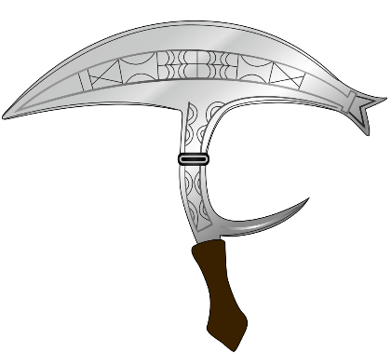

Onzil – punching dagger, throwing knife

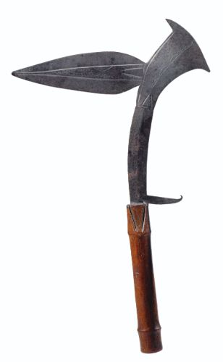
Kota Knife - The Kota knife originates from the Kota people, an ethnic group in Gabon and the Republic of Congo in Central Africa. The Kota are well known for their metalwork, particularly in iron and brass
The Kota knife is distinct but shares similarities with other African blade designs, such as:
- The Fang Machete (used by the Fang people, neighbors of the Kota), often with a longer, more utilitarian blade.

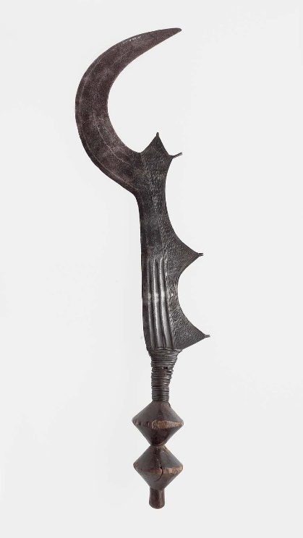
The Ngombe Execution Knife (Democratic Republic of Congo), known for its elaborate crescent-shaped blade.

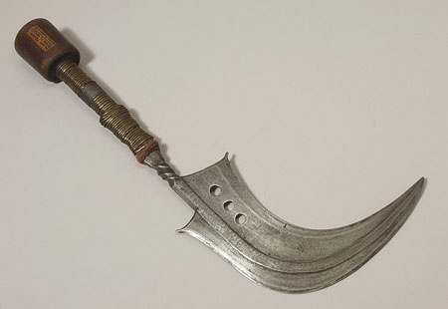

Mangbetu Sickle Knife Dagger

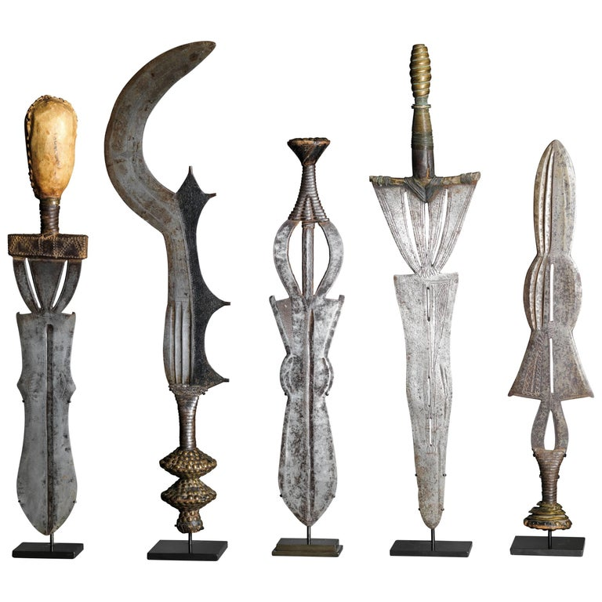
Five Fine Decorative Execution Knives, DR C, Ubangi, Ngombe Tribe

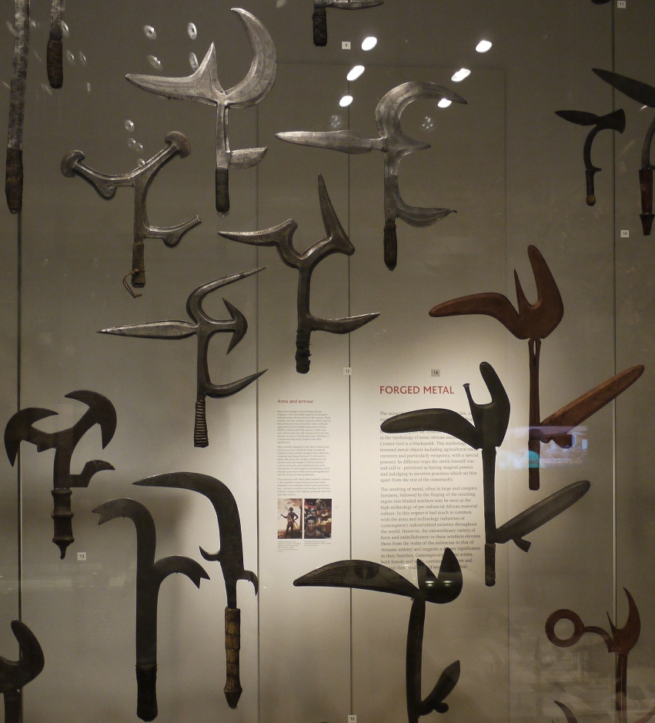

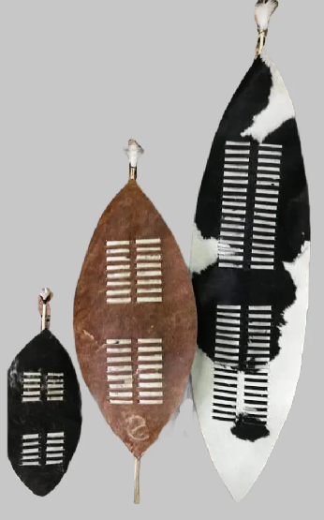
Shields

Isihlangu – large oval-shaped war shield, 5 feet (1.5 m) in length; warriors use it in an offensive way by hooking the opponent's shield during hand-to-hand fighting; similar to a tower shield

Umbumbuluzo – heavy oval-shaped war shield, 3.5 feet (1.1 m) in length, easily held in one hand; similar to a heavy wooden shield

Ihubelo - small oval-shaped shield used for hunting, smaller than isihlangu, but larger than the ihawu; similar to a light wooden shield

Ihawu - a small to medium-sized shield used at dances; similar to a buckler

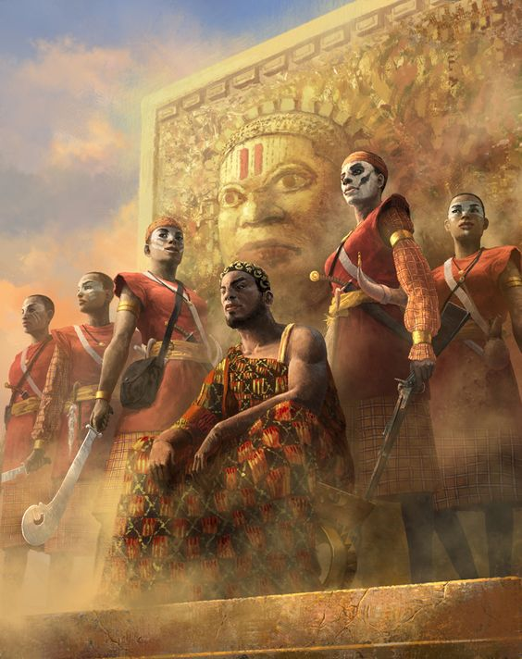
Local Deities
- Ogun – hunting god of lethal metalwork, specializes in weapons, honors warriors who honor their weapons, he inhabits metal and bestows his strength upon it, deals with justice and oaths (people will invoke his name in an oath but must be touching a piece of metal while doing so), if you treat Ogun with respect he’ll be trustworthy and protective; brother to Shango and the two do not get along well. Patron deity of Bokarra.
- Elegua – messenger of Olorun, trickster god, guardian of the Crossroads of Life, offers mortals the chance between opportunity and disaster in the form of propositions or wagers. Patron deity of Longspear.
- Aje, patroness of trade and wealth. Patron deity of Nyogo.
- Obaluaye – god of healing; One of the ORISHAS, he will do his best against infections and epidemics, especially the nasty infestations created by his spirit cousin Shakpana. He also has two dogs to sniff out infection. His favorite colors are brown, black and purple — the hues of bruising. Patron deity of Sikaar.
- Oya – river goddess, influences commerce, weather, transporting the dead to the afterlife, dresses in a brilliant display of colors; consort to Shango which is often a rocky romance. Patron deity of Tengaibo.
- Obatala – son of Olorun, greatest of the Orishas, white cloth god and drunken creator of the human race, forced to create mankind as a punishment and did so while drunk so mankind is imperfect. Patron deity of Ajabar.
- Ngi, the gorilla god of strength. Patron deity of Wakabi.
- Olorun – chief deity; He’s the great king of the Universe and the glorious pinnacle of Yoruba mythology. He is a three-in-one trinity god — comprising OLORUN the Lord of Heaven, OLODUMARE, the Ultimate Creator and OLOFI the Messenger. Patron deity of Harikanya.
- Anansi, spider god of stories and trickery. Patron deity of Oarana.
- Orunmila - Demi-God of Divinity and Wisdom; One of the ORISHAS, he’s a very useful spirit of knowledge. He has his own priests known as Babalawo. They are equipped with divining chains, but how these work is something you will have to ask them. Patron deity of Arolo.
- Shango – spirit of thunder, storms, drums, and dance, Oya is his mistress and the fight often, does not get along well with his brother Ogun. Patron deity of Ramala.
- Yemaya – wife to Obatala, moon goddess, mother of water and childbirth, blue and crystal skirts billow in wave-like motions, has an aversion to salt. Patron deity of Jaloro.
- Nyaminyami, protector of rivers and waterways. Patron deity of Scaringa.
- Eleduwa (Oduduwa) – hero god, younger brother of Obatala, created the world when Obatala was too drunk, appointed by his dad Olorun to rule over the world. Patron deity of Redwall.
- Takhar, god of justice and vengeance. Patron deity of Kemba.
- Shakpana – god of sickness, son of Yemaya; An old hobbling figure, he is responsible for inflicting pox and madness. Patron deity of Keromang.
- Ochosi - One of the Orishas, he’s a hunter spirit who is great at scouting for prey and sniffing out likely targets. As a barefoot detective of enormous cunning, OCHOSI is also good at uncovering that most elusive of animals — truth. Where required he can also dish out justice with his bow and arrow. Patron deity of Masuba.
- Orishas – multi-talented spirits under Olorun, several hundred of them, have various powers and motives.

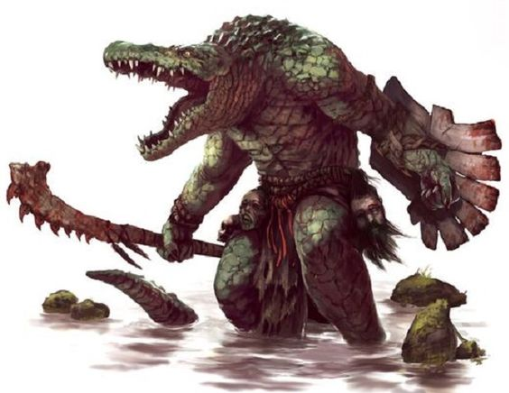
Creatures of Kondabo
Adze - The adze is a vampiric creature in this region. The adze takes the form of a firefly, though it will transform into human shape upon capture. When in human form, the adze has the power to possess humans. People possessed by the adze are called abasom by the locals and begin to carry out whatever evil schems the adze commands. In firefly form, the adze can pass through closed doors at night and suck blood from people as they sleep, causing the victim to fall sick and die.

Asanbosa – ogres with large blood-shot eyes, long legs, and feet pointing both ways. Its favorite trick is to sit on the high branches of a tree and dangle its legs so as to entangle the unwary hunter. It preys on humans and feasts on them with their iron teeth.

Buadu – It is said that long ago an evil sorcerer summoned dark spirits in the land. The spirits roam free and seek to possess the unwary who scoff at the gods. The budo is translated as the “evil eye” and anyone possessed by such a spirit takes on the evil eye. Some say this reveals itself as the power to strike people with sickness or worse with their malevolent gaze. When confronted, the Budo can transform into a hyena and flee. Priests of Kaduru are familiar with the rites for creating talismans, called a kitab, that protect against the Budo.
Eloko – Eloko are diminutive creatures dwelling in the darkest parts of the jungles. They are the size of a dwarf, have no hair, and are covered in moss that grows on their bodies. They hide in the jungle, fiercely protective of the fruits and wild game that live there as if they were their treasure. They have piercing eyes, snouts with mouths that can be opened wide enough to admit a human body, alive or dead, and long, sharp claws. Eloko savor human flesh. They wear tiny bells that are create a beautiful sound, and their voices can change to be soothing. Unwary travelers in the jungles who hear the bells or their voices may fall under their charms and be eaten.

Kongamato – are large pterosaur-like cryptid living in the Valley of Hunters region of Kaduru. Its name means 'breaker of boats' or 'overturner of boats', as the kongamatos are said to have capsized the canoes of natives and attacked people who ventured too close to the nearby rivers. It is described as a reddish lizard with membranous wings and teeth in its beak. Its wingspan ranges from 4 to 100 feet across. It is thought to eat mostly fish, but occasionally humans. Kongamato is also said to dig graves and steal human corpses.

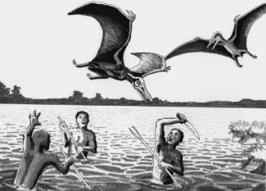

The Impundulu or Lightning Bird – a black and white bird which is said to summon thunder and lightning with its wings and talons. It is a small creature but can change its shape and size up to the size of a human. It is a vampiric creature associated with witchcraft, often the servant or familiar of a witch or witch doctor, which attacks the witch's enemies. It is said to have an insatiable appetite for blood. Sometimes it takes the form of a beautiful young man who seduces women.
The fat of the bird is believed to be of significance either as the fuel that the bird sets on fire when it throws down a lightning strike or as a component in valuable traditional medicine. The fat is believed to be procured by catching the bird at the moment when the lightning strikes the ground. The bird is believed to lay a large egg underground at the location of the lightning strike. This may be a good or bad omen that may require digging to procure or dispose of the eggs.
It is said that the lightning bird is immortal, because it outlives its masters. Legend recounts that the bird is passed down in a witch's family from mother to daughter, doing the bidding of its owner, and the impundulu has only one known weakness. The lightning bird is impervious to bladed weapons, most magic, and you cannot poison it or drown it. But it is said that the creature can be destroyed by fire.

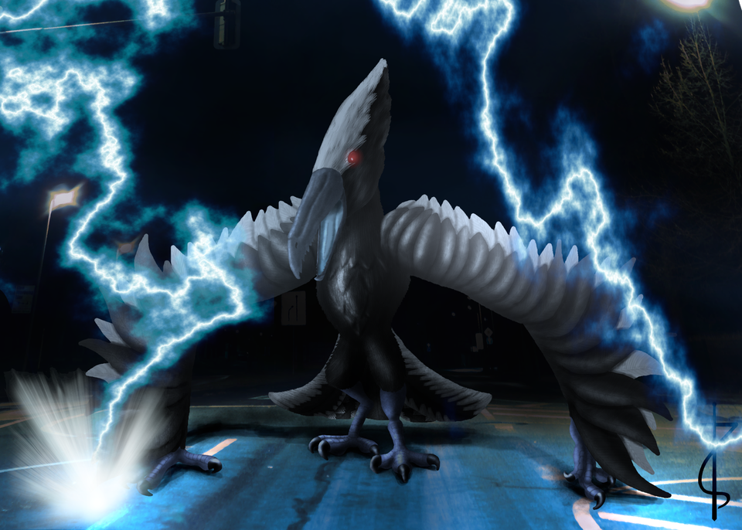

Grootslang - Great serpent-like creatures the size of an elephant. They were created by the gods in ancient times, but they proved to be too powerful and were split into snakes and elephants. One grootslang managed to escape and led to the creation of all modern grootslangs. They harbor great animosity towards the gods that attempted to destroy them. Grootslang dwell in deep subterranean places near or under the mountains. They have a love of gemstones, especially diamond, and can be bribed to let people to pass if given such stones.
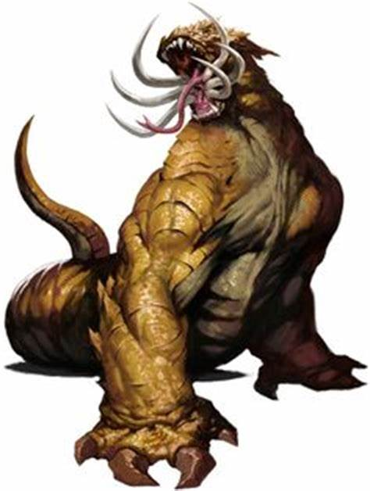

Umdhlebi – Also called the Dead Man’s Tree, it is a large poisonous shrub that grows throughout the Kaduru wilderness. The sap is harmful and gives off an irritating vapor. Contact with the eye can cause temporary or even permanent blindness. Contact with the mouth results in a rash, swelling, and peeling of the skin. Prolonged exposure or worsening of the injuries can even lead to death. The sap is sometimes used in the medicine of shamans but more commonly used in traps. Used by witches, it is usually considered wholly vile, any association with umdlebe is proof the person in question is an umthakathi: one who secretly uses evil medicine or charms.

Rompo is a mythological beast with the head of a hare, human ears, a skeleton-like body, the front arms of a badger, and the rear legs of a bear. It feeds only on human corpses and it is said to croon softly as it eats.
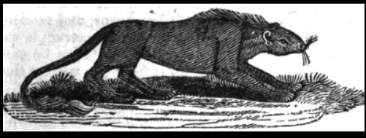

Mokele-mbembe – is a creature of brownish-gray color with a smooth skin, its size is approximately that of an elephant; at least that of a hippopotamus. It is said to have a long and very flexible neck and only one tooth but a very long one; some say it is a horn. They have a long, muscular tail like that of an alligator. Canoes coming near it are said to be doomed; the animal is said to attack the vessels at once and to kill the crews but without eating the bodies. The creature is said to live in the caves that have been washed out by the river in the clay of its shores at sharp bends. It is said to climb the shores even at daytime in search of food; its diet is said to be entirely vegetable
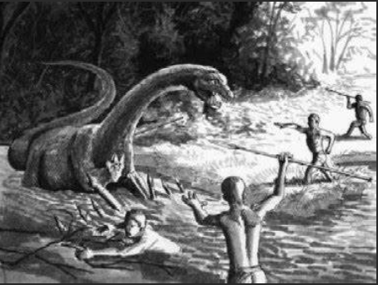

Maniwata – These are spirits of the water. They appear similar to mermaids: the upper body of a woman with the lower body of a fish, but sometimes of a serpent. Most times they appear with a serpent coiled about their necks. These are their animal companions and do their bidding. Unlike mermaids, the maniwata can transform to human form at will and are able to shape-shift to appear in any human form they desire. The spirits are capable of kindness but are wild and unpredictable. It is said they will occasionally abduct a human they find interesting and take them beneath the sea to show them their home. The humans almost always return later, gifted with great wisdom and good fortune from the experience.

Other Races
Elves

Dwarves

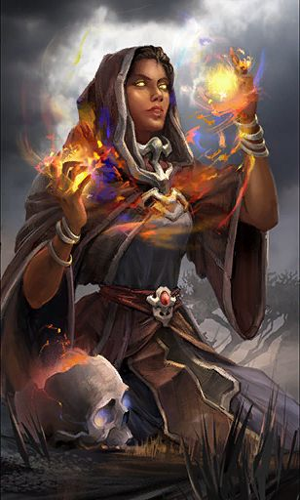
Magical Items

NPC Templates
This is a list of notes and stats to help develop NPC’s relevant to this region.

Developer Notes
The five regions of Kaduru should ideally reflect five different regions and cultures of Africa.
Possible ways to define the Kaduru kingdoms based on African regions:
- 6 Cultural regions: North Africa, West Africa, Central Africa, North East Africa, East Africa, Southern Africa.
  - 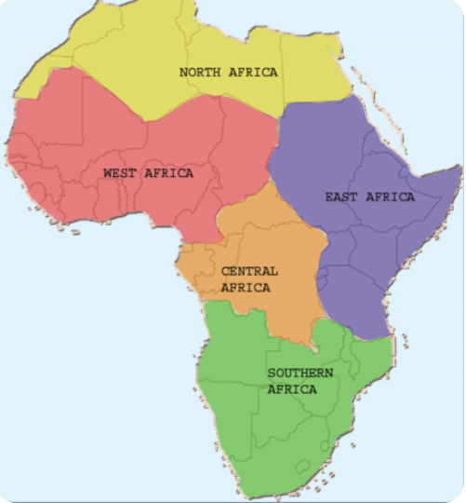
- 8 major physical regions (based on geography, separate from the human geography): the Sahara, the Sahel, the Ethiopian Highlands, the savanna, the Swahili Coast, the rain forest, the African Great Lakes, and Southern Africa
- 4 main language families, or phyla, of the continent are now considered to be Niger-Congo, Nilo-Saharan, Afro-Asiatic, and Khoisan.
- Ancient kingdoms that were present in Africa:
  - E.g. the ancient kingdom of Saba which is thought to have been located in present-day Yemen, Eritrea, Somalia and Ethiopia. One prominent feature of the Saba kingdom was the Queen of Sheba, mentioned in many religious texts. We can morph this figure into an original powerful female figure, whether current or in the past. Bilquis is the term used in Islamic texts and inspired the character in American Gods. Perhaps modify this to an original concept, perhaps with divine powers or just a powerful sorceress or powerful ruler.
  - Azania – ancient Greek name for lands around southeastern tropical Africa including the Swahili coast
  - Bantu region – region in west-central Africa where the Bantu family of languages is thought to have originated and expanded into sub-equatorial Africa due to the commonalities between the languages spoken there
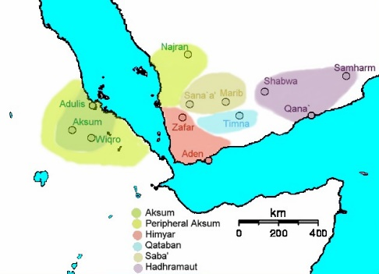
https://en.wikipedia.org/wiki/List_of_ethnic_groups_of_Africa
https://qz.com/africa/1210704/black-panthers-african-cultures-and-influences/
https://kidadl.com/articles/all-of-the-african-god-names-and-their-mythologies

Ultimate correlation between Kaduru and African regions:
- Kondabo – loosely based on the northeastern Africa region, with middle-eastern influences; the people originating out of the Lake Akdabat region and migrating westward, then becoming influenced by Tarbia; source reference Hausa, Amhara, Oromo, Somali, Nilotes peoples
- Oraba – Congo River Basin region of Africa; source reference Kongo, Mongo, Luba, Tutsi, Kikuyu, Ethiopian, Maasai peoples
- Rokari – Yoruba region of southern west Africa; source reference Yoruba, Ewe, Dahomey, Igbo, Akans, Mandinka, Fulani, Cameroon people
- Mthunzi – Swahili Coast region of Africa, have the savanna and great rifts in common with this region; source reference Zulu, Ndebele, Basotho, Shona, Chewa people
- Desert Regions; source reference Tuareg, Berber people
- Lost Lands - ?

Kondabo Names
Oromo https://www.fantasynamegenerators.com/oromo-names.php
Hausa https://www.fantasynamegenerators.com/hausa-names.php

Oraba Names
Kikuyu https://www.fantasynamegenerators.com/kikuyu-names.php
Ethiopian http://www.fantasynamegenerators.com/ethiopian-names.php
Tshiluba https://www.fantasynamegenerators.com/tshiluba-names.php

Rokari Names
Akan https://www.fantasynamegenerators.com/akan-names.php
Igbo http://www.fantasynamegenerators.com/igbo-names.php
Mandinka https://www.fantasynamegenerators.com/mandinka-names.php
Cameroonian http://www.fantasynamegenerators.com/cameroonian-names.php

Mthunzi Names
Zulu https://www.fantasynamegenerators.com/zulu-names.php
Ndebele https://www.fantasynamegenerators.com/ndebele-names.php
Basotho http://www.fantasynamegenerators.com/basotho-names.php
Shona https://www.fantasynamegenerators.com/shona-names.php

https://www.quora.com/What-armor-and-weapons-did-the-warriors-of-the-Mali-Empire-use
The malian empire had an army 100,000 strong. Armor typically included Chainmail, gambesons steel curiasses, wooden, reed, and hide sheilds made from elephant, Oxen and Rhino hide weapons were sabers, straight swords,lances, javalins, spears, barbed poisoned and flaming arrows horses would typically wear fabric armor interwoven with chainmail mail metal bress plates infantry were mainly armed with spears and longbows

https://en.wikipedia.org/wiki/Military_history_of_the_Mali_Empire
Approximation of titles in the military before modifying for story purposes.
Mansa – ruler – equivalent to a king?
Farima – equivalent to knights, feudal lords and cavalry commanders
Sufa (“horse father”) – squires or attendants to the Farima, guarded their horses
Ton-Tigui - "quiver master" – cavalry reporting to the Farima
Kèlè -Koun ("war-head") – infantry commanders
Kèlè -Bolo ("war-arm") – infantry units under the Kèlè -Koun, made up of Horon, or freemen
Horon – freemen
Jonow – slaves, early in history served as baggage carriers, later formed up in jonow infantry units
Note: the above titles evolved over the course of the Mali Empire. The Ton-Tigui early on were cavalry commanders and the Sofa (changed to Sufa to keep it from sounding too much like modern-day furniture) later gained more significance and replaced the Jonow in making up armed forces. For our purposes we will consider the above definitions near or at the height of the Mali Empire.

Altered structure and titles to fit story purposes:
Mansa – ruler – equivalent to a king?
Kèlètigui ("War Master") – A high-ranking general overseeing large military operations.
Farima (“Noble Commander”) - equivalent to knights, feudal lords; leaders of the cavalry units
Farari (“Brave Men”) - cavalry units that report to the Ton-Tigui
Tunkan-Tigui (“Shield Master”) – commander of infantry units
Tunkan-Bolo ("Shield Arm") – infantry units under the Tunkan-Tigui, made up of Horon, or freemen
Sanba-Tigui (“Archer Master”) – commanders over archer units
Sanba-Bolo (“Archer Arm”) – archer units under the Sanba-Tigui
Horon – freemen serving as professional soldiers
Jonow – freemen or prisoners serving as conscripts
Bara - “service,” squires or attendants to the Farima

Cavalry fought with lances, sabers and long swords. Imported chain mail and iron helmets would also be available to Mali's early cavalry.

A note on printed cloth in Africa
Below are examples of various handwoven cloths throughout Africa. Today they are collectively called “Ankara” as a style, but that name originates from the Dutch wax printing industry that made it popular and the name of the city in Turkey where it was originally produced. So, to use “Ankara” has no connection to Africa. The best option is to use a neutral term that doesn’t favor one language or region over another. For creative purposes, all decorative cloth worn in Kaduru will be called Uzuri (“beautiful” or “excellent” in Swahili). The ceremonial version of this cloth for each region is called the Bashogo, which represents the tribe, region, or kingdom, and is worn in battle and in formal ceremonies such as the giving of oaths. The Ajaye is a special version of the cloth inscribed with magical glyphs, words, or prayers that offer protection to the wearer.

- Kente – (Ghana) handwoven cloth made in elaborate designs with strips of silk and cotton. Historically the fabric is worn in a toga-like fashion by royalty or those being honored by royalty on special occasions. Below are colors that carry symbolic meaning in a Kente:
  - black: maturation, intensified spiritual energy, spirits of ancestors, passing rites, mourning, and funerals
  - blue: peacefulness, harmony, and love
  - green: vegetation, planting, harvesting, growth, spiritual renewal
  - gold: royalty, wealth, high status, glory, spiritual purity
  - grey: healing and cleansing rituals; associated with ash
  - maroon: the color of mother earth; associated with healing
  - pink: assoc. with the female essence of life; a mild, gentle aspect of red
  - purple: assoc. with feminine aspects of life; usually worn by women
  - red: political and spiritual moods; bloodshed; sacrificial rites and death.
  - silver: serenity, purity, joy; associated with the moon
  - white: purification, sanctification rites and festive occasions
  - yellow: preciousness, royalty, wealth, fertility, beauty
- Bogolan aka Mud Cloth – (Mali) cotton fabric traditionally dyed with fermented mud then painted. Mud cloth, also known as “Bogolanfini.” Immediately after childbirth, women are wrapped in the cloth, as it is believed to have the power to absorb pain and deflect anything negative or dangerous. The cloth is first dyed using tea leaves and branches, then dried in the sun. The vibrant and beautiful designs are painted on with fermented mud or sludge, after which the cloth is washed. Mud cloth patterns are rich in cultural significance as well, referring to historical battles, mythological concepts or Malian proverbs. The process is passed down generationally, and oftentimes, pattern meanings are known only to small communities of people.
- Kitenge – (Great Lakes Region) thicker cloth with edging on only a long side, used for formal dresses, sometimes includes a proverb in the decoration
- Kanga – (Great Lakes Region) printed cotton fabric with a border along all four sides, can be used as a skirt, head-wrap, apron, pot-holder, towel, and much more. Due to its ritual function, they do not always include a proverb. Kangas are also similar to Kishutu and Kikoy which are traditionally worn by men.
- Shweshwe – (South Africa) printed dyed cotton fabric widely used for traditional clothing. Originally dyed indigo, the fabric is manufactured in a variety of colors and printing designs characterized by intricate geometric patterns.
- Shuka – (Maasai of Tanzania, Kenya) striped and checkered cloth, usually colored red and black or blue and black; durable, strong, and thick, used to wrap around the body for protection against the harsh weather and terrain of the savannah
- Toghu – (Bamileke people of NW Cameroon) black velvety fabric embroidered with colorful patterns
- (note: I skipped the Habesha Kemis style dress because, according to some, the word habesha means “mixed” in Arabic and is sometimes equivalent to calling someone a slave)

One hundred rare and mysterious masks with extraordinary powers
http://dndspeak.com/2018/08/100-masks/
- Barn Owl Mask: grants advantage on perception checks that rely on hearing and sight.
- Oni Mask: grants advantage on intimidation checks.
- Cracked-clay Jester Mask: holds 5 charges of friends and one charge of charm person. Once all charges have been used the mask crumbles to dust.
- Luchador Masks: take advantage on grapple and acrobatics checks.
- Mask of Many Faces: This mask gives you advantage on deception checks to pretend to be someone else.
- Mask of Othersight: This mask begins blank, but can be re-sculpted to resemble the face of another person. The name can also be carved in. While worn, the wearer cannot see in front/around themselves, but does see essentially through the eyes of the person represented by the mask. Depending on how powerful the person represented by the mask is while the mask is worn, that person may or may not be aware of the fact.
- Spider Mask: While wearing the mask you ignore movement restrictions caused by webbing, Once per long rest you can use the mask to cast the spider climb spell as an action.
- Wolf Mask: Grants advantage on Wisdom (Perception) checks that rely on hearing or smell.
- Winter Wolf Mask: Grants advantage on Wisdom (Perception) checks that rely on hearing or smell, as well as advantage on Dexterity (Stealth) checks made to hide in snowy terrain.
- Mask of Silence: Anyone who sees the wearer of this mask will forget seeing them as soon as they look away.
- Mask of Mediocrity: penalty to remembering the wearer. Could also take effect when trying to follow them in a crowd.
- Deathmask of the Whiteface: +2 rounds of Raging if barbarian otherwise taking damage can (wearer’s choice, free action) trigger the spell Uncontrollable Rage for 2 rounds, forcing the wearer to attack the source of the damage.
- Mask of the (pick an animal): At the beginning of their turn the user can shapeshift (as the wildshape druid ability) into the matching animal lasting until the end of their next turn.
- Mask of the Dragon: wearer has a breath weapon that can be used once per short rest corresponding to the color of the mask, 30ft. Line 4d6 damage. Curse: the wearer cannot the remove the mask without making a DC 18 Wisdom save made only once per day. While wearing the mask they gain the flaw: ‘I sometimes forget that I’m not the beast this mask resembles.’
- Mask of Mechanus: An uncomfortable piece made mostly of metal and clockwork. While wearing this mask a creature rerolls every 1 and 20. They must take the second roll.
- Mask of Juiblex: Not so much a solid piece as an ooze that is rubbed over the face and head and remains there. While wearing this mask, a creature can move through a space as narrow as one inch wide without squeeze. A creature wearing this mask must eat a full meal every hour or suffer 2d12 acid damage as it begins to consume itself. Curse: A creature must succeed on a DC 15 Charisma saving throw to remove this mask. A creature can only attempt this saving throw once it has finished eating.
- Mask of Mystery: A creature wearing this mask is proficient in Charisma (Deception) checks. If the creature already proficient, it doubles its proficiency. In addition, a creature can cast Alter Self once a day.
- The Iron Mask: requires attunement by a monk. While attuned to and wearing this mask, a creature rolls an additional die for each unarmed strike.
- Mask of the Fey: This beautiful mask was created in the feywild by a fey creature of great power. A creature attuned to and wearing this mask is always under the effects of the spell Glibness. A creature wearing this mask during a long rest has a ten percent chance of being plane shifted into the court of the mask’s creator. Curse: This mask can only be removed by its creator.
- Mask of the Monarch: Advantage on persuasion checks for buying/selling items.
- Aku Aku Mask: This wooden tribal mask has feathers across the forehead and glowing yellow eyes. A sentient and good hearted shaman spirit lives within. the wearer has a +1 bonus to AC and may cast Arcane Lock once per day. The wearer gains Nature proficiency, but disadvantage on Intimidation. The wearer LOVES FRUITS. If a wearer of the Uka Uka mask is met, they shall each compare their wares. Whoever has a greater total gold value of GEMS gains 3 health and 5 speed PERMANENTLY.
- Uka Uka Mask: This wooden tribal mask has sharp teeth, glowing yellow eyes and a beard of leaves. A sentient and evil shaman spirit lives within this mask. this mask is CURSED and cannot be removed without harming the face. It grants a +1 bonus to AC. The wearer may cast Knock once per day. You gain poison and necrotic resistance, but Silvered vulnerability. You gain Intimidation advantage, but disadvantage with all other CHA checks. If a wearer of the Aku Aku mask is met, they shall each compare their wares. Whoever has a greater total gold value of GEMS gains 3 health and 5 speed PERMANENTLY. OPTIONAL: The wearer may spend 1 day crafting 1 stick of dynamite which requires a Dex, Int, and Wis check.
- Mask of Angels: This porcelain mask features a beautiful womanly face with closed eyes. The porcelain has a slight golden hue and gleam to it. Healing spells the wearer casts can critically strike (double healing). The mask sheds dim light and the wearer can cast Light at will. Once per day the wearer can choose to re roll a dice theyve used to determine a healing total (from a spell they cast).
- Mask of the Fallen Angel: Looks identical to the Mask of Angels, but has a slight black hue to it. This mask is CURSED and it dims the light around it. It grants the Chill Touch cantrip and necrotic damage resistance. All standard healing damages you, and instead you may use Chill Touch to heal yourself, undead, or any evil character (1d8 + modifier of YOUR CHOICE). If you are hit with a healing spell, or radiant damage you can choose to double the damage you take. When you do so the eyes of the mask open wide and the mask lets out a horrifying Banshee Screech. All creatures that hear the screech must make a con save. If they fail they lose Half of their total health and are deafened for 1 turn, if they succeed they take 3d6 psychic damage.
- The Grand Jester’s Smirk: This porcelain mask features a laughing face and a wide open mouth, and has all manner of colours and inlays on it. Inside the open mouth is just a black void, but if it is inspected a Jack-In-The-Box pops out. The mouth is in fact a 2×2 foot bag of holding. The wearer may cast Tasha’s Hideous Laughter 2 times per day, however they may also choose to do so telepathically by succeeding a Charisma check.
- Sludgy Ooze Mask of Goop: This disgusting mask is dripping with ooze. It may be any colour. While this mask has eye sockets and a mouth, they are mostly obscured by the ooze constantly emanating from it. The wearer has resistance to physical damage. The wearer can cast Sludgeous Form once day, which is like gaseous form but they cannot fly and look like sludge. 10 feet movement speed and climbing speed in this form. this mask is not cursed but requires a strength check to remove.
- Scarecrow Mask: This mask is CURSED and cannot be removed unless it is ripped from the face. Once the wearer is cursed, they walk in a bowlegged manner and their movement speed is reduced by 5. This mask is made from burlap, and has a half sown half shredded mouth. This mask grants immunity to the frightened condition. The wearer may cast Cause Fear 3 times, and Fear once per day. All critical hits (including intimidation) cause the frightened status effect. Once per day the wearer may (as a bonus or reaction) cause a frightened target to become incapacitated and scream for another turn.
- Bandaged Mask: A mask of bandage wrappings, that has some strands loosely hanging off and others stained with dried blood. This mask is CURSED. This mask has a slight smell of flesh putrefaction. It grants 1d10 health regeneration per turn. General injuries heal within minutes, and a major injury (like a broken bone) can be healed in a matter of days. If the body is healthy, the mask compels it to begin to grow cancerous tumours in different places. The only way to stop this is to have to body become injured so that the cancer is not the focus of the regeneration. If the cancer is left to grow the wearer will eventually turn into a gibbering mouther.
- Broken Porcelain Mask: This porcelain mask features cracks across it. The bottom right of the mask, from the jawline to the cheekbone to the chin is broken off. You can just make out the expression of terror carved into the remaining features of the mask. The wearer has 120 feet of tremorsense, and can cast earth tremor at 4th level once per day.
- Scorched Dryad Mask: This wooden mask features a head crest of branches. The entirety of the mask is scorched wood and it smells like charcoal. The wearer may roll a d20 if they are hit by fire damage. If they roll 11 or higher, they are healed instead. Being on fire gives the wearer inspiration that scales up to a d12 for being on fire each turn. They may designate one of their weapons to adopt the Flametongue trait and may cast Aganazzar’s Scorcher from the weapon once per day.
- Sabretooth Skull Mask: This mask is part of the skull of a sabretoothed tiger, without the bottom jaw. The eyes sockets are large, and the top jaw features 2 massive fangs that extend downward. The fangs can be removed and used as daggers. The wearer can cast Locate Creature once per day and has advantage on the first strike against it. The Located Creature has disadvantage on perception checks against the wearer.
- Plague Doctor Raven Mask: Smells of pleasant incense (replace each week). Grants you advantage on madness conditions + ALL crits (spells, melee attacks, but also intimidation, persuasion, deception) force your targets to make a save for a short term madness condition. Roll a d100 for the result of the effect.
- Mask of Anubis: Coloured black and gold, this mask gives you advantage on death saving throws and gives your targets disadvantage on saving throws if you brought them to 0 HP. Those you slay may be interacted with as ghosts for a short time before they are sent to the afterlife (1 hour).
- Jack of Blades Mask: If you die, your soul is magically transported into the mask where it may remain until you choose to move on to the afterlife. Anyone who puts on the mask can hear and speak to your soul. Until they take off the mask, you can keep talking to them.
- Mask of Drought: This red clay mask is cracked all over, resembling soil that has been drained off all water and cracked. This mask grants fire resistance, and Con save advantage from heat exhaustion, and grants the ranger’s Natural Explorer trait for DESERTS.
- Triceratops Mask: a large bone or wood mask with lots of potential for war paint. This mask grants the triceratops gore+trampling charge attack once per long rest. Damage is 1d8+5 at level 1 and scales with level. Only the target takes damage but every unit passed through must make a strength saving throw of decreasing difficulty (simulates momentum loss) or be knocked prone. This mask ALSO grants a +1 to AC when attacked from the front (90 degree).
- Dragonturtle Mask: This mask is turtle coloured and features the dragonturtle’s menacing hooked beak. This mask grants the dragonturtle’s steam breath ability once per long rest: 2d6+2 at level 1 and scales up. It ALSO grants +1 bonus AC when attacked from behind. Hidden ability: gain inspiration if you roleplay as a TMNT.
- Cthulhu Mask: Roll for colour. Straight up immunity to madness. Once per long rest you may cause ALL intelligent creatures in a 30 foot cone to make an INT saving throw. If they fail they spend the turn incapacitated and screaming. If they succeed they each gain 2 WIS for the duration of combat. If this is abused for WIS gains, you can summon Cthulhu to annihilate the PC.
- Dwarven Runebeard Mask: This mask has a beautifully carved runic beard. You gain the effects of Belt of Dwarvenkind. You can also mine significantly faster and you have a strange affinity to pickaxes.
- Mask of the Faceless: This mask causes your face to appear completely indiscernible and have all of its features obscured by a churning shadow. Your intentions, alignment, goodness/evilness are completely obscured. Insight does not work on you and you cannot be charmed. In fact, being charmed gives YOU inspiration. Spooky.
- Leshen mask: The wearer can phase through trees. This costs half your movement. The more its abused, the more prone the wearer is to exhaustion.
- Guy Fawkes Mask: This mask grants proficiency in CHA saves. Once per day, it may be activated with a command word to grant advantage on charisma checks for 1 hour.
- Gladiator Maximus Mask: Specifically grants the Gladiator’s By Popular Demand feature from the character backgrounds (Entertainer Variant). Adorning this mask gives the wearer opportunities to gain inspiration. This effect is triggered on all combat crits and killing blows. For such an event the wearer can choose to perform it with some ‘pizazz’: choose to make a performance, athletics, or acrobatics check. If successful, gain inspiration.
- Mosquito Mask: Huge eyes, antennae, proboscis. Once per long rest, you can spend 10 minutes siphoning the blood of a fresh victim. This heals half of your total health and grants 2d10 temporary Hit Points. Try not to get aids.
- Bunny Mask: Cute or creepy, your choice. Your speed is increased by 10 feet. You can cast Jump 3 times per day without expending spell slots. Once per day you can also choose to force an opportunity attack to miss you if the hit lands.
- Berserker Mask: This mask reminds you of skyrim. It grants Rage Beyond Death. In combat, if you drop to 0 hitpoints, you can choose to go unconscious or not. You still make death saving throws. You immediately go unconscious if combat ends after using this effect, and you wake up with one level of exhaustion. 1 use per day.
- Valkyrie Mask: This mask resembles a beautiful womanly face. It has wings on either side. It allows the wearer to cast Compelled Duel once per day. Whenever entering combat, if you are not surprised you can also choose to yell a morale boosting battle cry that acts as a weaker version of the Bless spell (does not grant a persistent d4 bonus, only a 1 time use d4 inspiration to 3 characters of the wearer’s choice).
- Predator mask: This wide mask has ornamented dread-locks, and large alien eyes. The wearer may cast Invisibility once per day. However, during this cast they may choose to ‘target’ a particular creature. A red dot appears on the targetted creature. The targetted creature has disadvantage one perceiving the predator. If the targetted creature is attacked, it always hits (you only need to roll if you crit or not). If you crit, you deal max damage. This mask also grants 120 feet of darkvision.
- Mask of Seduction: This mask resembles a succubus/incubus, though the wearer can choose for it to be hidden or not. If hidden, your eyes merely change colour to red. It lets the wearer speak and understand Infernal and abyssal. Once per day the wearer may cast the Succubus’s Draining Kiss ability. This mask also grants advantage on performance and persuasion checks that deal with flirting, charming, being sexy, and sexing.
- Mask of Mimicry: This mask may resemble a feathery Raven, or any bird of paradise. The wearer is granted the Mimicry ability, that it can perform at will.
- Beholder Mask: This mask is merely a large eye. Its pupil may be reptilian or cat like or human or anything really. Roll for colour of the eye. The wearer may activate the Beholder’s Antimagic Cone ability once per day. 120 foot cone of anti-magic that lasts 2 turns. At the end of the 2nd turn the wearer shoots an eye laser out of it. Roll for which laser is shot obviously. The laser must be shot unless an INT save is made. If it is failed, the wearer takes significant psychic damage.
- Blood Mage Mask: this porcelain mask is smooth and beautiful, except for the tears of blood coming from the eye sockets. The blood and the mask itself can be any combination of colour, but would most likely be found as a white mask with red or black blood. This mask gives the user a brand new spell: Shape Blood, which may be cast 2 times per day. This spell is exactly like Shape Water but is exclusive to blood. Damage is up to the discretion of the DM but my implementation is that it deals Magical physical damage (like silvered weapons).
- Blood Knight Mask: This porcelain mask resembles a skull with its mouth sowed shut. Your melee attacks deal magical damage. Whenever you strike an enemy they must make a con save. each time they fail they suffer a bleed d.o.t. that increases per failed save. It scales as 1d4, 1d6, 1d8, 1d10, 1d12, 2d12, 3d12, 4d12 etc. The bleed stops after 2 turns if its effect is not refreshed. Blood doesnt heal you, but you do enjoy a glass with your dinner.
- Patron’s Overwhelming Favour Mask: This porcelain mask is not particularly menacing, for it is very intricately made with many bright colours. Gold flairs and pseudo embroidery. Paisley shapes and the like. The wearer may add their Charisma modifier to all attack rolls. When you reduce a hostile creature to zero hit points, you gain temporary health equal to your level + Charisma modifier. You can hold your breathe indefinitely and you do not require any sustenance or sleep (you must sleep only to remove physical exhaustion). You gain 30 feet of Devil’s sight AND you cannot be charmed. Once attuned, this mask CANNOT be removed unless the wearer wishes to rip their own face off. Donning this mask binds your physical body, metaphysical body, and entirety of your soul to a particular patron, no matter what class you are (even if you choose to rip off the mask).
- The Trickster God’s Blessing: This porcelain jester mask is simple, and merely has an unsettling smile carved in. The eyes show the same glee that a child shows as they burn ants with a piece of glass, not fully grasping the value of life. This mask compels to wearer to tell jokes and play tricks. Often times they are twisted ones. The wearer also gains inspiration for successfully tricking, riddling, or pranking others as well as for killing. This effect stacks. Once per day, If the wearer is hit, they can choose to roll a Charisma Save. If successful they can laugh off the damage, no matter how painful it was.
- The Mask of Manipulation: This porcelain mask is serious. Its eye sockets are straight and focussed. A 9 pointed star is carved into the forehead, and the lips of the mask are made of a very exotic material. This mask allows the wearer to cast Modify Memory once per WEEK, and Zone of Truth once per DAY, and friends AT WILL. This mask also grants the wearer the Awakened Mind Warlock trait. This mask has a special ability in which the wearer may command the mask to cast Ultimate Modify Memory which is the same as Modify Memory but effects any intelligent creatures of the wearer’s choice up to a max radius of 1 Mile (no saves required). Once this ability is used the mask loses all of its abilities for good.
- Hoppy’s Mask: While wearing this mask one small weapon such as a dagger or throwing implement becomes enchanted with a 2d6 Of necrotic damage. It also makes it so that the weapon returns to your hand after you’ve thrown it, or it is no longer in your hand.
- Mask of Nightmares: You take on the appearance of what ever being or creature the observer is scared of. This could cause you to look different to different people as not everyone is scared of the same thing.
- Grey Man Mask: wearer of the mask becomes uninteresting to all observers.
- Mask of Eyes: allows wearer to see in all directions, bonus to sight perception rolls
- Skull Mask: causes undead to think you are just another undead. Intelligent undead will have a neutral reaction to you, so long as you don’t do anything the angers them they will not attack you.
- Grim Reaper Mask: Grants wearer death touch (save or die) once per day. Also grants the wearer the ability to see spirits and the ability to send any spirit, soul, undead to its appropriate after life or Pergatory.
- Mask of Infinity: looks like any other kind of mask. If anyone other than the wearer tries to pull the mask off, it creates a copy of the mask. The wearer appears to be wearing the same mask under the first mask. This works no matter how many time they try to pull the mask off. If the wearer removes the mask they can choose to create a copy or actually remove the mask. Note copies start fading away after about 20 mask are created or after 1 minute.
- Rebreather Mask: allows wearer to breath underwater and makes wearer immune to inhaled toxins.
- SCUBA Mask: similar to rebreather mask except it makes a lot of bubbles when wearer breaths underwater.
- Mask of the Bat: strike terror in the hearts of villains, learn martial arts, build cool gadgets, & beat the crap out of villains.
- Mask of Swarms: The mask resembles a giant locust head, recreated in remarkable detail. A close look reveals that it was created using the exoskeletons and body parts of millions of other bugs. When worn, insects, bugs, spiders, roaches, and any other creepy crawlies emerge, creating a swarm that engulfs the wearer’s body. The swarming bodies make the wearer more difficult to target and absorb damage. (Adds 20 Temporary HP, and, when worn during the day, adds 1 to AC. When worn at night or underground, imposed disadvantage on attacker).
- Mask of Brutality – This mask resembles a growling devil’s face shaped from a single piece of a dark grey metal, save that the eyes and mouth are covered by bars like a prison cell. The mask, when put on, immediately deals 1d8 damage to the wearer as sharp needles pierce the skull and begin pumping a potent alchemical mixture of growth hormones and other substances into the cranial cavity, fiendish in nature. 2d6 rounds afterwards, the wearer gains a +5 boost to STR as their muscles bulge and swell, and their bones thicken. However, the mixture introduced into the wearer’s body results in an equal penalty to INT, reducing the wearer to a drooling, beastly hulk. Removing the mask deals 2d8 damage to the wearer as the needles tear free of the skull; the effects of the mask wear off after a long rest.
- Mask Of The Half-Breed: This mask cannot be removed until the wearer is killed. When you are reduced to 0 Hit Points but not killed outright, you can drop to 1 hit point instead. You can’t use this feature again until you finish a Long Rest.
- Mask of Many Colors: This mask appears to be a muti-colored dragon skull. While wore the bearer transforms into a chromatic Dragonborn or Half-dragon of their choosing. If a Dragonborn or Half-dragon wears the mask they will transform into a full-fledged dragon. Curse: whomever wears said mask, has an overwhelming desire to hoard treasure, and to serve Tiamat.
- Red Mask: choose an enemy before combat starts. It has disadvantage on Initiative.
- Iron Mask of the Hallowed Eve: A somewhat heavy mask with intricately carved patterns and runes. Presumably made out of some sort of iron, although it is impossible to tell. The wearer is immune to mind-affecting magic and is much harder to identify with magic.
- Mask of the Shimmering Rainbow: A mask crafted from simple cloth and wood, it seems to change colour over time. The wearer can cast Absorb Elements at will. In addition, they have advantage on saving throws to resist petrification, charmed, frightened, and magical sleep.
- Shadowy Mask of the Eclipse: The mask is always the colour of shadows, no matter what the light level is. The wearer gains 120 feet of darkvision, or an extra 60 feet if they already had darkvision. The wearer can also cast Darkness as a level two spell three times a day.
- Grinning Mask of the Serpent: This mask resembles a snake’s head. The wearer cannot be frightened and has advantage on saving throws to resist charm effects. They also have advantage on intimidation checks and perception checks. However, they have disadvantage on persuasion checks.
- Mask of The Mask: An green tinged, hand carved wooden mask. Transforms the wearer into a ridiculous caricature of their former self (banana yellow zuit suit optional). Advantage on all Charisma/Dexterity rolls, +3 to Performance checks. When wearing the mask, you must make a DC10 Wisdom saving throw or suffer a bout of temporary madness.
- Mask of Lettuce: A large leaf of green lettuce pierced with two eyeholes. The wearer of this mask can polymorph into a head of lettuce for 1hr once a day. While they are a head of lettuce they retain their intelligence and wisdom, but all other ability scores are zero and they have 1hp. As a head of lettuce the player may speak to plants at will.
- Mask of Crystal Vision: A crystal mask cut at many angles. It’s wearer can simultaneously see (and comprehend) at every angle within 30ft. While they are wearing this mask they are incapacitated.
- Mask of Temples: a triangular clay mask embossed with a brick pattern. The mask has 5 charges. Spend one charge to cast one of the following spells: Moonbeam, Stone Skin, Spirit Guardians, Meld into Stone, Lighting Bolt, Hallucinatory Terrain. Each spell can only be cast once per day. Regain 1d4 charges a day. If the mask ever has zero charges it loses all magical abilities and it just a mask.
- Mask of Shadows: A black velvet mask with eye holes and no detailed features. The wearer can use the hide action as a bonus action while in dim light or darkness. Once per day the wearer may cast Gaseous Form on itself.
- Mask of Barnacles: A wooden mask covered in barnacles — it is always wet. The wearer may walk across water (or other liquid surfaces) as if it were solid ground. Once per day the wearer may cast Control Water.
- Mask of Maw: this silver tiger (or bear/lion/dragon) mask has row of pointed razor sharp teeth. The wearer may take a bite action as a bonus action. (Bite: +Dex to hit; 5ft reach; 2d6+3 piercing damage). Once per day the wearer may cast Fear as an action.
- Mask of the Time Druid: A silver mask with no eye mouth or nose holes. Adorning the mask lets the wearer see 3 hours into the past. The wearer cannot hear any sounds from the past or present while the mask is on.
- Mask of the godmaker: The name of the mask is never capitalised when referred to, as while the being within the mask has godlike powers, every being who knows about it will agree that it is no god. The mask itself is seemingly unremarkable, a multi coloured mask which looks like it was made of paper mache by a child, and painted haphazardly. However, when worn, the wearer will come into contact with a power being that will grant any one wish to the wearer. However, the wish will be granted as broken as possible, similar to a djinn or genie, causing the wearer to slowly transform into a powerful beast that is themed around their wish, bent on destruction of everything they held dear, while screaming praises to the godmaker.
- Mask of the Godbreakers: a mask that is wrought out of cast iron, and has the symbol of a large hammer embossed on the front. The mask belongs to a line of hunters that are bent of challenging the godmaker, usually consisting of loved ones of the godmaker’s chosen. When wearing the mask, the wearer can tap into the memories of those who had ever worn one of these masks, not just the mask they wear, as well as provide a mental link to others who wear the mask, allowing for a group of hunters to work in tandem perfectly. Said to be made from an older shattered mask, there are only a handful in existence.
- Mask of the Blinded One: a mask that resembles a bat, but is badly made, with the face being malformed, and the ears taking up much of the mask. When worn, the user loses all sight, and instead, is given the ability of perfect echolocation, being able to see with sound. Does not work well in places with a lot of hanging or free floating objects, such as in snow or the desert, but in solid places, such as caves and cities, is equal to or better than sight. Is capable of being used underwater. When removed sight is restored.
- The Perplexing Gaze: a large mask that encompasses the head, it resembles a human eye, veins and all, with a pink mass in the back resembling the muscles, as well as an optic nerve hanging from the back as if it was a pony tail. When worn,anyone who makes eye contact with the mask is unable to break eye contact, while no matter which direction they look at the mask from, it looks like they are still making eye contact. While eye contact is being made, all staring will have to make a roll to stop looking, with failed rolls causing them to be unable to do anything. User can cause the mask to ‘blink’, even though the mask lacks an eyelid, breaking eye contact with everyone, but stunning them for a round.
- Mask of the Forgotten Friend: A featureless mask, similar in colour to pale skin. Has no hole for eyes, nose or mouth, but allows the user to function as if not wearing a mask at all when worn. While it is worn, all but the strongest of minds will perceive the wearer as a friend or close one, but anyone who knew the wearer before would have no memory of them, simply knowing them as a friend. False memories can be implanted by suggestion from the wearer, but takes considerable skill to do well. If worn for too long, wearer can suffer from dissociative identity disorder or depersonalisation disorder, among other things.
- Dwarven mining mask – Designed and crafted by ingenious dwarven artificers and metal workers, this breathing mask was made to combat the dangerous brimstone fumes found deep under the earth. Grants the user immunity to any status effects and resistance to any damage from inhaling any form of dust or gas.
- An organic ‘mask’ that’s akin to a facehugger. It slowly drains the wearers constitution until their death.
- Face of the Arbiter: A delicate clay mask without holes, shaped in such a way that it requires no straps in order to be worn. The face on the mask is stern and emotionally neutral, with sharp red lines accenting the hard edges and sweeping curves of the otherwise bland white face piece. While the mask is being worn by it’s bound owner, they are able to see through the covered eyes of the mask. The owner is able to detect a consciously made lie made in their presence, though lies made unknowingly and lies of omission are not detected in this way. If the bound owner asks a direct question to a single creature, the creature must make a Wisdom saving throw against a DC of 8 + the owner’s proficiency modifier + the owner’s Wisdom modifier or be compelled to truthfully answer the question to the best of their knowledge. In addition, the wearer of the mask is unable to knowingly speak a lie, directly or through omission. The supernatural properties of the mask can only be used by a single person, someone who had a part of their face removed and used in the making of the mask. A part can take the form of a small chunk of skin and flesh, a few teeth, or even a nose or an eye. The part is mixed into the mask, binding the article to the donator and making it so that the power of the mask can only be used by them. Upon the bound owner’s death, the magic is severed and mask becomes a normal face piece.
- Face of the Harvester: A delicate clay mask without holes, shaped in such a way that it requires no straps in order to be worn. The face on the mask is steadfast and peaceful, with orange, yellow, and green lines forming simple yet appealing patterns across the earthy tones of the brow and cheeks. While the mask is being worn by it’s bound owner, they are able to see through the covered eyes of the mask. The owner is able to identify and harvest plants with greater clarity and efficiency, giving the wearer advantage and doubling their proficiency modifier on Nature and Survival ability checks to understand and collect vegetation, so long as the wearer has proficiency in that skill. If the wearer does not have proficiency in one or both of the skills, they do not benefit from the mask’s bonus to that particular skill. In addition, the bound owner is more likely to receive a fruitful harvest while wearing the mask. If the bound owner harvests a plant while wearing the mask, the freshness and potency of the plant is extended for one and a half times the duration it would otherwise last. If the owner has actively and personally cultivated the growth of the plant, the freshness and potency of the plant is instead extended for twice its original duration. The supernatural properties of the mask can only be used by a single person, someone who had a part of their face removed and used in the making of the mask. A part can take the form of a small chunk of skin and flesh, a few teeth, or even a nose or an eye. The part is mixed into the mask, binding the article to the donator and making it so that the power of the mask can only be used by them. Upon the bound owner’s death, the magic is severed and mask becomes a normal face piece.
- Le Masque Noirci: This wooden mask covers the upper half of the face and has a few shallow scratches over the left eye that cannot be removed or fixed, no matter who or what tries to fix it. The mask was most likely originally stained either jet black or a dark purple, but the color has faded over time. While worn, the owner cannot discern between different colors, seeing the world only in shades of black and white. That said, they receive an empowered darkvision that can pierce through even magical darkness, even if things can only be seen in black and white. Said darkvision extends out to 60 ft., but if the wearer possesses normal darkvision that extends farther, the effects will carry out to that distance. If the wearer of the mask attempts to look directly at anything emitting a light, they will suffer from temporary blindness that lasts for 15 to 30 seconds as a result. According to an old journal entry found with the mask, repeated attempts to look at light sources will increase the blindness time exponentially, to the point where the effect is permanent.
- Face of the Terrified: A papier-mâché mask, vaguely resembling the face of a wide-eyed screaming humanoid. To work properly, this mask must be bound to over the course of a day, worn 24 hours by the desired owner. While the mask is being worn by an unbound owner, they find average things frightening and receive disadvantage on saving throws against the Frightened status. While the mask is being worn by a bound owner, they are instilled with a strange sense of courage, receiving advantage on saving throws against the Frightened status. Also, once per day, the user may cast the spell Cause Fear as a 1st level spell without expending a spell slot. While casting the spell, the mask contorts and emits a high pitched screech, layered over the wearer’s own yelling.
- The Fencer’s Facemask: If an opponent scores a critical hit against you while you are wearing the mask, roll 1d6 and subtract that from the total damage.
- Surgical Mask: gain advantage on any medicine checks.
- Mask of the Hanged Man: A burlap sack around which hangs a noose. Upon putting on the mask, the rope tightens considerably, though not enough to choke the wearer. The fabric is ordinary sackcloth with a pair of scant eyeholes crudely torn into the front. The wearer must succeed in a DC15 Will save or become overcome with despair, suffering disadvantage on skill checks. Wearer can command the rope to attempt to grapple foes with advantage as a bonus action. Long term exposure to the mask causes 1d6 psychic damage per hour. Upon reaching 0 from this damage, the wearer simply becomes comatose, unwilling to move or take any action. Removal of the mask requires a will save of 15. This rough sack was the last thing that some condemned soul saw. As it hung with the recently dead, keeping them company as the carrion birds found them, it absorbed some malign energy.
- Exfoliating mask – reduces blemishes and grants the user +1 charisma for 2d6 hours after wearing this mask during a short rest. Only usable once.
- The Statue’s Shroud – a marble facemask that grants the effects of the spell stoneskin to the user while wearing the mask. However, the user’s speed is reduced by 5 ft./round and is further reduced by an additional 5 ft every hour that the mask is worn. If the user’s speed reaches 0, they are petrified and turned into marble.
- The Planar Visor – An obsidian mask with diamonds worth 100 gp each in the eye sockets. Wearing the mask and speaking the name of a plane of existence will allow the wearer to see into that plane through the eyes of the mask for 2d4 hours. One the time is up, the diamonds are absorbed into the mask and new ones must be placed in the eye sockets in order for the mask to work again.

References:
https://swordis.com/blog/african-swords/
https://swordis.com/blog/manding
https://swordis.com/blog/salampasu-sword/

