Notes on the Lands of Kazeldun
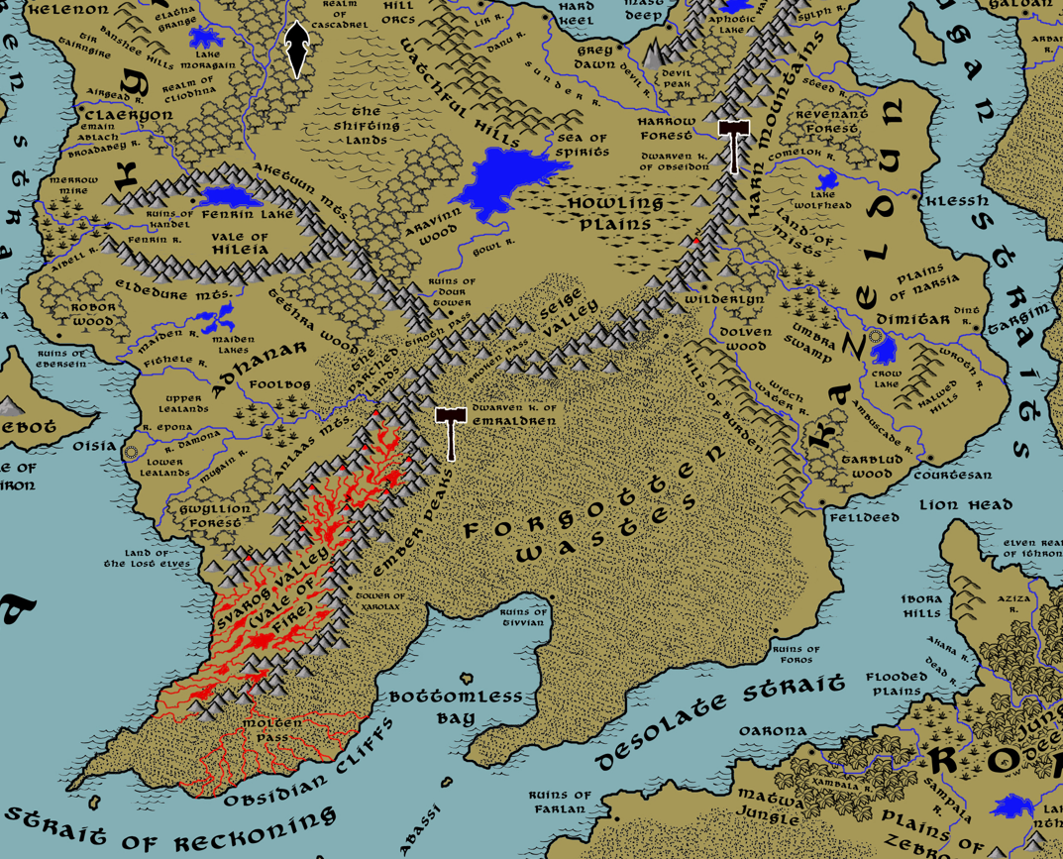

Table of Contents
- Overview
- Towns and Cities
- Best in the Land
- Stewards of Power in this Land
- Points of Interest
- History
- Local Goods
- Notes on Culture
- Weapons and Armor
- Local Deities
- Creatures
- Other Races
- Magical Items
- NPC Templates
- Developer Notes

Overview
Gaeadon is a hybrid continent, a crossroads situated at the center of the world. The massive Shadraak Mountain range runs from the northeast corner of the land mass at a diagonal, splitting off into the Aketuun and Eldedure Ranges, which head west and form the Vale of Hileia, and the Anlaas and Ember Ranges, which continue on to the southwest and border Svarog Valley. This divides Gaeadon into distinct regions, each of which have a character of their own.

The Kingdom of Kyre dominates the northwestern region, colonized there four thousand years ago by travelers from north of Treviland (190 AA4). Kyreans have worked to gentrify the region to resemble western Amadar and much of their culture resembles the kingdoms there. The culture is a highly superstitious one, reflecting the untamed spirits of the land. The Ondirron Elves that live in the Crescent Forest have proven a stalwart ally to humans, helping fight back Orc tribes from the east.
Kazelduun is a chaotic and barbaric region along the eastern shores of Gaeadon, ruled over by a series of tyrants that have made the city of Dimitar their customary base of power.
The northern area of Barter Bay is much less organized, made up of port towns dotting the coastline. Privateers make their home here and the laws in the land are dominated more by shifting alliances among merchants than any ruler.
Far to the south and west, sitting between the Hileias and the Shatterpeaks, is a stretch of land still being settled. Mostly unexplored wilderness, the interior is slowly being claimed by powers in the coastal city of Oisia, which was colonized by traders out of Mythens.
The southern third of Gaeadon is taken up by the vast Forgotten Wastes. This is a desert stretching from the Shadraak and Shatterpeak ranges all the way to the sea. What few towns there were on the coast are ruins now. Nomads travel the wastes, but they hold no seats of power. It is rumored they have organized hidden cities but that has never been confirmed.
Most of Gaeadon is completely wild, and mapped only according to legend. The central region of the continent is particularly dangerous to travelers. Orc tribes range out from the hills and mountains to plunder everything from the Howling Plains to the Valley of Strife to Aravinn Wood. The Sea of Spirits would make an inviting place for settlements if there were safe roads to reach it, but that has never been the case. Of particular note is the sharp rise in the central region compared to the rest of the continent. Millenia ago a dark druid sought to rule the interior of Gaeadon and caused the entire region to rise up two hundred feet from the surface. What remains is a rough escarpment of rock around the base that gives the region the look of one enormous elevated citadel. It is rumored that remnants of the Celedon invaders were trapped in this region and have long since settled it with their descendants.

Towns and Cities
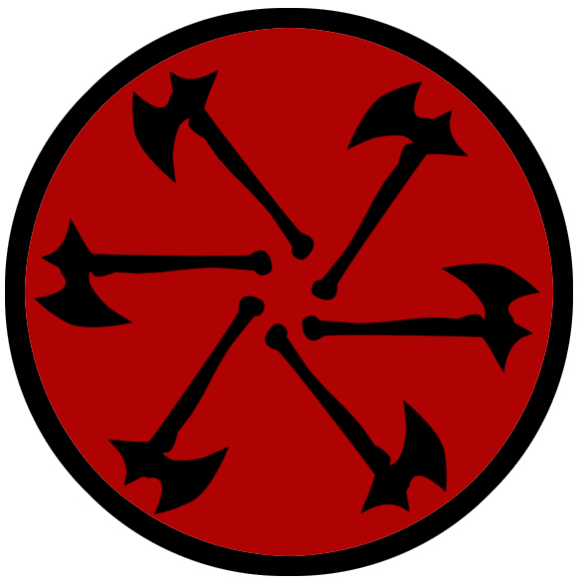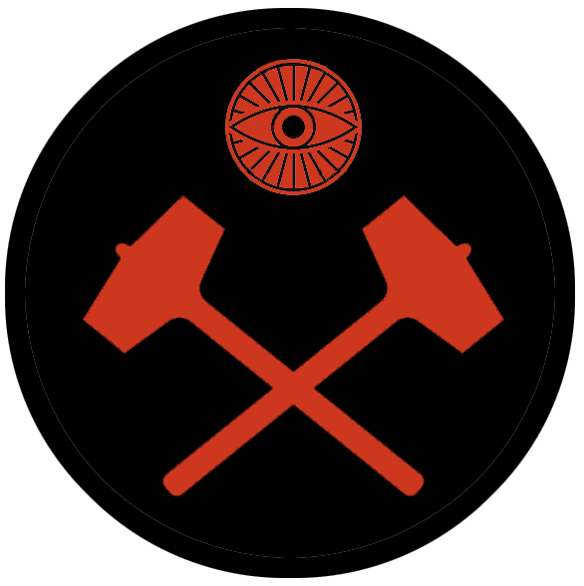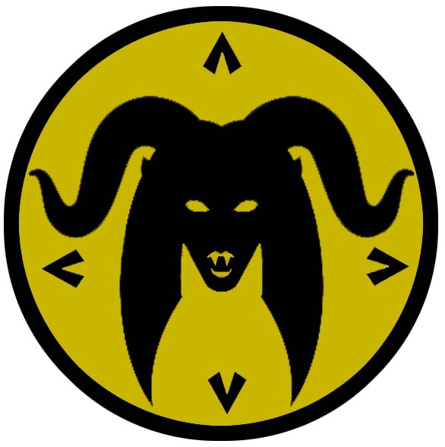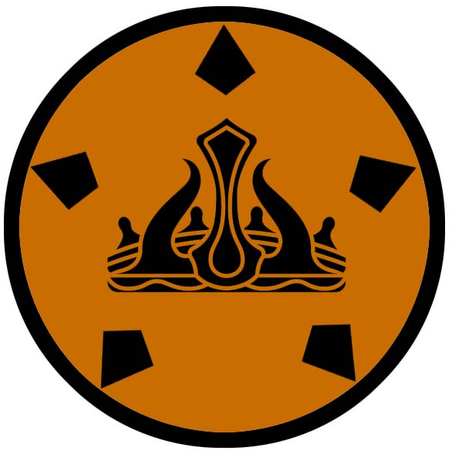
- Kazelduun
  - Klessh – small city, sign of the scorpion
  - Targim – small city, sign of the six axes
  - Courtesan – large city, sign of the mask and daggers
  - Felldeed – small city, sign of the hammers and eye
  - Wilderlyn – small town, sign of the antlers and flame
  - Dimitar – metropolis, sign of the succubus and four spearheads
- Svarog Vale – ruled by the Molten Queen, sign of the crown and five towers
- The Forgotten Wastes
  - The ruins of Cebrak

Best in the Land
Trade Hub:
Religion:
Arts:
Magic:
Spirits:
Steel:
Grain:
Crafted Goods (e.g. Pottery, Textiles, Metal Wares):
Harvested Goods (e.g. Aromatics, Medicine, Dyes):
Mined Goods:
Precious Metals:
Ship Building:
Other:

Stewards of Power in this Land
Kings and their armies are not the only wielders of power. There are many unseen friends and foes that shape the destiny of the land. Each of the groups listed below are well known to the people of this region. Some are feared, others venerated. All of them play their part in the grand drama of this land’s story.

Merchant Companies
Promise Morrow Traders – Courtesan

Mercenary Companies
Takers of Dawn – Klessh

Smuggling Rings
Indigo Night – Felldeed

Centers of Worship (Churches, Cathedrals, Shrines, Lodges, Temples)
High Temple of Vecna – Courtesan
High Temple of Hextor – Dimitar

Orders of Paladins
Order of the Burning Claw – Dimitar

Druidic Circles
Circle of Storm Mountain – Wilderlyn

Bands of Rangers
Band of the Mangrove – Wilderlyn

Schools of Magic
Carthanax Sanctum – Dimitar

Bardic Colleges
(none)

Warrior Academies
Hall of Fangarog – Klessh

Assassins Guilds
Blade of Mamara – Felldeed
Tofana Sisterhood - Courtesan

Cults
(none)

Other Guilds
(none)

Monasteries
Monastery of the Burning Brand - Southern end of the Ember Peaks near Molten Pass
Monastery of the Dark Mother - Southern end of the Shadraak Mts. near Seige Valley

Pirates
Captain Bildras Foulberth Ghun - Bottomless Bay
Captain Hellcat Helena (f) - unsettled lands east of Shadraak Mts

Points of Interest
- (Unnamed Island)

- Sumugan Straits

- Revenant Forest
- Troll Wood
- Tarblud Wood

- Land of Mists
  - Cloaked in the mists that surround this region is the tower of Ekurzakir, Master of Fallen, Arch Mage of the Kazeldun lands.
- Plains of Narsia

- Steed River
- Comelok River
- Wroth River
- Ambuscade River
- Witch Water River

- Wolfhead Lake
- Crow Lake

- Umbra Swamp – home to the mighty black dragon Haroar

- Shadraak Mts
  - Site of the Temple of the Dark Mother, where monks study and train in the ways of Tiamat, mother of chromatic dragons
  - Here dwells the Kazrith tribe of orcs, known by their sign of the jagged black line representing mountains
  - Here dwells the Hobberlong tribe of goblins, known by their sign of several arrows falling; they guard the Broken Pass and hail death down on any who venture this way.
  - Here dwell the tribe of Stone Giants called the Vrhgor.

- Halwed Hills
  - Here dwell the tribe of Hill Giants known as the Gorach.
- Hills of Burden
  - Here dwells the Druken tribe of orcs, known by their sign of the black upside down heart shape representing an open nasal cavity on a skull
  - Here dwells the Nilbog tribe of goblins, known by their sign of the bloody goat head

- Obseidon - Dwarven Kingdom
  - Bandenar - Dwarven town of Obseidon
  - Nengenor - Dwarven city of Obseidon
  - Blackseam - Dwarven town of Obseidon
  - Sledge - Dwarven town of Obseidon
  - Ruthara - Dwarven town of Obseidon
  - Bellows Keep - Dwarven outpost of Obseidon
  - Kelver Keep - Dwarven outpost of Obseidon
  - Anvil Keep - Dwarven outpost of Obseidon
  - Stryker Keep - Dwarven outpost of Obseidon

- Bottomless Bay
  - Within the waters here lurk the tribe of Sahuangin known as the Vissthak, known by their sign of six broken sea shells.
- Obsidian Cliffs
- Strait of Reckoning

- Forgotten Wastes - The desolate lands of the Forgotten Wastes are a desert unlike any seen in the world: shifting sand dunes are intermixed with deep pits that fade from view and large fields of glass formed into terrible shapes. These were the Gladden Fields in the Primordial Ages, before the Molten Queen of Svarog Vale wrought her revenge on the Cebraki people in this region and blasted the land into ruins.
  - The sultans of Cebrak of the Primordial Ages hired the Emeraad Dwarves to build vast catacombs that run beneath these lands, some tunnels extending as far north as Adhanar, Kazeldun, and the Howling Plains. These were used to launch invasions to expand the Cebrak Empire. But since the fall of the city in the Ancient Ages the entryways to the Catacombs have been lost and the labyrinth has been untouched in millennia.
  - – home to the brass dragon Samuset in the north, also home to the blue dragon Grahath near the ruins of Cebrak

- Anlaas Mts
  - Here dwells the Badderdalg tribe of orcs, known by their sign of the bloody fist
  - Here dwells the Skreet tribe of goblins, known by their sign of the impaled foot
  - Here dwell the tribe of Fire Giants called the Ognar, known by their sign of the foot above burning coals, stomping them out. They are fierce enemies with the Iznar Fire Giants who dwell across Svarog Valley among the Ember Peaks.
- Ember Peaks
  - Here dwell the tribe of Fire Giants called the Iznar, known by their sign of coals above a foot, burning it. They are fierce enemies with the Ognar Fire Giants who dwell across Svarog Valley among the Anlaas Mountains.

- Svarog Valley (Vale of Fire) - Ruled over by the Molten Queen, ruler of the Sirathren Fire Elves
- Sirathren – Elven Domain
  - The broken lands of the Valley of Svarog are home to the fire elves. Here, where rivers of hot lava flow and the land shifts to spout jets of flame, the fire elves are masters of their element. Their sacred duty: to serve as stewards of the vale and seek higher truth in the fiery, unstable land. Outsiders are not welcome here and the fire elves defend it violently.
  - (see Atlas: Notes on the Elven Kingdom of Sirathren)
- Molten Pass
  - Site of the Temple of the Burning Brand, where monks study and train in the ways of Neragal, god of fire and pain

- Ruins of Cebrak – site of a thriving port from the Ancient Ages (380 PA2 to 380 AA1), the city grew in power to control half the Gaeadon continent. Its famed diamond mines fed the ambitions of the line of sultans, all named Shkelq, and financed the dwarven-made Catacombs of Cebrak that ran beneath the entire Forgotten Wastes. The city and its people disappeared suddenly in 380 AA1 without warning and with no clue as to what happened.
  - In the First Written Age it was occupied by Celedonians and a garrison stationed there. The Xanthus Legion used the location to control Bottomless Bay and traffic through the Desolate Strait. Expeditions into the interior of the Forgotten Wastes were unsuccessful.
  - The desert just outside of the ruins is the home to a mighty blue dragon (needs name and history)
- Ruins of Foros


Klessh
Size: small city, population 12,000, guards / soldiers 120, militia 600
Trade Goods: grain, cotton, live stock
Local Goods:
Standard: sign of the scorpion
Colors: green and black
Patron Deity:
Ruler: Bandag Zagreda and his wife Balisha

Home: Weepwidow Fortress
Steward: Dazin Dorrukk
Marshal: Baarag Dinaar
House Priest: Dashan Kalaj
House Adviser (Scholar/Mage/etc): Adea Budo (f)
Captain of the Guard: Hammar Surron
Chief Warriors in Service:
Baaro Shabaan
Rynk Daadul
Raajo Baahar

Local Powers: The Broken Chains (thieves guild), Takers of Dawn (mercenary company), Hall of Fangarog (warrior school)
Local Sites: Hook and Talon Inn & Tavern, The Black Weasel Inn & Tavern, Dominestra’s (brothel)

Description:
Klessh is a wide, squat city with tall, brown sandstone walls that are capped with iron. Tall square towers stand at five points along the outer walls and one in the center, all topped with round domes. Wooden walkways connect the towers and offer a view of the streets below. The city sits alongside the Highvow River as it empties into the Primeval Straits. Canals have been built that run the river waters into channels throughout the city and flow into the sea. The smell of filth in the canals rises into the air, earning Klessh the nickname by travelers as the Sewer of Kazeldun. There is little order to the layout of the city. Barbarian tribes who have come here over the centuries have marked out sections of the city for themselves in a clumsy fashion. The markers move regularly and often with a fight. Each tribal section is decorated differently, has different customs, and features its own markets.

Industry:
Klessh is a turbulent economy, enriched with blood-soaked coin brought back by its mercenaries. Goods trade hands, but often by force. Livestock and grain are raised outside the city but the farmers live under the thumb of the resident warlords. Only the strongest of merchants maintain businesses. Often as not, they are also warlords or have alliances with them. Traders rarely make port here. Instead, caravans and ships take the city’s goods abroad.

Key Figures:
Klessh commands one of the fiercest armies in the world, most of them mercenaries from other lands. The mercenary company Takers of Dawn make their home here, hiring themselves out to fight in lands the world over. They are known by their black banners embroidered in a red sun. Legends tell of their campaigns taking place mostly by night, for their credo is to win the battle before sunrise. It is said their soldiers carry vials of an enchanted water which gifts them powers over the night. Their leader, Lolan Blakman, was a Mamaran assassin from Felldeed before becoming a master swordsman in the Hall of Fangarog.

The Red Fang pirates anchor far to the north up the coast and prey on merchant ships making their way through the Primeval Straits. These are of little concern to Klessh ships, which are armed for combat at sea. It is said the pirates avoid any Klessh sails for this reason. Others say the pirates often pay visits to Klessh and consider it a safe port.

Local Lore:
To the west and upriver sits Highvow Lake. This is a place of mystery and a place of sacred worship among some in Klessh. It is rumored the waters of the lake have special powers. Those who drink of the water and make a pledge to the gods are favored on their quests. West of the lake is the Land of Mists. Here it is feared walk the angry ghosts of the slain, drifting over the land hungry for blood. Others say it is a place of bewilderment, creating illusions of one’s greatest desires and even greater fears which can come to life. Reckless adventurers boast of carrying back arm loads of treasure and concubines of their dreams. Others venture here and are never seen again.

History:
Klessh is one of the oldest barbarian strongholds in Gaeadon. It once ruled over the entire northern region of Kazeldun and challenged Dimitar regularly in the old days for dominion of all.

The city of Galdan is one of Klessh’s major trade partners, which is surprising considering their mutual enmity. Klessh has a long history of invading southern Xiandai. On occasion Klessh forces have made significant inroads into the lands north of the Cagun Suhk. Three hundred years ago the Klessh invader Ulkan nearly destroyed Galdan, surprising the city in a night-time raid (180 WA4). The Moghun were forced to retreat and Ulkan’s men occupied the entire river valley. Further advances saw the Klessh army take half the lands to the north, almost as far as the Khadagan River. But within a year the Moghun tribes had reassembled and attacked from the east. Ulkan and his army were surrounded and decimated (184 WA4).

Customs:

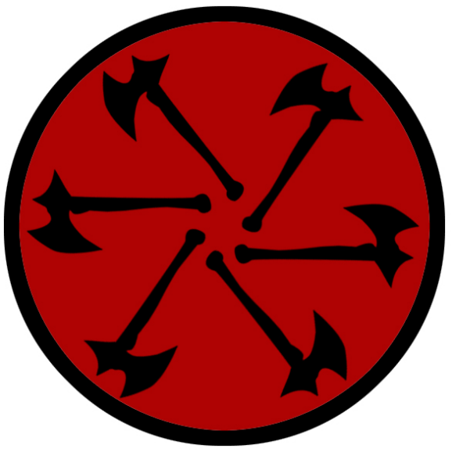
Targrim
Size: small city, population 12,000, guards / soldiers 120, militia 600
Trade Goods: spices, clay, tin
Local Goods:
Standard: sign of the wheel of six axes
Colors: red and black
Patron Deity:
Ruler: Xhevat Rodyn and his wife Yllpara (f)

Home: Castle Kellerus
Steward: Aadeyn Baahout
Marshal: Sawluk Muridon
House Priest: Bardhoke Blaku (f)
House Adviser (Scholar/Mage/etc): Shyrshaad Jashari
Captain of the Guard: Gorich Dushkan
Chief Warriors in Service:
Beizan Shabris
Dousteyn Gamshard
Shawkat Dramshok

Local Powers: Bitten Coins (thieves guild)
Local Sites: The Scoundrel’s Den Inn & Tavern, Servants’ Quarters (brothel)

Description:
Targrim sits alongside the Dint River overlooking the Primeval Straits. Its high walls consist of seven layers of expertly crafted stone, each layer a different type of stone from the Shadraak Mountains. In the old days the layers were each of a different color and were a symbol of the different peoples united here. Today the walls are stained dark with soot and pitch and years of neglect have created cracks that mar its former beauty.

Twelve tall, slender towers ring the city with a thirteenth, the High Tower of Kellerus, at the center. Of particular note on the city are the strange clouds that encircle it always. Sometimes thin wisps of clouds, at times dark and bulging barriers that almost conceal the city, these clouds are rumored to be the lingering curse of Oolorex’ magic centuries ago. This has earned Targrim the nickname the Clouded City among travelers. Wizards speculate that the shape and size of the clouds foretell coming dooms in this region.

Like other cities of Kazeldun, Targrim is a mix of barbarian tribes that move in and out of the region. Rule over the city is held by whatever warlord has fought his or her way to the High Tower. Upriver the city of Dimitar holds dominion over Targrim and seizes tribute from any goods traded or produced here. There is no sense of industry or ambition to the city like it once had, it is a coastal extension of Dimitar and a way station for warring tribes. Those that do seek their fortune here often look across the Primeval Straits to the sands of the Cagan Suhk. So deep is the sense of futility in Targrim that even the wastelands of the desert look to hold promise. Expeditions are sent to the nearby shores, where enterprising explorers hope to build homes there or explore the deserts for abandoned cities to occupy. Occasionally fortune hunters lead caravans into the desert, always wary of the Moghun.

Industry:

Key Figures:

Local Lore:
Legend tells of a sorcerer named Oorolex who coveted the power rising in Targrim. He crafted the Nine Orbs of Night. Each one contained incredible power, yielding disease, famine, dissension, fear, pestilence, chaos, storms, blight, and death. With them Oorolex united the barbarians around present-day Felldeed and Klessh, as well as orcs and goblins from the Hills of Burden. After a ten-year war Targrim was defeated and the region fell into a period of darkness from which it has never recovered.

History:
Targrim is the oldest city in the Kazeldun lands. Eleven thousand years ago the Caerron tribes were driven from the Plains of Narsia and settled the coastal region between the Dint and the Ambuscade Rivers (250 AA2). Over time the nomads took to working the sea. Trade ships encountered Harikanya in Kaduru and a rich exchange of goods and culture took place. The tribal chief Kellerus of Khovesh rose up during the Kaduru Wars. He drove out the Kaduru invaders and united the Caerron tribes under one banner (520 AA2). Kellerus commissioned Targrim to be built, along with a protected sea port, the draining of the bogs along the Wroth River, clay works along the estuaries, and mines in the Halwed Hills (560 AA2). The city prospered under Kellerus and for six generations of his heirs. The Kingdom of Caerron was the major power in Kazeldun until its fall during the Red River Wars in 970 AA3.

Customs:


Courtesan
Size: large city, population 25,000, guards / soldiers 250, militia 2250
Trade Goods: trade hub, tea, wine, flax, religious center
Local Goods:
Standard: sign of the mask and twin daggers
Colors: purple and black
Patron Deity:
Ruler: Luvar Bardulla and is wife Doriza (f)

Home: Castle Artifisse
Steward: Bardhosh Kolerem
Marshal: Ulkan Vallas
House Priest: Idris Kubutar
House Adviser (Scholar/Mage/etc): Emiriana of the Blood Sign (f)
Captain of the Guard: Delin Romustor
Chief Warriors in Service:
Joren Kirabo
Noras Bregan
Andon Aharon

Local Powers: Promise Morrow Traders, The Shadow Men (thieves guild), High Temple of Vecna (world seat of power for the followers of Vecna), Tofana Sisterhood (assassin’s guild)
Local Sites: The Silver Dagger Inn & Tavern, The Casual Cavalier Inn & Tavern, Desdemona Vineyards, Madame Lusinnda's (brothel)

Description:
Courtesan is a city that passes for civilized in Kazelduun. Wealthy merchants have brought in art and culture to create a haven of sophistication. This is mostly limited to the wealthier portion of the city, although the outer walls are adorned with frescoes, draperies, and statuary. Hanging gardens descend from the inner walls in thick carpets of ivy and flowers.

Luxury items stolen from kingdoms abroad become the fashion of the rich. The wealthy dress in gaudy attire, adorn themselves in white face makeup, and wear elaborate wigs. Socialite balls and lavish theatrical productions keep the gentry occupied while the people in the streets live in squalor.
Within the wealthy quarter lives a broiling cauldron of deception and intrigue. The upper-class families veil their intentions with silver tongues. Betrayal and murder are popular past times. Spies and thieves and assassins are hired to play out these games. In Courtesan the distractions of the rich become dangerous pageantry.

The Promise Morrow trading company dominates the Primeval, Jalaba, and Desolate shipping lanes. They are disreputable merchants, known to traffic in slaves and do business with pirates. Cutthroats are in their employ to strike fear in their rivals. Some jest that they are pirates in merchants’ clothing.

Industry:
Outside the city the farmers tend to fields of flax and tea plants as well as the proud vineyards.

Key Figures:

The Tofana Sisterhood is an underground network of women who distill and distribute some of the world’s deadliest poisons. Their aim is to remove men who they deem undesirable, most often for their crimes against women. Even the most powerful criminal elements fear the Tofana and have vowed to hunt down and eliminate the sisterhood. But access to their agents is heavily protected, with only a very trusted few being given an audience. Their poisons are almost impossible to detect and are most often peddled as perfumes or other beauty products. The tinctures can be prepared to an exact time of death for the victim: hours, days, weeks, even up to a year after being consumed.

Local Lore:

History:

Customs:

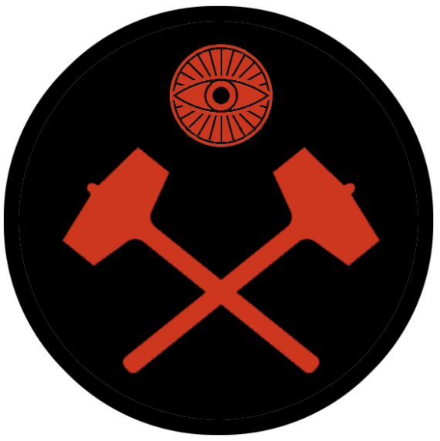
Felldeed
Size: small city, population 12,000, guards / soldiers 120, militia 600
Trade Goods: salt, iron, steel, metal wares
Local Goods:
Standard: sign of the crossed hammers and eye
Colors: black and red
Patron Deity:
Ruler: Varadi Arkelian and his wife Skedina (f)

Home: Castle Kharga
Steward: Marton Voros
Marshal: Aharon Viragis
House Priest: Zilvia Moloran (f)
House Adviser (Scholar/Mage/etc): Meszoros the Mystic
Captain of the Guard: Sorman Ispiryan
Chief Warriors in Service:
Viktor Voros
Marlen Danyar
Alibek Ardash

Local Powers: The Bloody Bodkin (thieves guild), Indigo Night (smuggling ring), Blade of Mamara (assassin’s guild)
Local Sites: Burning Tree Inn & Tavern, Lark Song (brothel), The Giddy Goblin Inn & Tavern

Description:
Felldeed is a city built on blood and misery. It is a mining town worked by slaves brought in from a hundred wars across Kazeldun as well as those shipped in from afar. Condemned criminals and prisoners of war are sent here to rid warlords of trouble. Throughout these lands the name ‘Felldeed’ fills one with dread, for it is a place from which no one returns.

The city straddles the Witch Water River just as it empties into the waters of the Desolate Straits. Its pale gray walls are a jumble of jagged stone slabs that resemble a giant pile of bones. No sign of masterwork masonry is evident: the walls have been built and rebuilt over the centuries from leftover material from the stone quarries and with strength in mind rather than aesthetic appeal. There is a heavy smell that hangs over the place like the pall of death.

Industry:
Roads lead up into the Hills of Burden to a complex of salt and iron mines. In the city there are smelting furnaces and bloomeries that burn night and day, working the iron ore and refining it into steel or setting aside wrought iron. The salt mines are vast and run deep. It is said there is one cavern within the salt mines that is so vast that it is called the Salt Cathedral. Stories tell of its majestic beauty in the midst of such grim conditions.

Within the city there are metal works where lower quality iron is made into metal wares. Female slaves are put to work mostly in the city’s walls fashioning every manner of wrought iron goods such as pots, tools, gates, stoves, anchors, chains, and siege artillery.

Key Figures:

Local Lore:
Orcs and goblins populate the Hills of Burden in large numbers. This has not posed a problem for the men of Felldeed, for they have a longstanding truce with the creatures and sometimes work together with them. As part of the truce the orcs provide cheap goblin labor for the mines. In exchange, laborers who have outlived their usefulness are handed over to the orcs. The only conflicts between men and orcs arise when an orc lieutenant becomes filled with bloodlust or gold is involved. These are frequent, but both sides deal with them swiftly to avoid all-out war.

History:

Customs:
No one in Felldeed goes by their actual name. Everyone’s identity is stripped away and replaced with a nickname given to them when they arrive.

Wilderlyn
Size: small town, population 2,000, guards / soldiers 20, militia 100
Trade Goods: stone, gold, furs, timber
Local Goods:
Standard: sign of the antlers and flame
Colors: green and black
Patron Deity:
Ruler: Mors Antebian and his wife Baresia (f)

Home: Tower Houndsbay
Steward: Lors Kilgar
Marshal: Abel Vetarum
House Priest: Maulen Fauske
House Adviser (Scholar/Mage/etc): Rorem Sarafian
Captain of the Guard: Odryn Votamas
Chief Warriors in Service:
Boja Sadirin
Madina Alibek (f)
Jyram Yender

Local Powers: Twin Skulls (thieves guild), Circle of Storm Mountain (order of druids), Band of the Mangrove (order of rangers)
Local Sites: The Saracen Inn & Tavern, Scorpion’s Sting Inn & Tavern, Rutting Lodge (brothel)

Description:
Wilderlyn is not a town in the conventional sense. It resembles more of a barbarian camp with walls. Its people have dwelt amongst the Shadraak Mountains and Dolven Wood since before memory and they have little use for civilization. It is only for defense against the orc and goblins coming down from the Shadraak Mountains and roaming these dark lands that the wild tribes united and fortified.

Within the town walls the sturdy timber cottages are separated into clan quarters. A pole stands before each cottage, a mark made upon it to show clan affiliation. The poles are also used as a form of messaging system. Enemies leave a dead crow hanging to signify a blood challenge. Friends leave a gift of meat or some other token of value. Suitors will show their interest in a mate by leaving a fur coat that they hope will be worn if the offer is accepted. Visitors here are met with suspicion, even if welcomed. Normally admittance is allowed only by the great chieftain who presides over the town.

Industry:
Another concession made by the Shadraak people hundreds of years ago was to engage in trade with the towns and cities to the south. From the beginning furs and timber were found to earn coin when sent downriver to Felldeed. But centuries ago the Shadraak made friends with the Dwarves in the mountains, who showed them how to mine stone. Since then the rangers of Wilderlyn have become skilled in finding other resources in the mountains, including gold. All of these are sent down river along with emissaries to collect the goods desired by the town. Every so often someone tries to cross the Shadraak in their dealings, or march on the town to demand tribute outright. None of these trespasses have gone without severe retribution. The south landers have learned to respect the Wilderlyn people.

Key Figures:

Local Lore:
Orcs and goblin tribes are a constant threat in this region. The Shadraak barbarians have a longstanding war with any and all humanoids. On occasion, however, they have begrudgingly worked together if powers move into the region to threaten them all. It is not uncommon to see half-orcs living among the Shadraak.

History:
The Shadraak Tribes, the name by which these wild people are known, have always been a mighty power when united. In the chaotic lands of Kazeldun, they have themselves marched on other lands and conquered. A thousand years ago it was their chieftain, Bardaloch the Cleaver, who sat on the throne in Dimitar. And for a hundred years the Shadraak barbarians wreaked havoc throughout eastern Gaeadon. Five hundred years ago they answered the call by the hero, Aelman the Brave, and helped to defeat the orc king Zarlek who marched out of the Valley of Strife. Stories often tell of their bravery, but also of their savagery.

Customs:
Behind their mighty oaken walls, the town folk gather and break bread. But few linger within the walls for long. Every man, woman, and walking child has the instincts of a ranger and make regular expeditions into the wild. Clan ties are strong, so feuding persists. But any such conflicts are settled outside the walls.

The custom of the Shadraak barbarians is to give each stranger they meet three chances to show their true face. An outsider may meet a Shadraaksman in battle, then a second time in a dispute, but by the third time offer them a boon and from that point on be considered a friend for life. The opposite is true, as well: if one were to meet a Shadraak on friendly terms, then again as a friend, but on the third meeting run afoul of them, then they are considered enemies for life. It is their belief that by the third meeting the gods have revealed the stranger’s true heart. This is an old custom and one that outsiders find confusing.

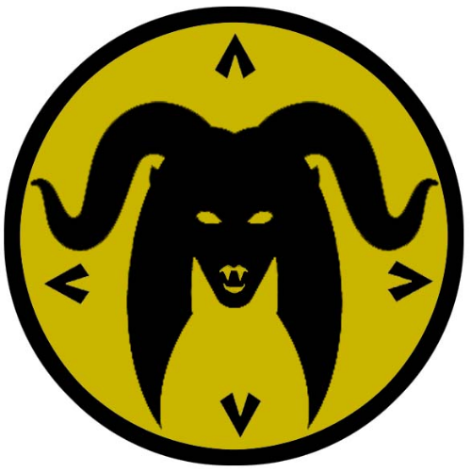
Dimitar
Size: metropolis, population 50,000, guards / soldiers 500, militia 2500
Trade Goods: lead, magic, opium, clay, religion
Local Goods:
Standard: sign of the succubus and four spears
Colors: yellow and black
Patron Deity:
Ruler: Arlan Tangeren and his wife Amireva (f)

Home: Castle Khyrzantem
Steward: Nardus Gurian
Marshal: Garit Caraman
House Priest: Egor Turtan
House Adviser (Scholar/Mage/etc): Aizada Baruzhan (f)

Captain of the Guard: Calin Brinza
Chief Warriors in Service:
Kirin Ardash
Birk Baedun
Kelric Dhandar

Local Powers: High Temple of Hextor (world seat of power for the Church of Hextor), The Hangmen (thieves guild), Order of the Burning Claw (order of paladins), Carthanax Sanctum (school of magic)
Local Sites: Fire and Forge Inn & Tavern, The Headless Rooster Inn & Tavern, The Caked Concubine (brothel)

Description:
City of Dark Delights, City of Ancient Curses, City of Fortune, City of Kings and Conquerors: all of these and more are names by which Dimitar is known. Its jet-black walls stand defiantly amidst the oozing muck and flaming geysers of the Narsian Plains. It is a haven in the wastelands and a city feared the world over. Dark magic pulses like a living heartbeat beneath its cramped streets. Thieves, gamblers, and cut-throats dispense with their ill-gotten fortunes in smoke-filled opium dens and brothels. Fighting pits beckon endless droves of fierce warriors to win fame and fortune. Far above, in their purple towers, demented wizards tap into the arcane lay-lines of this place to unleash unspeakable horrors. Above it all sits the king of Kazelduun, another in a long succession of warlords who have slain thousands to savor dominion over this land.

The city of Dimitar is old beyond reckoning. The obsidian walls that surround it have been rebuilt a hundred times, weaving through and around the city’s quarters at strange angles and in a variety of building styles. Needle-like towers protrude from within and atop the walls, each one the sanctuary for the wealthy. The streets are a densely-packed maze featuring narrow alleys, terraced plazas, and markets choked by vendor stalls offering things beyond imagination. Beneath it all are countless layers of sub-chambers and tunnels hailing back to centuries of the city’s previous incarnations, each one entombed after some great calamity prompted Dimitar to rebuild and forget the past.

Industry:
Dimitar does not boast valuable resources: lead mines in the Halwed Hills and clay pits around Crow Lake were the first industries here and remain to this day. The majority of wealth that built Dimitar has always been from other towns and cities under its thumb and from opium.

Travelers to Dimitar will find it full of opportunities but extremely dangerous. Trade goods and valuables will find a good price in the markets, but only if one can hold onto them or the money they return. The thieves of the Hangmen guild have eyes everywhere and are powerful in numbers, for they employ every child on the streets. Information is abundant as well if one knows where to look. But those asking questions run the risk of alerting the vast network of spies working for the wealthy families.

Key Figures:
Power is king in Dimitar. But power is a complex web of warring factions. The throne rules from Castle Khyrzantem, but only for as long as it crushes its enemies. The throne is always changing hands in a land of conquerors. Wealthy families dwelling in the high places of the city plot against the king and one another and spread their wealth to spies, assassins, thieves, and adventurous types willing to do their dirty work. The priests of Hextor hold power through the terror they invoke in the believers, who do their bidding for blessings from the god of war. The Hangmen work constantly to manage the hundred or more gangs that war with one another and act as broker to those looking for their skills. Meanwhile, the sorcerers and mages of Dimitar quietly sell their services while financing dark projects that threaten to unleash unspeakable powers.

Local Lore:
The rumors around Dimitar involving fell creatures are too numerous to list. Demons are a constant plague, being summoned by foolish wizards who cannot control them. Cursed items are spoken of often, for they seem to resurface regularly in the hands of brazen adventurers only to disappear again. Of particular note are the undead hosts that emerge from the Umbra Swamp to the west. It is thought that necromancers find the swamps appealing for the countless dead warriors submerged there from thousands of years of wars.

History:
Eleven thousand years ago Dimitar was at the center of a massive build-up of barbarian hordes who united under a chieftain dubbed General Dractus (494 PA4). General Dractus overthrew King Hyrom of Kazeldun and seized power over the barbarian tribes. Dractus sent armies north and west, around and over the Shadraak Mountains. His forces conquered Vigil and Barter Bay and invading the interior of Gaeadon. Later Dractus invaded Adhanar in W. Gaeadon and sacked Oisia.

Dractus’ spies reported rumors of the Crown of Power being collected by a wizard in Svarog Vale. Dractus' army found the Tower of Xarolax and stole pieces of the Crown of Power. This began his bloodlust to find them all. His quest would lead him to conquer all of the Caghun Suhk, make inroads into northern Xiandai, take parts of Kaduru, and even invade Mahabar. In 530 PA4 Dractus’ forces make it all the way to the Pearl Mountain, when eight monks came down from the mountain wielding the Scepters of Creation. In a terrible battle Dractus and his forces are destroyed utterly and the Crown of Power vanquished.

Three thousand years ago the Celedonian Empire invaded Kazeldun. In 370 WA1 the Quartus navy took the Kaduru city of Oarana and deployed the Drakon Legion. It wasn’t until the year 450 WA1 that the Celedonian Drakon Legion finally took the towns of Courtesan and Felldeed and invaded the interior of Kazeldun. But the barbarian tribes of Kazeldun did not make the conquest easy. In 510 WA1 the Celedonian Phlegon and Drakon Legions were destroyed in Kazeldun in a terrible defeat at the Battle of the Red Rocks. Fifty years later a second Celedon invasion of Kazeldun by the Poena Legion conquered the barbarian capitol of Dimitar and the Poena Legion established a garrison here.

Four hundred years ago the warlord Syzzagh invaded the Cagun Suhk and was turned back at Karmalan. There he learned of the valuable poppy plants growing there. Before his ultimate defeat he dispatched spies to collect the plants and capture the field hands tending them. Syzzagh commissioned fields to be prepared within the outer walls of Dimitar and poppy fields to be created. Since then Dimitar has had a thriving industry in opium production and distribution throughout Gaeadon and abroad.

Customs:

Svarog Vale
Size: small city, population 12,000, guards / soldiers 120, militia 600
Trade Goods: silver, platinum, gems
Local Goods:
Standard: sign of the crown and five diamonds
Colors: orange and black
Patron Deity: Mariel, fire goddess
Ruler: The Molten Queen

Home: Palace of Ignimontis
Steward: Jeardra Norcaryn (f)
Marshal: Theodmon Ianjyre
House Priest: Kilyn Olonorin (f)
House Adviser (Scholar/Mage/etc): Andrathath Reyric
Captain of the Guard: Onas Caijyre
Chief Warriors in Service:
Pelleas Sylnala
Finnea Cairalei (f)
Inialos Vencyne

Local Powers: Tower of Xarolax

Local Sites:

Description:
Svarog Vale is a dominion unto itself. The Molten Queen presides over a large stretch of darkened lands seething with volcanic activity. Rivers of lava flow down into the valley floor where large blacked rock formations float on a sea of bright flame. The landscape is ever changing as gouts of flame erupt sending ash and toxic gases into the air. This is the realm of the Fire Elves, who serve their queen.

Industry:
Svarog Vale is not a trade partner with any towns or cities. But it is teeming with silver, platinum, and precious gems that form in its fiery mantle. Intrepid merchants often come to a quick end if they do not approach the Molten Queen carefully or with respect. But a few do prove their worth in the trials she sets forth and trade goods she finds delightful for rare treasures that make them wealthy.

Key Figures:
The Molten Queen -

Local Lore:
The Vale of Svarog is known to be home to many fissures that regularly open as portals into the dark planes. Demons and devils frequently appear to wreak havoc. The Molten Queen bears the Scepter of Known Names, by which she can sense any demon or devil and subdue them to her will.

History:
670 PA3 - the city of Cebrak grows in power, controlling southern and central Gaeadon

680 PA3 - Cebrak forces invade Kazeldun, conquering the land

690 PA3 - the Sultan of Cebrak, hearing tales of the Molten Queen in Svarog Vale, launches a crusade to conquer the burning lands

700 PA3 - the Sultan of Cebrak conquers the Molten Queen with help of dark magic

705 PA3 - embracing the newfound power of the Svarog lands, the Sultan of Cebrak launches a massive invasion of northern Kaduru

707 PA3 - The Svarog War: Queen Malaka of Tengaibo calls on the water goddess Oya, defeats the armies of Svarog

708 PA3 - fleeing to Svarog Vale, the Sultan of Cebrak is incinerated by the enslaved Molten Queen after she frees herself; the Molten Queen dies from the effort

709 PA3 - Queen Malaka, tainted by the fire fever of Svarog's demons, transforms into a flaming humanoid like those native to Svarog Vale; the people of Svarog Vale convince her to beome their next Molten Queen

498 PA4 - Dractus invades Adhanar in W. Gaeadon, sacks Oisia, drives out the invaders from Drommica and Arropos ; his spies report rumors of the Crown of Power being collected by a wizard in Svarog Vale

500 PA4 - Dractus' army finds the tower of Xarolax and steals pieces of the Crown of Power, beginning Dractu's bloodlust to find them all

Customs:
The Molten Queen and her fire elves worship the fire goddess Mariel. She is a mercurial god given to fits of temper as well as compassion. She is the giver of flame and her heart burns with passion for her followers. But she is a vengeful goddess and demands retribution for any offenses against her name or her worshippers.

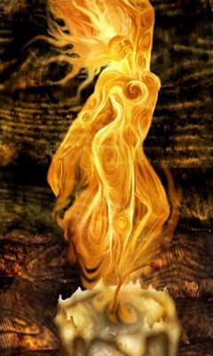

Ruled over by the Molten Queen
  - The Molten Queen is a supernatural figure, born of the primordial fires that created Nemmyrl. She rules over Svarog Valley, attended by the tribes of Fire Elves that dwell here. She is a frighteningly beautiful figure to behold: her body a seething mass of molten lava and blackened rock, shifting as she moves. Atop her head is the Molten Crown, which appears to thrust roots downward into her head, a living thing unto itself.
  - 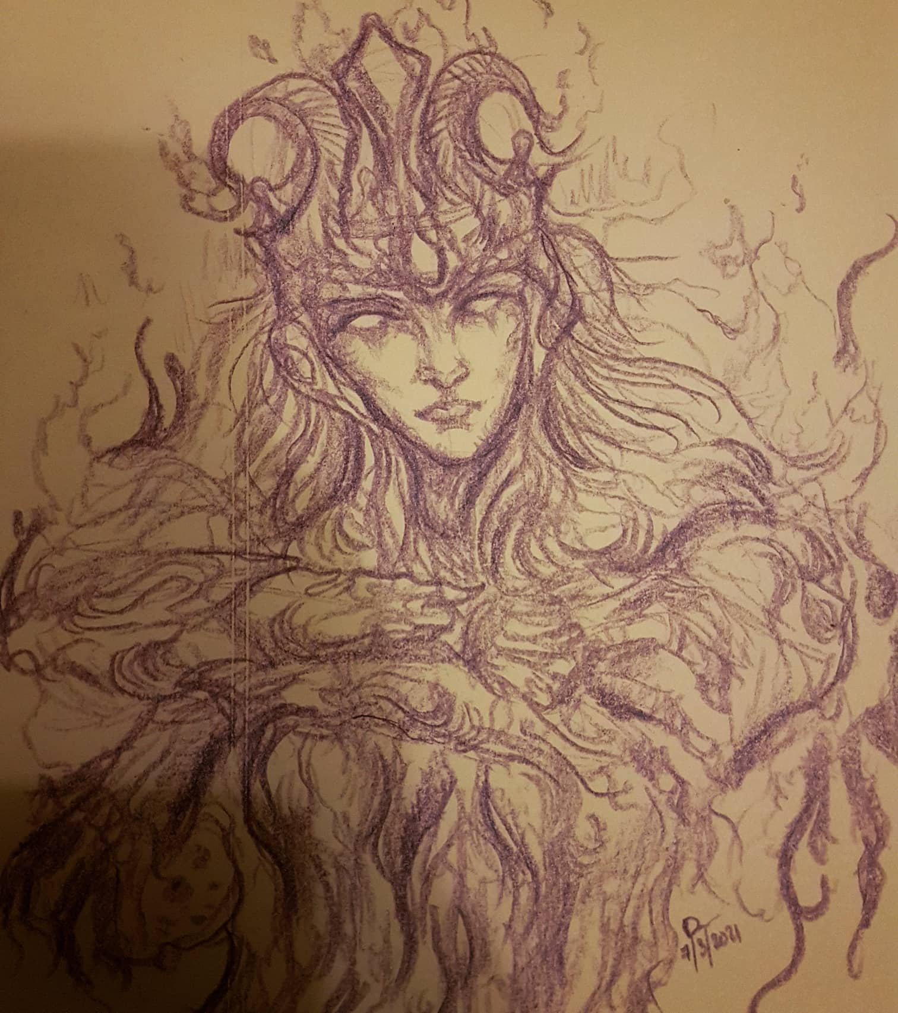
      - Illustration by Dave Liew

The Forgotten Wastes
Cebrak
Cebrak was a city in the early days of Nemmerle that rose in the desolate Forgotten Wastes and became a major port city in the region controlling the Desolate Strait.

620 PA2 - port city of Cebrak is founded by the Kurgs in the Forgotten Wastes of Gaeadon; it becomes a major port city in the region controlling the Desolate Strait

670 PA3 - the city of Cebrak grows in power, controlling southern and central Gaeadon
690 PA3 - the Sultan of Cebrak, hearing tales of the Molten Queen in Svarog Vale, launches a crusade to conquer the burning lands
700 PA3 - the Sultan of Cebrak conquers the Molten Queen with help of dark magic
705 PA3 - embracing the newfound power of the Svarog lands, the Sultan of Cebrak launches a massive invasion of northern Kaduru
707 PA3 – The Svarog War - Queen Malaka of Tengaibo calls on the water goddess Oya, defeats the armies of Svarog
708 PA3 - fleeing to Svarog Vale, the Sultan of Cebrak is incinerated by the enslaved Molten Queen after she frees herself; the Molten Queen dies from the effort
709 PA3 - Queen Malaka, tainted by the fire fever of Svarog's demons, transforms into a flaming humanoid like those native to Svarog Vale; the people of Svarog Vale convince her to beome their next Molten Queen

Cebrak fell to ruin in 380 AA1 for reasons unknown.

History of Kazeldun and the Forgotten Wastes

First Primordial Age (PA1)
Dawn of the Kurgs

10 PA1 - Hextor settles in the lands of Kazeldun and cultivates a land of war and barbarian kings

Second Primordial Age (PA2)
620 PA2 - port city of Cebrak is founded by the Kurgs in the Forgotten Wastes of Gaeadon; it becomes a major port city in the region controlling the Desolate Strait

Third Primordial Age (PA3)
670 PA3 - the city of Cebrak grows in power, controlling southern and central Gaeadon

680 PA3 - Cebrak forces invade Kazeldun, conquering the land

690 PA3 - the Sultan of Cebrak, hearing tales of the Molten Queen in Svarog Vale, launches a crusade to conquer the burning lands

700 PA3 - the Sultan of Cebrak conquers the Molten Queen with help of dark magic

705 PA3 - embracing the newfound power of the Svarog lands, the Sultan of Cebrak launches a massive invasion of northern Kaduru

707 PA3 - The Svarog War - Queen Malaka of Tengaibo calls on the water goddess Oya, defeats the armies of Svarog

708 PA3 - fleeing to Svarog Vale, the Sultan of Cebrak is incinerated by the enslaved Molten Queen after she frees herself; the Molten Queen dies from the effort

709 PA3 - Queen Malaka, tainted by the fire fever of Svarog's demons, transforms into a flaming humanoid like those native to Svarog Vale; the people of Svarog Vale convince her to beome their next Molten Queen

Fourth primordial Age (PA4)
494 PA4 - General Dractus overthrows King Hyrom of Kazeldun

496 PA4 - Dractus sends armies north and west, around and over the Shadraak Mountains; conquers Vigil and Barter Bay, invades interior of Gaeadon

498 PA4 - Dractus invades Adhanar in W. Gaeadon, sacks Oisia, drives out the invaders from Drommica and Arropos ; his spies report rumors of the Crown of Power being collected by a wizard in Svarog Vale
500 PA4 - Dractus' army finds the tower of Xarolax and steals pieces of the Crown of Power, beginning Dractu's bloodlust to find them all

502 PA4 - Dractus' armies in the east cross the Sumugan Straits and take Galdan, a prize highly coveted by Dractus to seek revenge for his father's defeat there decades ago

504 PA4 - Battle of the Fallen Horses: Dractus defeats the four Moghun chieftains in a decisive battle and absorbs their forces; marches to take all of southern Xiandai

505 PA4 - Dractus launches a campaign to conquer all of Southern Xiandai; defeats the Elves in Roku Forest

508 PA4 - Dractus secures all of Moghun lands, searches the Cagan Suhk for a holy man to find a piece of the Crown

510 PA4 - Dractus, desperate to find all the pieces of the Crown, extends his campaign; his first expedition is against White Crane

512 PA4 - Dractus conquers White Crane; rumors of the Crown lead him to invade Kaduru
514 PA4 - Dractus fails to take Harikanya but secures the Temple of the Orishas and Arolo; King of Harikanya has his wizard find and turn over a piece of the Crown

515 PA4 - Dractus seeks out another piece of the Crown of Power in Mahabar, invades the Bay of Kesh
517 PA4 - Dractus conquers Turutan and finds the eleventh piece of the Crown

520 PA4 - spies for Dractus learn of the last piece of the Crown being guarded by the Xiandai Emperor in Mingyun

521 PA4 - Battle of the Crying Bones - Dractus brings all his forces to bear to defeat the Xiandai armies guarding the Northern Pass; Dractus invades northern Xiandai

523 PA4 - Dractus marches to Mingyun, destroys the Elven settlement in the Donguri Forest

527 PA4 - Dractus takes Mingxia

526 PA4 - Dractus launches a campaign of destruction in Xiandai, destroys the Elven settlement in the Hundred Man Forest

528 PA4 - Dractus conquers Jade City

529 PA4 - Dractus conquers Fortune Town, destroys the Elven settlement in the Whispering Wood

530 PA4 - Eight monks come down from the Mountain of the Flaming Pearl wielding the Scepters of Creation, decimating Dractus' forces along the Longbow River

531 PA4 - Xiandai forces from Juhua, Kylin, and Huandao rally behind the eight monks and attack Dractus' forces

532 PA4 - The Dwarven Kingdom of Jasprendryn emerges from the Ryuluun Mountains to attack and destroy Dractus' rear guard at the Northern Pass

533 PA4 - Dractus, fighting on four fronts, personally attacks the army of the Eight Monks; in an epic battle Dractus, the Crown, the monks, and the Scepters are destroyed, ending the scourge of Dractus

534 PA4 - Dractus' army flees Xiandai. Moghun hordes waiting for them south of the Ryuluun Mountains destroy what is left of Dractus' mighty army.

872-888 PA4 - The Wizard War: Telemechus triggers a world-wide war of mages, some of whom march on Ongolk to stop him and some who join him in attacking the ley lines in their lands; epic battles wage all over the world, destroying cities and upsetting the balance of magic
888 PA4 - The Battle of Forlorn: Telemechus is slain but not before rupturing the magical ley lines permeating Nemmyrl; the victorious general Dragan of Celedon seizes the opportunity to rid the world of magic and ruptures the Singularion as it is embedded in the ley lines; the resulting explosion sends a shock wave that ruptures the magical ley lines around the world and triggers the Dead Century

First Ancient Age (AA1)
380 AA1 - fall of the city of Cebrak in southern Gaeadon; its doom remains a mystery

Second Ancient Age (AA2)
In 210 AA2 Kaduru invaded Kazeldun and controlled most of the kingdom for three hundred years. Kaduru rule transformed the land by introducing civilized laws and public works. But the tutelage of the Kaduru would only last until tribal chief Kellerus of Khovesh united the Caerron tribes and drove the Kaduru forces out in 520 AA2.
200 AA2 - Oraba, kingdom of Kaduru, invades southern Gaeadon: Adhanar, Vale of Svarog, and the Forgotten Wastes
210 AA2 - Rokari, kingdom of Kaduru, invades Kazeldun, the Caghun Suhk, parts of Mahabar
250 AA2 - Caerron tribes driven from the Plains of Narsia and settle the coastal region between the Dint and the Ambuscade Rivers
520 AA2 - tribal chief Kellerus of Khovesh rises up during the end of the Kaduru Wars; he drives out the Rokari forces and unites the Caerron tribes under one banner
560 AA2 - Rise of the Kingdom of Caerron; Kellerus commissions the building of the town of Targrim

Third Ancient Age (AA3)
The Caerron tribes would face another invader when Xiandai forces attacked Targrim (210 AA3).The Xiandai Empire would control the lands north of the Wroth River including the towns of Klessh and Targrim. But only after the Xiandai suffered a decisive defeat in Sakura would they weaken their grip enough in Kazeldun for the barbarians to stage an uprising in 680 AA3.

270 AA3 - Xiandai invades Kazeldun

680 AA3 - Caerron tribes drive out the last remnants of the Xiandai invaders

863 AA3 - Red River Wars: Fall of the Kingdom of Caerron

Fourth Ancient Age (AA4)
340 AA4 - Barbarians out of Kazeldun march on Alirith (present day Grey Dawn)

First Written Age (WA1)
240 WA1 - Quartus naval force enter Bottomless Bay and Xanthus Legion establishes a Garrison at Ruins of Cebrak

370 WA1 - Celedonian Drakon Legion and begins invasion of Kazeldun
450 WA1 - Celedonian Drakon Legion takes towns of Courtesan and Felldeed, invades the interior of Kazeldun
480 WA1 - Drakon Legion invades interior of Kazeldun and meets great resistance from barbarian tribes
510 WA1 - Celedonian Phlegon and Drakon Legions are destroyed in Kazeldun in a terrible defeat at the Battle of the Red Rocks

560 WA1 - Second Celedon invasion of Kazeldun by the Poena Legion takes the barbarian capitol of Dimitar; Poena Legion establishes a garrison there

600 WA1 - Ladon Legion marches north and conquers the rest of Kazeldun

770 WA1 - the mad druid Eraric avenges the Kazeldun by luring the Ladon Legion north of Tiroth Pass into the Valley of Strife; they are never seen again

780 WA1 - Celedonian Poena Legion, loyal to Glautus, breaks ties with Celedon and forms its own kingdom in the barbarian lands of Kazeldun

Second Written Age (WA2)
150 WA2 - the wizard Oolorex crafts the Nine Orbs of Night and unites orcs and barbarians out of Felldeed and Klessh to war on Targrim

163 WA2 - fall of Targrim to Oolorex and his forces

Third Written Age (WA3)
680 WA3 - Fall of the Eastern Imperium: Kazeldun war chief Gezeryzodd conquers the city Vigil; Kazeldun dominates the trade lanes to Xiandai for two hundred years

852 WA3 - Vigil conquered by Moghun invasion; Kazeldun overlords driven out

Fourth Written Age (WA4)
180 WA4 - Ulkan of Klessh invades and nearly destroys Galdan, surprising the city in a night-time raid

183 WA4 - Ulkan’s army from Klessh advance as far as the Khadagan River

184 WA4 - Moghun tribes reassemble and attack the Klessh army; Ulkan and his army are surrounded and decimated

302 - 415 WA4 - War of the Green Flame: Empress Becred of the Hadronath uses the Cauldron of Virdroth to magically taint the fires of Svarog Vale, which cast a green flame and poison the land; the Sirathren fire elves fight a desperate war to defend their valley
311 WA4 - the Sirathren fire elves counter with the Staff of Candronor, which emanates a magical ether capable of cause the very blood of the Drow to burst into flames
415 WA4 - Battle of Tiroth Pass: the Sirathren crush the invading army of Hadronath, sending them home and ending the War of the Green Flame

Local Goods of Kazeldun

Cereals: wheat, emmer (wheat), spelt (wheat), einkorn (wheat), durum (wheat), barley, oats, rye, millet
Fiber: hemp, flax
Fruits: pear, apples, figs, plums, vitis vinifera (grapes), black mulberry, cornelian cherry, date palm, fig, grape (called raisin, sultana, or currant when dried), jujube, olive, pomegranate, sycamore fig
Meat and poultry: beef, pork, chicken, lamb, mutton, duck, geese, rabbit, goat
Nuts:
Vegetables: pea, turnip, olives, beets, broccoli, brussel sprouts, cauliflower, kale, kohirabi (turnips), broad bean, lentil, chickpea, lupin beans
Herbs: ajwain, anise, centaurium, coriander, cumin, fennel, hyssop, garden cress, lavender, mahaleb cherry, myrtle, nigella, oregano, olive, rocket, rosemary, rue, sage, saffron, savory, sesame, sumac, thyme, black lovage, mastic, samphire, pennyroyal, calamint, pine nuts, purslane
Oils: linseed (flax), sesame oil, olive oil, palm oil
Fermented Drink:
Salt-water fish: sardines, anchovies, yellowfin tuna, red mullet, ray, swordfish, sturgeon, squid, octopus, shellfish, skaren (probably parrotfish - cheapest of fish)
Fresh-water fish: eels, pike fish, carp, catfish, mullus aka the goatfish (its scales turn red when dying out of water, often used as a meal presentation)
Wood: lignum vitae (also called guayacan), loquat, quince, fig, pomegranate, carob, mulberry, almond, cypress, palm, eucalyptus, olive, stone pine,
Textiles:
Dishes: tracta (bread, pastry, or pancake), testaroli (pasta or bread prepared using water, flour and salt, which is sliced into triangular shapes), melas zomos or black soup (soldier food a staple soup made of boiled pigs' legs, blood, salt and vinegar), acquacotta (hot broth-based bread soup, a peasant food of stale bread), lucanica (short, fat, rustic pork sausage), placenta cake (many dough layers interspersed with a mixture of cheese and honey and flavored with bay leaves, then baked and covered in honey), oxygala (yoghurt and honey), moretum (herb cheese spread made of herbs, fresh cheese, salt, oil and some vinegar), jusselle (broth-based soup dish prepared using grated bread, eggs, sage and saffron), garum (fermented fish sauce, universal condiment and almost replaces salt, production within a city is forbidden due to the smell), focaccia bread, flatbread, mixture of ground, lean meat mixed with fat by grinding, sieving, or puréeing the ingredients such as pork, fish, game meats, poultry, game birds, veal, and pork livers)

Notes on Culture

Weapons and Armor

Local Deities

Creatures

Other Races
Elves

Dwarves
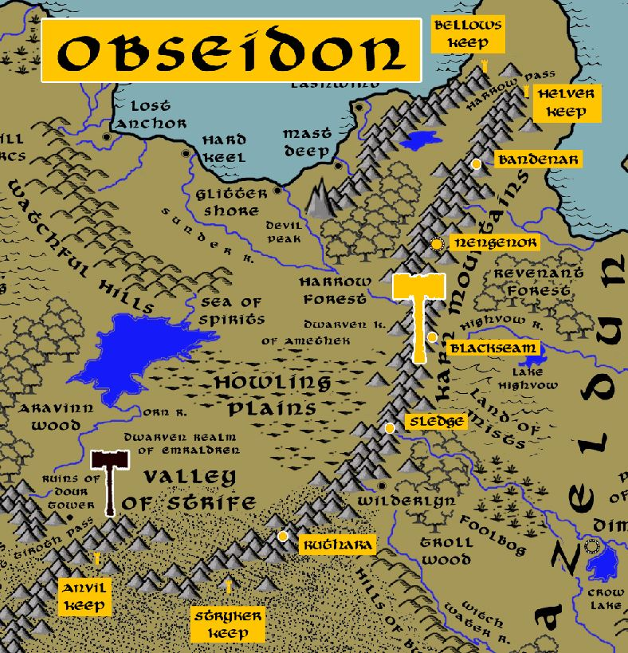

Magical Items

Nine Orbs of Night – magic orbs crafted by the wizard Oolorex in the 150 WA2. Each one contained incredible power, yielding disease, famine, dissension, fear, pestilence, chaos, storms, blight, and death. With them Oorolex united the barbarians around present-day Felldeed and Klessh, as well as orcs and goblins from the Hills of Burden. After a ten-year war Targrim was defeated and the region fell into a period of darkness from which it has never recovered.

The Scepter of Known Names - The Vale of Svarog is known to be home to many fissures that regularly open as portals into the dark planes. Demons and devils frequently appear to wreak havoc. The Molten Queen bears the Scepter of Known Names, by which she can sense any demon or devil and subdue them to her will.

NPC Templates
This is a list of notes and stats to help develop NPC’s relevant to this region.

Developer Notes
This is a list of notes on the development of this document, including notes on history, culture, and changes to the document.

