Notes on the Lands of
Barter Bay and Vigil
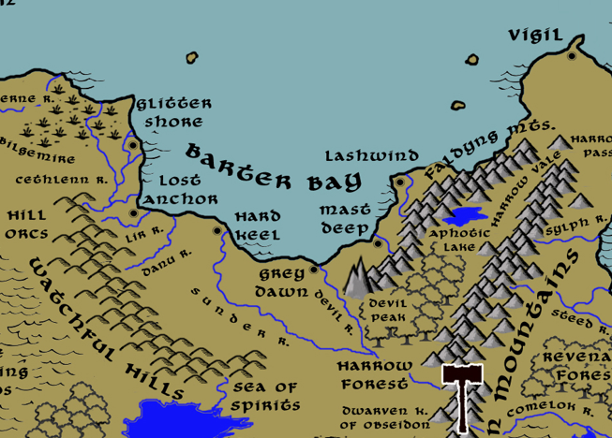

Table of Contents
- Overview
- Towns and Cities
- Best in the Land
- Stewards of Power in this Land
- Points of Interest
- History
- Local Goods
- Notes on Culture
- Weapons and Armor
- Local Deities
- Creatures
- Other Races
- Magical Items
- NPC Templates
- Developer Notes

Overview
Gaeadon is a hybrid continent, a crossroads situated at the center of the world. The massive Karn Mountain range runs from the northeast corner of the land mass at a diagonal, splitting off into the Aketuun and Eldedure Ranges, which head west and form the Vale of Hileia, and the Anlaas and Ember Ranges, which continue on to the southwest and border Svarog Valley. This divides Gaeadon into distinct regions, each of which have a character of their own.

Barter Bay is a loose collection of small towns that that slowly grew from simple fishing and pirate camps as ships passed through. Sea traffic has grown between the Inner Sea and the Myriad Sea along what sailors call the Myriad Route. Light houses stand along the shores, each of them as ancient as the dangerous reef systems here. Barter Bay became convenient to weigh anchor, take on provisions, and unload unsold goods. The six towns have become a sea haven to sailors, smugglers, and pirates and the culture of the towns reflects the salty way of life. No ruler holds dominion over the region, it is independent of outside powers. The kingdoms of Tirudor, Gildran, and Kyre have each attempted to colonize the area or seize control, but to no avail.

At the dawn of ages this was the Morda Bay region, home to the Morden tribes. The Morden dominated northern Gaeadon and ruled the Myriad Sea. Unfortunately, their Queen Netelia carried on a growing tradition of tyranny on the seas that isolated them from allies. Eight thousand years ago the Orcs of Gaeadon converged on the bay hungry for their gold. None of the other civilizations answered Netelia’s summons for help. The Kingdom of Morden was wiped out by Orcs in 380 PA4.

The Sharidia civilization settled here in 430 AA1 and built extensive groundworks and primitive fortifications. When the Celedonian forces arrived in 280 WA1 the Sharidia warriors mounted a fierce resistance. But in two years the superior numbers and tactics of the Celedonians wiped them out. Traces of their civilization can still be found all along the coastline of Barter Bay.

Fourteen hundred years ago the masters of the six towns met and signed a pact to support one another. They also codified the Code of the Cove, by which they agree not to openly make war on one another, not to take up arms with any foreign power against anyone else, and to help one another out in times of dire need.

Towns and Cities
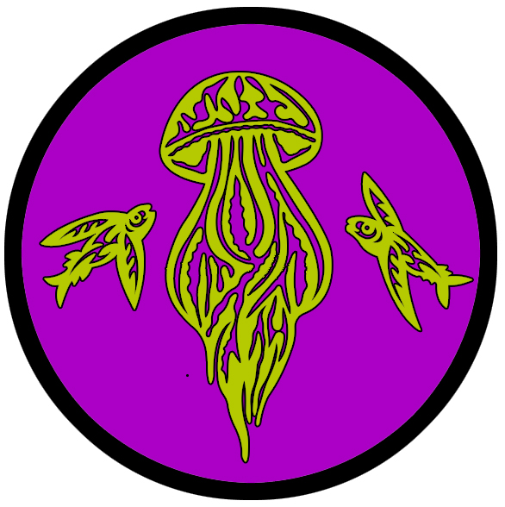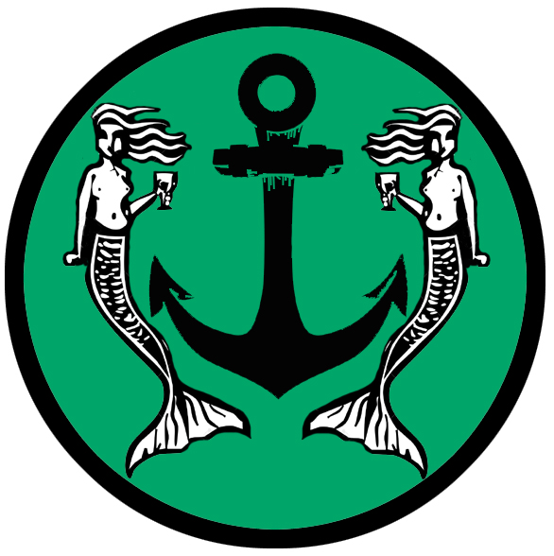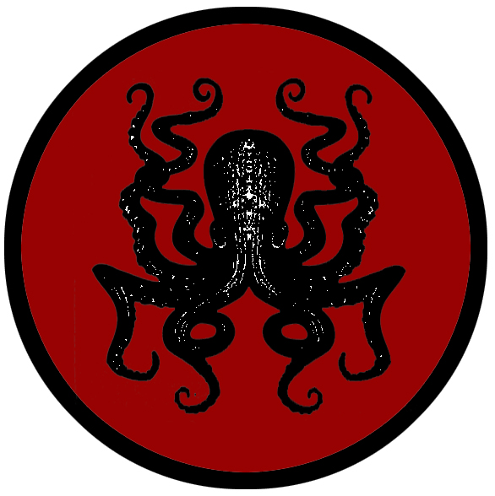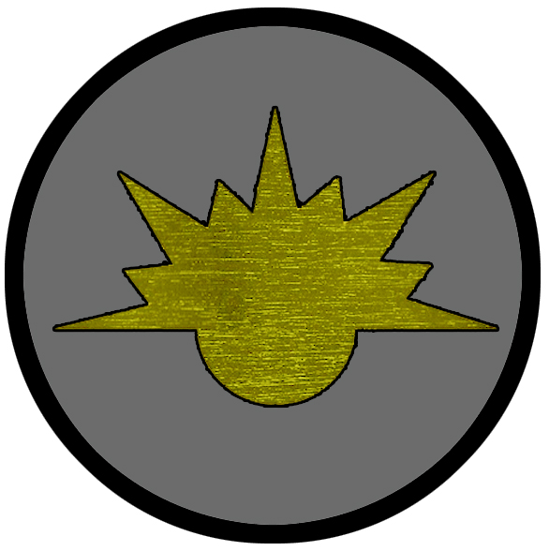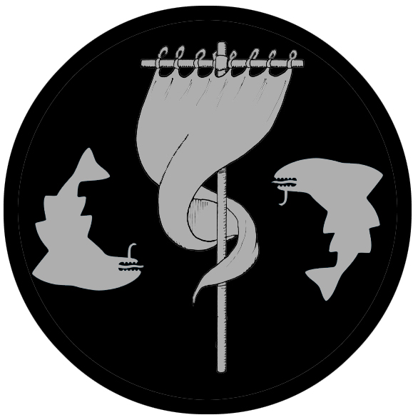

- Barter Bay
  - Glitter Shore – small town, sign of the jellyfish and twin sea turtles
  - Lost Anchor – small town, sign of the anchor and twin mermaids
  - Hard Keel – large town, sign of the black octopus
  - Grey Dawn – large town, sign of the dawn
  - Mast Deep – small town, sign of the ships mast and twin sharks
  - Lashwind – large town, sign of the clouds
- Vigil – large city, sign of the lighthouse

Best in the Land
Trade Hub:
Religion:
Arts:
Magic:
Spirits:
Steel:
Grain:
Crafted Goods (e.g. Pottery, Textiles, Metal Wares):
Harvested Goods (e.g. Aromatics, Medicine, Dyes):
Mined Goods:
Precious Metals:
Ship Building:
Other:

Stewards of Power in this Land
Kings and their armies are not the only wielders of power. There are many unseen friends and foes that shape the destiny of the land. Each of the groups listed below are well known to the people of this region. Some are feared, others venerated. All of them play their part in the grand drama of this land’s story.

Merchant Companies
Dawn's Pursuit Traders – Vigil

Mercenary Companies
Crimson Spears – Vigil

Smuggling Rings
Speckled Fang – Hard Keel

Centers of Worship (Churches, Cathedrals, Shrines, Lodges, Temples)
Temple of the Ventolin - Lashwind
Cathedral of Deepsea - Vigil

Orders of Paladins
Order of Asherah – Vigil

Druidic Circles
Circle of the Coiled Root – Grey Dawn

Bands of Rangers
Band of the Nautilus – Lost Anchor

Schools of Magic
(none)

Bardic Colleges
(none)

Warrior Academies
(none)

Assassins Guilds
Darkmantle – Vigil

Cults
Cult of Vornaron – Mast Deep

Other Guilds
(none)

Monasteries
Monastery of the True Strike - Harrow Vale

Pirates
(none)

Points of Interest
- Barter Bay – formerly the Bay of Morda in the Primordial Ages

- Aravinn Wood
- Harrow Forest

- Howling Plains
- Shifting Lands

- Danu River
- Lir River
- Gowl River
- Sunder River
  - At the fork of the Sunder and Devil Rivers stands the tower of Arianwen (f) of the Reek, Arch Mage of the lands around Barter Bay.
- Devil River
- Sylph River
- Bodach River

- Sea of Spirits
- Kildren Lake

- Bilge Mire
  - Here dwells the Rock Talons tribe of Saurians, known by their sign of the mountain with three sharp peaks.
  - In the waters near here lurk the tribe of Sahuangin known as the Vularagh, known by their sign of the coiling tentacles wrapping around a circular shape.

- Devil Peak
- Faldyng Mts.
  - Here dwell the tribe of Storm Giants called the Ardain, known by their sign of the circular sun overlayed with a crescent moon over water
  - In the waters around here lurk the tribe of Sahuangin known as the Kelvassath, known by their sign of a crown of jagged coral.

- Watchful Hills
  - Here dwells the Shagar tribe of orcs, known by their sign of the hunk of meat with four ribs protruding.

- Harrow Pass – the mountains overlooking the pass are home to the mighty gold dragon Kalameth
  - Site of the Temple of the True Strike, where monks study and train in the ways of Sucellos, god of protection and prosperity
- Harrow Vale
- Seige Valley
- Broken Pass
- The City of the Dead – Alone on the dry wastes of inner Gaeadon sits a crumbling shell of a city. Long ago, Lagren was an oasis of abundance in a land of hardship. But her people were vain and selfish, living in luxury on the backs of their indentured servants. Travelers were turned away with disgust, left to fend for themselves in the wastelands. But one day the crowds cheered watching an aged priest die a slow death within sight of their walls. The priest cast a curse upon the city, that they would never again taste the sweetness of wine or the smell of bread. The people of Lagren laughed, watching him be pulled apart by ankhegs. But years passed. Nothing happened. Babies were not born, the elderly did not die. Slowly the people devolved into shuffling, hollow versions of themselves. Today the city is peopled only with the undead: zombies craving to feel, to taste, to smell anything.

- Hill Orcs

- Emraldren - Dwarven Kingdom
  - Vosakaar - Dwarven town of Emraldren
  - Merlonn - Dwarven town of Emraldren
  - Konaar - Dwarven town of Emraldren
  - Bartizan - Dwarven town of Emraldren
  - Hamaar - Dwarven city of Emraldren
  - Lakunaar - Dwarven town of Emraldren
  - Corbel Keep - Dwarven outpost of Emraldren
  - Ashlar Keep - Dwarven outpost of Emraldren
  - Slagsmelt Keep - Dwarven outpost of Emraldren
  - Graver Keep - Dwarven outpost of Emraldren

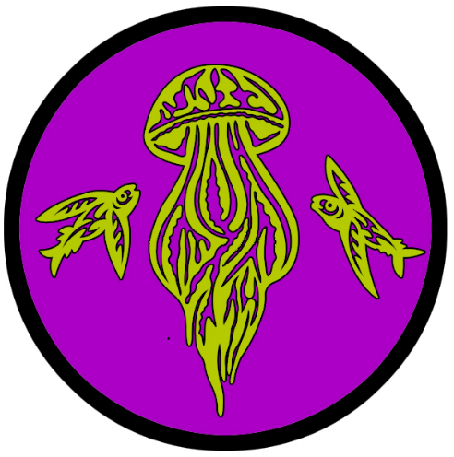
Glitter Shore
Size: small town, population 2,000, guards / soldiers 20, militia 100
Trade Goods: opium
Local Goods: fishing
Standard: jellyfish and twin sea turtles
Colors: purple and gold
Patron Deity:
Ruler: Master Austeyn Preston and his wife Mistress Roseen (f)

Home: Foxglove Keep
Steward: Geoffrey Quelen
Marshal: Erling Bretny
House Priest: Cooil Crayn
House Adviser (Scholar/Mage/etc): Hugo Kynrede
Captain of the Guard: Caly Kyeg (f)
Chief Warriors in Service:
Laurence Gilcobraght
Jamys Browne
Moris Nele

Local Powers: Purple Priesthood (thieves guild), House of Faerie Flower (opium groves), Lamprey Coven (cult)
Local Sites: The Bronze Buckler Inn & Tavern, The Sea Witch Inn & Tavern, House of Juratė (brothel)

Description:
From the shoreline the town of Glitter Shore gives the impression of a gentrified plantation. It boasts impressive stone walls to defend it from the sea and land. The stately manse at the rear of the town houses the town guard and leaders. Surrounding it is a lavish topiary and marble statues imported from all over the world. Here and there are tiny decorative elements that hail from Xiandai.

Industry:
Of all the towns in Barter Bay, Glitter Shore is the most profitable and sought after by wealthy travelers stopping this way. Shops are set up to capture the appeal of more civilized kingdoms of the west. Those who work the sea are housed in a different section of town than that of the shop owners and artisans. Residents discern those with coin, who are ushered to better quarters and treated with more graciousness.

Key Figures:

Master Austeyn Preston - unscrupulous, suspicious, a deal-maker
Master Preston is a short, burly man with dark, squinty eyes, a tousle of unkept brown hair, and an uneven beard. He dresses in a silk shirt under a shabby coat embroidered to appear like that of a naval commander. Preston is an eloquent talker, speaking in many languages and using large, often outdated words. He is a suspicious man, always with an eye on the horizon for trouble. He is also fond of haggling and making deals and will take any opportunity to swindle others. At his side he carries an elegant Tirudoran cutlass. He calls the cutlass Brandishard and has many tall tales of his exploits wielding it. Preston has an unfavorable opinion on the masters of the other Barter Bay towns and is loath to offer them help unless they claim the Code of the Cove.

Mistress Roseen Preston (f) – meek, retiring, young, hopeful

Mistress Preston is a slim, pale blonde with long curly hair and light blue eyes. She has a kind face with delicate features that are only broken by light freckles and frown lines on her brow. She dresses in white gowns with large skirts and a headdress as she is sensitive to the sun. Roseen was young and foolish when she got swept up in Austeyn’s charms. She has studied the workings of the plantation and has designs to take control if her husband continues his unscrupulous ways.

Local Lore:
The Bilge Marshes to the west are home to a clan of Saurians called the Rock Talons. Their mark is the mountain with three sharp peaks. Members of the clan regularly visit the town and often make trouble. Like most port towns, Grey Dawn is accustomed to all sorts of denizens. A dozen or more times in the past there has been open war with the Saurians, but for the last hundred years a truce has been observed. This hasn’t stopped the Rock Talons from wandering in, getting drunk, and running amok. Travelers are advised to steer clear of them.

The Lamprey Coven was an order of witches in the Primordial Ages that was thought to be destroyed. But from time to time their name is chanted in the Bilge Marshes, spreading terror in the region. They are thought to be reforming again today, with bodies staked to old trees at the edge of the swamps as testament to their darkness.

History:
Glitter Shore was once just a pirate camp of the same name. Fifteen hundred years ago Captain Gaeus Harrim fled a Tirudoran warship after a savage battle (940 WA2). He beached his ship, the Rosie Death, to perform repairs. Legend tells that his entire crew vanished over the course of three nights. Some say strange creatures crept down from Bilge Mire and stole them away.

Within the year another group of pirates arrived and found the Rosie Death. They claimed her, marked the spot, and sailed away on adventures. They returned, knowing the shoreline well, and wintered there after burying their treasure. Pages from their logs tell of strange people who bid them welcome from the Watchful Hills. The pirates slew their shaman and ran them off. Soon after, the pirates disappeared just as the original crew of the Rosie Death had. Legend tells of the Rosie Death being claimed and sailed and docked here twelve other times, each with the crew disappearing. Finally the ship was labeled cursed and set ablaze.

Fourteen hundred years ago (10 WA3) an enterprising pirate named Elias Mekkle sailed back from Xiandai with poppy plants and a handful of Xiandai sailors. A farmer’s son, Elias cultivated the crop into a high demand product. Called Faerie Flower among merchants, the opium from Glitter Shore made the camp wealthy enough to build an impressive coastal town. A partnership with the Speckled Fang smugglers in Hard Keel has helped to distribute the opium it produces.

Customs:

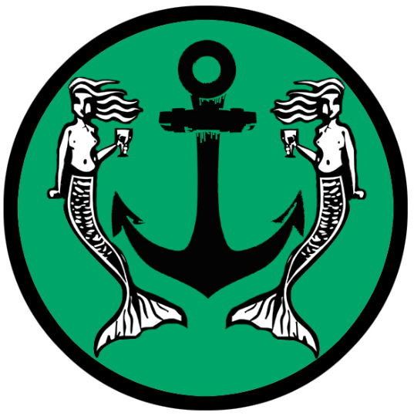
Lost Anchor
Size: small town, population 2,000, guards / soldiers 20, militia 100
Trade Goods: tin, metal wares
Local Goods: fishing
Standard: sign of the anchor and twin mermaids
Colors: green and black
Patron Deity:
Ruler: Master Thorulf Michel and his wife Mistress Caly (f)

Home: Leanstone Keep
Steward: John Cannon
Marshal: Custal Emere
House Priest: Carmick Tereboy
House Adviser (Scholar/Mage/etc): Caly Maderel (f)
Captain of the Guard: Paric Reynylt
Chief Warriors in Service:
Yvor Browne
Adaue Shirlok
Gilandrew David

Local Powers: The Taughtliners (thieves guild), Band of the Nautilus (order of rangers)
Local Sites: The Ferryman Inn & Tavern, The Angry Whelk Inn & Tavern, Daucina’s Grotto (brothel)

Description:
Lost Anchor is by all appearances a fishing village turned small town. What walls the town has are low, of poor masonry, and in disrepair. The land rises gradually up from the coast to a low, flat. Fishing huts along the beach give way to simple wooden cottages festooned with fishing nets, harpoons, lobster cages and other trappings of coastal life. At the top of the hill stands a cluster of larger stone houses and a crumbling tower built by Cormain.

People in Lost Anchor come from all over the world and every walk of life. The atmosphere here is open-minded and there is a strong sense of community. People feel little ownership over possessions, offering to share what they have. Music is appreciated and bards are welcomed warmly. There is a general sense that those who felt lost or dispossessed elsewhere feel they are at home in this place. It is a town of folk who lost their anchors and wandered here to linger a while. The motto of the town is “Tarry and be merry.”

Industry:
In addition to fishing and boat repair, the people work the tin mines in the Watchful Hills. Metal artisans fashion handy metal wares. These began as harpoons and fish hooks. Gnomes from gods-know-where came into the scene and made it a going concern with pots, pans, tools, and all manner of gadgets. What the town lacks in aesthetic appeal it makes up for in contraptions. An elaborate system of pulleys and cables runs through the town. The town guard is trained in working hidden levers to activate bells and signs for everyday use. In times of crisis the pulleys can operate small catapults, scorpions, trap doors leading to pits, man traps designed to disable intruders, and other defenses.

Key Figures:
Master Thorulf Michel - inventive, curious, crazy

Master Thorulf is a thin, wiry man with a bald head fringed by tufts of curly brown hair met in the front by a large bushy beard. His brown eyes twinkle in amusement and he is prone to laughter. He dresses in a leather apron, lined with many pockets for tools, over which he wears a worn overcoat when receiving visitors. Thorulf is a tinkerer and works in a large shop on a variety of inventions. Visitors from the Realm of the Sea Kings seek him out for clever weapons, traps, and other contraptions to use on their ships.

Mistress Caly Michel (f) - natural leader, opportunistic, dreamer, curious

Mistress Caly is a short, plump woman with red cheeks, large brown eyes, and a tangle of curly brown hair. She dresses in simple but elegant gowns and wears her hair in a netted headpiece. Caly is a warm and disarming personality, charming to visitors and welcoming to even the most undesirable guests. She is a smart woman with a good head for running the town while her husband tinkers. She has large plans for Lost Anchor, hoping to see it grow and to become more of a civilized place for the arts and culture.

The Band of the Nautilus is a clutch of rangers that meet in Lost Anchor from time to time. They tend to explore the inner lands of upper Gaeadon, especially the Watchful Hills. Some trek to the Shifting Lands to the west, some as far south as the Sea of Spirits. The casual air of the town draws them to dwell here from time to time and they feel an obligation to protect the place from evils that lurk in the region. They often bring back the heads of bizarre creatures, which are displayed along the main street of the town and add to the colorful feel of the place.

Local Lore:

History:
Nineteen hundred years ago the merchant ship Lucky Star drew in at Grey Dawn to take on fresh water. The next morning the ship had drifted a hundred miles east and beached itself. The captain found the anchor had broken off, leaving the ship to follow the tides. Captain Cormain owed more than his fair share of debts, so he was stuck without many resources. But he was a beguiling man and managed to make friends fast in the region. Before long he’d made camp, opened shop with the rum in his hold, and opened the hull of the Lucky Star as the first building in the area. Before long he’d convinced other peddlers to join him and founded a small town (580 WA2). The wreck of the Lucky Star remains at the center of town to this day.

Customs:
In the tradition of Cormain’s love for parties, every full moon the town celebrates a festival. There is music, food, dancing, and lights on the water. Each festival is different, borrowing from cultures from all over the world. One involves naming a girl from the village the Mermaid Queen and everyone dressing in sea weed as her court.

Another involves feasting on wild boar, naming it The Friday Beast (for Fridays are considered bad luck among sailors), then setting the carcass aflame and out to sea to rid the town of ill fortune. Yet another involves the Raid D’Amour, a mock invasion of the town by the fishermen dressed up as pirates and aiming to steal kisses.

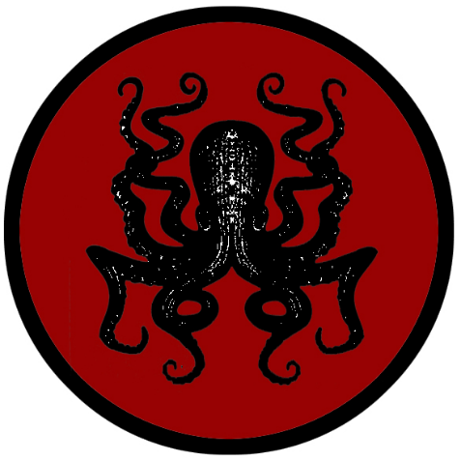
Hard Keel
Size: large town, population 5,000, guards / soldiers 50, militia 250
Trade Goods: fishing, ship-building
Local Goods:
Standard: black octopus
Colors: red and black
Patron Deity:
Ruler: Master Silvester Baye and his wife Mistress Andreca (f)

Home: Gildran Keep
Steward: Anghus Aleyn
Marshal: Kieran Qua
House Priest: Katryna Wode (f)
House Adviser (Scholar/Mage/etc): Rody Hymyn
Captain of the Guard: Reynold Marten
Chief Warriors in Service:
Hugh Stephan
Dolen Quanty
Altar Gibbon

Local Powers: Silken Sharks (thieves guild), Speckled Fang (smuggling ring)
Local Sites: Atargatis’ Grotto Inn & Tavern, The Drunken Whaler Inn & Tavern, Namaka’s Parlor (brothel)

Description:

Industry:
The ancient traditions of Silveron ship building lives on in the processes used in Hard Keel’s shipyard. Hard Keel ships live up to their namesake: the focus of the ship is on speed and the strength of the keel. For this reason, they are ideally suited for pursuit and ramming enemy ships.

Smuggling has become a lucrative side business in Hard Keel. Members of the Speckled Fang are adept at trolling the other ports in Barter Bay and swapping goods to move south through Gaeadon or sell to passing ships. Opium out of Glitter Shore is entrusted to them as they have built up the network of ships and merchants to net the largest profit safely.

Key Figures:
Master Silvester Baye – earnest, conscientious, caring, outspoken

Master Baye is a tall, middle-aged man with graying red hair and a short reddish beard. He has pale blue eyes that look over a large squashed nose. He has broad shoulders and large hands and is an imposing figure. He wears a simple jerkin of dark burgundy that appears to barely contain him. At his side he carries the ancient sword of his family: the longsword Ualach (which translates to “Burden” from ancient Kyrean). It is said to be a sword of justice that bestows strength but at a terrible price. Silvester is an earnest man, filled with compassion for the people of his town and their livelihood and not much else. He is a man of conviction, holding to the sanctity of fair dealings in Barter Bay and quite vocal about it to the dismay of his fellow town masters. He is the reluctant but stubborn conscience of the Bay towns, quick to warn others of danger to their region and always eager to help those in need.

Mistress Andreca Baye (f)

Mistress Baye is a tall, strong woman with short, mousy brown hair and gray, compassionate eyes. She has a noble bearing to her face, in spite of a terrible scar that covers half of it. She speaks in a soft but firm voice and is serene most times but is quick to laughter at a good jest. She wears plain linen gowns lovingly embroidered by the elderly women of the town. At her side hangs a small pouch containing a myriad of rare herbs. She calls the pouch the Mála Sláinte, given to her as a gift by an old crone from Harrow Forest, and it seems to heal almost anything. Andreca is a solid rock on which Silvester depends, for she loves and supports her husband but is brutally honest with him when he is being pig-headed. She cares very little for the politics of the Bay towns, conent to tend to her people. But she joins her husband in pressing the other leaders for the welfare of the region and its people.

Local Lore:

Long ago the Morden people erected a temple to a now-forgotten god. Legends tell of enormous power the Morden wielded recklessly in this land. One of the few remaining monuments to the Morden is a small shrine built atop a rock in the middle of the Sunder River. Atop the shrine stands the Ebony Falcon: an aged stone statue of a giant bird, its wings outstretched. Set into the tops of the wings are brilliant stones of many colors. The Sharidians who settled this region knew better than to disturb the statue. But in 10 AA4 the Kingdom of Gildran colonized Barter Bay by driving out the Sharidians along the Sunder River and founding the fort town of Alirith (present-day Hard Keel). The Gildran soldiers ignored the warnings of the Sharidian to not remove the sacred stones from the river shrine. Some say this act of desecration may be to blame for the fall of Gildran, but others say this is superstition.

History:
Forty-five hundred years ago the Kingdom of Gildran built a fortress at the mouth of the Sunder River in hopes of colonizing northern Gaeadon (10 AA4). They named the town Alirith. The fort sat atop a high, narrow ridge that stabbed out into the bay. Shipwrights from Silveron came over and were set to work building a second fleet to protect the Bay of Banners from the growing pirate threat out of the Gulf of Korsair.

After the fall of Gildran (330 AA4) only a handful of soldiers and town folk were left to carry on at the fort. One of them was Commander Ennis Garland. Knowing his kingdom was lost, he tried to continue in the traditions of their old land. Unfortunately, Garland was a military man and only knew one style of leadership. He instilled in the people a military style of discipline and absolute obedience. This served the fort town well, as barbarians from Kazelduun threatened to wipe out the colony a decade afterwards.

Two hundred years ago the warlord Tiergen the Mad led a war party out of the Howling Plains. He attacked the town and nearly wiped it out. Town folk bravely defended from the fort, but Tiergren was intent on starving them out. It was a paladin from Vigil named Lady Rainia who received a vision and rode to Hard Keel’s rescue. With the help of a group of adventurers accompanying her, they broke the ranks of the war party and defeated them. A statue stands to this day in the main square honoring Lady Rainia.

Over the centuries the history of Gildran faded from memory. Only the old fortress built by the colonizers remains as a memorial, for its original name too has been forgotten but it is now called Gildran Keep. The town folk renamed the settlement Hard Keel after the high, narrow ridge that stabs out into the bay (390 WA2). It is said ancient texts exist somewhere in Hard Keel that tell of the Gildran’s old ways. Most think they were buried with one of the priests. Ships came and went and people from other lands settled here. Now the town is a mix of tongues and cultures. But there are some who claim to be direct descendants of the Gildran settlers.

Customs:

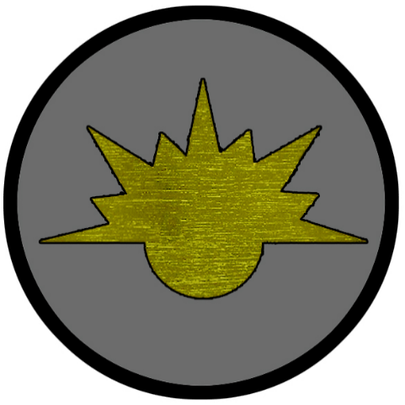
Grey Dawn
Size: large town, population 5,000, guards / soldiers 50, militia 250
Trade Goods: ship building, clay
Local Goods: fishing
Standard: sign of the dawn
Colors: grey and gold
Patron Deity:
Ruler: Master Colyn Tagart

Home: Orodon Keep
Steward: Fynlo Gilvorra
Marshal: Yvar Sharpe
House Priest: Ysaig Waller
House Adviser (Scholar/Mage/etc): Calypatric Brech
Captain of the Guard: Nicholas Cowle
Chief Warriors in Service:
Edmund Brice
Robert Marten
Moleyn Stole
Gilcolm Wilye

Local Powers: The Ransomed Coins (thieves guild), Circle of the Coiled Root (order of druids)
Local Sites: Addled Adder Inn & Tavern, The Salty Seahorse Inn & Tavern, Tsovinara’s Boudoir (brothel)

Description:
The town of Grey Dawn is a cluster of dark tinker-built buildings hidden beneath a low stone wall on a bluff overlooking the sea. An old Tirudoran stone keep stands watch at the highest point. It commands a sandy trail that descends to a stretch of beach that serves as a shipyard. A large brazier at the top of the keep serves as a makeshift lighthouse.

Industry:
Grey Dawn’s shipwrights specialize in cogs, clinker-built, generally of oak, fitted with a single mast and a square-rigged single sail. Their style suits veteran merchants but displeases the aesthetic tastes of most merchant companies looking for sleek appearances. Sturdy in storms, Grey Dawn ships are work horses of the sea and many a sailor who has survived a squall aboard one feels grateful for their design. Timber is floated down the Devil River from the Harrow Forest, where the strange oaks there are said to be of a magical ilk.

The clay found in the delta at the mouth of the Devil River is of exceptional quality. Colored a strange purple, the clays fire easily into pottery that is exceedingly strong. Grey Dawn supplies many of the storage containers for merchants working the Myriad Sea, for they are incredibly durable. A rare portion of the clay found in one particular tidal pool is known for its magical properties. This rare clay is called Skimarel it can be enchanted to be reformed into any shape on command. The final product appears to be kiln-fired clay but is as strong and as durable as metal.

Key Figures:
Master Colyn Tagart - religious, hard work ethic, speaks to the ships, mad

Master Tagart is a lean man of medium build whose limbs are banded with muscle from a lifetime of hard labor. The sun has left his skin a deep bronze and his long, wild mane of dark hair is now a light golden color. He usually dresses in nothing but loose short pants, leaving his feet and upper torso bare. He is constantly at work in the shipyard, carefully noting each step of production and experimenting with designs. Tagart is a man obsessed with boats and the sea, never taking a wife for he claims the sea is his only love. He can often be overheard whispering to the timbers of his ships or wading into the surf to offer sacrifices to the Ventolin wind spirits. A man of common upbringing, he assumed rule of the town after slaying the former master, whom he thought had grown complacent and that the gods decreed a proper disciple of the sea should take over. Most sailors hold Tagart in high regard for his craftsmanship, but most also fear him to be mad. He has no designs on interfering with the other towns of Barter Bay, preferring to foster his shipyards and pleasing the sea gods with his handiwork.

Local Lore:
The town dwells in the shadow of Devil’s Peak, which looms prominently in the distance. Rumors persist of dark creatures coming down from the mountain. At night strange lights can be seen twinkling near its peak. The druids of the Coiled Root convene in town once every three moons and warn the town folk of the evil in the mountains, but few heed the warnings.

Travelers to Grey Dawn may be surprised by the appearance of small, kobold-like creatures that live in the southeast corner of town. These are called the Klaubaterns and are friendly to sailors. Rumor has it that they wandered into Great Dawn from the Watchful Hills and were looking for a home. A shrewd sea captain put a few of them to work on his ship and they seemed to work well on the sea. Now they are regular levees for ships looking for cheap help. Klaubaterns live aboard ships and help sailors and fishermen in their duties. They are merry and diligent creatures, with an expert understanding of most watercraft and an irrepressible musical talent. They have been known to rescue sailors washed overboard and are considered good luck to sailors.

History:
Grey Dawn was the first of the new camps that appeared in Barter Bay since the fall of the Sharidian people. Tirudoran explorers founded the camp of Orodom in 220 WA2. Established as a shipyard by the Tirurdoran navy, it was put under the command of Timoteo Ribero, a famous sea captain. Ribero’s colony took hold and grew, with his son and then his grandson ruling over it. But Ribero the Third’s reckless pursuit of pirates out of the Gulf of Korsair ended in his fleet being destroyed (310 WA2). Tirudor lost interest in Orodom and a large group of boat builders, cooks, and carpenters were abandoned to their own designs. They made the most of it, renaming the camp Grey Dawn and building ships for the same pirates who sank Ribero’s navy. Only the fortress retains the name of the original town.

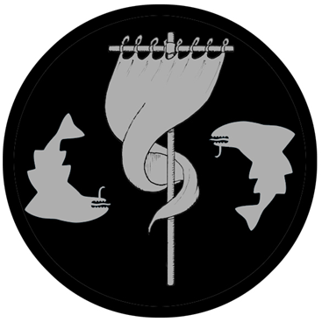
Mast Deep
Size: small town, population 2,000, guards / soldiers 20, militia 100
Trade Goods: cotton
Local Goods: fishing
Standard: mast and twin sharks
Colors: black and silver
Patron Deity:
Ruler: Master Hane Matton and his wife Mistress Conla (f)

Home: Starling Keep
Steward: Juan Bellos
Marshal: Lochlin Kemayn
House Priest: Marcus Quanty
House Adviser (Scholar/Mage/etc): Moirrey Quayes (f)
Captain of the Guard: Fayrhare Cowper
Chief Warriors in Service:
Gilaspic Cluage
Caroly Coryn
Nele Shakerley

Local Powers: Stolen Sonnets (thieves guild), Vornaron (cult)
Local Sites: Pint and Port Inn & Tavern, The Lost Seagull Inn & Tavern, Nanshe’s Lantern (brothel)

Description:
Mast Deep is a reclusive town, protected by a dangerous coral reefs a quarter mile from shore called Trecher’s Teeth. The reefs are hard to see and can tear a ship apart before one even knows there is danger. Sailors avoid this region of the sea, preferring to sail around to Grey Dawn or Lashwind. Only a few seamen know the reefs well enough to steer safely through the Teeth. Littering the waters here are the masts of a hundred ships sunken by the reefs, their tops protruding from the water in all directions and giving the town its name. Strange barnacles cling to the masts, encasing them so that even hundreds of years later they remain as ghosts of the distant past.

The town itself is supported by cotton groves further inland. Proud stone walls encircle the area, with a single tower watching over the front gate. Colorful flowers and ivy decorate the sides of the walls on both sides. A well-manicured topiary is featured in the main square where oil lamps give off a warm glow. The streets are paved with expertly laid flagstones. To anyone not familiar with the history of the town it appears to be the residence of a wealthy noble.

Industry:
Artisans here and in Lashwind fashion sails that are lighter and dry faster than those made with hemp or flax. With no reliable sea route, the plantation owners move their cotton bales over land west to Grey Dawn for export.

Key Figures:
Master Hane Matton – angry, restless, greedy, taskmaster, obsessed with silver in the mountains

Master Matton is a short, hunched man with pale skin and receding red hair that finds new life in fiery mutton chops at the sides of his pudgy face. He has tiny gray eyes that peer beneath menacing eyebrows framing his face into a perpetual frown. He wears a well pressed doublet beneath a sea captain’s coat. At his side is a cudgel he refers to as Cruacaen, which roughly translates from Kyrean to “hard head.” Some say the cudgel causes pain to any who carry it, but only when it draws close to silver. Matton is a miserable overlord to the people of the town. The third of his line to rule Mast Deep, Matton had aspirations to sail abroad and win his fortune. A bad leg kept him from his dreams and instead he suffers the indignity of managing cotton harvests in a backwater town. His greed has the best of him, for a passing traveler left him an ancient book of the Morden people that tells of glittering veins of silver in the Faldyng Mountains. Since then he has poured money and the lives of his workers into exploring the mountains but to no avail.

Mistress Conla Matton (f) - vain, greedy, dalliances with pirates, leader of a cult
Mistress Matton is a long and shapely woman with dark black hair and even darker eyes. She dresses in revealing gowns of rich imported silk and normally strolls around barefoot with a wine goblet in hand. Past the prime of her youth, she is obsessed with her own beauty and in preserving it. Expensive mirrors hang in every room of the Matton villa. Conla openly antagonizes her husband, having long regretted marrying him when she thought he was destined for adventure. She bides her time engaging in trysts with charming pirates who pass this way. She is also secretly a member of an evil cult that meets on the slopes of Devil’s Peak every full moon to worship the old gods of Gaeadon. Conla is a master of poisons and has paid explorers handsomely for strange and magical herbs that grow in Harrow Forest.

Local Lore:
Visitors may note pale humans with distinct green hair that live in the outlying huts and tend to the groves. These are the Kireen. It is said that their ancestors were born of the sea. Others say they sprung from the lands of Gaeadon herself. Their kind appeared in the region generations ago, saying they were a nomadic tribe with no history. They agreed to work on the farms tending to the plants in exchange for the right to stay. They are extremely talented with vegetation. Every three months they trek over the mountains to Harrow Wood to observe the rituals of their people. They are friends to the druids of Glitter Shore, who speak to them in a secret language but will share little of what they know.

Vornaron is an arch demon that is often mistaken for one of the old gods of the Morden. For the last five hundred years he has regularly appeared on and around Devil’s Peak on the full moon. He is a hungry demon that enjoys feasting on the flesh of the innocent. The cult of Vornaron has emerged in Mast Deep, unknown to anyone outside of the group itself. It is Vornaron’s plan to enslave the minds of the town and take over the towns of Barter Bay.

History:
The history of Deep Mast began seventeen hundred years ago (790 WA2). Captain Hiram Larkspur was returning from the east, his merchant ship, The Kilmarnen, full of emigrants and seeds. Trecher’s Teeth gashed his ship and somehow he managed to pilot his way to the shore. There he met a ragged band of survivors from the Tirudoran navy who had managed to make it ashore after an ill-fated pursuit of pirates some years ago. Larkspur united the group into a makeshift community. With the seeds from his hold, they managed to cultivate viable crops including cotton.

Mast Deep has a long friendship with the Dwarves of Obseidon. A hundred years after the Larkspur community landed, a foraging party crossed the Karn Mountains and encountered the Dwarves (890 WA2). The dwarves took pity on the humans and granted them gifts of stone and helped them build respectable cottages and a defensive wall around them. Years later in a gesture of friendship, the hero Airk Braven led a group of warriors to help the Dwarves retrieve a precious amulet stolen by the orcs of Karn (980 WA2). Since then, the Dwarves have built on the alliance with the humans of Mast Deep and have donated expert stonework to the town’s infrastructure.

Customs:


Lashwind
Size: large town, population 5,000, guards / soldiers 50, militia 250
Trade Goods: lead, cotton
Local Goods: fishing
Standard: clouds
Colors: blue and white
Patron Deity: the Ventolin Wind Spirits
Ruler: Master Yuan Craghen and his wife Mistress Edith (f)

Home: Bluster Keep
Steward: Eamon Bell
Marshal: Aspallan Vause
House Priest: Caly Kyeg (f)
House Adviser (Scholar/Mage/etc): Dramona the Tempestuous
Captain of the Guard: Allowe Gawe
Chief Warriors in Service:
Padeen Cashen
Fergus Smyth
Andrew Quene

Local Powers: Lost Wages (thieves guild), The Temple of Ventolin
Local Sites: Bard and Bow Inn & Tavern, The Sea Mither Inn & Tavern, Salacia’s Retreat (brothel)

Description:
Lashwind is built on a high promontory overlooking a wide cove below. The outer walls are painted sky blue and white, as are many of the buildings here. Tall poles with brightly colored banners and windsocks dot the countryside, catching the gusts of wind that seem forever to blow through this place. Large windmills turn lazily on the hilltops. Throughout the streets there hang chimes and pipes that make music from the breezes. If one wanders the countryside one can hear a soft song carried on the wind in this place.

Industry:
The original fishing village here eventually expanded when settlers took note of the rich soil. A second village formed made up of cotton farmers. This later became three villages when explorers found veins of lead in the Faldyng Mountains and laborers specialized in mining. Today the town is the marriage of all three villages, with quarters corresponding to the three trades. The cotton of Lashwind is spun from the turning of the windmills, creating a unique style of fiber. Artisans here and in Mast Deep fashion sails that are lighter and dry faster than those made with hemp or flax.

Key Figures:
Master Yuan Craghen – calm, philosophical, reliable caretaker
Master Craghen is a middle-aged man of medium height and build with soft blue eyes and long gray hair and beard. He dresses in tunics and breeches dyed in dark indigo and slippers and often carries a book wherever he goes. He wears a serene expression on his face and speaks in a low, even voice. Craghen is an even-tempered overseer of the town, making rounds each day to the three quarters and then retiring to his study to read. Some say he was a driven man of great enterprise when his ship passed this way twenty years ago, but now he is a student of history and philosophy content with seeing the town continue on as it always has. Other leaders of Barter Bay find the man cryptic, as any discussions with him seem to reveal no real agenda and usually end in long dissertations from history.

Mistress Edith Craghen (f) – absent-minded, possibly mad, singer, prophetess

Mistress Craghen is a petite woman, short and small of frame, with dark olive skin, auburn hair, and glittering green eyes. She dresses in short, loose gowns of light colors and dispenses with footwear or jewelry. A smile seems always to be on her lips, for she is a carefree spirit. Her mind wanders and she is given to speaking in riddles. Town folk rumor she may be mad. When not tending to her duties she wanders the windy hilltops and sings in a hauntingly beautiful keening voice in a language no one understands. It is said at times she enters a trance-like state after which she utters fortunes of the future.

Dramona the Tempestuous is the town mage and a weather-witch. She is rumored to be over two hundred years old but to all appearances is a lovely young woman. She is the protector of the town and mistress of the winds that threaten her harbor. Some nights she can be seen walking out over the waters, a mighty gale whipping around her as she communes with the elements. The people both love and fear her, including Master Craghen. She is said to hold the Book of Passing, a magical ledger containing every soul who has dwelled in Lashwind. Some even say the book steals the thoughts of the people here and contains untold wisdom and knowledge plucked from the weak-minded.

Local Lore:
Tales tell of the curse that lies on Lashwind. Many ships have foundered on the waters near the coast. Ghosts are said to wander the countryside and even out on the surf, the lost souls of those who perished on the open sea due to the winds. Their keening howls can sometimes be heard on the wind. It is said that if one ventures out alone at night one is at risk of being attacked by the baleful spirits. When the wails swell to a shriek it is said one’s own spirit is taken away.

The chapel of the Ventolin was raised to honor the good-natured wind spirits that look out for fisherman and seafarers. When asked they will provide a gentle breeze that will help those in need back to shore.

Air elementals are said to appear in this area from time to time, drawn from their elemental plane to the enchantments on this region.

History:
The town of Lashwind is named for the strong south-westerly winds that blow in from the Myriad Sea. Sailors alternately bless and curse the winds, for they are mercurial and the giver and taker of fortune on the sea. The town was in fact founded by ships that were blown off course and ended up here. The first of them was a slave ship that ran aground two thousand years ago. The freed slaves found the rich soil a good sign and counted it as fate to make this home (470 WA2).

Customs:
The town folk here are friendly and mild-mannered, leading wistful lives. Visitors may find them detached or forgetful. They are easily distracted by the comings and goings of ships and people, are constantly engaged in gossip, and given to flights of fancy. When pressed for any history of the place, few details emerge. It is almost as if no one has any real roots in the town: they only came by Lashwind within the last year or so, and most people they speak of recently took their leave of the place. Festivals are held almost weekly, but they seem hastily prepared, are short lived, and no one can confirm what they are for. The town and its countryside are doubtless charming, but one finds one’s own mind wandering soon after arriving. In fact, it seems a good place to settle down. Or have we already?

The town folk of Lashwind engage in whistling frequently throughout the day and especially when walking alone at night. Tradition dictates that whistling will frighten away the many spirits feared to dwell in and around the town.


Vigil
Size: large city, population 25,000, guards / soldiers 250, militia 2250
Trade Goods: trade hub, lead, grain, salt
Local Goods:
Standard: lighthouse
Colors: gold and black
Patron Deity: Asherah, mother goddess of the sea
Ruler: Lord Yuan Aystogh and his wife Lady Ainle (f)

Home: Castle Ishara
Steward: Roddy Brew
Marshal: Flan Ince
House Priest: Nel Moresson
House Adviser (Scholar/Mage/etc): Miall Hogeson
Captain of the Guard: Kieran Brewer
Chief Warriors in Service:
Abban Begson
Loghlan Wright
Brendan Sharluk

Local Powers: Dawn’s Pursuit Trading Company, Smiling Strangers (thieves guild), Order of Asherah (paladins), Crimson Spears (mercenary company), Darkmantle (assassin’s guild)
Local Sites: The Clever Coney Inn & Tavern, Duck and Bucket Inn & Tavern, House of Nepra (brothel)

Description:
Vigil is the old guard of the east, the ancient trade port that rivals Darmidia in the mix of people, cultures, goods, and merchants that pass through it. It is the dominant sea power in the Myriad Sea region. The diverse styles of architecture in the buildings throughout the city reflect the city’s long history and the many conquering powers who have ruled it.

The city is built on a high rise in the land that projects out into the sea. The peninsula to the northeast is enclosed by a low sea wall, protecting the market district. A dozen large marinas attach to the shoreline all around the peninsula, some facing east, some north, and some to the west. Depending on the time of year and weather patterns, different sides of the peninsula fare better than others. Clever captains will pay extra for the ‘fair side’ of the ports where the sea is calm for that time of year. This is called paying the “Fair Price.”

Vigil is a melting pot of many peoples from all over the world. Here the east meets west and the southern lands of Mahabar and Kaduru bring their goods to be traded in the western lands rather than hazard the Syren Straits. Markets tend to be segmented into quarters specializing in specific goods, so any given region of the world may be represented in different markets. The residential areas, however, are divided by what lands the residents hail from: the Xiandai Quarter, the Kaduru Quarter, the Moghun Quarter, and so on. Here dwell small fiefdoms of faraway lands where a traveler may see the world in just a few days. Music, food, theater, and dance are showcased in the ‘town squares’ of each residential quarter. The All Gods Forum is a section of the city where places of worship have been erected to almost every god imaginable. Some call it the Pandeithon.

The hallmark of the city is the Vigilant Lighthouse. Standing over three hundred feet tall, it was constructed at the founding of the city of a single stone raised up by ancient elemental magic. The stone has a brilliant white finish flecked with crystals that sparkle in the daylight. The hollowed-out interior has ten levels, each of which are palatial rooms that remain dimly illuminated from the crystals even at night. A powerful orb of light glows at the top level, called the Orb of Vigilance, and has glowed without ceasing for eight thousand years. Sailors for millennia have long seen the Vigilant Lighthouse as a beacon of hope in the darkness when sailing the Myriad Sea.

Industry:
The trading company Dawn’s Pursuit holds enormous power over Vigil’s port and markets. They have cultivated a working relationship with Shining Shore and Galdan in the east, but it was not always so peaceful. It is said that Dawn’s Pursuit employs the deadliest of thieves and assassins to undermine the operations of merchants who do not pay protection. They have also persuaded some pirate ships to work for them, running interference with the pirates out of the Gulf of Korsair to protect their more valuable vessels.

Key Figures:

Lord Yuan Aystogh – manipulative, cruel, cunning, obsessed with power

Lord Aystogh is a thin man of noble bearing. Of Kaduru descent, he is dark-skinned with dark, discerning eyes. He wears his hair short and is clean-shaven. His typical attire is close-fitting robes of the highest quality silks embroidered in gold. On his head he wears the ancient crown of Kyriarchia (“Crown of Dominion”) first crafted by the Morden Kingdom eight thousand years ago for the ruler of Vigil. Yuan is a mild-mannered gentleman of refined tastes. He speaks a dozen languages and is proficient in many customs of the east. He is also a master of manipulation, able to appease the many powers of the east with an assortment of charm, guile, and threats. He has a firm grip on the reins of the Dawn’s Pursuit trading company and leverages his Crimson Spears militia with brutal efficiency. Lord Aystogh affects an air of piety to keep the paladins of Asherah on his side, encouraging them to scour the lands for ancient magic artifacts which he collects. He is an unscrupulous man driven to power and has visions of ruling all of the Myriad Sea region and beyond.

Lady Ainle Aystogh (f) – elitist, patron of history and the arts, indifferent

Lady Ainle is a ravishing beauty, a woman of Mythenian descent with olive skin, dark hair, and sensuous dark eyes. She wears the finest gowns, sometimes several in one day, and is always bedecked with valuable jewels. She is a cunning woman, happy to support her husband in his pursuit of power. When she is not pulling the strings of power in Vigil she is an avid supporter of history and the arts. Ainle has commissioned expeditions all over the world to retrieve ancient treasures to display in the palace and throughout the city. Her palanquin tours the city once each week to inspect her many statues, tapestries, and buildings. She particularly enjoys the fanfare of the citizens and is amused at the state of squalor among the slums of the city.

Crimson Spears - The enormous trade revenue brought in has allowed Vigil to arm itself to keep outsiders from wresting power away again. The mercenary company of the Crimson Spears makes Vigil its home. When it is not commissioned to fight in wars abroad it is on retainer from the masters of the city to act as its defense.

Local Lore:
Legend tells of the ashrays, or Water Lovers, that lurk in the waters around Vigil. They are completely translucent water creatures that are often mistaken for sea ghosts. They can be both male and female and can be found only under water. Being completely nocturnal, one would never come across such creatures during the day. When captured and exposed to sunlight ashrays supposedly melt and only a puddle of water remains.

Although the city is open to all religions, the original patron goddess for Vigil was Asherah, mother goddess whose title is "She Who Walks Upon the Sea.” She remains the patron goddess for natives of Vigil and is sought after for blessings on the ships and sailors who come here. A large statue of Asherah stands fifty feet tall atop an atoll two miles out to sea. The paladins of the Order of Asherah call Vigil their home and defend the city and her independence. They are specially trained in combat on the open sea and have their own fleet of small war ships. They are often called into quests abroad to gather magical weapons that they collect in their armory.

History:
Founded eight thousand years ago by the Morden (130 PA4), Vigil has had many masters. In 380 PA4 it fell when orc tribes destroyed the Kingdom of Morda, only to be liberated a hundred years later by the Kazeldun warlord Dractus (496 PA4). After Dractu’s defeat the city was settled by people from many lands and became an independent power for the first time. Three thousand years ago it was taken over by the Celedonians at the high-water mark of their eastern expansion (600 WA1). The Ladon Legion was garrisoned here and built strong outer walls to reinforce the inner stone curtains of the main city complex. They built a massive shipyard from which they hoped to launch further expansion into the Myriad Sea. Then in 880 WA1 the Ladon Legion broke with Celedon and formed the Eastern Imperium. This lasted almost two thousand years as one minor emperor after another was crowned and the city infrastructure expanded. Eight hundred years ago the warlord Gezeryzodd took the city and Kazelduun dominated the trade lanes to Xiandai for two hundred years (680 WA3), after which it feell to the great Moghun Invasion of Gaeadon (900 WA3). Tirudor and Kyre have also made assaults on the city but their occupations were short lived. Four hundred years ago the Fall and Rise of Vigil took place, where the land barons of the city’s surrounding lands united and overthrew the Tirudoran baron ruling at that time (80 WA4). For the last four hundred years it has returned to being an independent power and has built up its defenses to stay that way.

Customs:
The people of Vigil have a very worldly view. They tend to be tolerant of, and well versed in, multiple cultures and their customs. They are amused by the looks on visitors’ faces who are seeing other cultures for the first time. Residents hold to a friendly custom of comparing gods when speaking with their neighbors from other lands, usually making good sport of their different faiths. A merchant from Xiandai might say to a merchant from Kaduru, “Farewell, my friend. May Nüwa grant Oya a tiny fraction of her beauty,” to which the Kaduru merchant may say, “Be well, my friend, and may Oya grant Nuwa a tiny fraction of her infinite wisdom for all know that Nuwa could use it.”

History of Barter Bay and Vigil

First Primordial Age (PA1)
510 PA1 – Dawn of the Morden people
Second Primordial Age (PA2)
870 PA2 - Rise of the Kingdom of Morden in present-day Barter Bay

Third Primordial Age (PA3)
100 PA3 - The sea hag Isidore Murik captures and slays Gwyneira queen of unicorns and forms the Lamprey coven, uniting the hags from around the bay region

370 PA3 - the ship Crested Kestrel sinks in the Myriad Sea, taking with it the bodies of six saints being returned west for burial

400 PA3 - the Dark Reign of the Hags: after forty years of searching, the Lamprey Hags retrieve the six saints from the Myriad Sea and harness the power of their relics

400-500 PA3 - the Dark Reign of the Hags: the hags of the Lamprey coven wreak unspeakable horrors on the Morden people

500 PA3 - Ellan Vannin and her band of heroes slay Isidore with the Seven Radiant Rings; the Lamprey coven is broken and the relics of the saints tossed into the sea

Fourth primordial Age (PA4)
130 PA4 - the city of Vigil is founded by a long forgotten Gaeadon civilization

380 PA4 - Fall of the Kingdom of Morden; Orc armies converge on the Bay of Morda and utterly destroy the settlements there; invaders from Arxis and Estarra abandon the region

496 PA4 - Dractus sends armies north and west, around and over the Karn Mountains; conquers Vigil and Barter Bay, invades interior of Gaeadon

535 PA4 - with word of Dractus' death, the city of Vigil is restored to independence

872-888 PA4 - The Wizard War: Telemechus triggers a world-wide war of mages, some of whom march on Ongolk to stop him and some who join him in attacking the ley lines in their lands; epic battles wage all over the world, destroying cities and upsetting the balance of magic
888 PA4 - The Battle of Forlorn: Telemechus is slain but not before rupturing the magical ley lines permeating Nemmyrl; the victorious general Dragan of Celedon seizes the opportunity to rid the world of magic and ruptures the Singularion as it is embedded in the ley lines; the resulting explosion sends a shock wave that ruptures the magical ley lines around the world and triggers the Dead Century

First Ancient Age (AA1)
430 AA1 - Sharidian civilizaton settles present-day Barter Bay

Second Ancient Age (AA2)
300 AA2 - Sharidian Kingdom is established in present day Barter Bay region

Third Ancient Age (AA3)

Fourth Ancient Age (AA4)
10 AA4 - Kingdom of Gildran colonizes Barter Bay by driving out the Sharidians along the Sunder River and founding the fort town of Alirith (present-day Hard Keel); they ignore the warnings of the Sharidian to not remove the sacred stones from their temple

330 AA4 - Fall of the Kingdom of Gildran: Alirith becomes a town of dispossessed refugees from Gildran

340 AA4 - Barbarians out of Kazeldun march on Alirith (present day Hard Keel)

First Written Age (WA1)
280 WA1 - Celedonians invade present-day area of Barter Bay in Northern Gaeadon

282 WA1 - Celedonian Secundus navy takes Barter Bay and the Phlegon Legion sacks the coastal towns; Celedon burns the settlements to the ground to punish the resistance mounted by the Morden; fall of the Morden civilization

360 WA1 - Celedonian Phlegon Legion marches south from Barter Bay into Gaeadon and meets huge resistance from orc tribes

440 WA1 - Celedonian Phlegon Legion attempts a second invasion of the interior of the Gaeadon lands, half of them lost in the Shifting Lands while half make it to the Sea of Spirits

600 WA1 - Celedonian Secundus navy besieges the city of Vigil

630 WA1 - Vigil falls, Celedon controls most of Gaeadon; Ladon Legion forms a garrison in Vigil

880 WA1 - Ladon Legion in Vigil breaks with Celedon and forms the Eastern Imperium, which includes the ships of the Septimus fleet

Second Written Age (WA2)
220 WA2 - Timoteo Ribero of Tirudor colonizes Gaeadon in Barter Bay and begins the town of Orodom

310 WA2 - Timoteo Ribero the Third's fleet is destroyed by pirates from the Black Coast

390 WA2 - the port town of Alirith is renamed Hard Keel

470 WA2 - the first of many ships wander into Barter Bay, driven there by the winds and fate; they begin to form a camp that will go on to be the town of Lashwind

580 WA2 - merchant ship Lucky Star beaches itself in Barter Bay, Captain Cormain establishes town of Lost Anchor

790 WA2 - the Kilmarnen beaches in Barter Bay, Captain Larkspur establishes the town Mast Deep

812 WA2 - foraging party from Mast Deep crosses the Karn Mountains and encounters the Dwarves of Obseidon, establishing an alliance

833 WA2 - the pirate ship Rosie Death runs aground at the mouth of the Cethlen River and its crew disappears

855 WA2 - the hero Airk Braven of Mast Deep leeds a group of warriors to help the Dwarves retrieve a precious amulet stolen by the orcs of Karn

Third Written Age (WA3)
10 WA3 - pirate Elias Mekkle returns to Glitter Shore with poppy plants from Xiandai; he converts the pirate camp into a town and begins an opium industry

680 WA3 - Fall of the Eastern Imperium: Kazeldun war chief Gezeryzodd conquers the city Vigil; Kazeldun dominates the trade lanes to Xiandai for two hundred years

852 WA3 - Vigil conquered by Moghun invasion; Kazeldun overlords driven out

Fourth Written Age (WA4)
80 WA4 - Fall and Rise of Vigil - Moghun overlords cast out, Vigil becomes a free city

Local Goods of Barter Bay
Cereals: wheat, spelt (wheat), barley, oats, rye
Fiber: cotton, hemp, flax
Fruits: blackcurrant, damsons, juniper berry, pear, raspberry, bilberry
Meat and poultry: beef, pork, boar, chicken, lamb, mutton, duck, geese, pheasant, quail, venison, veal, rabbit, goat
Nuts: chestnuts, hazelnut
Vegetables: angelica, cabbage, parsnips, radish, rapeseed, turnip, potatoes, carrots
Herbs: caraway, dill, hops, tarragon, thyme, oregano, wormwood, ramson, borage, celery, chives, gale, horseradish, juniper, mugwort, southernwood, water cress
Oils:
Fermented Drink: beer (ale, lager, malt, stout) with the following types: amber, blonde, brown, cream, dark, pale, strong, wheat, red, pilsner, golden, fruit, honey, and merchant; wines red and white
Salt-water fish: herring, cod, oysters, mussels and scallops
Fresh-water fish: pike, carp, bream, perch, lamprey, and trout
Wood: willow, alder, ash, beech, birch, chestnut, fir, hornbeam, larch, oak, pine, poplar, spruce, walnut, sycamore
Textiles:
Dishes:
All sop (pieces of bread served with broth, soup or wine, salt water)

Local Goods of Vigil

Cereals: wheat, emmer (wheat), spelt (wheat), einkorn (wheat), durum (wheat), barley, oats, rye, millet
Fiber: hemp, flax
Fruits: pear, apples, figs, plums, vitis vinifera (grapes), black mulberry, cornelian cherry, date palm, fig, grape (called raisin, sultana, or currant when dried), jujube, olive, pomegranate, sycamore fig
Meat and poultry: beef, pork, chicken, lamb, mutton, duck, geese, rabbit, goat
Nuts:
Vegetables: pea, turnip, olives, beets, broccoli, brussel sprouts, cauliflower, kale, kohirabi (turnips), broad bean, lentil, chickpea, lupin beans
Herbs: ajwain, anise, centaurium, coriander, cumin, fennel, hyssop, garden cress, lavender, mahaleb cherry, myrtle, nigella, oregano, olive, rocket, rosemary, rue, sage, saffron, savory, sesame, sumac, thyme, black lovage, mastic, samphire, pennyroyal, calamint, pine nuts, purslane
Oils: linseed (flax), sesame oil, olive oil, palm oil
Fermented Drink:
Salt-water fish: sardines, anchovies, yellowfin tuna, red mullet, ray, swordfish, sturgeon, squid, octopus, shellfish, skaren (probably parrotfish - cheapest of fish)
Fresh-water fish: eels, pike fish, carp, catfish, mullus aka the goatfish (its scales turn red when dying out of water, often used as a meal presentation)
Wood: lignum vitae (also called guayacan), loquat, quince, fig, pomegranate, carob, mulberry, almond, cypress, palm, eucalyptus, olive, stone pine,
Textiles:
Dishes: tracta (bread, pastry, or pancake), testaroli (pasta or bread prepared using water, flour and salt, which is sliced into triangular shapes), melas zomos or black soup (soldier food a staple soup made of boiled pigs' legs, blood, salt and vinegar), acquacotta (hot broth-based bread soup, a peasant food of stale bread), lucanica (short, fat, rustic pork sausage), placenta cake (many dough layers interspersed with a mixture of cheese and honey and flavored with bay leaves, then baked and covered in honey), oxygala (yoghurt and honey), moretum (herb cheese spread made of herbs, fresh cheese, salt, oil and some vinegar), jusselle (broth-based soup dish prepared using grated bread, eggs, sage and saffron), garum (fermented fish sauce, universal condiment and almost replaces salt, production within a city is forbidden due to the smell), focaccia bread, flatbread, mixture of ground, lean meat mixed with fat by grinding, sieving, or puréeing the ingredients such as pork, fish, game meats, poultry, game birds, veal, and pork livers)

Notes on Culture

Weapons and Armor

Local Deities

Creatures
Vornaron is an arch demon that is often mistaken for one of the old gods of the Morden. For the last five hundred years he has regularly appeared on and around Devil’s Peak on the full moon. He is a hungry demon that enjoys feasting on the flesh of the innocent. The cult of Vornaron has emerged in Mast Deep, unknown to anyone outside of the group itself. It is Vornaron’s plan to enslave the minds of the town and take over the towns of Barter Bay.

Bodach
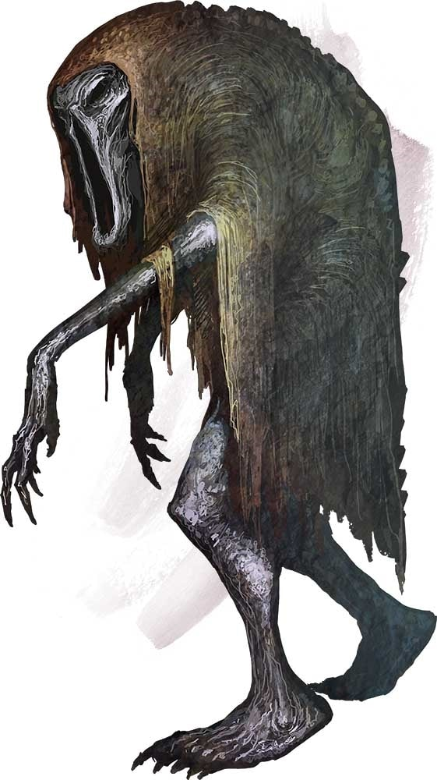

Other Races
Elves

Dwarves
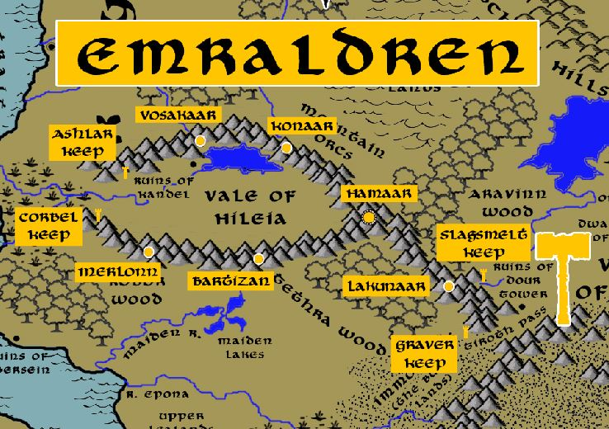

Magical Items
the Ebony Falcon: an aged stone statue of a giant bird, its wings outstretched. Set into the tops of the wings are brilliant stones of many colors. It stands atop a small shrine built onto a rock in the middle of the Sunder River near Hard Keel. It is said it was built by the Morden people and that the gems are not to be disturbed. The last settlers to do so recklessly were from the kingdom of Gildran, which fell just a few centuries later.
Cruacaen - a cudgel, the name of which roughly translates from Kyrean to “hard head.” Some say the cudgel causes pain to any who carry it, but only when it draws close to silver. Carried by Master Matton of Mast Deep.
Book of Passing - a magical ledger containing the names of every soul who has dwelled in Lashwind. Some even say the book steals the thoughts of the people living in the town and contains untold wisdom and knowledge plucked from the weak-minded. It is carried by Dramona the Tempestuous, the town mage and a weather-witch.

Crown of Kyriarchia – Ancient crown of the city of Vigil forged eight thousand years ago by the Morden people. It was lost for centuries but retrieved and is now worn by the ruler of Vigil. Imbued with powerful spells, the crown grants supernatural powers to its wearer, including long life, increased vitality, and access to many spell-like abilities that vary depending on the alignment of the wearer.
Skimarel – a rare clay found in a special tidal pool at the mouth of the Devil River. It can be enchanted to be reformed into any shape on command. The final product appears to be kiln-fired clay but is as strong and durable as metal.

Ualach - ancient sword of the Baye family, it is a magic longsword said to be a sword of justice that bestows strength but at a terrible price. Its name translates to “Burden” from ancient Kyrean.
Orb of Vigilance - A powerful orb of light that glows at the top level of the Vigilant Lighthouse in the city of Vigil and has glowed without ceasing for eight thousand years.

Mála Sláinte - a small pouch containing a myriad of rare herbs that seems to heal almost anything. Currently worn by Andreca Baye, mistress of Hard Keel, who received the pouch as a gift by an old crone from Harrow Forest.
Nine Stars of Malyonus – first witnessed by the Tebri wise man Malyonus when they fell from the sky in the First Primordial Age, these meteorites possess great power that is impossible to control; they were collected by Malyonus and studied before hidden by the wise man for the sake of mankind. Years later the necromancer Ylcerthon retrieved them and wrought terrible destruction on the lands of central Gaedon during the War of the Nine Stars. Ylceerthon the lich was destroyed in 341 WA2 and the stones sealed in a magically warded caskets and thrown into the sea.
Book of Plagues – written by Ylcerthon the Depraved in 38 WA2, it was used to create the City of the Dead, find the Nine Stars of Malyonus, and wreak terrible destruction in central Gaedon during the War of the Nines Stars. Ylceerthon the lich was destroyed in 341 WA2 and the book sealed in a magically warded casket and thrown into the sea.

NPC Templates
This is a list of notes and stats to help develop NPC’s relevant to this region.

Developer Notes
This is a list of notes on the development of this document, including notes on history, culture, and changes to the document.

