Notes on the lands of Mythenia

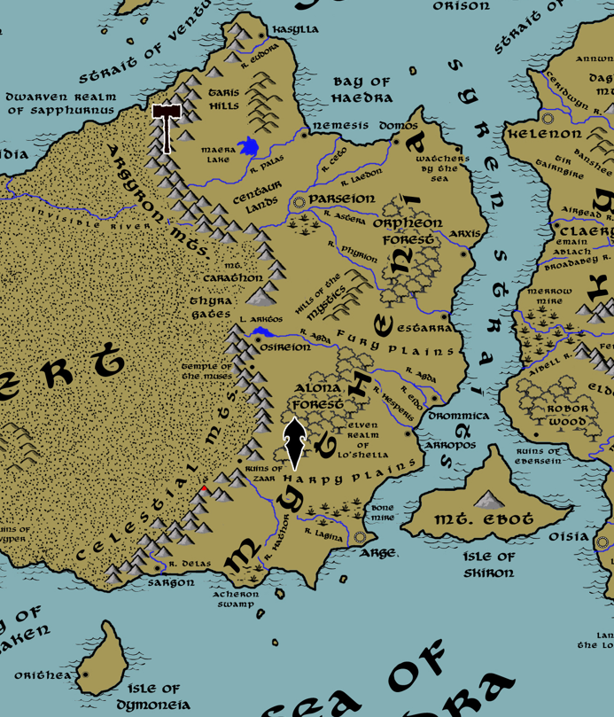

Table of Contents
- Overview
- Towns and Cities
- Best in the Land
- Stewards of Power in this Land
- Points of Interest
- History
- Local Goods
- Notes on Culture
- Weapons and Armor
- Local Deities
- Creatures
- Other Races
- Magical Items
- NPC Templates
- Developer Notes
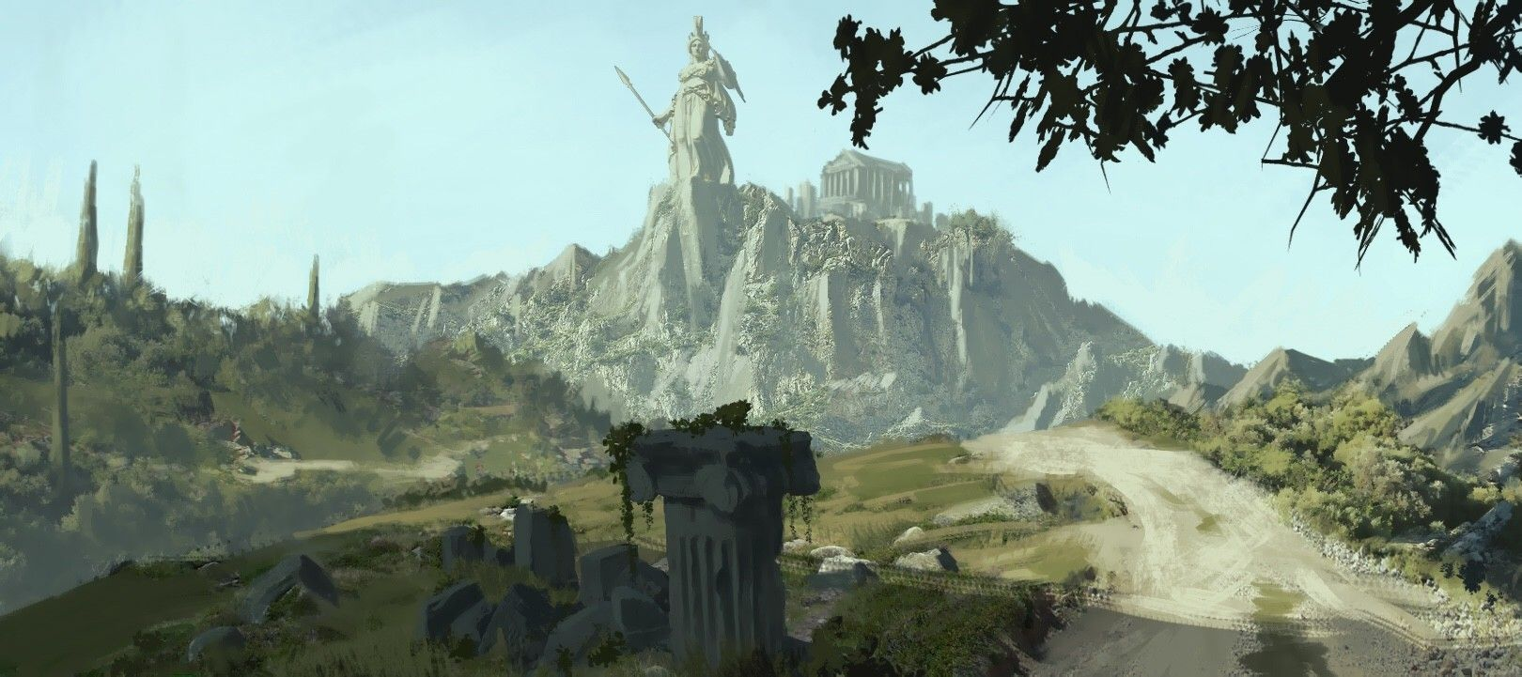

Overview
The Mythenian culture is a long-lived one, dating back to the Primordial Ages. The first peoples here called themselves Akerons, followed by the Prodians in the Ancient Ages. Today the tribes in this land are simply known as Mythenians.

Mythenia is an ancient land with a long history of building civilization and culture. While the peoples of Western Amadar were feuding barbarians thousands of years ago, Mythenians were already refining language and scholarly studies. Research into magic began here; some of the fundamental tenets of both divine and arcane magic were established millennia ago. The ancient Library of Sargon is said to contain texts dating back to the dawn of time.

Mighty armies have marched from here across the face of the Arnland continent and sailed on expeditions to Gaeadon, Kaduru, and Central Amadar. Scholars from this land started orders of learning half a world away millennia ago. All that are left of these now are crumbling ruins filled with dark secrets.

Today Mythenia is a land of independent city-states with an egalitarian mindset about rule. Each town or city is ruled by an Archon. The north is dominated by the metropolis of Parseion, the south by Argeia; the rulers of both powers still style themselves as kings. Most towns and cities are still based on fishing and exploring the sea.

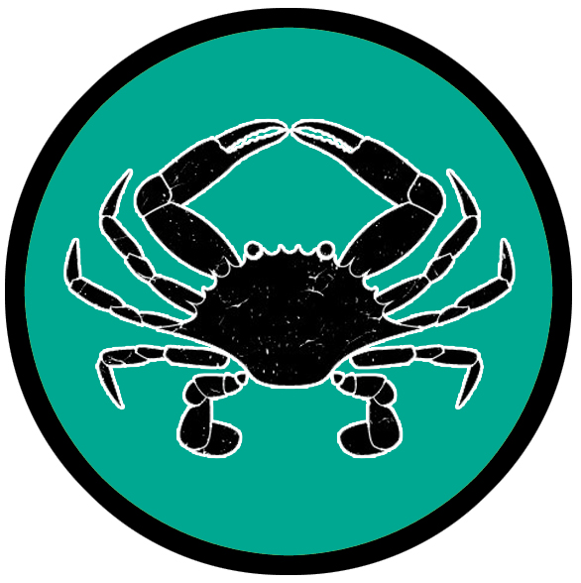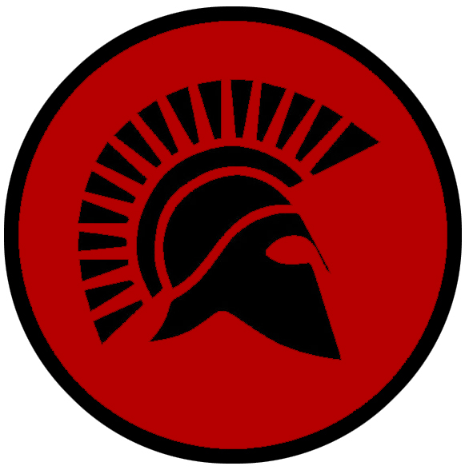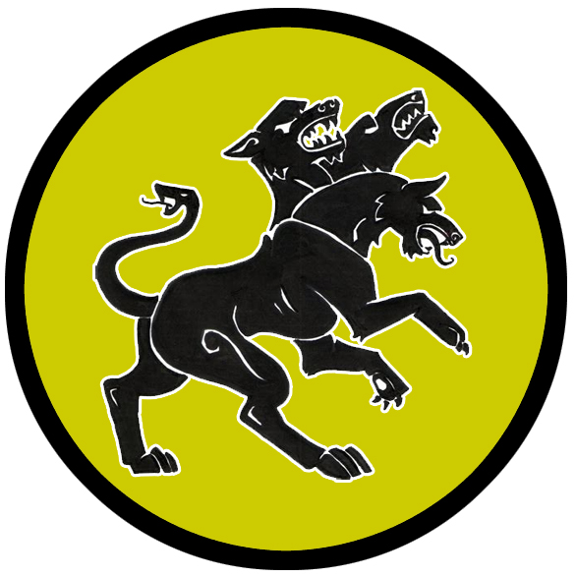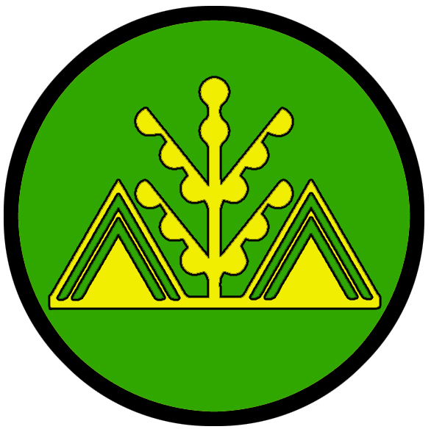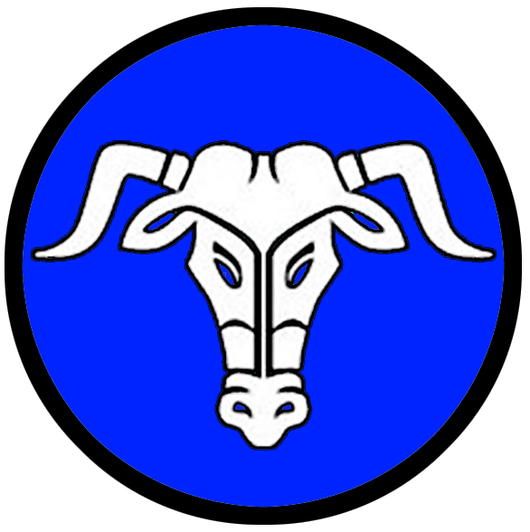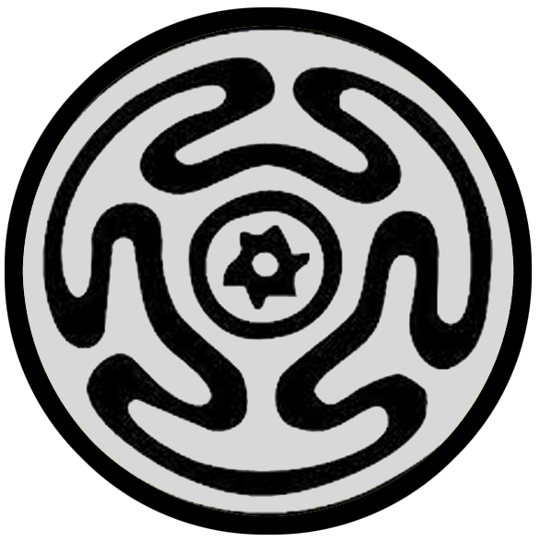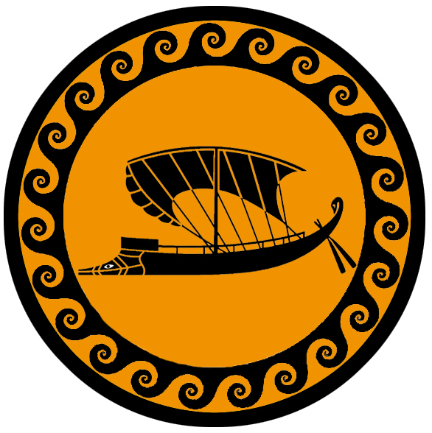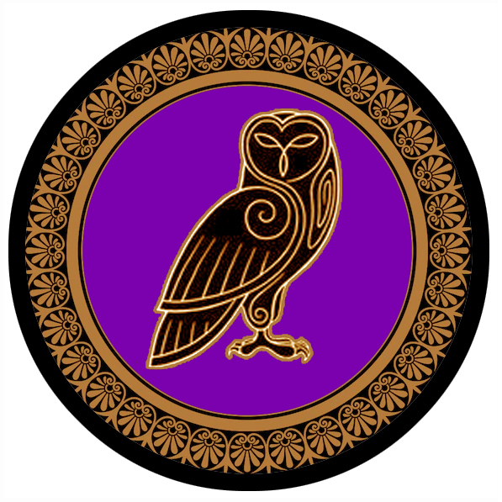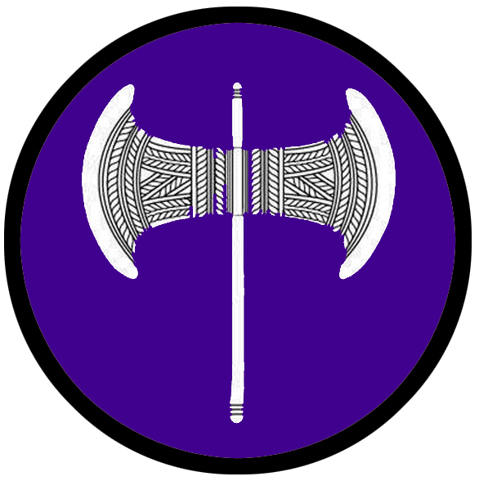

Towns and Cities
- Kasylla – large city, sign of a crab
- Nemesis – small city, sign of a helmet
- Domos – small city, sign of a trident
- Parseion – metropolis, sign of the cerberus
- Arxis – large town, sign of the olive tree
- Estarra – small town, sign of the Star of Vergina
- Osireion – small town, sign of the minotaur
- Drommica – large town, sign of Hecate’s Wheel
- Arropos – small city, sign of the trireme
- Argeia – large city, sign of the pegasus
- Sargon – large town, sign of the owl
- Elefthireia: Dymoneia – small city, sign of the silver labrys

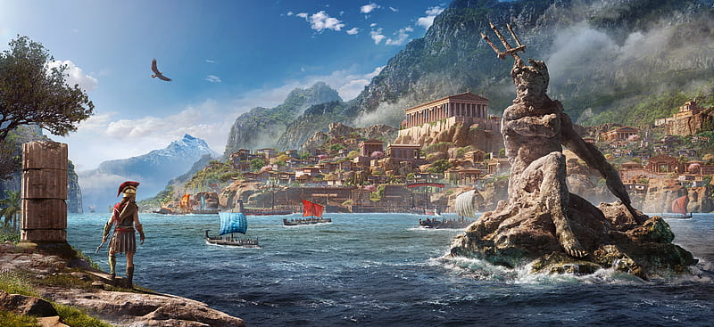

Best in the Land
Trade Hubs: Kasylla, Argeia
Timber and master woodworks: Arxis and Estarra
Stone masons: Sargon
Metal Works: Osireion
Ceramics: Domos
Theater and Garment District: Parseion
Arts and sculptors: Arropos
Advanced Infantry: Nemesis
Magic: Parseion
Historical Research: Sargon
Ship Building: Argeia
Rare Medicines: Arxis
Grain: Parseion and Arropos
Spirits: Drommica

Stewards of Power in this Land
Kings and their armies are not the only wielders of power. There are many unseen friends and foes that shape the destiny of the land. Each of the groups listed below are well known to the people of this region. Some are feared, others venerated. All of them play their part in the grand drama of this land’s story.

Merchant Companies
Arion Traveler Merchants – Kasylla
Gold Trident Traders – Argeia

Mercenary Companies
The Agema – Nemesis

Smuggling Rings
Geryon Syndicate – Nemesis
Sons of Autolycus - Argeia

Centers of Worship (Churches, Cathedrals, Shrines, Lodges, Temples)
Temple of Nerites - Kasylla
Temple of Thanatos - Nemesis
Temple of Psamathe - Domos
Temple of Selene - Parseion
Temple of Cybele - Arxis
Temples of Iris and Helios - Estarra
Temple of Kratos - Osireion
Temple of Soteria - Drommica
Temple of Glaucus - Arropos
Temple of Aidos - Argeia
Temple of Eidyia - Sargon
Temple of the Heavenly Queen - Elefthireia, Isle of Dymoneia

Orders of Paladins
Order of Empyrea - Domos
Order of the Winged Stallion - Parseion
Aretean Order - Argeia
Order of Euryleia - Elefthireia

Druidic Circles
Order of the Dryad – Estarra

Bands of Rangers
Band of the Centaur – Osireion

Schools of Magic
Corvus Sanctum (Order of Hecate) - Parseion
Coven of the Oneiromancers - Osireion
Collegium Cogitor - Sargon
Sanctum of Orithia - Elefthireia

Bardic Colleges
Aulos Amphitheater – Parseion
Barbiton Amphitheater – Arropos
The Epigonion – Elefthireia

Warrior Academies
Hall of Eudorus – Elefthireia

Assassins Guilds
Hemlock – Argeia

Cults
(none)

Other Guilds
Halls of Hephaestus (art institute)
Hall of Hestia (threshing house)
Great Library of Sargon – Sargon

Monasteries
Temple of the Stone Sentinels - Mythenia, Taris Hills
Temple of the Second Sight - Mythenia, in the Argyron Mountains
Temple of the Eternal Loop - Mythenia, Orpheon Forest
Temple of the Sprouting Shoot - Mythenia, Alona Forest
Temple of Brightest Day - Mythenia, in the Celestial Mountains
Temple of the First and Final Question - Mythenia, Southern end of the Celestial Mountains

Pirates
(none)

Points of Interest
- Isle of Skiron
  - Within the waters around here lurk the tribe of Sahuangin known as the Azlakkren, known by their sign of the anglerfish lure in the center of dark lines.
- Euryale – Sea Elf Domain
- Akmon Mt. – “Anvil Mountain” so named for an obscure god of old who worked his divine anvil teaching humans how to craft weapons and tools. It is said during times of great upheaval lighthing can be seen striking the mountain repeatedly for days on end. Sages have chronicled the mighty storms that have buffeted the mountain top, leading them to believe Akmon himself is sounding his approval (or displeasure). Explorers have ventured here to investigate, but many do not return. Those who have tell of a bowl-shaped depression at the top that glows eternally from the heat of the cosmic labors performed upon it. Some even tell of mighty weapons that daring wizards managed to craft here, imbuing them with divine energy.
  - home to the bronze dragon Kalos

- Isle of Dymoneia - 236 PA2 - the freed slaves escape to the nearby island of Dymoneia while Calaithe and a small host battle Akeron forces in Sargon to cover their escape; 240 PA2 - the sorceress Orithia discovers the Cradle of Life; the women assume the culture of amazons and proclaim the Isle of Dymoneia a sovereign kingdom

- Strait of Venture – a very busy strait between the Isle of Solas and the Arnland coastline, grants passage between the Ferrago Sea to the west and the Inner Sea to the east and is the site of much sea trade between the two halves of the world
- Bay of Haedra – The Portico to the Inner Sea, the Bay of Haedra has a northwestern face welcoming sea traffic from the Straits of Venture and Gales. It also hosts the ports of Nemesis and Domos, sometimes with calamitous results. Many battles have been fought in these waters, and many triremes dot the bottom of the sea.
- Syren Straits – strait between the Arnland and Gaeadon continents, it sees heavy sea traffic as it connects the Inner Sea with lands the Sea of Thundra and the Kaduru continent in the southern reaches of the world. It isn’t always a welcoming waterway: sirens lurk at the base of cliffs on either side, periodically appearing and luring ships to their doom on the rocks of the Arnland and Gaeadon coastlines. Some ships hire mages to travel with them to ward off the effects of the creatures.
  - In the northern part of the strait lurk the tribe of Sahuangin known as the Krazaad, known by their sign of a broken ship's prow sinking beneath the waves.

- Orpheon Forest – rumored to be the dwelling place of the Anthousai, flower nymphs
  - Site of the Temple of the Eternal Loop, where monks study and train the ways of Aion, god of eternity
  - Historical events of the Orpheon Forest
    - 810 PA3 - Song of Wood and Water - nymphs harassed by humans dry up the rivers of northern Mythenia: Ceto, Laedon, Astera, and Phyrion
    - 820 PA3 - rangers from Arxis and Estarra beseach the nymphs to make peace; the nymphs take husbands of the rangers and claim Orpheon Wood as their domain
    - 511 WA3 - the Alitheian monks are surrounded by Gnipho's personal guard in the Orpheon Forest; the monks overpower the armed forces against all odds
- Alona Forest – Home of the Elven Kingdom of Lo’Shella. The forest is also the realm of faun and dryads, who coexist peacefully with Elves. Humans, however, are rarely trusted and are better off keeping to themselves. There is a region at the far north where humans are allowed to travel by river and some may hunt game.
  - Site of the Temple of the Sprouting Shoot, where monks study and train in the ways of Aphaea, goddess of agriculture

- Lands of the Centaur –
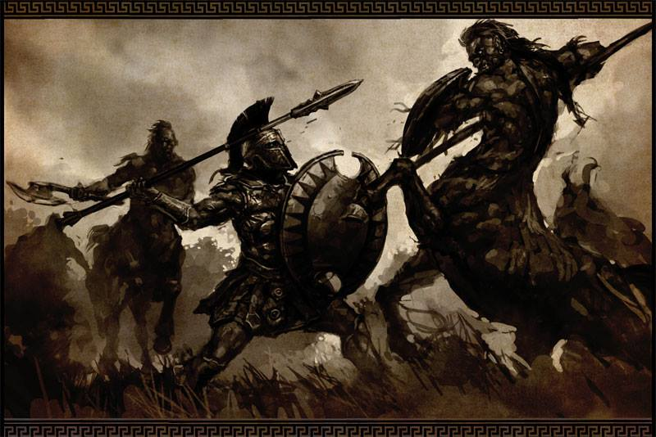
- Fury Plains –
  - Looming over the landscape here stands the tower of Amphiera (f) of the Caryatids, Arch Mage of the Mythenian lands.
- Harpy Plains –

- Eudora River – flows from the northern tip of the Argyron Mountains, where it empties into the Inner Sea and passes by the city of Kasylla
- Palas River – flows from the Argyron Mountains, on to the Bay of Haedra and the city of Nemesis; feeds Lake Maera; site of the Palas River War (720 AA3 – 810 AA3)
- Ceto River – part of the Hand of Rivers system, it breaks off from the Laedon River to empty into the Bay of Haedra
- Laedon River – part of the Hand of Rivers system, it breaks off from the Phyrion River to supply the city of Domos and empty into the Bay of Haedra
- Astera River – part of the Hand of Rivers system, it breaks off from the Phyrion River to supply the town of Arxis and empty into the Syren Strait
- Phyrion River – mightiest of Mythenian Rivers, it forms the wide Hand of Rivers system ruled by the city of Parseion; the Phyrion flows east from the Argyron Mountains before turning south and on to the Syren Straits and the town of Estarra; it is the tributary river for three other large rivers: the Ceto, Laedon, and Astera;
- Hesperis River – one of the Tryptic Rivers; it is fed by the Agda River and continues on to the sea and the city of Arropos
- Agda River - one of the Tryptic Rivers, flows from Lake Arktos, feeds the Eidos and Hesperis Rivers and continues on to the sea and the town of Drommica
- Eido River - one of the Tryptic Rivers; it is fed by the Agda River and continues on to the sea and the town of Drommica
- Lagina River – fed by the Hathor River, it continues on to the sea where it forms a natural barrier west of the city of Argeia
- Hathor River – flows from the Celestial Mountains near the ruins of Zaar, feeds the Lagina River and continues on to the sea where it feeds the Acheron Swamp; rumor has it that it was named by the Ebon peoples of Tarbia in the Primordial Ages when they explored this region
- River Delas –flows from the Celestial Mountains to the sea, where it forms a natural barrier to the eastward approach to the city of Sargon

- Maera Lake - 350 PA3 - the Centaur Wars: Centaur make war with the Akeron over the lands around Maera Lake; 370 PA3 - peace is struck between humans and the centaur tribes, who hold domain around Maera Lake
- Lake Arktos – sits at the entrance to the Thyra Gates and at the foot of the elevated town of Osireion

- Aethon Swamp – just south of the mighty city of Parseion lies an eerie wetland that at night appears to be lit with flames. None dare venture here, for it is said to have been cursed by a necromancer with the fires of hell and is in fact an opening to the infernal planes.
- Acheron Swamp – lies to the east of the city of Sargon; home to many fell creatures, including Helead (swamp nymph)
  - Here dwells the Gravid tribe of saurian, known by their mark of the circle containing five equally spaced circles
- Bone Mire Swamp – lies to the north of the city of Argeia; home to many fell creatures, including the Helead (swamp nymph); also home to elephants, who are often used as battle mounts by Argeia
  - Here dwells the Dewlap tribe of saurian, known by their mark of the four orange concentric half-circles descending

- Argyron Mts. – rumored to the dwelling place of the Oreades, mountain nymphs; home of the Sapphurnus kingdom of Dwarves
  - Site of the Temple of the Second Sight, where monks study and train in the ways of Pythia, the divine giver of truth
  - Dwelling here at the northern tip of the mountain range, overlooking the Straits of Venture, is the tribe of Storm Giants known as the Zephyrim, known by their sign of the rainbow. They are thought by many sailors to have a hand in the weather as ships pass through the strait. Many ships will stop to leave gifts at the northern shores, hoping to appease them.
- Mt. Carathon – home of Oreads, mountain nymphs
  - Here lies the Dwarven city of Petra, capitol of the Kingdom of Sapphurnus
- Celestial Mts. – home to humanoid tribes and barbarians
  - At the northern reaches of the mountain range dwell the Stromon, a tribe of Stone Giants.
  - Site of the Temple of Brightest Day, where monks study and train in the ways of Hemera, goddess of the day
  - The southern end of the mountain range is the site of the Temple of the First and Final Question, where monks study and train in the ways of the philosopher Anisodoros
  - At the southern end of the mountain range, overlooking the Sea of Thundra, dwell the tribe of Storm Giants known as the Notusor, known by their sign of the five lightning bolts radiating from a black cloud. It is rumored that the giants send mighty storms forth into the Sea of Thundra, lending the sea its name, and that it is for a grudge against men long since forgotten.

- Taris Hills – home of many giants and cyclopses
  - Site of the Temple of the Stone Sentinels, where monks study and train in the ways of Oureia, the gods of the mountains
  - Here dwells the Hezzirex colony of myrmekes (formians), known by their mark of the six circles stacked in a triangle
- Hills of the Mystics – home to a cult of augurs who keep to themselves but are often sought for divinations; their portents are dreaded by the common folk. It was here that the rules of the cities gathered in the Second Written Age to ponder the sharing of power after the Celedonians were driven out. The augurs named the land Mythenia and bid the cities rule themselves. But men are fools and kings have often cast this wisdom aside for sake of power.
  - Home to the great red dragon Thysiara
  - site of a great battle in 859 WA1 - Parseion leads entire northern forces against the Eidolon, Argeia the southern forces; battle is met with Eidolon south of the Hills of the Mystics
  - Here dwells the Tintalak colony of myrmekes (formians), known by their mark of the eight curved lines radiating outward in a swirl

- Thyra Gates – gap between the Argyron and Celestial Mountain Ranges, it opens up to the Tarbian Desert to the west
  - Here dwells the Xelex colony of myrmekes (formians), known by their mark of the three hexagons arranged in a triangle

- Watchers by the Sea – two great statues overlooking the northern entrance to the Syren Straits; one is near the Mythenian city of Drommica, the other on the Gaeadon side is located near the Kyrean city of Kelenon; it is said they are enchanted, placed their by the gods to grant safe passage to travelers passing through the Straits, others say they are watchers alerting the sea gods of any who carry malice in their hearts and bringing upon them wrath

- Sapphurnus - Dwarven Kingdom located in the Argyron Mountain Range
  - Hogback - Dwarven town of Sapphurnus
  - Undercloud - Dwarven town of Sapphurnus
  - Petra - Dwarven town of Sapphurnus
  - Ironmaul - Dwarven town of Sapphurnus
  - Krusibul - Dwarven town of Sapphurnus
  - Fuller Keep - Dwarven outpost of Sapphurnus
  - Lucern Keep - Dwarven outpost of Sapphurnus
  - Mandrel Keep - Dwarven outpost of Sapphurnus
  - Helvent Keep - Dwarven outpost of Sapphurnus
- Lo'Shella - Elven Kingdom - located in the Alona Forest
  - Seiveril - Elven town of Lo'Shella
  - Talaedra - Elven city of Lo'Shella
  - Calarel - Elven town of Lo'Shella
  - Wrenfaren - Elven town of Lo'Shella

- Temple of the Muses – the exact location is still a forgotten secret, this is the home of the nine muses and said to be where they return to Mythenia regularly to observe humans and inspire them
- The Great Library of Sargon - 110 PA4 - Library of Sargon is built atop the buried lair of the Eye of Ages; curators dubbed the Scribes of Draiachta comb the world for ancient writings
- Omphalos Stones – ancient upright stones set throughout the land of Mythenia, erected by priests of a bygone era; they hold special magical properties. It is believed that at the dawn of creation the gods sent eagles throughout the land to survey the work. The eagles laid eggs here and there, as watchers over men. These are the Omphalos Stones today, if it is to be believed. Each stone is inscribed with ancient Mythenia text, which only a few scholars can decipher.
- Ruins of Zaar - the town of Zaar was an important trade hub for the Akerons in the Primordial Ages and is considered the birthplace of their culture; the Well of Afthonia (abundance) is rumored to have been here, a source of life in the early days of the Akerons; 90 AA2 - Destruction of Zaar: the ancient city of Zaar, home to the Akeron culture, is laid to waste by Prodians looking to push all Akeron influence out of the land; the rumored Ephemeral Temple and its relics are lost beneath the ruins
  - Here dwells the Iklee Kelk colony of myrmekes (formians), known by their mark of the a vertical line splitting into ten descending parallel lines

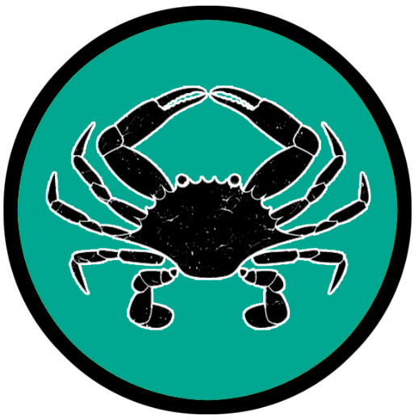
Kasylla
Size: large city, population 25,000, guards / soldiers 250, militia 2250
Trade Goods: trade hub, olive oil, iron, flax
Local Goods:
Standard: crab
Colors: sea green and white
Patron Deity: Nerites, god of the ocean, driver of the great sea chariot
Ruler: Archon Polymnestor

Home: Lysagora Palace
Steward: Danaos
Marshal: Admetos
House Priest: Eudora (f)
House Adviser (Scholar/Mage/etc): Metaneira (f)
Captain of the Guard: Kimon
Chief Warriors in Service:
Ktesias
Iphis
Olympias (f)

Local Powers: Arion Traveler Merchants, The Hidden Knives (thieves’ guild), Temple of Nerites
Local Sites: Antigone’s Hearth Inn & Tavern, House of the Phoenix Inn & Tavern, Temple of Tantalus (brothel)

Description:
Kasylla is the northernmost city of Mythenia, situated on a promontory of land that overlooks the Inner Sea. The location offers a vantage point for all nautical traffic passing through the Venture Straits. This has made Kasylla a major trade hub between the Ferrago Sea in the west to the Inner Sea and all points eastward. Behind the city is the northern reaches of the Argyron Mountains, to the south the Taris Hills. Both are sites of active mining, but also havens to creatures that have long plagued human settlements. The River Apyxa forms a natural barrier for Kasylla’s southern approach and is guarded by a massive citadel.

Industry:
Archon Polymnestor has engaged the Darmiddian merchant guilds in partnership against the warnings of his advisers. He has opened the city market to more features appealing to travelers from afar. He is not content with dealing in flax and olive oil and hopes to build Kasylla into a more diversified trade source for goods passing east-west through the Strait of Venture. Travelers will find Kasylla a very open community to outsiders, encouraging them to spend time and money here.

The humans of Kasylla have a long history of conflict with the Dwarves of Sapphurnus in the Argyrons. Both sides feel entitled to the iron found there. Guarded mines are operated on both sides, some very close to one another. Newly discovered deposits are a matter of flare-ups in the ongoing conflict.

Key Figures:
Archon Polymnestor is an ambitious ruler, looking to expand Kasylla’s influence beyond Mythenia. Many of the older nobility believe he has abandoned traditional values out of a sense of greed. Polymnestor has quieted his critics by having key members of the city disappear, courtesy of his secret assassins. He is a tall, lean man with fierce eyes and an elaborately braided beard. Citizens cower when he walks the streets.

Local Lore:
The Eye of Mati is an enormous enchanted sphere that hovers high over the city of Kasylla. Summoned millennia ago, it has a menacing black spot appearing at its center and can be seen for hundreds of miles at night. This is the Evil Eye, and is believed to cast curses on the enemies of the city. The Evil Eye is a superstition common among Mythenians, but is considered fell magic and all agree it is a shameful thing for Kasylla to employ regardless of its actual magical effects.

The iron mines in the Argyron Mountains are often plagued by basilisks which roam the area. Occasionally creatures wander north from the Taris hills to harass travelers, including cyclopses and myrmidons. It is said the Taris hills are infested with colonies of Myrmekes, giant ravenous ants the size of large dogs. Some say there are more intelligent versions of these ants called Formian, resembling a cross between an ant and a centaur, that dwell there and use the Myrmekes as domesticated beasts. Travel south of Kasylla is made dangerous by these creatures.

History:
Kasylla rose early in the history of Mythenia, utilizing its iron resources to become a major military power. Countless wars were waged with Parseion to the south, with control of northern Mythenia exchanging hands over the centuries. The city of Nemesis, located between the two, was just as often an ally as an enemy in these struggles. Today Kasylla’s navy is extensive, with a quarter of its vessels ready to be equipped for war. Its infantry forces are ready to march with little notice, the culture of war a part of life here. Merchant families in the city have secured alliances with Darmiddia far to the west in hopes of gaining leverage. This has led to resentment against the city from many Mythenians, who feel any Darmiddian presence is an unwelcome encroachment.

Ten thousand years ago the Mythenian civilization was already sophisticated enough that the settlements were the sites of great human expansion. Conflict broke out between the fledgling cities and engulfed all of eastern Arnland. The Great Cataphract Wars spanned a hundred and fifty years (280 PA2 to 435 PA2) and pitted Kasylla, Nemesis, Parseion, and Argeia and their regional tribes against one another.

Seven thousand years ago (190 AA1) the Oracle of Domos prophecied the Herothlon, a series of heroes each appearing every fifty years for the next five hundred years. This was in response to the Ten Curses of Salisar that commenced that same year. The Herothlon began with age of the hero Haeleosk, righteous warrior of Helios from Kasylla. Haeleosk slew the giant serpent from the underworld and its blackguard master Lapetus (240 AA1). He would go on to other great deeds and protect Kasylla from enemy invaders. This would earn him the legacy as the first of the heroes of the Herothlon.

War of Palas River (720 AA3 – 810 AA3) War erupts between Kasylla and Parseion; Nemesis conquers the armies of the north, ending the Wars of Palas; instead of asserting rule, the Nemesians sue for a lasting peace for the region
Customs:
The people of Kasylla rarely drink wine without diluting it first. A standard ratio of water-to-wine is four-to-one because heavy drinking and drunkenness are looked down upon and associated with barbarism.

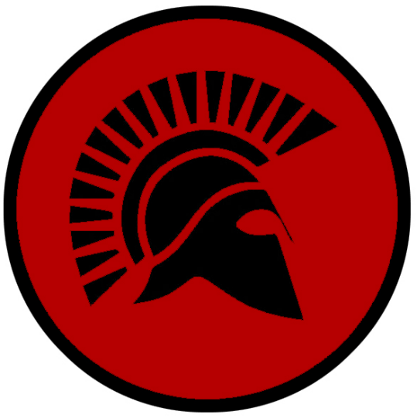
Nemesis
Size: small city, population 12,000, guards / soldiers 120, militia 600
Trade Goods: olive oil, flax, fishing
Local Goods: expert infantry
Standard: helmet
Colors: red and black
Patron Deity: Thanatos, god of death, depicted as a winged and sword-girt youth
Ruler: Archon Strophios and his wife Themistra (f)

Home: Fortress Chimera
Steward: Philon
Marshal: Lysippos
House Priest: Parsaeos
House Adviser (Scholar/Mage/etc): Briareos
Captain of the Guard: Hesperidis (f)
Chief Warriors in Service:
Philomelos
Nikandros
Theoginis

Local Powers: Temple of Thanatos, Sons of Cerberus (thieves’ guild), Geryon Syndicate (smuggling ring), The Agema (mercenary army)
Local Sites: The Naughty Nymph Inn & Tavern, Hyacinth House Inn & Tavern

Description:
Nemesis is a dark gray sentinel seated at the mouth of the Palas River. It overlooks the Bay of Haedra from stout, featureless buildings behind low walls that dare its enemies to attack. In the agora, or city square, people meet in the morning for calisthenics and for solemn rituals in the evening. No flags or banners fly here, no songs are heard. It is a somber place where everyone wears a stern expression.

Born from the ashes of war, the citizens of Nemesis live a life of military discipline and personal privation. Every Nemesian, from young to old, either train to fight or work in the armories. Camps in the Taris Hills and around Lake Maera are where boys and girls learn to fight on land and water. Youth pass into adulthood only after surviving a brutal trek into the Argyron Mountains to retrieve a Charon flower.

The city’s name probably originated after centuries of war between the power houses of the north, the cities of Parseion and Kasylla. The town originally known as Aklos wanted nothing to do with the ongoing conflict. But Parseion feared the town’s growing strength and saw it as a threat. In 305 PA2 the king convinced the town to sign a pact of peace. The following spring Parseion burned Aklos to the ground. After this the survivors adopted the motto “Hold everyone as your nemesis and life will never surprise you.” The city of Nemesis was born. To this day they have never forgotten this betrayal.

Industry:
Nemesis is an agrarian based market, cultivating flax and olive oil and fishing the sea as well as upriver in Lake Maera. A small mining venture has opened in the Taris Hills to the west. But the population tarries not at these tasks. Helots do the work, prisoners of war captured on the city’s campaigns. The citizens make warfare their occupation.

Nemesians carry no gold or fortune. Their local economy works from bars of iron. All real wealth is held in the city’s citadel. A representative of the city handles all currency with outsiders. Local hospitality is thin here. The two inns, The Naughty Nymph and Hyacinth House, are located outside the walls of the city and run by people not from Nemesis.

Key Figures:
Archon Strophios is a lean, strong man of many years. He is dark of skin, his mother having come from the Kaduru continent. He is respected for his many victories as a general, but younger warriors are beginning to covet his seat of power. Strophios never speaks. During his meetings with envoys he motions with his hands and an interpreter speaks for him. Rumor has it he lost his tongue in battle years ago.

Local Lore:
The land around Nemesis is hot, dry, and inhospitable. The barren lands are marked by craters and deep ravines. Within this place large mounds of soil appear. They are home to Formians, a race of centaur-like ants the size of humans. They are warlike and well organized, attacking from their mounds to kill anything alive to feed to their young. The warriors of Nemesis make it a part of their daily life to venture out to the plains to do battle with the Formians and their Myrmekes, large ants the size of dogs.

Nemesis worships Thanatos, the god of death, as its patron deity. Thanatos appears as a youth with wings and a sword at his side that indiscriminately sends mortals and gods alike to the afterlife. Mortals often resort to trickery or bargaining for their lives. In one famous tale, a merchant pled for his wife’s life. Thanatos responded, “Talk will win you nothing. I take her now, and dedicate her with my sword, for all whose hair is cut in consecration by this blade's edge are devoted to the gods below." It is a custom of Nemesian warriors to never cut their hair, allowing it to grow into elaborate braids. Some say it is a challenge to Thanatos, showing no fear by offering him a larger target for his sword.

History:
In the Primordial Ages (305 PA2) Parseion feared Nemesis challenging its power. The king signed a pact of peace with the city, only to burn Nemesis to the ground. The Nemesians have never forgotten this betrayal.

Four thousand years ago the Palas Wars broke out (720 AA3) between Kasylla and Parseion to take over the Palas River and newly discovered ore in the Taris Mountains. Massive battles waged and almost brought Parseion to complete destruction. In desperation Parseion lured Domos, Arxis, and Estarra into the war with promises of riches. At last Nemesis stepped in. With superior tactics and unyielding resolve, the Nemesian general Kartigia and his forces outmaneuvered both armies and conquered them in turn in what was called the Battles of Kartigia (810 AA3). No aide had come from the other cities: Nemesian scouts had stolen the shipments of treasure intended for the other cities and kept them out of the war. After the victory Kartigia refused to accept the surrender of either foe. Instead, he sued for a lasting peace in the north. Shortly thereafter the kingdom formally recognized city states. While this altered the ambitions of those wanting a Mythenian Empire, the city states would continue to war centuries later.

When the Celedonian Empire brought war to Mythenia in the First Written Age, both ground and naval forces were surprised at the resistance they met in Nemesis. Time and again the city threw the Celedonians back into the sea and routed its infantry. After thirty years, it was the last Mythenian city to fall. The saying developed among the Celedonians: “There are two kingdoms to conquer in the land of Mythenia: Nemesis, and all the rest of Mythenia”

Polydamas of Nemesis - The Elisium champion in 408 AA2 is said to have killed lions with his bare hands, pulled the hoof off a ferocious bull and brought a speeding chariot to a standstill with just one hand.
Nemesis is famous for the hero Argonesh, a mighty warrior who was also a renowned wrestler. It was seven thousand years ago that the second of the Ten Curses of Salisar was released (290 AA1). The lost Maze of Monokaam, constructed by the mad wizard centuries ago, was opened in the Taris Hills. All manner of evil creatures surfaced to plague the land. No army could manage to defeat the creatures, for they retreated into their caves and waited to pounce again. Argonesh is said to have braved the maze and vanquished its creatures, chief among them the mighty minotaur Gromm. This would later be celebrated as the second of the ten plagues defeated in the Herothlon. The entrance to the maze was collapsed and forgotten. But some say it lies beneath the Taris Hills to this day.

Customs:
The youth in Nemesis are trained in survival from a young age. Young boys and girls are encouraged to steal but are whipped when caught to teach them the consequences of failure. The most capable children are handed whips and taught to flog their peers to urge them to grow stronger.

Children pass into adulthood by trekking to the Argyron Mountains to retrieve the rare Charon flower. Young adults proudly wear the flower to mark their achievement. Others store their flower until their passing, at which time it is laid upon their funeral pyre.

Marriage in Nemeis is marked by women being abducted by their soon-to-be husbands as part of the wedding.

Each spring Nemesis holds an enormous festival which lasts for three days. On the first and last day, sacrifices and gifts are offered to the dead. The people eat nothing except special cakes, wear no flowers, sing no poems, and when the day is done, proceed quietly back to their homes. This practice is much more solemn than standard mourning traditions, and the rest of Mythenia finds it peculiar. The second day is filled with festivity. Poems and praise are sung to the gods, horse races are held, and songs of battle are sung. The day finishes with a procession of the local women riding in wicker chariots. Even slaves are allowed to participate in the festival and are encouraged to enjoy the freedoms of the day. Occasionally people from Parseion attend this festival to encourage goodwill between the two city-states.


Domos
Size: small city, population 12,000, guards / soldiers 120, militia 600
Trade Goods: pottery, cotton, clay, fishing
Local Goods:
Standard: silver trident
Colors: blue and black
Patron Deity: Psamathe, goddess of sand beaches
Ruler: Archon Selonidas and his wife Kosoma (f)

Home: Petrichor Palace
Steward: Aesor
Marshal: Thalas
House Priest: Zosimos
House Adviser (Scholar/Mage/etc): Perea the Faded (f)
Captain of the Guard: Timon
Chief Warriors in Service:
Phoibos
Nikanor
Iasoni

Local Powers: Red Talisman (thieves’ guild), Temple of Psamathe, Temple of the Oracle, The Order of Empyrea (order of paladins)
Local Sites: The Twin Trident Inn & Tavern, The Singing Salpinx Inn & Tavern

Description:
Domos is a marvel of nature, a city whose walls and towers are built from glittering blue and white quartz that can be seen for miles away at sea. The city sits atop a rocky butte thrust up from a great stretch of sand. Giant dunes rise and fall like the waves that meet them at the edge of the sea. The River Laedon empties here leaving a wide delta rich in silt and clays. Scattered throughout are tidal pools that fill and empty over the years as the sea finds purchase between the dunes. Large sections of this vast beach occasionally become treacherous as ocean waters seep up and create invisible patches of quicksand.

Domos is the traditional home of the Temple of the Haedra Oracle. It is a proud structure of pure white marble dedicated to Kassandra, a woman cursed to utter true prophecies, but never to be believed. It was built here in the Primordial Ages (680 PA2) in honor of the gods of truth and insight. Each generation a young woman emerges as the new Oracle of Domos and takes her place in the temple. Her wisdom is sought after by all in Mythenia, but she dispenses the wisdom only after an act of kindness or valor is performed. Then she judges whether or not the supplicant is worthy. Even after this, the wisdom is often in the form of song or riddles. For this reason, the Oracle is not always a popular choice among rulers or greedy merchants for advice. And some fearing her truths in the past have worked to eliminate the Oracle. There is a fellowship of paladins, the Order of Empyrea, that serve and protect her.

Industry:
City life for Domos is an industrious one connected to the river and the sea. Fishing boats ply the deep waters as fishwives comb the tidal pools. Well-tended clay pits supply a booming market for ceramics of every style and elaborately decorated in black-figure as well as red-figure styles. Some of the finest earthenware comes from Domos and they still take great pride in the signature look of their ornamental pottery: amphorae, epinetra, hydria, kylikes, pyxides, and every other sort of Mythenian vessel.
Long a vassal of Parseion, Domos now bristles under the yoke and is working to play a bigger role in the Inner Sea traffic. Sitting at the northern entrance to the Syren Straits gives the city a strategic trade location. While Kasylla commands the Inner Sea Crossing to the west, Domos hopes to control the straits that lead south and on to Kazelduun and Kaduru. Envoys to the town of Arxis negotiate for timber for building a larger harbor and establishing a world-class shipyard.

Key Figures:
Archon Selonidas is a shrewd ruler looking to raise the city’s prominence. He is a slight man, wiry of frame and slightly hunched. He works his nimble fingers together nervously as he schemes. Selonidas was the youngest of three brothers, the older two dying under strange circumstances. His wife, Kosoma, was married to each of the older brothers before being saddled with Selonidas. She openly abhors her husband and it is rumored she is having an affair with Timon, captain of the guard. This doesn’t seem to bother Selonidas, who spends hours communing in the Temple of the Oracle for divine vision for his ambitions.

The Empyrean Order of paladins stands ready to protect the Oracle of the Temple. They are the noblest of holy warriors in Mythenia, upholding a standard of virtue that is not tied to politics or coin. Throughout history when the land has fallen to turmoil, the warriors of the Empyrean have been known to take flight on their stable of pegasi and ride forth to vanquish evil. It is not uncommon to see them flying overhead, seeking out fell creatures or sorcerers who bring doom to the land.

Local Lore:
Legend has it that the Akerons who settled this place in the Primordial Ages were beset by cruel gods and torments. Their homes were destroyed by the winds and waves. They took shelter in the enormous sand dunes formed at the delta of the Tauryn River and prayed for rescue. Psamathe, goddess of the sands and beaches, happened upon them and took pity. She called for the sands to spring forth and hardened them into walls of stone. Ships from Hylux who first spied the city on their travels termed the stone “Aventurine” from their word “aventura,'' which means “by chance.''

Within the circular rotunda of the Temple stands the Hall of the Herothlon and statues of Mythenia’s ten heroes of the Herothlon: Haeleosk, righteous warrior of Kasylla; Argonesh, wrestler from Nemesis; Daeleina, female archer from Osireion; Helon, cunning pirate of Drommica; Daricles, high priest of Helios from Arxis; Kanibar the thief from Argeia; Lithia, fleet-footed warrior from Arropos; Plaebeon, master musician and story-teller from Parseion; Astormorinx, feared sorceress from Sargon; and Olytius, the vagabond adventurer from Domos.

The ceramic vessels of Domos were the inspiration for a wizard millennia ago, who created the art of the Scribe Cups. These are cups that are passed around a banquet with each person writing a passage in their own hand. In some cases these cups are enchanted to collect unlimited passages. These collect wisdom of the common folk as well as that of the educated. If activated, the cup can recite in an audible voice every verse ever collected upon it. It can also receive whatever new inscriptions a person wishes to write. The cup accepts writing in any language and will recite the passages in a way understandable to any listener.

History:
It was almost seven thousand years ago that the end of the Herothlon took place here (690 AA1), five hundred years to the day after the Oracle of Domos prophesied it (190 AA1). The last hero was an outcast named Olytius from Domos who dared to challenge the lich Sarlisia. Sarlisiar summoned an army of devils that descended upon the entire land of Mythenia. Olytius opened a portal in the Hall of the Herothlon and convened all nine of the past heroes. The ensuing battle shook the earth, with Mythen’s greatest heroes striking blows and weaving magic to utterly destroy the demon army. In the end the lich was finally defeated, but all the heroes including Olytius sacrificed themselves by seizing the Ten Lamps of Vengeance and hurtling with them into the same abyss that consumed Salisar.

Customs:
The people of Domos make their world famous pottery a part of their lives, balancing small jugs on their heads wherever they go. Children are raised at a young age to walk with perfect posture to learn to carry small jars filled with ceremonial oil. Greetings to outsiders commonly involve the application of oil to their foreheads, seen as a blessing.

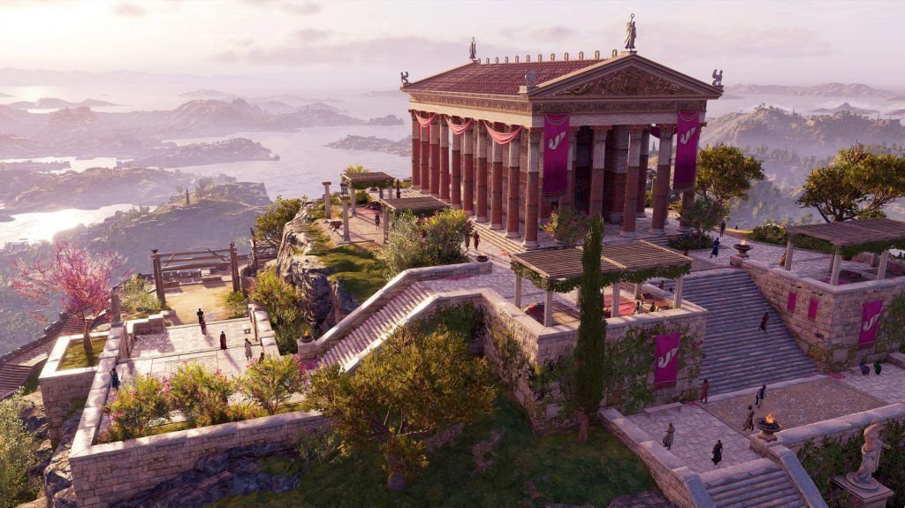

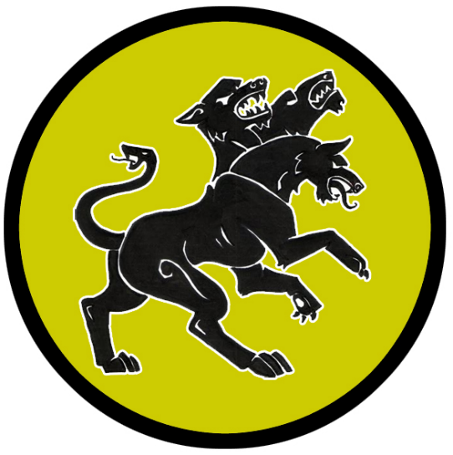
Parseion
Size: metropolis, population 50,000, guards / soldiers 500, militia 2500
Trade Goods: dyes, olive oil, grain, magic center, salt, stone
Local Goods: garment district
Standard: sign of the cerberus
Colors: gold and black
Patron Deity: Selene, goddess of the moon
Ruler: King Croesus and Queen Minaera (f)

Home: Palace of Amalthea
Steward: Ireneus
Marshal: Kyriakos
House Priest: Myrrine (f)
House Adviser (Scholar/Mage/etc): Theodotus
Captain of the Guard: Pelagios the Unbroken
Chief Warriors in Service:
Anicetus
Cleon
Eustath

Local Powers: The Hidden Knives (thieves’ guild), Aulos Amphitheater (bardic college), Corvus Sanctum (school of magic), Temple of Selene, Order of the Winged Stallion (paladins)
Local Sites: Drakon’s Nest Inn & Tavern, The Laughing Zephyr Inn & Tavern, House of the Honey Lights (brothel)

Description:
Parseion is the largest and most powerful of city state in Mythenia. It is called the Hand of the Rivers, for it sits at the central point of the Hand of Rivers system formed by the mighty Phyrion. The city dominates a wide plateau flanked on both sides by waterfalls that feed the mighty Tauryn and Phyrion Rivers. These in turn feed two larger rivers to the north and east. Domos, Arxis, and Estarra all sit down river from Parseion and have long been under the influence of the city that commands the waterways. Tall white towers tinged in the green of river algae can be seen from miles away, looming over a wide set of terraces decorated in dazzling mosaics. The sprawling metropolis thrives within the protective borders of the rivers.

The mighty city is a center of arts, culture, and philosophy. Travelers here are dazzled by the beauty of the city’s pristine streets, towering statuary, and markets filled with luxurious delights. The main entrance to the city features a majestic propylon, or processional gateway, leading to the public square (agora) surrounded by storied colonnade (stoa).

Today Mythenia is no longer ruled by a single power, each town or city ruling as a sovereign power. But Parseion still exerts powerful control over these lands, both economically and politically. It is here the great Hill of Koderon still hosts the highest-level debates and is home to the annual gathering of all city states when deciding matters of importance to Mythenia.

The town square is decorated with life size statues to Mythenia’s greatest heroes. Among them is Theagenes of Osireion, a popular warrior from the Elysium Games.

Industry:
The city of rivers ships stone and salt from mines in the Argyron Mountains. A truce was made with the centaurs to allow passage along the Phyrion River. Vast fields of grain and olive groves employ an army of farmers that in turn feed much of northern Mythenia. Other fields host plants for every color of dye, creating a thriving fashion district. Garments of the Parseion fashion have become the object of desire throughout the land.

The Corvus Sanctum is the oldest known school of magic in the world. It is a tall tower of shimmering purple stone crowned in massive goat horn fixtures. Legend has it that it was here the first wizards committed spells to arcane writing. The famous sorceress Lithia of the Dark Eyes lit the one hundred lamps here four thousand years ago to open portals into far off realms for the first time (110 AA4). The lamps burn to this day, but their secrets are lost to wizards who study them now. It is here the Order of Hecate meet, an exclusive group of high level sorcerers and wizards from around Mythenia.

Key Figures:
King Croesus and his queen Minaera are charismatic leaders. Their beguiling manners seek to win the friendship of Archons throughout northern Mythenia. They wear the titles of king and queen openly, implying lordship over the north. Rulers are right to be wary of their charms, for Parseion has built up the wealth and the stature to threaten a repeat of history.

Queen Minaera has her eye on Archon Menodora with designs to arrange a marriage between her and their son the prince.

Local Lore:
The Aulos Amphitheater is said to rest on the site of the first Mythenian plays. Today it is a gargantuan structure, the seats topped with the finest marble and the stage aglow with enchantments that simulate every weather condition. Actors of the Aulos, like all Mythenian actors, employ special masks to heighten the dramatic effect of their characters. It is said that Aulos Masks possess special magical properties imbued by their original creators. All who wear the masks are magically endowed with enhanced disguise abilities, the ability to charm or fascinate, and the ability to modify one’s voice. A select few are able to create the effects of fear, giddiness, rage, or friendship in others depending on the expression depicted on the mask.

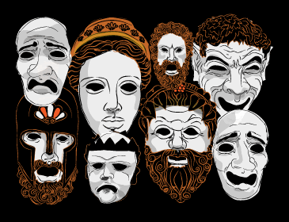

The nine muses make regular visits here. Appearing as normal mortal women, they appear in disguise and observe the artists while they work. If an artist is deemed worthy of inspiration, one of them may approach and befriend them. The muses appear in Parseion depending on who might be working on projects to their liking: Calliope (epic poetry), Clio (history), Erato (lyric poetry), Euterpe (music), Melpomene (tragedy), Polyhymnia (sacred poetry), Terpsichore (dance and chorus), and Thalia (comedy and idyllic poetry), and Urania (astronomy).

Rumors abound that the city is afflicted with the presence of lamia, attractive female vampires who seduce young men to feast on their flesh. It is a big city, with many people taking part in social delights. Young men may go missing for any reason, whether to travel afar in the dead of night or take employment in a noble house. But disappear they do.

Far up river from Parseion, at the head of the Phyrion River, are caves within the Argyron Mountains. These are home to the gorgon queen Rymara and her brood. Legend says these creatures enjoyed the waters of the Phyrion and its tributaries, but were driven out by humans. Rymara holds a special hatred for the people of Parseion. Her gorgons attack and slay any who venture into the mountains. Travelers to this area will shudder to see the Garden of Still Souls, a field of petrified humans, elves, and dwarves the gorgons have arranged near the foot of the mountains.

History:
The ancient times saw the city grow in military might and conquer every settlement from the Inner Sea down to the Sea of Thundra. At one point the Mythenian Empire even rivaled Celedon and for centuries the two powers clashed in battles that are still sung of today. Citadels were commissioned all along the Argyron and Celestial mountain ranges and expeditions launched into the interior of the Tarbian Desert. A vast navy of triremes ruled the seas as far west as the Ferrago.
Three thousand years ago the Celedon Empire attacked the coastal cities of Mythenia before the Argus and Nessus legions marched through the Thyra Gates and crushed the seven jeweled cities. The Argus Legion established a stronghold in Parseion and garrisoned it to control the land.

It was seven thousand years ago during the Herothlon of Heroes that the evil lich Salisar unleashed his eighth curse: an abomination called the Ear Serpent (590 AA1). Infernal creatures, the worms would enter the ears of men and enslave them to Salisar’s will. It was also at this time there was a famous musician named Plaebeon the musician gained reknown. During his travels Plaebeon noticed the evil in the land. The rulers had become corrupt and the common folk were made to suffer.

Plaebeon was dismayed by the excess and corruption of the rulers in Mythenia. Such was his power that his music could alter the mood of any person, high or low. So Plaebeon set out to sing songs to turn the hearts of the rulers. But to his surprise his songs had quite a different response. Every ruler in every town would turn on the musician when they heard his songs. Plaebeon grew curious and set out to test every city in Mythenia, but the response was identical wherever he went: rulers would grow red with rage and order the musician be put to death. After a year of traveling, he was a wanted man.

At last one day Plaebeon resolved to revenge himself on the corrupt kings and perchance restore civil order for the people. He composed an enchanted song that sang the praises of Arelei, the daughter of the king in Parseion, and spoke of her admirers in courts all across the kingdom. So infused was the song that it would drive any mad man wild with desire for her and be left to ponder who these royal rivals could be.

So it was that Plaebeon disguised himself to avoid suspicion and went forth to sing his Ode to Arelei. At each court he stopped and played, battling agents of Salisar who rose to stop him. And in each city the ruler was left helpless with desire for Arelei, as well as full of rage at the thought of any king having her but him. Even the king of Parseion was gripped with rage, wondering who among the other kings would dare seek out his daughter in such a way. Thus Parseion marched out his troops and discovered the entirety of noblemen and their hosts waiting for him. All of them eager to fight for Arelei’s hand. And so commenced the great Battle of Arelei. Every ruler and his personal guard fought for three days, after which not a soul was left alive. Then did Plaebeon ride into Parseion and win the hand of Arelei for himself.

The minstrel would go on to champion Mythenia for the rest of his days, inspiring worthy men and women to assume the rule of its cities. His wit and wisdom were such that a rebirth of the laws and just rule were now common. And for this reason he is known as the eighth hero in the Herothlon.

War of Palas River (720 AA3 – 810 AA3) War erupts between Kasylla and Parseion; Nemesis conquers the armies of the north, ending the Wars of Palas; instead of asserting rule, the Nemesians sue for a lasting peace for the region
Customs:
The people of Parseion are obsessed with fashion, adorning themselves in chitons of extraordinary colors and design. Each year the most prominent color changes, with garments of the previous year’s color falling out of fashion. Lower class citizens are looked down upon for wearing the colors of previous years.

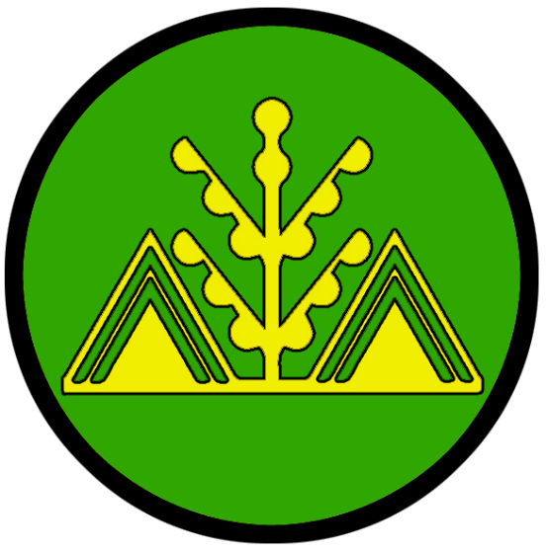
Arxis
Size: large town, population 5,000, guards / soldiers 50, militia 250
Trade Goods: olive oil, timber, fishing
Local Goods: elder oak, master woodworking, medicines
Standard: olive tree symbol of protection
Colors: green and yellow
Patron Deity: Cybele, mother and nature goddess, often depicted enthroned, with lion, cornucopia, and mural crown
Ruler: Archon Menodora (f)

Home: Hall of Carmanor
Steward: Pyrron
Marshal: Eusebios
House Priest: Cariphia (f)
House Adviser (Scholar/Mage/etc): Korrina (f)
Captain of the Guard: Zephyros
Chief Warriors in Service:
Theron
Xoria (f)
Calistes

Local Powers: Temple of Cybele, Bones of the Bat (thieves’ guild)
Local Sites: The Merry Myrmidon Inn & Tavern, The Black Lamprey Inn & Tavern

Description:
Arxis is an agrarian town, situated along the river and nestled between Orpheon Forest to the west and the Mythenia coast to the east. Much of the town is decorated in a fashion to be one with nature, surrounded by palisades of elder oak decorated with garlands of magnificent colors. Houses are built of handsomely milled and carved timbers. The people here are quiet, earnest people who work hard and have little concern for the politics of the large cities.

Industry:
Olive groves and fishing are staples of this rustic town. But it is the rare timbers of the Orpheon Forest that define the look of the town and attract coin. Maple and beech are harvested, but of particular interest are the oaks of Orpheon, which are the oldest in the world and believed to have special properties. These are called Elder Oak. Master carpenters work the wood into exquisite furniture, lintel posts, and statuary. Arxis has gained the attention of Domos to the north, who covets the town’s lumber supply. Arxis is looking to leverage the industry into a new source of revenue and another ally against Parseion.

Key Figures:
Archon Menodora is a kind ruler to her people and welcoming to visitors from afar. She has traveled to Claeryon many times, often bringing back culture and art (and lovers). She is a free spirit, having spent much of her childhood in the Orpheon forest with the Anthousai flower nymphs. She knows of Queen Minaera’s desire to see her marry the prince of Parseion. She knows full well this would bring her town under the power of the city and legitimize Parseion’s control of the north. Minaera is not interested in the prince, but is happy to string the royal family along to get what she wants.

Local Lore:
A statue stands in the town square celebrating Arrichion of Arxis, famed winner of the Elysium Games pankration combat matches. Caught in a terrible stranglehold, Arrichion seized the foot of his opponent and, with the last of his strength, crushed it, dislocating the ankle. Unable to bear the pain, the unnamed man raised his index finger to signal submission. At the very same moment Arrichion gasped his last breath. He was posthumously awarded the victory because his rival had surrendered.
The Orpheon Forest is home of the Anthousai flower nymphs as well as water nymphs that live in the River Astera. The people of Arxis are on good terms with all the woodland creatures, but are careful to approach the Anthousai. They are friendly, free spirits of the land, but their enchantments are strong and often tempt humans into joining them in the forest forever.
History:
Historically Arxis and its neighbor to the south, Estarra, were conscripted by the mighty Parseion forces to join them in war against the southern Mythenian lands. But since the rise of the city states, Arxis seeks partnership with Estarra to help relieve the economic pressures that Parseion still employs. Together the two towns have sent envoys across the water to the independent city of Claeryon, hoping to trade directly with them and secure their future.

Almost nine thousand years ago the region suffered the blight of the Song of Wood and Water. Nymphs of the river system were harassed by humans. In response they dried up the rivers of northern Mythenia (810 PA3). For ten years the land suffered, until rangers from Arxis and Estarra beseached the nymphs to make peace; the nymphs took husbands of the rangers and claimed Orpheon Wood as their domain.

Seven thousand years ago, Arxis was the site of the fifth of the Ten Curses of Salisar. The demon Tarjeen was unleashed and terrorized the land. Daricles, a high priest of Helios, summoned his order to face the demon. But when an army of undead hoplites emerged from the Orpheon Forest most of the clerics fled. Darkness filled the skies around the eastern coast of Mythenia, but Daricles would not be shaken. He took up the Oil Lamp of Caphros, a holy relic of uncertain origin, and prayed over it. It is said he rode forth brandishing such light as has never been seen before or since. Over the course of a year Daricles met the undead in battle, constantly cutting them off from harming the surrounding villages. After a year of victories Daricles at last met the demon Tarjeen (440 AA1). Tarjeen had taken on many guises and by this time had confused households and generals all over the region. But Daricles held up the lamp and exposed the demon, forcing him to show his true form. A great battle was fought and Tarjeen cast into the Abyss. For the next forty years Daricles would enforce the will of Helios throughout Mythenia and build churches. He would be known as the fifth hero in the Herothlon.

Customs:
The people here are fond of festivals and song as well as creatures of the wood and sea. Old forms of medicine are practiced here, with herbs and roots from the forest rivaling the power of magic with its effects.


Estarra
Size: small town, population 2,000, guards / soldiers 20, militia 100
Trade Goods: olive oil, timber
Local Goods: elder oak, master woodworking
Standard: Star of Vergina aka Argead Star
Colors: blue and white
Patron Deity: Iris, goddess of the rainbow, sea, and sky; messenger among the Mythenian gods
Ruler: Archon Prochor and his wife Artimedora (f)

Home: Hall of Petraea
Steward: Phaedrus
Marshal: Kyron
House Priest: Nereus
House Adviser (Scholar/Mage/etc): Pherenike (f)
Captain of the Guard: Pholas
Chief Warriors in Service:
Stanizor
Ceretus
Monides

Local Powers: Temple of Iris, Temple of Helios, The Lucky Crows (thieves’ guild), Order of the Dryad (order of druids)
Local Sites: The Hungry Hydra Inn & Tavern, The Sea Sprite Inn & Tavern, Aspasia’s Arbor (brothel)

Description:
Estarra is a quiet rural town. It is surrounded by palisades of elder oak harvested from the Orpheon Forest.

Estarra’s position along the coast and the Syren Straits has opened it up to the outside world, but it is still seen as a small power. Estarra, along with its twin town Arxis to the north, have long been held under the sway of the mighty Parseion upriver. But it has also opened channels with the city of Claeryon across the waters.

Industry:
Farmers tend lush groves of olive trees, which are central to the economy here. Like Arxis to the north, Estarra harvests stands of the oldest oaks in the world in the Orpheon Forest, called Elder Oak. Master carpenters fashion the oak into plans for ship building, furniture, and ornamental pieces.

Key Figures:
Archon Prochor and his wife Artimedora are lazy rulers, leaving much of the work to the farmers and carpenters. The couple enjoys the country life spending most of their time in their remote villa outside the town. Their daughter, Sotera, is the industrious one in the family and runs most of the town’s operations. She is a brilliant organizer and a firm task master. Her sister, Eriboea, is exceedingly beautiful and sought after by many suitors. But she is taken to life in the woodlands and spends her time riding horses and communing with the druids. Some say she communes with unicorns and has been welcomed as a regular guest to their hidden grove in the forest.

Local Lore:
The Temple of Iris is situated on the western side of town, straddling the River Phyrion. An elaborate system of fountains within the temple draws from the mighty river, releasing the waters back in an extraordinary cascade on the eastern side that catch the light of the sun to project dazzling rainbows.
On the east side of town, facing the rising sun, is the Temple of Helios. Light from the temple radiates directly to the Temple of Iris, creating its dazzling rainbows. It is believed the two deities are interlinked, possibly even lovers. The Temple lay dormant for centuries, its god believed to have departed Nemmyrl forever. Recently there has been a rumor of a high priest arriving and promising Helios’ return.
Griffins are known to dwell mostly in the Hills of the Mystics, far upriver from Estarra. Druids of the Order of the Dryad make this journey regularly in their patrols of the land. They are said to have secured lasting friendship with the griffins in the hills. The beasts are unpredictable and as likely to attack careless travelers in those parts. But in times of dire need the druids have been known to mount these steeds and employ their help in chasing down evil where it sprouts in the land.
History:
40 PA2 - Reign of the cyclops Yorgemus
It was five thousand years ago (340 AA3) that came the age of the hero Jonos of Estarra: half-man/half-giant who destroyed the famed dungeons of the evil king Xerxilles and created a massive flood to save the city by destroying Xerxilles' army of hell lions.

Customs:

Osireion
Size: small town, population 2,000, guards / soldiers 20, militia 100
Trade Goods: iron, steel, silver, stone
Local Goods:
Standard: sign of the minotaur
Colors: blue and white
Patron Deity: Kratos, personification of strength and power
Ruler: Archon Kallistra (f) and her husband Heroidion

Home: Hall of Eunomia
Steward: Lycus
Marshal: Origenes
House Priest: Sostrate (f)
House Adviser (Scholar/Mage/etc): Porphirios
Captain of the Guard: Timaion
Chief Warriors in Service:
Solon
Tychon
Sophos

Local Powers: Temple of Kratos, The Unseen Priests (thieves’ guild), Band of the Centaur (band of rangers), Coven of the Oneiromancers (wizard’s sanctum)
Local Sites: Orithyia’s Table Inn & Tavern, Song of Pandoura Inn & Tavern

Description:
Osireion is a small town that grew from the ancient fortress that once watched over the Thyra Gates. It sits atop a plateau, surrounded by a wall of soil that has been piled high and packed hard. These are capped with stone slabs. Two ramparts approach the top of the plateau, one on the east and one on the west. These were erected thousands of years ago and are now lined with cobble stones and poles from which pinions fly. To the north Lake Arktos gleams like a mirror. From a distance the city is an uninviting bloom of reddish brown springing up from the plains.

Within the town streets are narrow and wind this way and that. It is said that a mad architect designed the place like a maze, and it is easy to believe. Some say there are several levels of a vast labyrinth that lie deep beneath the town. Some tunnels were man made, others a natural honeycomb of caverns. These were once home to horrors the Akerons would imprison there.

Osireion overlooks the gap between the Argyron Mountain range to the north and the Celestial Mountain range to the south. This gap, called the Thyra Gates, leads into the burning deserts of Tarbia to the west. It also sits in the shadow of Carathon Mountain to the north. This region has seen its fair share of battles, both between the northern and southern armies of Mythenia and with Tarbian and Celedonian invaders marching through the Thyra Gates.

Industry:
Osireion is a small town whose economy revolves around its mines and quarries in the Celestial Mountains. It has fair relations with the Dwarven city of Petra, situated in Mount Carathon to the north and capitol of the Kingdom of Sapphurnus. After centuries of war over the mountains, humans and Dwarves here work together. This is in sharp contrast to the attitude of the city of Kasylla far to the north, self-sworn enemies of the Dwarves. Osireion trades almost exclusively with the settlements Arropos and Drommica down-river from it. The three have formed a coalition to counter the overwhelming influence of Argeia far to the south.

The Coven of the Oneiromancers is a wizard sanctum that concentrates on visions. The tower is full of dark rooms filled with smoke that draw acolytes into trances. Some see this in direct competition with the Oracle in Domos. The Coven attempts to see visions of the future, yes, but also visions of the past and present. Large altars with crystal spheres are used to scry on all parts of Mythenia and beyond.

Key Figures:
Archon Kallistra has a grim aspect to her, but she is not unkind. She was raised with shield in hand, ready to defend the town against invaders from the Tarbian Desert. She casts a wary eye towards the southern lands, mindful of the atrocities Argeia unleashed on this region. Her envoys treat regularly with Drommica and Arropos, recruiting them to her purposes. She is a believer in order and justice, and brooks little dissent. Her mindset is that of one besieged, for she is certain that danger lurks from the mountains, the deserts, the plains, and the Forest of Alona. Her disposition has made her difficult to negotiate with, but she rarely fails to get what she wants. For her, strength and preparedness are key to survival and she has impressed this upon her town folk. She has conditioned her subjects to be wary of outsiders.

Theagenes of Osireion – champion of the pankration combat events in the Elysium Games. He was the ultimate symbol of this brutal and wildly popular sport. Born to a priest in the temple of Kratos in Osireion, the locals came to believe Theagenes’ true father was the god Kratos himself. Famous from the moment he tore a bronze statue from its base in the square in Osirieon and carried it home aged just nine, Theagenes went on to win the wrestling and a pankration the Elysium Games in 480 AA1. Subsequently, he toured the Arnland continent reportedly winning more than 1400 victory wreaths. A life-size statue of the man stands in the great square of Parseion.
Local Lore:
This region is also rumored to be home to many secret caves and sites of magical significance. Ancient cults and orders made their homes here. Some were dedicated to religious and magical reasons tied to Carathon Mountain. Others merely operated here for the safety of the wilderness and avoiding problems with forces from the larger cities.

The humans of Osireion have little to do with the Elves of Alona Forest. The town mistrusts those of the woodland realm, including the fauns and dryads there. Hundreds of years ago a conflict between humans and Elves have left bad blood in the town. Boats are allowed to travel the river through the northern reach of Alona but no human from Osireion is welcome there, even in the region granted for hunting for the people of Arropos and Drommica.

It is said that many strange creatures lurk in the foothills of the Celestial Mountains. Some say one such cave is home to the Graeae, three old women with one tooth and one eye among them. They are reputed to have the power of sight over men’s fates. They are also fond of human meat.

Otikle the Alchemist was a wizard who dwelled in Osireion three hundred years ago. He was a brilliant weather mage who built the famous octagonal Tower of Winds, the faces of which are marked with the four cardinal directions of the winds as are the four in-between directions (northwest, northeast, etc.). The tower still stands tall at the edge of the city. Within the tower he also devised elaborate optics with which he studied the stars.

Otikle had a reputation as a mad wizard who tinkered with mechanical things. It is said he used his powers to open portals to other worlds, gaining knowledge to create metal automatons that resembled humans. Some fear that Otikle’s creations stir deep beneath the tower to this day. Tales tell of large figures, clothed in iron, being seen on the battlefield in wars past.

The Antikythera was another invention of Otikle. It was a mechanism resembling an astrological clock that employed gears and wheels that mimic the movements of the stars. It was built by Otikle three hundred years ago for purposes unknown. Some say the device measures the height of ten men and while its wheels turned the land would seethe for miles. Legend tells it was destroyed by heroes of Osireion when they slew Otikle in his laboratory deep beneath the city, but there is no trace of where that may be today.

History:
Traditionally Osireion was a vassal of Argeia as part of the southern Mythenians. In the olden days before the rise of the city states, Osireion was called to battle the forces under Parseion and its allies. This put the town at the front of the conflict, and many expeditions into the northern lands were staged here. It also meant the town was the first to fall when Parseion gained the upper hand.

Seven thousand years ago this region was the site of the Curse of Sarlisar (210 AA1). Working out of a cave in the mountains, Sarlisar the mage of Osireion crafted the Ten Lamps of Vengeance and unleashed ten curses on the land. An evil horde emerged from the underworld and spread from the Alcyon and Celestial Mountains to cover all of Mythenia. This would eventually lead to the Herothlon of Heroes, each of whom defeated one of the ten plagues.

Osireion was also the site of the third of Salisar’s plagues. In 340 AA1 an undead army rose up from the Tarbian Desert and rode towards the Thyra Gates. None could stand in their path. At last the hero Daeleina, famed archer from Osireion, called upon the gods and received a bow capable of delivering death to the undead. Songs tell of her scaling Mount Carathon and engaging the enemy day after day, firing upon them while escaping their clutches. Such was her cunning and precision that after a fortnight she descended the mountain with the army turned to dust beneath her sandals. She would later be celebrated as the third hero in the Herothlon and went on to earn fame for bringing justice to the land.
The Coven of the Oneiromancers is located in a high clifftop cavern, where sisters practice the art of divination through dreams. Those curious about the future travel here and must pass a test to have an audience with the sisters.

Customs:

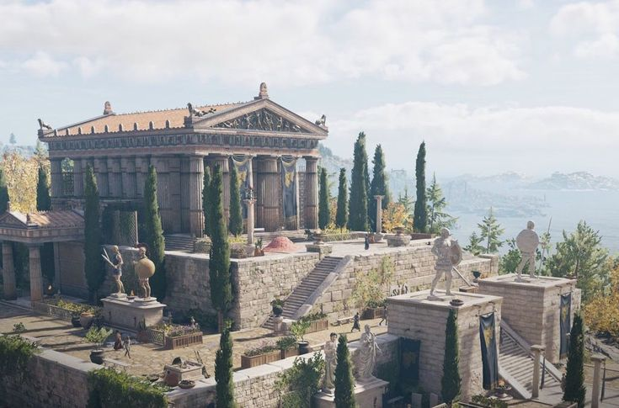

Drommica
Size: large town, population 5,000, guards / soldiers 50, militia 250
Trade Goods: wine, furs, fishing
Local Goods: Ephyra wine
Standard: wheel of Hecate
Colors: white and black
Patron Deity: Soteria, goddess or spirit of safety and salvation, deliverance, and preservation from harm
Ruler: Archon Oneus and his wife Niketa (f)

Home: Hyacinth Villa
Steward: Kodemos
Marshal: Phoerius
House Priest: Lysander
House Adviser (Scholar/Mage/etc): Isadora (f)
Captain of the Guard: Kyriak
Chief Warriors in Service:
Hieros
Helena (f)
Galenos

Local Powers: Temple of Soteria, Masters of Midnight (thieves’ guild)
Local Sites: The Blue Delphin Inn & Tavern, The Hidden Key Inn & Tavern, Ephyra Vineyards

Description:
Sun-dappled vineyards blanket the rolling fields between the Agda and Eido Rivers. In their midst, the low mud walls of Drommica appear like an island in a green ocean. Foot paths, and a few roads wide enough for carts, snake through the vineyards following no particular design. In some places the stalks grow high enough the view of the surrounding area is lost altogether.

At the town’s gates tall tawny arches greet visitors and lead to a large central town square. There stands a tall stone statue of a man dressed in sailor’s garb, his curve sword held skyward. Visitors will notice right away that all the walls and buildings in Drommica are covered in creeping vines of various sorts: morning glories, honeysuckle, clematis, mandevilla, moon flower, climbing rose, nasturtium, star jasmine, hyacinth bean, scarlet runner, passion flower, hydrangea, and wisteria. The vines even cross the streets overhead, their varied flowers painting a wild and colorful vista.

People here are earnest and hard-working. Their skin is ruddy from working in the sun, their feet stained purple from the grape presses. At daybreak the hunters depart for the forest, the fishermen to the river banks or to the coast of the Syren Straits. Most of the townfolk work the vineyards. Once each month boats are sent upriver to Osireion.

Industry:
Drommica produces the finest wine in Mythenia, which is known in shorthand as Ephyra. Unlike wines produced elsewhere, Ephyra is mixed with water in precise proportions in a vessel called a krater. Sometimes it is mixed with salt water as a preservative and for the taste it imparts, other times honey is added. Connoisieurs refer to the blends as Ephyra, Sea Ephyra, Honeyed Ephyra, and so forth. The mixing of water and wine, it is believed, is for the drinker to maintain composure and self-control, traits that are highly valued in Mythenian society. In fact, Mythenians believe that only barbarians would drink unmixed wine.

Some say the young and impetuous god Susyniod came to Nemmyrl at the dawn of time and held a wild party here with the first humans. Where his cup spilled, the ground soaked up the heavenly spirits. Ephyra wine is popular throughout Mythenia and is the major export of the town.

Like Arropos to the south, Drommica is a town of farmers and hunters. It traffics with ships passing up and down the Syren Straits, trading its wares for goods being shipped through here. But Drommica has no large port to launch trade of its own nor the means to assert itself as a power and grow. Both towns use the waterways to trade up-river with Osireion. The trade partners have formed a pact to keep Argeia’s power in check in central Mythenia.

Key Figures:
Archon Oneus has allied with Archon Dorius of Arropos to counter the overwhelming influence of Argeia in the region. Oneus’ daughter, Alemene, is betrothed to Dorius’ son, Midylos.

Local Lore:
The humans of Drommica have had peaceful dealings with the Elves of Alona Forest. They have secured permission to travel the river as well hunt for game in the northern reaches of the forest. Dark runes cut into trees indicate the northern edge of the Lo’Shella Elves and humans are not allowed south of this without permission and an escort. The forest is also the realm of faun and dryads, who coexist with little conflict with Elves. Humans, however, are rarely trusted and are better off keeping to themselves.

History:
Hundreds of years ago people from Drommica fled the town in the wake of Aegiean warfare. Their boats landed on the shores of the Isle of Skiron, which is located at the southern end of the Syren Straits. Over time the town folk set up camps on the island and some even stayed on to build a new life. To this day the island folk feel a kinship with their cousins in Drommica and there are regular visits between the two groups. The village on Skiron carries the name Ophelos and is a well-kept secret. Its location is known only to trusted kin in Drommica.

Drommica is the home of the legendary hero Helon, the cunning pirate who vanquished the dreaded Kraken of Drommica. It was seven thousand years ago and the fourth of the Curses of Salisar when the kraken was unleashed. Helon, a wanted privateer who sailed the Siren Straits, watched as the sea monster destroyed the finest war galleys from Parseion and Argeia. Defying the warnings of his peers, Helon took his speedy ship, the Sagonas, and out-maneuvered the beast in a death-defying dance around the Isle of Skiron. At last, he managed to lure the kraken into the dangerous reefs of Skiron and impaled it with the prow of the Sagonas. Helon would be hailed a hero and continue on, issuing his brand of justice on greedy merchant ships for years to come. He would be recorded as the fourth of the heroes in the Herothlon.

Customs:
Every spring the people of Drommica hold raucous parties as they press the grapes from the vineyards. Music is played and people young and old dance in large vats, crushing the grapes.

Drommica holds large open-air festivals every full moon. These are called the Susynoids, named for the fabled god of partying, and are wine-fueled feasts that draw the rich from all corners of Mythenia. Attendees dress in outrageous costumes and celebrate a wide range of subjects: heroes, gods, magical beasts, even death itself is toasted in one mid-winter celebration. Each night a King and Queen of the Susynoid are chosen and paraded throughout the town on thrones. The wealthy are drawn to these feasts and it is the one time where peasants and nobility mingle freely.

Arropos
Size: small city, population 12,000, guards / soldiers 120, militia 600
Trade Goods: grain, wool, furs, fishing, arts
Local Goods:
Standard: sign of the trireme
Colors: orange and black
Patron Deity: Glaucus, a prophetic sea god
Ruler: Archon Dorius and his wife Genna (f)

Home: Palace of Triptolemus
Steward: Hesiodos
Marshal: Kallias
House Priest: Ligeia (f)
House Adviser (Scholar/Mage/etc): Kallikrates
Captain of the Guard: Kassandor
Chief Warriors in Service:
Lysandros
Trodior
Romedes

Local Powers: Temple of Glaucus, The Dead Coins (thieves’ guild), Barbiton Amphitheater (bardic college), Halls of Hephaestus (art academy for painters, sculptors, architects, and craft workers), Hall of Hestia (major grain threshing house and repository)
Local Sites: Corvus’ Cup Inn & Tavern, The Golden Lyre Inn & Tavern

Description:
Arropos is a small city with one foot in its agrarian tradition and the other in the arts. Walls of the buildings are covered in colorful frescoes. The buildings themselves feature clever and unconventional architectural features. Statues large and small can be seen throughout the city. The main square never seems empty, for the number of life-size statues that stand here. The people here wear brightly colored garments and strange hair styles. Music hangs in the air at all hours, with street musicians carrying the day.

Arropos sits at the southern end of the Syren Straits with the Hesperis River flowing through it.
Argeia to the south has long enjoyed dominance in the southern regions of Mythenia and has made Arropos feel like the poor country cousin. This doesn’t seem to bother the regular citizens of the city but it does prick the pride of those in the artisan class and the court of Archon Dorius.

Industry:
Arropos is a city of farmers, hunters, and herders. It does well commercially from the traffic along the Syren Straits but without a large port it has hit a wall in growth. Most of its income comes from the large pastures to the south where grain and wool are harvested. Grain is vitally important to the southern lands of Mythenia. Much of it comes from Arropos, which is called the Basket of the South.

Arropos is home to a school of arts that has existed since the city’s founding. Artists fled the confines of the larger cities to the tranquility of this region. Sculptors, painters, and architects study at the Halls of Hephaestus. Patrons from other cities come here to commission works or hire artists for long-term work, some outside of Mythenia. The large and beautiful villa has scenic workspaces where artists work in secrecy and hold feasts at night. A large sign outside the villa bears the image of a donkey, the beast of choice for Hephaestus god of sculptors.

The Hall of Hestia is a large estate that controls the storage and selling of grain to towns and cities in southern Mythenia. It controls threshing floors and silos in the surrounding region. Farmers bring grain to the hall every harvest, where the merchants pay good coin. In turn the grain is sold to outside towns and cities, which can become quite profitable during times of famine.

Arropos, along with Drommica, are currently working to compete with Argeia’s hold of the trade routes. Both towns use the waterways to trade up-river with Osireion.

Key Figures:
Archon Dorius shares a strong bond with Archon Oneus of Drommica. Dorius’ son, Midylos, is betrothed to Oneus’ daughter, Alemene.

Local Lore:
The humans of Arropos have had peaceful dealings with the Elves of Alona Forest. They have secured permission to travel the river as well hunt for game in the northern reaches of the forest. Dark runes cut into trees indicate the northern edge of the Lo’Shella Elves and humans are not allowed south of this without permission and an escort. The forest is also the realm of faun and dryads, who coexist with little conflict with Elves. Humans, however, are rarely trusted and are better off keeping to themselves.

The nine muses make regular visits here. Appearing as normal mortal women, they appear in disguise and observe the artists while they work. If an artist is deemed worthy of inspiration, one of them may approach and befriend them. The muses appear in Arropos depending on who might be working on projects to their liking: Calliope (epic poetry), Clio (history), Erato (lyric poetry), Euterpe (music), Melpomene (tragedy), Polyhymnia (sacred poetry), Terpsichore (dance and chorus), and Thalia (comedy and idyllic poetry), and Urania (astronomy). Bards and minstrels travel to Arropos from time to time, hoping for the chance to meet one of the fabled muses.

Glaucus is the patron deity of Arropos. He was born mortal and turned immortal upon eating a magical herb. He comes to the rescue of sailors and fishermen in storms, having earlier earned a living from the sea himself. He is he seen as a man whose hair and beard are dripping with water, with bristly eye-brows, his breast covered with sea-weeds, and the lower part of the body ending in the tail of a fish. It is widely held that once each year Glaucus visits all the coasts and islands, accompanied by marine monsters, and gives his prophecies. Fishermen and sailors pay particular reverence to him, and watch his prophets, which are believed to be very trustworthy.

History:
Before the rise of the city states, Arropos always held to its fealty to Argeia and answered with troops when called. Today Dorius feels a closer kinship to the city’s smaller twin to the north, Drommica, and their ruler, Archon Oneus.

Seven thousand years ago the city of Arropos was the site of the seventh of the Ten Curses of Salisar. In 540 AA1 the evil lich Salisar summoned the evil sorceress Hyliva and bid her unleash a kingdom-wide scourge by her army of harpies. It was Lithia, a fleet-footed warrior from Arropos, who ended the reign of terror. Such was her quickness that she managed to evade and attack the harpies and save towns and villages from their evil. It is said that when she finally faced the Hyliva the sorceress managed to cast a spell that trapped Lithia within a tomb of ice. But Hyliva had been deceived: such was Lithia’s speed that it was merely her shadow that had been trapped. Lithia managed to defeat Hyliva and protect the kingdom for the next several years, earning her the title of the seventh hero in the Herothlon.

Customs:

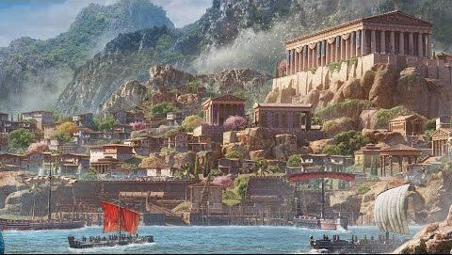

Argeia
Size: large city, population 25,000, guards / soldiers 250, militia 2250
Trade Goods: trade hub, pottery, papyrus, flax, clay, ship building
Local Goods:
Standard: Pegasus
Colors: black and silver
Patron Deity: Aidos, goddess of modesty, respect, and moral direction
Ruler: King Markos and Queen Myrrine (f)

Home: Palace of Polemos
Steward: Lopatros
Marshal: Heriod
House Priest: Someros
House Adviser (Scholar/Mage/etc): Kallisto (f)
Captain of the Guard: Gennador
Chief Warriors in Service:
Euteron
Diokles
Telamon

Local Powers: Gold Trident Traders, Hemlock (assassin’s guild), Typhon’s Shadow (thieves’ guild), Sons of Autolycus (smuggling ring), Temple of Aidos, Order of Aratea (order of paladins)
Local Sites: The Golden Trireme Inn & Tavern, The Wandering Chelys Inn & Tavern, Basileia’s (brothel)

Description:
Argeia is the great Mythenian city in the South. Historically it has held sway over all other southern towns and has been the bitter rival of Parseion for control of all Mythenia. It sits a majestic jewel atop a hill overlooking the entrance to the Syren Straits.

Argeia is an imposing city with mighty vertical bronze bands running the height of the ruddy stone walls. The walls descend a gently sloping hill to meet the bay below and the massive sea port. Visitors arriving at the port ascend the slope, famous for the processions made here. They are greeted by a massive brazier atop the gates whose flames are always lit in an offering to the heavens. One might shudder to think of the olden times when enemies were thrown to the flames to appease the dark gods of war. Inside, the city is a sprawl of maze-like streets cast in shadow. It is an elegant city but one shrouded in malevolent strength.

To the west runs the river Lagina and forms a natural barrier around the city. To the north lies the Bone Mire Swamp. Elephants who live in the swamp have historically been used as war mounts by the Argeians.

Industry:
Argeia operates a thriving trade hub from the traffic coming down the Straits as well as from Kaduru and beyond. It also has a large ship-building complex that enables it to build an imposing navy and launch expeditions abroad.

Key Figures:
King Markos, one of only two rulers who style themselves a king in Mythenia, is a ruthless despot. He has long observed the history of Argeia as a super power and longs to rule all of eastern Arnland. His soldiers roam the city brutally enforcing the king’s will and collecting crushing taxes. Myrrine, his queen, dresses in lavish fashion and takes delight in humiliating her subjects as well as envoys from other Mythenian cities. While she throws extravagant parties and parades, Markos plots and schemes to gain allies from abroad for conquest. It is rumored he has agents working in the Svarog Valley in Gaeadon, envoys in Ajabar and Longspear, and a secret army of mercenaries in the Tarbian Desert. He has invested heavily in his sprawling port and is eager to make allies across the Thundra Sea. His exact plans are known only to his shadow court.

King Markos suffers a burning desire for Aspasia, wife of Archon Teleon in Sargon. For years she has spurned his advances. Markos plots to have Teleon murdered and Aspasia stolen away.

Local Lore:
The region around Argeia is rife with dangerous creatures. To the immediate north is the Bone Mire, home to Helead (swamp nymphs) and Chimera. To far north lie the Harpy Plains, plagued by creatures of the same name. Overland travel westward brings the risk of dire lions trolling the open plains.

History:
Seven thousand years ago, it was Arxis that saw the sixth of the Ten Curses of Salisar. By 490 AA1 the evil mage Salisar had perished and come back as an evil lich living in the Argyron Mountains. For his sixth curse he lit the sixth Lamp of Vengeance and unleashed a terrible cyclops from Maeleera. Salisar infused the cyclops with skin like iron, with feet that could level houses when they struck the ground, and a terrible eye that hurled forth magical rays from a gem embedded within it. The armies of Parseion and Argeia fled before the beast, who terrorized the land with a horde of lesser beasts ravaging in its wake. At last came forth the thief Kanibar of Argeia. Kanibar’s adventures were many and always seemed to bring destruction to the host of the cyclops. At last Kanibar stole the gem of the cyclops of Maeleera and ended a year of darkness in the land. Kanibar would be hailed as the sixth hero in the Herothlon.

380 PA4 - the Battle of Dymoneia: King Spyros of Argeia launches a full attack on Dymoneia, obsessed with having the amazon queen as his slave
382 PA4 - after two long years of battles on land and at sea the Argeian army is driven out of Dymoneia with their fleet in flames; prisoners are sent home in chains
Age of Argeian Conquest (460 AA4 – 800 AA4)
Customs:
Centuries ago, the Oracle in Domos prophesied that Argeia’s history of war had angered the gods. In response the gods decreed that every ten years the gods of the sea would call up such a storm as to wipe the city from the world. A giant water clock appeared outside the city, with the warning that if the gods were not appeased the clock would run down and bring their doom. As a matter of tradition the people of Argeia answer this threat by carrying fresh water to the water clock and anointing it while uttering prayers to the gods. It has stayed the march of the clock, for the time being.

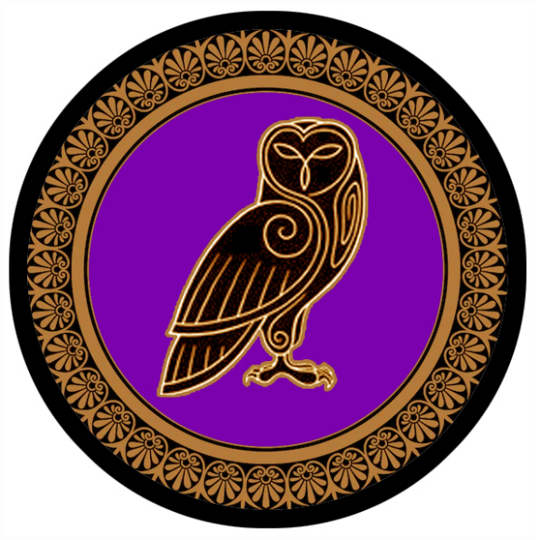
Sargon
Size: large town, population 5,000, guards / soldiers 50, militia 250
Trade Goods: olive oil, wool, stone
Local Goods: scholarship of the Library of Sargon, stone masonry
Standard: owl
Colors: gold and purple
Patron Deity: Eidyia, an Oceanid, a goddess of knowledge
Ruler: Archon Teleon and his wife Aspasia (f)

Home: Palace of Astraios
Steward: Latarchis
Marshal: Ethanris
House Priest: Tryphaina (f)
House Adviser (Scholar/Mage/etc): Zephyron
Captain of the Guard: Sapphus
Chief Warriors in Service:
Platon
Doroso
Stratus

Local Powers: Temple of Eidyia, Sons of the Cyclops (thieves’ guild), The Great Library of Sargon, The Collegium Cogitor (institute of learning)
Local Sites: The Centaur’s Beard Inn & Tavern, The Sisters Gorgon Inn & Tavern

Description:
Sargon is an old city even by Mythenian standards. It is rumored this was the first place the gods touched when they arrived in Nemmyrl. It is a quiet town of farmers, masons, and sheep herders tucked away in the crook of the mountains where they meet the sea. It has ancient walls and architecture, all of which are built stronger than their appearance suggests. The stonework here is colored dark grey and black. The black sections of the outer wall are covered in writings from all over the world that date back thousands of years.

The Great Library of Sargon is housed in an elaborately decorated, fortress-like structure at the center of town. Built eight thousand years ago (110 PA4), it houses tomes that date back to the Primordial Ages. Some say that magic lost to the world can be found surviving here, but only in the deepest depths. Forgotten lower levels, moving hallways, and disappearing doors make it difficult to navigate the labyrinth of secrets. It is said an especially old repository called the Vault of Enigma vanished two thousand years ago without explanation. Scholars from around the world make pilgrimages to Sargon: some to research, some to gain a reputation as a world class scholar for having been here. An exclusive circle of scholars here make up the Collegium Cogitor. They graduate certified Cogitors who serve as advisors to kings the world over.

Industry:
The stone quarry nestled into the Celestial Mountains has been in use for over eight thousand years. Marble of the most exquisite patterns come from this region. It was here the great Keystone of Qama was pulled that now protects the gates of Parseion. Here too the obelisks built as wards for the Thyra Gates. The greatest stone masons of Mythenia come from here. Some trek into the mountains to learn from the Dwarves in Helvent Keep and Krucible.

Key Figures:
Archon Teleon is rarely seen by his people. He is an elderly and thoughtful man, often lost in his thoughts. Years ago he was offered Aspasia as a young bride, but he never took the time away from his books to start a family with her. Aspasia is a striking beauty, even in her forties, and assumes the role of public ruler to her people. She is also keen to invite dashing heroes to her court to tell her of their adventures. She has fought off the advances of King Markos in Argeia for years. She has no deep love for her husband, but she is fond of her life in Sargon and fears what the king may do.

Local Lore:
Deep within the Library is the Scriptorium of Eidyia. Here scribes labor night and day to chronicle writings from around the world. It is the home of the Scribes of Draiachta, an order of monks whose sole mission in life is the collection and preservation of all knowledge in Nemmyrl. Agents of the order are dispatched to the far corners of the world in secret. There they adopt the roles of servants or hirelings, working their way into the palaces, studies, and libraries. They bide their time, making copies of the tomes and scrolls and secreting them back to Sargon. It is said that special papyrus and vellum are left in many studies, called Dictum Ledgers. Seen as normal blank pages, they carry the special property wherein any writings made on them automatically appear on identical pages in the Scriptorium. In this way the Scribes are able to collect writings before they are even completed.

The Eye of Ages resides deep beneath the Library in a natural cavern system that predates the town. Little is known of the mighty artifact and no one is permitted into the caverns. It is rumored the gods created it to watch and know the feats of humans. Some say the Eye collects every deed or word spoken in Sargon, perhaps all of Mythenia or even the world. A strong field of divination can be felt above ground by those attuned to such an aura.

The southern end of the Celestial Mountains is home to many dangerous creatures, the most prominent of which are hydra. Some say there is a cavern deep below the mountains where an ancient hydra queen laid her eggs. Every so often a new hydra will appear outside the town and terrorize farmers. Some years they are numerous enough to terrorize the plains as far east as the Hathor River. This makes travel over land perilous for the people of Sargon.

History:
At the beginning of known time (rumored to be 450 PA1) the Eye of Ages awoke at the site of present-day Sargon. The eternal eye watches and records the feats of heroes and tyrants.

110 PA4 - Library of Sargon is built atop the buried lair of the Eye of Ages

Seven thousand years ago (640 AA1), it was Sargon that saw the ninth of the Ten Curses of Salisar. The lich mage sent an enchantment of dismay over the land of Mythenia, causing the people to speak strange tongues and fall into chaos. It was at this time that Astormorinx, feared sorceress from Sargon, who journeyed the astral planes to solve the riddles of the Sphinx Dardala and retrieve the Cipher Book of Horonn. With the help of the book Astormorinx cracked the code of the strange glyphs that appeared on temples in every city and lifted the enchantment. The sorceress went on to solve many more strange magical ailments throughout the land and is still seen today as one of the greatest sorceresses of all time. For this she was dubbed the ninth hero in the Herothlon.

Customs:
The people of Sargon are fond of writings of every kind. Books and scrolls are aplenty even in taverns and the market. Language is an art form even among the commoners, who tend to speak more languages than citizens of other towns. The town itself is like a writer’s tablet, with graffiti written on buildings offering ancient wisdom.

The outer walls of the town are covered in writings from travelers and townspeople dating back to the founding of the town. Anyone visiting the town is welcome to scribe a message here. Small ebony stones litter the foot of the walls and are used for such writings. The walls themselves are enchanted, receiving whatever is traced on them with these stones with little effort. Newcomers may find on revisiting the town that rude or profane writings might be replaced with rude comments containing the writer’s name! Some say the wall itself is sentient and not interested in ignorant writings.

Entry to the town of Sargon is unconventional. At each gate there are three puzzles displayed carved in the archway, each of them more challenging than the last. These puzzles change every day. For the simple-minded, only the easiest of puzzles is solvable but doing so leads one down an alley that leads to the poorest sections of the town. The middling level puzzle operates in the same way, leading the visitor to the average sections of the city that are cleaner and safer. The most challenging puzzle leads anyone who solves it down a marble-lined hallway to the richest section of town. Those who emerge from this tunnel are gifted with simple laurel crowns that designate them as superior beings and which earn them favorable prices from vendors, free drinks at taverns, and access to the more exclusive corners of the town.

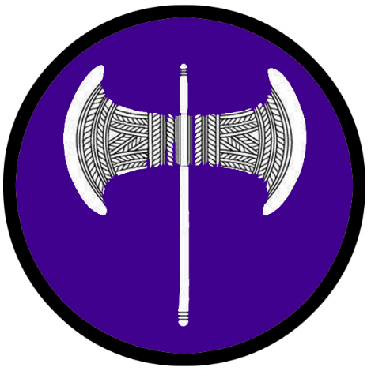
Elefthireia: Isle of Dymoneia
Size: small city, population 12,000, guards / soldiers 120, militia 600
Trade Goods: incense, olive oil, magic center, flax
Local Goods:
Standard: silver Labrys or double-bladed axe (also known as Pelekys or Sagaris)
Colors: purple and white
Patron Deity: Simetra, goddess of the hunt, the wilderness, wild animals, the Moon, and chastity
Ruler: Queen Latoreia (f)

Home: Palace of Valasca
Steward: Alcmene (f)
Marshal: Myrleia (f)
House Priest: Cynna (f)
House Adviser (Scholar/Mage/etc): Kotoanta (f)
Captain of the Guard: Valasca (f)
Chief Warriors in Service:
Clyemne (f)
Thraso (f)
Hypsipyle (f)

Local Powers: Temple of the Heavenly Queen (temple to Simetra), Order of Euryleia (order of paladins), Sanctum of Orithia (school of magic), The Epigonion (bardic college), Hall of Eudorus (warrior training hall)
Local Sites: The Empty Amphora (tavern), Lotus and Lyre (tavern)

Description:
Dymoneia is a magical place unto itself. Situated off the deserted shores of Tarbia, the island is a stronghold for the race of amazons who have made this their refuge from the world. Thought it sits in plain sight within the Bay of Kraken and passing trader ships, it is rarely visited, much less threatened. Magical wards protect the island and each woman here is a capable warrior.

Dymoneia was founded ten thousand years ago when the legendary warrior Calaithe led a revolt of enslaved women in Feronia in modern-day Celedon (230 PA2). The freed army of women moved across the grueling deserts of Tarbia, gathering recruits along the caravan routes. It passed over the Celestial Mountains into present-day Mythenia and doubled in size as it freed the women from slave pens up and down the coast.

At last, the Akeron armies caught up to them near Sargon. Calaithe ordered her spies to slip into the Bay of Kraken and board the enemy vessels at her back. During the night half the fleet had been taken. The next day Calaithe and her elite guard fought a holding action against their enemies as the majority of her army escaped to the island. Calaithe and her host fell, but she had secured a haven for her army. Years later one of their number, the sorceress Orithia, discovered a hidden artifact on the island and mastered its use. It was a sphere of immense power called the Cradle. Immeasurable life energies emanated from the Cradle and soon it was convinced that the amazons were its friends and it empowered them with the ability to fend off any outsiders.

The Cradle of Life is an ancient artifact that emanates enormous life-nurturing energies. it resembles a giant silver sphere and is situated within the mountains in the interior of the island. Amazonian priestesses tend to the Cradle and commune with it. Some even enter it and are gone for weeks at a time. Anyone stepping foot on the island will sense an uplifting feeling of the Cradle’s presence. Evil-aligned characters, however, will feel sick at the feel of the energy if they resist it. The Cradle itself is hyper intelligent and is aware of every living creature on the island. It communicates with the priestesses to alert them to any trouble.

Today the amazons of Dymoneia enjoy peace while cultivating art and culture and following the discipline of military training handed down by their hero Calaithe. Visitors are strictly prohibited unless granted an invitation from the Queen herself. Those washing ashore in distress, however, are not treated without mercy. The amazons are not cold blooded but they are quick to respond to any perceived threat.

Many wonder how an island of women can sustain itself over the centuries. There are rumors that amazon ambassadors are regularly dispatched to visit other lands. Traveling in secret they learn of other cultures and sometimes bring back women who are persecuted and seek a better life. Other rumors have it that some amazons venture into the world for the express purpose of mating and returning to bear children. How it is that they bear only daughters is a mystery, if even the tales are true.

Industry:
The amazons of Oritheia are content to divide their time between tending their groves, studying music and dance, and training for war. Lush fields surround the city filled with aromatic plants, flax, and olive trees.

Key Figures:
Queen Latoreia is a fair and just ruler, preferring to keep minimal contact with the outside world. She is an older amazon who still retains a regal beauty and sharp mind. She has no patience for the merchants who seek to create markets on her island. She prefers their ships stay at the docks, conduct their business, and go.

Local Lore:
The nine muses make regular visits here. Appearing as normal mortal women, they appear in disguise and observe the artists while they work. If an artist is deemed worthy of inspiration, one of them may approach and befriend them. The muses appear in Oritheia depending on who might be working on projects to their liking: Calliope (epic poetry), Clio (history), Erato (lyric poetry), Euterpe (music), Melpomene (tragedy), Polyhymnia (sacred poetry), Terpsichore (dance and chorus), and Thalia (comedy and idyllic poetry), and Urania (astronomy).

History:
230 PA2 - Calaithe leads a revolt of enslaved women in Feronia (in present-day Celedon); she leads an ever-growing army east through the Tarbian Desert
233 PA2 - Battle of Calaithe's Flight: the freed women's army battle Auran and Ebon soldiers at the Thyra Gates, defeating them to secure their passage into Akeron lands
235 PA2 - Calaithe's army moves south through Akeron lands, growing with more freed slaves
236 PA2 - the freed slaves escape to the nearby island of Dymoneia while Calaithe and a small host battle Akeron forces in Sargon to cover their escape
240 PA2 - the sorceress Orithia discovers the Cradle of Life; the women assume the culture of amazons and proclaim the Isle of Dymoneia a sovereign kingdom

33 AA3 - Alyaqut syndicate issues as proposal to the Amazons: marriage of the queen to a Tarbian prince and leave to build a port on the Isle of Dymoneia; the Amazons refuse
34 AA3 - War of the Scales: Alyaqut hire mercenary armies and attack Dymoneia; an Alyaqut wizard discovers the Sunduq Albahr, an ancient magic chest that can summon terrible powers from the sea
36 AA3 - the Amazons soundly defeat the merchant armies and capture their fleet; the Sunduq Albahr is used to summon the Kraken, which destroys the ships around Dymoneia
37 AA3 - Amazons defeat the mercenaries on land and cast the Sunduq Albahr into the sea; the freed Kraken turns on the towns

Customs:

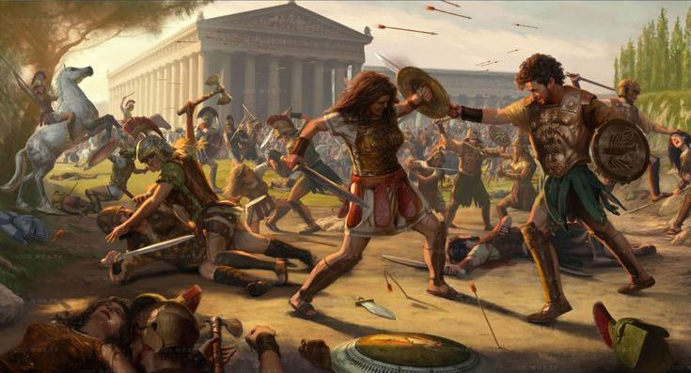

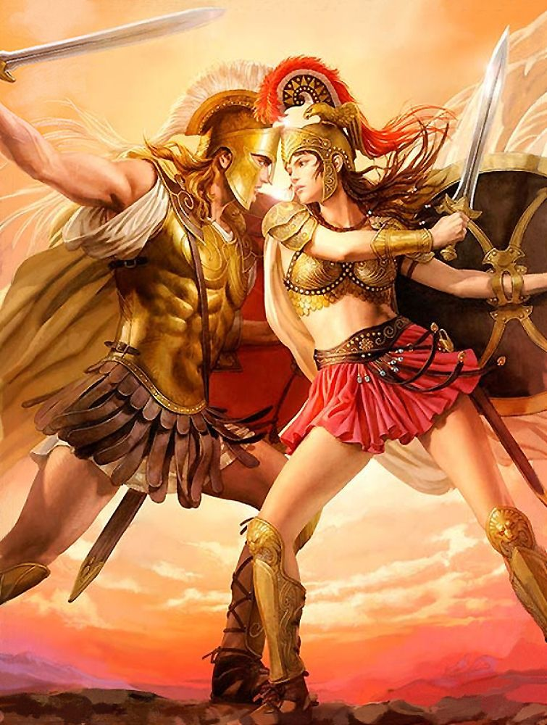

Customs of Mythenia
Agonas
Mythenians celebrate athletic prowess as a reflection of the gods and their favors. Dating back to the earliest times, the Agonas has been a popular pastime. Literally translated as “race” but also as “struggle” or “fight,” competitors cross great distances on foot and push themselves to the brink of death to win honor for their people. Several Agones are held throughout the year, each pitting one town or city against one another. Racers are not allowed to attack one another, for proof of such a deed securing a victory would bring great shame to the victor. Once each year the Great Agonas is held, which runs from Kasylla all the way to Sargon.
The Elysium Games
Also in keeping with a tradition of athletic achievements, once each year the entire land of Mythenia sends its greatest athletes to compete in the great Elysium Games. The city or town that hosts these games changes every year. The lands greatest athletes show up to compete in running, jumping, wrestling, running, pole-vaulting, archery, the discus throw, pankration (unarmed combat), and chariot racing. Competitors do so completely naked. Often the sweat of these men and women is scraped off after the games and sold to enthusiastic spectators.
Pankration is a no-holds-barred form of unarmed combat, where only biting and gouging are prohibited. It is a brutal event that occasionally ends in death for one of the opponents. Three competitors live on in Mythenian legend:
Arrichion of Arxis - Caught in a terrible stranglehold, Arrichion seized the foot of his opponent and, with the last of his strength, crushed it, dislocating the ankle. Unable to bear the pain, the unnamed man raised his index finger to signal submission. At the very same moment Arrichion gasped his last breath. He was posthumously awarded the victory because his rival had surrendered.
Theagenes of Osireion - the ultimate symbol of this brutal and wildly popular sport.Born to a priest in the temple of Kratos in Osireion, the locals came to believe Theagenes’ true father was the god Kratos himself. Famous from the moment he tore a bronze statue from its base in the square in Osirieon and carried it home aged just nine, Theagenes went on to win the wrestling and a pankration the Elysium Games in 480 AA1. Subsequently, he toured the Arnland continent reportedly winning more than 1400 victory wreaths. A life-size statue of the man stands in the great square of Parseion.
Polydamas of Nemesis - The Elisium champion in 408 AA2 is said to have killed lions with his bare hands, pulled the hoof off a ferocious bull and brought a speeding chariot to a standstill with just one hand.

History of Mythenia
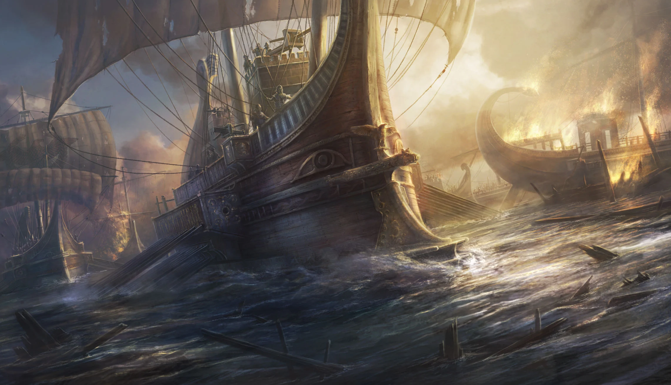
Major Historical Events
- Cataphract Wars (280 PA2 – 435 PA2) saw the region gripped in war between the northern, central, and southern peoples; the conflict helped form the identities of the towns and cities but also created never ending tensions between these regions
- Mythenian Empire (170 PA4 – 740 PA4)
- Curse of Salisar and the Herothlon (190 AA1 – 690 AA1)
- Rule of the Primacy out of Argeia (820 AA1 – 520 AA2)
- 570-720 AA2 - Age of the Philosophers, during which some of the greatest Mythenian writings are created
- 820 AA3 - formation of the Mythenian City States
- Age of Argeian Conquest (460 AA4 – 800 AA4)
- Celedonian Occupaton (70 WA1 – 5 WA2)
First Primordial Age
Dawn of the Akeron peoples
450 PA1 - The Eye of Ages awakens at the site of present-day Sargon; the eternal eye watches and records the feats of heroes and tyrants
690 PA1 - the Reign of the Fauns - satyrs harass the Akeron people, luring some to abandon the tribes to live in the wild; the chieftains beseech the gods to rid them of the satyrs; the gods answer by sending nymphs to distract the beast men
870 PA1 - the town of Zaar becomes an important trade hub for the Akerons and is considered the birthplace of their culture; the Well of Afthonia (abundance) is rumored to have been here, a source of life in the early days of the Akerons
Second Primordial Age
40 PA2 - Reign of the cyclops Yorgemus in Estarra
231 PA2 - The slave Calaithe leads a revolt of enslaved women in Feronia (in present-day Celedon)
232 PA2 - Calaithe's army marches to other Auran cities, defeating Auran forces and freeing more enslaved women
233 PA2 - Calaithe's forces enter the Tarbian desert, beginning a grueling trek eastward to escape Auran forces
235 PA2 - Battle of Calaithe's Flight: After surviving many perils in the Tarbian desert, Calaithe's forces defeat Ebon and Akeron forces at the Thyra Gates to enter Akeron lands
236 PA2 - Calaithe's Last Stand: Calaithe sacrifices herself and her personal guard holding off the Akeron forces as ten thousand women escape to the Isle of Dymoneia; the Amazon kingdom is formed
240 PA2 - the sorceress Orithia discovers the Cradle of Life; the women assume the culture of amazons and proclaim the Isle of Dymoneia a sovereign kingdom
Cataphract Wars (280 PA2 – 435 PA2) saw the region gripped in war between the northern, central, and southern peoples; the conflict helped form the identities of the towns and cities but also created never ending tensions between these regions
280 PA2 - The Cataphract Wars - the oracle Dynasia travels to the underworld and returns with a riddle that spooks the fledgling Ebon towns
281 PA2 - Kasylla attacks Parseion igniting war, Nemesis abstains from joining
283 PA2 - Osireion wages war on Drommica and Aropos in a bid to strengthen its position in the south
290 PA2 - Arxis and Estarra assert control over the Siren Straits, seizing boats from the southern towns
293 PA2 - Argeia comes to the aide of Drommica and Aropos, uniting the southern tribes into attacking Arxis and Estarra
300 PA2 - Parseion strikes an alliance with Arxis and Estarra, uniting central Mythenia
305 PA2 - Parseion, fearing Nemesis getting involved in the wars, signs a pact of peace with them; later that year Parseion burns the town to the ground
306 PA2 - Domos, fearing for its safety, joins Parseion and marches on Kasylla
330 PA2 - survivors of Nemesis dwelling in the Argyron Mts build up their resources to take revenge; their warriors don black and attack unseen, starting rumors of the Underworld Army
435 PA2 - Battle of the Underworld: the necromancer Charexei and his army of undead are destroyed; End of the Cataphract Wars
680 PA2 - Temple of the Oracle is built in Domos
Third Primordial Age
190 PA3 - Terror of the Gorgons in Arxis
350 PA3 - the Centaur Wars: Centaur make war with the Akeron over the lands around Maera Lake
370 PA3 - peace is struck between humans and the centaur tribes, who hold domain around Maera Lake
810 PA3 - Song of Wood and Water - nymphs harassed by humans dry up the rivers of northern Mythenia: Ceto, Laedon, Astera, and Phyrion
820 PA3 - rangers from Arxis and Estarra beseach the nymphs to make peace; the nymphs take husbands of the rangers and claim Orpheon Wood as their domain
Fourth Primordial Age
110 PA4 - Library of Sargon is built atop the buried lair of the Eye of Ages; curators dubbed the Scribes of Draiachta comb the world for ancient writings
Mythenian Empire (170 PA4 – 740 PA4)
170 PA4 - Rise of the Mythenian Empire: Parseion and Argeia form a pact to share Mythenia and launch expeditions outward
180 PA4 - Parseion partners with Kasylla, Nemesis, and Domos on a series of expedtions that land in Tirudor and the Krenn lands
190 PA4 - Argeia sends armies into western Kaduru, conquering the towns and occupying lands west of the Joro Mts.
200 PA4 - Osireion launches expeditions into the Tarbian Desert, conquering the seven cities
210 PA4 - expeditions from Kasylla lay claimto the eastern shores of Celedon and the Isle of Infernus
220 PA4 - Arxis and Estarra colonize present-day Kyre
230 PA4 - Drommica and Arropos occupy Isle of Skiron and Adhanar lands
240 PA4 - Osireion's forces invade Isles of Phoenix and Orpheon as well as the Tauran Mt region of present-day Celedon
250 PA4 - Arxis and Estarra subjugate the Mordens in the Bay of Morda
260 PA4 - Arxis and Estarra conquer the city of Vigil
380 PA4 - the Battle of Dymoneia: King Spyros of Argeia launches a full attack on Dymoneia, obsessed with having the amazon queen as his slave
382 PA4 - after two long years of battles on land and at sea the Argeian army is driven out of Dymoneia with their fleet in flames; prisoners are sent home in chains
496 PA4 - Dractus conquers the city of Vigil; conquerors from Arxis and Estarra flee
498 PA4 - Dractus invades Adhanar in W. Gaeadon, sacks Oisia, drives out the invaders from Drommica and Arropos
640 PA4 - Krenn tribes unite to drive out all Mythenian invaders in the Bay of Banners region
660 PA4 - Argeian forces are wiped out in western Kaduru
680 PA4 - the Badawi tribes defeat the Mythenian occupational forces, forcing the Mythenians to leave; rule of the seven cities returns to the Fajar people
690 PA4 - newly organized Ordonian peoples retake all of present-day Tirudor region
730 PA4 - Kings of Parseion, Argeia, and Osireion break their alliances, each of them claiming rule over all of Mythenia
740 PA4 - Fall of the Mythenian Empire
750 PA4 - cut off from their patrons in Mythenia, Kasylla forces in Celedon abandon their claims, as does Osireion on the Isles of Phoenix and Orpheon and the Tauran Mt. region of Celedon
872-888 PA4 - The Wizard War: Telemechus triggers a world-wide war of mages, some of whom march on Ongolk to stop him and some who join him in attacking the ley lines in their lands; epic battles wage all over the world, destroying cities and upsetting the balance of magic
888 PA4 - The Battle of Forlorn: Telemechus is slain but not before rupturing the magical ley lines permeating Nemmyrl; the victorious general Dragan of Celedon seizes the opportunity to rid the world of magic and ruptures the Singularion as it is embedded in the ley lines; the resulting explosion sends a shock wave that ruptures the magical ley lines around the world and triggers the Dead Century

First Ancient Age
190 AA1 - The Curse of Sarlisar: Sarlisar the mage of Osireion crafts the Ten Lamps of Vengeance, unleashing ten curses on the land; an evil horde emerges from the underworld and spreads from the Alcyon and Celestial Mountains and consumes all of Mythenia
190 AA1 - the Oracle of Domos speaks and prophecies the Herothlon: the coming of ten heroes to face the Ten Curses of Salisar, each appearing every fifty years for the next five hundred years
240 AA1 - Age of the hero Haeleosk, righteous warrior of Helios from Kasylla, who slew the giant serpent from the underworld and its blackguard master Lapetus
290 AA1 - Age of the hero Argonesh, wrestler from Nemesis who vanquishes the feared minotaur Gromm and seals the Maze of Monokaam
340 AA1 - Age of the hero Daeleina, female archer from Osirieon, who single-handedly held off the invading army of undead Tarbian cavalry from her perch atop Carathon Mountain
390 AA1 - Age of the hero Helon, the cunning pirate of Drommica who vaquished the dreaded kraken with his ship the Sargonas
440 AA1 - Age of the hero Daricles, high priest of Helios from Arxis, who vanquished the demon of Tarjeen and his army of undead hoplites with the Oil Lamp of Caphros
490 AA1 - Age of the hero Kanibar of Argeia, the thief who stole the gem of the cyclops of Maeleera and ended a year of darkness in the land
540 AA1 - age of the hero Lithia, fleet-footed warrior who ended the kingdom-wide scourge of the sorceress Hyliva and her army of harpies
590 AA1 - Age of the hero Plaebeon, master musician and story-teller from Parseion, who spins tales of such mastery that he turns every city state in Mythenia against one another, causing all the evil rulers to vanquish each other for the love of the fabled Arelei, whom Plabeon wins for himself
640 AA1 - Age of the hero Astormorinx, feared sorceress from Sargon who journeys the astral planes to solve the riddles of the Sphinx Dardala and retrieve the cipher book of Horonn
690 AA1 - End of the Decathlon of Heroes - the last hero is an outcast named Olytius from Domos who dares to challenge the mage Sarlisar, who is still alive five hundred years later as a lich ; Sarlisar summons an army of devils - Olytius opens a portal in the hall of heroes and convenes all nine of the past heroes of the decathlon - the battle shakes the earth and the lich is defeated, but all the heroes sacrifice themselves as they and the hall of heroes tumble into an abyss
800 AA1 - emergence of the Prodian peoples who consider themselves superior to the native Akerons
820 AA1 - the wealthy Prodians of Argeia form the Primacy, a cult bent on racial purity and conquest of the land for the Prodian people
Second Ancient Age
30 AA2 - Conquest of the Primacy: wealthy Prodians in Argeia raise an army and begin conquest of the land
90 AA2 - Destruction of Zaar: the ancient city of Zaar, home to the Akeron culture, is laid to waste by Prodians looking to push all Akeron influence out of the land; the rumored Ephemeral Temple and its relics are lost beneath the ruins
200 AA2 - Battle of Parseion: after decades of taking coastal cities, the Primacy moves inward and takes Parseion; the Prodians assume control of present-day Mythenia, the Akeron people fade from history
220 AA2 - Kondabo, kingdom of Kaduru, invades southern Arnland
462 AA2 - Kondabo forces are driven out of present-day Mythenia
570 AA2 - Fall of the Primacy: the oracle Mariada convinces the people of the folly of the Primacy and their regime: a new order of compassionate rule is established and the Primacy collapses, ushering in the Age of Philosophers
570-720 AA2 - Age of the Philosophers, during which some of the greatest Mythenian writings are created
720 AA2 - Last of the Philosopher Kings: Dakis the Wise passes without an heir; he is replaced by a greedy tyrant Yiorgos who tempts the Prodian people with dreams of conquest and riches

Third Ancient Age
33 AA3 - Alyaqut syndicate issues as proposal to the Amazons: marriage of the queen to a Tarbian prince and leave to build a port on the Isle of Dymoneia; the Amazons refuse
34 AA3 - War of the Scales: Alyaqut hire mercenary armies and attack Dymoneia; an Alyaqut wizard discovers the Sunduq Albahr, an ancient magic chest that can summon terrible powers from the sea
36 AA3 - the Amazons soundly defeat the merchant armies and capture their fleet; the Sunduq Albahr is used to summon the Kraken, which destroys the ships around Dymoneia
37 AA3 - Amazons defeat the mercenaries on land and cast the Sunduq Albahr into the sea; the freed Kraken turns on the towns of Vyper and Saqaar and destroys them, ending the Alyaqut syndicate
252 AA3 - the Green Sails enter Mythenia: after many adventures at sea the fleet enters Sargon and her people given refuge
254 AA3 - the Last Flight of the Green Sails: cultists lurking in Sargon incite mobs to protest the refugees and ask the rulers to hand them over for their sacrifices; the local priest Aggelos warns the fleet and begs them to accept the local peasants as part of their caravan; the fleet grows by another dozen ships and sets sail to the open sea
340 AA3 - Age of the hero Jonos of Estarra: half-man/half-giant who destroys the famed dungeons of the evil king Xerxilles and creates a massive flood to save the city by destroying Xerxilles' army of hell lions
720 AA3 - War of Palas River erupts between Kasylla and Parseion

810 AA3 - Nemesis conquers the armies of the north, ending the Wars of Palas; instead of asserting rule, the Nemesians sue for a lasting peace for the region
820 AA3 - formation of the Mythenian City States

Fourth Ancient Age
110 AA4 - Lithia of the Dark Eyes lights the hundred lamps in Parseion, opening portals for far off realms for the first time
460 AA4 - the Argeian Conquest: Queen Rhodothea of Argeia discovers the Kithara of Conquest, a lyre of such enchantment it emboldens armies to be unbeatable
461 AA4 - armies of Argeia surprise Parseion in a night-time raid; Argeia's ships attack up the coast of the Siren Straits, seizing ports and sinking ships that oppose them
470 AA4 - within a decade, Rhodothea has conquered all the cities of Mythenia and is coronated Mythenian Empress
800 AA4 - Fall of the Argeian Empire: agents from Sargon invade the Citadel of Argeia and set off a magical explosion to destroy it; the Kithara of Conquest is lost in the destruction of the Citadel

First Written Age
60 WA1 - the Mythenian seer Themistoklis foresees the Celedonian attack on Sargon and transports several hundred ancient tomes to a distant island in the region of the Great Maelstrom; the Isle of Scholars is founded
70 WA1 - Celedonian Secundus navy attacks Sargon and Primus attacks Kasylla, begins invasion of Mythenia
90 WA1 - Celedonian Secundus navy attacks Mythenian cities in the Syren Straits, takes Isle of Skiron; Orthaon Legion establishes a garrison in Tijara
100 WA1 - Celedon Argus and Nessus Legions defeat the Mythenians at the Thyra Gates and conquer the last of the Mythenia cities, Nessus Legion is later wiped out when invading Dymoneia, Argus Legion establishes a garrison in Parseion
826 WA1 - Eusaron, a Celedonian general in charge of the garrison at Sargon and scholar of history, stumbles across a map in the Great Library; the map leads to the location of the Crown of Power
829 WA1 - after leading an expedition of adventurers into the Celestial Mountains Eusaron claims the Crown of Power; he goes insane and begins summoning fell creatures to his lair in the ruins of Zaar
831 WA1 - Eusaron's cult grows into the Eidolon, named for the many wraiths that accompany their host; the Eidolon spreads its terror into southern Mythenia
833 WA1 - the sorceress Agathe and Myrine, paladin of Sargon, battle the Eidolon forces and drive them back into the Tarbian Desert
834 WA1 - the Eidolon spreads into the Tarbian Desert, slaying and possessing legions of Celedonian troops stationed there; within two years Celedon is desperately battling undead hordes coming out of the desert
851 WA1 - hungry for fresh blood, the Eidolon crosses back through the Thyra Gates and invades Mythenia
855 WA1 - Osireion falls to the Eidolon armies
857 WA1 - Battle of Agda - the elves of Lo'Shella are crushed by the Eidolon forces at the Agda River and are forced to flee
859 WA1 - Parseion leads entire northern forces against the Eidolon, Argeia the southern forces; battle is met with Eidolon south of the Hills of the Mystics
862 WA1 - Battle of Phyrion - Mythenia forces are surrounded and on the brink of defeat when the Sapphurnus dwarves ride down out of the Argyron Mountains to the rescue
863 WA1 - Mythenia forces that make it out of the Mystic Hills regroup on the far side of the Arxis River as the Eidolon wraiths march on Parseion to crush the high temple there
865 WA1 - Isidor the famous thief of Osireion receives a vision, leads his gang of thieves to the ruins of Zaar; there, they find and steal the Scepters of Power hidden there by Eusaron
868 WA1 - Isidor and his band fight their way through one horror after another to reach the Mystic Hills; Isidor and his companions liberate the elves imprisoned in the Alona Forest
870 WA1 - Isidor and his band confront the Eidolon and slay Eusaron and destroy the Crown of Power

Second Written Age
5 WA2 - Mythenians drive out the Celedonians; at the Battle of Osireion the Argus Legion falls to the combined forces of the Mythenian cities
250 WA2 - Mythenia and Suramir give up on Gaeadon

Third Written Age
20 WA3 - the great sage Anisodoros establishes the Alitheian school of philosophy; followers take to the school so fervently they adopt a monastic pursuit of truth
500 WA3 - King Gnipho of Mythenia oppresses the people of Mythenia in a vain pursuit of wealth and power
504 WA3 - Alitheian monks rise up to protest the tyranny of Gnipho
511 WA3 - after years of fighting, the Alitheian monks are surrounded by Gnipho's personal guard in the Orpheon Forest; the monks overpower the armed forces againts all odds
513 WA3 - Gnipho dies after attempting to hunt down the Alitheian monks; his nephew Sebastos, who is a student of the Alitheian way

Fourth Written Age
300 WA4 - Otikle the Alchemist builds the Tower of the Winds in Osireion
310 WA4 - Otikle builds the Antikythera, a mysterious mechanical device that seems to affect the very land when in operation
320 WA4 - Otikle is slain by the heroes of Osireion for reasons unknown; his tower is sealed off

Local Goods

Cereals: wheat, emmer (wheat), spelt (wheat), einkorn (wheat), durum (wheat), barley, oats, rye, millet
Fiber: hemp, flax
Fruits: pear, apples, figs, plums, vitis vinifera (grapes), black mulberry, cornelian cherry, date palm, fig, grape (called raisin, sultana, or currant when dried), jujube, olive, pomegranate, sycamore fig
Meat and poultry: beef, pork, chicken, lamb, mutton, duck, geese, rabbit, goat
Nuts:
Vegetables: pea, turnip, olives, beets, broccoli, brussel sprouts, cauliflower, kale, kohirabi (turnips), broad bean, lentil, chickpea, lupin beans
Herbs: ajwain, anise, centaurium, coriander, cumin, fennel, hyssop, garden cress, lavender, mahaleb cherry, myrtle, nigella, oregano, olive, rocket, rosemary, rue, sage, saffron, savory, sesame, sumac, thyme, black lovage, mastic, samphire, pennyroyal, calamint, pine nuts, purslane
Oils: linseed (flax), sesame oil, olive oil, palm oil
Fermented Drink:
Salt-water fish: sardines, anchovies, yellowfin tuna, red mullet, ray, swordfish, sturgeon, squid, octopus, shellfish, skaren (probably parrotfish - cheapest of fish)
Fresh-water fish: eels, pike fish, carp, catfish, mullus aka the goatfish (its scales turn red when dying out of water, often used as a meal presentation)
Wood: lignum vitae (also called guayacan), loquat, quince, fig, pomegranate, carob, mulberry, almond, cypress, palm, eucalyptus, olive, stone pine,
Textiles:
Dishes: tracta (bread, pastry, or pancake), testaroli (pasta or bread prepared using water, flour and salt, which is sliced into triangular shapes), melas zomos or black soup (soldier food a staple soup made of boiled pigs' legs, blood, salt and vinegar), acquacotta (hot broth-based bread soup, a peasant food of stale bread), lucanica (short, fat, rustic pork sausage), placenta cake (many dough layers interspersed with a mixture of cheese and honey and flavored with bay leaves, then baked and covered in honey), oxygala (yoghurt and honey), moretum (herb cheese spread made of herbs, fresh cheese, salt, oil and some vinegar), jusselle (broth-based soup dish prepared using grated bread, eggs, sage and saffron), garum (fermented fish sauce, universal condiment and almost replaces salt, production within a city is forbidden due to the smell), focaccia bread, flatbread, mixture of ground, lean meat mixed with fat by grinding, sieving, or puréeing the ingredients such as pork, fish, game meats, poultry, game birds, veal, and pork livers)
Flowers:
- Carnations - used in Mythenian ceremonial crowns. Carnation, comes from carnis (flesh)which refers to the original color of the flower, or perhaps the word incarnacyon(incarnation), which refers to the incarnation of god made flesh.
- Daisies - Decorations and jewelry
- Lilies - In Mythenian marriage ceremonies the bride wears a crown of lilies and wheat implying purity and abundance.
- Hyacinth- said to have sprung from the body of Hyacinthus, who Apollo loved
- Narcissus - said to have sprung from the body of Narcissus, who fell in love with his own image and, becoming completely entranced, was unable to leave. He eventually wasted away to nothing, and in the spot where he died the narcissus flower sprung up.
- Peony - said to have sprung from the body of Paeon the healer of gods
- Sunflower - said to have sprung from the body of Clytie, who longed for the sun god Apollo
- Hellebore - said to have been gifted by Melampus, who introduced the flower to cure insanity
- Roses
- Honeysuckle
- Violets

Notes On Culture

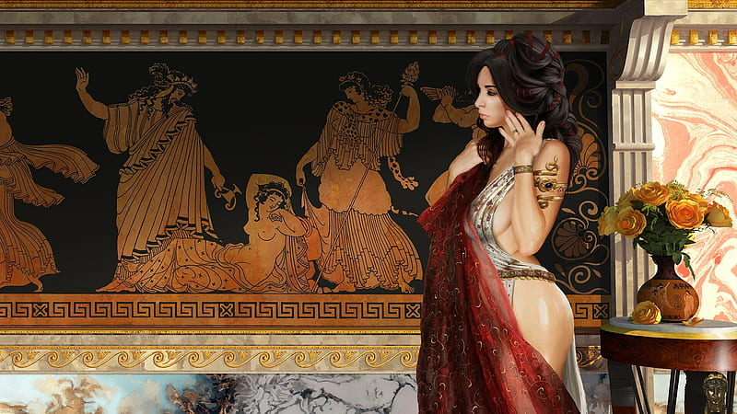

Good Strife
The philosophers of Mythenia devised the concept of “good strife” versus “evil strife.” Good strife constitutes hard work and a drive to excel at something better than others, which could be anything from farming to art to business. Evil strife was the discontent uncivilized people feel and are driven to greed without hard work, which leads to war. Individuals are prone to select a ‘nemesis’ in life, someone who is a peer in their livelihood, and work to be better than them. These rivals use their conflict to improve themselves and oddly form strong friendships over the rivalry. It is uncommon for a person to try and crush their rival. This would make no sense, as people see their rivals as necessary to drive greatness and feel great emptiness if their rival fails.

Clothing and style:
Most Mythenians wear a chiton, which is basically a long, sleeveless tunic. Both men and women wear this garment but it is not uncommon for youth to engage in sports in the nude. Women possessing a unibrow are considered intelligent and beautiful. If women are lacking in the eyebrow department, they might use kohl, an eye cosmetic made from galena ore (a source of lead), to fill in the gap.

Architecture
The agora (/ˈæɡərə/; Ancient Greek: ἀγορά agorá) was a central public space in ancient Greek city-states. It is the best representation of city form's response to accommodate the social and political order of the polis. The literal meaning of the word is "gathering place" or "assembly"
Ancient Greek architecture is best known from its temples, many of which are found throughout the region, and the parthenon is a prime example of this, mostly as ruins but many substantially intact. The second important type of building that survives all over the Hellenic world is the open-air theatre, with the earliest dating from around 525–480 BC. Other architectural forms that are still in evidence are the processional gateway (propylon), the public square (agora) surrounded by storied colonnade (stoa), the town council building (bouleuterion), the public monument, the monumental tomb (mausoleum) and the stadium.
See also: https://www.historyhit.com/what-were-houses-like-in-ancient-greece/
Styles of Temples
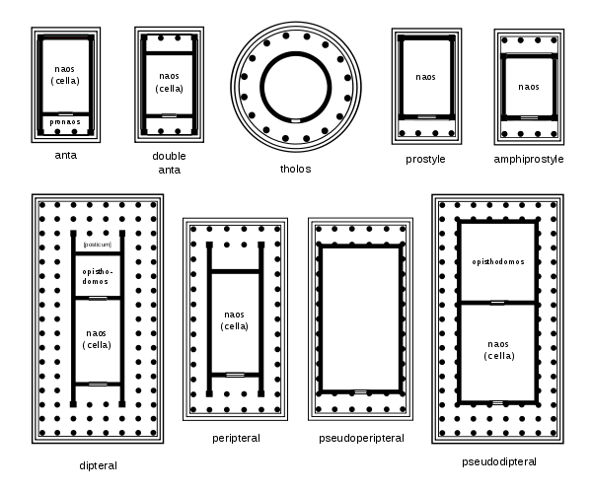
Styles of vessels
https://www.ancient.eu/article/489/a-visual-glossary-of-greek-pottery/
Alabastron (pl. alabastra) - a small jar for storing perfumes, named after the material (alabaster) the first examples were made from. They were often carried by a string looped around the neck of the vessel.
Amphora (pl. amphorae) - one of the most common forms in Greek pottery, various shapes, always with two vertical neck-handles and used for storing and transporting oil, wine and foodstuffs such as olives. Often with a lid but these have rarely survived.
Black-Figure Style Decoration (c. 620 - c.530 BCE) Invented in Corinth, the style was adopted in Attica to become the dominant style in Greek pottery. Figures were painted in black silhouette with details such as muscles and hair incised using a sharp instrument.
Epinetron (pl. epinetra) - a half-cyclinder worn over the thigh with the closed end over the knee, used for preparing wool for weaving. The upper surface was often incised to make a rough surface against which the wool fibres could be rubbed. Often with a female head at the closed end.
Figure-of-eight Vase - named after the distinctive handle shape, from the Minoan civilization.
Hydria (pl. hydriai) - used principally to store water and one of the commonest shapes in Greek pottery. Two horizontal handles were for carrying the vessel when full and one vertical handle used when pouring. They could also be used as a burial container for children. They were also often made in bronze versions.
Kantharos (pl. kantharoi) - a cup with two large vertical handles and a stemmed foot.
Krater (pl. krateres) - a large vessel with two handles, used to mix water and wine, usually to a ratio of 3:1 or 5:3.
Kyathos (pl. kyathoi) - a ladle-like cup used for serving wine.
Kylix (pl. kylikes)- a stemmed cup with two horizontal handles and a stemmed foot, used for drinking wine. One of the most common shapes in Greek pottery, over 30 varieties exist.
Pelike (pl. pelikai) - a jar used for storing liquids such as oils and wines. Also used to contain ashes after cremation.
Pinax (pl. pinakes) - a decorative plaque affixed to walls in tombs and temples.
Pithos (pl. pithoi) - from the Minoan civilization, a large jar for the storage of foodstuffs such as grain and olives. Large magazines of pithoi are a typical feature of Minoan palace complexes.
Pyxis (pl. pyxides) - a small circular box with a lid, often used for the storage of jewellery and toileteries.
Red-Figure Style Decoration (from c. 530 BCE) Replacing the earlier black-figure style, vessels were painted black to leave unpainted figures the red colour of the original clay. Details were then added to the figures using a fine brush. Much greater attempts were made at realism and perspective in this style.
Stemmed Cup - a drinking cup with two handles, a stem and base. Popular in the Mycenaean civilization, they would later develop into the unbiquitous kylix.

Weapons and Armor

Cestus - leather bands wrapped about the fist and forearms
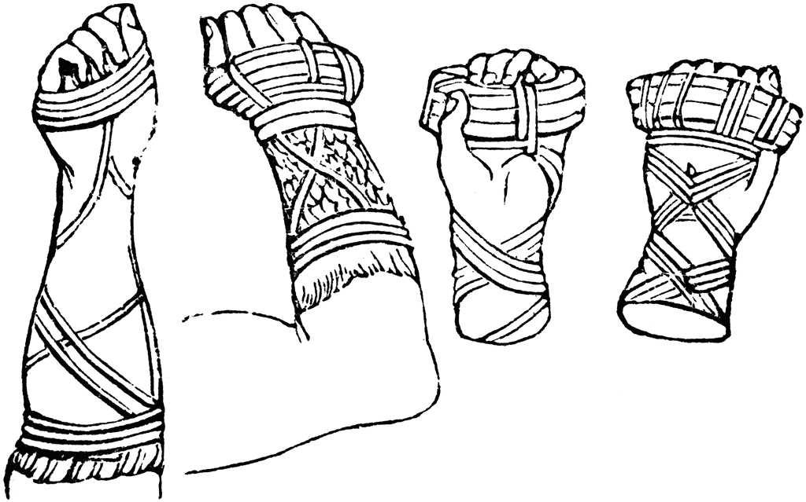

Kopis (dagger) 1d4 /19-20
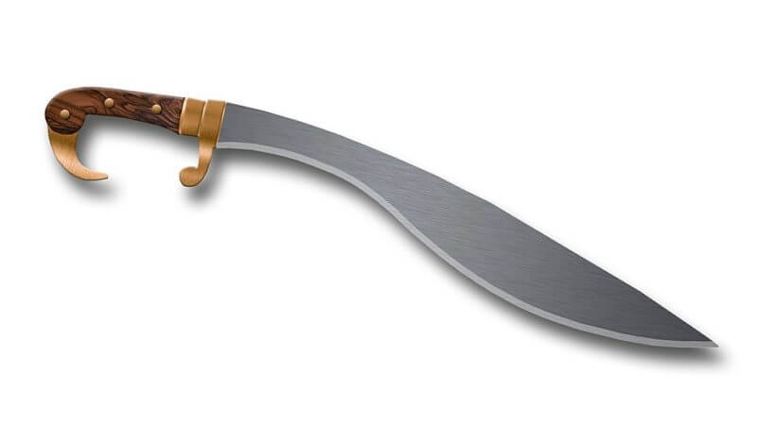
Encheiridion (dagger) 1d4 /19-20
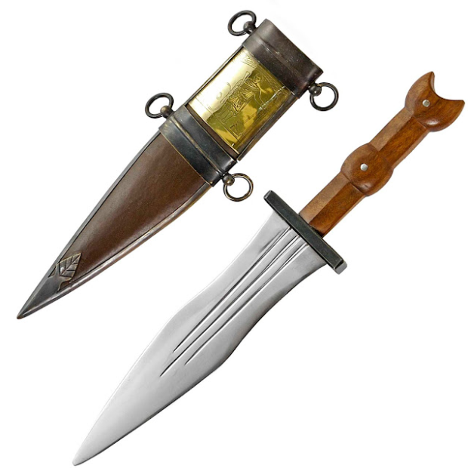

Harpe (sickle) 1d6 /x2
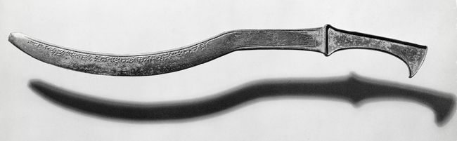

Sarissa (longspear, 6-meter-long pike) 1d8 /x3, carried by phalanx soldiers
Dory (spear) 1d8 / x3
Gastraphetes “Belly Bow” - (heavy crossbow) 1d10 /19-20
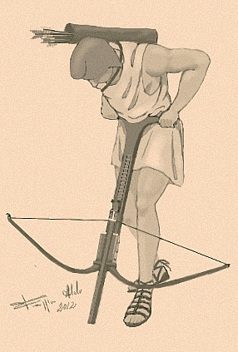
Javelin 1d6 /x2
Kestros (sling) 1d4 /x2

Makhaira (short sword) 1d6 / 19-20
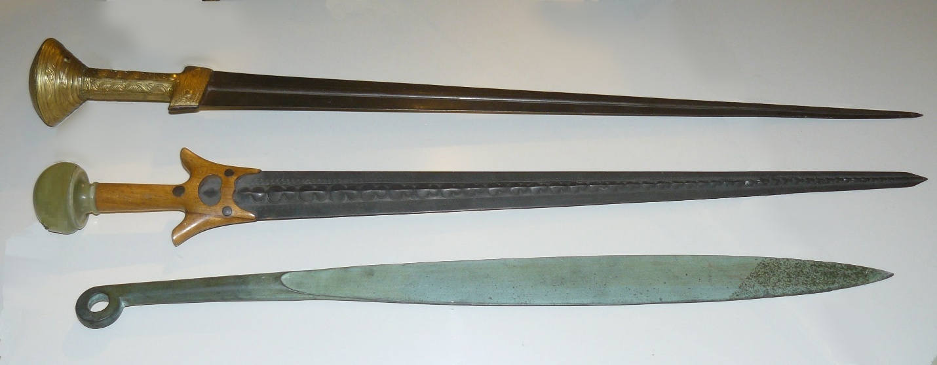

Labrys or Pelekus (battleaxe) 1d8 /x3

Xiphos (long sword) 1d8 / 19-20

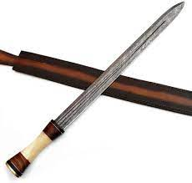

Trident 1d8 /x2

Sagaris (Warhammer) 1d8 /x3

Falcata (falchion) 2d4 18-20/x2
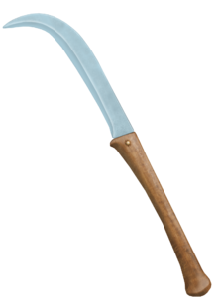

Rhomphaia (greatsword) 1d6 / 18-20

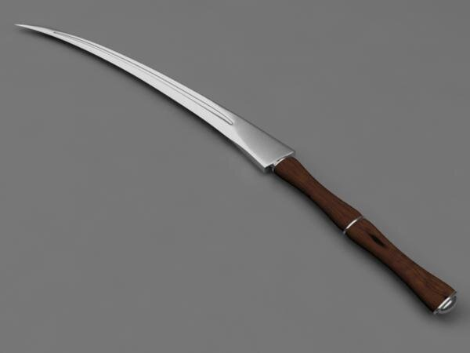

Menaulion (ranseur) 2d4 /x3

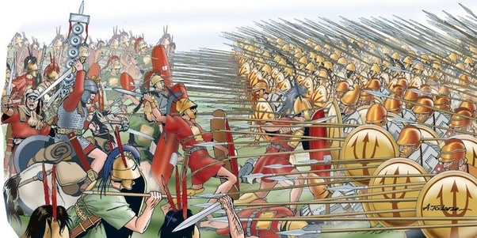

Gastraphetes - Crossbow, light

Armor
Cuirass - breastplate with greaves, shoulder, foot, thigh, and forearm guards +5
Aspsis – light circular wooden shield +1
Telamon – light circular metal shield +1 carried by phalanx soldiers
Hoplon - heavy round metal shield +2
Linothrax armor (padded armor) +1
Hoplite helmet aka Corinthian helm - covering the head and face with slits for eyes and a nasal guard and decorated with horsehair comb
Chalcidian helmet
Pilos helmet – conical helm with cheek guards
Thracian helmet –
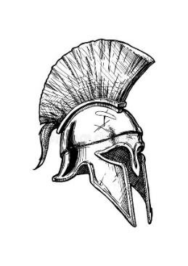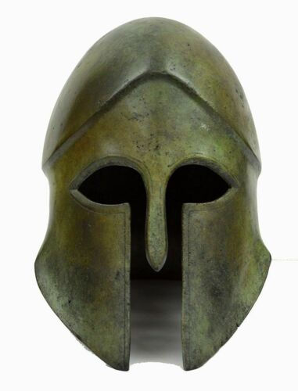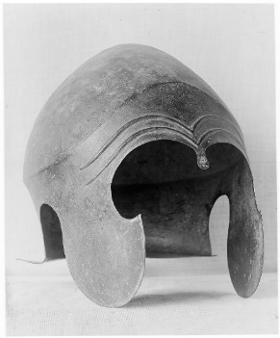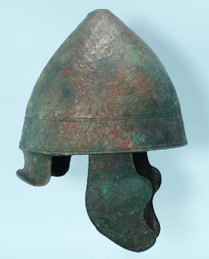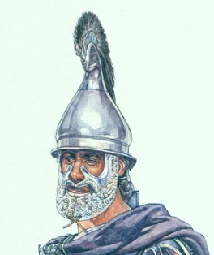
(l to r: Corinthian helmet, Corinthian, Chalcidian, Pilos, Thracian)

The hoplite army consisted of heavy infantrymen. Their armour, also called panoply, was sometimes made of full bronze for those who could afford it, weighing nearly 32 kilograms (70 lb), although linen armor now known as linothorax was more common since it was cost-effective and provided decent protection.

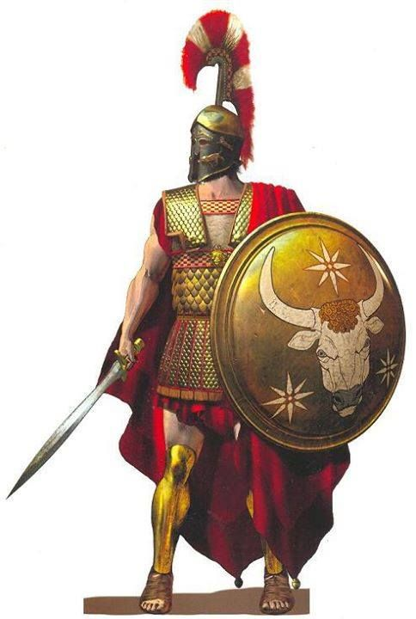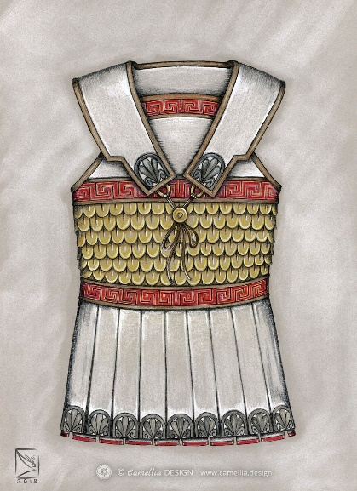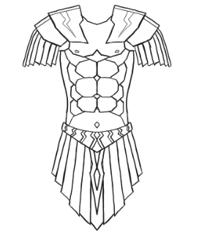
(l to r: panoply, linothrax, cuirass)

The average farmer-peasant hoplite cannot afford any armor and typically carries only a shield, a spear, and perhaps a helmet plus a secondary weapon. The richer upper-class hoplites typically have a bronze cuirass of either the bell or muscled variety, a bronze helmet with cheekplates, as well as greaves and other armour. The design of helmets varies. The Corinthian helmet was at first standardized and was a successful design. Later variants included the Chalcidian helmet, a lightened version of the Corinthian helmet, and the simple Pilos helmet worn by the later hoplites. Often the helmet was decorated with one, sometimes more horsehair crests, and/or bronze animal horns and ears. Helmets were often painted as well. The Thracian helmet had a large visor to further increase protection. In later periods, linothorax was also used, as it is tougher and cheaper to produce. The linen was 0.5-centimetre (0.20 in) thick.

The Macedonian phalanx was an infantry formation developed by Philip II from the classical Greek phalanx, of which the main innovation was the use of the sarissa, a 6-metre pike. The sarissae were carried in two pieces before a battle and then slid together when they were being used. At close range such large weapons were of little use, but an intact phalanx could easily keep its enemies at a distance. The weapons of the first five rows of men all projected beyond the front of the formation, so that there were more spear points than available targets at any given time. Men in rows behind the initial five angled their spears at a 45-degree angle in an attempt to ward off arrows or other projectiles.
The secondary weapon was a shortsword called a xiphos. The phalangites also had a smaller and flatter shield than that of the Greek aspis, measuring about 24 inches and weighing about 12 pounds. The shield, called a "telamon", was made of bronze plated wood and was worn hung around the neck so as to free up both hands to wield the sarissa. All of the armor and weaponry a phalangite would carry totaled about 40 pounds, which was close to 10 pounds less than the weight of Greek hoplites' equipment.
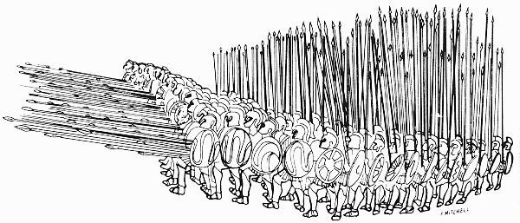
Naval Warfare
Triremes –
https://www.worldhistory.org/trireme/

Local Deities
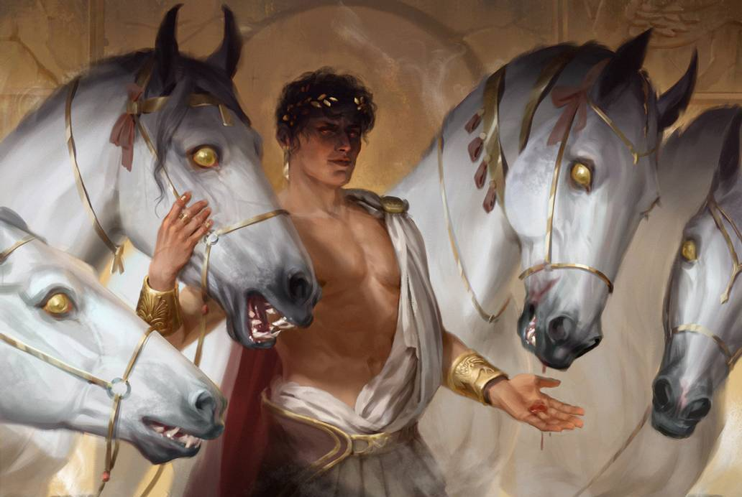
- Nerites, lesser deity of the ocean, driver of the great sea chariot. Patron deity of Kasylla.
- Thanatos, god of death, depicted as a winged and sword-girt youth. Patron deity of Nemesis.
- Psamathe, goddess of sand beaches. Patron deity of Domos.
- Selene, goddess of the moon. Patron deity of Parseion.
- Cybele, mother and nature goddess. Patron deity of Arxis.
- Kratos, personification of strength and power. Patron deity of Osireion.
- Iris, goddess of the rainbow, sea, and sky; messenger among the Mythenian gods. Patron deity of Estarra.
- Soteria, goddess or spirit of safety and salvation, deliverance, and preservation from harm. Patron deity of Drommica.
- Glaucus, a prophetic sea god, born mortal and turned immortal upon eating a magical herb. He comes to the rescue of sailors and fishermen in storms, having earlier earned a living from the sea himself. Patron deity of Arropos.
- Aidos, goddess of modesty, respect, and moral direction. Patron deity of Argeia.
- Eidyia, an Oceanid, a goddess of knowledge. Patron deity of Sargon.
- Simetra, goddess of the hunt, the wilderness, wild animals, the Moon, and chastity. Patron deity of Elefthirea.

Creatures of Mythenia
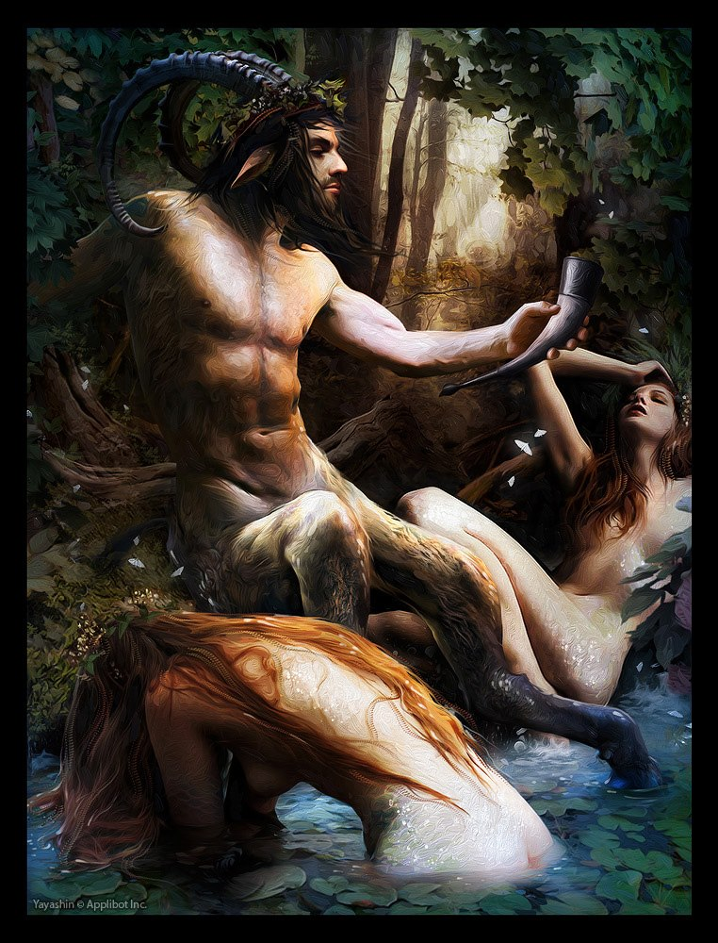
Vrykolakes - These are walked dead creatures, similar to wights, that leave their graves at night. They knock at the doors of farmers’ houses, uttering the names aloud of those within. It is said that if there is no answer after the first knock, no harm comes to the innocent. However, if one is unfortunate enough to answer, they die after a few days and transform into a vrykolakes.
Nymphs are female nature spirits that are associated with the air, seas, woods, water or particular locations or landforms. Nymphs are generally regarded as tutelary spirits who animate or maintain nature for the environments where they live, and are usually depicted as beautiful, young, and graceful maidens. They are not necessarily immortal, but live many years.
- Dryad (wood nymph) – inhabit the Alona and Orpheon Forests
- Naiad (river nymph) – inhabit every river of Mythenia, but keep to themselves
- Nereid (sea nymph) – found all along the Mythenian coast
- Oread (mountain nymph) – most commonly found in the Argyron and Celestial Mountains
- Helead (swamp nymph) – found in the Acheron and Bone Mire Swamps
- Napaea (valley nymph)
- Aurae (breezes) – most commonly found on the open plains
- Asteriae (stars) – most commonly found on the open plains
- Anthousai (flowers) – make their home in the Orpheon Forest, though they often visit the open plains wherever large fields of wild flowers grow
- Lampades (nymphs of the underworld, they bear torches and accompany Hecate on her night-time travels and hauntings. Some accounts tell of how the light of the Lampads' torches has the power to drive one to madness.)
- Mimallones (music) – found throughout Mythenia, often disguising as regular humans wherever music is played

Centaurs – most commonly found on the plains west of Maera Lake, where they hold dominion
Fauns – most commonly found in Orpheon and Alona Forests
Cyclops - most commonly found in the Taris Hills
Chimera - most commonly found in Bone Mire Swamp north of Argeia
Gorgon - most commonly found in caves in the Argyron and Celestial Mountains
Harpies - most commonly found in caves within the mountains and hills, often seen circling above open plains
Sirens - most commonly found along the coastline of Mythenia, particularly along the Syren Straits
Griffins - most commonly found in the Hills of the Mystics
Hydras - most commonly found in the Celestial and Argyron Mountains
Manticores - most commonly found in the Celestial and Argyron Mountains
Phoenix – the only one known to exist dwells on Mount Ebot on the Isle of Skiron
Unicorns - most commonly found in the Alona and Orpheon Forests
Lamia – attractive female vampires who seduce young men to feast on their flesh
Pegasi - most commonly found in the Alona and Orpheon Forests but also in the Celestial Mountains
Myrmidons - most commonly found in the open plains
Dire Lions - most commonly found on the open plains
Furies – The Erinyes are more ancient than any of the Mythenian deities. Their task is to hear complaints brought by mortals against the insolence of the young to the aged, of children to parents, of hosts to guests, and of householders or city councils to suppliants—and to punish such crimes by hounding culprits relentlessly. Some say there are many, but only three are known:
- Alecto – Punisher of moral crimes (anger, etc.)
- Megaera – Punisher of infidelity, oath breakers, and theft
- Tisiphone – Punisher of murderers
Muses – The Muses are nine beautiful young women who are the goddesses and embodiments of science, literature, and the arts. In Mythenia they are the source of orally related knowledge of poetic lyrics and myths, and are the personification of knowledge and of the arts, especially dance, literature and music. They reside in Elysium but they often visit Mythenia to observe the feats of humans and inspire a select few. Nine statues stand in a forgotten cave deep within the Celestial Mountains. The statues spring to life whenever the Muses arrive in Mythenia and it is here mortals may venture to entreat them. The cave is enormous, housing a luxurious palace with groves of flowers and fruit-bearing plants, fountains of magical waters, comfortable furnishings in the Mythenian style, a library of the works of human history, balconies looking out over the world, and the sounds of music wafting throughout its halls.
Arropos, Parseion, and Elefthirea are spots frequented by the muses, as there is an abundance of artists in residence there.
- Calliope, the Muse of epic poetry
- Clio, the Muse of history
- Erato, the Muse of lyric poetry
- Euterpe, the Muse of music
- Melpomene, the Muse of tragedy
- Polyhymnia, the Muse of sacred poetry
- Terpsichore, the Muse of dance and chorus
- Thalia, the Muse of comedy and idyllic poetry
- Urania, the Muse of astronomy

Telchines - The Telchines (Τελχινες), sea spirits native to the island of Rhodes; the gods killed them when they turned to evil magic. The Telchines were regarded as wizards and envious daemons. Their very eyes and aspect were said to have been destructive. They had it in their power to bring on hail, rain, and snow, and to assume any form they pleased; they further produced a substance poisonous to living things. Thus, they were called Alastores for supervising the ceaseless wanderings of people and Palamnaioi for pouring the water of Styx with their palms and hands in order to make the fields infertile. The Telchines were described to have stings and being rough as the echinoid and thus, their names teliochinous that is “having a poisonous telos like an echinoid”
Echdina - Long ago the gods appointed a guardian over the Oracles of Mythenia. A grand she-serpent named Delphyne was brought into existence, with an aspect both terrible and beautiful. When the priests of Parseion grew jealous of the Oracle of Domos, they devised a trap for Delphyne. She was banished to the outer planes and corrupted by their magic. Delphyne transformed into Echidne, a horribly disfigured create. She returned to Nemmyrl, but far from her home of Mythenia. She now lurks in the shadow of the Tauran Mountains in the Sea of Drakaina, so named for her and the terror she has spread. Here she broods in her anger, lashing out at all living creatures. She is especially vengeful of priests of any kind, snatching them up and torturing them for decades. Echdine is a seductive creature, capable of guile and illusion. She can appear as an attractive female of almost any race. Doing so, she has seduced countless victims, bearing children from them that become unspeakable monsters. For this Echidne is called the Mother of Monsters.
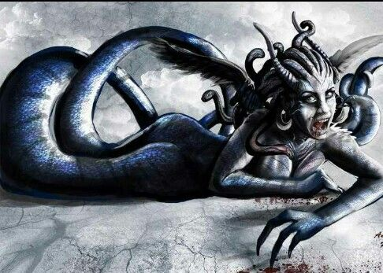

Other Races
Elves
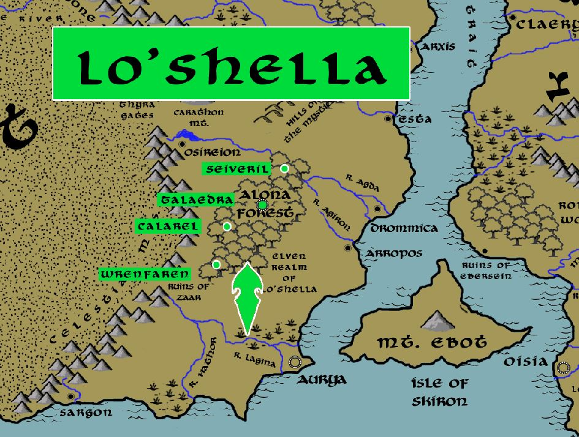

Dwarves
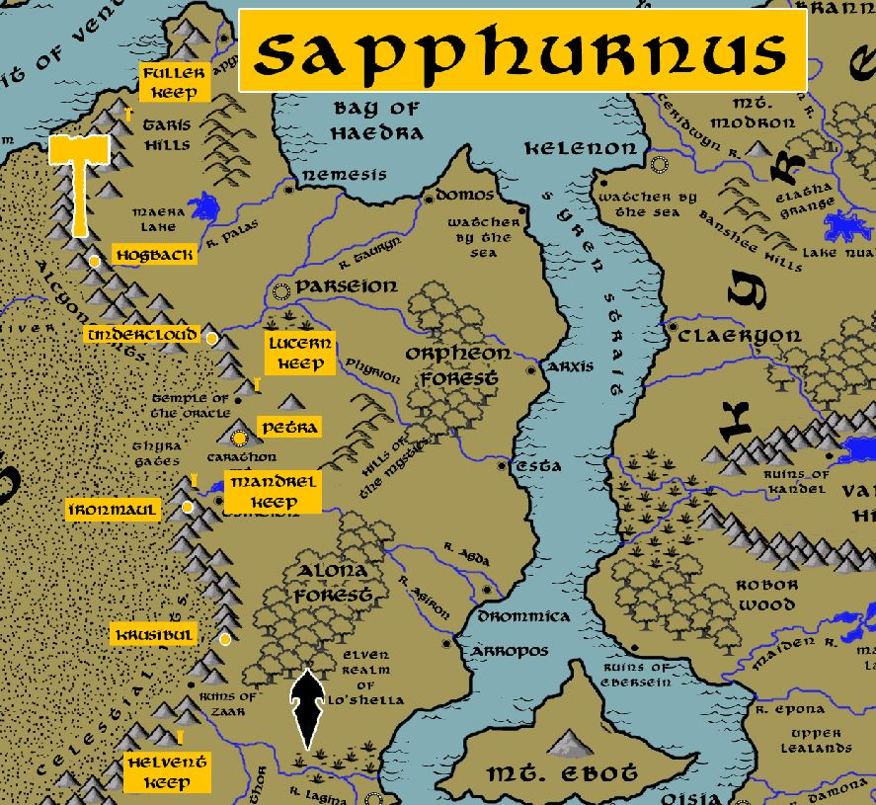

Magical Items

Mythenian Scripting Cups
These are cups that are passed around a banquet with each person writing a passage in their own hand. In some cases these cups are enchanted to collect limitless passages. These collect wisdom of the common folk as well as the nobility. If activated the cup can recite in an audible voice every verse collected upon it. It can also receive whatever new inscriptions a person wishes to write. The cup accepts writing in any language and will recite the verses in a way understandable to any listener.

Skyphos of Eidyia - a drinking cup containing enormous power of knowledge; it was unearthed in the Library of Sargon in the Fourth Primordial Age and empowered the Akeron people to launch the Akeron Empire, dominate the seas, and replace the old Ebon tribes in eastern Arnland.

NPC Templates
This is a list of notes and stats to help develop NPC’s relevant to this region.

Developer Notes
This is a list of notes on the development of this document, including notes on history, culture, and changes to the document.

All content contained within this document is related to the Nemmyrl story world copyright 2019 Albin Johnson.
Mythenian Rival Custom
Philosophy of Good Strife vs Evil Strife
Mythenians embrace good strife, hard work and a drive to excel at something whether common work or art etc. Individuals are prone to select a "nemesis", a contemporary in their caste whom they work to outperform. These rivals use their conflict to improve themselves and oddly form strong friendships over the rivalry. It is uncommon for a person to try and crush their rival. It is said people see their rival as necessary and feel great emptiness and sadness if their rival fails, for there is nothing left for them to strive against.

Mythenians rely on olive oil as a major industry. But the cultivation of olive groves requires an enormous amount of effort, planning, and patience. It may take three generations for a new grove to turn a profit.

Mythenian dark age lasted for 800 years, after an autocratic style of rule collapsed. A small upper class nobility disappeared, with much of the civilization going with it. But the commoners carried on, farming and trading but with no effort for writing, science, or the arts. Eventually civilization returned but in a more egalitarian style.

Names: Hellenic names from www.fantasygenerators.com

The rhomphaia (Ancient Greek: ῥομφαία) was a close-combat bladed weapon used by the Thracians as early as 350-400 BC. Rhomphaias were weapons with a straight or slightly curved single-edged blade attached to a pole, which in most cases was considerably shorter than the blade.
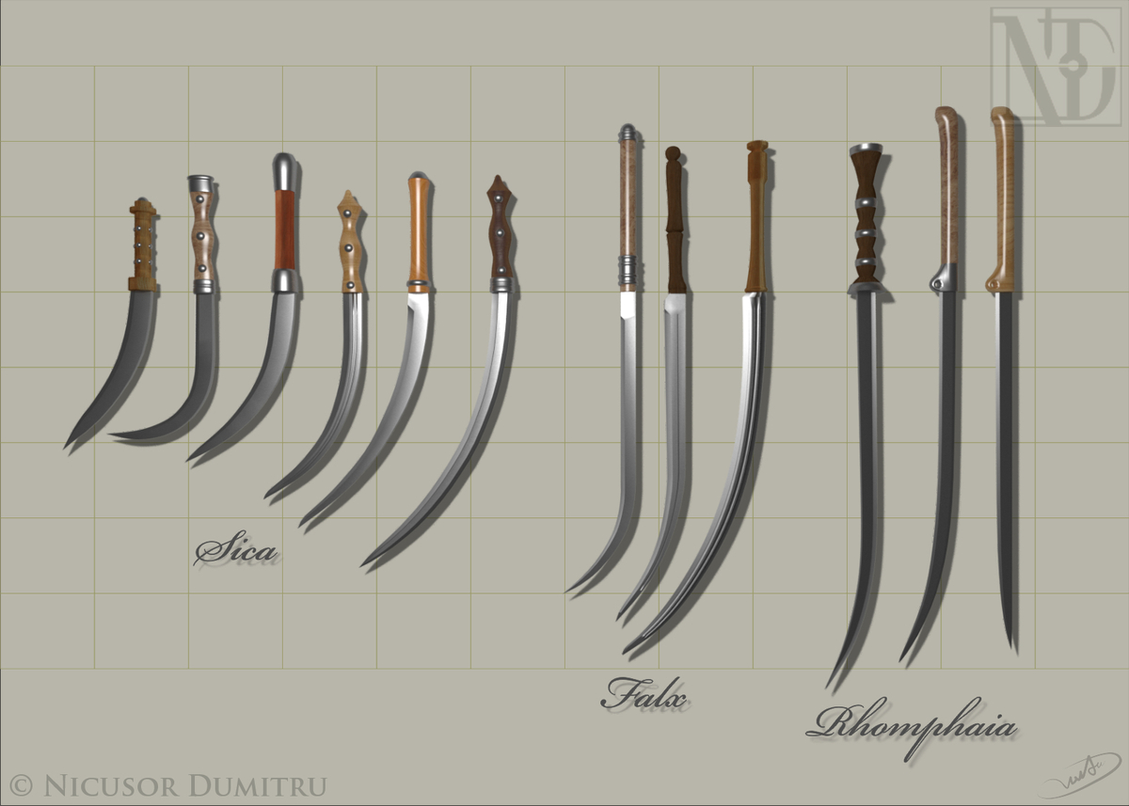
The falx was a weapon with a curved blade that was sharp on the inside edge used by the Thracians and Dacians – and, later, a siege hook used by the Romans. The Dacian falx came in two sizes: one-handed and two-handed. The shorter variant was called sica (sickle). The two-handed falx was a pole-arm. It consisted of a 3 feet (0.91 m) long wooden shaft with a long curved iron blade of nearly-equal length attached to the end. The blade was sharpened only on the inside and was reputed to be devastatingly effective. However, it left its user vulnerable because, being a two-handed weapon, the warrior could not also make use of a shield. It may be imagined that the length of the two-handed falx allowed it to be wielded with great force, the point piercing helmets and the blade splitting shields - it was said to be capable of splitting a shield in two at a single blow. Alternatively, it might have been used as a hook, pulling away shields and cutting at vulnerable limbs, or striking the edge of a strong shield. The inward curving point was still able to pierce the armour or flesh of the target behind the shield, rendering even the most reinforced shields much less effective against a falx wielder.

