Notes on the lands of Tarbia

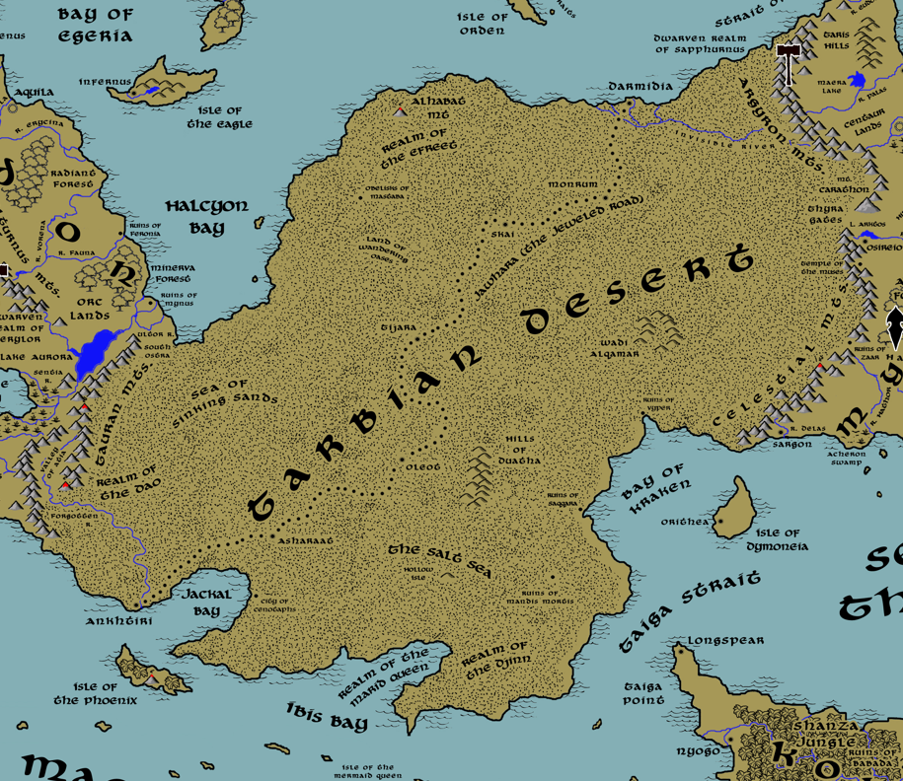

Table of Contents
- Overview
- Towns and Cities
- Best in the Land
- Stewards of Power in this Land
- Points of Interest
- History
- Local Goods
- Notes on Culture
- Weapons and Armor
- Local Deities
- Creatures
- Other Races
- Magical Items
- NPC Templates
- Developer Notes
Overview
The vast wasteland of the Tarbian Desert dominates most of the Arnland continent, separating the lands of Mythenia in the east from Celedon in the west. It is a land of austere beauty: an endless vista of ever-shifting sand dunes baked by the sun. Its people are proud and resourceful and given to hospitality as a deep cultural and practical custom. Caravans of camels cross the wide lands like ships on a dry sea. They travel from secret oases to the few fortified cities that stand along the north-south route called the Jawhara or Jeweled Road.

Eons ago, a few large rivers cut through this region and supported life along their banks. Over the centuries the rivers cut deep ravines into the ground. The rivers are now gone or hidden from view. The rich grasslands have disappeared, replaced by sand dunes. Some of the ravines are now half-lit underworlds populated by lush vegetation and exotic animal and insect life.

There are seven great cities of Tarbia. Some sit along the edges of the desert and overlook the seas, Qadimar and Darmidia to the north, Ankhtiri and Qasreth to the south. Three cities, Hafzara, Tijara, and Asharaat, stand as stubborn sentinels amidst the sprawling dunes. They abide along the Jawhara, the Jeweled Road, a caravan route running north-south across the wastes that only skilled nomads know how to follow. Each city is its own sovereign power, but all of them have fallen sway to Darmidia, the richest of them all.

Oldest of the seven cities is Ankhtiri. Nine thousand years ago, the deserts were ruled by the Ebon Empire (920 PA2 to 70 PA4). It wasn’t until Ankhtiri conquered all the cities that the Ebonene truly spread their ideas and architecture. They built enormous irrigation projects that extended the reach of the great rivers. They erected glittering pyramids and obelisks of marble and obsidian. They even built a gigantic underground city, the Qasramaq, untouched by the sun. And they worshipped gods now almost forgotten. Their kingdom disappeared over eight thousand years ago during the Cataclysm of Mahrutep (73 PA4). Yet their culture, language, and customs linger in the Tarbian population.

The cities of today were rebuilt by the Fajar peoples in the Ancient Ages. After the Cataclysm of Mahrutep the deserts were in constant warfare in the absence of the cities. But in 420 AA1 the cleric Aseela (f) of the Fajar received a vision from the gods guiding her to the location of the buried cities of the Ebon. In 502 AA1 the Fajar, led by their war chief Katheer Akram, left the safety of the Atia Vale to explore the buried cities. Within 150 years the new cities were being built on the sites of the old ones.

The people of Tarbia today are divided between the Almadina, or city dwellers, and the Badawi, nomads who dwell exclusively in the desert wastes. The Almadina regard the Badawi with contempt as savages, while the Badawi shake their heads that the Almadina have lost their connection with the land in favor of growing soft with civilization. Over the centuries either side has proven a boon to the other, but the divide remains.

Among the Badawi are the Zadaar, a savage tribe of nomadic warlords that roam the desert and slay all they meet. Over the centuries they have grown in size and regularly threaten to overwhelm one or the other cities of Tarbia. In some cases, they have succeeded, conquering no more than a single city at a time and using it as a base of operations. In every case the Tarbians have come to the aide of their brethren and liberated these cities, but only after much destruction. Today the Zadaar continue their quest to conquer the Tarbian cities and wrest control for themselves.

Badawi Tribes
- Banu Muqtar – tribe of the stars
- Banu Safir – tribe of the staff
- Banu Qazir – tribe of the tears
- Banu Huzam – tribe of the seers
- Banu Hadriim – tribe of the healers
- Banu Barzah – tribe of the story tellers
- Banu Zadaar – tribe of the cloak

Towns and Cities

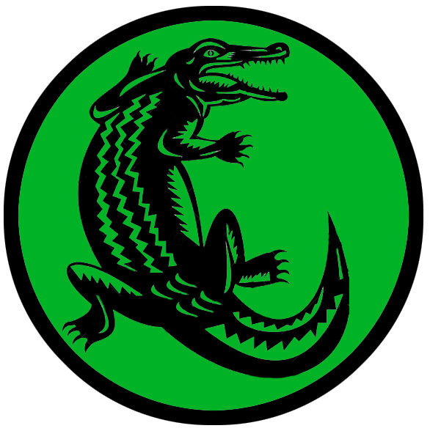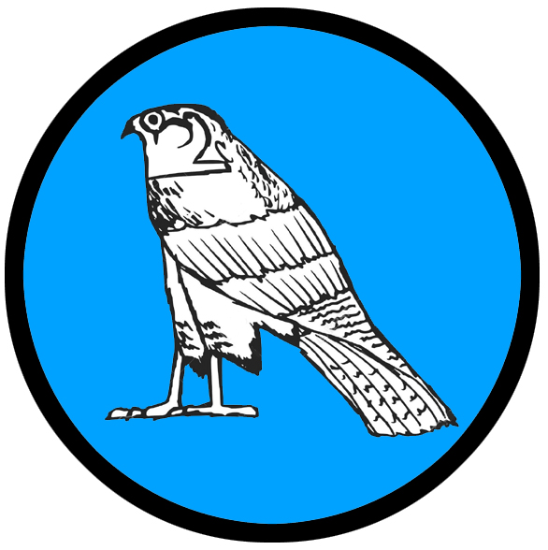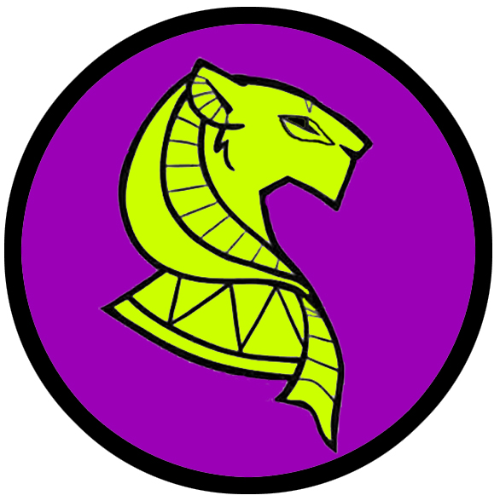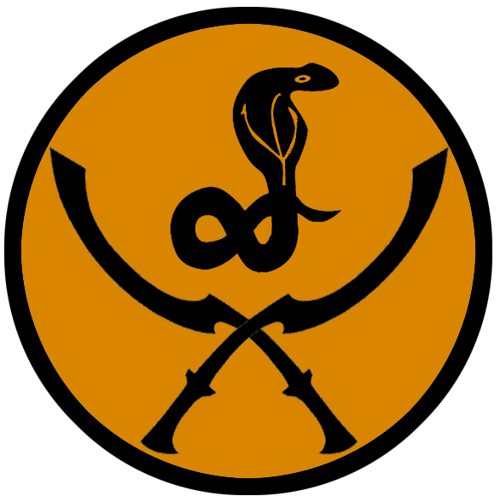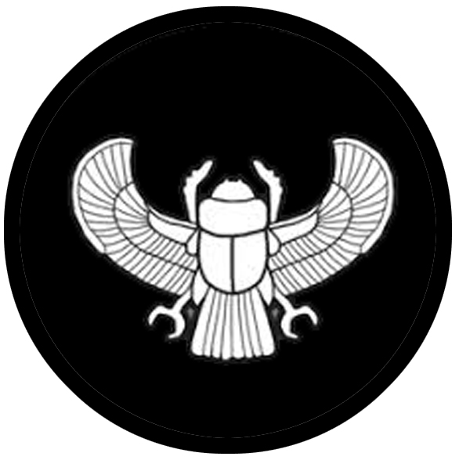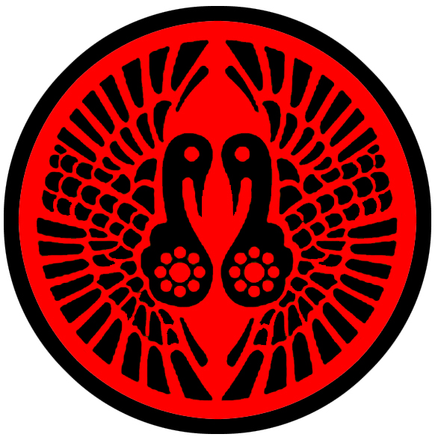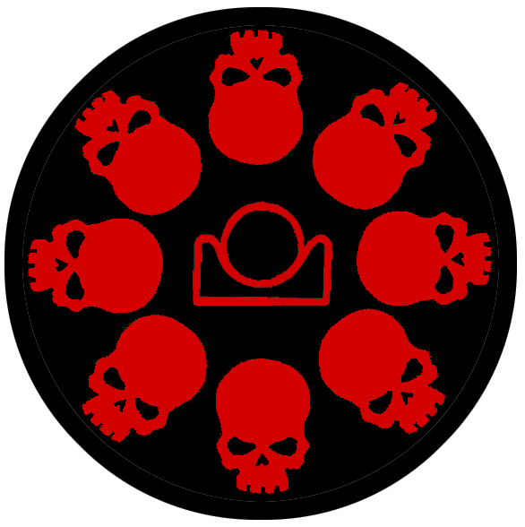
- Seven Jeweled Cities of Tarbia
  - Darmidia – metropolis, sign of the crocodile
  - Hafzara – small city, sign of the sun and hands
  - Qadimar – small city, sign of the falcon
  - Tijara – large city, sign of the lioness
  - Qasrath – small city, sign of the serpent and twin khopesh
  - Asharaat – small city, sign of the winged scarab
  - Ankhtiri – large city, sign of the twin ibis
- Charnella, Isle of Orpheon – small town, sign of the skulls and setting sun

Best in the Land
Trade Hub: Darmidia, Anhktiri
Religion: Ankhtiri
Arts: Asharaat
Magic: Ankhtiri
Spirits: Darmidia
Steel: Ankhtiri
Grain: none
Crafted Goods (e.g. Pottery, Textiles, Metal Wares): Darmidia, Qadimar, Asharaat (metal wares)
Harvested Goods (e.g. Aromatics, Medicine, Dyes): Hafzara, Qadimar, Tijara, Qasrath, Asharaat (spices); Hafzara, Tijara, Qasrath (aromatics), Ankhtiri (medicine)
Mined Goods: Ankhtiri (stone, iron)
Precious Metals: Qasrath (gold), Darmidia (silver)
Ship Building: Darmidia
Other:

Stewards of Power in this Land
Kings and their armies are not the only wielders of power. There are many unseen friends and foes that shape the destiny of the land. Each of the groups listed below are well known to the people of this region. Some are feared, others venerated. All of them play their part in the grand drama of this land’s story.

Merchant Companies
Pyxis Nautica Traders – Darmidia
Kirim Kemir Traders – Ankhtiri

Mercenary Companies
Nim Jadeem – Tijara

Smuggling Rings
The Blue Djinn – Darmidia
The Marid Sisters – Ankhtiri

Centers of Worship (Churches, Cathedrals, Shrines, Lodges, Temples)
Temple of Sobek - Darmidia
Temple of Aten - Hafzara
Temple of Seker - Qadimar
Temple of Sekhmet - Tijara
Temple of Pakhet - Qasrath
Temple of Khepri - Asharaat
Temple of Thoth - Ankhtiri
Tower of Anguish (Nerull) – Charnella, Isle of Orpheon

Orders of Paladins
Order of the Quarashi Falcon – Darmidia
Order of Alsalam – Qadimar
Order of the Scarab – Asharaat

Druidic Circles
Circle of the Shifting Sands – Qasrath

Bands of Rangers
Band of the Horned Viper – Tijara

Schools of Magic
Circle of the Seba (astrologers) – Qadimar
Doubhadn Sanctum - Ankhtiri

Bardic Colleges
(none)
Warrior Academies
Mashafra (sword makers) – Ankhtiri

Assassins Guilds
Sons of Nirah – Darmidia
The Nephtharim – Qasrath
Keepers of the Crypt - Ankhtiri
The Nizari – Charnella, Isle of Orpheon

Cults
(none)

Other Guilds
The Dhahab Alliance (bank) – Darmidia
Garden of the Gods (temples) – Tijara
Cloud Mill (apothecary) – Charnella, Isle of Orpheon

Monasteries
Temple of Dhakira (Temple of Memory) - Vale of Atia in southern Tauran Mts.
Temple of the Silver Light - Northern edge of the Tarbian Desert, looking out over the Ferrago Sea
Temple of the Master Measure - Eastern interior of the Tarbian Desert
Temple of the Unbroken Knot - Tarbian Desert, in the Hills of Dul-Giguna
Temple of the World Child - Southern edge of the Tarbian Desert, overlooking the Taiga Strait

Pirates
Captain Hammerhead Ahala – Isle of Orpheon
Captain Ouahid Fellgale Akoujan - Bay of Ibis
Captain Ashraf Amberjack Valis – Bay of Kraken

Points of Interest
- Isle of Orpheon – Jungle dominates the interior of the Isle of Orpheon. Creatures of bizarre origin stalk the wild interior; some say they were summoned by mages millennia ago and forgotten. A cult of Nerull runs the town of Charnella with an iron grip. Acolytes walk the streets with faces painted like skulls, lash marks visible on their backs and arms. It is a dark place where most who linger here are not residents by choice.
  - Mt. Atranox, a dormant volcano, looms prominently to the north west above the treetops.
  - home to the mighty blue dragon Alamawt
  - A colony of Sahuagin, the Erekel, make the northern banks of the island their home. From there, they attack ships passing along the Lower Via Maris shipping route. They are known by their sign of the four black dots arranged in a diamond shape.

- Phoenix Isle – Phoenix Isle guards the mouth of Jackal Bay at the southwestern end of the Tarbian mainland. In the Primordial Ages the Nephera people dwelt here and for four hundred years ruled the Tarbian sands before being defeated. Today the isle is the home of fishermen and merchants. Nepheran architecture and customs can still be found among the residents, who are considered an odd lot by the mainlanders. The Marid Sisters, a smuggling ring based in Ankhtiri, use the isle as a way station for goods they run all over the southern waters. They are keen to keep their work secret from the Darmidian merchants especially the Four Stars company. The interior of the island is covered in dense jungle growth, which conceals the ruins of the ancient civilization that once ruled here. Some say the ruins run deep and open into a honeycomb of underwater caverns. Strange lights appear in the sky above Phoenix Isle, flashes light lightning within distant clouds. It is said a cloud giant once patronized this island and his cloud palace returns from time to time.
  - Mt. Bennu-ra, an active volcano, stands at the center of the island. It is said to be the home of the divine fire bird Bennu, which renews itself in the rays of the sun and is giver of life. Some even say the place is holy and holds the gift of rebirth to the fallen.

- Jackal Bay – the wide coastline that encircles the bay was once the domain of the Nephera people, who invaded in the second Primordial Age. They settled the coastline, building earthen structures and piers into the waters to transform it into a bustling trade hub. It was soon taken over by the Ebon people, but in 550 PA3 a clumsy mage summoned the great Ekkidon, a gargantuan starfish from the plane of water; the creature destroyed everything in Jackal Bay and made it its home. The waters of the bay are fraught with danger, as the Ekkidon attacks randomly anything that enters its domain.
- Ibis Bay –
  - Location of the underwater city of Qasr Almarjaan, the Coral Palace, stronghold for powerful Marid genies from the elemental plane of water. From here rules the dreaded Jasra Aiesar (“Jasra of the Hurricanes”), greatest of Marids and self-styled queen of the southern seas. From her city Jasra hunts the southern oceans for sport, capturing prizes of ships, treasure, and even humans to serve her. She finds the Great Maelstrom intoxicating as well as terrorizing those foolish enough to sail that way.
  - the deserts around Ibis Bay are home to the cruel and mighty blue dragon Bariqar
- Bay of Kraken – The Bay of Kraken is, as the name suggests, inhabited by a colossal leviathan that destroys any ship that passes through these waters. It was summoned in 36 AA3 by the greedy men of the Alyaqut Syndicate to attack amazons and capture the Isle of Dymoneia. But the magic chest that controlled the beast was lost to the seas and the creature turned on its masters, destroying them.
- Taiga Strait – Passing between the southeastern coast of the Arnland continent and the westernmost tip of the Kaduru continent, the Taiga Strait connects the Southern Seas and the Sea of Thundra. It is a busy strait, with merchant ships passing from the Lower Via Maris and Skirt Jaunt trade routes northward to more populous lands. It is also a treacherous region, with irregular tidal currents. It is also the domain of the Sahuagin Nurikka tribe, which are known by their sign of the blue and orange stripes. The Nurikka regularly make trouble for larger ships passing through their waters but are extremely dangerous to smaller craft.

- Realm of the Efreet – The northern sands are ruled over by the Efreet, genies from the elemental plane of fire. Here the sands are scorching to the touch, with some areas blasted into a glassy top layer. The air close to the ground shimmers with heat, creating mirages and draining any living creature of moisture. Occasionally gouts of flame erupt unexpectedly from the sands, small fire elementals attempting to escape imprisonment below, but are pulled back down.
  - Greatest of these is Hariq the Terrible, a cruel and powerful master who relishes the heat of the deserts and is known to stoke the plains to even greater temperatures. He rules from a subterranean fissure deep beneath the surface, tormenting humans and enslaving any who pass this way. He is also credited with bolstering The Sirocco, the great hot winds that blow north across the Tarbian wastes and into the Ferrago Sea.
  - The deserts of northern Tarbia are home to the mighty blue dragon Mumitra. She dwells in a deep underground lair, sleeping just outside the hidden cave entrance above and hidden in the sands. Mumitra tolerates Hariq and has worked with him on occasion.
- Burden Mountain – An active volcano rising up from the sands, the mountain is in fact alive and capable of speech. Massive cave openings on the southern side of the mountain resemble eyes, a nose, and a mouth. Some speculate it is a gargantuan earth elemental who became trapped her millennia ago. Travelers approaching the mountain, if seen, are greeted politely by Burden Mountain, it’s voice like a rumbling earthquake. It is prone to talk at length, bemoaning the fact that it isn’t facing the sea, and will ask travelers to describe what it looks like. Anyone who is cordial with the mountain may then ask it to take on the burden of some terrible thought, secret, or memory. Doing so instantly relieves the person and grants them a lasting peace about the topic. An unintended consequence, however, is that the mountain remembers all sad tales and these are woven into the many rambling stories that it talks about to itself. It also adopts a single word or phrase from the most recent story as its name. Many travelers have been confused when looking for Burden Mountain, only to be greeted by the mountain with a different name, likely one that came from the last story it was told. It is said that certain stories have moved the mountain to great emotion, causing it to erupt. Some of the greatest eruptions of Burden Mountain have been caused by particularly talented minstrels who have intentionally or unintentionally moved it to tears, anger, or uncontrollable laughter.
- Realm of the Dao – The sands just east of the Tauran Mountains are the domain of the Dao, genies are from the Elemental Plane of earth. The greatest of the Dao is Raesha, Mountain Breaker and ruler of the deserts here. She oversees a vast cavernous network beneath the Taurans, mining gems and precious metals. Any who venture this way would do well to offer tribute to Raesha or be enslaved to work her mines. It is said that she built the mighty walls of Ankhtiri at the dawn of history. Raesha has little to do with other genies, but is paid handsomely by Hariq the Terrible for raw materials for his own machinations. She tolerates the orc tribes dwelling nearby, but only as long as they supply her with slave labor for her mines.
- Sea of Sinking Sands – As the name suggests, this wide swath of desert is unstable and filled with countless sink holes that swallow up anything of substantial weight. Only the tiny kahrabar lizards, known to other lands as shock lizards, survive here. They are light enough to skitter across the sands safely. However, they pose an additional danger to travelers coming this way.
  - In 334 PA3 the Tarbian scoundrel and adventurer Aqeel the Trickster heard of the troubles in the Celedonian town of Mynus. The town was besieged by stone giants out of the Tauran Mountains. Aqeel convinced the town to pay him to rid them of the giants. He did so by leading the giants into the Sea of Sinking Sands, where they were swallowed up forever.
  - Deep within this region stands the tower of Odion of the Glyphs, Arch Mage of the Tarbian lands.
- Land of the Wandering Oases – To the north and west of the Tarbian deserts lies a place of mystifying magic. This was once the domain of Miska al-Zamani, a beguiling sorceress who spurned the advances of Katheer, the cruel malik of Qadimar. She was hunted her entire life, but delighted in creating trouble for the evil ruler. She made her home in a beautiful oasis, but wove a magical effect over many miles that shifted the location of several such oases to avoid capture. Katheer ignored the counsel of his vizier and in 382 AA4 foolishly led an expedition to capture Miska, but died in the dry wastes. Visitors here quickly become disoriented as the landscape shifts every twelve hours. Those who do happen upon one of the oases will find a lush spring of pure water surrounded by date palms and welcoming shade. But in time any traveler risks jeopardy in ever finding their way out of this region. It is said that Miska left complex puzzle boxes made of fine metals and jewels in each of the oases. Each contains a magic scarab that can lead one wherever they desire. But the puzzle boxes are difficult to open and dangerous to the unwary.
- The Salt Sea – A 4,000-square-mile salt flat covered by a thick crust over a brine pool heavy with poisonous gases and metals. Travelers here would be wise not to excavate the soil, for the glittering silver found below is flammable and poisonous, as are the gases trapped below. At the center of the salt flats is a large elevated area named the Hollow Isle covered in cacti and coral-like fossils. The isle is actually the top of an extinct volcano reaching up from the middle of the salt flat. Thousands of years ago this area was one gigantic lake surrounding the island, with most of the volcano submerged beneath water.
  - 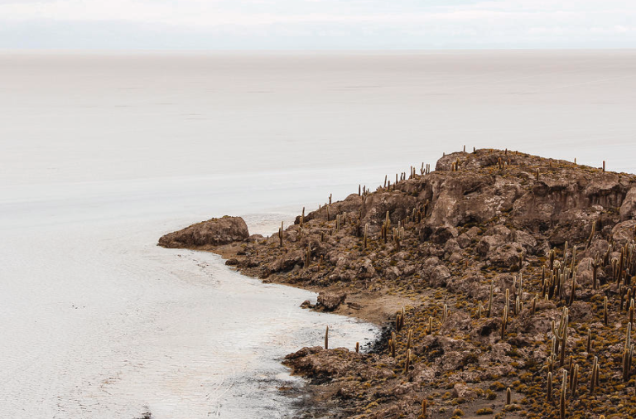

- Invisible River – Like many of its sister rivers in the desert, the Invisible River has cut a deep channel in the earth and flows fifty feet or more below the sands. A lush garden of plants and insects inhabits the bottom of the channel, a haven from the heat above. Flowing westward from the Argyron Mountains it empties into the Inner Sea. The great bazaar city of Darmidia grew from the river’s banks and has flourished from it.
- Forgotten River – Winding its way southward from the Tauran Mountains, the Forgotten River feeds the Atia Valley before making its way across the southernmost Tarbian Desert and spilling into the Maelstrom Seas. There it meets the ancient city of Ankhtiri where it helped the Ebon civilization grow at the beginning of time. It is a mysterious river, blessed by the gods and a source of divine power. The devout who make a pilgrimage to the Temple of Dhakira ritually bathe here. It is believed that the spring that is its source, hidden deep in the mountains, is a gateway to celestial realms and brings new life.
- Hills of Dul-Giguna – Legends tell that the hills were once the site of a mighty Ebon city of old, where they built the Crypts of Anubis. It is a place shrouded in darkness. Some parts of the deep interior remain forever blocked from the sun. Many tombs are hidden here and the dead are said to be restless. Long ago explorers from Qasrath discovered gold here. The Malik personally oversees these operations and makes sure the gold makes its way to his treasury. This has invited thieves to open small mines of their own in the hills.
  - The hills were once the resting place of Amenset, an evil cleric who was slain and buried here in 768 PA3. She rose again and was slain by the ranger Nadeera with an enchanted Mashafra sword named Alsalam in 88 AA2.
  - Renenet, queen of the Ebon people, was said to be buried here. Rumor has it that thieves disturbed her crypts in the hills, awakening her mummified corpse and her hordes of undead followers.
  - The hills are home to the brass dragon Wahidra
- Wadi Alqamar – a narrow valley carved out by water millennia ago. The bottom of the valley is a flat series of dry riverbeds that snake through rocky hills colored pink, purple, and orange. Alqamar is the Tarbian word for ‘moon.’ Caravans stop here to rest and seek shelter from the sun. Druids come here to hold rituals to the moon at special times of the year. The wadi is the haunt of the mysterious figure known as Ruh Yurshad, a man who appears as a simple traveler riding his camel, but who has been spoken of for centuries. It is believed that Yurshad is in fact a Jann, one of the minor genies but powerful nonetheless among those on the wastes.
  - Wandering among and beneath these hills is the tribe of Fire Giants known as the Ihtiraakh, known by their sign of the flaming tongue

- Valley of Atia – A crook in the foothills of the Tauran Mountains has created a pocket of cooler air and calm winds where the soil is rich and vegetation flourishes. The Forgotten River winds its way through the land, nourishing the soil. The peaceful valley has been a refuge to travelers in this barren land for millennia. It is here the Temple of Dhakira was erected in 97 PA4 and where holy women and men have served as advisers to both Badawi and Almadina peoples.
  - Temple of Dhakira – Dhakira became the holy site of the Fajar faith in the Ancient Ages. The Fajar tribes huddled in the Valley of Atia, waiting out the destruction on the open deserts. It was here that the Alabaster Ewers of Alhayaa were hidden, containing waters from the divine springs beneath all seven cities before the cataclysm of Mahrutep. The ewers were used in the reclamation of the Ebon cities in the First Ancient Age by Mukarram the Righteous. Here they remain, watched over by the high priest known as the Bearer of the Waters.
The Temple is a low, round structure featuring a resplendent blue dome supported by pillars of shining blue-green marble. The monks here commune with the elemental plane of water and seek to nurture the land’s hidden springs in hopes of restoring them to their original grandeur. The site is of utmost religious importance to many Fajar, who pledge to make a pilgrimage here on foot at least once in their lifetime.

- Realm of the Djinn – The southern sands of Tarbia looking out onto Ibis Bay are the domain of the Djinn, genies from the elemental plane of air. The greatest of these is Rishadidar (“Mighty Wind”). He is a merry ruler, vain and fond of treasure and always ready to receive gifts and flattery from humans who seek him out. Some caravans go out of their way to seek his invisible palace, but the way is fraught with danger. He is also master of The Sirocco, the great hot winds that blow north across the Tarbian wastes and into the Ferrago Sea. Rishadidar is friendly with Jasra the Marid Queen ruling out of Ibis Bay, but the two have a stormy relationship. Once every decade or so a terrible hurricane will rise up in the region, sign of the two having a quarrel or passionately making up from one.

- Obelisks of Mastaba
- Ruins of Vyper – established by merchants from Tijakhun in 725 PA3, the city rose to power in the Second Ancient Age when it partnered with the city of Saqqara to form the Alyaqut, or “Sapphire Syndicate.” The Alyaqut dominated trade in the Thundra Sea for almost five hundred years. But in 37 AA3 the merchants became greedy for the Isle of Dymoneia and unleashed a Kraken to destroy the Amazons. The Kraken instead destroyed their fleet and both cities, bringing an end to the Alyaqut. Since that time, the ruins of Vyper have become the stronghold of bandits and Saurians.
- Ruins of Saqqara - established by merchants from Hafikhun in 374 PA3, the city rose to power in the Second Ancient Age when it partnered with the city of Saqqara to form the Alyaqut, or “Sapphire Syndicate.” The Alyaqut dominated trade in the Thundra Sea for almost five hundred years. But in 37 AA3 the merchants became greedy for the Isle of Dymoneia and unleashed a Kraken to destroy the Amazons. The Kraken instead destroyed their fleet and both cities, bringing an end to the Alyaqut. Since that time, the ruins of Saqqara have become the stronghold of bandits and Saurians.
- Ruins of the City of Cenotaphs
- Ruins of Mandis Mortis
- Temple of the Silver Light – located in the far north of Tarbia, overlooking the Ferrago Sea; here monks study and train in the ways of Khonsu, god of the moon
- Temple of the Master Measure – located in the eastern Tarbian deserts, here monks study and train in the ways of Thoth, god of knowledge
- Temple of the Unbroken Knot – located in the Hills of Dul-Giguna, here monks study and train in the ways of Helios, guardian of oaths
- Temple of the World Child – located at the southern edge of the Tarbian Desert, overlooking the Taiga Strait; here the monks study and train in the ways of Amunet, the creation goddess
- Saurian Tribes
  - Lizard folk dwell in the land of never-ending sands, which comes as quite a surprise to travelers who expect them only in wet marshland terrain. But these are a different breed than their water-loving kin. Southern Saurians are lizards adapted to the extreme heat and arid conditions of the desert. Their bodies contain multiple moisture bladders and their skin are protected against the sun’s rays. Much like base lizards, the Saurians of these lands gain great energy from the sun and are fond of sunning themselves on rocky surfaces.
  - The five tribes of Saurians in the Tarbian desert:
    - Kazrith, known by their sign of three wavy vertical lines; they dwell in the western sands near Halcyon Bay
    - Vutax, known by their sign of three vertical lines topped by a semicircle; they dwell in the eastern sands, near the Thyra Gates leading to Mythenia
    - Agutra, known by their sign of a triangle with two horizontal bars above and below; they dwell in the southern sands near Jackal Bay
    - Durzen, known by their sign of the six chevrons stacked in a triangle; they dwell in the southern sands near Ibis Bay
    - Heela, known by their sign of a vertical line with each end radiating four more lines outward; they dwell in the southern sands near the Bay of Kraken
- The Sirocco – name given to the hot desert wind that blows northward from the Tarbian desert, across the Ferrago Sea, and toward the southern coast of Amadar. More broadly, it is used for any kind of hot, oppressive wind.

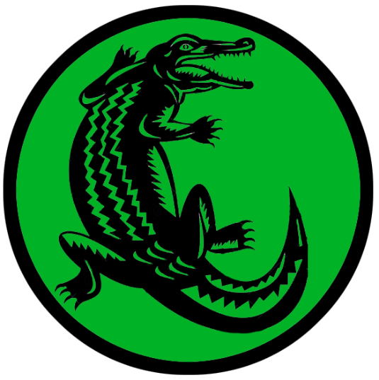
Darmidia
Size: metropolis, population 50,000, guards / soldiers 500, militia 2500
Trade Goods: trade hub, metal wares, papyrus, silver, gems, ship-building
Local Goods: Holding Houses of the Dhahab Alliance
Standard: sign of the crocodile
Colors: green and black
Patron Deity: Sobek, god of cunning and of protection on the waters
Ruler: Sultan Zuhair Hamad and his wife Isatra (f)

Home: Opal Palace
Steward: Anshar Sabatok
Marshal: Simbar Shipak
House Priest: Quiyama (judge) Meresura Sarenan (f) priestess of Sobek
House Adviser (Scholar/Mage/etc): Vizier Ouahabra of the Serpent Jar
Captain of the Guard: Amasis Dim-Tir
Chief Warriors in Service:
Walidah (f)
Pausiris
Utultar

Local Powers: Pyxis Nautica Traders, The Blue Djinn (smuggling ring), Temple of Sobek, Order of the Quarashi Falcon (order of paladins), Sons of the Khopesh (thieves guild), Sons of Nirah (assassin’s guild), The Dhahab Alliance (world spanning bank and controller of all Holding Houses)
Local Sites: Djullanar's Lair Inn & Tavern, Pipe and Cup Inn & Tavern, Shedeh House (distillery), Pillow Houses of Naseema (brothel)

Description:
Darmidia is the Bazaar to the World, wrote the Celedon poet Cadius. A sprawling expanse of markets, shipyards, warehouses, groves, and artisan shops, it offers almost every conceivable good and service to those with the coin to buy it. Commodities from every corner of the known world are brought here and made available. And to some parts of the world, this is the only place from which to find the unobtainable. Darmidian merchants are world renown for their ability to procure rare items and make them available for the highest price to those who crave them. They are also the cleverest of hagglers, the biggest liars, and the quickest to cheat to get their way.

Today the city is a resplendent paradise on the sea. The tall outer sandstone walls are topped with palm trees. Colorful rugs decorate the interiors of every house. Gleaming metal wares and glittering glass of every color give the city a dazzling charm.

Darmidian merchants are ruthless and insatiable, always trying to out-do one another to earn a place of honor in the Opulent Tower, where the most successful merchants live like kings and control the world’s markets. It is not unheard of to see a Darmidian-backed expedition picking their way through savage lands on the other side of the world looking to procure some new, rare commodity. Adventurers are often sought after by Darmidians looking to blaze a trail to a new and unreachable market.

Darmidia does a brisk business packaging and distributing Shedeh, a liquor made from pomegranates and grapes popular in the Tarbian region. Shedeh House is located within the city and has strong ties to the shipyards where they make sure they have ready access to merchant ships.

Industry:
In the many bazaars there are stands offering almost anything the buyer could ask for. Some are run by merchants from other lands. All are managed by the great Holding House of Darmidia, which keeps a sharp eye on the flow of coin here. The Holding House is the public name of the business run by the Dhahab Alliance based here. So prosperous is the Holding House that it has built houses in large markets abroad, where it lends coin with interest, finances building projects, funds wars, and holds secure items that its customers hold dear. For as dubious as a Darmidian merchant can be, a sacred trust is put on any object kept in a Holding House.

Key Figures:
Sultan Zuhair Hamad – ruthless, brilliant, greedy
Hamad is a lean man with a weathered face, prominent cheekbones, and a meticulously groomed beard. He dresses only in radiant silk and when his head is uncovered by a shemagh he wears a thin circlet of gold as he fashions himself a self-styled king. He rules over the Opulent Court, made up of merchants pledged to the Darmidian fraternity. He commands untold thousands of laborers, money lenders, merchants, street vendors, sea captains, mercenaries, thieves, and spies. Every member of the Opulent Court is a potential enemy, none more dangerous than the Dhahab Alliance that runs Holding Houses across the world.

Hamad is a ruthless man with the blood of ten thousand innocents on his hands. He is ever watchful of what transpires in his city and his both feared and loved by the Almadina (city dwellers). He also keeps an eye on the desert, for he secretly fears the Badawi (desert nomads) and knows full well their displeasure with his ruthless ambitions. Hamad carries with him Asp Amulet, a magic gem capable of influencing men’s minds as well as inflicting mental anguish for any who resist him.

Local Lore:
Sobek is the patron god of Darmidia. Personified as a crocodile, he is god of cunning and of protection on the waters. His temple is surrounded by a large lake filled with crocodiles, a low wall ringing it to keep them in. Priests often wear headpieces fashioned like that of a crocodile head. It is said this temple more than any other hordes treasures worthy of Sobek, but it is also laced with ingenious and deadly traps also worth of the god of cunning. Most famous of all treasures here are the Teeth of Sobek, a collection of different colored gems cut in the shape of crocodile teeth. They were once worn as a necklace by the high priest of Sobek. Some of the stones have gone missing over the centuries. Each stone has a unique power but when combined together the necklace is said to grant powers over the waters and protection.

The deserts far to the west of the city are home to the mighty blue dragon Mumitra. Much closer to the city, the wastelands are inhabited by hordes of desert spiders and giant lizards.

History:
The City of Bazaars has proven resilient over the millennia. When the Ebon Empire ruled the sands Darmidia was known as Darmikhun and was already a growing sea town. Its deep ports made it valuable to the empire’s war ships. The Great Cataclysm of Mahrutep in 73 PA4 buried Darmikhun beneath the sands, but almost fifteen hundred years later (511 AA1) the Fajar revived the divine springs beneath the seven cities and renamed the city Darmidia.

In 130 AA4 the city asserted itself as an independent power and soon became the launching point for naval excursions all over the Ferrago and Inner Seas. Ancient rulers in Amadar, Gaeadon, and Mythenia whispered the name Darmidia synonymously with doom.

When the Ebon Empire crumbled the city retained a large naval architecture. For a brief century or two Darmidians were privateers of their own city state, gathering fortune and learning the sea for their own purposes.

At last came the Celedonian war machine. In 30 WA1 the Celedonian Argus Legion attacked Darmidia after the city refused to pay tribute. Darmidia was the first conquest in Tarbia by the Celedon Empire and its capture began the rise of Celedon Empire. In 32 WA1 at the Battle of Arinol Celedon naval commander Tortorus outmaneuvered the Darmidian sea captain Hakaar and set the entire Darmidian fleet ablaze. The following year Darmidia was renamed Tortorron in honor of their conqueror and many soldiers garrisoned there. Tortorus would go on to launch a large building project that would eventually position Darmidia as a major power in the region long after the fall of the Celedon Empire.

Now the city became a naval launching point for the conquest of neighboring Mythenia, as well as an overland launching point to take the Jawhara or Jeweled Road. Centuries passed, with the Celedonians tightening their grip on the Tarbian people. But the Darmidians were clever, showing no resistance to their conquerors. Their way was the way of negotiation, and as the Darmidian saying goes, “Everything is negotiable.”

While the other Tarbian peoples continued to resent their new masters, the Darmidians swallowed their pride and accommodated them. This earned them scorn from their brethren, which lingers to this day. The city’s merchants eventually earned the trust of their masters. Celedonian officers enjoyed the city’s food, wine, bath houses, and women. But the Darmidians in turn learned from the Celedons, adopting their engineering techniques, mastery of ship-building, management of currency and government and even people themselves. At the end of the Celedon reign it was Ardhuhan the Perfumed, a prominent consort of the city, who gave the signal and in within the week the Celedonian soldiers lay still, poisoned by those who had entertained them. This began the Darmidian Revolt and the end of occupation by the Celedonians (820 WA1).

The Curse of Aquilus came (970 WA1), bringing a strange disease to all of Arnland. It was Darmidia that read the signs and dispatched its ships abroad. The sailors and merchants aboard the ships congratulated themselves for surviving. Almost two decades later (987 WA1) they stumbled upon a rare plant in Kaduru that could treat the plague and praised the gods. When they returned the city, along with all the cities along the Jawhara or Jeweled Road, were laid to waste. Darmidians made the cure available but did so for a price. The lucrative salvation was dubbed the Darmidian Blessing and further soured the reputation of the city as callous profiteers. Today the term ‘Darmidian Blessing’ has a negative connotation to refer to any help from the city that comes at a price.

Customs:
Haggling has worked its way into every level of social interaction in Darmidia: personal conversations always seem to be working towards securing something. Visitors from other lands especially will be goaded and cajoled into making deals. It is also common for

As in every Tarbian social setting the Sharaf is an important gesture to bestow upon a person when first meeting them or meeting them after a long absence. The Sharaf, which means “honor,” is a statement that expresses gratitude and respect towards someone. It is expected to be spoken eloquently, with extra consideration given for floral poetic notes and (in the cases of vain rulers) grandiose hyperbole. But the average Badawi respects a simple and truthful Sharaf, even if it includes a small joke at their expense.

“Talimat, you are known throughout all the southern sands,” he said to the leader of the Badawi tribe. “You are a busy and successful man, which probably explains why your feet are in need of washing.”


Hafzara
Size: small city, population 12,000, guards / soldiers 120, militia 600
Trade Goods: incense, perfume, glass wares, spices
Local Goods: Wadjet incense, Tawaret perfume
Standard: sun and hands
Colors: yellow and black
Patron Deity: Aten, god of the setting sun and is the creator, giver of life, and nurturing spirit of the world
Ruler: Malik Hishaam Abed and his wife Zumruda (f)

Home: Saffron Palace
Steward: Abdur Sha’am
Marshal: N’Kruma Akekh
House Priest: Quiyama (judge) Sabaah, priest of Aten
House Adviser (Scholar/Mage/etc): Vizier Naazil of the Taloned Hand
Captain of the Guard: Safar Salama Ta-Bat
Chief Warriors in Service:
Humaira (f)
Merodach
Abilsin

Local Powers: Black Sun (thieves guild), Temple of Aten
Local Sites: House of Tenenet Inn & Tavern, Crossed Palms Inn & Tavern, The Lavender Heaven (brothel)

Description: Hafzara, the Scented City, sits in the shadow of the Argyron Mountains and overlooks the Strait of Venture. It is a popular city with ships arriving every day out of Saludor and Kasylla. Bright streamers fly overhead, creating a rainbow of colors that can be seen for miles. The smells of incense and perfumes waft through the air here, mixing with the smells of the ocean. The sands around Hafzara are hazardous to travel. Quicksand pits dot the landscape. Only experienced guides can lead travelers safely past them.

Aten is the patron god of Hafzara. He represents the setting sun and is the creator, giver of life, and nurturing spirit of the world. His sign is seen in the standard of the city.

Industry:
Hafzara is a popular source of aromatics from Tarbia. Producing perfumes and sweet incense, its only rival is its sister city of Qasrath. Frankincense trees and myrrh trees are carefully irrigated to produce the ingredients for incense as well as for perfumes. Hafzara incense and perfumes tend to have a floral aroma to them. The Wadjet incense is believed to bestow protection when burned. Tawaret perfume is highly prized for its alluring scent, believed to incite passion and help with fertility.

Key Figures:
Malik Hishaam Abed – jovial, decadent, lazy

Malik Abed is a plump, middle-aged man with a beard that is turning white, crossed eyes that make him look ridiculous, and sweaty, tiny hands. Most days he is only half dressed and unaware of the time of day. His only reliable trait is his great taste in luxury items, which have allowed him to host fabulous feasts and secure the tentative loyalty of merchants who see him as a way to elevate their station.

Abed is the third in his line ruling the city of Hafzara and has very little to do with the city or any of its problems. He is much more content tending to his harem, wine cellar, and the fighting pits that he runs just outside the palace. Not an overly bright man, Abed leaves much of the work of running the city to his steward, Abdur Sha’am. Abed wears the Bracelets of Alhimaya, magical items handed down through each generation of his family. They respond only to those of his bloodline and may never be taken off except by him. While he wears them, he is protected against physical and magical attacks of every kind.

Local Lore:
It is said that the Qareen visit the city of Hafzara regularly. Spiritual figures that resemble humans, they accompany certain people they choose with either benevolent or evil designs.

The vain and crafty Reziran the Luminous dwells a half day’s ride outside of Hafzara. A freed djinni, she has taken residence within an abandoned manse in the midst of a long-forgotten oasis. There she lives in extravagant style, beguiling merchants and caravans into bringing her the finest fabrics, fruits, wines, jewels, and perfumes.

Monstrous scorpions roam the deserts just outside of Hafzara. While not as prolific or as well-organized as the ones near the city of Asharaat, they are a menace to unwary travelers.

History:
Hafzara was once the site of the ancient city of Hafkhun and part of the Ebon Empire. The Great Cataclysm of Mahrutep in 73 PA4 sent the Hafkhun sinking beneath the sands, but almost fifteen hundred years later (511 AA1) the Fajar revived the divine springs beneath the seven cities and renamed the city Hafzara.

Hafzara was once the site of a great conflict between heaven and the underworld. The Holy Scrolls of the Seer Badru were written almost nine thousand years ago (820 PA3), the writings gifted to him through special sight. When an evil wizard named Moharem discovered them, he sought to seize absolute power over the land. The War of the Scrolls erupted that lasted a century (780-880 AA2), with priests on either side calling on assistance from Qareen to prevail. The war ended in a cataclysm, blasting the land all around Hafzara. The scrolls were lost but the portals to the other worlds were sealed. To this day the Qareen visit to intercede in the search for the scrolls and for the fate of the city. Some suspect the climactic battle led to the appearance of the sink holes all around Hafzara.

Customs:
Herb-Smoking Rituals – Certain herbs are burned in clay bowls to keep insects away, purify the air, and invoke calm, often used in both daily life and special gatherings.

Stone Cairns for Travelers – Small stone piles are left in the desert as markers for safe paths, left by earlier travelers as a guide for others to follow.

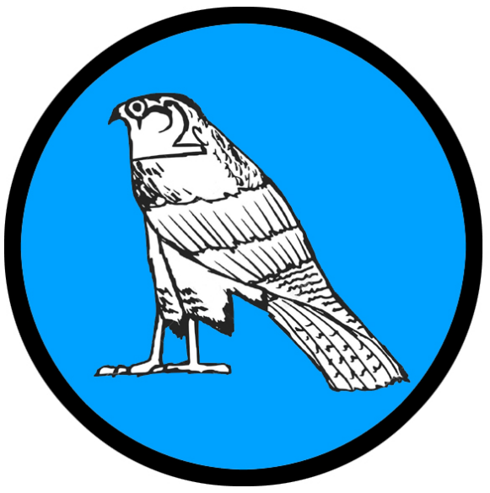
Qadimar
Size: small city, population 12,000, guards / soldiers 120, militia 600
Trade Goods: metal wares, glass wares, flax, spices
Local Goods:
Standard: sign of the falcon
Colors: blue and silver
Patron Deity: Seker, god of craftsmen as well as having power over resurrection
Ruler: Malik Haani Salloum and his wife Kissare (f)

Home: Alram Palace (“sand glass”)
Steward: Sadiki Jonesh
Marshal: Merhabi Safran
House Priest: Quiyama (judge) Olufemi (f) priestess to Seker
House Adviser (Scholar/Mage/etc): Vizier Monireh (f) the Scorpion Wife
Captain of the Guard: Abubakar
Chief Warriors in Service:
Azra
Kisharim
Ibbidan

Local Powers: Shadow of the Jaguar (thieves guild), Temple of Seker, Order of Alsalam (paladin order), Circle of the Seba (astrologers)
Local Sites: Djarni’s Grotto Inn & Tavern, Maiden Mirage Inn & Tavern, The Gold Pomegranate (brothel)

Description:
Qadimar sits far to the northwest overlooking Halcyon Bay to the south and the Ferrago Sea to the north. Unlike the other cities of Tarbia, Qadimar sits high above the desert planes atop a small mountain. Low walls ring the outside of the city at the edge of the mountain. Winches operate platforms that can be lowered to the sands below, but there are said to be hidden doorways in the sides of the mountain concealed by magic and known only to the Malik. Some buildings are erected on stilts, where wind chimes are a popular decoration.

Colorful glass discs are hung in places to catch the sun, casting a rainbow of colors on the streets below. These can be seen from miles away, heralding the way for travelers who marvel at the far-off lights. Falcons and other birds of prey are popular pets here and can be seen flying overhead. They are used as messengers between the city and approaching caravans.

Industry:

Key Figures:
Malik Haani Salloum - reverent, diplomatic, brave
Salloum is a young ruler, having taken over for his parents after they were slain by assassins. He is tall, well built, with short, curly black hair, a thin beard, and warm chestnut eyes. He carries himself like an older man, his voice gentle until provoked. He wears a simple tunic and robes but is tidy and bears the badge of his station with pride. He also wears the symbol of his god, Seker, and is a devout follower.

Salloum was taught by his parents to honor the temple and the gods and seeks to do right by his people. He is extremely pious, praying daily in the temple, dedicating his works to Seker, and supporting the local temple’s religious activities. He says little, preferring to listen to the counsel of others. At a young age he was lost in the desert, fleeing his parents’ killers. But the Badawi found him and helped him exact his revenge and take back his city. He has very close ties with the desert nomads and seeks to bring peace between the Almadina of the city and the desert dwellers. Salloum carries the sword of justice, Eadala. It is a magic sword of legend once worn by his father and reclaimed during Salloum’s adventures.

Local Lore:
Seker is the patron god of Qadimar. He is personified as a falcon and rules over a region of the underworld. He is a god of craftsmen as well as having power over resurrection. In some stories he is depicted in funerary garb, but the prophets claim he has since broken free of the underworld to look upon this world again. Those who seek his boon must render service to his priestesses.

The sands around Qadimar are infested with giant serpents. Vipers of enormous size lay in wait, sensing any vibration in the sands and pouncing on unsuspecting prey. Experienced guides are able to assist in masking the passage of caravans, provided they stay on the paths indicated and equip their camels with a special charm. The yellow stone called the Afeea is the size of a coin and is created exclusively by the mages of Qadimar in warding off the giant serpents in the area. These are not for sale but can be bought with service to Qadimar or on the black market for a high price.

The falcons of Qadimar are especially trained to attack the vipers and slay them, but it requires several birds and is difficult. There are rumors that the serpent Falak, is older than the sands and is born of dark magic. It lurks in the wastelands and bides its time, waiting for the gods to lift their protection so it may consume the people of Qadimar and steal their treasure.

History:
Qadimar was once the site of the ancient city of Qadrikhun and part of the Ebon Empire. The Great Cataclysm of Mahrutep in 73 PA4 buried the Qadrikhun beneath the sands, but almost fifteen hundred years later (511 AA1) the Fajar revived the divine springs beneath the seven cities and renamed the city Qadimar.

It is said that two thousand years ago (150 WA2) the city was under attack by the Zadaar, nomadic warlords that terrorized Tarbia. In their time of need Khaleela, priestess to Seker, called upon his aid. She was ordered to travel to the far-off Dwarven kingdom of Saphurnus, which lies in the east in the Alcyone Mountains on the borders of Tarbia. On a large magical falcon she flew, and told her tale to the Dwarf King Gogrumri Caskbreaker. The Gogrumri received her gifts of desert jewels and took pity on her plight. He gifted her a handful of magical stones he called the Seeds of Nemmerle. These she took back and planted along the outer walls of the city in the dark of a moonless night. To her amazement a mountain rose up, lifting the city above the sands. The city was saved and to this day the mountain stands with the city perched atop it.

Customs: Ceremonial Scarves or Veils – Many of the city residents wear specially colored scarves or veils that represent their family or clan. These are often exchanged during special events like weddings or feasts.

Sand-Warding Amulets – The people here wear amulets made of polished stones or carved wood, believed to ward off sandstorms and protect travelers.

Tijara
Size: large city, population 25,000, guards / soldiers 250, militia 2250
Trade Goods: dyes, glass wares, perfume, opium, spices
Local Goods: Qetesh perfume
Standard: lioness
Colors: purple and gold
Patron Deity: Sekhmet, warrior goddess as well as goddess of healing
Ruler: Malik Urei Allajani and his wife Zoshae; son Oukesi, daughter Falina

Home: Sawajet Palace
Steward: Bila Kadashman
Marshal: Sharokeen Yangi
House Priest: Quiyama (judge): Zuraara,priestes of Sekhmet, first female Quiyama in 1000 years, can shape-shift to a leopard in service to Sekhmet, helped to her seat by the party of the Eight Pointed Star
House Adviser (Scholar/Mage/etc): Vizier Saadiq (evil – thought killed by the game party but working abroad), replaced by Sabiyya (f), female cleric of Amon-Ra
Captain of the Guard: Palassar Ashur
Chief Warriors in Service:
Maruud
Dorara (f)
Akhiqar

Local Powers: The Draped Order (thieves guild), Band of the Horned Viper (order of rangers), Nim Jadeem “The Sons of None” (mercenary company), Temple of Sekhmet
Local Sites: Sarabi’s Den Inn & Tavern, The Master’s Tent Inn & Tavern, Garden of the Gods, Palace of a Thousand Sighs (brothel)
- Garden of the Gods – section of the city where temples have been erected to every god from abroad, some barely maintained because the travelers in whose name they were erected have long since moved on and not come back
Description:
Tijara sits at the western edge of Tarbia, overlooking Halcyon Bay. The circular walled city is divided into four quarters, with the main roads running north-south and east-west leading to the four gates of the city and intersecting at the center. At the center is the Great Well of Life, a deep cistern where waters from the Invisible River flow. Lush vegetation grows along the sides of the well and around the ring at the surface. An aqueduct system radiates out from the well, where hand-operated pumps bring water up from below and distribute it to the city. A citadel complex is built around the well opening. Here are located the palace, private gardens, garrison of soldiers, and the holy Garden of the Gods.

Industry:
Qetesh is an enticing perfume produced in Tijara. Scented with rose petals and animal musk, it is believed to enslave men’s desires and bring prosperity.

Key Figures:
Malik Urei Allajani – adventuresome, restless, reckless
Malik Allajani is a short, broad-shouldered man with dark skin, fierce eyes, a balding head he covers with various caps, and a perennial smile on his face. He wears a plain tunic and slippers when in the palace, donning a luxurious robe only when there are guests. But he is more often in riding clothes and brandishing his sword Makhlab, also called Bright Claw, a powerful sword of legend that is said to have beheaded a dozen desert serpents.

He is a robust figure and full of energy. Impatient with matters of rule, he makes snap decisions after only a brief review of information and defers to his advisors. Allajani yearns for adventure and is very athletic. He regularly takes small expeditions out into the desert, where he enjoys camel races, mock combat between small bands of his men, and exploring the wastes. He is friends with the Badawi and often leaves for weeks on journeys with them. Allajani makes no secret he welcomes conflict along the Jeweled Road, for he longs for the chance to do battle with his fellow maliks.

Local Lore:
The patron god of Tijara is Sekhmet, the feline goddess. She is a warrior goddess as well as goddess of healing. She is depicted as a caracal, the desert wild cat, the fiercest hunter known to the Tarbians. It was said that her breath formed the desert. She is represented not only by her priestesses in the Temple of Sekhmet, but also through her Quiyama, or judge, who doles out justice on behalf of the Malik.

The Eyes of Bast - Sekhmet is a close ally with the goddess Bast, a goddess of luck and protection. While Bast does not favor Tijara exclusively with her presence, it is here where she is most powerful. Cats are her favored animal, and they appear everywhere in the city. It is said that every visitor to Tijara is chosen by one of the many thousands of cats, which will follow the traveler unseen and evaluate their hearts and deeds. On occasion if a traveler is deemed a worthy soul, the cat may make itself visible to him or her and offer aide or speak with them. It is said that they will even heal wounds with a lick of their tongue, if allowed. The cats serve as Bast’s eyes and ears, gathering information and delivering messages.

Ekzejes, warlord Thri-Kreen chieftain, commands a series of large underground hives in the desert lands around Tijara. Untold thousands of Thri-Kreen dwell just beneath the surface and ambush caravans and travelers out on the wastes. Ekzejes is said to harbor a deep hatred of humans and seeks to conquer the city and see every human fed to his hive’s larvae nursery.

Watchful travelers to Tijara will notice a fine sprinkling of grains of sand descending from overhead. Legend tells that the evil cleric Mahrutep of Tijara contrived a scheme to harness the powers of the great Hourglass of Ages. This led to the infamous Cataclysm in 70 PA4. A hundred year later a young cleric by the name of Haaritha (f) sought out the Hourglass in the heavens and managed to contain most of it (170 PA4). However a tiny crack remained in the hourglass. It is said that the Sands of Time still leak to this day, but only within a confined region. Each time the sandfall appears, Viziers of every city work to dispel it but they only seem able to send it to another location. For centuries the sands have been relocated from one city to another, with each attempt to dispel it growing more and more difficult. Currently, it is said, that the sands now descend on Tijara. The court of mages works night and day to find a way to send them elsewhere.

History:
Tijara was once the site of the ancient city of Tijakhun and part of the Ebon Empire. The Great Cataclysm of Mahrutep in 73 PA4 buried Tijakhun beneath the sands, but almost fifteen hundred years later (511 AA1) the Fajar revived the divine springs beneath the seven cities and renamed the city Tijara.

Three thousand years ago the combined forces of the Argus, Orthaon, and Nessus legions from Celedon marched through Tarbia and brought it to its knees (90 WA1). The Orthaon Legion established a garrison in Tijara where it controlled the entire desert region.

Customs:
Firelight Story Circles – In the evenings, city dwellers gather around fires to listen to tales, legends, and songs, connecting with their ancestors and sharing knowledge.

Shade-Based Hierarchies – Elders, honored guests, and leaders are given priority under the limited shaded areas, symbolizing respect and protection.

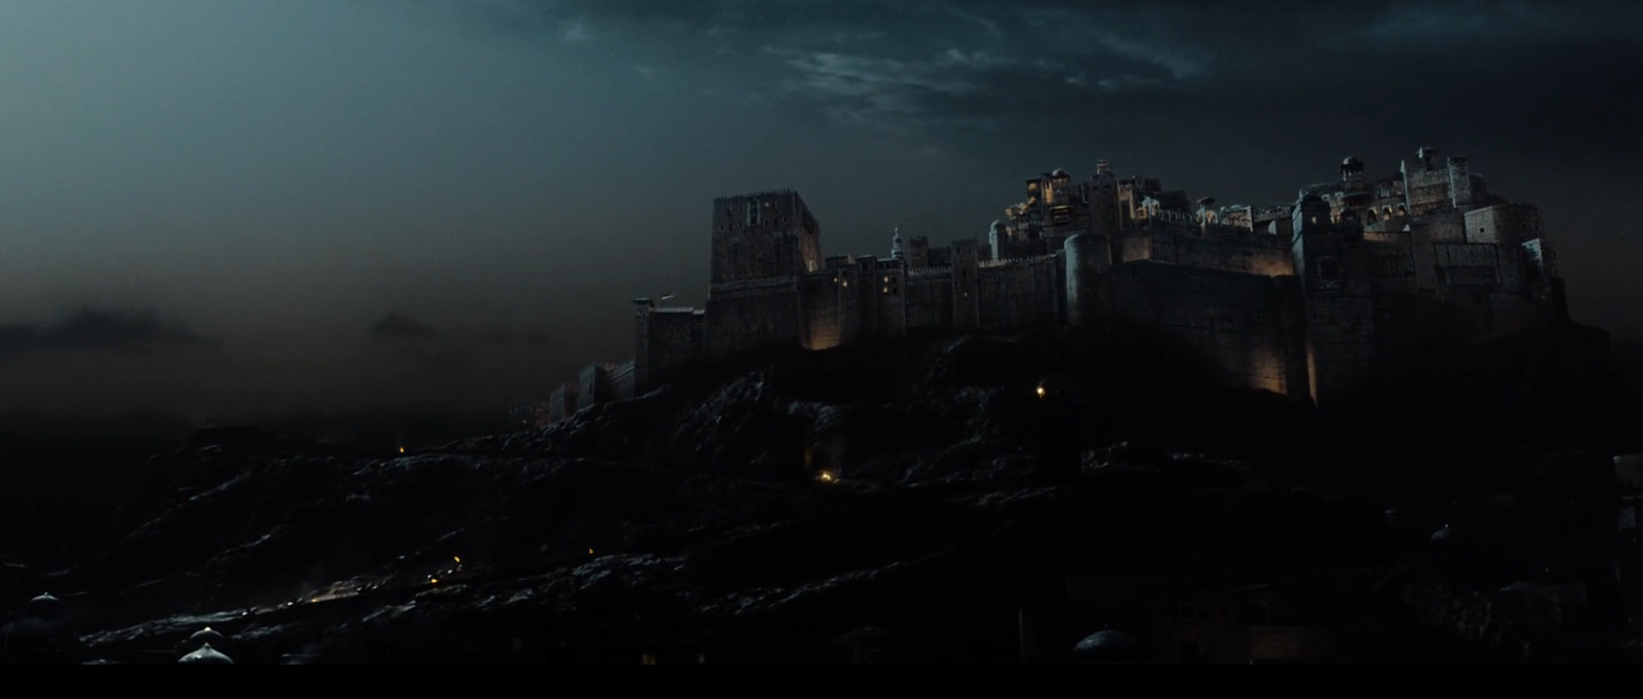

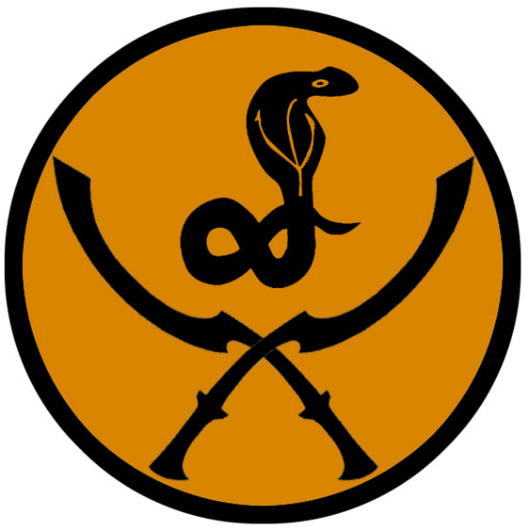
Qasrath
Size: small city, population 12,000, guards / soldiers 120, militia 600
Trade Goods: incense, perfumes, glass wares, gold, spices
Local Goods: Serqet incense, Hathora perfume
Standard: sign of the serpent and twin khopesh
Colors: orange and black
Patron Deity: Pakhet, goddess of hunting and of childbirth
Ruler: Malik Irfaan Shahid and his wife Paldina (f)

Home: Rainbow Palace
Steward: Mardina Shamiran (f)
Marshal: Athan Mlimar
House Priest: Quiyama (judge) Shafeeqa (f), priestess of Pakhet
House Adviser (Scholar/Mage/etc): Vizier Anokeen of the Unseen Council
Captain of the Guard: Humaid Ra’ad
Chief Warriors in Service:
Waseem
Beshara
Ashqar

Local Powers: The Right Hand (thieves guild), Circle of the Shifting Sands (order of druids), Temple of Pakhet, The Nephtharim (assassin’s guild)
Local Sites: Barkabad’s Salon Inn & Tavern, House of Qetesh (brothel)

Description:
Qasrath rises from the horizon like an enormous pair of stone hands emerging from the sands. Built on a broad stone mesa, the city is surrounded by ten towers that are fashioned to look like fingers stretching skyward. A tall wall connects them all, fashioned to look like the outside of the hands, gently cupping the protected interior. Large groves of palm oil trees and colorful flowers are watered from mists that spray over them from the tips of the finger towers. The haze of the waters hangs in the air, catching the sunlight to create brilliant rainbows.

Industry:
Qasrath is a popular source of aromatics from Tarbia. Producing perfumes and sweet incense, its only rival is its sister city of Hafzara to the north. Frankincense trees and myrrh trees are carefully irrigated to produce the ingredients for incense as well as for perfumes. Oloet incense and perfumes tend to have a citrus aroma to them. Serqet incense is believed to help with magical rites as well as healing, specifically venomous stings and bites. Hathora perfume is highly prized for its alluring scent, which is believed to evoke thoughts of love and desire.

Long ago explorers from Qasrath discovered gold in the Hills of Dul-Giguna to the northwest. The Malik personally oversees these operations and makes sure the gold makes its way to his treasury. This has invited thieves to open small mines of their own in the hills.

Key Figures:
Malik Irfaan Shahid - reclusive, scholarly, stoic, disfigured
Malik Shahid is a man of average size and build, with thinning black hair and a short beard. His face, disfigured years ago, is covered in a decorative mask. He has kind eyes that peer from out of the mask and a gentle voice. He wears dark robes and covers his head in a shemagh most of the time. Around his neck he wears a set of glass lenses which he produces from time to time to inspect objects very closely. Some say the lenses are the Eyes of Thoth, the god of scholars, and gives him great insight into his studies.

Shahid is an avid scholar, preferring books and artifacts. At an early age he was schooled in the studies of the stars, the elements, and of nature. He spends many hours in his private study or in the palace library. It is said Shahid conducts experiments with the aide of various scholars that come to visit the city. He is also a student of engineering, working with masons and other craftsmen on projects to innovate the city’s irrigation system and architecture. Less well known is that Shahid is also a student of the engines of war and spends some of his time preparing the city’s defenses as well as developing siege weapons.

The Circle of the Shifting Sands is a secretive group of druids who meet in Qasrath. While most consider the desert a wasteland bereft of life, the druids make the desert their home and commune with the creatures and plants that hide there. There they safeguard the land from creatures that would upset the balance of life. They are expert trackers and guides that can find water in the driest of places. Yet they are wary of rescuing beleaguered travelers, for they do not see themselves as saviors for those who do not respect the terrain.

Local Lore:
Pakhet is the patron goddess of Qasrath. She takes the form of a panther and is the goddess of hunting and of childbirth.

The brass dragon Wahidra lives to the northwest beyond the Hills of Dul-Giguna.

Giant desert spiders lay in wait all around the city. Many make homes in the sand, creating trap doors from which they spring and attack anything that passes by.

Legend tells that the Hills of Dul-Giguna to the northwest were once the site of a mighty Ebon city of old. Renenet, queen of the Ebon people, was said to be buried there. Rumor has it that thieves have disturbed her crypts in the hills, awakening her mummified corpse and her hordes of undead followers.

History:
Qasrath was once the site of the ancient city of Hafikhun and part of the Ebon Empire. The Great Cataclysm of Mahrutep in 73 PA4 buried Hafikhun beneath the sands, but almost fifteen hundred years later (511 AA1) the Fajar revived the divine springs beneath the seven cities and renamed the city Qasrath.

In 620 AA2 the infamous consort Mehmet Dalkaya bewitched the malik of Qasrath and began a war between the Seven Cities. The war lasted almost twenty years and was called the Consort Wars.

594 WA3 - Talasaaq the Jinn raged against Qasrath after being summoned by a clumsy mage. The druids of the Circle of the Shifting Sands banished Talasaaq, but only after half the city was destroyed. There are strange animals and misshapen landmarks in the city that still bear the mark of the Jinn’s magic.

Customs:

Desert Bloom Festivals – During rare seasons when flowers bloom, communities celebrate with dances and feasts, honoring the brief beauty and abundance of the desert.

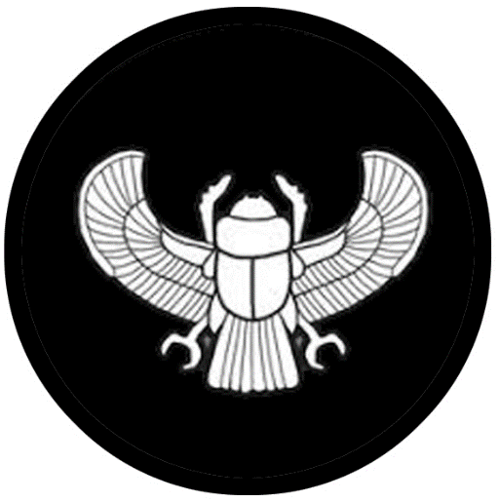
Asharaat
Size: small city, population 12,000, guards / soldiers 120, militia 600
Trade Goods: metal wares, glass wares, tea, spices, arts (calligraphy)
Local Goods:
Standard: sign of the winged scarab
Patron Deity: Khepri, god of the rising sun, of renewal and rebirth
Ruler: Malik Amjad Aly and his wife Zubaida (f)

Home: Diaphana Palace
Steward: Sharo Kikkiya
Marshal: Anlel Khnan
House Priest: Quiyama (judge) Harkhem, priest to Khepri
House Adviser (Scholar/Mage/etc): Vizier Rdita of the Golden Eyes
Captain of the Guard: Ador Eilbra
Chief Warriors in Service:
Ashuraam
Warda
Nahroona

Local Powers: The Night Whistlers (thieves guild), Temple of Khepri, Order of the Scarab (paladin order), Alsamawi (“heavenly”) School of Kufic Calligraphy
Local Sites: House of Qetesh Inn & Tavern, The Singing Sistrum Inn & Tavern, The Cowrie Shell (brothel)

Description:
Asharaat is called the Shimmering City. It has a magical aura that surrounds it and creates illusions. Travelers who are not familiar with the location of Asharaat are met with shimmering apparitions in the distance that appear to be the city. These mirages are designed to lead caravans to nowhere, leaving them to die in the sun.

Industry:

Calligraphy is a practiced and revered art form in Tarbian cities, mastered by scholars and said to hold great power. It is a beautiful, flowing form of writing that is present as decorative script in bowls, tapestries, jewelry, and even common household items. It is also prominently merged with the elaborate mosaic designs in architecture and can be seen everywhere in Tarbian cities. The Alsamawi (“heavenly”) school of calligraphy in Asharaat is the most revered place of study and practice of Kufic. The children of nobility attend the school to learn the art form, but masters of Kufic are often clerics who devote their lives to its perfection. It is said that mages and clerics alike research the most powerful Kufic characters and scripts to channel great power in their scrolls.

Key Figures:
Malik Amjad Aly – paranoid, master of disguises, master spy
Malik Aly is an average sized man with a narrow build but very flexible. His thin arms and legs are surprisingly strong, owing to his regimen of combat training and gymnastics. He wears very plain garments that are cut in expensive fabrics but tailored to allow him full range of movement. His short beard is well groomed and pointed, his eyebrows very expressive, and his dark eyes penetrating. He rarely smiles and is keen to listen rather than to speak.

Aly long ago studied the source of the illusions that surround Asharaat and became obsessed with mastering the arts of deception and espionage. It is his belief that what his city lacks in strength can be made up in guile and misdirection. He has employed extensive intelligence operatives to travel the Jeweled Road and collect information on the other cities of Tarbia. He has surrounded himself with experts on cryptography and languages. On his wrist he wears the Bracelet of Harba, a magic item that gives him the ability to change his appearance, voice, and even scent upon command. He is a suspicious man, always looking for the weaknesses in his rivals. It is his hope to one day be prepared to turn the tables on those who seek harm to him and his city.

Local Lore:
The sands around Asharaat are infested with large scorpions. It is said that their mother is a giant scorpion named Ishra who commands them. Ishra is mentioned many times in legends, having plagued the Tarbian sands millennia ago with her army of scorpions.

It is rumored that in the outlands around Asharaat dwell the mystical beasts the Shadhavar. These resemble white stallions with a single horn, much like unicorns. Unlike the unicorn, the Shadhavar’s horn has hollow branches which, when the wind passes through them, produce a pleasant sound that induces animals to kneel and listen. Horns of these creatures, sometimes gifted to kings, can be played on like flutes. When played on one side, they produce a cheerful sound, and when the other, the music is so sad it makes people cry. Others say these are in fact the Sirânis, a close cousin to the Shadhavar that resembles a white stallion. When it plays music, it is to lure its victims within reach and then impale and consume them.

Khepri is the patron god of Asharaat. He is the personification of the rising sun, of renewal and rebirth. He appears in the form of a sacred scarab beetle. Worshippers gather each dawn to greet the rising sun and offer prayers to him. In times of war the army of Asharaat prefers to fight in the morning to bring good fortune.

The deserts around Ibis Bay are home to the mighty blue dragon Bariqar

History:
Asharaat was the site nine thousand years ago of the fabled Scorpion Wars (660 PA2) where Ishra ruled all of the deserts but was defeated by the hero ranger Manzati (f).

Asharaat was once the site of the ancient city of Ashakhun and part of the Ebon Empire. The Great Cataclysm of Mahrutep in 73 PA4 buried Ashakhun beneath the sands, but almost fifteen hundred years later (511 AA1) the Fajar revived the divine springs beneath the seven cities and renamed the city Aharaat.

Customs:
In times of war the army of Asharaat prefers to fight in the morning to bring good fortune.

Blood Bonds Among Allies – Allies or trading partners seal deals with small blood rituals, pressing pricked thumbs together to symbolize trust.

Sun Salutations at Dawn and Dusk – People greet the sun with prayers and gestures as it rises and sets, acknowledging its importance and strength in daily life.

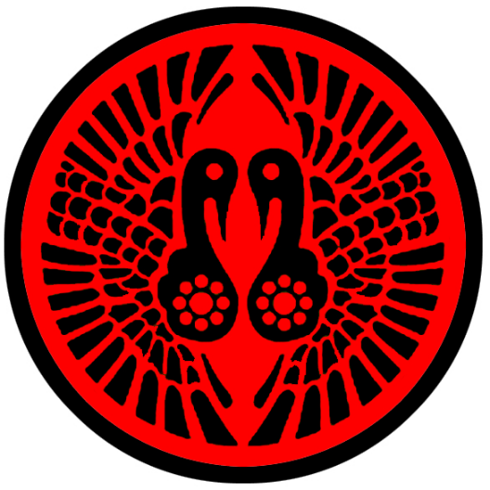
Ankhtiri
Size: large city, population 25,000, guards / soldiers 250, militia 2250
Trade Goods: trade hub, steel, iron, magic center, religious center, stone
Local Goods:
Standard: Sign of the twin ibis
Colors: red and black
Patron Deity: Thoth, god of magic, writing, science, and judgment of the dead
Ruler: Malik Azzaam Faraqh and his wife Madjida (f)

Home: Ephemera Palace
Steward: Nebu Shnina
Marshal: Hasani Aroeris
House Priest: Quiyama (judge) Amasis, priest of Thoth
House Adviser (Scholar/Mage/etc): Vizier Pen-Ba-Kak of the Night Flame
Captain of the Guard: Ahmes Tunar’i
Chief Warriors in Service:
Kanra
Avil-Kan
Marduk

Local Powers: Kirim Kemir Traders, Temple of Thoth, Twelve Cats (thieves guild), The Marid Sisters (smuggling ring), Doubhadn Sanctum (school of magic), Keepers of the Crypt (assassin’s guild), Mashafra Forge (sword makers)
Local Sites: Ten Thieves Inn & Tavern, The Tin Kettle Inn & Tavern, Barana’s Bath House (brothel)

Description:
Ankhtiri of all the Tarbian cities is the oldest and retains the most of the ancient cultures of the land. Buildings here tend to be of darkened mud, stone, and timber and have a venerable aesthetic to them. Much of the city is built atop two or more previous foundations, the work of rebuilding on the architectures of civilizations dating back as far as the Ebon people. Residents have a muted congeniality, tending to their work or studies in a city of so many libraries and mines.

It is here the High Temple to the Tarbian gods stands and is the religious center for all who would make pilgrimage to the great crypts and the Cobra of Dooms. The Cobra statue stands thirty feet tall with glittering rubies for eyes. It is said that the faithful may peer into its eyes and receive a vision of the future. Some are disturbed to find they are obligated by the Cobra with a quest for redemption. None may refuse the quest if commanded or suffer death.

Industry:
The Mashafra is the oldest and greatest smithing guild in Tarbia. Its name in the Tarbian tongue translates to “water blade.” Long ago the Mashafra masters created forging techniques to produce “watered steel,” blades that have a wavy or “watered” pattern, produced in the steel prior to forging using specific smelting and crucible techniques. The technique, called Mashafraning, is also used in the inlay of metal surfaces such as those of a breastplate or a sword blade with gold or silver. All blades and armor throughout Tarbia bear this decorative style, but only a few possess true Mashafra blades or armor and they are of far superior quality and value.

Key Figures:
Malik Azzaam Faraqh - obsessed, cursed, enigmatic
Malik Faraqh is a middle-aged man with rosy cheeks, long curly black hair, large hands and a devilish gleam in his eye. He wears expensive fabrics cut in a sensible style and precious gem stones on his fingers. The coveted Dagger of Okerem hangs from his sash, a sign of his membership in the prestigious scholars’ society founded in Akhtiri. Faraqh is charismatic and eager to hear and tell stories to travelers and show them the ancient monuments in the city. Unknown to most he is a member of a secret inner circle of the society that seeks out forbidden magic dating back to the Ebon Empire. His group finances thugs along the waterfront to procure victims for their secret ceremonies. Faraqh hides a horrible patch of rotting skin on one thigh, inflicted on him in a ceremony where he lost control of the dark forces and he was cursed. The rot eats away at him slowly, driving him mad and desperate for a cure. He will stop at nothing to find the blood of a stranger from a far-off land as prescribed by the ancient texts. But after years of attempts none of the visitors to Ankhtiri have met the prophecy’s requirements.

Local Lore:
Thoth is the patron god of Ankhtiri. He is depicted as having the head of a baboon but sometimes he appears as an ibis bird. He oversees the arts of magic, the system of writing, the development of science, and the judgment of the dead.

Bastoph, a lamia noble, dwells a half day’s ride outside the city beneath the ruins of a town long forgotten. Here he plots against the city and seeks to gain the precious magic treasures within her royal vaults. His jackalweres roam the sands, infiltrating the city at night when possible and making off with information and items to serve Bastoph’s aims.

The coastline around Ankhtiri is marked by inlets populated with wild hippopotamuses. Sailors are wary of the beasts as they are enormous and attack passing boats.

History:
Ankhtiri was the birthplace of the Ebon civilization (140 PA2). In 520 PA2 the- Sea People of the Isle of Phoenix attacked the fledgling city of Ankhtiri. In the Battle of Khnurn (540 PA2) Ankhtiri naval commander Shak-amen destroyed the Phoenix fleet, crushing the island's hold on the region. This freed the way for Ankhtiri to expand its control of the coast and waterways.

Eight hundred years would go by until the Ebon rulers would seek to control all of Tarbia. In 850 PA2 Ankhtiri armies marched on the city of Ashakhun (present-day Asharaat) and conquered it. This was quickly followed by more victories: Hafikhun in 860 PA2, Tijakhun ten years after that, Qadrikhun in 880, Hafkhun in 890, and eventually Darmikhun in 910 PA2. Following this expansion the Ebon Empire had reached the northern shores of the Tarbian Desert and began control of the waters from the Ferrago to the Inner Sea.

Ankhtiri was once the capital of the Ebon Empire. The Great Cataclysm of Mahrutep in 70 PA4 buried the city beneath the sands. But almost fifteen hundred years later (511 AA1) the Fajar revived the divine springs beneath the seven cities and restored Ankhtiri.

Customs:
Desert Burial Rites – Burial takes place at dusk, and the deceased are laid to rest in the cool sands, believed to ensure peace and prevent the body from turning to dust prematurely.

Stargazing and Sky Mapping – Communities honor the stars for navigation, gathering to map out constellations and pass down their stories, often associated with ancestors or deities.

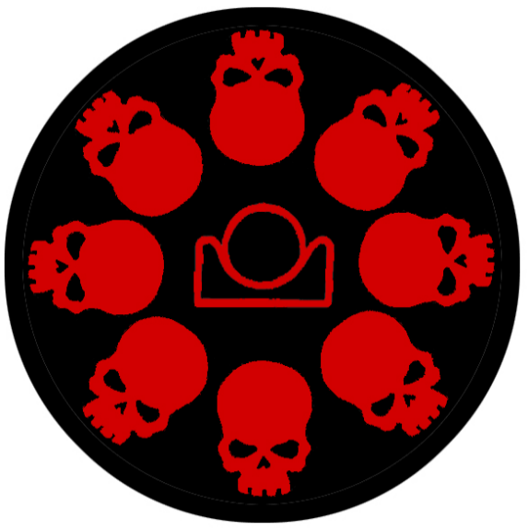
Charnella
Size: small town, population 2,000, guards / soldiers 20, militia 100
Trade Goods: incense, perfume, medicine
Local Goods: Kykeon wine
Standard: sign of the skulls and setting sun
Colors: black and red
Patron Deity: Nerull
Ruler: Kalumtum of the Freed Corpse (f)

Home: Tower of Anguish
Steward: Namtar
Marshal: Urhamsi
House Priest: Nabu Bel-Uzur
House Adviser (Scholar/Mage/etc): Arua of the Flayed Flesh (f)
Captain of the Guard: Abi-Maras
Chief Warriors in Service:
Gudea
Tir-Utur
Idadu

Local Powers: world seat of power for the worshippers of Nerull, The Nizari (assassin’s guild)
Local Sites: Kykeon Vineyards, Tower of Anguish, Cloud Mill, Charnel Delights (brothel)

Description:
Charnella is a town of ancient beauty concealing a dark menace. Dark orange stonework makes up the older structures, which peek out of the green foliage of the island’s jungle. These are of a forgotten architecture decorated in ancient Ebon markings from the Primordial Ages. More modern buildings built from wood lay at the foot of the hills against the water.

Charnella is a dark place, filled with people of little cheer and few words to any stranger. Most of the inhabitants are here without choice, either banished here from Celedon or Tarbia or press-ganged into service on a passing ship and left here to die. Some make the most of the life the island has to offer, but hope is in short supply.

Jungle dominates the interior of the Isle of Orpheon. Mt. Atranox, a dormant volcano, looms prominently to the north west above the treetops. Creatures of bizarre origin stalk the wild interior; some say they were summoned by mages millennia ago and forgotten.

Industry:
What little solace can be had is in the groves where workers cultivate ingredients for incense and other aromatics. The apothecary, referred to by the faithful as the Cloud Mill, produces an exotic array of ointments, oils, potions, and herbal remedies. Some of these have power over diseases and would be highly sought after by markets abroad. But most are made exclusively for use in cult rituals and are prized for their mind-altering effects.

The Kykeon estate located outside of town produces a fruity spirit containing an unusual mix of barley, cheese, and wine. The drink has psychedelic properties and is often used in the cult ceremonies on the island. Various blends of the spirit are made with varying degrees of potency. The darker the red of the Kykeon, the more severe the effects on one’s mind. A light rose colored bottle might create states of euphoria and giddiness. A dark, almost black blend is so powerful it can drive the drinker to madness. This is a rare drink outside of Charnella. It is highly sought after by the decadent rich around the world. The black market pays top price to anyone willing to secret it off the island.

Key Figures:
The cult of Nerull runs the town with an iron grip. Acolytes walk the streets with faces painted like skulls, lash marks visible on their backs and arms. Wherever they go they look for any who would speak out against Nerull and their high priest.

A hill rises at the center of the town. There stands the Tower of Anguish, a soot-colored stone keep where screams issue forth in the night. Thousands of skulls stare down menacingly from the walls, their eye sockets aglow from torchlight. This is the high temple to Nerull. It is said evil spirits are summoned here with offerings of blood.

The temple features a pleasure house, known by the nickname Charnel Delights. Here beautiful young men and women are lured in a haze of smoke and engage in sadistic orgies. The acolytes chant as the priests and priestesses participate. Human sacrifices are performed in a number of grisly manners, all the while giving power to Nerull.

Local Lore:
The blue dragon Alamawt dwells on the island. Alamawt cares little for the affairs of humans and keeps to himself in a large cave system on the west coast of the island. There he revels in the tropical storms rolling in off the sea. Worshippers of Nerull often pay tribute to the dragon out of fear and respect, leaving cattle and sometimes humans for him to devour.

A colony of Sahuagin, the Erekel, make the northern banks of the island their home. From there, they attack ships passing along the Lower Via Maris shipping route. They are known by their sign of the four black dots arranged in a diamond shape.

History:

Customs:

History of Tarbia

First Primordial Age (PA1)
Dawn of the Ebon Peoples

90 PA1 - the gods Sobek, Aten, Seker, Sekhmet, Pakhet, Khepri, and Thoth visit the wide sands of the Tarbian Desert on their magical barge. Each of them bring forth water from the sands and birth what would be the Seven Jeweled Cities. A mighty series of rivers are created to flow throughout the desert.

820 PA1 - Teremun, high priest of the Underworld Altar, forms the cult of Numeret

823-850 PA1 - the Numeret terrorize the vast lands of Tarbia as countless people are snatched away and sacrificed to the dark gods

850 PA1 - the Alisham, priests of the Sun Altar, break free of imprisonment; they defeat the zealots of the Numeret and slay Teremun

851 PA1 - Teremun's followers seal his organs in the Canopic Jars of Numeret

Second Primordial Age (PA2)
140 PA2 - City of Ankhtiri is founded, beginning the period of the Ebon civilization

231 PA2 - The slave Calaithe leads a revolt of enslaved women in Feronia (in present-day Celedon)

232 PA2 - Calaithe's army marches to other Auran cities, defeating Auran forces and freeing more enslaved women

233 PA2 - Calaithe's forces enter the Tarbian desert, beginning a grueling trek eastward to escape Auran forces

235 PA2 - Battle of Calaithe's Flight: After surviving many perils in the Tarbian desert, Calaithe's forces defeat Ebon and Akeron forces at the Thyra Gates to enter Akeron lands

236 PA2 - Calaithe's Last Stand: Calaithe sacrifices herself and her personal guard holding off the Akeron forces as ten thousand women escape to the Isle of Dymoneia; the Amazon kingdom is formed

240 PA2 - the sorceress Orithea discovers the Cradle of Life; the women assume the culture of amazons and proclaim the Isle of Dymoneia a sovereign kingdom

350 PA2 - the elder djinn Ghakanesh terrorizes the Tarbian wastes

520 PA2 - Sea people of the Isle of Phoenix attack the fledgling city of Ankhtiri

540 PA2 - Battle of Khnurn - Ankhtiri naval commander Shak-amen destroys the Phoenix fleet, crushing the island's hold on the region

660 PA2 - The Scorpion Wars - the giant scorpion Ishra dominates the sands of Tarbia with her army of scropions; the hero ranger Manzati (f) defeats the scorpion and prevents the army from overunning the Ebon cities

791 PA2 - Battle of Khnurn: Ankhtiri naval commander Shak-amen destroys the Phoenix fleet, crushing the Nepheran hold on the region

813 PA2 - Ankhtiri armies march on the city of Ashakhun and conquer it, adding it to the Ebon Empire
824 PA2 - Ankhtiri armies march on the city of Hafikhun and conquer it, adding it to the Ebon Empire
831 PA2 - Ankhtiri armies march on the city of Tijakhun and conquer it, adding it to the Ebon Empire
849 PA2 - Ankhtiri armies march on the city of Qadrikhun and conquer it, adding it to the Ebon Empire
855 PA2 - Ankhtiri armies march on the city of Hafkhun and conquer it, adding it to the Ebon Empire
871 PA2 - Ankhtiri armies reach the northern shores of the Tarbian Desert and conquer Darmikhun; Ebon Empire goes on to control the waters from the Ferrago to the Inner Sea

882 PA2 - Ebon Empire begins under its first king, Rakhamen

887 PA2 - Rakhamen unites the Almadina and the Badawi, commissions the Crown of Pschent

Third Primordial Age (PA3)
120 PA3 - Apophis, high priest to Khepri, begins building the Qasramaq, a vast complex of tombs and temples beneath Ashakhun (present-day Asharaat)

200 PA3 - the Order of the Scarab is founded in Ashakhun, dedicated to honoring the ancient gods by delving into the underworld; the paladins pledge to extend the Qasramaq, keep it secret, and defend its secrets

680 PA3 - after 500 years of work, the Qasramaq secretly extends tunnels beneath all seven cities of Tarbia

740 PA3 - the high priestess Amenset is consumed with lust for power and takes over the Qasramaq, slaying the Order of the Scarab

752 PA3 - a handful of surviving Scarab paladins and clerics defeat Amenset and entomb her in the Crypt of Anubis in the Hills of Dul-Giguna east of Qasrath

820 PA3 - Scrolls of the Seer Badru are written, gifted with holy knowledge from the Qareen (spiritual doubles of humans in a parallel dimension)

Fourth Primordial Age (PA4)
70 PA4 - The Great Cataclysm of Mahrutep - dabbling with power beyond his control, the cleric Mahrutep of Tijara ruptures the Hourglass of Ages and unleashes a sandstorm that lasts a hundred years and wipes out the ancient Ebon Empire, burying their cities forever

75 PA4 - All the surface rivers of the desert disappear. The only rivers that remain are cut deep into channels beneath the sands.

170 PA4 - the priestess Haaritha (f) seeks out the Hourglass in the heavens and manages to contain most of it. However a tiny crack remains in the hourglass, spilling the Sands of Time in various spots around Tarbia

180 PA4 - with the deserts calm again, the Badawi nomads return to cross the sands; chaos reigns in the Tarbian desert in the absence of the Ebon kingdom; Badawi tribes war constantly for control

200 PA4 - Osireion launches expeditions into the Tarbian Desert, conquering the seven cities

680 PA4 - the Badawi tribes defeat the Mythenian occupational forces, forcing the Mythenians to leave; rule of the seven cities returns to the Fajar people

872-888 PA4 - The Wizard War: Telemechus triggers a world-wide war of mages, some of whom march on Ongolk to stop him and some who join him in attacking the ley lines in their lands; epic battles wage all over the world, destroying cities and upsetting the balance of magic

888 PA4 - The Battle of Forlorn: Telemechus is slain but not before rupturing the magical ley lines permeating Nemmyrl; the victorious general Dragan of Celedon seizes the opportunity to rid the world of magic and ruptures the Singularion as it is embedded in the ley lines; the resulting explosion sends a shock wave that ruptures the magical ley lines around the world and triggers the Dead Century

First Ancient Age (AA1)
420 AA1 - Founding of the Homam, a society of mage astrologers who study the secrets of the stars
700 AA1 - The cleric Aseela (f) of the Fajar people receives a vision from the gods guiding her to the location of the buried cities of the Ebon
702 AA1 - The Fajar, led by their war chief Katheer Akram, leave the safety of the Atia Vale to explore the buried cities of the Ebon kingdom
720 AA1 - The Fajar people begin to rebuild on the site of the ancient Ebon city of Ankhtiri
750 AA1 - The Fajar people begin to rebuild on the site of the ancient Ebon city of Ashakhun; the new city is named Asharaat
770 AA1 - The Fajar people begin to rebuild on the site of the ancient Ebon city of Hafikhun; the new city is named Qasrath
790 AA1 - The Fajar people begin to rebuild on the site of the ancient Ebon city of Qadrikhun; the new city is named Qadimar
820 AA1 - The Fajar people begin to rebuild on the site of the ancient Ebon city of Hafkhun; the new city is named Hafzara
830 AA1 - The Fajar people begin to rebuild on the site of the ancient Ebon city of Tijakhun; the new city is named Tijara
850 AA1 - The Fajar people begin to rebuild on the site of the ancient Ebon city of Darmikhun; the new city is named Darmidia
Second Ancient Age (AA2)
60 AA2 - Amenset rises from her crypt in the Hills of Dul-Giguna, seeking revenge for her imprisonment 2300 years later
77 AA2 - Amenset recruits evil clerics throughout Tarbia and spreads unholy terror throughout the seven cities
81 AA2 - Purge of the Seven Jewels - desperate for help, the seven cities recruit the help of the Badawi, Tarbian nomad tribes, to fight Amenset's demons plaguing the land
83 AA2 - Nadeera, famed ranger of the Tarbian Desert, leads the Badawi nomadic tribes in an all-out war against Amenset
88 AA2 - Nadeera and her six companions split up and each liberate one of the Tarbian cities; Nadeera slays Amenset with an enchanted Mashafra sword named Alsalam
91 AA2 - Order of Alsalam is founded in the city of Qadimar, honoring Nadeera and the Badawi heroes
220 AA2 - Kingdom of Bokarra invades southern Arnland
780-880 AA2 - War of the Scrolls - evil wizard Moharem discovers the Scrolls of Badru, priests on either side call on assistance from Qareen to prevail.
880 AA2 - War of the Scrolls ends in a cataclysm, blasting the land all around Hafzara but sealing portals to other worlds; the hero Rasalased drives back the hordes of evil and gains prominence
890 AA2 - Rasalased ("the Lion's Mane") the greatest warrior chieftain of Tarbian History rises up out of Tijara and conquers the seven cities and rules the deserts; his reign would usher in a golden age of Tarbian power over Arnland

Third Ancient Age (AA3)
33 AA3 - Alyaqut syndicate issues as proposal to the Amazons: marriage of the queen to a Tarbian prince and leave to build a port on the Isle of Dymoneia; the Amazons refuse

34 AA3 - War of the Scales: Alyaqut hire mercenary armies and attack Dymoneia; an Alyaqut wizard discovers the Sunduq Albahr, an ancient magic chest that can summon terrible powers from the sea

36 AA3 - the Amazons soundly defeat the merchant armies and capture their fleet; the Sunduq Albahr is used to summon the Kraken, which destroys the ships around Dymoneia

37 AA3 - Amazons defeat the mercenaries on land and cast the Sunduq Albahr into the sea; the freed Kraken turns on the towns of Vyper and Saqaar and destroys them, ending the Alyaqut syndicate

244 AA3 - the Green Sails enter Tarbia: after two years of rescuing people along the shores of Celedon, the fleet has grown larger and is welcomed in Ankhtiri

246 AA3 - Second Flight of the Green Sails: the cleric Asamud petitions Salmus to let the beleagured slaves of Sargon join his fleet, another twenty ships join the caravan

300 AA3 - War of the Cubs - descendants of Rasalased engaged in civil war, bringing and end to the Golden Age of Tarbia
620 AA3 - Consort Wars - Mehmet Dalkaya the infamous consort bewitches the sultan of Qasrath and begins a war between the Seven Cities
640 AA3 - Battle of Tikar - Southern cities of Tarbia defeat Qasrath and its northern allies, ending the Consort Wars

Fourth Ancient Age (AA4)
130 AA4 - Darmidia rises in power; a watering hole for caravans crossing Arnland quickly becomes a hub of trade and lays the seeds for the Almadina to once again control the cities along the Jawhara or Jeweled Road

First Written Age (WA1)
30 WA1 - Celedonian Argus Legion attacks Darmidia - start of the rise of Celedon Empire
32 WA1 - Battle of Arinol - Celedon naval commander Tortorus outmaneuvers the Darmidian sea captain Hakaar and sets the entire Darmidian fleet ablaze
33 WA1 - Darmidia is renamed Tortorron by the Celedonians; Tortorus begins a large building project that will eventually position Darmidia as a major power in the region
40 WA1 - Battle of the Temples - Celedon Nessus Legion invades Ankhtiri
50 WA1 - Celedon Orthaon Legion crosses the Tauran Mountains and joins Argus and Nessus to sweep across the Tarbian Desert and conquer the Seven Jeweled Cities, securing all of Tarbia
100 WA1 - the last of the Fajar princes is slain by the Celedonians, depriving the Fajar of heirs to continue the dynasty; the Darmidian elders move quickly to prepare for the noble class of the Almadina to assume control of the Seven Cities once the Celedonians are gone
950 WA1 - Darmidian Revolt - Ardhuhan the Perfumed, a prominent consort of the city, gives the signal and within the week hundreds of Celedonian soldiers lay dead, poisoned by those who had entertained them.
970 WA1 - Aquilan Curse - a mysterious illness sweeps across Celedon and spreads to Tarbia and Mythenia

980 WA1 - Tarbian cities revolt against the Celedonian occupation; the Almadina hire mercenaries to drive the Celedonians out into the deserts, where the nomad tribes wipe them out including the Orthaon Legion
987 WA1 - The Darmidian Blessing: Darmidian merchants discover a rare plant in Kaduru that cures the disease dubbed the Aquilan Curse; merchants of Darmidia profit greatly by making the cure available for a price

Second Written Age (WA2)
30 WA2 - Darmidian elders hand pick the new rulers of the Seven Cities, placing caliphs in each city to assert control for the Almadina class
150 WA2 - City of Qadimar beseiged by Zadaar tribe
155 WA2 - Khaleela, priestess to Seker, travels to Dwarven city of Saphurnus; Gogrumri Caskbreaker gifts her the Seeds of Nemmyrl, which she uses to create the giant fortifications around Qadimar
161 WA2 - the Order of Alsalam of Qadimar leads the Badawi nomadic people in a victory over the Zadaar, driving them out to the wastelands

Third Written Age (WA3)
140 WA3 - Darmidian merchants form the Dhahab Alliance, the single greatest concentration of wealth in the world
390 WA3 - Dhahab Alliance establishes the first Holding House in Darmidia; Holding Houses begin to form in major cities throughout the civilized world, all controlled by the Dhahab Alliance

Fourth Written Age (WA4)
20 WA4 - the Four Stars merchant company of Darmidia claims one of the outer isands of the Great Maelstrom region as its base of operations
150 WA4 - Unbeknownst to the outside world, the Dhahab Alliance triggers the War of the Red Moons to gain exclusive access to rare spices found in the western Amadar forests
240 WA4 - A freedom fighter rises up among the Badawi, the Tarbian desert nomad tribes: he is called the Habat Ramal, the "Grain of Sand," for his clandestine tactics take down the Dhahab corruption in the Tarbian cities and free the slaves working for them
490 WA4 - Zuraara becomes the first Qiyama of Tijara in a thousand years

Local Goods

Cereals: barley, oats, rye, einkorn (wheat), emmer (wheat), spelt (wheat), einkorn (wheat), durum (wheat), sesame, wheat
Fiber: cotton, jute, hemp, flax
Fruits: fig, date, pomegranate, grapes, muskmelon, casaba melon
Meat and poultry: lamb and mutton
Nuts: almond, deeknut, kurrajong, argan
Vegetables: carrots, cucumbers, leeks, lettuce, onions, parsley, radishes, linseed, olives, bitter vetch, chickpea, lentil, pea
Herbs: almond, asafetida, bay leaf, black mustard seed, dill seed, fenugreek, garden cress, garlic, lemon, marjoram, onion, poppy, rose, tarragon, parsley, mustard, eucalyptus
Oils: linseed (flax), yellow sarson (mustard), sesame oil, olive oil, palm oil, frankincense, myrrh, balsam, argan oil
Fermented Drink: shedeh, leben
Salt-water fish: sea bream, grouper, meager and gray mullet
Fresh-water fish:
Wood: cypress, palm, eucalyptus, olive, stone pine,
Textiles:
Dishes: korkot (dried or roasted cracked wheat), flatbread, koshari (vegetarian dish of rice, lentils, macaroni, garlic and chickpeas, bought together by a spicy tomato sauce and topped off with fried onion, tharida (soup of broth, stewed meat, and bread crumbs), hummus (chickpea spread), manakeesh (round bread sprinkled with meat or herbs (zaatar)), grilled halloumi (cheese made from goat and sheep milk), ful meddamas (blobby brown mush: fava beans, olive oil, parsley, onion, garlic, and lemon), falafel, tabouleh (bulgur, parsley, mint, onion, and tomatoes), moutabal (eggplant spread), fattoush (salad of rispy lettuce, crunchy fried squares of pita, diced tomatoes, cucumbers and onion, garlic, lemon, olive oil and mint), shanklish (cow or sheep milk cheese is usually fashioned into golf ball-sized bites and rolled in zaatar herbs or chili flakes often enjoyed with diced tomato, onion and olive oil), shawarma, shish tawook (simple skewered chicken dish served with pure garlic paste), dolma (succulent lamb or juicy vegetables stuffed with vine leaves), kofta (balls of minced lamb or beef have a spicy, onion kick), quwarmah al dajaj (curried chicken flavored with lime, ginger, turmeric, baharat, cumin, cardamom, black pepper, cinnamon, nutmeg, paprika), mansaf ( tender mutton, covered in yogurt sauce and sprinkled with almond and pine nuts), kebab karaz (served with sour cherries and pomegranate pips, rendering the meaty mix blood red, sweet and sour), baklava (Buttery filo pastry, chopped nuts, sweet syrup and honey dressing), knafeh (cheesecake uses Nabusi cheese, the blush coloring comes from orange blossom water or rose water), masgouf (slow-cooked carp served with lemon and pickles), harissa (thick porridge made from korkot (dried or roasted cracked wheat) and fat-rich meat, usually chicken or lamb), maghreb (butter milk)

Cumin - One of the most popular spices in Tarbian food
Nutmeg – Tarbians use it on meat dishes quite commonly. A hint of nutmeg is the secret ingredient, add that extra “something special”
Cardamom - Cardamom is commonly used in Tarbian coffee, giving it a very unique flavor. Cardamom originates from Tarbia and is one of the most ancient known spices. It also is the second most expensive spice after saffron. Cardamom has a warm flavor with lemony undertones. It is commonly used in stews, meats, and in rice dishes.

Sumac - Sumac is a spice that originated on the Arnland continent. It is a reddish-purple powdered spice that is made from the dried berries of the Sumac bush. It is typically used as a souring agent for meats, stews, and in dressings.

Fenugreek - This ancient herb originated in Tarbia. It is typically used in curries, salads, meat dishes, and in rice. In terms of flavor, fenugreek is mildly sweet and a bit nutty. It often is described as a cross between maple and celery.

Notes on Culture
Tarbian Titles
Sultan / Sultana – king/queen who rule over all the cities
Malik / Malika – city rulers
Amir / Amirah – tribal leaders
Vizier – sage / counsel / wizard
Morza – nobility title serving the king or malik
Caliph – religious leader
Qiyama – special religious judge appointed to rule over cases in each city

Traditional Tarbian Songs
- Dance of the Veils (bawdy)
- The Curse of Saqqara (sad)
- Children of Haruun (sad)
- Zalika, Flower of the Desert (romantic)
- The Master's Camel (funny)
- Ahakban the Trader (funny)
- Saffron (festive)
- Sands of the Sky (scary)
- Kiss of the Marid (scary)
- Shaheena and her Bow (inspiring)
- Silver Swords of the Sultan (inspiring)
- The Pilgrims of the Sky (religious)

Tarbian Calligraphy: Kufic
Calligraphy is a practiced and revered art form in Tarbian cities, mastered by scholars and said to hold great power. Collectively termed Kufic, it is a beautiful, flowing form of writing used as decorative script in bowls, tapestries, jewelry, and even common household items. It is used alongside elaborate mosaic designs in architecture and can be seen everywhere in Tarbian cities. The Alsamawi (“heavenly”) school of calligraphy in Asharaat is the most revered place of study and practice of Kufic. Children of nobility attend the school to learn the art form, but masters of Kufic are often clerics who devote their lives to its perfection. It is said that mages and clerics alike research the most powerful Kufic characters and scripts to channel great power in their scrolls. Warriors bear Kufic inscriptions on their weapons and armor, the words believed to have protective powers and blessings.
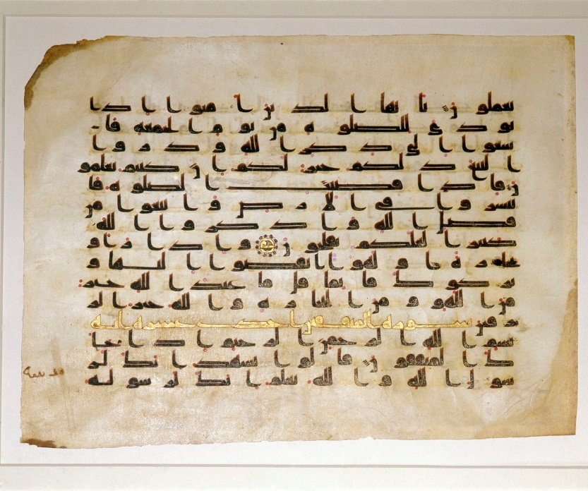

Tarbian Clothing
Tarbian clothing is loose-fitting and covers much of the body. The chief garments are a loose shirt, chemise, or robe, an over tunic or vest that is open in the front, a draped cloak; wide, baggy trousers; a waist sash; and a head cloth worn as a wrap or turban. Footwear ranges from simple sandals and delicate slippers with up-turned toes to low and high leather boots also with up-turned toes.
The simple basic garment for both sexes is a loose, long shirt, chemise, or tunic, which often has long sleeves. In general, linen, cotton, and wool are the norm, but the well-to-do wear garments made from rich fabrics with a silk base. Some of the most luxurious vestments are the baldachin, the richly decorated fabric with a warp of gold thread and a weft of silk, and damask, a richly patterned silk fabric.

Men
Simple attire for men can include a loose, open shirt. Over this they wear a vest, either plain or richly embroidered. Instead of a vest, men may wear a robe or mantle called the djellaba. The garment generally has wide, long sleeves, and the long skirt may be slit up the sides; some styles are open in front like a coat or caftan. Sashes are common, which may tie like a belt and hang in the front or may feature many overlapping layers.
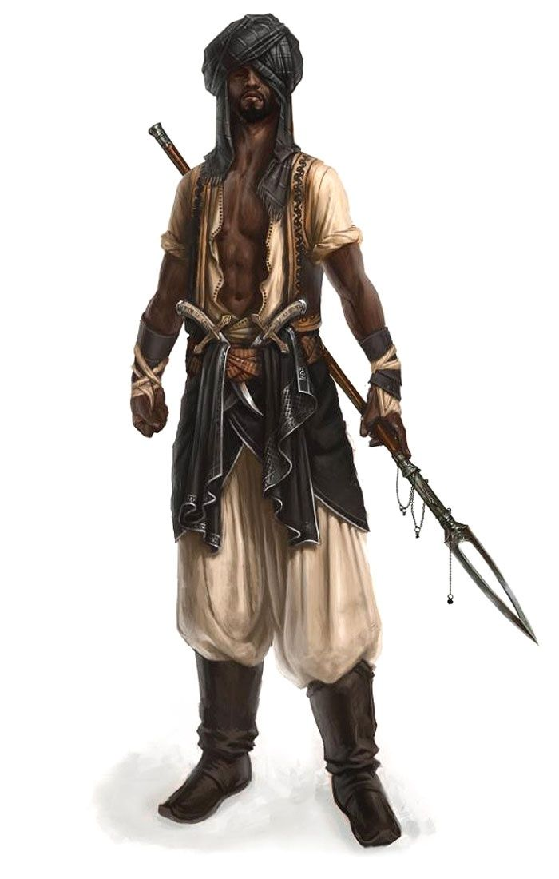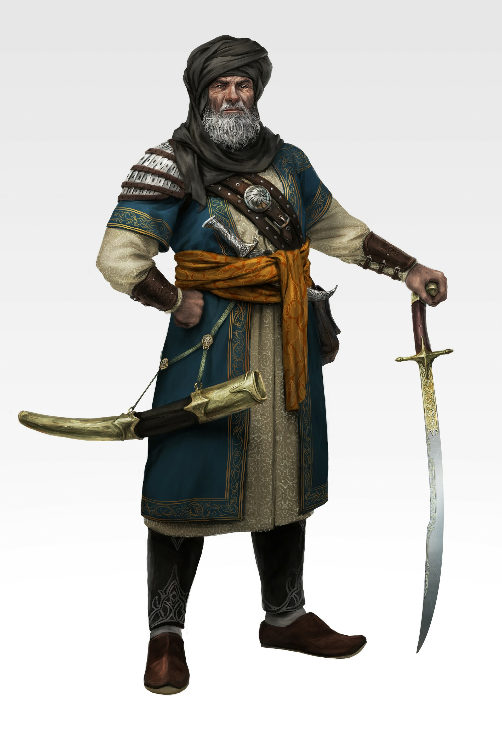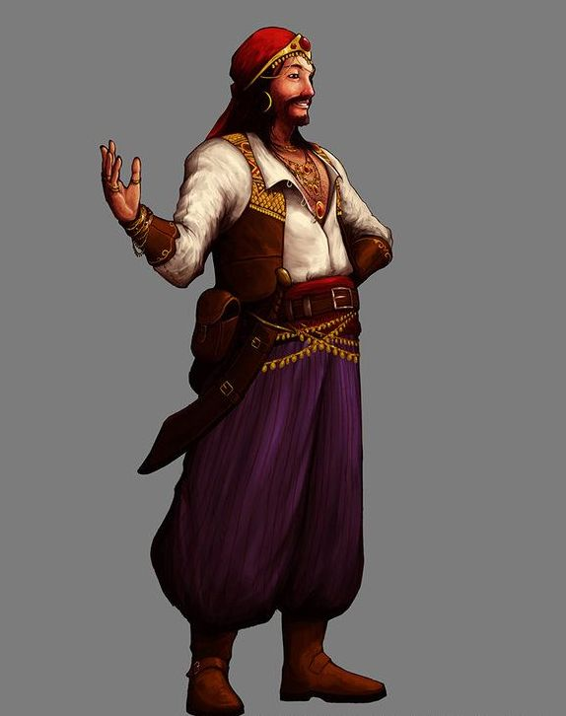

Apparel
Qamis: A simple, loose-fitting tunic made of undyed wool or linen, reaching knee-length.
Izar: A basic wrap or loincloth worn under the tunic for modesty.
Overtunic or vest: open in the front with buttons, clasps, or toggles. Quality ranges from coarse or fine weave and from plain to dyed and to dyed and embroidered, sometimes with gold thread.
Sirwal: Loose-fitting trousers, often worn under the tunic for added protection and comfort.
Amama: A simple head wrap or turban for sun protection. Can be wrapped around the head as a turban or parts left hanging loose. Nobles wear the highest quality material and are dyed and embroidered, sometimes in gold thread.
Waist sash
Sandals: Basic leather-soled footwear or barefoot.
Khuff: soft leather ankle boots
Tall leather boots
Cloak or Cape (Ridā): Wool or cotton cape, offering warmth and minor protection. Rectangular piece of cloth or fabric, often used as an upper body covering. Quality ranges from coarse or fine weave and from plain to dyed and to dyed and embroidered, sometimes with gold thread.
Burnous - A long cloak with a pointed hood used for warmth day or night. It has no sleeves but drapes over the shoulders. Quality ranges from coarse or fine weave and from plain to dyed and to dyed and embroidered, sometimes with gold thread.
Haik - an oblong piece of material used to wrap around their bodies and heads for day or night wear; the material measured about 18 feet by 6 feet.

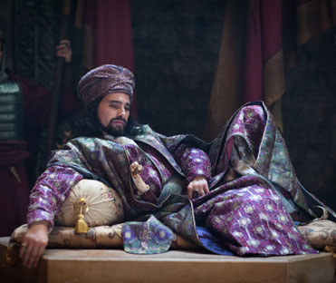

Women
Women’s attire ranges from the casual to the modest. It is common to see loose-fitting, light tops or full-length outfits ending in low skirts. Some may bear their mid-riffs with strapless tops and billowy leggings.
The abaya "cloak" is a simple, loose over-garment, essentially a robe-like dress, which covers the whole body except the head, feet, and hands. They range in colors and are often decorated with embroidery. Abaya vary in style but most are caftans, cut from light, flowing fabrics like crepe, georgette, and chiffon. Other known styles are front open and front closed abaya. Styles differ from region to region.

Face and head coverings. Some Tarbian women, usually nobility, cover their faces out of a sense of modesty. If they do, most sport a veil, which is translucent and made of fine material. Others go further, employing either a hijab, a scarf that leaves the face open; a niqab, which covers the face while leaving the eyes uncovered; a chador which is a shawl pinned at the front leaving the face open; or a burqa, which covers the entire body with only a mesh screen.

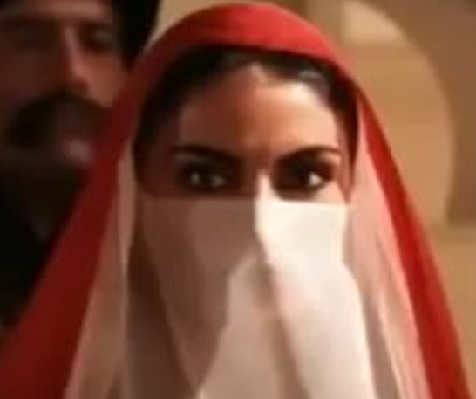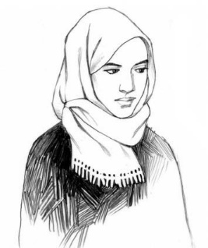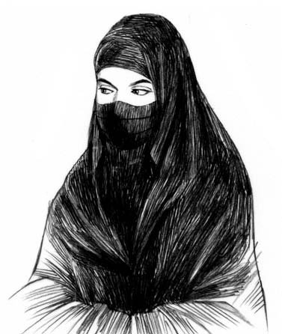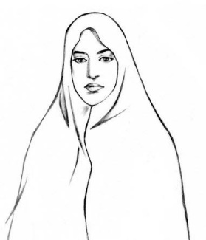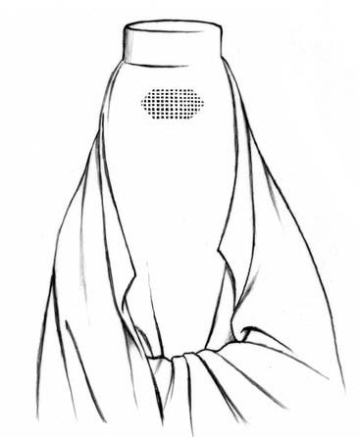
(l. to r. veil, hijab, niqab, chador, burqa)
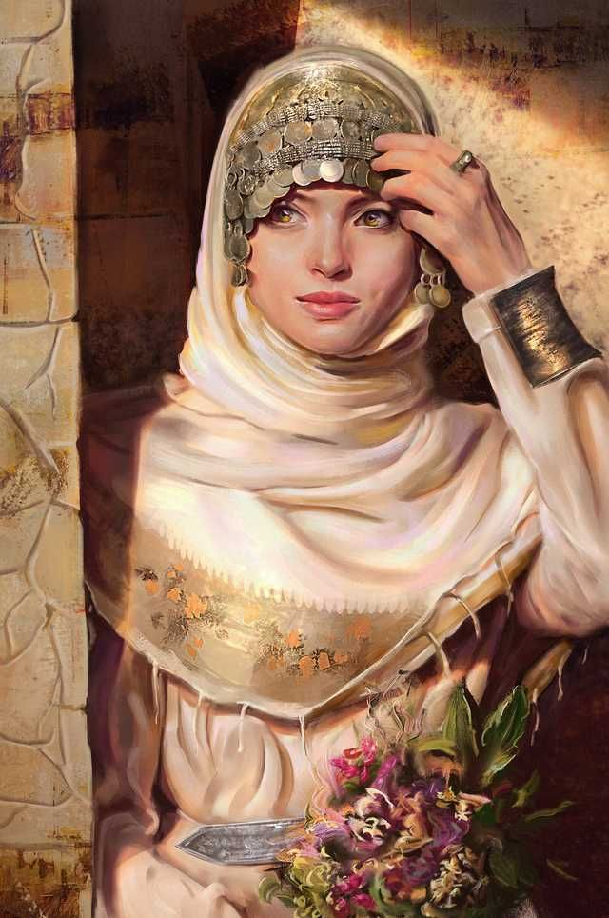

Badges of Station
Head cloths called shemagh, or keffiyeh, are traditionally worn to ward off the sun. These are fastened around the head with brightly colored cords called agal. The cords are colored to denote social rank and profession. Knots are tied into the cords to indicate rank. They can number from one, for the lowest classes, to seven, for the highest class. Typically, seven knots denote the royal class or incredibly wealthy.

The colors of the agal are associate with the following professions:
- Red – fighters, warriors
- Green – wizards and scholars
- Blue – priests and healers
- Orange – tradesmen
- Purple – entertainers
- Black – government officials, aristocrats
- Brown – farmers, drovers, craftsmen

Tarbia is composed of two populations:
- The Badawi, nomadic tribesmen who wander the deserts. They eschew the sedentary city life, sticking to their ancient traditions living out on the open sands. They are a proud people who speak their own dialect and honor the beauty of the natural world. Badawi are fierce fighters whose loud cries strike fear in the hearts of their enemies. But they are an honorable people and hold to the code of Diyafa (hospitality). If required, even an enemy must be given shelter and fed for some days. Poverty does not exempt one from one's duties in this regard. Generosity is a related virtue, and in many Bedouin societies, gifts must be offered and cannot be declined. There is a long history of the Badawi being refused equal treatment in the cities, which they visit only to trade and resupply. In desperate times the seven cities have been aided by the Badawi, such as during the Celedonian invasion in the First Ancient Age.
  - In addition to the “noble” tribes who trace their ancestry to either Kahabri (northern Tarbian) or Tiruwa (southern Tarbian) origin, traditional Badawi society comprises scattered “ancestor-less” groups who shelter under the protection of the large noble tribes and make a living by serving them as blacksmiths, tinkers, artisans, entertainers, and other workers.
  - Camels, in particular, have numerous cultural and functional uses. Having been regarded as a "gift from God", they are the main food source and method of transportation for many Badawi. In addition to their extraordinary milking potentials under harsh desert conditions, their meat is occasionally consumed. As a cultural tradition, camel races are organized during celebratory occasions, such as weddings or religious festivals.
  - In areas where rainfall is very unpredictable, a camp will be moved irregularly, depending on the availability of green pasture. Where winter rainfall is more predictable in regions further south, some Badawi people plant grain along their migration routes. This proves a resource for the livestock throughout the winter. In regions where there is more predictable rainfall, the Badawi plant crops near permanent homes in the valleys where there is more rain and move their livestock to the highland pastures.
  - Oral poetry is the most popular art form among the Badawi. Having a poet, called a Hukawati, in one's tribe is highly regarded in society. In addition to serving as a form of art, poetry was used as a means of conveying information and social control.
- The Almadina, citizens of the large city states. Some Almadina regard the Badawi with contempt as savages, while the Badawi feel the Almadina have lost their connection with the land in favor of growing soft with civilization.

Tarbian architecture is a unique style. The principal architectural types for large or public buildings are: the Temple, the Tomb, the Palace and the Fort. Interior structures feature horseshoe archways. Buildings are often topped with barrel vaults and elaborate domes. Intricate mosaics decorate the interior and exterior walls. Bright white walls of palaces contrast with the ruddy brown sandstone housing of the slums. Glittering glass windows sparkle with a rainbow of colors from towers and windows decorated in elaborate latticed designs.

The traditional Tarbian hanging lamps (lanterns) are made out of tinted stained glass and rustic brass or wrought iron metalwork. The metalwork lattice can be extremely elaborate and even awe-inspiring. These lanterns are traditionally designed to hold candles / tea lights.

A ribat is a fortification that can remain a fortress, but can also evolve into a building that houses a monastery, school, or hostel, among other things.

Naming Conventions
For simplicity’s sake, Tarbian names include the Ism (given name), which can be descriptive, followed by one or more of the four surnames or honorifics below.
Ism - is the given name, first name, or personal name; e.g. "Ahmad" or "Fatimah". Most Tarbian names have meaning as ordinary adjectives and nouns, and are often aspirational of character. For example, Ali means 'Exalted' or 'High'.
Nasab - is a patronymic or series of patronymics. It indicates the person's heritage by the word ibn ("son of") or ibnat ("daughter of").
Laqab – is a nickname; title, honorific; last name, surname, family name. The laqab is typically descriptive of the person. An example is the Abbasid caliph Harun al-Rashid (of One Thousand and One Nights fame), which uses the definite article al-. Harun is the Arabic version of the name Aaron and al-Rasheed means "the Rightly-Guided".
Nisbah - surname could be an everyday name, but is mostly the name of the ancestral tribe, city, country, or any other term used to show relevance. It follows a family through several generations. It also used the article al-. The laqab and nisbah are similar in use, and hence, a name rarely contains both.
Kunya - A kunya is expressed by the use of abū (father) or umm (mother) in a genitive construction, i.e. "father of" or "mother of" as an honorific in place of or alongside given names in the Arab world. A kunya may also be a nickname expressing the attachment of an individual to a certain thing, as in Abu Bakr, "father of the camel foal", given because of this person's kindness towards camels. Use of a kunya implies a familiar but respectful setting.

So, an example name would be:
Hikma ibn Alfatih al-Tijara abu rumaan
Hikma (“wise”) ibn Alfatih (his father’s name, which means ‘conqueror) al-Tijara (from the city of Tijara) abu rumaan (father of pomegranates, maybe he made a fortune off of being a pomegranate merchant).

But most names would only include one of the four surnames/honorifics depending on the setting.

List of common Tarbian household items
1. Hookah: A water pipe used for smoking flavored tobacco.
2. Tajine Pot: A clay or ceramic pot with a conical lid, used for slow cooking stews and meats.
3. Oud: A pear-shaped string instrument similar to a lute, commonly used in music.
4. Mortar and Pestle: Used for grinding spices and herbs.
5. Teapot: Used for brewing and serving tea, often ornately decorated.
6. Coffee Pot (Dallah): A traditional Arabic coffee pot used for brewing and serving coffee.
7. Quran Stand: A stand or holder for displaying the Quran during prayer or reading.
8. Hamsa: A hand-shaped amulet believed to protect against the evil eye.
9. Tapestry: Intricately woven fabric used for decoration and insulation.
10. Hookah Base: The glass or ceramic base of a hookah, filled with water to cool and filter smoke.
11. Turkish Delight: A sweet confection made of gel and sugar, often flavored with rosewater or citrus.
12. Bedouin Tent: Portable tents made of goat hair or fabric, used by nomadic tribes.
13. Sitar: A long-necked string instrument used in traditional music.
14. Date Bowl: A bowl for serving dates, a common fruit in Arab cuisine.
15. Saffron Threads: Expensive spice derived from the crocus flower, used for flavoring and coloring dishes.
16. Censer: A container for burning incense, often used in religious ceremonies.
17. Kohl: Eye makeup made from powdered lead sulfide, used for darkening the eyelids.
18. Calligraphy Set: Brushes, ink, and paper used for Arabic calligraphy, an art form highly prized in Arab culture.
19. Dallah Warmer: A base used to keep the dallah (coffee pot) warm.
20. Hookah Hose: Flexible hose attached to the hookah, used for drawing smoke.
21. Sandalwood Incense: Fragrant wood used for incense burning, popular in Arab homes.
22. Damascus Steel Knife: A high-quality steel knife forged using ancient techniques from Damascus.
23. Shisha Flavor: Flavored tobacco used in hookah smoking, available in various fruit and spice flavors.
24. Moroccan Lantern: Intricately designed metal or glass lanterns used for decoration and lighting.
25. Majlis Sofa: Low-slung sofas used for seating in traditional Arab homes.
26. Khanjar: A traditional curved dagger worn as a symbol of status and pride.
27. Kufiya: A checkered scarf worn by Arab men, traditionally used for protection from the sun and sand.
28. Tamarind Paste: Tangy paste made from tamarind fruit, used in cooking and as a condiment.
29. Qibla Compass: A compass indicating the direction of Mecca, used for prayer alignment.
30. Ottoman Footstool: Small upholstered stool used for resting feet.
31. Shisha Charcoal: Charcoal discs used for heating the flavored tobacco in a hookah.
32. Bakhoor Burner: A vessel used for burning bakhoor (wood chips soaked in fragrant oils) for incense.
33. Copper Samovar: A metal container used for heating and serving tea, common in Arab households.
34. Henna Paste: Paste made from the henna plant, used for temporary body art and hair dyeing.
35. Miswak: A teeth-cleaning twig made from the Salvadora persica tree, used as an alternative to toothbrushes.
36. Hookah Tongs: Metal tongs used for handling hot charcoal in a hookah.
37. Arabic Perfume (Attar): Traditional perfumes made from natural oils and extracts.
38. Mint Tea Glasses: Small glasses used for serving traditional mint tea.
39. Astrolabe: An ancient astronomical instrument used for navigation and timekeeping.
40. Kohl Stick: A small stick used for applying kohl to the eyes.
41. Arabic Carpet: Handwoven carpets featuring intricate geometric designs, often used as prayer mats or floor coverings.
42. Khan El Khalili Lamp: Ornate brass lamps common in Arab markets, used for decoration.
43. Turkish Bath Towel (Peshtemal): Thin, absorbent towels used in Turkish baths.
44. Baklava Tray: Decorative tray used for serving baklava, a sweet pastry made of layers of filo dough, nuts, and honey.
45. Moroccan Pouf: Cushioned, low seating typically made of leather or fabric.
46. Sitar Case: A protective case for storing and transporting a sitar.
47. Aladdin Lamp: A metal oil lamp with a spout and handle, reminiscent of the famous fictional lamp.
48. Tambourine: A percussion instrument consisting of a small drum with metal jingles.
49. Saffron Infuser: A tool for infusing saffron threads into liquids, such as water or milk.
50. Belly Dancing Costume: Colorful and embellished costumes worn by belly dancers.
51. Arabic Coffee Cups: Small, handle-less cups used for serving Arabic coffee.
52. Hookah Wind Cover: Metal cover placed over the hookah bowl to control heat and airflow.
53. Sandalwood Fan: Handheld fan made of sandalwood, used for cooling in hot climates.
54. Fez Hat: A felt hat with a tassel, traditionally worn by men in the Arab world.
55. Kaftan: A long, loose-fitting robe or tunic worn by both men and women.
56. Nargile Bowl: The bowl of a hookah pipe where flavored tobacco is placed.
57. Arabic Manuscript: Handwritten books or scrolls containing Arabic literature or religious texts.
58. Fustanella Skirt: A traditional skirt worn by men in some Arab cultures, consisting of pleated fabric.
59. Eid Lantern: Colorful lanterns used to decorate homes and streets during Eid celebrations.
60. Hookah Grommet: Rubber or silicone ring used to create an airtight seal between hookah components.
61. Turkish Bath Soap (Hamam Sabunu): Olive oil-based soap used for cleansing in Turkish baths.
62. Majmar: A traditional Arab heater or brazier used for warming rooms.
63. Arabic Manuscript Stand: A stand for holding open manuscripts or scrolls during reading or display.
64. Alabaster Oil Lamp: A lamp made of alabaster stone, used for lighting.
65. Tajine Mitt: Protective mittens used for handling hot tajine pots.
66. Bukhoor Box: A decorative container for storing and dispensing bukhoor (incense chips).
67. Falafel Mold: A tool for shaping and frying falafel, a popular Arab snack made from ground chickpe

Weapons and Armor

Tarbian warriors typically wear lighter armor, opting for speed over heavy protection as well as being suited to a hotter climate. Armor is typically a shirt of mail, with bronze or gold rings intermingled with steel rings. The use of plate is confined to helmet, short vambraces and greaves, and, to some extent, reinforcement of the mail shirt with steel plates. Warriors wear conical helmets with mail or cloth coifs, ornamented with a band of silk or fur, and carry round metal shields. The preferred weapon is the scimitar or saber, having a long, slightly curved blade with a single cutting edge. Other arms include spears, javelins, battle axes, maces, and recurve bows. These weapons are used by both foot soldiers and mounted cavalry. Blades are usually crafted with a wavy or “watered” pattern, called the Mashafra technique, produced in the steel prior to forging. This is also featured in the inlay of breastplates and other portions of armor. Decorations can also include enameling, gilding, gold or silver inlay or encrusting, and jeweled settings. Armor can also be etched with floral or animal motifs as well as calligraphy. Calligraphy words are typically from holy passages or pious invocations, which function as expressions of piety or defensive talismans or simply as visually pleasing ornament.
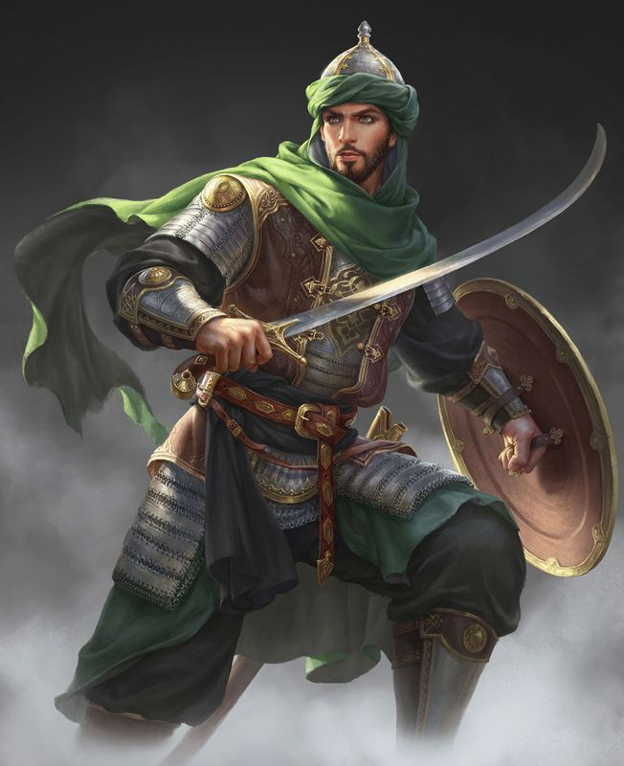

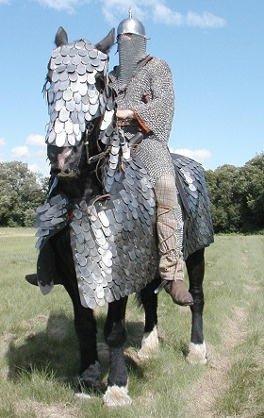
Cataphract, complete with a full set of scale armor for the horse. The rider is covered by extensive mail armor.
A cataphract was a form of armored heavy cavalry that originated in Persia and was fielded in ancient warfare throughout Eurasia and Northern Africa.
Historically, the cataphract was a very heavily armored horseman, with both the rider and mount almost completely covered in scale or lamellar armor over chain mail, and typically wielding a kontos (lance) as his primary weapon.
Cataphracts served as the elite cavalry force for most empires and nations that fielded them, primarily used for charges to break through opposing heavy cavalry and infantry formations.

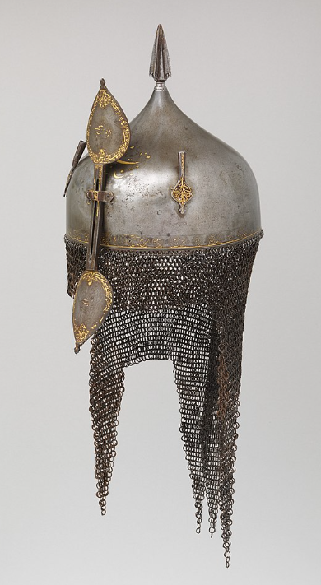
Khula Khud helmets are worn my captains and mounted officers in the Tarbian armies. They are also worn in Mahabar and Hyderis. Made of steel, these bowl-shaped helmets are designed as either low and flat, or high and pointed. They sometimes contain a spike socket at the top of the helmet, which resembles a spearhead with a cross-like section. Two or three plume holders are attached on either side of the skull, used to mount feathers from birds such as the egret.
The helmet has an iron-and-brass or brass-and-copper aventail that hangs at the base of the helmet to protect the neck, shoulders and the temple of the face. Sometimes, the aventail extends down to cover the eyes and the nose. The low end of the aventail is often shaped in a zig-zag triangular pattern (vandyked).
A bar made of iron or steel is attached to the front of the helmet with a bracket and can be adjusted in position - so when not in use, it can slide upward and fasten with a link, a hook, or a set screw. The two ends of the bar expand into leaf-shaped plates, forming a final. In some Khula Khud helmets the lower end of the bar is designed as a large crescent-shaped metal guard that protects most of the face below the eye level.
Despite the similarity in their design, the Khula Khud helmets are decorated with a wide degree of variations depending on the tribes or regions from which they were created. Decorations often appear in the skull and the nasal bar, which are often heavily decorated with patterned motifs of inlaid brass, silver or gold; or decorated with figurative images.
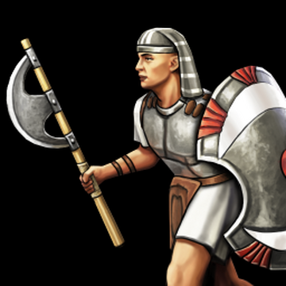
Ebon Epsilon Axe

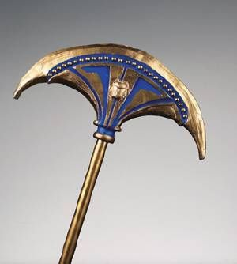 Palm Axe

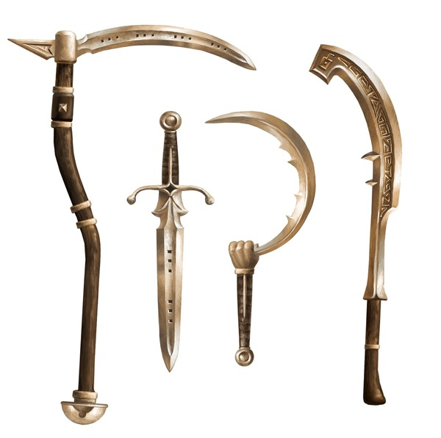
Scythe, sword, sickle, khopesh
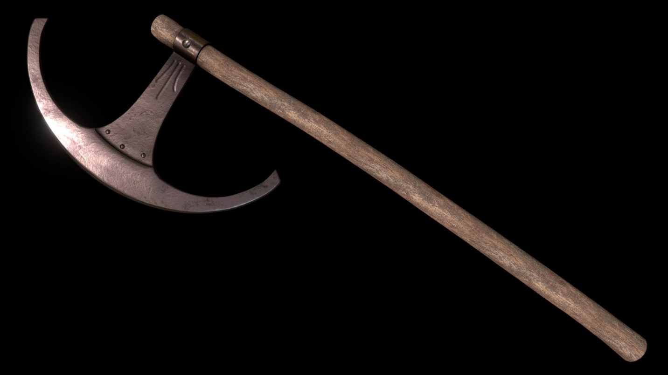
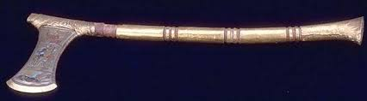

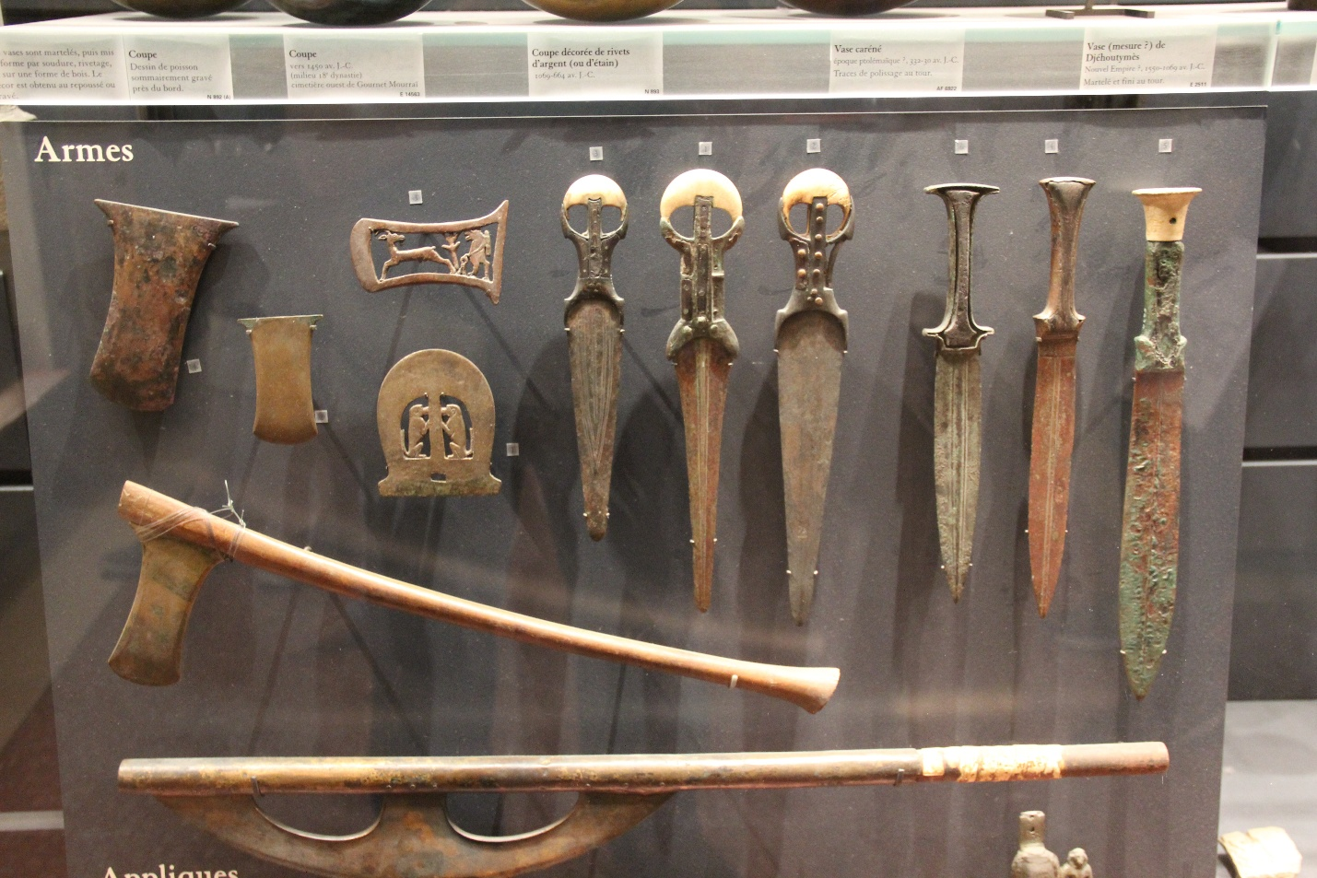

Local Deities

Tarbians worship the old gods of the Ebonene. Thousands of years ago the gods walked freely among the people, accepting offerings and overseeing the blossoming of civilization. Today a desperate war is being fought for the soul of the desert lands. The evil god Set, ruler of the desert, relentlessly attacks the invisible realms of the other gods while sending his agents into the cities to corrupt the spirits of their followers. Shrines and temples still stand to each of the gods in the seven cities, but each city has one grand temple dedicated to their patron god or goddess. Some say there are ancient temples out in the wastes that date back to the Ebonene times, their dusty halls still holding hidden magic.

The Patron Deities
Sobek, god of cunning and of protection on the waters. Patron deity of Darmidia.
Aten, god of the setting sun and the creator. Patron deity of Hafzara.
Seker, god of craftsmen as well as having power over resurrection. Patron deity of Qadimar.
Sekhmet, warrior goddess as well as goddess of healing. Patron deity of Tijara.
Pakhet, goddess of hunting and of childbirth. Patron deity of Qasrath.
Khepri, god of the rising sun, of renewal and rebirth. Patron deity of Asharaat.
Thoth, god of magic, writing, science, and judgment of the dead. Patron deity of Ankhtiri.

Other Deities that dwell in Tarbia:
- Geb and Nut – god of the earth and goddess of the sky
- Serquet – goddess of scorpions and poison; chaotic neutral
- Nephthys – goddess of the rivers; good
- Bast – goddess of luck, protection; good
- Set - The god of the desert, storms; evil
- Apep – ancient Egyptian deity who embodied chaos (ı͗zft in Egyptian) and was thus the opponent of light and Ma'at (order/truth). He appears in art as a giant serpent.; evil

Tarbian Deities
- Ra - The god of the sun, Ra was the first pharaoh of the world, back in the days when gods inhabited Egypt. Each day, Ra’s golden sun ship would sail across the sky, and each night it would travel through the underground world of the Duat, sailing the River of Darkness, and fighting off monsters. The Egyptians celebrated each sunrise, when Ra emerged victorious again and caused a new day to begin. After many centuries, Ra became old and senile, and retreated into the heavens, giving up his throne to Osiris.

- Geb - The god of the earth, Geb was one of the first gods to appear from the sea of chaos at the beginning of time. He appears as a man made of earth, with rivers, forests and hills across his entire body.

- Nut - was Geb's wife, the goddess of the sky. Yes, we know she’s got a funny name, but she was not the goddess of peanuts. She appeared as a woman with skin like a starry sky, dark blue and covered in constellations. She is often pictured stretching over Geb, as the sky stretches over the earth.
Although Geb and Nut loved each other very much, Ra had a prophecy that their children would try to overthrow him someday, so Ra did his best to keep them apart. Despite this, Nut managed to have five children, and the oldest, Osiris, did indeed take over the throne from Ra.

- Shu - Nut’s father, the god of the air, was given the job of keeping Nut and Geb apart. This is why the sky is so far above the earth. The god of the wind stays between them, keeping his daughter from visiting her love the earth. Shu is usually not pictured, because he is invisible like the wind.

- Osiris - The first son of Geb and Nut, Osiris was a wise and good pharaoh when he took over the world from Ra. Osiris taught man about farming, and created the first cities in Egypt. Unfortunately, Osiris’s brother Set was jealous of him. Set tricked him into laying down in a golden coffin, then sealed the coffin and cut it into pieces. Set scattered the pieces all over Egypt, and Osiris’s wife Isis spent years searching for them. Eventually, Isis put her husband back together, binding him in cloth to make the first mummy, but Osiris only came partially back to life. After that, he was the god of the underworld, sitting in judgment over the souls of the dead. He appears as a king with blue skin and white robes.

- Isis - Osiris’s wife was the goddess of magic, and clever and ambitious woman. She tricked Ra into retiring by poisoning him with a magic snake, then encouraging the old sun god to reveal his secret name so Isis could cure him. Once Isis knew Ra’s secret name, she could force him to do just about anything. She encouraged him to retreat into the sky, opening the throne for Osiris. Isis was the patron of magicians, and loved her husband very much. She encouraged their son Horus to take vengeance on the evil Set, who had killed Osiris. Isis is often pictured as a beautiful woman with multicolored wings.

- Set - The god of the desert, storms, and evil, Set was one mean dude. His color was red, the color of sterile soil and the desert. Set was the strongest of the gods, and very tricky. He became pharaoh of Egypt after killing his brother, but was later overthrown by his nephew Horus. After that, Set fled into the desert, where he controlled all the evil harsh lands outside the Nile Valley. Set wasn’t all bad, however. In the old days, he sailed on Ra’s boat and helped defend the sun god from the armies of the chaos serpent Apep. Set is usually pictured with red skin and the head of an unknown animal demon – part dog, part anteater, all ugly

- Nephthys - The river goddess, wife of Set and the sister of Isis. Nephthys didn’t like her husband very much, because after he killed Osiris, Nephthys helped Isis collected his pieces and bind them together. She was a kind and gentle goddess, and mother of Anubis, the god of funeral rites.

- Horus - Called the Avenger, Horus was the son of Isis and Osiris. When he grew to manhood, he challenged Set and eventually defeated him, becoming the new pharaoh of Egypt. Afterwards, all mortal pharaohs considered themselves to be the descendants of Horus. Horus’s symbol was the falcon, and he is often pictured as a man with a falcon’s head.

- Bast - Cats were extremely popular in Egypt, because they could kill snakes, scorpions, and other nasty creatures. Bast, the goddess of cats, was just as popular. Bast was a protective goddess, and people would wear amulets with her likeness for good luck, especially during the bad luck Demon Days at the end of each year. In cat form, Bast is often pictured with a knife, fighting the chaos serpent Apep. She was Ra’s faithful cat.

- Sobek - The god of crocodiles was both respected and feared. Crocodiles were strong creatures. In ancient Egypt, an entire city was named after them: Crocodilopolis, and Sobek had a temple with a lake full of crocodiles. However, crocodiles were fearsome predators, and many Egyptians were killed each year if they got too near the river. Sobek was pictured as a crocodile-headed man. His sweat was said to have created the rivers of the world. Yuck!

- Serquet - The goddess of scorpions was both good and bad. She could send scorpions after her enemies, and a single scorpion bite could kill you. On the other hand, you could pray to Serqet for protection from poison, and sometimes she was seen as a guardian of children. She was pictured as a woman with a giant scorpion for a crown.

- Anubis - Anubis the god of funerals was one of the most important gods, because he helped prepare the soul for the Afterlife and escorted the dead to the hall of judgment. The Egyptians noticed jackals hanging around their graveyards, so they decided jackals must be Anubis’s sacred animals. Priests even wore jackal masks when they made the pharaoh’s body into a mummy. Anubis helped Isis make Osiris into the first mummy. Anubis is usually pictured as a man with a jackal’s head, leading a departed spirit through the Duat.

- Bes is god of dwarves, protector of households, mothers and children. One of the ugliest and most popular gods in Ancient Egypt, Bes had the power to scare off evil spirits. He often appeared on amulets and in sculpture as a hairy little man with a lion-like mane and a pug nose. Egyptians believed that dwarves (and other people who were born different) were inherently magical. Bes was considered extremely good luck. He watched over the common man, children, women in childbirth, and anyone else who needed protection from evil.

- Apep - ancient Egyptian deity who embodied chaos (ı͗zft in Egyptian) and was thus the opponent of light and Ma'at (order/truth). He appears in art as a giant serpent.

- Ma’at - ancient Egyptian goddess of truth, justice, harmony, and balance (a concept known as ma'at in Egyptian). She appears as a winged woman, often with an ostrich feather on her head, or simply as a white ostrich feather. The feather of Ma'at is an integral part of the Weighing of the Heart of the Soul ceremony in the afterlife where the heart of the soul of the dead person was weighed in the scales of justice against the feather.

Creatures

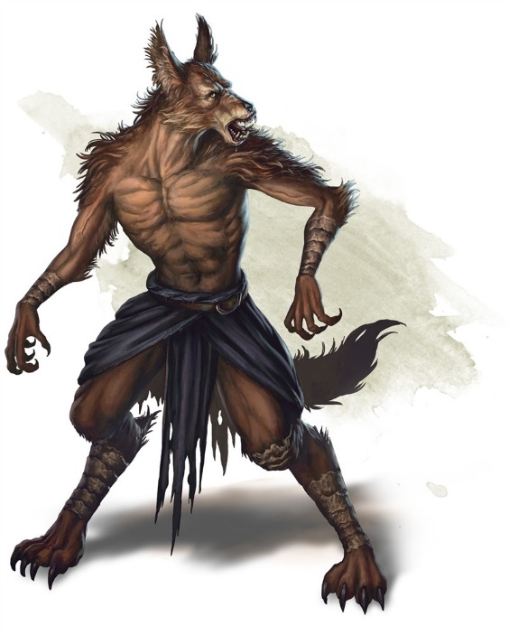
Jackalwere
Medium humanoid (shapechanger), chaotic evil
Armor Class 12
Hit Points 18 (4d8)
Speed 40 ft.
STR 11 (+0) DEX 15 (+2) CON 11 (+0) INT 13 (+1) WIS 11 (+0) CHA 10 (+0)
Skills Deception +4, Perception +2, Stealth +4
Immunities bludgeoning, piercing, and slashing damage from nonmagical attacks that aren't silvered
Senses passive Perception 12
Languages Common (can't speak in jackal form)
Challenge 1/2 (100 XP)
Shapechanger. The jackalwere can use its action to polymorph into a specific Medium human or a jackal-humanoid hybrid, or back into its true form (that of a Small jackal). Other than its size, its statistics are the same in each form. Any equipment it is wearing or carrying isn't transformed. It reverts to its true form if it dies.

Keen Hearing and Smell. The jackalwere has advantage on Wisdom (Perception) checks that rely on hearing or smell.

Pack Tactics. The jackalwere has advantage on an attack roll against a creature if at least one of the jackalwere's allies is within 5 feet of the creature and the ally isn't incapacitated.

Actions
Bite (Jackal or Hybrid Form Only). Melee Weapon Attack: +4 to hit, reach 5 ft., one target. Hit: 4 (1d4 + 2) piercing damage.

Scimitar (Human or Hybrid Form Only). Melee Weapon Attack: +4 to hit, reach 5 ft., one target. Hit: 5 (1d6 + 2) slashing damage.

Sleep Gaze. The jackalwere gazes at one creature it can see within 30 feet of it. The target must make a DC 10 Wisdom saving throw. On a failed save, the target succumbs to a magical slumber, falling unconscious for 10 minutes or until someone uses an action to shake the target awake. A creature that successfully saves against the effect is immune to this jackalwere's gaze for the next 24 hours. Undead and creatures immune to being charmed aren't affected by it.

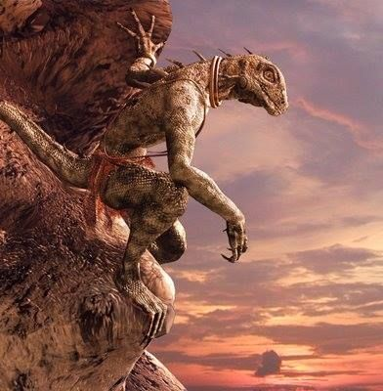
Saurians (lizardfolk)
Size/Type: Medium Humanoid (Reptilian)
Hit Dice: 2d8+2 (11 hp)
Initiative: +0
Speed: 30 ft. (6 squares)
Armor Class: 15 (+5 natural), or 17 (+5 natural, +2 heavy shield), touch 10, flat-footed 15 or 17
Base Attack/Grapple: +1/+2
Attack: Claw +2 melee (1d4+1) or club +2 melee (1d6+1) or javelin +1 ranged (1d6+1)
Full Attack: 2 claws +2 melee (1d4+1) and bite +0 melee (1d4); or club +2 melee (1d6+1) and bite +0 melee (1d4); or javelin +1 ranged (1d6+1)
Space/Reach: 5 ft./5 ft.
Special Attacks: —
Special Qualities: Hold breath
Saves: Fort +1, Ref +3, Will +0
Abilities: Str 13, Dex 10, Con 13, Int 9, Wis 10, Cha 10
Skills: Balance +4, Jump +5, Swim +2
Feats: Multiattack
Environment: Temperate marshes
Organization: Gang (2-3), band (6-10 plus 50% noncombatants plus 1 leader of 3rd-6th level), or tribe (30-60 plus 2 lieutenants of 3rd-6th level and 1 leader of 4th-10th level)
Challenge Rating: 1
Treasure: 50% coins; 50% goods; 50% items
Alignment: Usually neutral
Advancement: By character class
Level Adjustment: +1
A saurian is usually 6 to 7 feet tall with green, gray, or brown scales. Its tail is used for balance and is 3 to 4 feet long. A saurian can weigh from 200 to 250 pounds. Saurian speak Draconic.

Combat
Saurian fight as unorganized individuals. They prefer frontal assaults and massed rushes, sometimes trying to force foes into the water, where the saurian have an advantage. If outnumbered or if their territory is being invaded, they set snares, plan ambushes, and make raids to hinder enemy supplies. Advanced tribes use more sophisticated tactics and have better traps and ambushes.

Hold Breath
A saurian can hold its breath for a number of rounds equal to four times its Constitution score before it risks drowning.

Skills
Because of their tails, saurian have a +4 racial bonus on Jump, Swim, and Balance checks. The skill modifiers given in the statistics block include a -2 armor check penalty (-4 on Swim checks) for carrying a heavy shield.

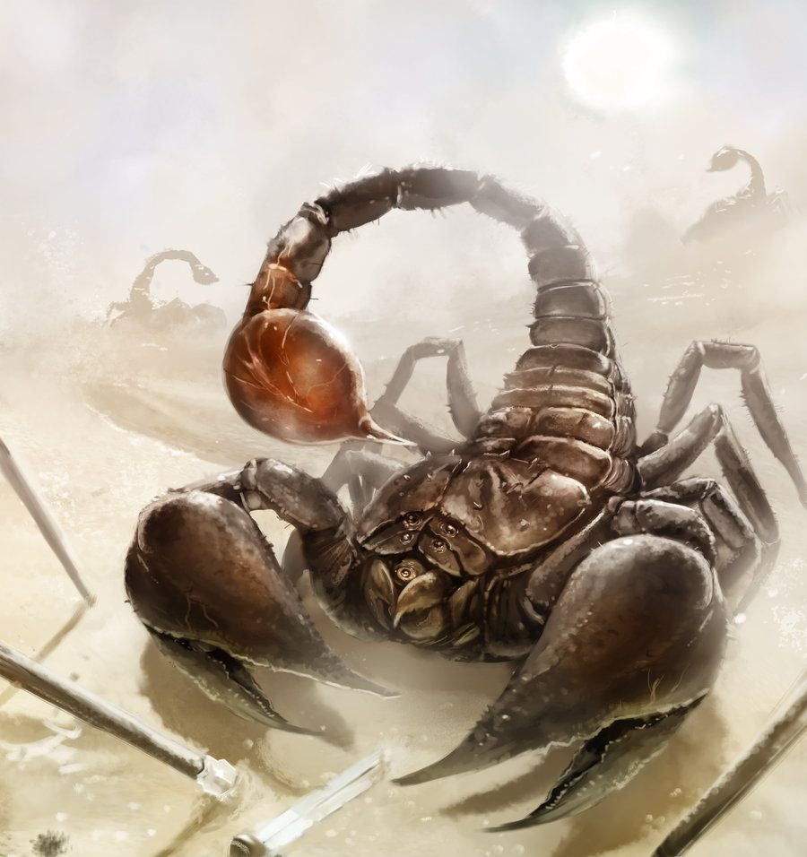
Giant Scorpion
Large beast, unaligned
Armor Class 15 (Natural Armor)
Hit Points 52 (7d10+14)
Speed 40 ft.
STR
15 (+2) DEX 13 (+1) CON 15 (+2) INT (-5) WIS 9 (-1) CHA 3 (-4)
Senses Blindsight 60 Ft., passive Perception 9
Challenge 3 (700 XP)
Actions
Claw. Melee Weapon Attack: +4 to hit, reach 5 ft., one target. Hit: (1d8 + 2) bludgeoning damage. The target is grappled (Escape DC 12) The scorpion has two claws, each of which can grapple only one target
Multiattack. The scorpion makes three attacks: two with its claws and one with its sting.
Sting. Melee Weapon Attack: +4 to hit, reach 5 ft., one creature. Hit: (1d10 + 2) piercing damage. The target must make a DC 12 Constitution saving throw, taking 22 (4d10) poison damage on a failed save, or half as much damage on a successful one.

The sands around Asharaat are infested with large scorpions. It is said that their mother is a gargantuan scorpion named Ishra who commands them from her underground lair. Ishra is mentioned many times in legends, having plagued the Tarbian sands millennia ago with her army of scorpions.

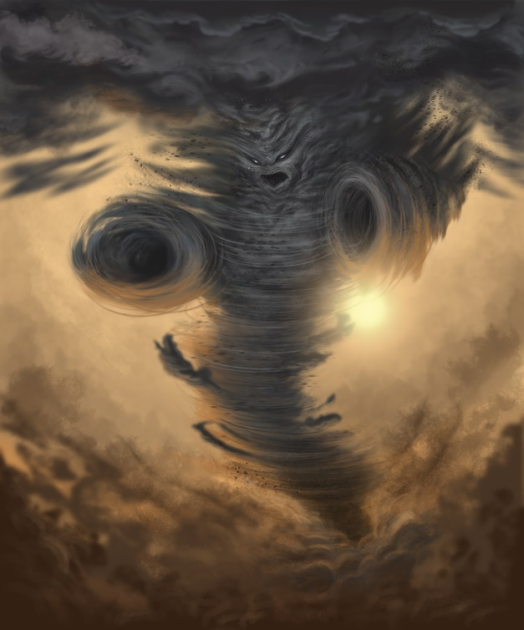
Air Elemental – Air elementals are known to roam the open desert, feeding off the Sirocco, the hot desert wind that blows northward across the Tarbian desert. Some say these creatures were unleashed during the Cataclysm of Mahrutep. Many sandstorms that rage unexpectedly in the deserts are thought to be the work of these elemental marauders.

Large Air Elemental
Size/Type: Large Elemental (Air)
Hit Dice: 8d8+24 (60 hp)
Initiative: +11 (+7 Dex, +4 Improved Initiative)
Speed: Fly 100 ft. (perfect)
AC: 20 (-1 size, +7 Dex, +4 natural)
Attacks: Slam +12/+7 melee
Damage: Slam 2d6+3
Face/Reach: 5 ft. by 5 ft./10 ft.
Special Attacks: Air mastery, whirlwind
Special Qualities: Elemental, damage reduction 10/+1
Saves: Fort +5, Ref +13, Will +2
Abilities: Str 14, Dex 25, Con 16, Int 6, Wis 11, Cha 11
Skills: Listen +10, Spot +10
Feats: Dodge, Flyby Attack, Improved Initiative, Weapon Finesse (slam)
Climate/Terrain: Any land and underground
Organization: Solitary
Challenge Rating: 5
Treasure: None
Alignment: Usually neutral
Advancement: 9-15 HD (Large)

Combat
Elemental: Immune to poison, sleep, paralysis, and stunning. Not subject to critical hits.

Air Mastery (Ex): Airborne creatures suffer a -1 penalty to attack and damage rolls against an air elemental.

Whirlwind (Su): The elemental can transform itself into a whirlwind once every 10 minutes and remain in that form for up to 1 round for every 2 HD it has. In this form, the elemental can move through the air or along a surface at its fly speed.

The whirlwind is 5 feet wide at the base, up to 30 feet wide at the top, and up to 50 feet tall, depending on the elemental’s size. The elemental controls the exact height, but it must be at least 10 feet.

Creatures one or more sizes smaller than the elemental might take damage when caught in the whirlwind (see the following table for details) and may be lifted into the air. An affected creature must succeed at a Reflex save when it comes into contact with the whirlwind or take the listed damage. It must also succeed at a second Reflex save or be picked up bodily and held suspended in the powerful winds, automatically taking the listed damage each round. A creature that can fly is allowed a Reflex save each round to escape the whirlwind. The creature still takes damage but can leave if the save is successful. The DC for saves against the whirlwind’s effects varies with the elemental’s size.

The elemental can eject any carried creatures whenever it wishes, depositing them wherever the whirlwind happens to be. A summoned elemental always ejects trapped creatures before returning to its home plane.

If the whirlwind’s base touches the ground, it creates a swirling cloud of debris. This cloud is centered on the elemental and has a diameter equal to half the whirlwind’s height. The cloud obscures all vision, including darkvision, beyond 5 feet. Creatures 5 feet away have one-half concealment, while those farther away have total concealment. Those caught in the cloud must succeed at a Concentration check to cast a spell (DC equal to the Reflex save DC).

—––—— Air Elemental Size ——––— —––—— Whirlwind ——––—
Elemental Height Weight Save DC Damage Height
Large 16 ft. 4 lbs. 16 2d6 10-40 ft.

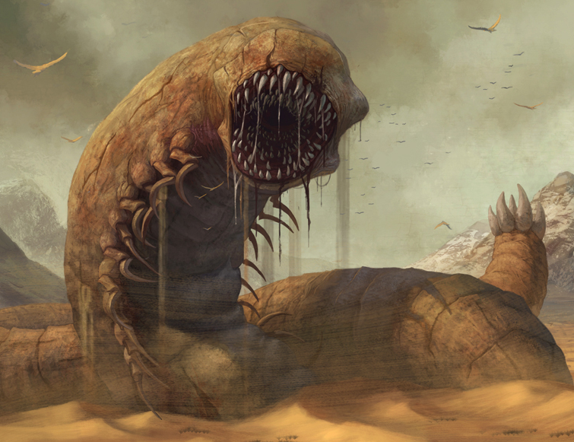
Sandworm
Gargantuan monstrosity, unaligned
Armor Class 18 (natural armor)
Hit Points 201 (13d20 + 65)
Speed 40 ft., burrow 30 ft.
STR DEX CON INT WIS CHA
20 (+5) 15 (+2) 20 (+5) 3 (-4) 9 (-1) 5 (-3)
Saving Throws Str +9, Con +9
Skills Intimidation +5
Damage Vulnerabilities necrotic, thunder
Damage Resistances fire; bludgeoning, piercing, and slashing from nonmagical attacks
Damage Immunities poison
Condition Immunities blinded, poisoned
Senses blindsight 120 ft. (blind beyond this radius), tremorsense 60 ft., passive Perception 9
Languages Terran
Challenge 9 (5,000 XP)
Tunneler. The sandworm can burrow through solid rock at half its burrow speed and leaves a 10-foot-diameter tunnel in its wake that lasts for 1d4 hours before collapsing.
ACTIONS
Multiattack. The sandworm makes two attacks.
Bite. Melee Weapon Attack: +9 to hit, reach 15 ft., one target. Hit: 16 (2d10 + 5) piercing damage.
Slam. Melee Weapon Attack: +9 to hit, reach 30 ft., one target. Hit: 18 (3d8 + 5) bludgeoning damage. If the target is a creature, it must succeed on a DC 15 Strength saving throw or be knocked prone.

The sandworm, a creature of varying size and lethality that is only found in the deserts of the world and in the lair of the sandworm king. they move around the desert either above ground leaving a trench or by burrowing and creating a "wave" of sand. The shortest sandworm is half a mile long and at least 15 feet in diameter. The longest sandworm is two miles long and 40 feet in diameter.

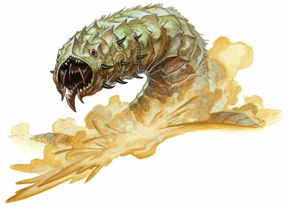
Dunewinder
CR 10 N Magical Beast
This mighty creature looks something like an elephant-sized grub. Its body is covered in bristles and flaps, some of which seem to push it along and others seemingly more offensive in nature. Its maw is filled with multiple saw-like rows of teeth, each moving independently.
Dunewinders are desert relatives of frost worms. Like them, they are infused with elemental power, in this case, that of fire. They live as ambush predators of sandy wastes, and can survive a long time between meals. As such, when food is available they are ravenous, and often consume huge amounts of meat at a time. Their gullets are relatively small, so they cannot swallow prey whole. Instead, they grab it, pull it next to their barbed skin, and shred it into manageable chunks. The spines of a dunewinder ooze sticky green venom that causes blood to clot in place. When slain, the internal fires within the creature erupt, causing the dunewinder to explode in a shower of super-heated blood and venomous spines.
Dunewinders spend most of their lives beneath the ground, feeling vibrations in order to detect prey. If they need to travel quickly, they dig their way to the surface and move in a serpentine fashion like a sidewinder snake, resulting in characteristic tracks. They only come together in order to mate, which is done in a perfunctory fashion. Dunewinders are simultaneous hermaphrodites, and both partners typically impregnate the other. Eggs are laid in a leathery cocoon deep beneath the ground and abandoned. Dunewinders have few predators except each other, and cannibalism is a common source of mortality for dunewinder young.
Dunewinder CR 10
XP 9,600
N Huge magical beast (fire)
Init +6; Senses darkvision 60 ft., Perception +10, tremorsense 60 ft.
Defense
AC 24, touch 10, flat-footed 22 (-2 size, +2 Dex, +14 natural)
hp 126 (12d10+60)
Fort +13, Ref +10, Will +8
Immune fire, poison
Defensive Abilities barbed defense; Weakness vulnerable to cold
Offense
Speed 50 ft., burrow 20 ft.
Melee bite +18 (2d6+12 plus grab)
Space 15 ft.; Reach 10 ft.
Special Abilities breath weapon (12d6 fire, 60 ft. line, Ref DC 21, 1/hour), constrict (2d6+12 bludgeoning and piercing plus poison), death throes
Statistics
Str 27, Dex 17, Con 21, Int 2, Wis 14, Cha 10
Base Atk +12; CMB +22 (+24 bull rush, +26 grapple); CMD 34 (36 vs. bull rush, cannot be tripped)
Feats Awesome Blow, Improved Bull Rush, Improved Initiative, Iron Will, Power Attack, Vital Strike
Skills Perception +10, Stealth +4 (+12 in deserts); Racial Modifiers +8 Stealth in deserts
SQ dune winding
Ecology
Environment warm deserts
Organization solitary
Treasure incidental
Special Abilities
Barbed Defense (Ex) A creature striking a dunewinder with a natural weapon, unarmed strike, touch attack or melee weapon attack must succeed a DC 18 Reflex save or take 1d6+4 points of piercing damage and be exposed to the creature’s poison. Melee weapons with the reach property do not endanger their wielder in this way. The save DC is Dexterity based.
Death Throes (Su) When a dunewinder is killed, it explodes, dealing 6d6 points of piercing damage and 6d6 points of fire damage to all creatures in a 60 foot radius (Reflex DC 21 halves). A creature that takes any damage from this is also exposed to the dunewinder’s poison. The save DC is Constitution based.
Dune Winding (Ex) A dunewinder does not treat any form of sand as difficult terrain.
Poison (Ex) Barbed defense or constrict—injury; save Fort DC 21; duration 1/round for 4 rounds; effect 1d4 Con damage; cure 2 saves. The save DC is Constitution based.

Desert Centipede
CR 7
Chaotic (any) Huge Animal
Init/Senses +2/Listen +5, Spot +5
AC 18 (-2 size, +2 Dex, +8 nautral), touch 10, flat-footed 16
hp 52 (6d8 + 5 HD)
Fort/Ref/Will +5/+2/+0
Speed 60 ft.
Melee Charge (4d6 + 7) or
Melee Bite (2d8 + 7 + 1d6 poison)
Base Atk/Grp +6/+7
Abilities Str 25, Dex 15, Con 20, Int 2, Wis 10, Cha 2
Advancement —
Strategies and Tactics
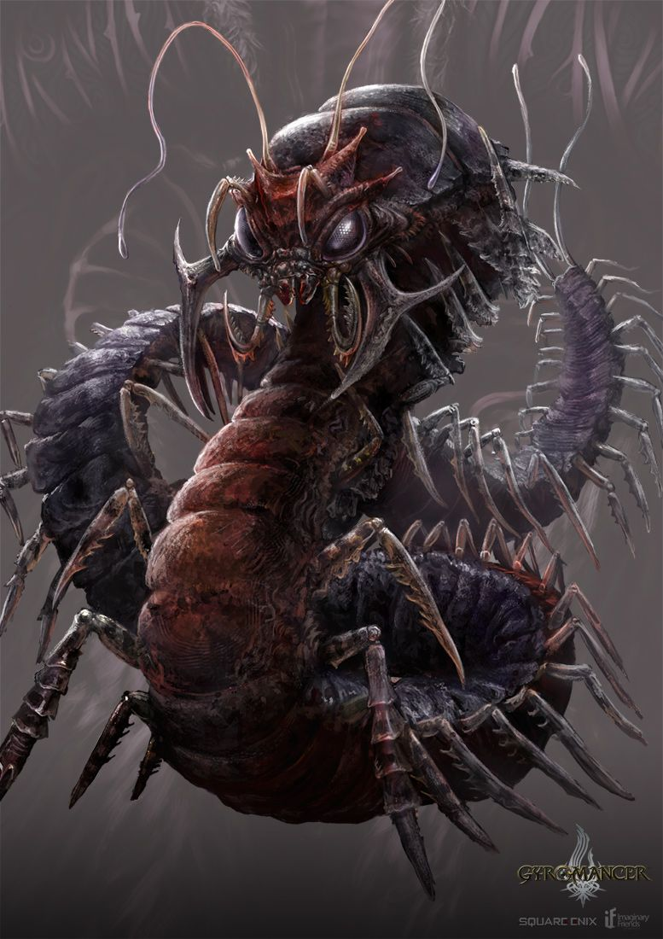
This creature charges across the desert sands, its well-trained feet easily staying sturdy in the sand. It will attempt to barge you over with a stab of its powerful horns.

Ecology This creature lives in an almost harmonious relationship with the Desert Worm, which digs tunnels under the sand for the Desert Centipede to chase victims into.

Environment Typical Desert Centipedes live in desert or extreme dry areas, and can survive on very little water.

Typical Physical Characteristics: Having moved from forestry long ago, these creatures have evolved to better fit their new environment. You would hardly know that they were related to their Monstrous brethren. Their segments have lessened, for speed. Their armor has hardened, to protect them from the harsh sandstorms. Their eyes glow a yellow, and are able to see in the dark, as to better locate prey. Their eyes are also covered with a protective film, to stop sand from blinding them. They lost all of their legs except for four. These legs are incredibly muscular, perfect for balance and charging. Two large horns face forward. They are sharp and perfect for charging. Their scales now range from browny-yellow to a deep red, as to better camouflage in the desert sands. They havea long, arching neck with spikes running up it, and a small tail, both for balance.

Alignment: Desert Centipedes are always chaotic, and they can be nurtured to be either good or evil.

Lore Desert dwelling townsfolk warn of the Desert Centipede, but say if trained properly, it can be a fantastic companion.

Society None.

Sample Lair Traditionally, Desert Centipedes live in shielded areas, such as caves or under cliffs.

Typical Treasure Desert Centipedes often have a lot of loot around their lairs, but most of it is mundane loot from their prey.

For Player Characters
Desert Centipedes are tame able by slowly gaining their trust over a series of days, feeding them, and then finally succeeding a handle animal check of 25.

Epic Creatures

Ekkidon - In 550 PA3 a clumsy mage summoned the great Ekkidon, a gargantuan starfish from the plane of water; the creature destroyed everything in Jackal Bay and made it its home. The waters of the bay are fraught with danger, as the Ekkidon attacks randomly anything that enters its domain.

Ishra - The sands around Asharaat are infested with large scorpions. It is said that their mother is a gargantuan scorpion named Ishra who commands them from her underground lair. Ishra is mentioned many times in legends, having plagued the Tarbian sands millennia ago with her army of scorpions.

Kraken – inhabits Jackal Bay, destroying everything that passes through these waters

Genie
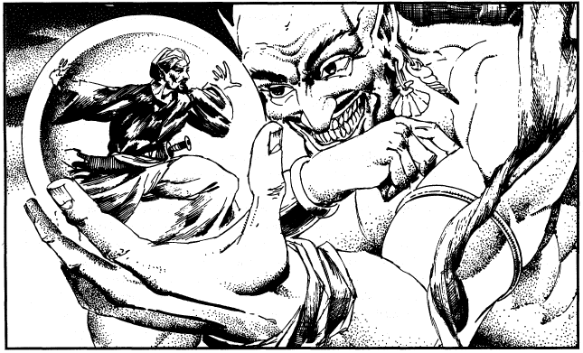

Types of Genies
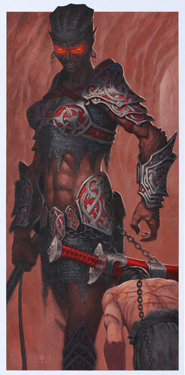
Dao - These genies are from the Elemental Plane of earth. The greatest of the Dao is Raesha, whose name means “tremor” in the old tongue. She is the Mountain Breaker and ruler of the deserts just east of the Tauran Mountains. She oversees a vast cavernous network beneath the Taurans, mining gems and precious metals. Any who venture this way would do well to offer tribute to Raesha or be enslaved to work her mines. It is said that she built the mighty walls of Ankhtiri at the dawn of history. Raesha has little to do with other genies, but is paid handsomely by Hariq the Terrible for raw materials for his own machinations.

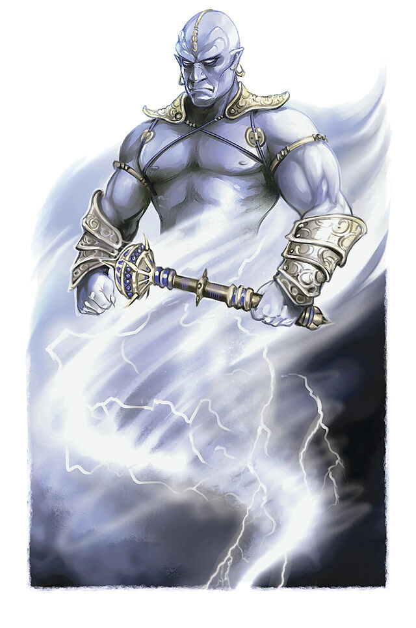
Djinn - Genies from the Elemental Plane of Air. The greatest of these is Rishadidar (“Mighty Wind”), who rules out of the southern Tarbian desert. He is a merry ruler, vain and fond of treasure and always ready to receive gifts and flattery from humans who seek him out. Some caravans go out of their way to seek his invisible palace, but the way is fraught with danger. He is also master of The Sirocco, the great hot winds that blow north across the Tarbian wastes and into the Ferrago Sea. Rishadidar is friendly with Jasra the Marid Queen, but the two have a stormy relationship. Once every decade or so a terrible hurricane will rise up in the region, sign of the two having a quarrel or passionately making up from one.

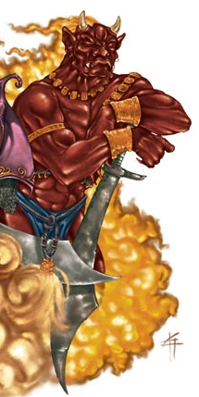
Efreet - Coming from the Elemental Plane of Fire, these genies are said to be made of basalt, bronze and congealed flames. Greatest of these is Hariq the Terrible, a cruel and powerful master who relishes the heat of the deserts and is known to stoke the plains to even greater temperatures. He rules from a subterranean fissure deep beneath the surface, tormenting humans and enslaving any who pass this way. He is also credited with bolstering The Sirocco, the great hot winds that blow north across the Tarbian wastes and into the Ferrago Sea.

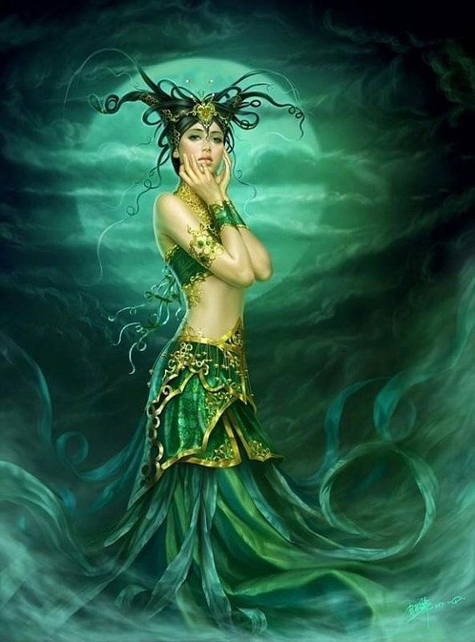
Marids - Genies are from the Elemental Plane of Water. The greatest of these in Nemmyrl is the dreaded Jasra Aiesar (“Jasra of the Hurricanes”), self-styled queen of the southern seas. From her city Qasr Almarjaan, the Coral Palace, Jasra hunts the southern oceans for sport, capturing prizes of ships, treasure, and even humans to serve her. She finds the Great Maelstrom intoxicating as well as terrorizing those foolish enough to sail that way. She is friendly with Rishadidar lord of the Djinn, but their passions run hot and cold and on occasion cause great storms to form in southern Tarbia.

Jann – the weakest of genies, they usually appear in the form of humans on the material plane but still have magical powers

Qareen - It is said that the Qareen visit the city of Hafzara regularly. Spiritual figures that resemble humans, they accompany certain people they choose with either benevolent or evil designs.

Shadhavar - It is rumored that in the outlands around Asharaat dwell the mystical beasts the Shadhavar. These resemble white stallions with a single horn, much like unicorns. Unlike the unicorn, the Shadhavar’s horn has hollow branches which, when the wind passes through them, produce a pleasant sound that induces animals to kneel and listen. Horns of these creatures, sometimes gifted to kings, can be played on like flutes. When played on one side, they produce a cheerful sound, and when the other, the music is so sad it makes people cry. Others say these are in fact the Sirânis, a close cousin to the Shadhavar that resembles a white stallion. When it plays music, it is to lure its victims within reach and then impale and consume them.

The Eyes of Bast - It is said that every visitor to Tijara is chosen by one of the many thousands of cats, which will follow the traveler unseen and evaluate their hearts and deeds. On occasion if a traveler is deemed a worthy soul, the cat may make itself visible to him or her and offer aide or speak with them. It is said that they will even heal wounds with a lick of their tongue, if allowed. The cats serve as Bast’s eyes and ears, gathering information and delivering messages.

Ruh Yurshad – There is a mysterious stranger who wanders the deserts, appearing as a simple man on a camel or sometimes other mounts. Travelers have spoken of meeting this man, who never speaks his name but is known as the Spirit Guide. He appears mostly to those who are lost on the open dunes, offering them help and sometimes wisdom. The Wadi Alqamar in the east is said to be his haunt and he has been seen there many times over the centuries.

Kahrabar Lizards - known in other lands as shock lizards, they are common to the region of the Sea of Sinking Sands. The lizards are light enough to skitter across the sands safely. However, they pose an additional danger to travelers coming this way.

Aarakocra

Wight

Thri-Kreen – insectoid race of humanoids

Dragon, Blue - Blue dragons are vain, deadly, territorial and an enormous threat to any desert caravan or nomadic tribe. These dragons can attack from the air or from under the sand. A blue dragon’s liar should be easy to find by looking for a raging thunderstorm in the desert.

Dragon, Brass -

Earth Elemental - Like a walking hill, an earth elemental can glide through rock, earth or sand like liquid. A group traveling through the desert would be easy for an earth elemental to pinpoint and surprise attack.

Lamia -

Mummy -

Mummy Lord -

Adamantine Golem

Addazahr

Androsphinx

Axe beaks

Behir –

Criosphinxes - were a type of ram-headed sphinx that enjoyed extorting tolls from travelers, as they found wealth extremely attractive

Desert centaurs were nomads inhabiting the vast deserts. They often executed raids on bandit camps, using their speed and savage skills to their advantage. Desert centaurs were known to zealously protect their lands

Giant Lizard
Gynosphinx
Hairy Spider
Hieracosphinx
Jackal
Lamia
Lamia Noble
Lammasu
Sand Cat
Sand Golem
Sandman
Thri-kreen
Thornslinger
Thunderherder

Dendan – magical fish from Arabian Nights

Other Races
Elves

Dwarves

Magical Items

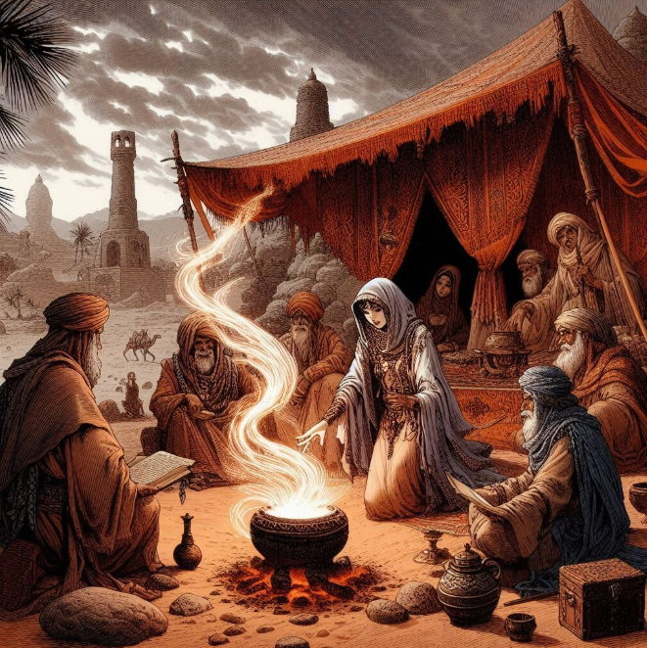

Medu-Djat "Words of the Eternal" – the first holy book written in 505 PA1 by Ramahatra, first high priest of the old gods in Ebon. It set down a code of laws used for the span of Ebon civilization.

Alabaster Ewers of Alhayaa – These are seven alabaster ewers containing waters from the divine springs beneath all seven cities. The springs were the miracle of the ancient gods when they first moved upon this land, allowing these cities to flourish in the wastelands. The Circle of the Seba, a partnership of astrologers from each city, foresaw the doom of Mahrutep. In 73 PA4 they collected the divine waters and stored them in the Temple of Dhakira in the Vale of Atia just as the Ebon cities were destroyed. The ewers were used in the reclamation of the Ebon cities by Mukarram the Righteous in the First Ancient Age. The ewers are housed in Dhakira today, watched over by the Bearer of the Waters, the title of the high priest of the temple.

Asp Amulet - a magic gem capable of influencing men’s minds as well as inflicting them with mental anguish.; worn by Sultan Hamad of Darmidia

Bracelets of Alhimaya - magical items handed down through each generation of the Abed family. They respond only to those of his bloodline and may never be taken off except by the one wearing them. While ones wears them he or she is protected against physical and magical attacks of every kind.

Eadala - Legendary sword of justice, worn by Malik Salloum of Qadimar

Dagger of Okerem - a magic dagger that us a sign of membership in the prestigious scholars’ society founded in Akhtiri.

Makhlab, also called Bright Claw, a powerful sword of legend that is said to have beheaded a dozen desert serpents. Worn by the malik of Tijara.

Eyes of Thoth – lenses that channel the favor of Thoth, the god of scholars, and gives the wearer great insight into anything they study; worn by the malik of Qasrath

Bracelet of Harba, a magic item that gives the wearer the ability to change his or her appearance, voice, and even scent upon command; currently worn by Malik Aly of Asharaat

Afeea Stone - The yellow stone called the Afeea is the size of a coin and is created exclusively by the mages of Qadimar in warding off the giant serpents in the area. These are not for sale but can be bought with service to Qadimar or on the black market for a high price.

The Canopic Jars of Numeret – These are four jars containing the remains of the Teremun, dark priest of the Underworld Altar from the first Primordial Age. Teremun formed a cult that sacrificed hundreds of innocent victims to the dark gods before the priests of the Sun Altar defeated him. His followers, the Cult of Numeret, retrieved his body and stored his organs in four jars to preserve his power (851 PA1). They were all lost during the great Cataclysm of Mahrutep in the Fourth Primordial Age. If found and reunited on the lost Underworld Altar, they can be used to wield incredible power. The four jars include:
- Numeret Jar of Imsety: decorated with a man’s head to preserve the liver; commands the power of air
- Numeret Jar of Duamatef: decorated with a jackal head to preserve the stomach; commands the power of earth
- Numeret Jar of Hapi: decorated with the head of the baboon to preserve the lungs; commands the power of water
- Numeret Jar of Qebehsenuf: decorated with the head of a falcon to preserve the intestines; commands the power of fire
The Mask of the Life River – an ancient artifact granted by the gods to the first high priest of the Ebon Empire. It is composed of two halves, each of which resembles a decorative eye. The two halves are the Eye of Wadjat and the Eye of Udjat. If joined together they grant the power to read men’s minds and even to see the future.
Underworld Altar – dark altar of the priests of the underworld, located in the Qasramaq underground city, lost during the Cataclysm of Mahrutep in PA4; commands the forces of darkness
Sun Altar – holy altar of the priests of the renewing life force, located in the Qasramaq underground city, lost during the Cataclysm of Mahrutep in PA4; commands the forces of heaven
Deshret Crown – ancient crown of the first king of the Badawi people
Hedjet Crown – ancient crown of the first king of the Almadina people
Pschent Crown – ancient crown of the first king of the Ebon Empire, Rakhamen, who united the Badawi and Fajar in 925 PA2
Sunduq Albahr – An ancient relic of the sea gods, this chest controls great powers of the deep. It is unpredictable, however, and extremely dangerous. In 34 AA3 the Alyaqut Syndicate attempted to wield the chest to summon destruction on the Amazons of Dymoneia. But the chest was lost in battle, causing the Kraken to turn on the Alyaqut and destroy the cities of Saqqara and Vyper.
Chalzedek Cartouche – enchanted nameplate sealing the tomb of the high priest Chalzedek, who was obsessed with remaining undisturbed even in death; broken in 300 PA3 by a thief robbing his tomb, unleashing a curse of insanity on the city of Qadimar; thousands riot, killing one another and spreading the curse to the other cities
Sistrum of Solace – holy musical instrument that Amuniris, princess of the Ebon Empire, played in every city along the Jeweled Road, removing the curse of madness on the people inflicted by the Chalzedek Cartouche
Cobra of Dooms - statue in the High Temple of the Gods in Ankhtiri; stands thirty feet tall with glittering rubies for eyes. It is said that the faithful may peer into its eyes and receive a vision of the future. Some are disturbed to find they are obligated by the Cobra with a quest for redemption. None may refuse the quest if commanded or suffer death.

The Eyes of Bast - It is said that every visitor to Tijara is chosen by one of the many thousands of cats, which will follow the traveler unseen and evaluate their hearts and deeds. On occasion if a traveler is deemed a worthy soul, the cat may make itself visible to him or her and offer aide or speak with them. It is said that they will even heal wounds with a lick of their tongue, if allowed. The cats serve as Bast’s eyes and ears, gathering information and delivering messages.

Sword of Alsalam - Nadeera slew the lich Amenset with the enchanted sword in 88 AA2; it is now enshrined in the hall of the Order of Alsalam in Qadimar

The Puzzle Boxes of Miska – Miska al-Zamani, a beguiling sorceress from Qadimar, created these puzzle boxes in the fourth Ancient Age and hid them in the many oases where she dwelt. Each box is made of finely wrought brass and covered in colorful jewels. They are almost impossible to open and dangerous to the unwary thief. Some are said to contain pocket dimensions the size of large palaces. One prize to be had are the Busla Scarabs, magical animated scarabs made of gold that can guide a person to wherever they desire. The scarabs are the size of a coin, but can fly and guide a person who holds one to wherever they command.

Busla Scarabs - magical animated scarabs made of gold that can guide a person to wherever they desire. The scarabs are the size of a coin, but can fly and guide a person who holds one to wherever they command.

Other items under development:
From the Doa: The Jinn of Earth
1) The Sands of Time
2) ???
3) ???

From the Djinni: The Jinn of Air
1) The Wind Catcher Bracelets (Sirocco)
2) The Haboob Staff (Sirocco)
3) The Magic Carpet of Prince Hussain (Sirocco)

From the Marid: The Jinn of Water
1) ???
2) ???
3) ???

From the Efreeti: The Jinn of Fire
1) Aladdin's Lamp (The Sultana)
2) Roxelana's Amulet (The Sultana)
3) ???

Lesser Treasures
1) The Fakir's Lariat (Samarkand)
2) Aladdin's Ring (The Sultana)

The Flying Horse of Adamant

The Doa:
3) The Jambiya of Fate: A rather plain looking and slightly rusty dagger with a worn scabbard; it makes it possible to alter or ensure Fate, ones-self or another's. (Alternatively, it can actually contact Fate on behalf of the bearer so they may influence Fate, one way or another.)

Marid:
1) Water Jar of Abundance (not quite what it sounds like--the holder of the jar can control the water level of local wells by how full of water he keeps the jar. A full jar yields productive wells. An empty one makes them dry up)
2) The Vizier's Pool (this stationary item allows transport from the Pool into any other body of water the user knows about: wells, fountains, oases, lakes, rivers, oceans, etc.)

The Lamp of the Tales (when lit, it produces a lot of smoke, which drifts into "illustrations" of what the speaker is saying; makes storytelling mesmerising of course, but can also be used to persuade, or to make enemies talk peacefully).

The Black Sword of 'Antar (actual item from folklore, believed to have been forged from meteoric iron; 'Antar was the slave turned poet-warrior who wielded it rather than its maker).

It's a long way pre-Islamic, but Middle Eastern: the Tablet of Destinies (just what it sounds like, a stone tablet with all the world's fates carved upon it; this is from Mesopotamian mythology).

Feather of the Simurgh (summons her; should generally only be used by legendary heroes).

The Talismanic Tunic of the Ninety-Nine Names of God, that gives protection to the righteous warrior:
http://www.metmuseum.org/toah/works-of-art/1998.199

The Ring of Ali al-Mawla, that banishes sorrow and anguish
http://www.metmuseum.org/toah/works-of-art/12.224.6

The Saber of Sultan Süleyman I, called the Magnificent, that gives wisdom to rulers as well as victory in battle
http://www.metmuseum.org/toah/works-of-art/36.25.1297

The Falnama, Qazvini Book of Omens, whose brilliant paintings have not faded over five centuries, and still give guidance to the righteous who gaze upon them (I would have the faces be subtly familiar, and the scenes adjust to give clues)
http://www.metmuseum.org/toah/works-of-art/35.64.3

The Standard of the Twelve Imams, that does something cool I haven't thought of ( :) )
http://www.metmuseum.org/toah/works-of-art/1984.504.2

Sahnshatan (Demon Bowl) - a special bowl used to catch demons. Inscribed inside the bowl is a long line of text that spirals inwards towards the center. A priest (magus) reads the text aloud to get the demon's attention, and when he reached the end in the middle of the bowl, he quickly covers it with a lid trapping the demon.

NPC Templates
This is a list of notes and stats to help develop NPC’s relevant to this region.
Fighters: Use the standard NPC Fighter stats but add the following details. (Since the NPC stats were based on western European heavily armored fighters, AC is adjusted with a higher DEX score for Tarbians as well as armor inscribed in calligraphy adding +1 protection – this calligraphy offers no protection to a non-Tarbian wearing the armor as it is not of their faith.)
- chain shirt +5 AC, light steel shield +1 AC, scimitar 1d6 / 18-20, short bow 1d6 / x3, spear 1d8 / x3, conical helmet decorated with a silk band, steel reinforcements to chain shirt, sword and armor glitters with a wavy pattern of the Mashafra steel design
- [add +1 DEX (+1 AC), add +1 AC (calligraphy)]

Developer Notes
This is a list of notes on the development of this document, including notes on history, culture, and changes to the document.
A majority of Arab males wear a keffiyeh or shemagh. It is a traditional square cotton scarf, which they put on their heads and then hold it in place it with strong cord, known as agal. However, there a many different ways a shemagh can be draped around the head.

The word thawb is the standard Arabic word for 'a garment'. It is traditional clothing style for men. It is sometimes spelled thobe or thaub. It is a tunic, generally long.

Weapons

- Axe
- Khopesh
- Bow
- Chariot

The Epsilon Axe was a type of curved edged axe that originated Egypt in the early kingdom and used until the end of the Bronze age. They were made of bronze and was the main weapon of the Egyptian army before the introduction of the Khopesh. The epsilon axe is a type of battle axe named for its similarity to the Greek letter epsilon. The epsilon axe was widely used throughout the Middle East, its usage spread from there and grew in popularity to be used in eastern Europe and Russia as well as the Nordic countries.

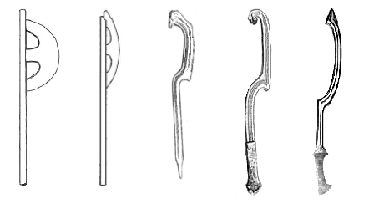
Epsilon axe (far left, 2nd to left) and khopesh

The Khopesh was a curved sword that derived from the Epsilon axe, they were all made out of bronze as well but some were believed to have been made from Iron during the introduction of the Iron age;

The Egyptian bow was also a common and main weapon of the Egyptians, it was long and similar to the English longbow;

Mughal armor is indicative of the “Islamic” armor and weapons of the time.
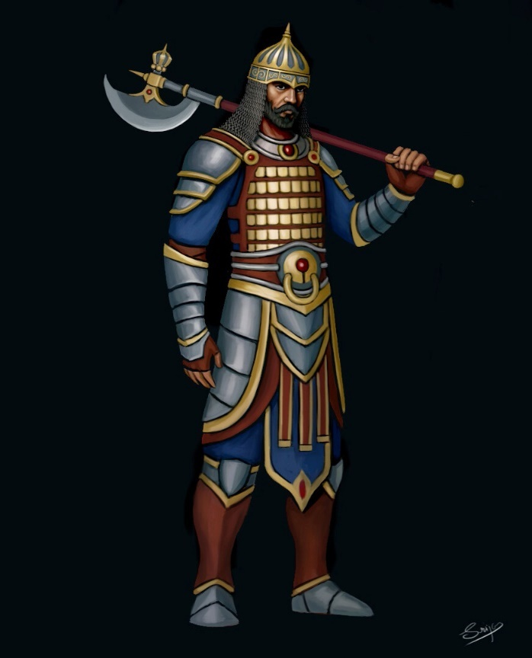

https://www.metmuseum.org/toah/hd/isaa/hd_isaa.htm
One of the main characteristics of Islamic armor is that, compared to armor from the western kingdoms, it is often relatively lighter and less extensive. This fact owes as much to a strategic and tactical preference for speed over heavy protection, as to the usually hot climate of Islamic countries. The use of plate is confined to helmet, short vambraces (arm defenses) and greaves (lower leg defenses), and, to some extent, reinforcement of the mail shirt with steel plates joined by areas of mail.
Soldiers wear conical helmets with mail coifs
Shields were usually of round shape, and constructed—unlike the majority of their European counterparts—of metal.
scimitar or saber, having a long, slightly curved blade with a single cutting edge. Other arms included javelins (throwing spears), battle axes, maces, and recurve bows (so called because the ends of the arms/limbs in their relaxed state curve forward, adding additional momentum to the arrow when the bow is strung). Although the above weapons were certainly also used by foot soldiers, all were essentially suited for use by cavalry.

Sword blades of “Damascus steel” or “watered steel” refer to blades that had been given a wavy or “watered” pattern, produced in the steel prior to forging using specific smelting and crucible techniques. Although this technique was practiced in the Islamic Middle East at least since the Middle Ages, in western Europe such blades were believed to originate from Damascus (Syria), hence the name. Along similar lines, the inlay of metal surfaces such as those of a breastplate or a sword blade with gold or silver was known as “damascening,” a term again alluding to the city of Damascus and the apparent Eastern origins of this technique.
Jambiya dagger - a short, curved blade with a prominent medial ridge. The blade is usually broad at the hilt and tapers toward the tip.

Islamic arms and armor were decorated using a variety of techniques such as damascening, gilding, inlay, gold and silver encrusting, as well as setting with jewels and enameling. On some ceremonial items, the decoration could achieve such sumptuous and spectacular effects that the final appearance of the object has more in common with an item of jewelry than a weapon. Indeed, the splendor of the Mughal empire was such that even today the term “mogul” is synonymous with enormous wealth and power, a notion easily verified by Mughal arms and armor.

Apart from floral and animal motifs, a dominant part of Islamic iconography on arms and armor is confined to calligraphy. Although the representation of (sacred) figures is not strictly forbidden in the Qur’an, images as objects of devotion were avoided in Islamic art from its very beginning. Islamic artists relied instead on the words of the Prophet Muhammad to inspire and to give literal shape to their designs. As a result, calligraphy in Islamic lands developed into a fine art, becoming in the process the principal form of religious ornament. Thus, Islamic arms and armor were often decorated with a wide variety of Qur’anic passages and pious invocations, which functioned as expressions of piety, as powerful defenses in the form of talismans, or simply as visually pleasing ornament.

https://www.arabamerica.com/the-art-of-armor-in-islam/

Arabic music:
https://www.youtube.com/watch?v=lcy_MF_jGdE

distances and travel times (by camel, traveling average of 25 miles per day)
distance between Akhtiri and Darmiddia:1600 miles; journey of 64 days

Darmidia to Hafzara 200-250 miles; journey of 8 to 10 days
Hafzara to Qadimar 250-300 miles; journey of 10 to 12 days
Qadimar to Tijara 300-350 miles; journey of 12 to 15 days
Tijara to Qarath 350-400 miles; journey of 15 to 20 days
Qasrath Asharaat 350-400 miles; journey of 15 to 20 days
Asharaat to Ankhtiri 350-400 miles; journey of 15 to 20 days

New distances and travel times (by camel, traveling average of 25 miles per day)
Darmidia to Hafzara 350 miles; journey of 14 days
Hafzara to Tijara 400 miles; journey of 16 days
Tijara to Asharaat 400 miles; journey of 16 days
Asheraat to Ankhtiri 450 miles; journey of 18 days

Quadimar to Darmidia 650 miles; journey of 26 days
Qadimar to Hafzara 450 miles; journey of 18 days
Qadimar to Tijara 500 miles; journey of 20 days
Qadimar to Asharaat 800 miles; journey of 32 days
Quadimar to Ankhtiri 1200 miles; journey of 48 days

Qasrath to Ankhtiri 1100 miles; journey of 44 days
Qasrath to Asharaat 700 miles; journey of 28 days
Qasrath to Tijara 600 miles; journey of 24 days
Qasrath to Hafzara 850 miles; journey of 34 days
Qasrath to Darmidia 1150 miles; journey of 46 days

distance between Akhtiri and Darmiddia:1600 miles; journey of 64 days

