Notes on the lands of Sadara
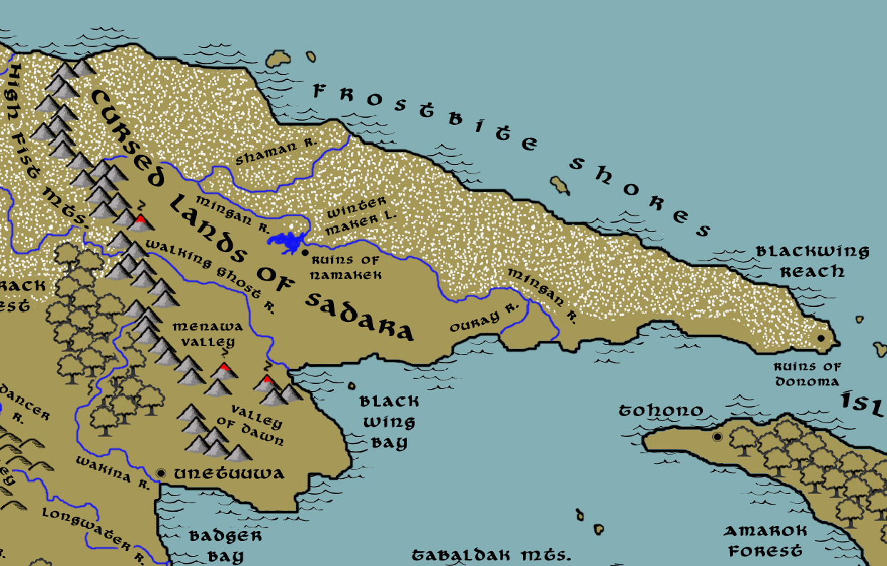

Table of Contents
- Overview
- Towns and Cities
- Best in the Land
- Stewards of Power in this Land
- Points of Interest
- History
- Local Goods
- Notes on Culture
- Weapons and Armor
- Local Deities
- Creatures
- Other Races
- Magical Items
- NPC Templates
- Developer Notes

Overview
Sadara was settled

Towns and Cities
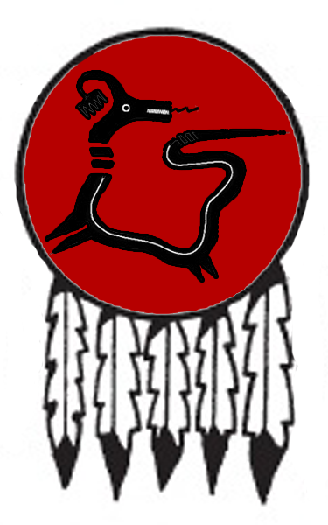
- (this is a summary only, with links to the individual towns and cities entries below)

Best in the Land
(suggested categories for any prominent towns/cities that are leaders in a particular good)
Trade Hub:
Religion:
Arts:
Magic:
Spirits:
Steel:
Grain:
Crafted Goods (e.g. Pottery, Textiles, Metal Wares):
Harvested Goods (e.g. Aromatics, Medicine, Dyes):
Mined Goods:
Precious Metals:
Ship Building:
Other:

Stewards of Power in this Land
Kings and their armies are not the only wielders of power. There are many unseen friends and foes that shape the destiny of the land. Each of the groups listed below are well known to the people of this region. Some are feared, others venerated. All of them play their part in the grand drama of this land’s story.

Merchant Companies
(none)

Mercenary Companies
(none)

Smuggling Rings
(none)

Centers of Worship (Churches, Cathedrals, Shrines, Lodges, Temples)
(none)

Orders of Paladins
(none)

Druidic Circles
(none)

Bands of Rangers
(none)

Schools of Magic
(none)

Bardic Colleges
(none)

Warrior Academies
(none)

Assassins Guilds
(none)

Cults
(none)

Other Guilds
(none)

Monasteries
(none)

Pirates
(none)

Points of Interest

- Black Wing Bay
  - Here lurk the tribe of Sahuangin known as the Ulsharok, known by their sign of a wavy fish spine.
- Black Wing Reach
- Frostbite Shores

- White Tail River
- Shaman River
- Ouray River
  - Where the river empties into the sea stands the tower of Rowtag of the Forbidden Flame, Arch Mage of the Sadaran lands.
- Mingan River

- Wintermaker Lake

- High Fist Mts.
  - Here dwell the Reegra tribe of goblins, known by their sign of the goblin fist.
  - home to the great white dragon Waquina
  - Here dwell the tribe of Stone Giants known as the Amatuk

- Caul Hills

- Morenrin – Drow Domain
  - The cursed lands of Sadara have been long bereft of human overlords. They were crushed by the Haka’Na centuries ago. So now the Morenrin prevail, having left the High Fist Mountains to rule the lands above and below. Deep within their mountain palace the Great Emberpit burns with a cursed flame consuming the bodies of a hundred slain demons. The black souls create a thick smoke that covers the skies above Sadara, casting the world in gloom. Large dire bats circle overhead, their Drow riders locked in constant combat and preparing for the day they lead their armies westward against the Haka’Na. Unnatural screams echo across the landscape, thought to be the fading souls of the tortured demons below. Lord Zaevruc bides his time, seeking out the lost treasures of the fallen city of Namakek of old. His warriors lay in wait along the Frostbite Shores, ready to pounce on unsuspecting sailors who attempt to weather the arctic seas there.

- Valley of Dawn
- Menawa Valley

- Ruins of Namakek
- Ruins of Donoma

Nimerigar
Size: small city, population 12,000, guards / soldiers 120, militia 600
Trade Goods:
Local Goods:
Standard:
Colors:
Patron Deity:
Ruler:

Home:
Steward:
Marshal:
House Priest:
House Adviser (Scholar/Mage/etc):
Captain of the Guard:
Chief Warriors in Service:

Local Powers:
Local Sites:

Description: A relic of an age long gone, Koyot is a city ringed with stone and built of stone in a land where few masons hail from.

Industry:

Key Figures:

Local Lore:

History:

Customs:

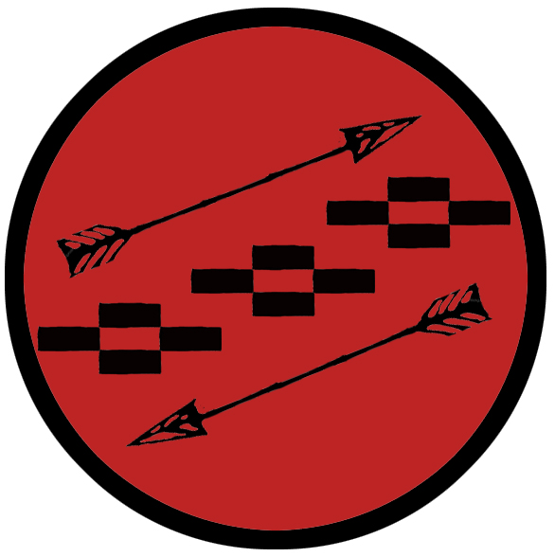

History
First Primordial Age (PA1)
545 PA1 - Haka tribes in the east cross the High Fist Mountains and settle the lands later called Sadara

Second Primordial Age (PA2)
722 PA2 - the powerful shaman Howahkan is beguiled by dark spirits to cross the High Fist Mountains, his cult finds the crown of power

730 PA2 - Howahkan's power grows, he sends his warriors and unholy acolytes to lay waste to the land, making friends with unnatural beasts

740 PA2 - Howahkan's dark reign comes to an end when the Eight Elders trek over the High Fist Mountains armed with eight war clubs given by Wakheon; they defeat Howahkan and are lost in a great fire

Third Primordial Age (PA3)

Fourth primordial Age (PA4)
800 PA4 - the evil wizard Iretrix rises to power past the High Fist Mountains; dark kingdom of Sadara forms in Eastern Amadar

822 PA4 - Founding of Namakek, seat of power in Sadara

838 PA4 - Founding of Donoma in Sadara

872-888 PA4 - The Wizard War: Telemechus triggers a world-wide war of mages, some of whom march on Ongolk to stop him and some who join him in attacking the ley lines in their lands; epic battles wage all over the world, destroying cities and upsetting the balance of magic

888 PA4 - The Battle of Forlorn: Telemechus is slain but not before rupturing the magical ley lines permeating Nemmyrl; the victorious general Dragan of Celedon seizes the opportunity to rid the world of magic and ruptures the Singularion as it is embedded in the ley lines; the resulting explosion sends a shock wave that ruptures the magical ley lines around the world and triggers the Dead Century

First Ancient Age (AA1)

270 AA1 - War of Falling Stars: Haka'Na tribes unite and march east past the High Fist Mountains to wage war on Iretrix and his dark host

292 AA1 – End of the War of Falling Stars: after years of bloody battles, the Haka’Na tribes succeed in slaying the wizard Iretrix and destroying the evil Kingdom of Sadara

Second Ancient Age (AA2)
250 AA2 - a trio of Jindun ships from a convoy anchor off the shores of Sandara while the rest continue to explore the Noreast Jaunt route; ship and crew disappear

Third Ancient Age (AA3)

Fourth Ancient Age (AA4)

First Written Age (WA1)

Second Written Age (WA2)
230 WA2 - Norgarde ships land in far eastern land of Sadara; set up traveler's havens along the Frostbite Shores for passing ships to anchor and take on water and shelter from storms

370 WA2 - a dark power comes down from the High Fist Mountains in Sadara and wipes out all Norgarde settlements, driving the Norgardians out of Sadara completely

Third Written Age (WA3)

812 WA3 - evil shaman Hehosho uses the Broken Hoop to summon demons in Namakek, builds an army of bugbears and gnolls under the banner Black Sky

814 WA3 - Black Sky invades Haka'Na lands, destroys Unetuuwa

815-821 WA3 - War of Black Sky: Liluye, Ayaabe, Ioskeha, and Tall Bear fight Hehosho's forces, who plunder eastern Haka'Na lands and conquer Sunwalk Valley; Hehosho desecrates the valley and makes it his stronghold
821 WA3 - Battle of Sunwalk - Red Horn joins the Haka'Na alliance, which marches on Sunwalk Valley from the north; Kiwidinok (f) the huntress is gifted the Bow of Hawenniyo and slays Hehosho; the Black Sky armies are destroyed

Fourth Written Age (WA4)

Local Goods
(this comes from the dnd-economics.xlsx document from the Origins of Foods tab)
Cereals:
Fiber:
Fruits:
Meat and poultry:
Nuts:
Vegetables:
Herbs:
Oils:
Fermented Drink:
Salt-water fish:
Fresh-water fish:
Wood:
Textiles:
Other:
Dishes:

Notes on Culture
(this can include research information from real world historical notes)

Ruins of Donoma
Translates to “Sight of the Sun”

Weapons and Armor

Local Deities
(summary of patron deities from each settlement description, plus more that fit into this region’s cultural feel)

Creatures
(creatures from Monster Manuals that fit this region, or home brew creatures that fit this region’s real-world cultures and myths)

Other Races
Elves

Dwarves

Magical Items

The Broken Hoop – a cursed item of enormous power, the Broken Hoop was created out of pure chaos magic. It grants whoever wields it power over probability, making the near-impossible within ones grasp. It was wielded in 812 WA3 by the evil Sadaran shaman Hehosho to summon demons in Namakek and build an army of bugbears and gnolls under the banner Black Sky. With it, he conquered the eastern Haka’Na lands and desecrated Sunwalk Valley before the combined Haka’Na armies marched on him. Kiwidinok (f) the huntress was gifted the Bow of Hawenniyo and slew Hehosho. The Broken Hoop was lost and its current whereabouts unknown.

NPC Templates
This is a list of notes and stats to help develop NPC’s relevant to this region.

Developer Notes
This is a list of notes on the development of this document, including notes on history, culture, and changes to the document.

